1. Given H = [3, 1, 4], the function should return 10. The result can be achieved by covering the first two buildings with a banner of size 3×2 and the third building with a banner of size 4×1:

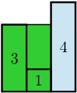

2. Given H = [5, 3, 2, 4], the function should return 17. The result can be achieved by covering the first building with a banner of size 5×1 and the other buildings with a banner of size 4×3:

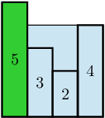

3. Given H = [5, 3, 5, 2, 1], your function should return 19. The result can be achieved by covering the first three buildings with a banner of size 5×3 and the other two with a banner of size 2×2:

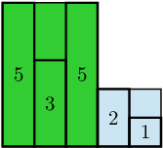

4. Given H = [7, 7, 3, 7, 7], your function should return 35. The result can be achieved by using one banner of size 7×5:

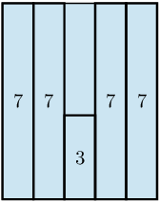

5. Given H = [1, 1, 7, 6, 6, 6], your function should return 30. The result can be achieved by using banners of size 1×2 and 7×4:

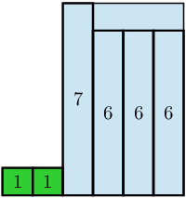

Write an efficient algorithm for the following assumptions:

* N is an integer within the range [1..100,000];
* each element of array H is an integer within the range [1..10,000].