HealthBuddy

Nihal C Anil
Presidency University
Bengaluru, India
nihallanil@gmail.com

Ande Yogendra Reddy
Presidency University
Bengaluru, India andeyogendrareddy260@gmail.com

Ken John James
Presidency University
Bengaluru, India
kenjohn297 @gmail.com
Royal Mahesh
Presidency University
Bengaluru, India royalmahesh1201@gmail.com
Dr. Taranath
Professor and Guide
School of Computer Science, Presidency University
taranath@gmail.com

ABSTRACT
Health literacy is a critical feature of individual happiness, yet it remains a question for many specifics in today’s hectic world. With growing commands on time and facilities, public generally lack way in to clear and authentic wellness details. This space leaves them impotent to recognize possible wellness hazards or control symptoms efficiently, leading to detained curative consultations, late detections, and avoidable troubles. In spite of the expansion of wellness statistics platforms, many fail to provide food for the common citizens. They are often overly technological, furnish limited scope, or work behind subscription login walls, further isolating those who need counsel the most. The Health Buddy ia an android application that is imagined as an extensive solution to this pressing trouble. It goals to popularize access to wellness statistics by designing an adaptable platform that furnishes authentic and easy-to-understand specifics about diseases, symptoms, and preventative measures. The app’s main aim is to allow users to make familiar decisions about their health, acknowledge symptoms early, and take preventive steps to enrich overall well-being. Health Buddy not only furnishes individual health control but also contributes to reducing the load on healthcare systems caused by preventable illnesses and late-stage diagnoses. The app will feature a huge, handpicked database of medical states and symptoms presented in easy language, making it ready to users of all backgrounds. In addition to symptom analysts, Health Buddy will give preventive care tips and wellness development modules, making sure users can boldly regulate their well-being. Unlike other platforms, Health Buddy will aim on affordability and inclusivity, making the platform reachable to all without hidden costs. By addressing the space in reachable health statistics, the Health Buddy app takes the potential to change how individuals involve with their health.

Keywords:Symptom analyst,illness,diagnoses,android application,affordability,inclusivity
1.INTRODUCTION
1.1 Background

Health is universally identified as one of the most critical sides of human well-being. As the old saying goes, “Health is Wealth,” it affirms that without good health, material wealth loses its importance. However, the value of health has been weakened in recent society. The quick pace of life, coupled with full-time and unique responsibilities, has designed an extensive fact where people are not prioritizing their physical well- being. From working long hours to leading household duties, keeping a healthy lifestyle repeatedly falls by the wayside.

Existing health statistics applications are crucial for uniting users to medical knowledge, but their effectiveness and limits differ. WebMD and Healthline, for example, furnish extensive health-related content, such as symptom checks and wellness tips. Many apps furnish useful data, but their difficulty or sheer volume of data can be overwhelming, making it tough for users to find what they need. Another popular app is Mayo Clinic, which furnishes reliable and exact medical statistics, involving health counsel and a symptom examiner. However, because it focuses on medical conditions, it may be less handy to people looking for common health advice.

1.2 Motivation:

The motivation behind “Health Buddy” is fixed in the wish to provide an easily reachable and comprehensive solution to address these health statistics gaps. By using the technology and reach of smartphones, the application can make health consciousness and disease prevention handy to individuals at their fingertips. Unlike normal methods, mobile apps can furnish instant, exact, and understandable data, adapted to the user’s demands. The aim of this project is to allow individuals by furnishing them with a platform that can assist them make informed opinions about their health, potentially preventing serious health conditions before they progress. With the arrival of mobile technology, there is a huge chance to combine real- time updates, symptom examiners, and valid data into an easy-to-navigate format. The motivation is to design an app that not only gives complete medical knowledge but also presents it in a way that’s reachable to the average user. This covers simple language, intuitive design, and aspects that support ongoing health monitoring. The Health Buddy app aims to serve as a genuine companion that furnishes timely updates on symptoms, diseases, and treatment options, making it simple for users to stay informed and take action when necessary.

1.2 Problem Statement

In today's fast-moving world, the majority of individuals lack entry to valid and clear health statistics. The burden of managing health-related knowledge is frequently placed on healthcare professionals, leaving individuals in the dark about their symptoms or risk factors. Many individuals slow down seeking medical aid due to variability about their health status, granting to late diagnoses. Existing health statistics platforms, though plentiful, frequently fail to meet the needs of the normal public due to difficulty, limited data, or subscription-based services.

Therefore, the issue that this project seeks to address is the absence of comprehensive, simple, and readily accessible health statistics. There is a vital space in the market for a health application that delivers valid data in a simple format, enabling people to acknowledge symptoms early, take preventive measures, and build more informed decisions about their health. The Health Buddy app aims to fill this space by offering a reachable database of diseases, symptoms, and preventative measures to assist users manage their health proactively.

2 LITERATURE SURVEY

2.1.1 Existing Health Information Applications
Existing health statistics applications are crucial for combining users to medical knowledge and supplies, but their productiveness and limits differ. WebMD and Healthline, for example, furnish an extensive health-related content, such as symptom checks, condition data, and wellness tips. Many apps furnish useful data, but their sheer volume of data can be overwhelming, making it tough for users to find what they require. Another popular app is Mayo Clinic, which provides stable and exact medical data, including health advice and a symptom examiner.

However, because it focuses on medical conditions, it may be less useful to people looking for general health advice. However, its use is confined to individuals who are previously enrolled in specific healthcare systems. Medscape, on the other hand, is firstly designed for healthcare executives, furnishing clinical tools and complete medical data, but its scientific nature makes it inapt for the public.

Apps like HealthTap furnish practical doctor consultations and health advice, but the standard of these consultations varies, and the app may not furnish enough detail in terms of health statistics. While these present applications furnish key services, they usually suffer with accessibility, personalization, and reliable, emphasizing the need for a more simple and complete solution for the public.

2.1.2 Critique of Existing Solutions
While the apps introduced above furnish valuable health statistics, they also come with vital flaws that affect their usability and availability:

1.Complex User Interface: The design of many health apps is more focused on furnishing data than on ensuring that users can easily navigate the app. This can be particularly challenging for older adults, individuals with disabilities, or those who are not technologically smart.

2.Limited Scope of Information: Although these apps frequently cover a wide range of diseases and conditions, they may not go deep enough into preventive concern and self-care. The content might also be overly common and not customized to individual requirements.

3.Lack of User Engagement: Most health apps are educative but lack interactive aspects that involve users in their health control. An aspect that would permit users to track their symptoms, receive notifications, or schedule preventive checkups could expand the app’s utility.

4.Cost Barriers: Many health apps need users to pay for premium aspects, which limits access for individuals with financial constraints. This can stop the app from reaching a larger audience.

2.1.3 Need for a New Approach
After examining the constraints of current health applications, it is clear that a new plan is required. Current systems typically fail to give health statistics in a simple and reachable style to users who lack medical knowledge. As a result, there is the chance to design an app that furnishes reliable, detailed, and regularly updated health statistics while being easy to use for a broad range of users.

The Health Buddy app tries to close this space by furnishing a solution suited to the general public. It will cover detailed disease data, preventive care ideas, and an interactive symptom examiner, all presented in an understandable format. This software enables individuals by promoting reachability and user involvement.

3 PROPOSED METHODOLOGY
3.1 Overview of Methodology
Many health applications suffer to keep up with the quick growth of medical knowledge because they often fail to update their material on a regular basis. Outdated data can offer real concerns, particularly when new research results in changes to treatment guidelines, diagnostic methodologies, or illness management fares. This problem is most prominent in apps that depend on fixed data origins that do not cover the most recent studies, medical advice, or rising health issues.

The Health Buddy app will correct this issue by keeping its data up to date. It will cover real-time updates and links to good medical sources, allowing users to access the most recent and exact health data available.

3.2 Planning Phase
The planning phase is aimed on determining the demands of the target audience, particularly those with less medical knowledge who demand quick and reliable access to health data. This step also covers deciding which diseases, symptoms, and features will be included to make the app relevant and simple.

This phase's key tasks are as follows:

Requirement Gathering: Surveying potential users to determine their health issues, and level of awareness with technology.

Feature Definition: Outlining key aspects such as a symptom examiner, disease database, preventive health tips, and health reminders to make sure the app meets user beliefs.

3.3 Design Phase
After defining the needs, the design process includes creating the UI and UX. The aim is to make the app simple and easy to navigate. The design should be simple, with clear images and straightforward language.

1.Wireframes: Sketches or wireframes are designed to outline the app's design and layout.
2.Prototyping: A prototype is created to picturize the app's flow and confirm it matches user beliefs.
3.User Feedback: Fetch feedback from a small group of users to enhance the design before moving on to development.

3.4 Devlopment Phase
During the development process, the Health Buddy app is coded and programmed. The app is being made with Android Studio, with Java/Kotlin for the backend and XML for the user interface.

1.Database Design: Firebase is used to set up a real-time database, permitting the app to save and recover data more efficiently. This database will contain data on diseases, symptoms, treatment choices, and preventive concern guidelines.
2.Feature Implementation: The app's main aspects, such as the symptom examiner, disease database, and health reminders, are designed and integrated.

3.5 Design Phase
After the development phase, the app faces careful testing to make sure its functionality and usability.
1.Unit Testing: Individual components of the app are checked to confirm that they work as expected.
2.System Testing: The whole app is checked as a whole to spot any integration issues or bugs.
3.User Testing: A group of users will be invited to check the app and furnish feedback on usability, and functionality.
4.Deployment: The app is launched on the Google Play Store successfully after testing, for public use..
4 IMPLEMENTATION
4.1 System Architecture
The "Health Buddy" system architecture uses a client-server model, with the mobile app communicating with a remote server that saves health data.The platform used is android studio.The system is composed of three main layers:

1.User Interface layer: The layer that interact with user.The UI is clear,natural and easy to navigate
2.Business Logic Layer: Handles user input,does computations,and communicate with the database to recover relevant data.
3.Data Layer: Stores and controls health data, such as diseases, symptoms, treatments, and preventive actions. Data is stored on Firebase for scalability and real-time updates.

  - System Components
1.Disease Database: Stores data about diseases, symptoms, treatments, and preventive.
2.Symptom Checker: A feature that permits users to input their symptoms and obtain possible diagnoses based on the app’s database.
3.Health Reminders: A feature that directs users reminders to take medications, schedule doctor visits, or make lifestyle changes based on their health status.

  - Integration and Testing
Integration of elements is carried out to make sure that the frontend communicates efficiently with the backend. After integrating the system, it faces careful testing to make sure the app’s robustness, and scalability.

1.Unit Testing: Ensures individual elements function as expected.
2.System Testing: Ensures the whole system works as expected, including communication between the UI, backend, and database.

  - External APIs:
The App fuses with Google Maps api for finding nearby hospitals and symptom api from infermedica for identifying symptoms.

5 OUTCOMES

The “Health Buddy” app is created to enhance the way individuals control their health, furnishing them with easy access to valuable medical data. After the development and deployment of the app, various positive outcomes were identified. These outcomes not only reflect the efficiency of the app but also show how it could potentially change users’ health behaviours and lifestyle choices. Below are the extended outcomes expected from the app’s implementation:
One of the quick outcomes expected from the “Health Buddy” app is a rise in health awareness among its users. By furnishing access to a comprehensive database of diseases, symptoms, treatments, and preventive measures, the app educates users on a broad variety of health topics. The app’s understandable language and simplified explanations make medical knowledge reachable to users. As a result, individuals will be better supplied to recognize symptoms early and understand the basic preventative steps for common diseases.

1.User Education: The app acts as a health education tool that assists a better understanding of diseases, symptoms, and treatments.
2.Symptom Awareness: Users will become more aware of the symptoms of common diseases, empowering them to seek timely medical advice.

6.Block Diagram

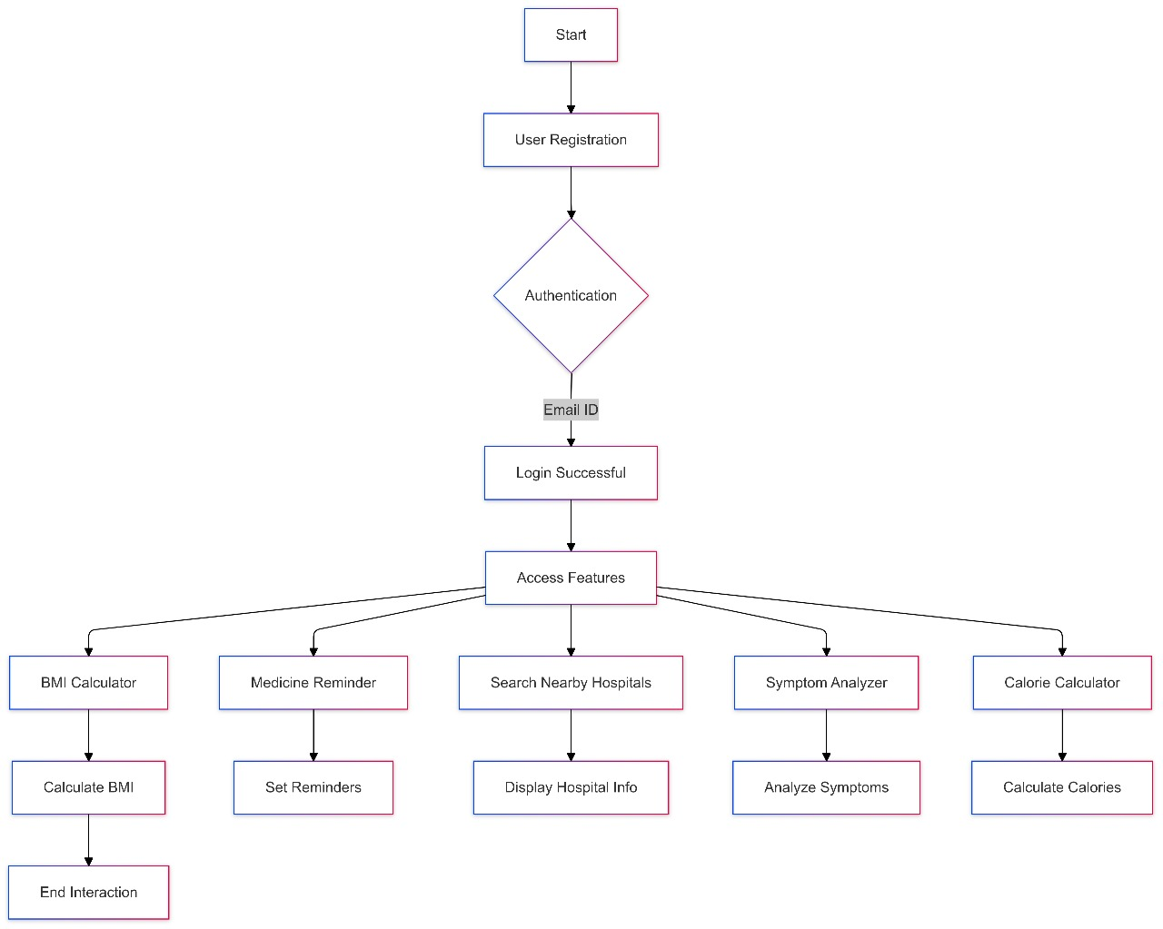

7 RESULTS

The “Health Buddy” app was designed with the aim of furnishing users with a simple tool for managing their health, from tracking symptoms to receiving health reminders and educational content. After deploying the app and fetching feedback from a various group of users, many key results were noticed.

8 CONCLUSION

The development and deployment of the Health Buddy app has marked a vital step forward in enhancing the way individuals control their health. Through its simple interface, various health supplies, and innovative aspects such as symptom tracking, health reminders, and preventive care suggestions, the app has exhibited its potential to positively impact users' health behaviors, improve their awareness, and furnish valuable tools for managing everyday health concerns. The results from the app’s first use and feedback expose promising outcomes, verifying the need for such a health management tool in today's fast-moving and health-conscious world.

The Health Buddy app has attained its main aim of permitting users with the knowledge and tools required to take manage their health. By presenting a comprehensive and reachable platform, the app has made it easier for users to spot health issues early, restore regular health routine. The ease with which users can log symptoms, set health reminders, and access educational content has shown to be highly efficient in nurturing proactive health management.

However, as with any technology-based solution, the Health Buddy app is not without its challenges. The feedback collected showed that while the app is highly useful for many users, there are places for advancement, such as improving the depth of medical content and addressing concerns related to data isolation. These challenges furnish essential intuitions that will guard future updates of the app.

The potential for future growth of the Health Buddy app is huge. With the integration of wearable devices, the incorporation of artificial intelligence for customized health intuitions, and the addition of telemedicine aspects, the app could develop into a comprehensive health management tool that goes beyond symptom checking and health reminders. These developments would allow the app to provide even more value to users, particularly those managing chronic conditions or those seeking detailed, real-time health statistics.

As technology grows and the healthcare landscape unfolds, the Health Buddy app is assured to be a key player in the next generation of health management tools, helping individuals live healthier. The results and feedback from the app’s first deployment have been promising, and with continuous updates and improvements, the app holds good potential for broader adoption and long-term clash in the area of health and wellness.

9 REFERENCES
- Smart Health Predicting System Using K-Means Algorithm by Ravuvar, H. N., Goda, H., R, S., & Chinnasamy, P. International Conference on Computer Communication and Informatics 2020.

- Symptom Based Health Prediction using Data Mining by Vijava Shetty, S., Karthik, G. A., & Ashwin, M. . International Conference on Communication and Electronics Systems 2019.

- A survey on Different Algorithms used in Chatbot by Siddhi Pardeshi, Suyasha Ovhal, Pranali Shinde, Manasi Bansode, Anandkumar Birajdar. International Research Journal of Engineering and Technology 2020.

- Smart Health Consulting Android System by Ravi Aavula, M.Kruthini, N.Ravi teja, K.Shashank. International Journal of Innovative Research in Science, Engineering and Technology 2017

- An Improved Method for Disease Prediction Using Fuzzy Approach by Chetty, N., Vaisla, K. S., & Patil, N. . Second International Conference on Advances in Computing and Communication Engineering 2015

- SMART HEALTH CARE (AN ANDROID APP TO PREDICT DISEASE ON THE BASIS OF SYMPTOMS) by Prashant Tiwari, Aman Jaiswal, Narendra Vishwakarma, Pushpanjali Patel. International Research Journal of Engineering and Technology 2017.

- Android Based Health Care Monitoring System by
Devashri Deshmukh, Ulhas B. Shinde, Shrinivas R. Zanwar. INTERNATIONAL JOURNAL OF ADVANCE SCIENTIFIC RESEARCH AND ENGINEERING TRENDS 2017.

- Android based health care monitoring system by Kumar,M. A., & Sekhar, Y. R. . International Conference on Innovations in Information, Embedded and Communication Systems 2015.

