

White Paper
Federator SDS Unified Storage Orchestrator for Cloud
－ HP Helion OpenStack

May 2016

ProphetStor Data Services, Inc.

Content

Profile ............................................................................................................................................................. 3

Introduction of program ................................................................................................................................ 4

Architecture .................................................................................................................................................... 4

FEDERATOR SDS of ProphetStor Data............................................................................................................ 4

HPE Helion OpenStack Docking.......................................................................................................................... 5

Traffic modeling module TMM ....................................................................................................................... 7

X86 SAN Storage Virtual Machine - FLEXVISOR.......................................................................................... 8

FEDERATOR SCALE-OUT Storage Cluster.................................................................................................... 8

Main features and advantages of the application program.......................................................................... 8

Case introduction........................................................................................................................................... 9

Conclusion ..................................................................................................................................................... 10

Profile
The present OpenStack develop very fast after several years of brewing, and has grown to be the most welcome open source cloud platform. Every year, Openstack Foundation will thoroughly investigate a wide range of application conditions of OpenStack worldwide. It can be seen from the survey results, OpenStack has substantial increasement in the current deployment, OpenStack has become the private cloud's preferred platform, and continue to gain more and more supports both from the traditional IT giants, such as IBM, HP, Cisco etc., or from the world's leading open source and the most mainstream companies, such as RackSpace, RedHat, Marantis and so on.

For more and more enterprises, cloud computing and virtualization is the main way to reduce the total cost of ownership (TCO), and improve the efficiency of management. There are more and more enterprises migrate their service and application to the cloud via virtualization means.

In the process of building, maintaining and using the enterprise private cloud, it needs strong flexibility in the architecture to adapt to the change and diversity of enterprise business needs. Moreover, it needs for easy, flexible deployment and expansion capabilities, in order to facilitate the enterprise resource adjustment; it also needs to have a very high continuity and good management ability, so as to ensure the operation of business; meanwhile, as a result that enterprises will conduct a large-scale deployment, it is also an essential requirement not being bound by a specific vendor and improving hardware compatibility to control costs.

OpenStack's openness, flexible structure and the characteristics of virtualization well meet the requirements of many enterprises. However in practice, OpenStack also has a lot of spaces to be perfected, such as its relatively primitive block storage service module Cinder, and management to the physical resource is not perfect. Therefore, only an open source OpenStack is not enough for an open unified management platform in the realization of real cloud computing and virtualization architecture. In the case by the combination of HPE’s Helion OpenStack platform, the PropherStor Data’s FederatorTM SDS software-defined storage achieves and upgrades private cloud platforms, makes private cloud platforms don’t be restricted by hardware and manufacturers; based on this to achieve automatic storage management and delivery of storage resources in the private cloud platform.
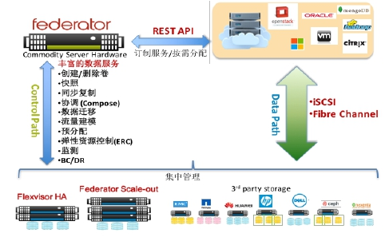

Introduction of program
As the private cloud’s unified storage resource management part, ProphetStor Data’s FederatorTM SDS makes the enterprise unified management platform integrate, as well as flexibly and effectively manage all storage resource of the whole private cloud via the rich and open API; users can complete the control, operation on different kinds of storages from different manufacturers, simply via a general management interface, and obtain good storage characteristics and performance, such as snapshots, streamlined configuration.

Architecture

Customized service/ distribution on demands
Rich data service
Create / delete volumes
Snapshot
Synchronous copy
Compose
Data migration
Flow modeling
Pre-allocation
Elastic resource control
Monitor
BC/DR

Centralized management

In this solution orchestrator, Federator SDS not only provides a distributed storage system based on commercially available hardware plus of high performance and high reliability storage, but also realizes the delivery of uniform management of different heterogeneous storage infrastructure in the private cloud environment. Abstract the underlying multi vendors’ heterogeneous storage resources, and allow administrators to create storage service. Automatically configure the required application server according to the required characteristics such as the level of IOPS or RAID.

The Cinder volume driver provided by Federator SDS is deployed in every control node, and docks with the Federator SDS controller via the OpenStack. Various storage services are developed through the Federator SDS controller management interface; they are automatically mapped to the OpenStack volume category via the Cinder driver, and enable to meet demands of virtual machines in different application environments.

The docking with VMWare/Hyper-V and physical machines’ application environment can directly create a volumn needed the application environments through the Federator SDS control management interface, and directly map from the storage to the server via iSCSI/FC/RBD.

FEDERATOR SDS of ProphetStor Data
The FederatorTM SDS of ProphetStor Data is the software defined storage platform, provides the out-off-band storage management system, plus of complete and rich data service. The core of Federator™ SDS is the storage resource allocator (Orchestrator) Federator, which can provide and monitor the storage arrays of different manufacturers and the standard hardware. Federator can be automatically enabled, abstracts multiple hardware store pools with different functions of entities into a virtual storage pool, as well as do collaborative work in a coordinated way, including data storage, access, migration and management.

FederatorTM SDS of ProphetStor data achieves management in the storage infrastructure, and can be accessed through the single open HTTP RESTful API programming. Therefore, even if you do not have any knowledge of the underlying hardware implementation details, service can be stored based on the application strategy, dynamic composition and delivery.

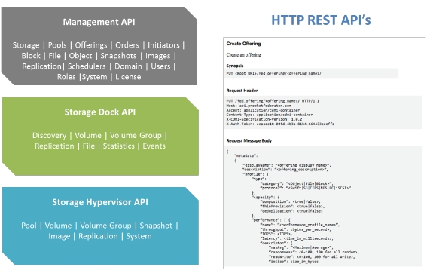

Beside of the data storage service provided by Flexvisor HA SAN Server based on virtual x86 storage and Federator Scale-Out distributed storage, the storage defined by Federator™ SDS software can manage the heterogeneous third-party SAN storage system at the same time; provide storage service in different service class via the uniform storage strategies and interfaces. Federator communicates with the storage system in the control path; while the means of programs to access the distributed storage devices are via iSCSI or fibre channel data path. This infrastructure can guarantee the influence caused by the control plane on data operation is reduced to the minimum.

Automatic and real-time delivery of storage pool resources can be made through the dynamic monitoring of an intelligent resource scheduler; it can also choose to meet requirements for capacity and performance, such as QoS (quality of service) or SLA (service level agreement).Federator communicates with the applications and final users through open standard HTTP rest APIs, let it easily be integrated with OpenStack and the third-party cloud computing or Big Data environment.

When used in the environment of OpenStack, Federator strengthens Cinder, which is the OpenStack’s original and relatively primitive block storage service module, and enriches its functions with more advanced storage management and data services. Thus, a complete and self-contained cloud storage environment is formed; you can choose to connect to the existing isomorphic or heterogeneous storage infrastructure, while connect with other commercial hardware due to the future growth.

HPE HELION OPENSTACK Docking

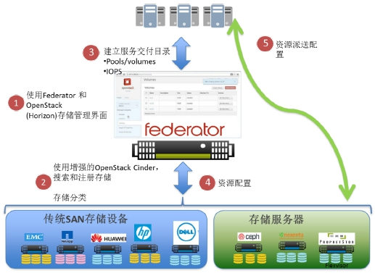

3. Establish service delivery directory
5. Resource delivery allocation

1. Use Federator and OpenStack (Horizon) storage management interface;

2. Use the enhanced OpenStack Cinder, search and register storage;
4. Resource allocation
Storage classification

Traditional SAN storage device
Storage server

To sum up, the storage defined by Federator SDS software has the following characteristics:
- Easy to be installed. Software can be very easy to be deployed regardless of the physical machine or virtual machine of commercial x86 hardware; pre-installation of operating systems or database don’t needed.
- Automatic deployment. The storage defined by Federator SDS software provides a simple and fast automatic deployment method, which can be used for deploying a large number of storage nodes, significantly shorten the deployment time and reduce human intervention

- OpenStack cloud platform achieves the integration and expansion of OpenStack; it can support OpenStack environment through the seamless integration of storage defined by Federator Software and data services. So that a new generation of IT infrastructure platform and services can be constructed by customers based on the open source community of software and technology, which are extensible and non-binding suppliers.
- Storage analysis and flexible resource management. Provide customers with real storage visualization, deeply insight into the relationship between storage and application; reports and early warnings may be given for issues and trends occurred in the storage, plus of storage resource optimization and use. The storage resources can be used more efficiently by intelligent operations and analyses.
- Federated scale-out infrastructure. Based on scale-out infrastructure of software-defined storage, the storage nodes can be very easy for capacity expansion and reduction; if a single node fails, the data doesn’t lost, and the storage business doesn’t interrupt.
- Discovery and configuration of simplified storage resources. Eliminate the complicated storage discovery and configuration workload, so that customers can easily find out and register the storage resources.
- Advanced storage configuration service. Provide the best service to flexible storage configuration according to the user service level (SLA); support automatic streamlined configuration and IOPS create services in different modes.
- Advanced software-defined storage and services. Provide rich software-defined storage and data services, for example, provide analysis, automatic configuration, protection, recovery and optimization services based on the abstraction of core storage service.
- Support RESTful API. Federator to communicate with the end-customers through open standard HTTP REST API and applications; make it easy to integrate with OpenStack and the third party’s cloud computing or Big Data environment.
- Support the OpenStack’s cloud system. OpenStack is an open cloud operating system; the administrator control and manage computing, storage and cyber source via the instrument panel in the data center; users can manage resources via the Web interfaces.

Traffic modeling module TMM
If there are infinite IT budgets, enterprises certainly deploy all-solid-state storage infrastructure for applications with high I/O requirements. Unfortunately, most enterprises don’t do like this; therefore, the statistical multiplexing of the storage system has urgent needs. After all, price of the flash is still over 9 times if compared to that of the rotating disk.

In a typical enterprise environment, the storage space used by a particular application is hardly to keep constant in a day or a week. Conversely, the peaks and troughs storage requirements exist usually in some or a few fixed time ranges per day. Moreover, the storage requirements of peaks and troughs time for each application are also different.

In different time periods, not only the applications need different storage bandwidth, but also their priority levels demand changes. Take the following two applications’ I/O traffic patterns as examples. Intuitively, the storage manager can configure larger solid-state disk (SSD) to the Application 1 during the peak memory requirements of the Application 1, to serve as the cache space; or else, release SSD and configure it to the Application 2.

Now, imagine in the environment involving a few of competing applications, which share the same hardware; the system administrator can't analysis all I/O using modes, and manually adjust the storage components needed in the different time periods and different applications, so as to achieve the real-time optimization of the system’s overall performance.

Federator built-in Traffic Modeling Module (TMM) can monitor the in-pool level I/O traffic patterns. TMM adopts the intelligence of advanced artificial nerve network and fuzzy logic algorithm, so as to provide short-term (response) and long-term (prediction) storage resource management. The configuration structure is especially suitable for multi-tenants and multi workload environment, to optimize the hybrid storage system (HDD and SSD).

X86 SAN Storage Virtual Machine - FLEXVISOR
Flexvisor x86 SAN is a component of ProphetStor data Federator SDS solutions, it is an internal storage virtual machine management program specially developed to achieve TMM response and prediction of storage configuration, and with the elastic resource control (ERC) function. It can transform standard commodity hardware to be managed by the storage server, so as to provide the enterprise level storage function, such as the storage pool (no need to reserve the storage capacity), redirect-on-write (to ensure the consistency of the data), checksum (to achieve data integrity verification and self correction), fast snapshot, write snapshot, rollback snapshot, remote replication, volume creation from Snapshot and the volume consistency group.

By elastic resource control (ERC), Flexvisor can dynamically change storage efficiency via full use of SSD installed on the server end, according to the specific application’s prediction of I/O efficiency. The cache mechanism is proper distribution of SSD to each storage pool to match the read and write. "Hot-spot" data can be selectively maintained in the SSD to improve the random read speed. The random writing is always before they are written to the rotation disk, will be cached and serialized in advance.

ERC can usually make a typical workload realize 50% performance gain more than on the hard disk.

FEDERATOR SCALE-OUT Storage Cluster
➢ Federator SDS can provide Scale-Out storage service space by Federator Scale-out
➢ High scalability (horizontal scale), up to 4096 nodes
➢ High reliability and high speed fault reconstruction
➢ Reduce human errors through the automatic deployment
➢ Volume streamlined configuration

Main features and advantages of the application program
➢ To the upper layer, easily integrate into the overall unified platform management in complete interface form
- To the lower layer, comprehensively and uniformly manage different brands of various storage from different manufacturers
- Federator SDS provides x86 SAN and horizontal expansion cluster etc storage resources.
- An automated and integrated system, is deployed on uCloud and Federator SDS (storage controller and system management program), plus of the environment to implement pre-boot execution environment (PXE) function on the commercial hardware
- Autonomously allocate traditional and commercial storage system
- The enterprise-level complete and rich data services, including mobile data, data migration, traffic modeling, elastic resource control, copy management and disaster recovery
- The high cost performance in many aspects:
O Initial hardware and software purchases
O Deployment
O Management and maintenance

Case Introduction
HPE currently assist one domestic large chain education institution to establish a private cloud platform education system based on the operation platform of Helion OpneStack, which contains the curriculum video recording, playback and archiving and other application systems, which require the storage space must support the elastic expansion. At the initial setting period of HPE Helion OpenStack, the attached Scale-Out (Ceph) storage system is used to satisfy customers’ demands on storage; however, some problems occur in the early operation of the process:

1. Heliion OpenStack Scale-out storage uses the original CEPH system without carrying out the optimization of infrastructure and independent management interface; therefore, it needs more human intervention. Moreover, there are also some issues to be solved in the operation and maintenance.
■ These issues have been solve by HPE engineers one by one, however HPE hopes to cooperate with other solutions to let the system operate more smoothly, as well as improve integrity of the solutions.

2. Another difficult issue is some customers’ application systems are running in the Scale-Out (Ceph) storage, and customers find it can’t satisfy the performance requirements of some specific application systems, so HPE decides to import another HPE storage virtualization solution VSA to join HPE Helion OpneStack, so as to meet the needs of different applications. However, in the cinder configuration and operation of CEPH and VSA, concurrent operation and management complexity can’t be carried out.

At present, this dilemma can be easily eliminated through the ProphetStor Data Federator SDS unified storage resource management solution.
 Before import Federator SDS:
HPE Helion OpenStack can only choose the deployment connection Scale-Out CEPH or virtulization storage VSA.

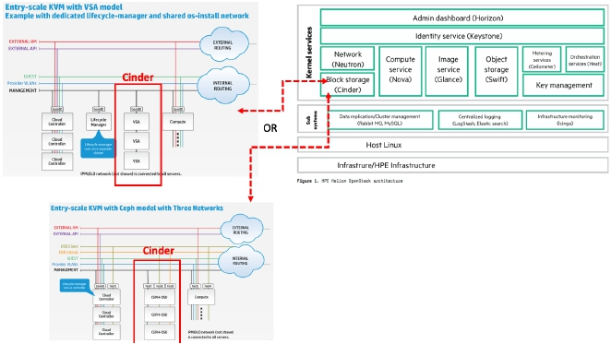

 After import Federator SDS:

Through the Federator SDS Unified Storage, Orchestrator have all storage resources to be mixed deployed in all kinds, through the unified interfaces of Federator to Helion openstack. Meanwhile, the storage source in ProphetStor Cloud can provide customers with various application choices, which can simplify the management of storage resources.

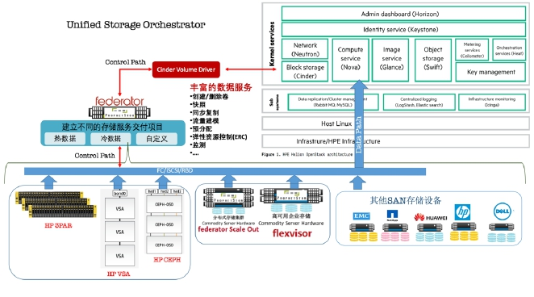

Rich data service
Create / delete volumes
Snapshot
Synchronous copy
Flow modeling
Pre-allocation
Elastic resource control
Monitor

Create different storage service delivery projects
Hot data Cold data Self-definition

Other SAN storage devices
Distributed memory cluster
High availability enterprise storage

Conclusion
The ProphetStor Data FederatorTM SDS can effectively help to establish the unified storage resources to realize coordinative management in the HPE Helion OpenStack private cloud; it also can be integrated into the unified management system through the RESTful API. Integrate all workload on isolated physical servers and traditional storage arrays, so that the storage in the united management platform can exert more functions when keeping transparent.

This solution can be fast and easily applied in various IT environments, in the modular method, fully automated deployment services and complete API. Because of Federator SDS, whether it is new extended storage system and the traditional array, setting and management can be carried out from a single virtual management platform. By use of Federator series of data services, it can help enterprises transform simply storage services into rich data services, as well as achieve more effectively and simply explore data from more dimensions.

