User profile modification

This job is wordpress theme modification, themenaem “FreelancerEngine”

FreelancerEngine has a plugin called AE Fields, it can add customized fields to front pages.

The AE fields document: <http://support.enginethemes.com/customer/portal/articles/1815431>

**Employer post project modification**

URL: <http://test.accesspath.com/submit-project/>

Username: kevinclient; pass: goodluck

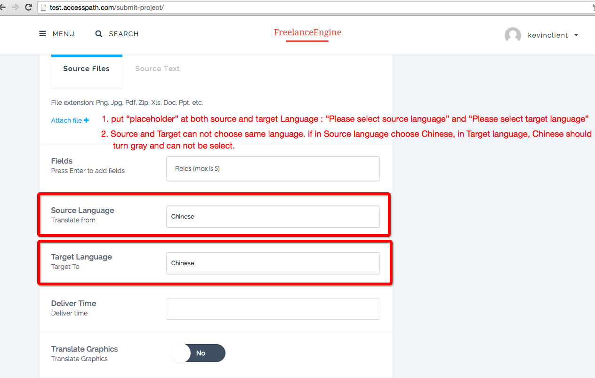

like this put place holder

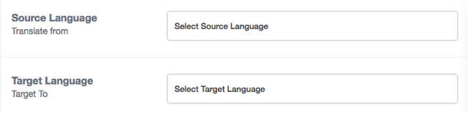

if source language is selected in “Chinese”, the target language “Chinese”style should same as field “Chinese” turn’s to gray. Style like below.

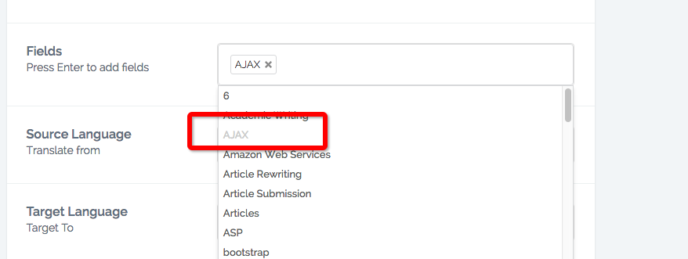

1. Translate graphic bug

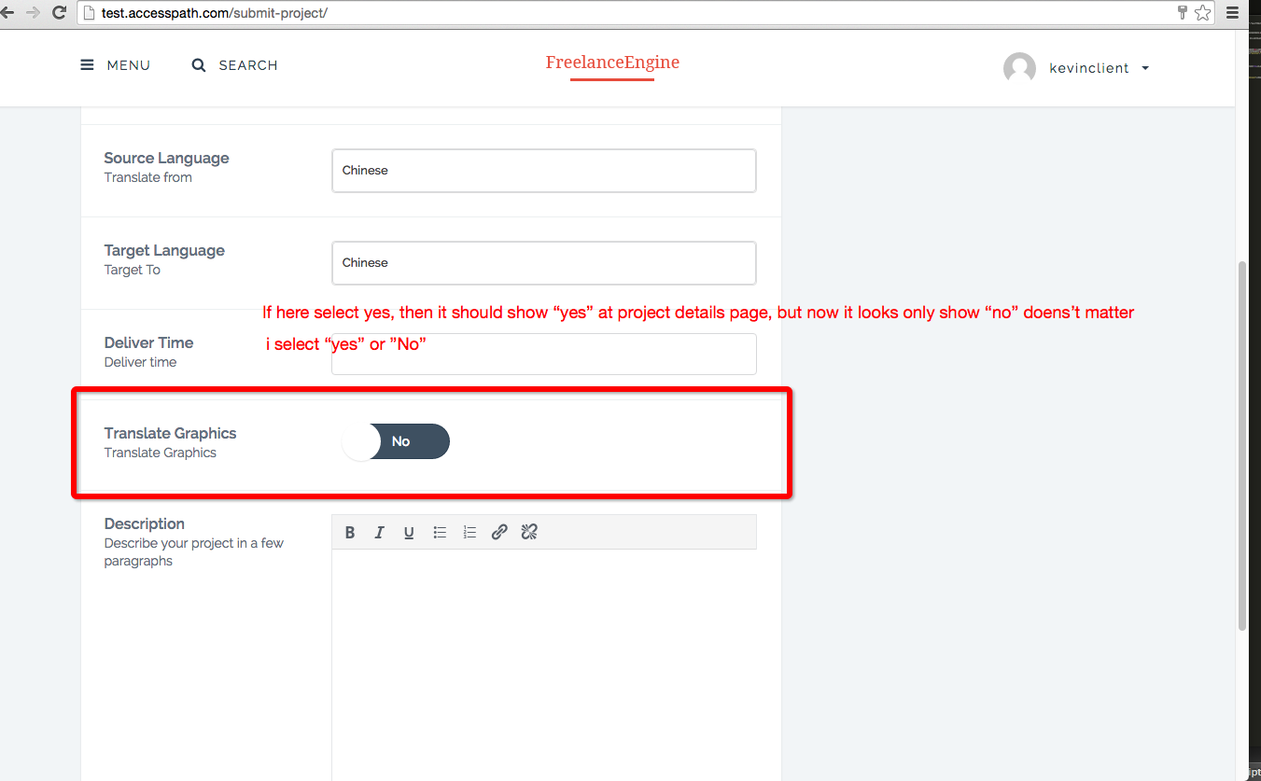

**Freelancer User profile modification**

1. <http://test.accesspath.com/profile/> after login (username: kevinfreelancer; pass: goodluck)“Profile Details”tab bug

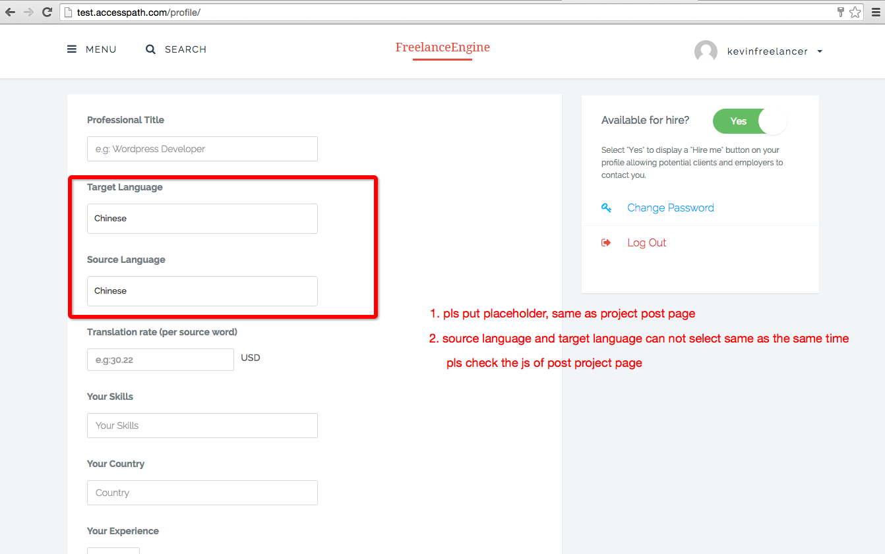

for source and target language function same requirement as <http://test.accesspath.com/submit-project/>, but need to login with employer account (username: kevinclient; pass: goodluck)

All these change please working on Child theme, not in the main theme.

Deliver:

1. Record the changes of mysql databases
2. Record the changes of files.
3. All data need to upload to github.