Simon Wu



Simon Wu is an Engineering Manager with Voyager Software a company specializing in high end Data Analytic software. Simon has been with Voyager since graduating from university in Computer Science 4 years ago. He was originally a software engineer working on the development of the new Voyager “PowerWarp” product. Six months ago he was promoted to become one of 5 Engineering Managers who report to the CTO Ron Lim. Simon and his team of 10 engineers are responsible for user interface elements of “PowerWarp” and he is therefore responsible for all aspects of the user interface including development, production and support.

Voyager is a fast moving and ambitious company, Ron Lim is one of the 3 founders and he drives everybody very hard. He shares the “Voyager Vision” to make Voyager a major player in Data Analytics and the first goal is to become number 1 in China, to do this Voyager will have to overtake some famous international companies. The “Voyager Vision “also included having the company successfully IPO by the end of 2018.

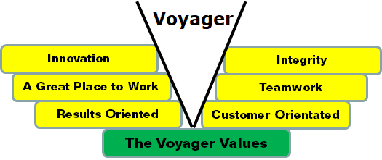

The 3 Voyager founders previously worked together in a major US multinational, their experience there has convinced them that having a strong corporate culture would be important for Voyager, they created the “Voyager Values” as the Voyager culture.

When Simon was made a manager Ron Lim told him that as a manager his number 1 responsibility was to be a Role Model for the “Voyager Values”.

Voyager uses Management by Objectives throughout the company. Ron has just given Simon his objectives for the next year.

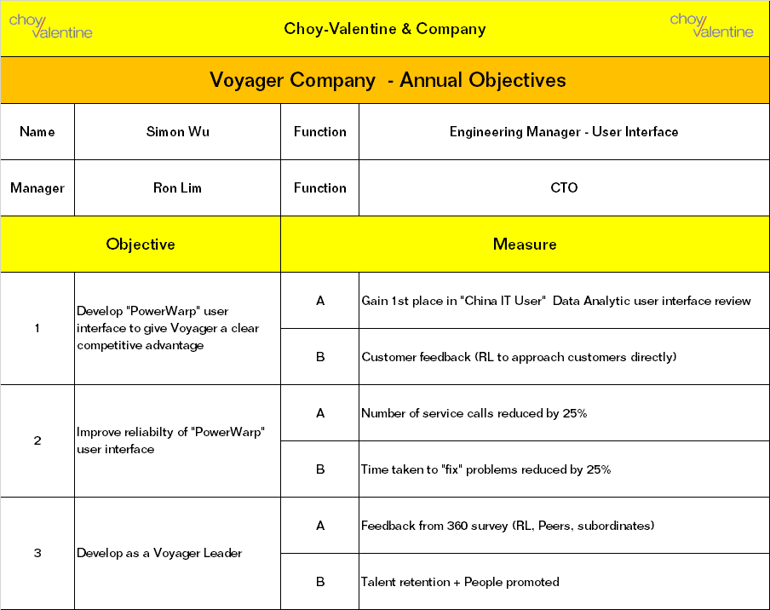

Simon now has to give objectives to his people.

Thomas Lee:

Thomas is responsible for the quality and reliability aspects of the PowerWarp user interface. Simon relies on Thomas to ensure the user interface is well tested and reliable. Thomas also has to work closely with other members of Simon’s team as they are creating the code. Simon has observed that overall this is one of Thomas’s strengths and as a result he sees Thomas as a potential Voyager leader. However he has also noticed that sometimes Thomas has upset colleagues by being overly critical rather than encouraging them to do better.

For Thomas, Simon has three main objectives for the next year:

1. To achieve a high quality standard reflected in the number of service calls and the time taken to fix the problems.
2. Develop his Team work skills to the point where his colleagues view him as a great asset in helping them produce a great user interface.
3. Develop his leadership potential by becoming a role model of the “Victory Values”

Your Task:

Complete the Objectives for Thomas Lee’s for the next year.

