RMarkdownExampleOne
Ken Magnuson
2025-01-03
library(caret)
library(rpart)
library(rpart.plot)
library(pROC)
library(gmodels)
library(vcd)

Part A
TP = 135
FP = 80
FN = 2
TN = 203
accuracy = (TP + TN) / (TP + TN + FP + FN)
error_rate = 1 - accuracy
expected_accuracy = ((TP + FN) * (TP + FP) + (FP + TN) * (FN + TN)) / ((TP + FP + FN + TN)^2)
kappa = (accuracy - expected_accuracy) / (1 - expected_accuracy)
sensitivity = TP / (TP + FN)
specificity = TN / (TN + FP)
precision = TP / (TP + FP)
recall = sensitivity
f_measure = 2 * ((precision * recall) / (precision + recall))
list(
Accuracy = accuracy,
ErrorRate = error_rate,
Kappa = kappa,
ExpectedAccuracy = expected_accuracy,
Sensitivity = sensitivity,
Specificity = specificity,
Precision = precision,
Recall = recall,
FMeasure = f_measure
)
## $Accuracy
## [1] 0.8047619
##
## $ErrorRate
## [1] 0.1952381
##
## $Kappa
## [1] 0.6127291
##
## $ExpectedAccuracy
## [1] 0.4958617
##
## $Sensitivity
## [1] 0.9854015
##
## $Specificity
## [1] 0.7173145
##
## $Precision
## [1] 0.627907
##
## $Recall
## [1] 0.9854015
##
## $FMeasure
## [1] 0.7670455

Part B

Step One
heart = read.csv('heart_data.csv')

Step Two
print('Structure: heart')
## [1] "Structure: heart"
str(heart)
## 'data.frame': 302 obs. of 14 variables:
## $ age : int 63 67 67 37 41 56 62 57 63 53 ...
## $ sex : chr "male" "male" "male" "male" ...
## $ painType : chr "Typical Angina" "Asymptomatic" "Asymptomatic" "Non-Anginal Pain" ...
## $ restingBP : int 145 160 120 130 130 120 140 120 130 140 ...
## $ cholesterol : int 233 286 229 250 204 236 268 354 254 203 ...
## $ highBloodSugar: logi TRUE FALSE FALSE FALSE FALSE FALSE ...
## $ restingECG : chr "Hypertrophy" "Hypertrophy" "Hypertrophy" "Normal" ...
## $ restingHR : int 150 108 129 187 172 178 160 163 147 155 ...
## $ exerciseAngina: logi FALSE TRUE TRUE FALSE FALSE FALSE ...
## $ STdepression : num 2.3 1.5 2.6 3.5 1.4 0.8 3.6 0.6 1.4 3.1 ...
## $ STslope : chr "Downsloping" "Flat" "Flat" "Downsloping" ...
## $ coloredVessels: int 0 3 2 0 0 0 2 0 1 0 ...
## $ defectType : chr "FixedDefect" "Normal" "ReversibleDefect" "Normal" ...
## $ heartDisease : logi FALSE TRUE TRUE FALSE FALSE FALSE ...
print('Summary: heart')
## [1] "Summary: heart"
summary(heart)
## age sex painType restingBP
## Min. :29.00 Length:302 Length:302 Min. : 94.0
## 1st Qu.:48.00 Class :character Class :character 1st Qu.:120.0
## Median :56.00 Mode :character Mode :character Median :130.0
## Mean :54.49 Mean :131.7
## 3rd Qu.:61.00 3rd Qu.:140.0
## Max. :77.00 Max. :200.0
##
## cholesterol highBloodSugar restingECG restingHR
## Min. :126.0 Mode :logical Length:302 Min. : 71.0
## 1st Qu.:211.2 FALSE:257 Class :character 1st Qu.:133.2
## Median :241.5 TRUE :45 Mode :character Median :152.5
## Mean :246.9 Mean :149.5
## 3rd Qu.:275.0 3rd Qu.:165.8
## Max. :564.0 Max. :202.0
##
## exerciseAngina STdepression STslope coloredVessels
## Mode :logical Min. :0.000 Length:302 Min. :0.0000
## FALSE:203 1st Qu.:0.000 Class :character 1st Qu.:0.0000
## TRUE :99 Median :0.800 Mode :character Median :0.0000
## Mean :1.043 Mean :0.6722
## 3rd Qu.:1.600 3rd Qu.:1.0000
## Max. :6.200 Max. :3.0000
## NA's :3
## defectType heartDisease
## Length:302 Mode :logical
## Class :character FALSE:163
## Mode :character TRUE :139
##
##
##
##

Step Three
heart$heartDisease = as.factor(heart$heartDisease)

Step Four
heart = na.omit(heart)

Step Five
set.seed(123)
train_index <- sample(seq_len(nrow(heart)), size = 0.8 * nrow(heart))
heart_train <- heart[train_index, ]
heart_test <- heart[-train_index, ]

Step Six
tree_model <- rpart(heartDisease ~ ., data = heart_train, method = "class")
rpart.plot(tree_model)
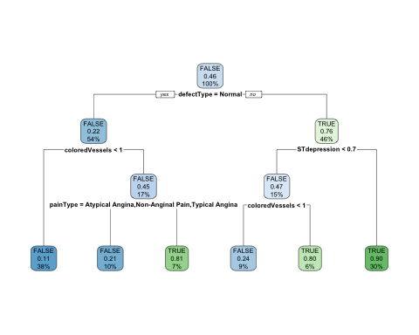

Step Seven
pred_class <- predict(tree_model, heart_test, type = "class")

Step Eight
head(pred_class)
## 2 3 12 15 19 38
## TRUE TRUE FALSE FALSE FALSE TRUE
## Levels: FALSE TRUE

Step Nine
confusion_matrix = table(Predicted = pred_class, Actual = heart_test$heartDisease)
confusion_matrix
## Actual
## Predicted FALSE TRUE
## FALSE 27 7
## TRUE 6 20

Step Ten
CrossTable(confusion_matrix)
##
##
## Cell Contents
## |-------------------------|
## | N |
## | Chi-square contribution |
## | N / Row Total |
## | N / Col Total |
## | N / Table Total |
## |-------------------------|
##
##
## Total Observations in Table: 60
##
##
## | Actual
## Predicted | FALSE | TRUE | Row Total |
## -------------|-----------|-----------|-----------|
## FALSE | 27 | 7 | 34 |
## | 3.684 | 4.503 | |
## | 0.794 | 0.206 | 0.567 |
## | 0.818 | 0.259 | |
## | 0.450 | 0.117 | |
## -------------|-----------|-----------|-----------|
## TRUE | 6 | 20 | 26 |
## | 4.817 | 5.888 | |
## | 0.231 | 0.769 | 0.433 |
## | 0.182 | 0.741 | |
## | 0.100 | 0.333 | |
## -------------|-----------|-----------|-----------|
## Column Total | 33 | 27 | 60 |
## | 0.550 | 0.450 | |
## -------------|-----------|-----------|-----------|
##
##

Step Eleven
Kappa(confusion_matrix)
## value ASE z Pr(>|z|)
## Unweighted 0.5608 0.1076 5.213 1.854e-07
## Weighted 0.5608 0.1076 5.213 1.854e-07

Step Twelve
sensitivityValue <- sensitivity(pred_class, heart_test$heartDisease)
specificityValue <- specificity(pred_class, heart_test$heartDisease)
list(Sensitivity = sensitivityValue, Specificity = specificityValue)
## $Sensitivity
## [1] 0.8181818
##
## $Specificity
## [1] 0.7407407

Step Thirteen
precisionValue <- posPredValue(pred_class, heart_test$heartDisease)
recallValue <- sensitivityValue
fMeasureValue <- 2 * (precisionValue * recallValue) / (precisionValue + recallValue)
list(Precision = precisionValue, Recall = recallValue, F_Measure = fMeasureValue)
## $Precision
## [1] 0.7941176
##
## $Recall
## [1] 0.8181818
##
## $F_Measure
## [1] 0.8059701

Step Fourteen
pred_prob <- predict(tree_model, heart_test, type = "prob")

Step Fifteen
head(pred_prob)
## FALSE TRUE
## 2 0.18750000 0.8125000
## 3 0.09722222 0.9027778
## 12 0.88764045 0.1123596
## 15 0.76190476 0.2380952
## 19 0.88764045 0.1123596
## 38 0.20000000 0.8000000

Step Sixteen
roc_curve <- roc(heart_test$heartDisease, pred_prob[, 2], levels = rev(levels(heart_test$heartDisease)))
## Setting direction: controls > cases
plot(roc_curve, col = "blue", main = "ROC Curve")
abline(a = 0, b = 1, lty = 2)
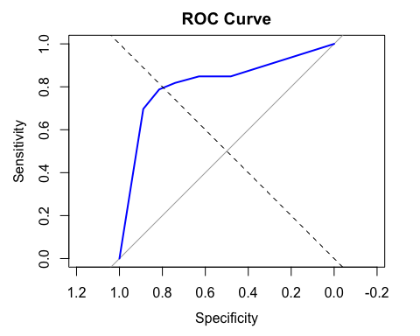

Step Seventeen
auc_value <- auc(roc_curve)
performance_level <- ifelse(auc_value < 0.6, "Poor",
ifelse(auc_value < 0.7, "Fair",
ifelse(auc_value < 0.8, "Good",
ifelse(auc_value < 0.9, "Very Good", "Excellent"))))
list(AUC_Value = auc_value, Performance = performance_level)
## $AUC_Value
## Area under the curve: 0.8165
##
## $Performance
## [1] "Very Good"

Step Eighteen
set.seed(123)
folds <- createFolds(heart$heartDisease, k = 10, list = TRUE)
str(folds)
## List of 10
## $ Fold01: int [1:30] 9 16 18 31 32 38 51 66 72 73 ...
## $ Fold02: int [1:30] 19 22 41 42 48 56 71 87 114 125 ...
## $ Fold03: int [1:29] 8 10 14 23 30 35 49 50 54 62 ...
## $ Fold04: int [1:29] 4 13 44 47 52 57 58 69 92 107 ...
## $ Fold05: int [1:29] 24 39 65 79 89 95 100 119 126 133 ...
## $ Fold06: int [1:30] 17 26 34 40 60 70 74 90 93 98 ...
## $ Fold07: int [1:30] 3 12 20 27 33 36 37 45 53 61 ...
## $ Fold08: int [1:30] 6 28 29 75 81 105 127 136 141 152 ...
## $ Fold09: int [1:30] 1 2 7 21 43 59 80 83 96 101 ...
## $ Fold10: int [1:30] 5 11 15 25 46 55 78 84 88 97 ...

Step Nineteen
cv_results <- lapply(folds, function(fold_indices) {
train_data <- heart[-fold_indices, ]
test_data <- heart[fold_indices, ]
cv_tree_model <- rpart(heartDisease ~ ., data = train_data, method = "class")
cv_pred <- predict(cv_tree_model, test_data, type = "class")
levels(cv_pred) <- levels(test_data$heartDisease)
accuracy <- confusionMatrix(cv_pred, test_data$heartDisease)$overall['Accuracy']
return(accuracy)
})
cv_results
## $Fold01
## Accuracy
## 0.8
##
## $Fold02
## Accuracy
## 0.8666667
##
## $Fold03
## Accuracy
## 0.7931034
##
## $Fold04
## Accuracy
## 0.7586207
##
## $Fold05
## Accuracy
## 0.8965517
##
## $Fold06
## Accuracy
## 0.8333333
##
## $Fold07
## Accuracy
## 0.8333333
##
## $Fold08
## Accuracy
## 0.6333333
##
## $Fold09
## Accuracy
## 0.8
##
## $Fold10
## Accuracy
## 0.8666667

Step Twenty
mean(unlist(cv_results))
## [1] 0.8081609

