

DoorDorz

Group 5

Names : Bayu Kurniawan Rusdi

Kennan Fattahillah Herdyhanto

Sudrajat Ali Mustofa

Class : 1CC9

CEP CCIT

FAKULTAS TEKNIK UNIVERSITAS INDONESIA

2019

**Developed by**

1. **Bayu Kurniawan Rusdi**
2. **Kennan Fattahillah Herdyhanto**
3. **Sudrajat Ali Mustofa**



**PROJECT ON**

*DoorDorz*

**DoorDorz**

Batch Code : Group 5

Start Date : <Start date>   
End Date : <End date>

Name of Faculty : Susi Maulidiah

Names of Developer :

1. Bayu Kurniawan Rusdi
2. Kennan Fattahillah Herdyhanto
3. Sudrajat Ali Mustofa

Date of Submission: 18 December 2019

**CERTIFICATE**

This is to certify that this report titled “DoorDorz” embodies the original work done by Bayu Kurniawan Rusdi, Kennan Fattahillah Herdyhanto and Sudrajat Ali Mustofa. Project in partial fulfillment of their course requirement at NIIT.

Coordinator:

Susi Maulidiah



**ACKNOWLEDGEMENT**

On behalf of **DoorDorz**’s project, we would like to thanks and appreciates our faculty Mrs. Susi Maulidiah to guide and support our work, and to other faculties that involved directly in the project.

Unfortunately, we might have a deficiency in writing the project. Therefore, we apologize to the readers for any fuzziness words, presentation, or even a figure.

Sincere,

Authors.

**SYSTEM ANALYSIS**

**System Summary**:

**ERD**

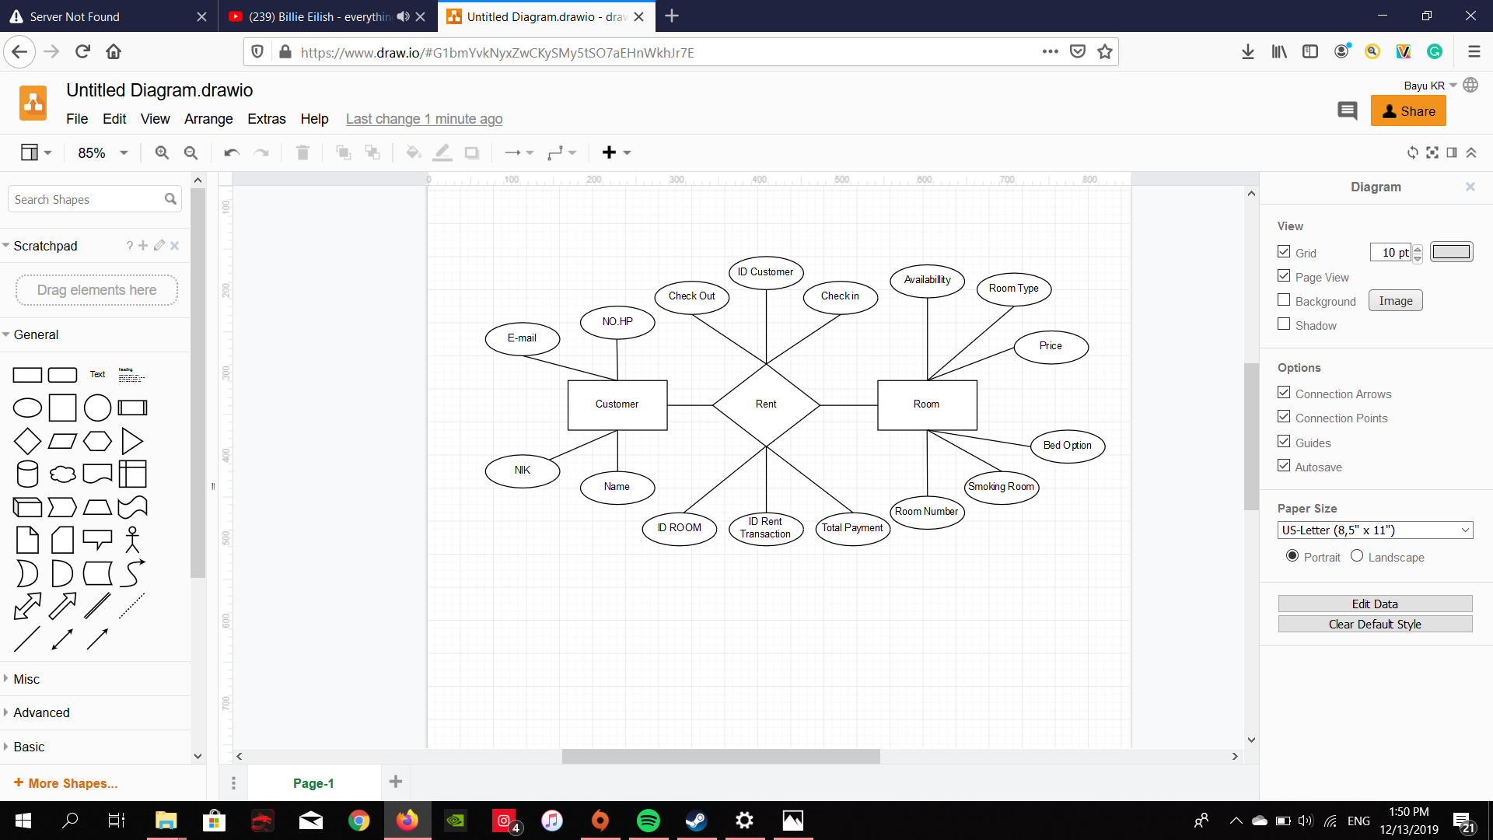

\

sssssssssss

**DATABASE DESIGN**

**SCHEMATIC DIAGRAM**

**Table User Identity**

|  |  |  |  |
| --- | --- | --- | --- |
| Field Name | Data Type | Width | Description |
| IdentityId | INT | 4 bytes | Identity's identifier |
| FirstName | NVARCHAR | 50 | User's first name |
| LastName | NVARCHAR | 50 | User's last name |
| IDCardCode | VARCHAR | 16 | User's ID Card Code |

**Table User Data**

|  |  |  |  |
| --- | --- | --- | --- |
| Field Name | Data Type | Width | Description |
| UserId | INT | 4 bytes | User unique identifier |
| UserEmail | VARCHAR | 255 | User's email address |
| UserPhoneNumber | VARCHAR | 16 | User's contact number |
| UserPassword | NVARCHAR | 16 | User's password |
| UserIdentityId | INT | 4 bytes | Reference to User's identity information |

**Table Booking Transaction**

|  |  |  |  |
| --- | --- | --- | --- |
| Field Name | Data Type | Width | Description |
| TransactionId | INT | 4 bytes | Transaction's unique identifier |
| UserId | INT | 4 bytes | Foreign key of User's identifier |
| HotelId | INT | 4 bytes | Foreign key of Hotel's identifier |
| RoomId | INT | 4 bytes | Foreign key of Room's identifier |
| Duration | INT | 4 bytes | Stay durations length |
| CheckIn | SMALLDATETIME | 4 byets | Check In date and time |
| CheckOut | SMALLDATETIME | 4 bytes | Check Out date and time |
| BookingId | VARCHAR | 255 | Booking id from hotel's reservation |

**Table Hotel**

|  |  |  |  |
| --- | --- | --- | --- |
| Field Name | Data Type | Width | Description |
| HotelId | INT | 4 bytes | Hotel's unique identifier |
| HotelName | NVARCHAR | 255 | Hotel's name |
| HotelLocation | INT | 4 bytes | Reference to hotel's location information |
| StarRating | INT | 4 bytes | Hotel's Star rating grade |
| ReviewScore | FLOAT | 4 bytes | Average score by given review from users |
| LowestPrice | INT | 4 bytes | Show lowest price available |

**TABLE DESIGN**

**Table Hotel Facilities**

|  |  |  |  |
| --- | --- | --- | --- |
| Field Name | Data Type | Width | Description |
| FacilityId | INT | 4 bytes | Facility's unique identifier |
| HotelId | INT | 4 bytes | Foreign Key of Hotel's identifier |
| FacilityName | VARCHAR | 18 | Facility's name |

**Table Hotel Location**

|  |  |  |  |
| --- | --- | --- | --- |
| Field Name | Data Type | Width | Description |
| LocationId | INT | 4 bytes | Location's unique identifier |
| Street | NVARCHAR | 255 | Hotel street name |
| City | NVARCHAR | 255 | Hotel city name |
| Province | NVARCHAR | 255 | Hotel province name |
| ZipCode | INT | 4 bytes | Hotel Zip Code |

**Table Hotel Review**

|  |  |  |  |
| --- | --- | --- | --- |
| Field Name | Data Type | Width | Description |
| ReviewId | INT | 4 bytes | Review's unique identifier |
| UserId | INT | 4 bytes | Foreign Key of User's identifer |
| HotelId | INT | 4 bytes | Foreign Key of Hotel's identifier |
| Score | TINYINT | 1 bytes | Score given from user (range: 1 to 5) |

**Table Hotel Rooms**

|  |  |  |  |
| --- | --- | --- | --- |
| Field Name | Data Type | Width | Description |
| RoomId | INT | 4 bytes | Room's unique identifier |
| HotelId | INT | 4 bytes | Foreign Key of Hotel's identifier |
| RoomType | VARCHAR | 255 | Room types |
| PricePerNight | INT | 4 bytes | Indicate room's price fror one night |
| BedOption | VARCHAR | 10 | Represent for bed count (Single or Double) |
| isSmokingRoom | BIT | 1 byte | Indicates smoking is supported |
| isAvailable | BIT | Indicates room availability |

**TABLE DESIGN**

**VALIDATION PERFORMED**

**CONFIGURATION**

**Hardware :**

**Operating System :**

**Software :**

|  |  |  |
| --- | --- | --- |
| **PROJECT FILE DETAILS** | | |
| **S.No** | **File Name** | **Remarks** |
|  |  |  |

\

sssssssssss