CODE REPORT
Kenndy
6742014


Title for the HTML page

PART 1

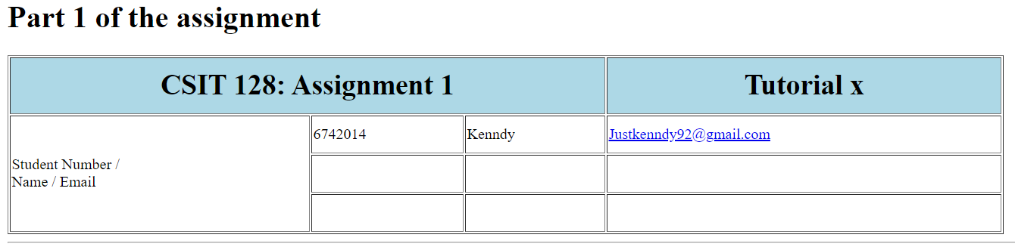

(Code for the first row)
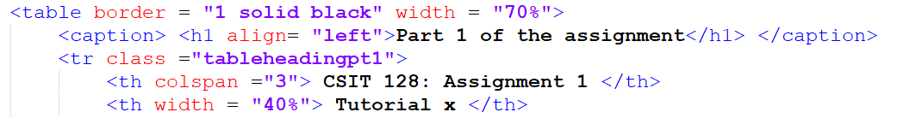
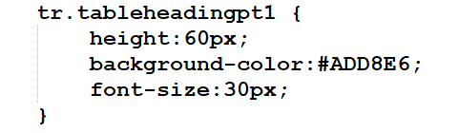
The two pictures above shows the code for the first row of the table as well as the CSS code for it. Table border is set to 1, width is set to 70% so as to not take up the whole width of the screen. On the <tr> the class is set to .tableheadingpt1, this class sets the height to pixels, background color to light blue, and font size to 30 pixels. On the first column, its span is set to 3 as per assignment specifications and on the second column it’s width is set to take up 40% of table’s total width.

(Code for the second row)
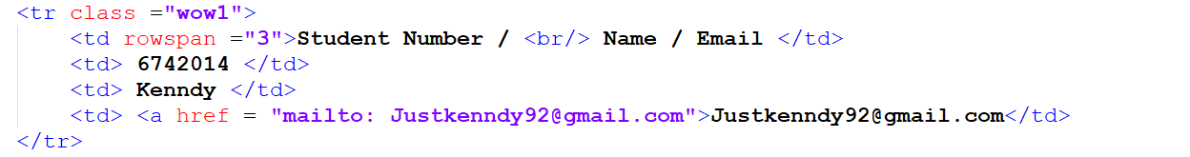
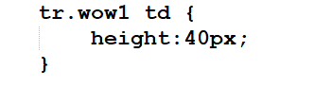
The two pictures above show the code for the second row as the well as the CSS code. In this row we use the class .wow1, this class is written on tr and applies to every td child of it, it’s functionality is to set the cell height to 40 pixels. On the first column the rowspan is set to 3 per assignment specification. And on the last column we have a href link to the student’s email.

(Code for third and fourth row)
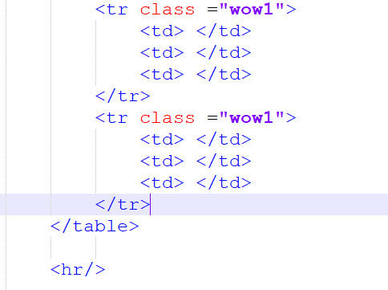
On both of these rows, there are no content so we just set the class to .wow1, this way the cell height will be set to 40. <hr/> is there to separate part1 and part2 of the assignment

PART 2

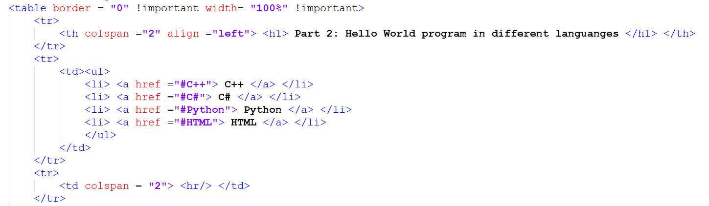
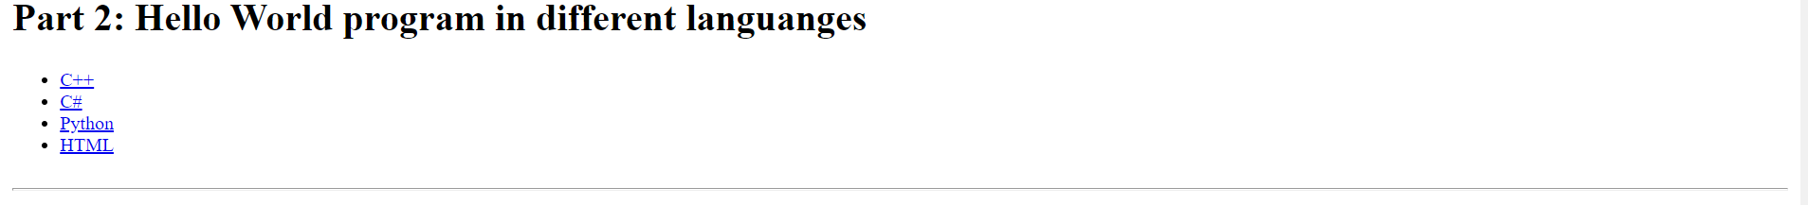
(Heading)
First a table without border is made to house all the elements for part 2, this way the contents will be neatly laid out. The first row is the title of the assignment and is set to 2 rows so that it takes up to whole screen. On the second row, an unordered list is made to serve as sort of an index or link to targets within the document, here we set up 4 list and inside each one of them we embed a <a href> to the target id. Next, we have a <hr/> this only serves as a separator.

C++
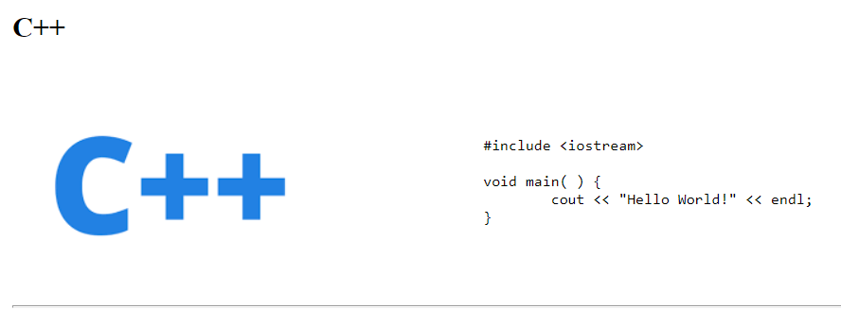
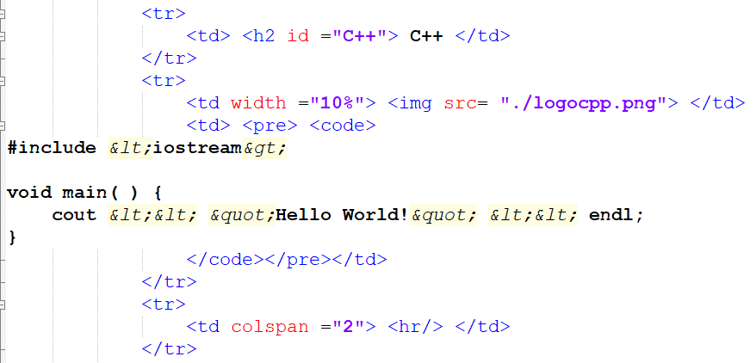
On the first row, we have a heading to indicate C++. Moving on to the second row, the first column is reserved for the image, and we have a href for a image link. On the second column, we encase the code inside <pre> and <code> to keep its format. And lastly, we have a <hr/> to act as a separator.

PART 3
Plagiarism
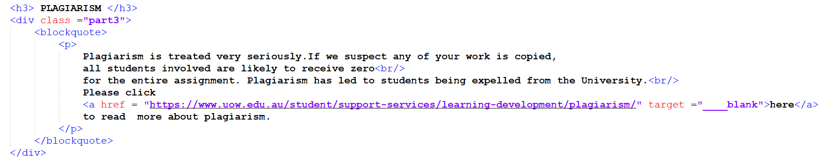
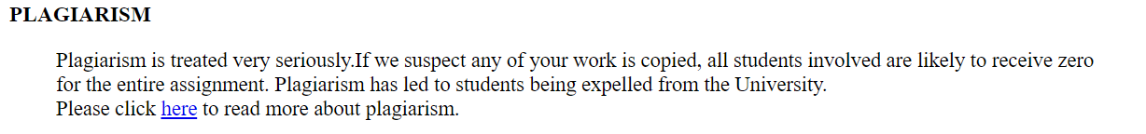

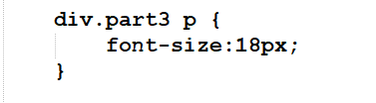
This part of code is encased in div, the purpose of this is to apply the class “part3” to increase the font size to 18. After the div we have a blockquote to indent all the text to right, and finally we have a <p> tag, where the plagiarism content is displayed, inside the <p> tag we also have <href> link it’s target is set to blank so that it will open a new tab.

PART 4
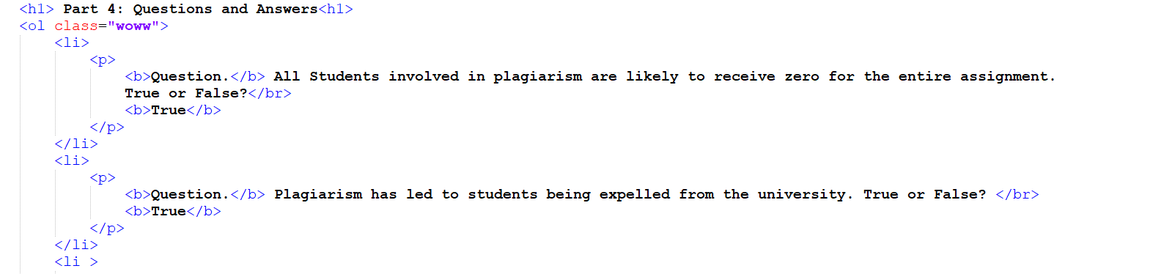
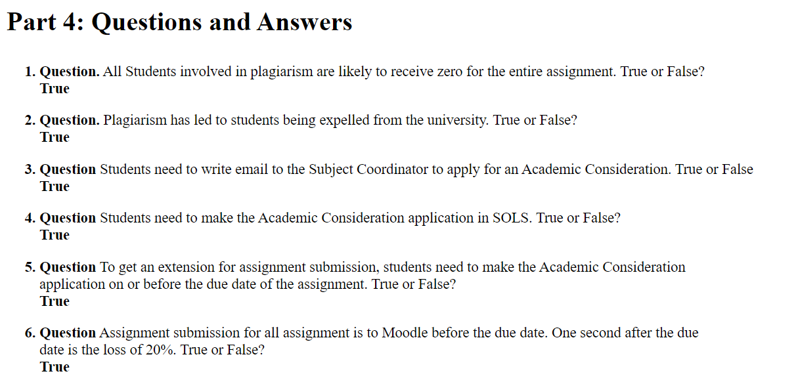
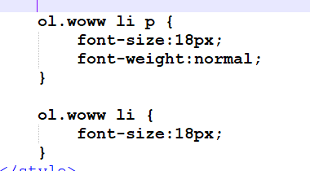
In part 4, the <ol> contains all the questions and answers, the <ol> belongs to the class “wow”, and on style we can see that the class “wow” will
1) Change the font size to 18 and font weight to normal on <p>
2) Change the font size to 18 on <li>

END OF CODE REPORT

