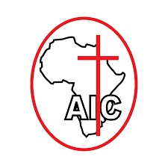 **AFRICA INLAND CHURCH** A.I.C KALAMA R.C.C

P.o Box 2550-90100 Machakos  *Fouded in 1895*

**R.C.C C.E.D CALENDER OF ACTIVITIES 2025**

**1. MEETINGS**

a. Choir, C.Y.A , CSC, B.E.E, & C.W.F – 5/2/2025

b. C.M.F, Sunday school, C.S.B & CWP – 14/2/2025

c. C.E.D BOARD – 20/2/2025

d. Communiy bible study

**2. PASAKA – 18/4/2025**

**3. C.E.D Day – 15/6/2025**

**4. RALLIES –** a) Choir – Special 24/10/2025 R.C.C

Special 31/10/2025 – Area

Advanced – 01/11/2025- Area

b) Star Cadette – 15/8/2025 – R.C.C – walk- New testament

22/8/2025 -Area

Age 6 -12 Years

**5. R.C.C SEMINARS KWA KAVOO**

1. C.W.P – Wajane Wote – Kivoyo – 2/10/2025
2. C.W.F - Teachers i. 29/5/2025 - Kalima Nzalu D.C.C

ii. 25/9/2025 – Katanga D.C.C

1. C.W.F Kivoyo – 16/7/2025
2. B.E.E – 23/6/2025 – Kwa Kavoo . Each D.C.C **5** People
3. Camp – December
4. C.M.F – Teachers – 23/5/2025- Eacha D.C.C 3,000/=
5. Batallion – Captains, Warden, Squad Leaders – 17/6/2025 each 300/=
6. Sunday school – Seminars
7. C.E.D Day – 15/6/2025

Prepared By:

Rev J. Muambi

**Kalama R.C.C C.E.D Co-ordinator**