TMNT Sales Analysis. Excel Project

Introduction

My current training at Utiva included a Capstone Project focused on the BG Group premium fashion lines. This project allowed me to practice my data cleaning, analysis, and visualization skills using power bi. Additionally, I created a reporting dashboard to showcase my findings from the dataset. Overall, the project was an excellent opportunity to apply what I learned in the training and gain hands-on experience with real-world data.

Problem statement

1. What is the top sales by City?
2. What is the top 10 agents per sales value?
3. Sales territory?
4. Sales by validation?
5. Sales chain category?
6. Top 5 IDs per sale value?

Create a dashboard with the report and sliceable by:

1. Territory

Skills/Concepts Demonstrated

Power query

Dashboard

Data Modelling

## Data Preparation / Cleaning:

The dataset was shared with students of Utiva., showing sales of BG Group premium fashion lines.

It has 3 tables;

Names (9 columns 105 rows)

Shop Territory (3 columns 105 rows)

Competitive Territory (2 columns and 11 rows)

**Data cleaning and transformation**

For the shop territory I had to split city column

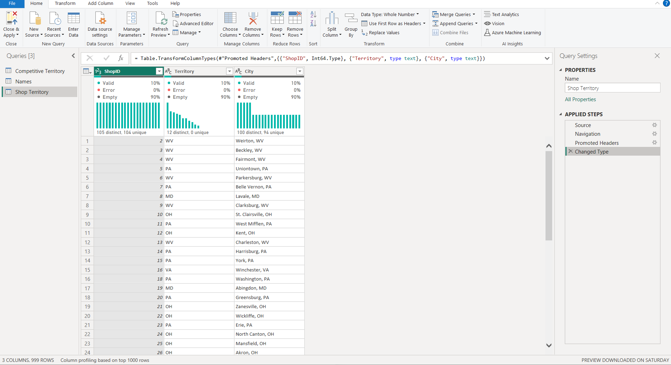

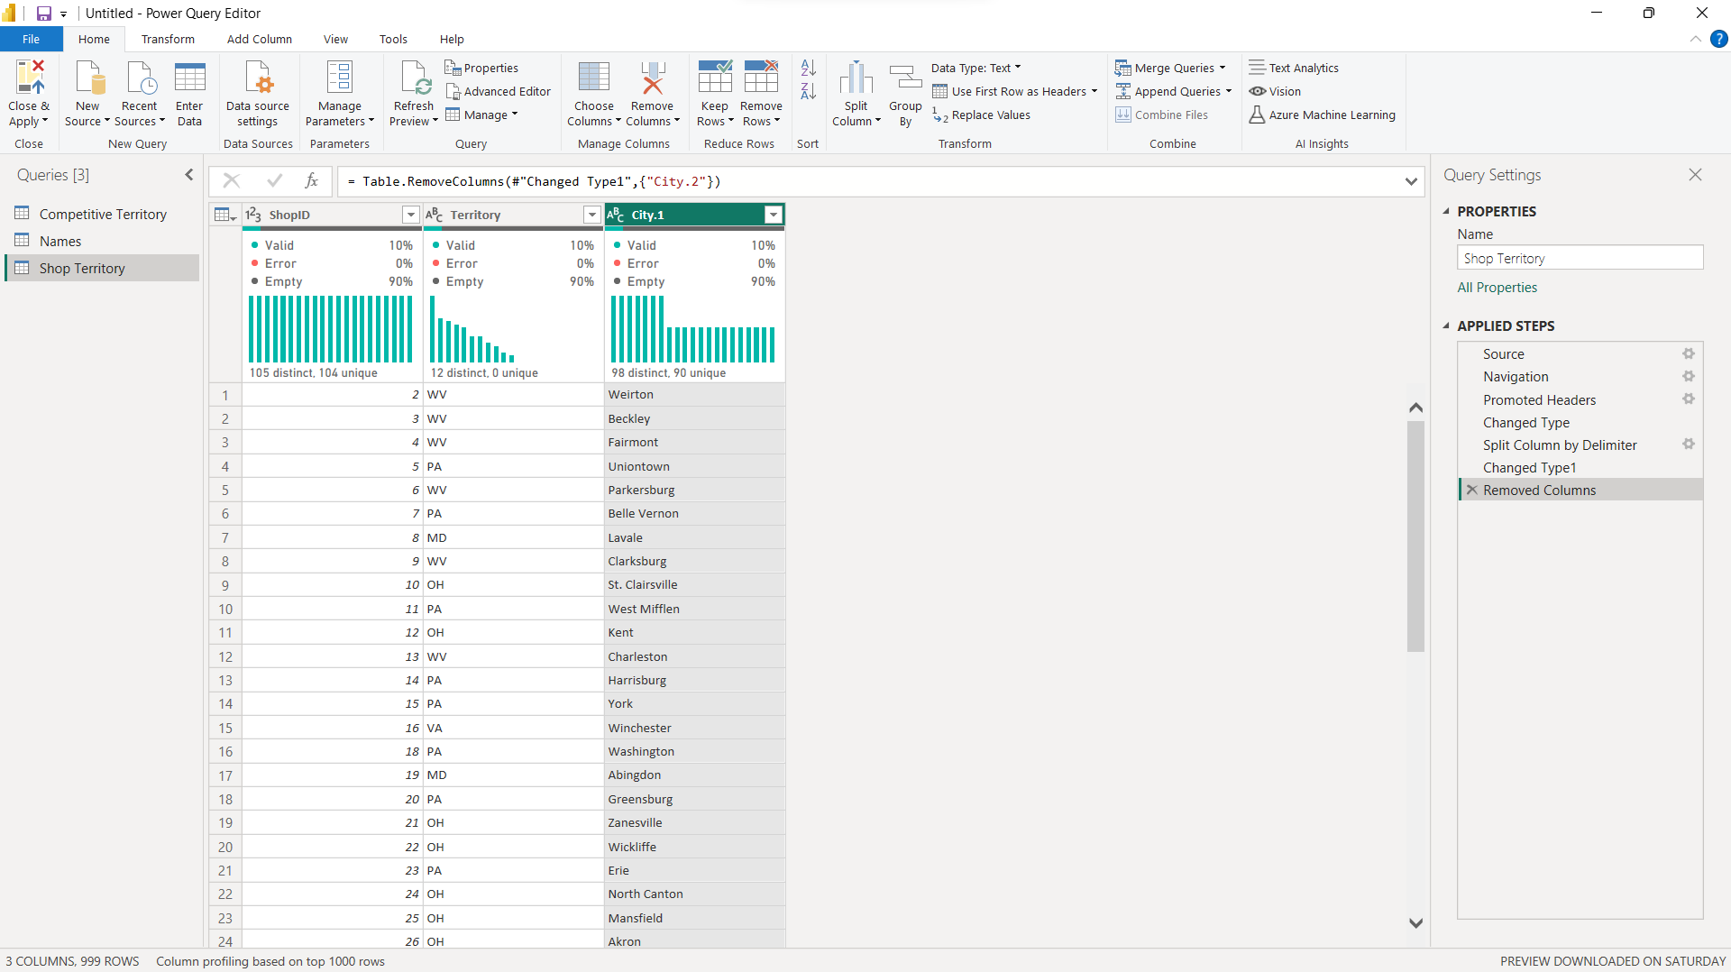

Name table I splitted the names column, set the changed the data type for sales, annual, sales, and Annual sales per selling area to whole number data type

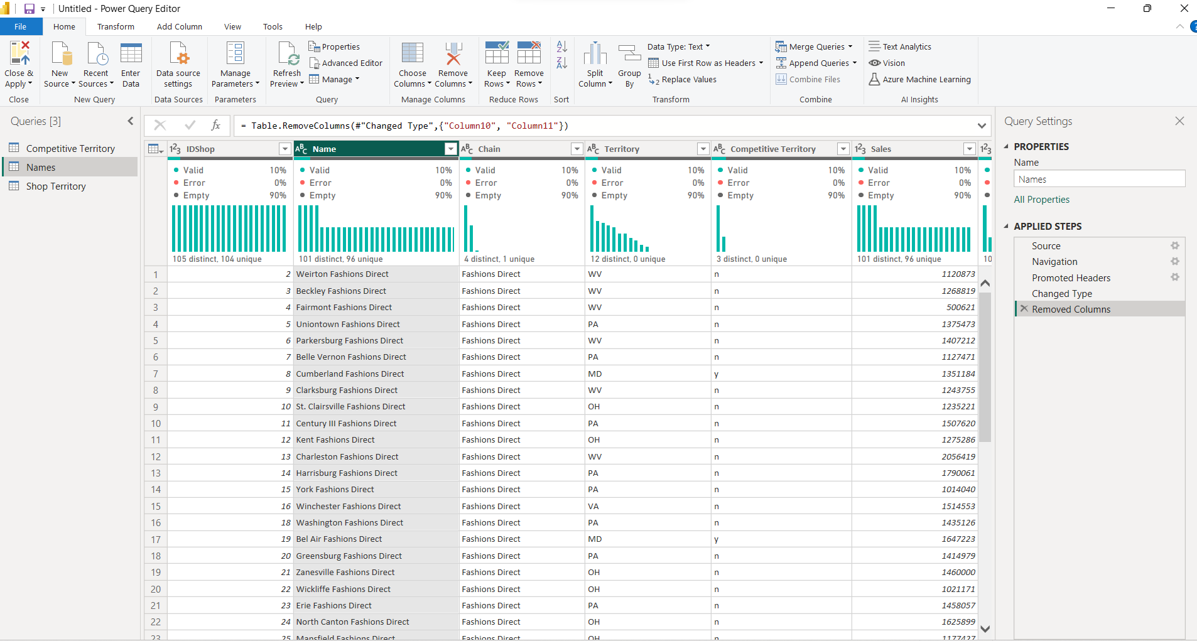

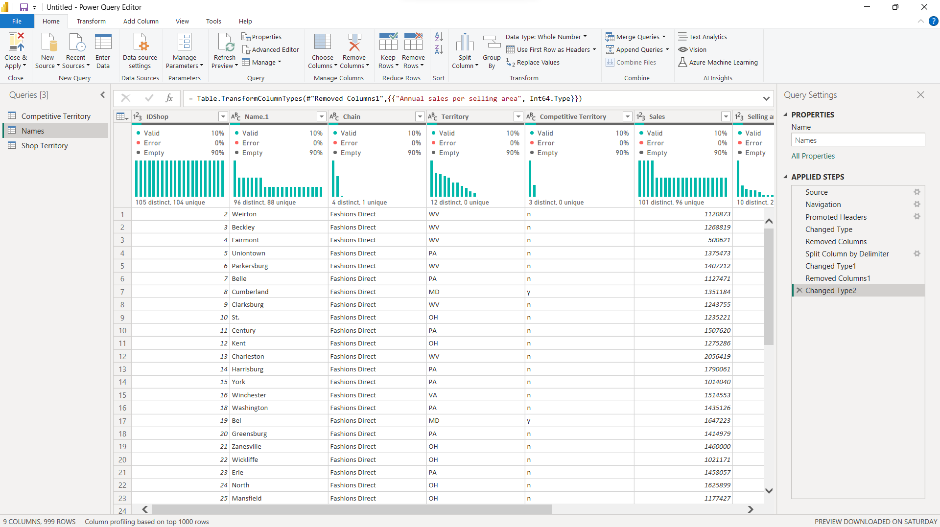

The Competitive territory

I replaced the null with empty space for the two columns

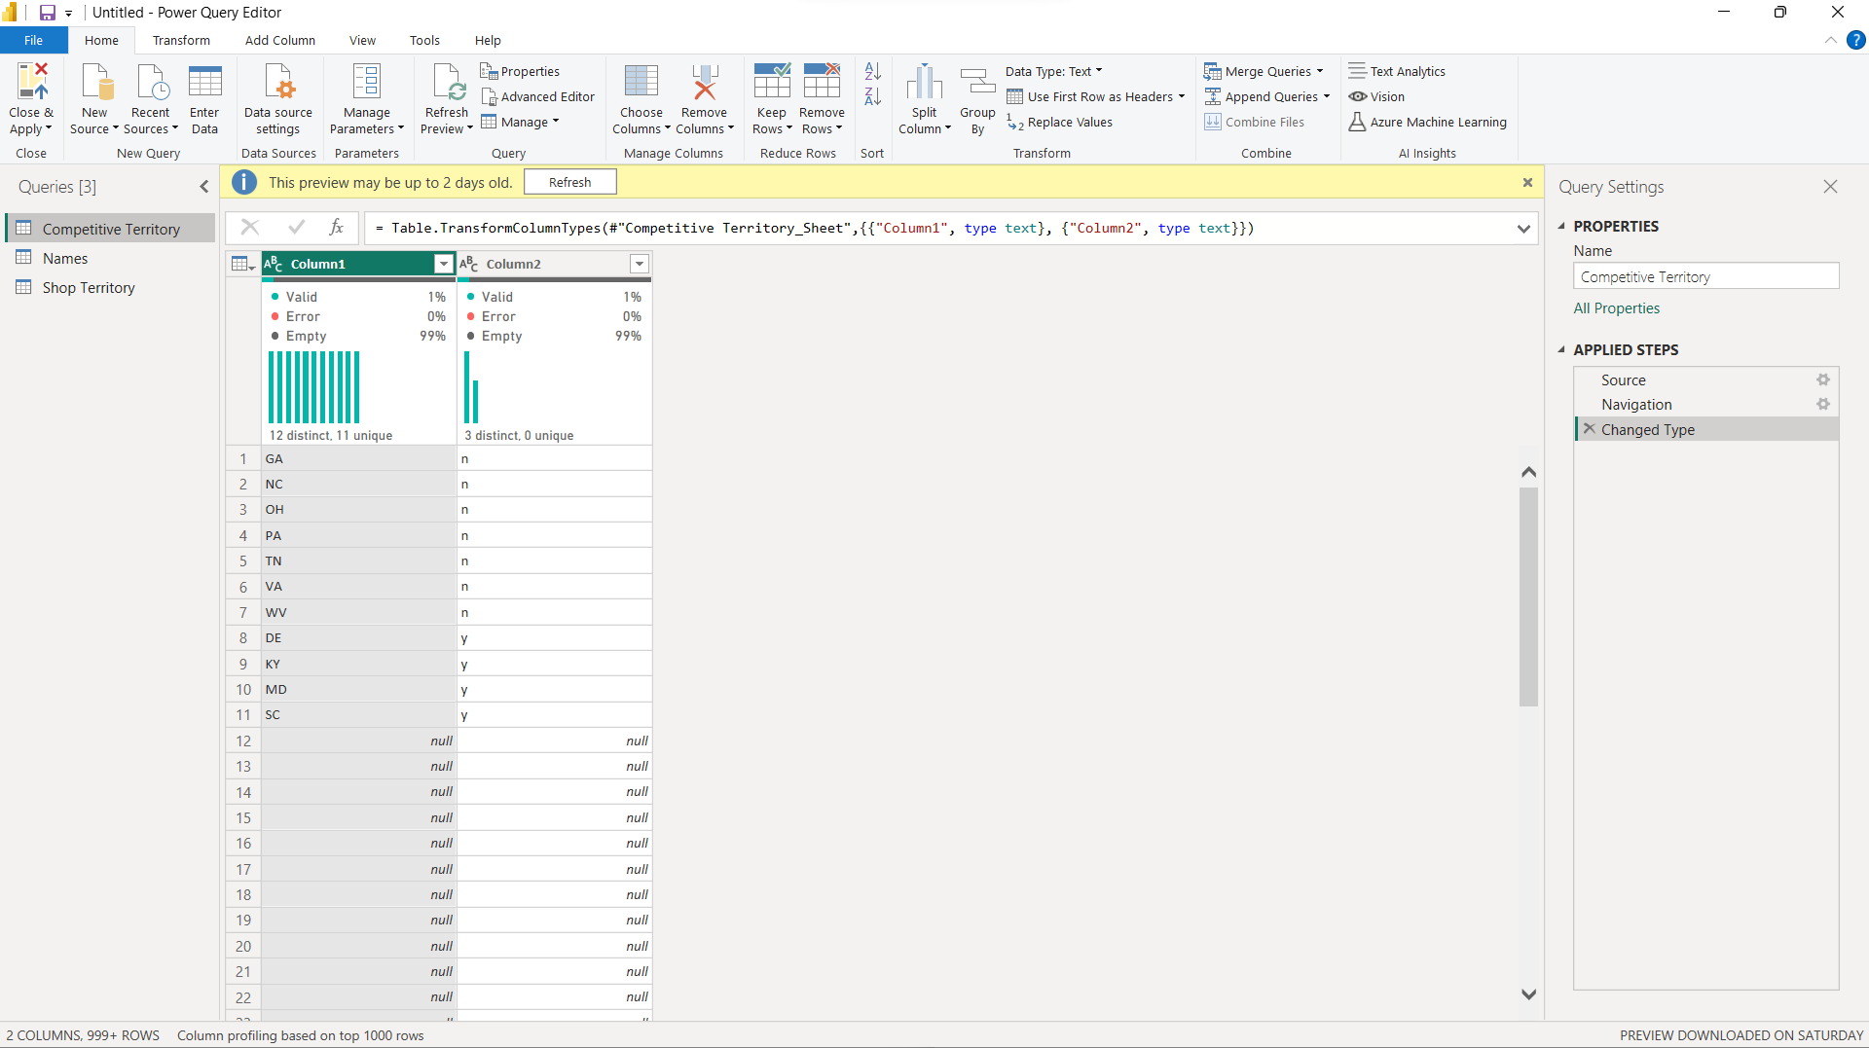

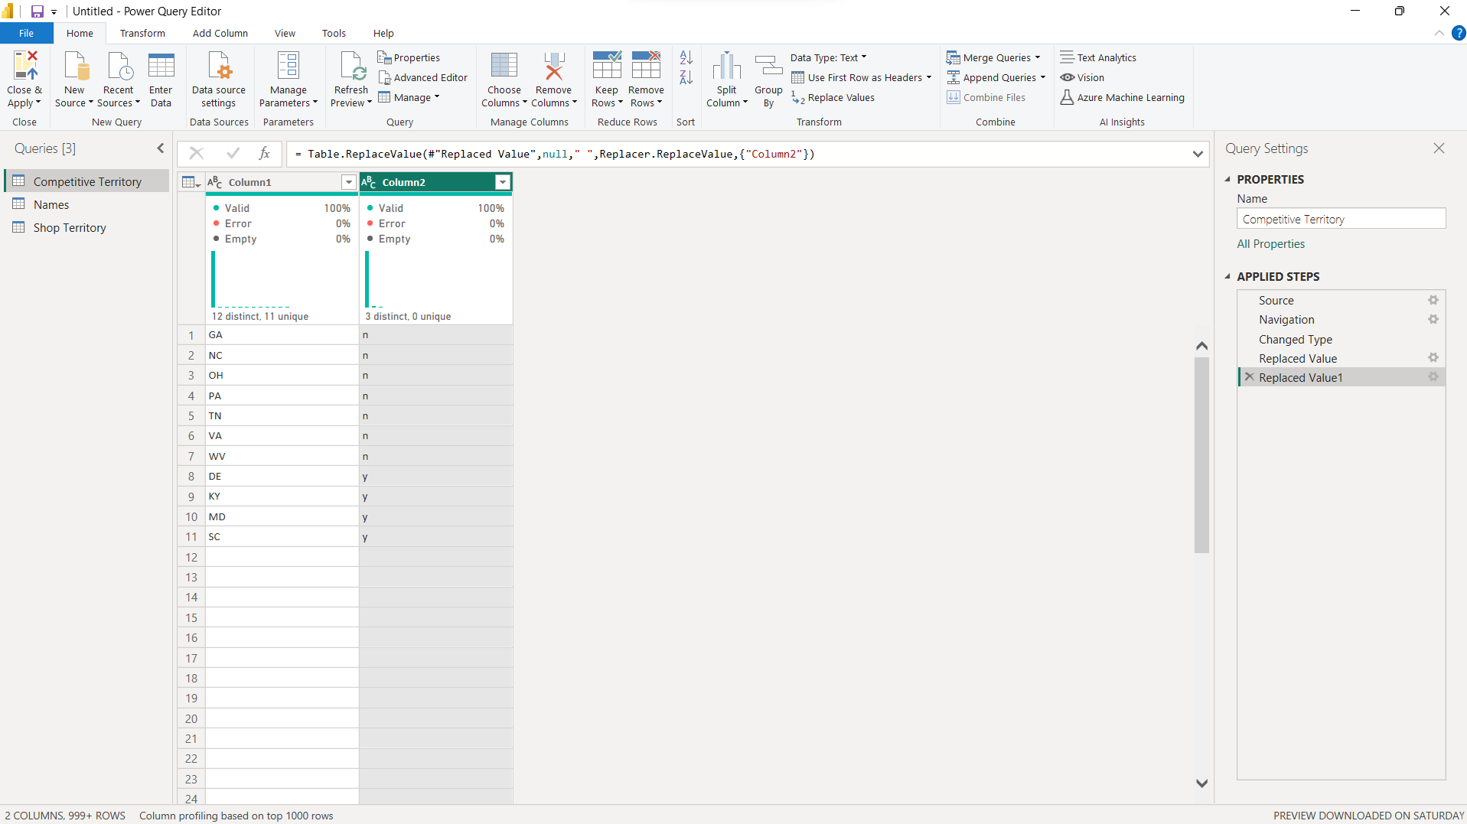

Data Modelling

I had to create relationship between the three tables

For the Names table

columns IDshop many to many relationships with Shop Territory shopID

Competitive territory table

Comp_territory many to many relationships with the Names table competitive territory

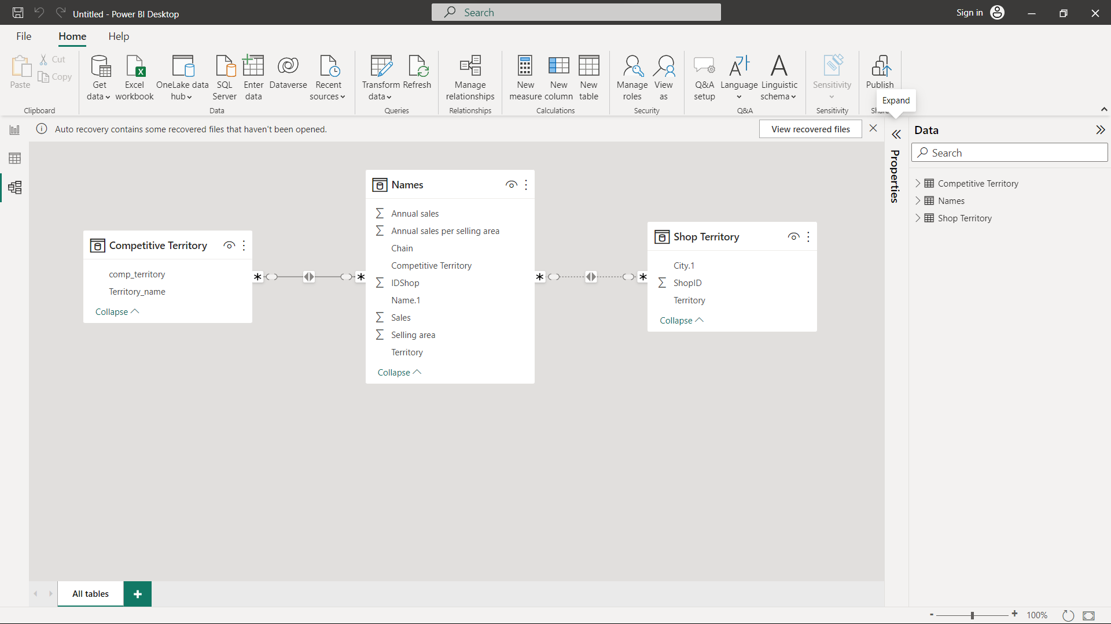

MY Dashbaord

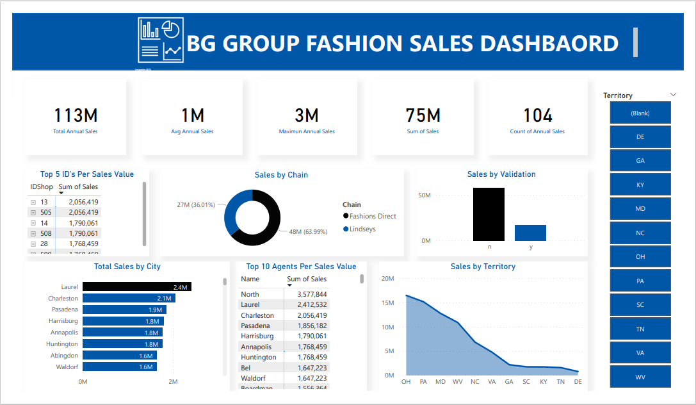

Insights :

1. In January, vanities and wine were our top two revenue-generating products.
2. Among our teams, Donald Reynolds's team generated the most revenue from Decoratives in January, bringing in $140,196 and earning first place. Joshua Ryan's team came in second, generating $123,860 in revenue from Decoratives.
3. We've observed that revenue tends to increase with population and median income. The higher the population and median income in a given area, the higher the revenue tends to be.

Dashboard



Recommendation and Conclusion

1. Teams that generate the highest revenue should be rewarded, while teams that have the lowest revenue should be evaluated to identify areas for improvement.
2. To maximize our reach, we should consider opening more stores in the top 5 states with the highest population.
3. It's important to ensure that decorative products are always available in all of our store locations to meet the demands of our customers.

Hey everyone! I'm thrilled to share my Excel capstone project, which focuses on analyzing the TMNT stores. This project was part of my training at Utiva, and I'm excited to share the insights I gained from the dataset to solve business problem for TMNT stores.

https://github.com/Kennedy87670/TMNT-Sales-Analysis/blob/main/README.md