
MASENO UNIVERSITY
SCHOOL OF COMPUTING AND INFORMATICS
DEPARTMENT OF INFORMATION TECHNOLOGY
PROJECT PROPOSAL REPORT
PROPERTY KONNECT [PK]
A PROPERTY MARKETPLACE AND STUDENT ACCOMMODATION PLATFORM

A project report submitted to the Department of Information Technology,
School of Computing and Informatics, Maseno University,
in partial fulfilment of the requirements for the Year III Final Software Project.

DECLARATION
I declare that this project report is my original work and has not been presented for an academic award in any other institution. Where the work of other people has been used, it has been acknowledged through appropriate citations and references.
Student’s Name: __________________________________________
Registration Number: _____________________________________
Signature: __________________________ Date: ____ / ____ / ______
This project report has been submitted for examination with my approval as the university supervisor.
Supervisor’s Name: _______________________________________
Signature: __________________________ Date: ____ / ____ / ______

ABSTRACT
Property Konnect (PK) is a Flutter-based property marketplace and student accommodation platform intended to connect property owners, tenants, students and service providers across Kenya. The project addresses the difficulty of discovering property and accommodation information through fragmented channels, as well as the challenge students face when searching for hostels, roommates and campus-related services. The overall objective is to develop a centralised mobile application that supports property discovery and management alongside student accommodation and campus services. The specific objectives are to establish user registration and role-based access; provide property search, listing and details functions; develop student-focused hostel, roommate, services, communities and marketplace modules; provide administrative tools for verification and moderation; and apply suitable security, data-management and usability controls. The system is developed using Flutter and Dart, with Firebase Authentication, Cloud Firestore, Firebase Storage and Firebase Cloud Functions supporting authentication, data storage, media management and selected backend operations. Requirements and functions described in this report are based on the supplied Property Konnect project documentation. The implemented functionality includes bilingual English/Kiswahili interfaces, property search and listing management, favourites, service discovery, student hub features, administrative dashboards, reporting and review moderation. The project is intended to improve access to property information, simplify accommodation discovery and provide a central platform for related student services.
Keywords: Property marketplace, student accommodation, Flutter, Firebase, property search, roommate finder, Kenya.

ACKNOWLEDGEMENT
I acknowledge the guidance and support provided by the Department of Information Technology, School of Computing and Informatics, Maseno University. I also appreciate the contribution of my project supervisor, Mr Gabriel Oliko whose advice, encouragement and support have contributed to the development of this project.

TABLE OF CONTENTS
Note: In Microsoft Word, update this table after opening the document by selecting References → Table of Contents → Update Table. Heading styles have been applied throughout the report.

LIST OF ABBREVIATIONS
Abbreviation | Meaning
PK | Property Konnect
UI | User Interface
UX | User Experience
GPS | Global Positioning System
KYC | Know Your Customer
ID | Identification
DB | Database
HCI | Human-Computer Interaction
API | Application Programming Interface
CSV | Comma-Separated Values
OTP | One-Time Password
RBAC | Role-Based Access Control
SDK | Software Development Kit
OS | Operating System
ERD | Entity Relationship Diagram
DFD | Data Flow Diagram
UAT | User Acceptance Testing

DEFINITION OF TERMS
Term | Definition in this project
Property listing | A record describing a property available for rent or sale.
Property owner | A registered user who creates and manages property listings.
Tenant | A person searching for accommodation or property to rent.
Student Hub | A collection of student-focused accommodation and campus service features.
Roommate post | A request from a person seeking someone to share accommodation.
Ads-Verified | A time-limited advertisement verification status managed by administrators.
KYC | A process of checking property-owner identity and supporting documents.
Firestore | Firebase's cloud-hosted NoSQL document database used by the application.
Firebase Storage | A cloud service used to store uploaded images, videos and documents.
Biometric authentication | Identity confirmation using supported fingerprint or facial recognition features.
Pagination | Retrieving records in smaller batches rather than loading all records at once.

LIST OF TABLES
Table 1: Summary of functional requirements
Table 2: Summary of non-functional requirements
Table 3: Main system actors and use cases
Table 4: Core data entities and descriptions
Table 5: Development tools and technologies
Table 6: Proposed system test cases

LIST OF FIGURES
Figures to be inserted from the actual application and design artefacts: application logo and loading screen; language selection; homepage; property search; property details; Student Hub; owner dashboard; administrator dashboard; and relevant system models (context diagram, DFDs and ERD). Screenshots and diagrams should be numbered and captioned before final submission.

CHAPTER ONE: INTRODUCTION

1.1 Background
The property and accommodation sector depends on the timely exchange of information between people offering space and people seeking it. In Kenya, prospective tenants and buyers may rely on property agents, social networks, noticeboards, personal referrals and individual property advertisements to identify available accommodation. Although these channels can provide useful information, the information is often distributed across different sources. A person searching for a property may need to contact several owners, repeat the same enquiries and manually compare prices, locations and facilities. Property owners, on the other hand, need practical ways to advertise available units and respond to prospective customers.
Students experience additional accommodation challenges when joining or studying at universities and colleges away from their usual homes. They may need to identify hostels near a campus, compare room types and budgets, find people with whom to share accommodation and locate useful services within the campus environment. Information about these needs may be spread across student groups, social media pages, informal contacts and separate service providers. This fragmentation can make discovery time-consuming and may expose users to incomplete, outdated or misleading information.
Mobile applications provide an opportunity to bring related information and services into a single digital environment. A property marketplace can allow users to search using categories, location and price, view detailed listing information and contact property owners. A student-focused hub can extend this functionality by supporting hostel discovery, roommate requests, campus services, student communities and the exchange of goods. A central platform can also provide administrators with tools to verify property owners and listings, moderate user-generated content and respond to reports.
Property Konnect (PK) is proposed as a mobile application addressing these needs. It is developed using Flutter and Dart, with Firebase services providing authentication, cloud data storage, media storage and selected backend operations. The application is designed for the Kenyan market and includes property categories such as residential, commercial, short-stay accommodation and land. Its property search function supports rent and sale searches, manual county and sub-county selection, optional GPS-based distance filtering and price sorting. Property details include images, videos, amenities, descriptions, contact options and location information.
The application also includes a Student Hub with hostel discovery, roommate finding, student services, campus communities and a Comrade Marketplace. Users can save properties, services and roommate posts through a Favourites page. Registered property owners can manage their profiles and listings, while administrators access dedicated management pages for owner verification, listing review, reports, FAQs, reviews, student content and application settings. English and Kiswahili support is provided, alongside light and dark appearance settings.
Security and trust are important considerations because the platform handles account information, contact details, property records, uploaded documents and user-generated content. Property Konnect therefore uses Firebase Authentication, role checks, Firestore access rules, device-related identification features and biometric options where enabled and supported. These controls must be complemented by server-side authorization, secure storage rules, privacy safeguards and systematic testing. The project consequently combines property discovery, student accommodation and administrative management in one mobile application.

1.2 Problem Statement
Property seekers and students in Kenya often obtain property, hostel, roommate and campus-service information from fragmented sources that may be difficult to search, compare and verify. Property owners also lack a single integrated platform within this project context for publishing and managing listings alongside communication with prospective tenants or buyers. Students may have to use separate channels to find hostels, roommates, campus services, communities and second-hand goods. This fragmentation increases the effort required to obtain relevant information and can make it harder to identify trustworthy listings. Property Konnect addresses this gap by providing a central mobile platform for property discovery and management, student accommodation and campus services, supported by verification and administrative moderation features.

1.3 Overall Objective
To develop a mobile-based property marketplace and student accommodation platform that connects property owners, tenants, students and service providers in Kenya through integrated property search, listing management and campus-related services.

1.4 Specific Objectives
To identify and analyse the functional and non-functional requirements of a mobile platform for property discovery, property management and student services.
To design the system architecture, user interfaces and data structures required to support property listings, user accounts and student-focused services.
To implement user registration, authentication, role-based navigation and property-owner profile management.
To implement property search, property details, listing creation, editing, favourites and owner-to-customer contact functions.
To develop student-focused modules for hostel discovery, roommate finding, student services, campus communities and the Comrade Marketplace.
To develop administrative functions for property-owner verification, property-listing review, reports, FAQs, reviews, student content and application settings.
To test the application functions, usability, data handling and security controls against the identified requirements.

1.5 Scope and Limitations

1.5.1 Project Scope
The project covers the design and development of a Flutter mobile application supported by Firebase services. Its scope includes:
First-launch language selection and persistent language, theme and text-size preferences.
Public homepage, navigation and property-category exploration.
Property search for rent and sale, including category, subtype, county, sub-county, GPS location, optional 15 km radius filtering and price sorting.
Property details, image and video viewing, owner contact, favourites, sharing, reviews and reporting.
Property-owner registration, login, email verification, profile management, biometric setup and property listing management.
Student Hub functions for hostels, roommates, student services, campus communities and the Comrade Marketplace.
Administrative functions for owner verification, property review, report management, FAQ management, roommate-post viewing, terms and privacy content, student hub moderation, review moderation and app management.
Firebase-backed data storage, media storage, authentication and selected Cloud Function operations.
English and Kiswahili language support and light/dark themes.

1.5.2 Project Limitations
The project does not establish that every property or service advertised on the platform has been independently inspected. Verification labels depend on the platform's administrative processes and the evidence available to administrators. GPS search depends on device capability, permission and the availability of valid coordinates. Biometric authentication depends on device support and user configuration. The quality and completeness of user-generated listings depend on the information submitted by users. The supplied project description does not establish the availability of an integrated payment gateway, automated tenancy contracts, live property-agent dispatch, or a guarantee of property ownership; these are therefore outside the confirmed scope of this report.

1.6 Significance of the Project
Property Konnect is significant because it brings property discovery, property-owner listing management and student accommodation-related services into one mobile platform. It is intended to reduce the effort involved in finding properties and campus services, provide owners with a channel for advertising listings, and give students access to hostels, roommates, communities and campus marketplaces. Administrative verification and moderation functions can further support platform trust, while bilingual and responsive interfaces improve accessibility for a wider range of users.

CHAPTER TWO: LITERATURE REVIEW
2.1 Existing Systems
Existing property and student accommodation platforms provide various services that help users search for houses, advertise available properties, find hostels and connect with service providers. However, these services are often distributed across different platforms, making it difficult for users to access all the information they need in one place. The following section examines common existing approaches and their objectives and limitations.
System | Objectives | Limitations
1. Online Property Listing Platforms | • Allow property owners and agents to advertise houses, apartments, commercial premises and land.  • Enable tenants and buyers to search for properties based on location, price and property type.  • Provide property descriptions, photographs and contact information.  • Connect property seekers with property owners or agents. | • Some platforms have limited verification of property owners and listings.  • Users may encounter outdated, unavailable or misleading advertisements.  • Student-specific accommodation requirements may not be fully addressed.  • Additional services such as roommate finding and campus communities may be unavailable.
2. Student Accommodation and Hostel Platforms | • Help students discover hostels and accommodation near learning institutions.  • Provide information about room types, rental prices and accommodation facilities.  • Enable students to compare available accommodation options.  • Simplify the process of finding accommodation around university campuses. | • May concentrate mainly on hostel discovery without supporting general property searches.  • May have limited roommate-matching functionality.  • May not provide integrated student services or campus communities.  • Availability and accuracy of accommodation information may depend on property advertisers.
3. Social Media and Online Community Platforms | • Allow users to share accommodation advertisements and service information.  • Enable students and property seekers to communicate with property owners and other users.  • Support the formation of student groups and campus communities.  • Provide channels for sharing information about available services and opportunities. | • Property advertisements may be mixed with unrelated content.  • Information can be difficult to organise and search systematically.  • Verification of property advertisements and service providers may be limited.  • Fraudulent advertisements and misleading information may be difficult to identify.  • Property management and administrative moderation features may be limited.
4. General Online Classified and Marketplace Platforms | • Allow individuals and businesses to advertise products and services.  • Enable users to search for goods, services and other opportunities.  • Support communication between buyers and sellers.  • Provide a digital environment for advertising and discovering available offers. | • May not be specifically designed for student accommodation and campus needs.  • May lack specialised property search and owner verification workflows.  • Student services, roommate discovery and campus organisation features may not be integrated.  • Users may need to move between several platforms to access related services.
The reviewed categories demonstrate that existing digital platforms provide useful services in property advertising, student accommodation discovery, online communication and marketplace activities. Nevertheless, the different functions are not always available within a single specialised platform designed around the needs of Kenyan property seekers, property owners and students.
2.2 Gap Analysis
An analysis of the existing systems highlights several gaps that affect the process of finding and managing property information and accessing student-related services.
Online Property Listing Platforms provide useful property advertising and search capabilities. However, users may encounter outdated listings, insufficient verification and limited student-focused features. These platforms may also concentrate on property discovery without offering additional services such as roommate finding, student communities and campus-based marketplaces.
Student Accommodation and Hostel Platforms help students identify accommodation near their institutions. However, their functionality may be restricted to hostel discovery and accommodation information. Students who also need roommates, cleaning services, moving services, campus communities and affordable goods may have to use separate platforms.
Social Media and Online Community Platforms provide convenient communication and information-sharing opportunities. However, property advertisements and service information are often mixed with unrelated content. Searching for specific accommodation requirements can therefore be difficult. In addition, the verification and moderation of advertisements may not follow a dedicated property-management process.
General Online Classified and Marketplace Platforms support the advertising and discovery of goods and services. However, they may not provide specialised features for property owners, tenants and university students. Functions such as property verification, hostel searching, roommate discovery and campus-based service management may not be integrated.
The analysis therefore identifies the following major gaps:
- Fragmented services: Property discovery, hostel searching, roommate finding, student services and online marketplaces are often accessed through different platforms.
- Limited verification: Users may have difficulty determining whether property owners, property advertisements and service providers are genuine.
- Limited student-focused functionality: General property platforms may not adequately address campus-based accommodation and student lifestyle requirements.
- Difficulty locating relevant information: Users may have to search through several websites or social media groups to find suitable properties and services.
- Limited administrative oversight: Some platforms may not provide specialised tools for reviewing listings, verifying owners, investigating reports and moderating user-generated content.
- Limited integration: Property management and student community activities may operate independently, resulting in a disconnected user experience.
These gaps demonstrate the need for an integrated property and student accommodation platform that brings related services together while providing organised search, verification, communication and administrative management capabilities.

2.3 How the Proposed System Improves
The proposed Property Konnect (PK) system is designed to address the identified limitations by providing an integrated mobile platform for property discovery, property management and student-related services. It combines features that would otherwise require users to access several separate platforms.
The system improves property discovery through a guided property search process that allows users to identify properties according to their intended purpose, property category, location and price preferences. Users can view property descriptions, photographs, amenities, available contact information and other relevant details. Location-based searching also supports users who want to identify properties within a specified geographical radius.
Property Konnect introduces administrative verification processes for property owners and property listings. Administrators can review owner information, inspect submitted identification documents, assess property advertisements and manage listing verification statuses. This provides a structured approach to platform oversight and helps users distinguish verified listings from unverified or deactivated ones. Verification does not, by itself, guarantee the physical condition or legal ownership of a property.
The platform also improves student accommodation discovery through its Student Hub, which combines hostel searching, roommate finding, student services, campus communities and the Comrade Marketplace. Students can search for hostels according to campus, room type, budget and location. They can also discover potential roommates, find services, participate in campus communities and advertise or discover student-related products.
To improve user convenience, Property Konnect provides additional features such as favourites, property comparisons, direct communication with property owners and service providers, search filters, reporting mechanisms and user account management. Users can save preferred properties and services for future reference and contact advertisers through available communication channels.
The administrative dashboard provides tools for managing property owners, reviewing listings, handling user reports, moderating student-related content, managing frequently asked questions and overseeing selected application settings. These functions support centralised platform administration and content management.
Overall, Property Konnect seeks to provide a more connected and organised experience by integrating property discovery, student accommodation and related services within one Kenya-focused mobile application.

2.4 Mobile Application Development
Mobile applications provide users with access to digital services through smartphones and tablets. They are particularly useful for services that require frequent access to information, location-based functionality, image viewing and communication. In the property sector, mobile applications allow prospective tenants and buyers to search for available properties, compare options and contact property owners without depending entirely on desktop computers.
Property Konnect is developed using Flutter, a user interface toolkit that supports the development of applications from a shared codebase. The application uses Dart as its programming language. Flutter's widget-based architecture supports reusable interface components, responsive layouts and consistent application design.
The mobile approach enables Property Konnect to provide features such as property searching, image galleries, account registration, favourites, student services and administrative interfaces. It also supports the development of a user-friendly interface that can accommodate different categories of users, including tenants, property owners, students and administrators.
2.5 Cloud-Based Backend Systems
Cloud-based backend systems provide application developers with managed services for authentication, database management, file storage and application operations. These services allow applications to store and retrieve information without requiring developers to maintain every backend component independently.
Property Konnect uses Firebase Authentication for account-related functions and Cloud Firestore for storing application records, including user profiles, property listings, reports and student-related information. Firebase Storage is used to store uploaded media such as property photographs and other supported files. Firebase Cloud Functions supports selected backend operations that require trusted server-side execution.
The use of cloud-based services supports centralised information management and access to application data across supported devices. However, cloud services must be configured correctly. Authentication, database security rules, storage permissions, server-side validation and monitoring are important for protecting application information and preventing unauthorised access.
2.6 Property Marketplace Systems
A property marketplace is a digital platform that connects property owners, agents and prospective tenants or buyers. It allows property advertisers to publish information about available properties while enabling users to search for properties according to specific requirements.
Common property marketplace functions include property categorisation, location filtering, price comparison, photographs, property descriptions, contact information and listing management. Some platforms also provide property verification, saved listings and communication facilities.
Property Konnect incorporates these functions through its property search assistant, property listing pages, detailed property views, favourites and property-owner dashboard. The system supports different property categories, including residential properties, commercial properties, short-stay accommodation and land. It also provides administrative facilities for reviewing property listings and managing their verification status.
These features are intended to improve the organisation and accessibility of property information while providing a centralised environment for property seekers and property owners.
2.7 Student Accommodation and Campus Platforms
Student accommodation platforms address requirements that may differ from those of general property marketplaces. Students commonly need to consider factors such as proximity to their learning institutions, available room types, rental budgets, accommodation facilities and opportunities to share accommodation.
Beyond accommodation, students may also require access to services such as cleaning, moving, repairs, furniture and other campus-related opportunities. Online campus communities and marketplaces can further support communication, networking and the exchange of goods and services among students.
Property Konnect addresses these requirements through its Student Hub, which contains five main sections: hostels, roommates, student services, campus communities and the Comrade Marketplace. The sections allow students to discover accommodation, connect with potential roommates, find service providers, participate in campus organisations and access student-related marketplace advertisements.
By integrating these functions, the system aims to provide a convenient platform that addresses several accommodation and campus-related needs.
2.8 Information Security and Trust
Information security is an important consideration in applications that store personal information, property advertisements, contact details and identification documents. Such systems must protect information against unauthorised access, disclosure, modification and deletion.
Authentication establishes the identity of a user, while authorization determines which resources and operations that user is permitted to access. Property Konnect uses Firebase Authentication for account authentication and role-related checks to distinguish users such as property owners and administrators. Access to protected information and operations should also be enforced through appropriately configured Firestore Security Rules, Firebase Storage Security Rules and trusted backend functions.
The application includes administrative processes for reviewing property-owner information, verifying listings and handling reports. These processes are intended to support accountability and improve trust within the platform.
Other important security considerations include secure password handling, appropriate management of uploaded documents, validation of user input, protection of administrator operations, data minimisation and clear privacy notices. Client-side role checks alone are not sufficient to secure sensitive operations; authorization must also be enforced by trusted backend services.
2.9 Chapter Summary
This chapter has reviewed existing approaches to property listing, student accommodation, online communities and general marketplaces. It has identified gaps relating to fragmented services, limited verification, student-specific functionality, information organisation and administrative oversight.
The chapter has also discussed the technologies and concepts relevant to Property Konnect, including mobile application development, cloud-based backend systems, property marketplace operations, student accommodation platforms and information security.
Property Konnect seeks to address the identified gaps by integrating property discovery and management with hostel searching, roommate finding, student services, campus communities and a student marketplace within one mobile application.
The next chapter presents the research methodology, system requirements and approaches used in analysing and designing the proposed system.

CHAPTER THREE: PROJECT METHODOLOGY
3.1 Introduction
This chapter describes the methodology adopted in the development of Property Konnect (PK). It explains the approaches used to identify user requirements, analyse system processes, determine the system's functional and non-functional requirements, and guide the design and implementation of the application.
The chapter also identifies the different categories of users, the techniques used in requirements analysis, the modelling methods and the tools and technologies used in developing the system. These activities provide a foundation for designing a reliable, user-friendly and integrated property and student accommodation platform.
3.2 Requirements Gathering
Requirements gathering involves collecting information about the needs, expectations and challenges of the intended users. It helps establish the functions that the proposed system should provide and the problems it should address.
The following techniques are suitable for gathering requirements for Property Konnect:
3.2.1 Interviews
Interviews involve directly engaging with individuals such as property owners, tenants, students, service providers and system administrators to obtain detailed information about their experiences, challenges and expectations.
For Property Konnect, interviews can help identify challenges encountered when searching for rental properties, advertising available houses, finding hostels, locating roommates and accessing student-related services. Discussions with property owners can also establish their requirements when registering accounts, submitting property advertisements and managing listings.
Interviews with administrators can help identify the procedures required for verifying property owners, reviewing property listings, handling reports and managing application content.
3.2.2 Surveys
Surveys involve collecting information from a wider group of potential users through structured questions. They can help establish common user requirements, preferences and challenges.
In the Property Konnect project, surveys can be used to gather information from students, tenants, property owners and service providers. The questions may cover property-search preferences, accommodation budgets, preferred locations, hostel requirements, roommate preferences and the challenges associated with finding reliable property information.
Survey findings can help determine which application features should receive priority and how the interface should be organised to meet the needs of different users.
3.2.3 Observation
Observation involves systematically examining how people perform activities in their existing environments without necessarily interfering with their normal processes.
For Property Konnect, observation can involve examining how students search for hostels and roommates, how property seekers obtain rental information, how property owners advertise available properties and how users discover local services.
The observations can help identify difficulties such as fragmented information, repeated communication, unreliable advertisements and the time required to find suitable accommodation. These findings can inform the design of the application's search, listing and communication features.
3.2.4 Document Analysis
Document analysis involves reviewing relevant project documents, existing application processes, technical documentation and institutional requirements.
For Property Konnect, this includes examining the project assessment guidelines, application requirements, Firebase documentation, Flutter documentation and relevant information concerning property advertising and user privacy.
The analysis helps establish the technical and operational requirements that guide application development.
Methodological note: The final submission should state which interviews, surveys, observations and document reviews were actually conducted. Where a technique was not used, it should not be presented as completed research. Actual participants, dates, questionnaires and findings should be included where available.
3.3 Users of the System
Property Konnect is designed to serve different categories of users, each with specific responsibilities and access requirements. The main users of the system are public users or property seekers, property owners, students, service providers and system administrators.
3.3.1 Public Users / Property Seekers
Public users are individuals who access the application to search for properties and obtain information about available accommodation and services. They can browse property listings, filter search results, view property details, save favourites, compare selected properties and contact property owners through the available communication options.
They can also access public student-related features, including hostel discovery, roommate searching, student services and campus communities. Their interaction with the system helps connect them with relevant property and service information.
3.3.2 Property Owners
Property owners are registered users who advertise and manage properties through the application. They can create accounts, submit their required registration information, complete the relevant verification stages and publish property listings.
They can also edit existing listings, upload property photographs and videos, manage property information and monitor listing activity. Their access is subject to account status, ownership checks and the platform's verification procedures.
3.3.3 Students
Students are users who access accommodation and campus-related services through the Student Hub. They can search for hostels according to campus, room type, budget and location. They can also discover potential roommates, browse student services, participate in campus communities and access the Comrade Marketplace.
These functions are intended to simplify access to accommodation and other student-related opportunities through one application.
3.3.4 Service Providers and Post Owners
Service providers and post owners are individuals who advertise services or publish student-related content on the platform. These may include providers of cleaning, moving, plumbing, electrical, repairs, furniture and other property-related services.
They can create and manage eligible advertisements or posts, provide contact information and communicate with interested users. Depending on the type of post, they may also edit, remove or update their published information.
3.3.5 System Administrators
System administrators are authorised individuals responsible for managing and monitoring the application. Their responsibilities include verifying property owners, reviewing property listings, managing user reports, moderating reviews and overseeing student-related content.
They can also manage frequently asked questions, selected application settings, administrator accounts and platform information. Their activities help maintain the organisation, reliability and trustworthiness of the system.
Together, these user categories form the main operational structure of Property Konnect, supporting property discovery, property management, student services and platform administration.
3.4 Requirements Categorisation
System requirements are categorised into functional and non-functional requirements to distinguish the services the application must provide from the quality standards it should maintain.
3.4.1 Functional Requirements
Functional requirements describe the specific operations and services that Property Konnect must provide.
The main functional requirements include:
a) User registration and authentication.
b) First-launch language selection and user preference management.
c) Property searching by purpose, category, subtype, location and price.
d) GPS-based property filtering within a specified 15 km radius where valid coordinates are available.
e) Property listing creation, editing and management by authorised owners.
f) Property details, photographs, videos, amenities and contact information display.
g) Property-owner and property-listing verification by administrators.
h) Hostel searching based on campus, room type, budget and location.
i) Roommate searching and posting.
j) Student service discovery and management.
k) Campus community discovery and management.
l) Comrade Marketplace product advertising and discovery.
m) Favourites management and property comparison.
n) Reporting of suspicious or inappropriate content.
o) Administrative management of users, reports, reviews, FAQs and application settings.
p) English and Kiswahili language support.
3.4.2 Non-Functional Requirements
Non-functional requirements describe the expected quality and operational characteristics of Property Konnect.
The major non-functional requirements include:
a) Usability: The application should provide a simple, understandable and consistent interface for different user categories.
b) Security: Authentication, authorization and database and storage access rules should protect user information and application resources.
c) Performance: The application should retrieve information efficiently and use pagination or batched loading where appropriate.
d) Reliability: The system should provide meaningful loading indicators, error messages, empty states and retry options.
e) Maintainability: The application should use organised and reusable code structures to simplify future updates.
f) Compatibility: The application should operate on supported Android devices and screen sizes.
g) Scalability: The backend architecture should support growth in users, property listings, media files and student-related records.
h) Privacy: Personal information and uploaded documents should be accessed only for legitimate application purposes.
i) Accessibility: The interface should provide readable text, suitable contrast and clear navigation controls.
j) Localisation: The application should support English and Kiswahili and preserve the user's selected language.
3.5 Analysis Techniques
The development of Property Konnect uses system analysis techniques to understand user interactions, data movement, application processes and relationships between system components.
3.5.1 Data Flow Diagrams (DFDs)
Data Flow Diagrams are used to illustrate how information moves between external users, application processes and data stores.
For Property Konnect, DFDs can represent processes such as user registration, property listing submission, property searching, hostel discovery, student content management and administrative verification. They show how information enters the system, how it is processed and where the resulting records are stored.
3.5.2 Activity Diagrams
Activity diagrams illustrate the sequence of activities involved in completing particular system operations. They help explain workflows, decisions and alternative actions.
In Property Konnect, activity diagrams can represent processes such as registering a property owner, submitting a property listing, searching for accommodation, reporting inappropriate content and verifying a property listing.
3.5.3 Use Case Analysis
Use case analysis identifies the interactions between different users and the application. It establishes the functions available to each actor and helps ensure that the system requirements cover the needs of the intended users.
For Property Konnect, the main actors include public users, property owners, students, service providers and administrators. Their use cases include searching properties, managing listings, finding hostels, posting student-related content and administering the platform.
3.6 Modelling Requirements
The system requirements are visually represented using the following modelling techniques:
- Use Case Diagrams: Illustrate the interactions between system actors and the functions provided by Property Konnect.
- Context Diagrams: Show the application as a central system and illustrate how external users exchange information with it.
- Data Flow Diagrams (DFDs): Show the movement of information between processes, external entities and data stores.
- Entity Relationship Diagrams (ERDs): Illustrate the main data entities and their relationships.
- Activity Diagrams: Represent the workflows and decision-making processes involved in important application operations.
These models provide a visual understanding of the system's structure, functionality and information flow. The detailed diagrams are presented in Chapter Four.
3.7 Development Tools and Technologies
The development of Property Konnect relies on a combination of mobile development tools, cloud services, data management technologies and supporting packages.

Tool / Technology | Role in the Project | Justification
Flutter | Mobile application development | Supports a reusable codebase and responsive user interfaces.
Dart | Application programming language | Provides the language used to implement the Flutter application.
Visual Studio Code / Android Studio | Code editing, debugging and build execution | Provides development and debugging support for Flutter and Android.
Firebase Authentication | User registration and sign-in | Supports account authentication and identity management.
Cloud Firestore | Application data storage | Stores user profiles, property listings, reports and student-related records.
Firebase Storage | Media and document storage | Stores property photographs, videos and supported uploaded documents.
Firebase Cloud Functions | Backend operations | Supports selected trusted server-side operations.
SharedPreferences | Local preference storage | Stores non-sensitive preferences such as language and appearance settings.
Flutter Secure Storage | Secure local value storage | Supports storage of sensitive local values where required.
Local Authentication | Device biometric authentication | Provides access to device-supported biometric authentication.
Geolocator | Location services | Supports GPS-based location functionality where permission is granted.
UML / Diagramming Tools | System modelling | Support the preparation of use case, activity, data flow and data structure diagrams.
Android Device / Emulator | Application testing | Provides an environment for running and evaluating the application.
The selected tools provide the foundation for implementing the mobile interface, managing user accounts, storing application information and supporting the major property and student-related functions.
3.8 Chapter Summary
This chapter has presented the methodology used to guide the analysis and development of Property Konnect. It has discussed requirements-gathering techniques, the different categories of system users, functional and non-functional requirements, analysis techniques, modelling requirements and the tools and technologies used in implementation.
The next chapter presents the solution analysis and specification, including the system actors, functional processes, use cases, data flow descriptions and principal data entities.
CHAPTER FOUR: SOLUTION ANALYSIS AND SPECIFICATION
4.1 Introduction
This chapter presents the analysis and specification of Property Konnect (PK). It describes the system's major users, functional and non-functional requirements, use cases, data flow processes and database structure.
The chapter also provides an overview of the system's use case diagram, context diagram, Level 1 Data Flow Diagram, Entity Relationship Diagram and Activity Diagram. These models illustrate how different users interact with the application, how information moves through the system and how the main application processes are organised.
4.2 Requirements Determination
Requirements determination involves identifying and documenting the functions and quality characteristics required for Property Konnect to operate effectively. The requirements are based on the intended operations of the application, including property discovery, owner management, student accommodation, student services and administration.
4.2.1 System Actors
The main actors who interact with Property Konnect are public users, property owners, students, service providers or post owners and system administrators.

Actor | Description | Main Responsibilities
Public User / Property Seeker | An individual accessing public application functions. | Browse and search properties, view details, save favourites, compare properties, contact owners and submit reports or reviews where supported.
Property Owner | A registered user advertising properties. | Register, complete verification stages, manage profile information, create and edit property listings, upload media and monitor listing activity.
Student | A user accessing student-focused application functions. | Search for hostels and roommates, discover services, participate in campus communities and access the Comrade Marketplace.
Service Provider / Post Owner | An individual advertising services or student-related content. | Create, edit and manage eligible advertisements or posts and respond to interested users.
Administrator | An authorised individual responsible for managing the application. | Verify owners and listings, review reports, moderate reviews and student content, manage FAQs and oversee application settings.
These actors interact with different parts of the application according to their responsibilities and the permissions assigned to their accounts.
4.2.2 Functional Requirements
Functional requirements define the operations that Property Konnect must perform to meet user and administrative needs.
ID | Functional Requirement
FR1 | The system shall allow first-time users to select an application language.
FR2 | The system shall save the selected language and user appearance preferences.
FR3 | The system shall allow registered users to create accounts and sign in.
FR4 | The system shall check the authenticated user's profile and account status.
FR5 | The system shall direct users to functions appropriate to their roles and registration stages.
FR6 | The system shall allow users to search properties by purpose, category, subtype and location.
FR7 | The system shall support optional GPS-based property filtering within a 15 km radius where valid coordinates are available.
FR8 | The system shall allow property search results to be sorted by price.
FR9 | The system shall display property details, images, videos, amenities and available contact options.
FR10 | The system shall allow authorised property owners to create and edit property listings.
FR11 | The system shall allow users to save and remove property, service and roommate favourites.
FR12 | The system shall provide hostel searching based on campus, room type, budget and location.
FR13 | The system shall allow users to browse and publish roommate posts.
FR14 | The system shall provide student services, campus communities and marketplace functions.
FR15 | The system shall allow users to report suspicious or inappropriate content.
FR16 | The system shall provide administrators with property-owner and property-listing verification functions.
FR17 | The system shall allow administrators to review reports and moderate user reviews.
FR18 | The system shall allow administrators to manage FAQs and student-related content.
FR19 | The system shall provide administrative statistics and selected application settings.
FR20 | The system shall support English and Kiswahili interfaces.
FR21 | The system shall allow users to view and manage their favourites.
FR22 | The system shall provide property comparison functionality for up to three selected properties.
FR23 | The system shall allow eligible property owners and post owners to manage their published information.
FR24 | The system shall provide communication options such as telephone, WhatsApp, email or supported external websites where available.
FR25 | The system shall provide administrative tools for managing user reports, listing statuses and selected platform records.
4.2.3 Non-Functional Requirements
Non-functional requirements describe the quality standards and operational characteristics expected of the system.
Category | Requirement
Usability | Interfaces should be understandable, consistent and responsive across supported screen sizes.
Performance | Lists should load records in batches where appropriate and avoid unnecessary full-collection reads.
Security | Authentication, role authorization and database and storage rules should restrict unauthorised access.
Reliability | The application should provide meaningful loading, empty, retry and error states.
Maintainability | Code should be organised into reusable pages, services, models and shared components.
Compatibility | The application should operate on supported Android devices and operating system versions.
Accessibility | Text, contrast, controls and navigation should support clear interaction.
Privacy | Personal information and uploaded documents should be accessed only for legitimate application purposes.
Localisation | The interface should support English and Kiswahili and preserve the user's selection.
Scalability | The backend should support increasing numbers of users, listings, reports and media files.

4.3 System Analysis and Use Case Modelling
The main system processes are user account management, property discovery, property listing management, student services and platform administration.
The use case model identifies the different actors and the functions they can perform within the application.
4.3.1 Use Case Diagram
The Property Konnect use case diagram illustrates how different users interact with the application to access property, accommodation and student-related services. It identifies five major actors: the public user or property seeker, property owner, student, service provider or post owner, and system administrator.
The Public User / Property Seeker interacts with the application mainly for property discovery and information purposes. The user can browse property categories, search for available properties, apply location and price filters, view property details, save favourites, compare selected properties and contact property owners. Public users can also access supported student-related functions and submit reports or reviews where available.
The Property Owner is responsible for publishing and managing property advertisements. The owner can register an account, complete the required registration and verification stages, create property listings, upload photographs and videos, edit listing information and monitor available listing activity. The owner can also view the status of submitted properties.
The Student interacts with the Student Hub to discover accommodation and campus-related opportunities. The student can search for hostels, find roommates, browse student services, participate in campus communities and access the Comrade Marketplace.
The Service Provider / Post Owner uses the system to advertise eligible services or publish student-related posts. The actor can create and manage supported posts and communicate with users interested in the advertised services or products.
The System Administrator manages the overall application. The administrator can verify property owners, review property listings, manage reports, moderate reviews, oversee student-related content, manage FAQs and update selected application settings.
Together, these actors demonstrate how Property Konnect supports different user activities through one integrated application.

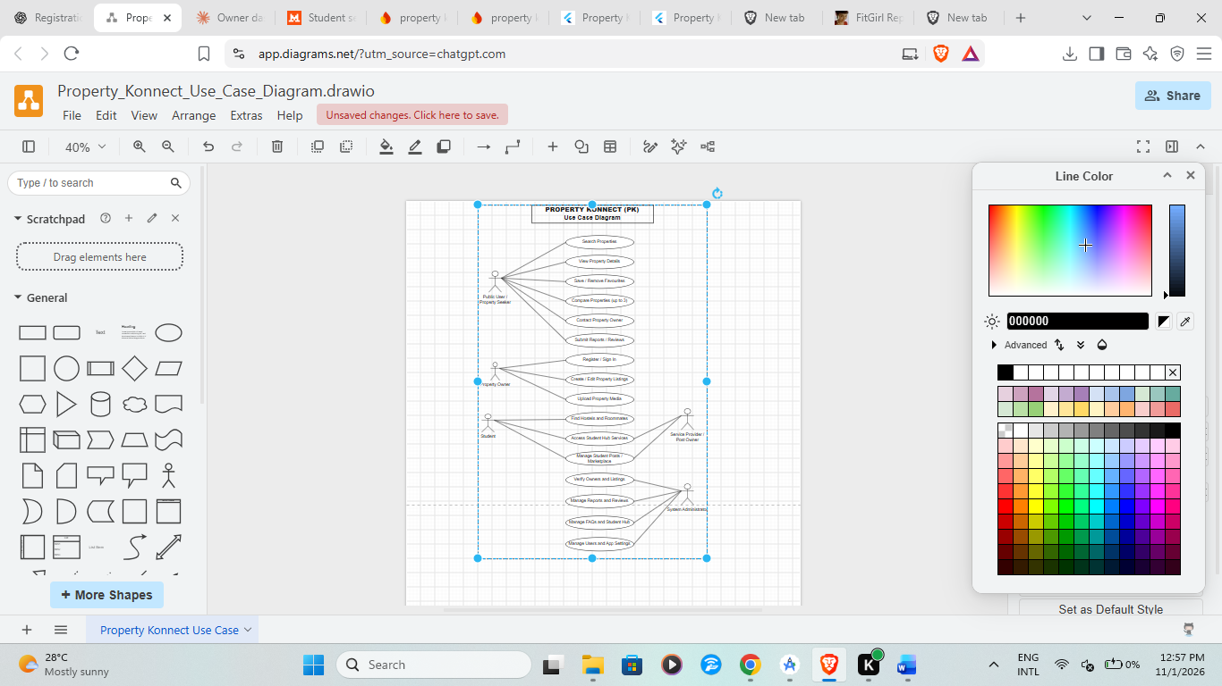
Figure 4.1: Use Case Diagram.
4.3.2 Context Data Flow Diagram
The Property Konnect context diagram provides a high-level representation of how the application interacts with its external users and backend services. It shows Property Konnect as the central system through which users submit information, request services and receive application data.
The Public User / Property Seeker interacts with the system by submitting property search criteria, requesting property details, saving favourites and contacting property owners. The user receives matching property information, listing details and available communication options.
The Property Owner submits registration information, property details and supporting media to the system. The owner can also request access to existing listings, update property information and receive information about listing status.
The Student submits search criteria for hostels and roommates and requests student-related information. The system provides available hostel listings, roommate posts, student services, campus communities and marketplace advertisements.
The Service Provider / Post Owner submits information about services or student-related advertisements and can update eligible posts. The system stores and displays the information to interested users.
The System Administrator interacts with the system to review property owners, manage property listings, investigate reports, moderate content and manage application settings. The administrator receives relevant records and updates the status of approved, rejected, hidden or otherwise managed content as permitted.
The application communicates with Firebase services to authenticate users, store structured records, manage uploaded media and execute selected backend operations. These services support the system's data management and application functionality.
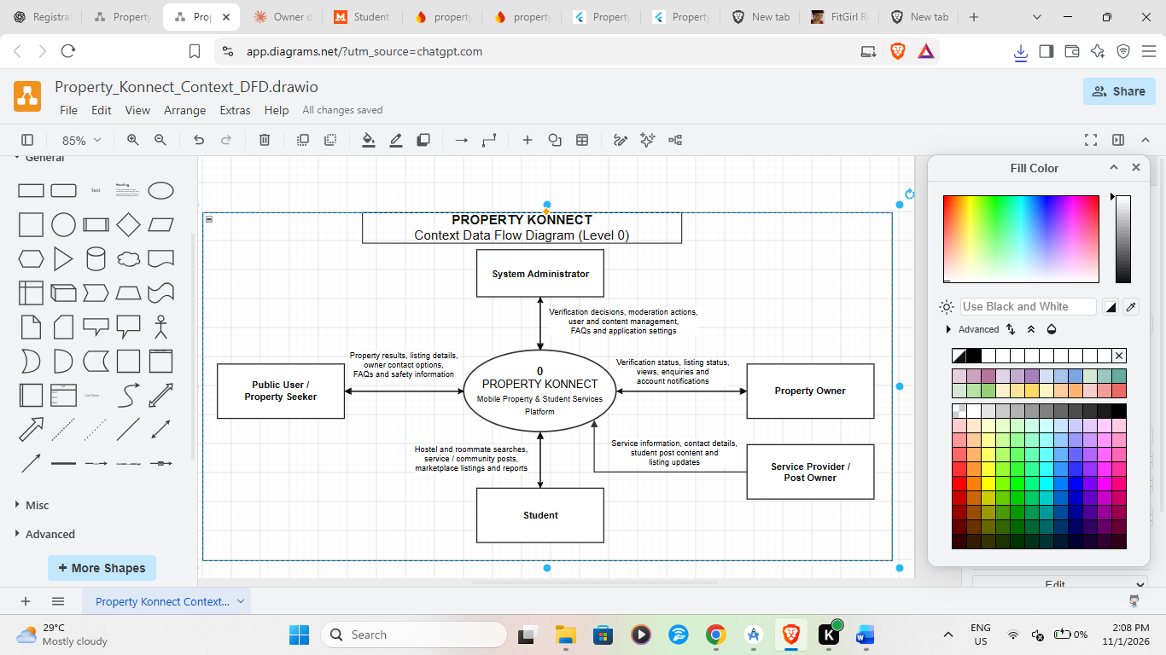
Figure 4.2: Context Data Flow Diagram.
4.3.3 Level 1 Data Flow Diagram
The Level 1 Data Flow Diagram for Property Konnect provides a more detailed representation of the information exchanged within the application. It breaks the overall system into major processes, external actors and data stores.
The User Account Management (1.0) process handles registration, sign-in and user profile information. Users submit their authentication details, after which the system communicates with Firebase Authentication and retrieves the corresponding user profile information from Cloud Firestore. The process also checks the account status and registration stage before granting access to the appropriate application functions.
The Property Search and Listing Management (2.0) process handles property discovery and property advertisement management. Public users submit search criteria such as property purpose, category, location and price. The system retrieves matching property records from the Property Listings data store and displays the results. Property owners submit new listing information and media, which are stored through Firebase Storage and Cloud Firestore. Listing status and verification information are maintained for administrative review.
The Student Hub Management (3.0) process handles hostel searching, roommate discovery, student services, campus communities and marketplace activities. Students submit search requests or create eligible posts. The system retrieves or stores information in the corresponding student-related data stores and displays relevant results to users.
The Administrative Management (4.0) process allows authorised administrators to manage users, verify property owners, review listings, investigate reports, moderate reviews and manage FAQs. Information is retrieved from the relevant data stores, and permitted administrative actions update the corresponding records.
The Favourites and Reporting Management (5.0) process handles saved properties, services and roommate posts, as well as user-submitted reports. Users can save or remove supported items from their favourites and submit reports concerning suspicious or inappropriate content. The system stores these records for retrieval and, where applicable, administrative review.
The main data stores represented in the Level 1 DFD include:
- D1: User Records – stores user profile information, account roles and relevant registration details.
- D2: Property Listings – stores property advertisements, descriptions, locations, prices and listing statuses.
- D3: Student Hub Records – stores hostel, roommate, student service, campus community and marketplace information.
- D4: Reports and Reviews – stores user-submitted reports and review information.
- D5: Favourites Records – stores references to properties, services and roommate posts saved by users.
- D6: Application Management Records – stores relevant FAQs, application settings and administrative information.
These data stores are conceptual representations of the application's information areas. Their actual implementation is based on the Cloud Firestore collections and related Firebase resources used in the project.
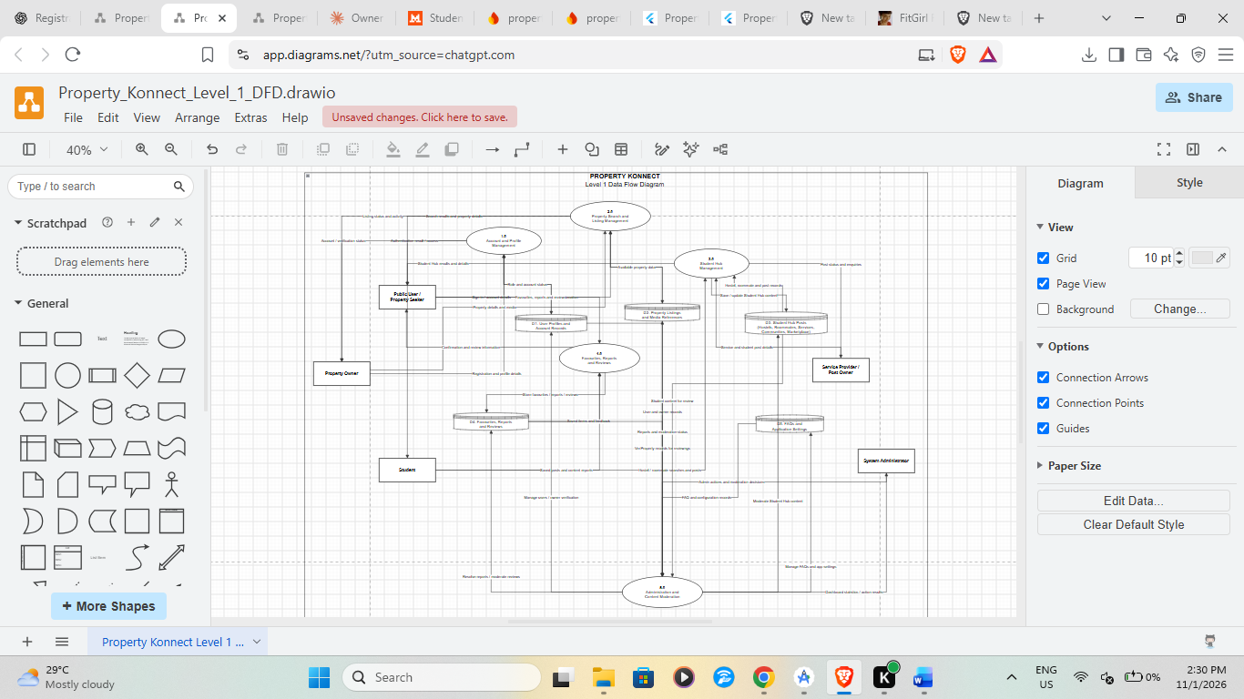
Figure 4.3: Level 1 Data Flow Diagram.
4.3.4 Entity Relationship Diagram (ERD)
The Entity Relationship Diagram represents the major information entities in Property Konnect and illustrates how they relate to one another. It provides a logical view of the data required to support user accounts, property advertisements, student services and administrative activities.
The main entities include User, Property, Hostel, Roommate Post, Student Service, Campus Community, Marketplace Listing, Favourite, Report, Review and FAQ.
The User entity represents individuals registered on the platform. It stores relevant profile information, including the user's unique identifier, name, email address, phone number, role and account status. A user may own or create multiple property listings and may also publish eligible student-related posts.
The Property entity stores information about advertised properties. Its attributes may include property identification, owner identification, title, description, property category, purpose, location, price, amenities, media references and verification status. A property owner can create multiple property listings, while each property listing is associated with its owner.
The Hostel entity stores accommodation information intended for students. Its information includes the hostel name, location, campus, room type, budget or price information, available facilities and relevant contact details. The information can be displayed through the hostel discovery function.
The Roommate Post entity stores information submitted by users searching for potential roommates or advertising available shared accommodation. It can include the campus, accommodation type, gender preference, budget range, location and contact information.
The Student Service entity stores information about services advertised to students. These services may include cleaning, moving, repairs and other relevant activities. A service provider or authorised post owner can create and manage eligible service records.
The Campus Community entity stores information about student organisations, clubs, societies, sports groups and other campus-based communities. It contains details used to identify the organisation, its campus, category and available joining information.
The Marketplace Listing entity stores information about products advertised through the Comrade Marketplace. It may include the product title, description, price, condition, category, campus, photographs, seller information and availability status.
The Favourite entity stores references to items saved by users. It links a user to a property, service or roommate post that the user wants to access again.
The Report entity stores information submitted by users concerning suspicious or inappropriate content. It includes the reporting user, the affected content, report category, description, date and report status. Administrators use these records during content review and moderation.
The Review entity stores user feedback and ratings associated with supported property listings. It allows administrators to review, hide, restore or delete content according to the application's moderation procedures.
The FAQ entity stores frequently asked questions and their corresponding answers. It supports the application's information and help section and can be managed by authorised administrators.
The main relationships include:
- One user can own or create many property listings, while each property listing is associated with its owner.
- One user can create multiple eligible roommate, student service, campus community or marketplace posts.
- One user can save multiple properties, services and roommate posts as favourites.
- One property can receive multiple reviews, while each review is associated with its author and the relevant property.
- One user can submit multiple reports, while each report is associated with the content being reported.
- An administrator can manage multiple property owners, property listings, reports, reviews and student-related records.
- Student-related records can be associated with their respective creators or service providers where the application stores ownership information.
The ERD provides a logical representation of the relationships between these records. Since Property Konnect uses Cloud Firestore, the actual database implementation may use document references, embedded fields and separate collections rather than traditional relational foreign keys.
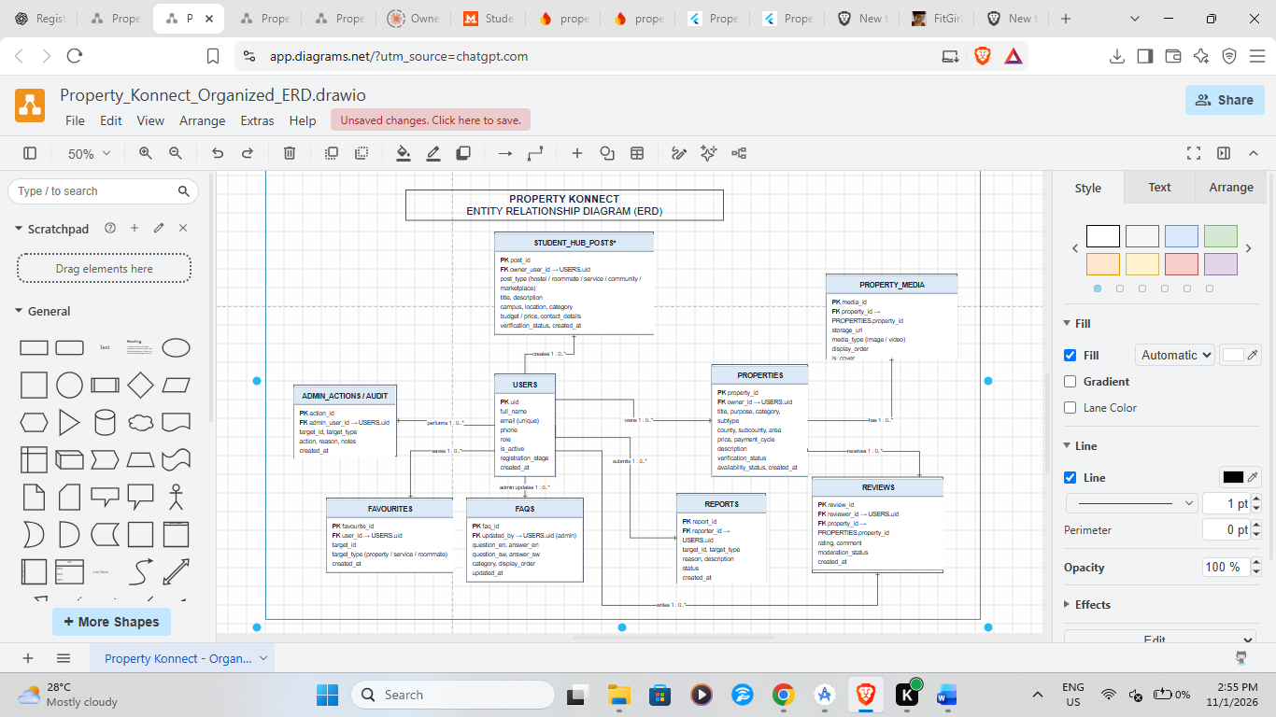
Figure 4.4: Entity Relationship Diagram.
4.3.5 Activity Diagram
The Activity Diagram illustrates the sequence of activities involved in the operation of Property Konnect. It can be used to demonstrate the general workflow from user access to the completion of a property or student-related operation.
The process begins when a user launches the application. On the first launch, the user is presented with the language selection interface and selects a preferred language. The selected preference is saved so that subsequent application launches can use the stored setting.
The user can then browse the public application or proceed to account registration and sign-in. When a registered user signs in, the system authenticates the credentials through Firebase Authentication and retrieves the associated user profile from Cloud Firestore.
A decision is made based on the user's account status and role. If the account is inactive, the system displays an appropriate message. If the account is active, the user is directed to the relevant application functions according to the assigned role and registration stage.
A public user or property seeker can proceed to search for properties by selecting the intended property purpose, category and location. The user can apply the available filters and submit the search request. The system retrieves matching listings and displays the results. The user can select a property to view its details, photographs, amenities, location and available contact information.
A property owner can proceed to create a property listing. The owner enters the required property information, selects supporting photographs or videos and submits the listing. The application validates the information and uploads the selected media to Firebase Storage before saving the listing information in Cloud Firestore. The listing is then available for the relevant administrative review process.
Students can access the Student Hub and select the required function. They may search for hostels, discover roommates, browse student services, explore campus communities or access the Comrade Marketplace. The application retrieves the relevant information and displays matching records.
When a user submits a report, the system stores the report information for administrative review. An authorised administrator can inspect the report, examine the associated content and take the permitted action, such as resolving, reopening or deleting the report.
The administrator also manages property-owner verification and property listing statuses. If a property listing satisfies the applicable verification requirements, the administrator can update its status accordingly. Listings that require further attention can remain unverified or be deactivated as appropriate.
Overall, the Activity Diagram demonstrates how Property Konnect manages user access, property discovery, listing submission, student services and administrative oversight through a sequence of connected application activities.
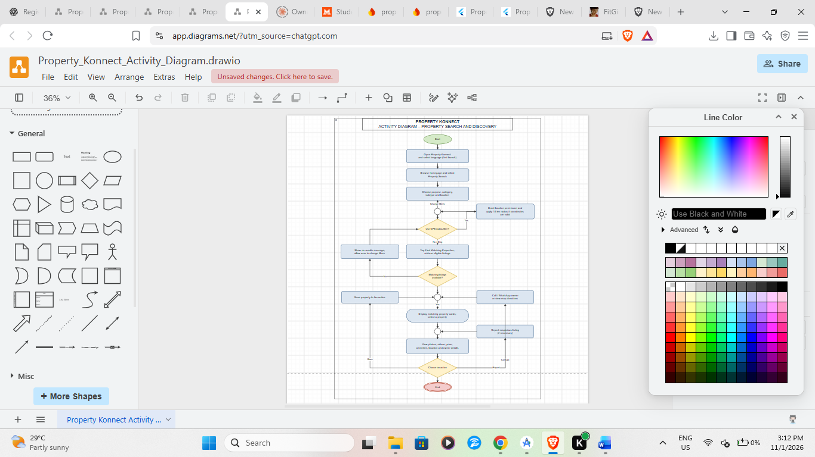
Figure 4.5: Activity Diagram.
4.4 Process and Data Flow Description
Property Konnect operates through interactions between users, the Flutter mobile application and Firebase backend services. Users submit requests through application pages and forms, while the application validates the submitted information and communicates with the appropriate backend service.
4.4.1 User Registration and Authentication Process
A new property owner enters the required registration information through the registration page. The application validates the submitted details and creates the user's authentication account through Firebase Authentication. The corresponding profile information is stored in Cloud Firestore.
During sign-in, Firebase Authentication verifies the user's credentials. The application then retrieves the user's profile and checks relevant account information, including role, active status and registration stage. The user is directed to the appropriate page based on the retrieved information.
4.4.2 Property Search Process
A property seeker begins by selecting the intended purpose of the search, followed by the relevant property category, subtype and location. Additional filters may include price sorting and a location radius where valid GPS coordinates are available.
The user submits the search criteria, after which the application retrieves matching eligible listings from Cloud Firestore. The results are displayed in batches to support efficient loading. The user can open a listing to view its details and available communication options.
4.4.3 Property Listing Management Process
An authorised property owner accesses the property submission page and enters information about the property. The owner selects the relevant category, location, price, amenities and description, and uploads supporting photographs or videos.
The application validates the information and uploads the selected media to Firebase Storage. The corresponding listing information is saved in Cloud Firestore. New listings are assigned the appropriate initial verification status and can be reviewed by authorised administrators.
4.4.4 Student Hub Process
Students and other permitted users access the Student Hub to discover hostels, roommates, student services, campus communities and marketplace listings.
The user selects the relevant section and provides search criteria where applicable. The application retrieves matching records from Cloud Firestore and displays them. Users can access details, save supported items as favourites and contact the relevant advertiser through available communication options.
4.4.5 Reporting and Administrative Management Process
Users can submit reports concerning suspicious advertisements or inappropriate content. The system stores the report information for authorised administrators to review.
Administrators access the relevant management section, retrieve submitted reports and examine the associated records. They can update report statuses and take permitted moderation actions. Administrative activities may also include owner verification, listing review, review moderation, student content management and FAQ updates.
These processes support the centralised management of information and the administration of Property Konnect.
4.5 Solution Specification
Property Konnect is specified as a Flutter-based mobile application integrated with Firebase backend services. The system is designed to provide property discovery, property-owner management, student accommodation and related campus services through one application.
The client application contains public-facing pages, property-owner functions, student-related modules and administrative interfaces.
The main technologies used in the system include:
- Flutter: Provides the mobile application interface and application structure.
- Dart: Provides the programming language used to develop the application.
- Firebase Authentication: Manages user registration and authentication.
- Cloud Firestore: Stores structured application information.
- Firebase Storage: Stores property media and supported uploaded documents.
- Firebase Cloud Functions: Supports selected trusted backend operations.
- SharedPreferences: Stores non-sensitive user preferences.
- Flutter Secure Storage: Supports secure local storage of sensitive values where required.
- Local Authentication: Provides access to device-supported biometric authentication.
- Geolocator: Supports location-based features where the user grants permission.
The application supports English and Kiswahili, together with light and dark appearance settings. Its major functional modules include the homepage, property search, property details, property management, Student Hub, favourites, services marketplace, FAQs, contact information, authentication and administration.
The system uses a role-based approach to present appropriate application functions to different categories of users. Access to protected records and administrative operations should be enforced through Firebase Security Rules and trusted backend authorization.
4.6 System Constraints and Assumptions
The operation of Property Konnect depends on several technical and operational conditions.
4.6.1 System Constraints
- Internet connectivity is required for most authentication, database and cloud-storage operations.
- GPS-based search depends on device location services and user permission.
- Property search results depend on the availability and accuracy of submitted property information.
- Media uploads depend on available network connectivity and supported file formats and sizes.
- Certain application functions are available only to authenticated users or authorised administrators.
- Application performance may be affected by device capabilities, network conditions and the volume of retrieved records.
4.6.2 System Assumptions
- Users have access to compatible Android devices.
- Property owners provide accurate property information when creating advertisements.
- Users provide valid contact information where communication details are required.
- Administrators are authorised to review property owners, listings and user-submitted reports.
- Firebase services are configured and available to support the application's backend operations.
- Users grant the necessary device permissions when accessing location or biometric functionality.
4.7 Chapter Summary
This chapter has presented the analysis and specification of Property Konnect. It has identified the main system actors, functional and non-functional requirements, and the interactions between users and the application.
The chapter has also described the use case diagram, context diagram, Level 1 Data Flow Diagram, Entity Relationship Diagram and Activity Diagram, together with the major processes involved in authentication, property searching, property listing management, student services and administration.
The next chapter presents the detailed system design, including the application's input and output designs, database structures, user interfaces and implementation architecture.

CHAPTER FIVE: SOLUTION DESIGN

5.1 Introduction
This chapter describes the design of Property Konnect, including the user interface, input forms, validation, database structure and output reports. Actual screenshots, ERDs and data-flow diagrams should be inserted from the implemented project before final submission.

5.2 System Architecture Design
The system follows a client-and-cloud-services architecture. The Flutter application presents the interface and handles user interaction. Firebase Authentication provides user identity. Cloud Firestore stores application records. Firebase Storage stores uploaded files. Cloud Functions provide selected server-side operations. The client communicates with these services through their supported SDKs.
Layer | Components | Responsibility
Presentation layer | Flutter pages, widgets, navigation, localisation and themes | Displays information and collects user input.
Application logic layer | Dart services, validation, state handling and role-based routing | Coordinates application workflows and validates input.
Authentication layer | Firebase Authentication and local biometric integration | Manages account identity and supported sign-in checks.
Data layer | Cloud Firestore | Stores profiles, listings, reports, reviews and student content.
Media layer | Firebase Storage | Stores property photos, videos and uploaded documents.
Backend operations | Firebase Cloud Functions | Executes selected trusted operations and administrative workflows.

5.3 Input Design

5.3.1 Registration Form
The registration form collects a user's full name or business name, email address, Kenyan phone number, password and password confirmation. The user must accept the Terms and Conditions before registration. Input validation should check required fields, email format, phone format and password strength before account creation.

5.3.2 Login Form
The login form accepts an email address and password. It includes password visibility controls, Remember Me, Forgot Password and navigation to registration. Authentication is performed through Firebase Authentication, followed by a Firestore profile and account-status check.

5.3.3 Property Listing Form
The Add Property form collects the property title, purpose, category, subtype, location, price, payment cycle, amenities and additional information. It supports photo and video uploads, photo arrangement, cover-photo selection and listing preview. The form supports both new listing creation and editing.

5.3.4 Student Content Forms
Student-related forms collect information relevant to the specific module. Roommate posts include campus, accommodation type, gender, budget and preferred location. Student service and community posts contain their title, description, campus or location and relevant contact or joining information. Marketplace posts include item name, price, description, condition, campus, area, seller name, phone number and photos.

5.4 Data Coding and Validation
Data coding should use consistent field names, enumerated status values and normalised values for fields such as campus, county, category and payment cycle. Validation should be performed before submission and reinforced by trusted backend checks and database rules.
Input | Validation / control
Email | Required where account registration or login needs it; validate email format.
Phone number | Validate expected Kenyan number format and normalise consistently.
Password | Apply password-strength requirements and confirmation matching.
Property price | Require a valid numeric value greater than zero; reject invalid or non-finite values.
Property location | Require applicable county, sub-county and area fields.
Property media | Validate allowed file types, file size and maximum upload count.
Roommate budget | Accept valid numeric values and ensure minimum does not exceed maximum.
Marketplace price | Require a valid positive numeric amount.
Administrative actions | Require authenticated administrator authorization and record relevant audit information.
Search radius | Apply the 15 km constraint only when the strict radius option is enabled and coordinates are valid.

5.5 Database Design
Cloud Firestore is used as the application's document database. The following table identifies principal collections referenced in the project documentation. Exact field names, indexes, subcollections and relationships must be confirmed against the current Firestore implementation and represented in the final ERD or data model.

Collection / data store | Purpose
users | User profiles, roles, account status, registration and verification information.
properties | Property listings, owner references, prices, locations, amenities, media and listing status.
registered_emails | Email-to-user lookup records used by the registration and account workflows.
reviews | Tenant reviews and ratings associated with properties.
reports | Reports submitted about properties and other platform content.
roommates | Roommate requests and accommodation preferences.
student_services | Student service listings.
campus_communities | Campus clubs, societies and organisations.
comrade_marketplace | Student marketplace products and seller information.
property_services / services | Property-related service advertisements and provider details.
app_config/settings | Application name and support contact settings.
admin_audit_logs | Administrative action records.
Firebase Storage | Property media, marketplace images and uploaded owner documents.

5.6 Data Dictionary (Summary)
Entity | Representative attributes | Description
User | uid, name, email, phone, role, isActive, registrationStage | Identifies an application user and their account state.
Property | propertyId, ownerId, title, purpose, category, price, county, subCounty, images, videos, availability, property_status | Describes a property listing and its ownership and status.
Roommate | postId, ownerId, campus, accommodationType, gender, budget, preferredLocation, createdAt | Describes a roommate request.
Student service | serviceId, ownerId, title, category, campus, location, description, contact | Describes a student-focused service.
Community | communityId, ownerId, name, campus, category, joinLink, verified | Describes a campus organisation or group.
Marketplace item | itemId, ownerId, itemName, price, condition, campus, photos, status | Describes an item advertised for sale.
Report | reportId, reporterId, targetCollection, targetId, reason, status, createdAt | Records a report submitted for administrative review.
Review | reviewId, reviewerId, propertyId, rating, comment, status | Stores a property review and moderation status.

5.7 Database Normalisation and Integrity
Firestore is a NoSQL document database and does not use relational normalisation in exactly the same manner as a relational database. The design should nevertheless minimise unnecessary duplication, use stable document identifiers, maintain consistent references such as ownerId and propertyId, and define clear rules for updating related records. Where summary fields are duplicated for performance, update logic should keep them consistent. Security rules and backend functions should enforce ownership and role constraints.

5.8 Output Design
The application presents outputs through responsive cards, detail pages, dashboards, dialogs, status labels, charts or summary statistics where implemented, and export files. Interface design should follow HCI principles by maintaining consistency, providing clear navigation, using readable text and giving users feedback during loading, saving and error conditions.

5.9 Reports and Exports
Administrative pages support CSV exports for selected records, including reports, property listings, owner information and student content. Property details can also be exported into a downloadable text file by administrators. Exported information should be relevant to the administrative purpose and should not expose unnecessary personal information.

5.10 Chapter Summary
This chapter has described the system architecture, input forms, validation, Firestore data design and output functions. The next chapter discusses implementation, testing, security and recommendations.

CHAPTER SIX: SOLUTION IMPLEMENTATION AND RECOMMENDATIONS

6.1 Introduction
This chapter describes the implementation of Property Konnect, the main prototype functions, security considerations, testing procedures, user documentation and recommendations. The report reflects the functionalities described in the supplied project documentation. Actual screenshots, test execution evidence and measured results should be added from the running application.

6.2 Implementation Environment
The application is implemented using Flutter and Dart. Firebase services provide authentication, cloud data storage, media storage and selected backend operations. Development and debugging are carried out using a Flutter-compatible development environment and Android devices or emulators. The final report should record the exact Flutter, Dart, Android SDK and package versions used for the submitted build.

6.3 Implemented Prototype Functionalities

First-launch language selection
The application presents a language selection page on first launch, applies the selected language and stores the choice for subsequent sessions.

Homepage and navigation
The homepage introduces the platform, property categories and student features and provides navigation to the main application pages.

Property search
Users select purpose, category, subtype and location, optionally apply GPS radius filtering and sort results by price.

Property details
Users view property descriptions, media, amenities, location, owner contact options and other supported listing actions.

Property owner account
Owners register, sign in, complete verification stages, manage profiles and use supported biometric functions.

Property management
Owners create and edit property listings, upload photos and videos, arrange photos, choose a cover image and preview listings.

Favourites
Users save and manage properties, service providers and roommate posts; property comparison supports up to three properties.

Hostel discovery
Students search hostel listings using campus, room type, budget and location.

Roommate finder
Users post and search roommate requests using campus, accommodation, gender, budget and location criteria.

Student services and communities
Users discover and manage student services and campus organisations.

Comrade Marketplace
Students advertise, browse, edit and manage items for sale, including photo uploads.

Administration
Administrators manage owner verification, property listings, reports, FAQs, reviews, student content and application settings.

6.4 Administrative Implementation
The administrative prototype includes dedicated pages for verifying property owners, reviewing property listings, managing reports, FAQs, roommate posts, terms and conditions, student hub content, privacy policies, reviews and application settings. These pages provide search, filters, status changes, details views and selected export functions. Some operations also record audit information. All administrative operations must be protected by server-side authorization and restrictive database and storage rules.

6.5 Security Features and Principles
Security area | Implementation described / required control
Authentication | Firebase Authentication manages registered user identity and sign-in.
Role checks | User profiles and roles determine the intended application navigation and access.
Account status | The login workflow checks whether a user account is active.
Biometric option | Fingerprint or face authentication is available on supported devices when configured.
Device identification | Device-related identifiers support selected device checks and duplicate-report prevention.
Database access | Firestore Security Rules should enforce authentication, ownership and role permissions.
File access | Firebase Storage Rules should restrict access to uploaded documents and media according to ownership and role.
Trusted administration | Sensitive administrative operations should be verified by trusted backend code, not client-side checks alone.
Data privacy | Personal information and identity documents should be collected and exposed only where necessary.
Auditability | Administrative actions should be recorded with actor, action, target and timestamp where applicable.

Security qualification: the presence of a client-side role check or a device identifier does not by itself prove that a function is secure. Final verification should include review of deployed Firestore and Storage rules, Cloud Functions authorization, authentication flows, data exposure and administrative privileges.

6.6 Testing and Associated Procedures
Testing should verify that each module behaves according to the functional and non-functional requirements. The following test levels are recommended. The student should replace the status column with actual observed results after executing the tests.
Test level | Purpose | Example test
Unit testing | Test individual functions and validators. | Check price, email, phone and budget validation.
Widget testing | Test individual Flutter interface components. | Verify form fields, dropdowns, tabs, dialogs and loading indicators.
Integration testing | Test communication between application modules and Firebase. | Register a user, create a profile and retrieve the profile after login.
System testing | Test complete application workflows. | Search for a property, open its details and contact the owner.
Security testing | Check access restrictions and data protection. | Attempt unauthorized access to another owner's listing or an administrative function.
Usability testing | Assess ease of use and clarity. | Ask representative users to complete a property search or hostel search.
Compatibility testing | Check supported device and screen configurations. | Run the application on different supported Android screen sizes and versions.
User acceptance testing | Confirm that the system meets intended user needs. | Ask intended users to complete agreed scenarios and record feedback.

6.6.1 Sample Test Cases
Test ID | Test scenario | Expected result | Actual result
TC01 | Launch the application for the first time. | Language selection page is displayed. | To be completed after execution.
TC02 | Select and confirm Kiswahili. | Language is applied and retained on the next launch. | To be completed after execution.
TC03 | Sign in with valid credentials. | User is authenticated and routed according to profile and role. | To be completed after execution.
TC04 | Sign in with an inactive account. | Access is restricted and an appropriate message is displayed. | To be completed after execution.
TC05 | Search for a property using valid filters. | Matching eligible listings are displayed after Find Matching Properties is pressed. | To be completed after execution.
TC06 | Enable strict 15 km radius filtering. | Only listings with valid coordinates inside the radius are displayed. | To be completed after execution.
TC07 | Submit a property form with an invalid price. | Validation prevents submission and displays an error. | To be completed after execution.
TC08 | Create a property listing as an authorised owner. | Validated listing information and media are saved. | To be completed after execution.
TC09 | Attempt to edit another owner's listing. | The operation is denied by trusted authorization and database rules. | To be completed after execution.
TC10 | Search for a hostel by campus and budget. | Matching hostel listings are displayed. | To be completed after execution.
TC11 | Submit a report about a listing. | A report record is created for administrative review. | To be completed after execution.
TC12 | Attempt an administrative action as a non-admin user. | The action is denied by backend authorization and security rules. | To be completed after execution.

6.7 User Help Manual

6.7.1 Getting Started
Install and launch Property Konnect on a supported Android device.
On first launch, select the preferred language and confirm the selection.
Use the homepage navigation to access property search, Student Hub, services and other public pages.
Register or sign in when a feature requires an account.
Use App Settings to change language, appearance or text size.

6.7.2 Searching for a Property
Open Property Search from the homepage.
Select whether the property is for rent or sale.
Choose the property category and subtype.
Choose a county and sub-county or use the available GPS location option.
Optionally enable the strict 15 km radius filter and choose a price sorting order.
Press Find Matching Properties to apply the selected filters.
Select a listing to view its details and available contact options.

6.7.3 Registering as a Property Owner
Open the registration page and enter the required personal or business information.
Create and confirm a password and accept the Terms and Conditions.
Submit the registration form.
Follow the email verification and subsequent ID-upload and biometric setup stages as required by the account workflow.

6.7.4 Adding a Property
Sign in and open the Property Owner Dashboard.
Select Add Property.
Enter the required property information, location, price, payment cycle and amenities.
Upload the available property photos and videos.
Arrange the photos, select a cover photo and review the listing preview.
Submit the listing and check its status from My Listings.

6.7.5 Using Student Hub
Open Student Hub and choose Hostels, Roommates, Student Services, Campus Communities or Comrade Marketplace. Follow the search controls on the selected page. Review listing details and use the contact, join, report or favourite functions where available.

6.7.6 Administrator Functions
Authorised administrators sign in and open the Admin Dashboard. They can select the relevant management page to review owners, listings, reports, FAQs, student content, reviews and application settings. Administrative actions should be performed only where the administrator has the required authorization and supporting information.

6.8 Conclusion
Property Konnect brings together property discovery, property-owner listing management and student-focused services within one Flutter mobile application. The system includes property search, property details, owner account workflows, favourites, hostel discovery, roommate finding, student services, campus communities, a student marketplace and administrative management functions. Firebase services support authentication, data storage, media storage and selected backend operations. The project provides an integrated approach to property and student accommodation information for the Kenyan market.

6.9 Recommendations
The following improvements are recommended for future development and operational strengthening:
Complete and independently review Firestore and Firebase Storage security rules, ensuring that ownership and administrator permissions are enforced on the server side.
Use trusted Cloud Functions for sensitive administrative actions, account deletion, role changes and other operations requiring elevated privileges.
Expand automated unit, widget, integration, security and user-acceptance testing, and retain evidence of test execution.
Improve listing media management through upload validation, photo reordering, cover-photo controls, cleanup of abandoned uploads and safe deletion procedures.
Introduce a map-based property location selection and improve validation of property coordinates.
Provide draft listing support so owners can save incomplete property advertisements and complete them later.
Improve search performance with suitable Firestore indexes, cursor-based pagination and carefully designed query filters.
Provide clearer listing expiry reminders and owner notifications where supported.
Review privacy, retention and deletion procedures for identity documents, contact details, device identifiers and user-generated content.
Consider future integration of secure payment processing only after defining payment requirements, provider arrangements and regulatory obligations.

6.10 Further Work
Further work may include a secure in-app payment integration, map-based property discovery, enhanced recommendation and matching functions, owner and tenant notifications, improved analytics, additional accessibility features, and expansion to other platforms. Any future integration should be preceded by requirements analysis, security assessment and user testing.

LIST OF REFERENCES
The following official technical documentation is relevant to the technologies identified in this project. Confirm access dates and apply the citation style required by the Department before final submission.
Google. (n.d.). Android Developers documentation. https://developer.android.com/
Google. (n.d.). Google Play policy centre. https://support.google.com/googleplay/android-developer/
Google. (n.d.). Firebase documentation. https://firebase.google.com/docs
Google. (n.d.). Cloud Firestore documentation. https://firebase.google.com/docs/firestore
Google. (n.d.). Firebase Authentication documentation. https://firebase.google.com/docs/auth
Google. (n.d.). Firebase Storage documentation. https://firebase.google.com/docs/storage
Google. (n.d.). Cloud Functions for Firebase documentation. https://firebase.google.com/docs/functions
Flutter. (n.d.). Flutter documentation. https://docs.flutter.dev/
Dart. (n.d.). Dart language documentation. https://dart.dev/guides
OWASP Foundation. (n.d.). OWASP Mobile Application Security. https://mas.owasp.org/

APPENDICES

Appendix A: Application Screenshots
Insert clear, numbered screenshots from the running Property Konnect application. Recommended screenshots include:
Application logo/loading screen
First-launch language selection
Homepage and navigation drawer
Property search assistant and results
Property details and media gallery
Student Hub
Hostel search
Roommate search and details
Student services and campus communities
Comrade Marketplace
Login and registration
Property owner dashboard
Add Property form and preview
Administrator dashboard
Owner verification and listing review
Reports and review management
App Management settings

Appendix B: Additional diagrams
a) PROJECT TIMELINE (GANTT CHART)
The Property Konnect project timeline outlines the activities undertaken during the analysis, design, development, testing and documentation of the application. The project begins with requirements gathering and analysis, followed by user interface design, system modelling and database structuring. The development phase involves implementing the Flutter frontend and integrating Firebase backend services, including Authentication, Cloud Firestore, Firebase Storage and Cloud Functions.
The application modules are developed incrementally, covering user authentication, property search and management, hostel discovery, roommate finding, student services, campus communities, the Comrade Marketplace and administrative management. Testing and debugging are then conducted to identify and resolve errors, improve performance and verify that the different modules work together. The final activities involve system refinement, preparation of technical documentation and project submission.
Table: Project Implementation Timeline
Activity / Week | W1 | W2 | W3 | W4 | W5 | W6 | W7 | W8 | W9 | W10
Requirements Gathering and Analysis | ● | ●
UI/UX Design (Wireframes and Layouts) |  | ● | ●
System Modelling (UML, DFDs and ERD) |  |  | ● | ●
Database Design (Firestore Structure) |  |  | ● | ●
Mobile Application Development (Flutter Frontend) |  |  |  | ● | ● | ● | ●
Backend Integration (Firebase Services) |  |  |  |  | ● | ● | ●
Property Search and Listing Management |  |  |  |  | ● | ●
Student Hub Development (Hostels, Roommates and Services) |  |  |  |  |  | ● | ● | ●
Campus Communities and Comrade Marketplace |  |  |  |  |  |  | ● | ●
Administrative Module Development |  |  |  |  |  |  | ● | ●
Testing and Debugging |  |  |  |  |  |  |  | ● | ●
System Refinement and Optimization |  |  |  |  |  |  |  |  | ●
Final Technical Documentation and Submission |  |  |  |  |  |  |  |  | ● | ●
Key: ● = Activity scheduled for the particular week.
Note: The timeline is a proposed 10-week development schedule. The actual schedule should reflect the time spent on the project.
b) PROJECT BUDGET
This section presents the estimated budget required for the development, testing and documentation of Property Konnect. The application uses Flutter and Firebase technologies, which help reduce development and infrastructure costs. The budget covers internet access, backend services, documentation, transport, domain registration, application publishing, pilot testing and unforeseen expenses.
Table: Estimated Project Budget
Item | Description | Quantity | Unit Cost (KES) | Total Cost (KES)
Internet/Data Bundles | Research, coding, Firebase integration and testing | 3 months | 1,500 | 4,500
Hosting and Backend Services | Estimated Firebase usage and cloud services | 1 | 3,000 | 3,000
Documentation Printing and Binding | Final project report, printing and binding | 3 | 1,000 | 3,000
Transport and Communication | Research, consultations and project-related meetings | 5 | 1,000 | 5,000
Domain Name Registration | Optional domain for the project website or platform | 1 | 1,500 | 1,500
Google Play Developer Registration | Estimated one-time developer registration allowance | 1 | 3,250 | 3,250
Pilot Testing Allowance | User testing and feedback collection | 10 | 500 | 5,000
Test Devices | Existing Android phone and development laptop | 1 | 0 | 0
Contingency | Unforeseen development and operational expenses | 5 | 3,000 | 15,000
TOTAL ESTIMATED COST |  |  |  | 40,250
The budget assumes that an existing laptop and Android smartphone will be used for development and testing. Firebase costs are provisional and may change depending on usage and the services enabled. Domain registration and Google Play publishing are included as planning allowances and may be excluded if the project is only being demonstrated academically.
The total estimated project expenditure is KES 40,250.

