# Case 1 – Isocratic

## Control Variables

|  |  |  |  |
| --- | --- | --- | --- |
| Variable | Bounds | Levels | Type and Details |
| $$ϕ$$ | $$[0.05,0.95]$$ | $$10$$ | Vol/Vol |
| $$T$$ | $$[20,50]$$ | $$4$$ | Celsius |
|  |  |  |  |

## Model Parameters

|  |  |  |
| --- | --- | --- |
| Parameter | Value | Units |
| $$a_{0}$$ | 40 |  |
| $$C_{T}$$ | 1200 |  |
| $$S_{S}$$ | 8 |  |

Notes:

1. sampling times = False
2. reporting_interval = 0.05 mins
3. SCHEDULE: CONTINUE until 0.95 CUMULATIVE + 1 MIN
4. Isocratic: organic modifier $ϕ$ constant over time
5. Parameters Screenshot

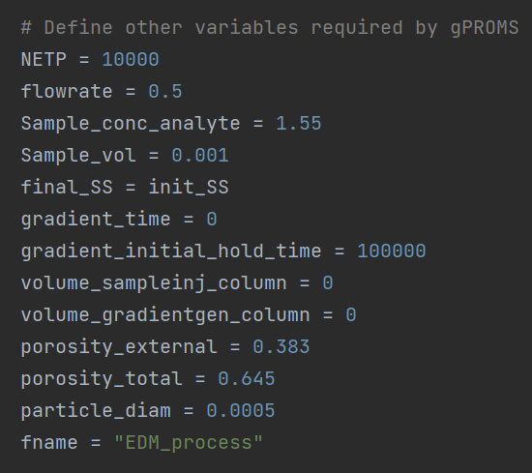

## Case 2 – Linear Gradient

## Control Variables

|  |  |  |  |
| --- | --- | --- | --- |
| Variable | Bounds | Levels | Type and Details |
| $$ϕ_{0}$$ | $$[0.05,0.95]$$ | $$10$$ | Vol/Vol |
| $$t_{G}$$ | $$[5, 50]$$ | $$10$$ | Min. |
| $$T$$ | $$[20,50]$$ | $$4$$ | Celsius |

## Model Parameters

|  |  |  |
| --- | --- | --- |
| Parameter | Value | Units |
| $$a_{0}$$ | 40 |  |
| $$C_{T}$$ | 1200 |  |
| $$S_{S}$$ | 8 |  |

Notes:

1. $ϕ_{F}=1.00$ is fixed
2. sampling times = False
3. reporting_interval = 0.05 mins
4. SCHEDULE: CONTINUE until 0.95 CUMULATIVE + 1 MIN
5. Isocratic: organic modifier constant over time
6. Parameters Screenshot

