SS1 AGRICULTURAL SCIENCE
COMPLETE LESSON NOTES
First Term • Second Term • Third Term

Compiled by
Kenneth Chiakwa
B.Sc. Agricultural Economics | M.Sc. Agricultural Economics
Enugu State University of Science and Technology (ESUT)

KENNESSY EBOOKS
kennessyebooks.github.io

SS1 Agricultural Science — Complete Lesson Notes
(First, Second and Third Term)
Copyright © 2026 Kenneth Onyekachi Chiakwa
All rights reserved. No part of this publication may be reproduced, stored in a retrieval system, or transmitted in any form or by any means — electronic, mechanical, photocopying, recording, or otherwise — without the prior written permission of the copyright holder, except for brief quotations used in reviews or academic citation.
This book is sold subject to the condition that it shall not, by way of trade or otherwise, be resold, hired out, or otherwise circulated without the publisher's prior consent.
Published by Kennessy Ebooks
kennessyebooks.com
First Edition — 2026
Printed and distributed via Selar.com and Amazon KDP.

PREFACE
This volume brings together the complete First, Second, and Third Term Lesson Notes for SS1 Agricultural Science into a single, easy-to-use reference. It was compiled so that students, teachers, and parents can follow the full academic session's scheme of work — from the meaning and importance of agriculture in the first term, through soils and farm tools in the second term, to farm power, crop husbandry, and irrigation in the third term — without needing to search through separate booklets.
Each week's lesson follows a consistent structure: clear explanations, KEY DEFINITIONS highlighted for quick revision, diagrams and tables that simplify difficult ideas, and REVIEW QUESTIONS to test understanding before moving to the next topic. This compilation adds a consolidated Revision Questions section, a Glossary of key terms drawn from all three terms, and a References list at the back of the book, so that revision for examinations is faster and more thorough.
It is my hope that this book will make Agricultural Science an enjoyable and practical subject — one that connects classroom learning to the farms, food systems, and rural livelihoods that shape everyday life in Nigeria.
Kenneth Chiakwa

ABOUT THE AUTHOR
Kennethi Chiakwa is an agricultural scientist, secondary school teacher, and author based in Nigeria. He holds a B.Sc. and an M.Sc. in Agricultural Economics from the Enugu State University of Science and Technology (ESUT), and brings hands-on experience in farming and poultry production together with years of classroom teaching to his writing.
Through the Kennessy Ebooks imprint, he publishes educational lesson notes for Nigerian secondary school students alongside practical agricultural guides for farmers, including titles on broiler production and poultry health. His lesson notes are used by students and teachers across Nigeria and are designed to align closely with the WAEC/NECO curriculum while remaining accessible to learners at every level.
More of his work can be found at kennessyebooks.com, with titles also available on Selar.com and Amazon KDP.

TABLE OF CONTENTS
Preface 3
About the Author 4
FIRST TERM 6
WEEK 1: Meaning and Importance of Agriculture 9
WEEK 2: Problems of Agricultural Development and Solutions 12
WEEK 3: Subsistence and Commercial Agriculture 14
WEEK 4: Role of Government in Agricultural Development 17
WEEK 6: Role of NGOs in Agricultural Development 19
WEEK 8: Agricultural Laws and Reforms 21
WEEK 9: Land and Its Uses 23
WEEK 10: Agricultural Ecology 25
WEEK 11: Factors Affecting Land Availability for Agricultural Purposes 28
SECOND TERM 31
WEEK 1: Agro-Allied Industries 34
WEEK 2: Environmental Factors Affecting Agriculture 36
WEEK 3: Rock Formation 39
WEEK 4: Soil Formation and Profile Development 42
WEEK 6: Soil Types, Composition and Properties 45
WEEK 8: Simple Farm Tools 49
WEEK 9: Farm Machinery and Implements 52
WEEK 10: Maintenance of Farm Machinery 55
WEEK 11: Problems of Agricultural Mechanization 58
THIRD TERM 62
WEEK 1: Prospects of Agricultural Mechanization 65
WEEK 2: Sources of Farm Power 68
WEEK 3: Classification of Crops 71
WEEK 4: Husbandry of Selected Crops 74
WEEK 6: Pasture and Forage Crops 77
WEEK 8: Plant Nutrients and Nutrient Cycle 80
WEEK 9: Irrigation 84
WEEK 10: Drainage 88
WEEK 11: Agricultural Pollution 91
REVISION QUESTIONS 96
GLOSSARY 100
REFERENCES 101

SS1 AGRICULTURAL SCIENCE
FIRST TERM
LESSON NOTES eBOOK

SS1 AGRICULTURAL SCIENCE

FIRST TERM LESSON NOTES

Compiled by:

Kenneth Chiakwa

B.Sc. Agricultural Economics | M.Sc. Agricultural Economics

Enugu State University of Science and Technology (ESUT)

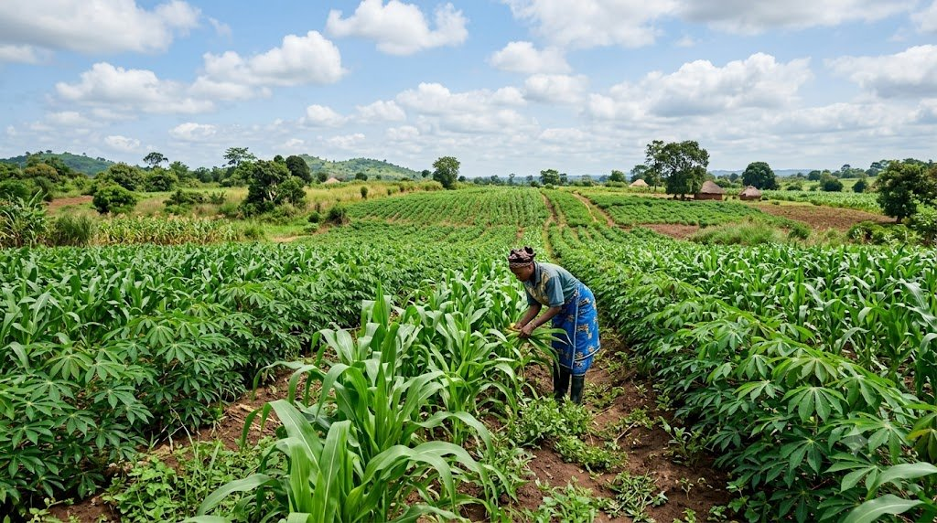
TOPICS COVERED IN THIS BOOK

Week 1: Meaning and Importance of Agriculture
Week 2: Problems of Agricultural Development and Solutions
Week 3: Subsistence and Commercial Agriculture
Week 4: Role of Government in Agricultural Development
Week 5: Mid-Term Examination
Week 6: Role of NGOs in Agricultural Development
Week 7: Mid-Term Break
Week 8: Agricultural Laws and Reforms
Week 9: Land and Its Uses
Week 10: Agricultural Ecology
Week 11: Factors Affecting Land Availability
Week 12: Examination

HOW TO USE THIS BOOK

Dear Student,

Welcome to your SS1 Agricultural Science First Term Lesson Notes. This book has been carefully written to make Agricultural Science easy, interesting, and understandable for you.

Here is how to get the best from this book:

- Read each week's lesson carefully before coming to class. This will help you understand the teacher's explanation better.
- Study the diagrams and tables — they give you a quick visual summary of the key points.
- Copy the KEY DEFINITIONS into your notebook and memorise them — they often appear in exams.
- Answer the REVIEW QUESTIONS at the end of each week in your exercise book.
- Highlight or underline the points your teacher emphasises in class.
- Form a study group with your classmates and discuss the topics together.

Agricultural Science is not just a subject — it is about the food you eat, the land your family farms, and the future of Nigeria. Study it with interest!

Best wishes,
Kenneth Chiakwa
B.Sc., M.Sc. Agricultural Economics, ESUT

WEEK 1
Meaning and Importance of Agriculture

A. What is Agriculture?
Agriculture is the science, art, and business of cultivating the soil, rearing animals, and processing their products for human use. In simple terms, agriculture means farming — the growing of crops and keeping of animals to provide food, clothing, shelter, and income for people.

The word 'Agriculture' comes from two Latin words:
- AGER — meaning field or land
- CULTURA — meaning cultivation or growing

KEY DEFINITION
- Agriculture is the deliberate effort by man to cultivate crops and rear animals for the benefit of mankind.

B. Branches of Agriculture
Agriculture is a very wide subject. It has several branches:

Branch | What It Involves
Crop Production (Agronomy) | Growing of food and cash crops like maize, yam, cassava, cocoa, etc.
Animal Husbandry | Rearing of domestic animals like cattle, goat, sheep, poultry for food and income
Fishery | Catching or farming of fish for food and income
Forestry | Planting and management of trees for timber, fuel, and environment
Agricultural Economics | Study of how farm resources are used to make profit
Agricultural Engineering | Use of machines and engineering methods in farming
Soil Science | Study of soil types, properties, and how to improve them
Agricultural Extension | Teaching farmers new and better farming methods

C. Importance of Agriculture to Individuals
Agriculture is very important to every individual in the following ways:
- Food supply: Agriculture provides food such as rice, yam, vegetables, meat, and fish for individuals and their families.
- Income generation: Farmers earn money by selling their farm produce in the market.
- Employment: Agriculture provides jobs for millions of people — farmers, farm workers, processors, and traders.
- Raw materials: Crops like cotton and rubber provide raw materials for clothing and manufacturing.
- Savings: A family that farms can reduce the money spent on food by growing their own.

D. Importance of Agriculture to the Community and Nation
- National food security: Agriculture ensures that enough food is available for the entire country.
- Foreign exchange earnings: Nigeria earns foreign money by exporting crops like cocoa, palm oil, groundnut, and rubber.
- Industrial raw materials: Many industries depend on agricultural products, e.g., flour mills use wheat, breweries use sorghum and maize.
- GDP contribution: Agriculture contributes greatly to Nigeria's Gross Domestic Product (GDP) — the total value of goods and services produced in a country.
- Rural development: Agriculture brings development to rural communities through roads, markets, and schools built around farming areas.
- Poverty reduction: When people farm and earn money, poverty is reduced in the society.

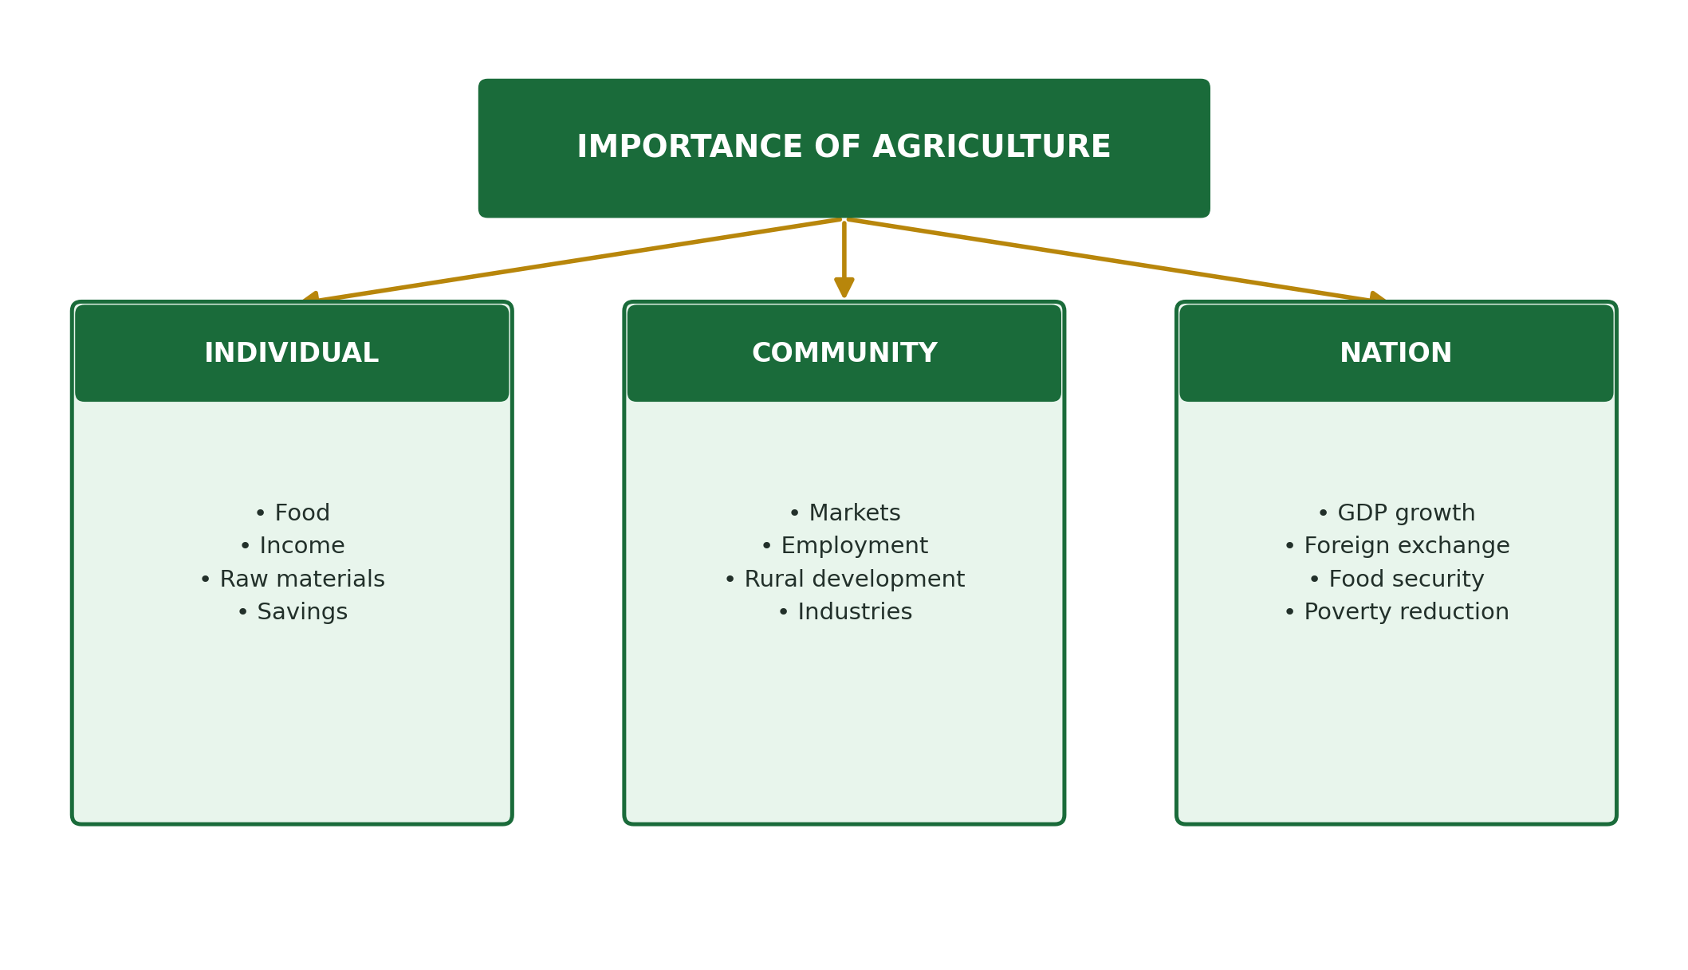

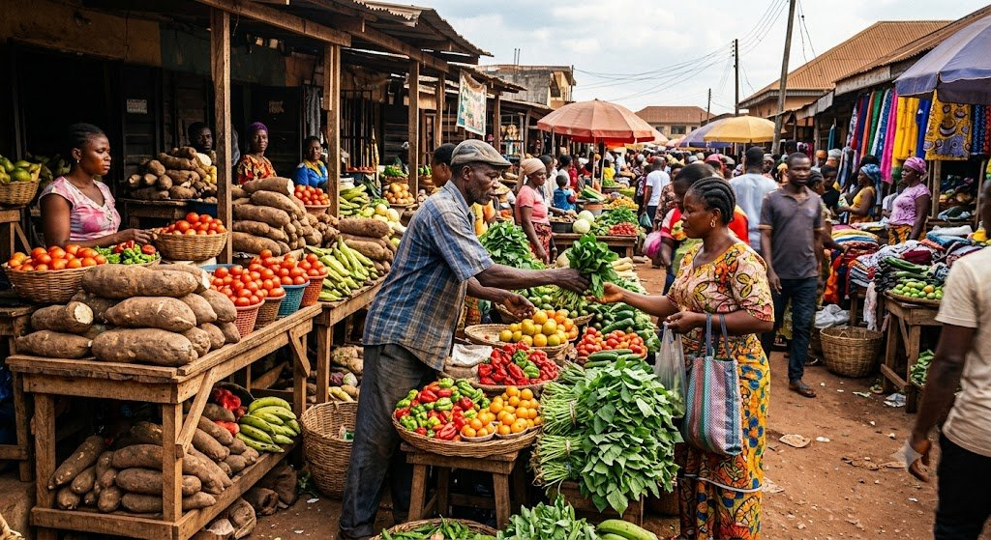
A busy Nigerian local food market — the final destination of agricultural produce.

REVIEW QUESTIONS
- 1. Define agriculture in your own words.
- 2. List FIVE branches of agriculture and explain TWO of them.
- 3. State THREE ways in which agriculture is important to an individual.
- 4. Explain how agriculture contributes to Nigeria's national development.
- 5. What does GDP mean? How does agriculture contribute to it?

WEEK 2
Problems of Agricultural Development and Solutions

A. Introduction
Despite its importance, agriculture in Nigeria and many African countries faces many serious problems that prevent farmers from producing enough food and earning good income. In this lesson, we will identify these problems and suggest possible solutions.

B. Problems of Agricultural Development in Nigeria
1. Land Tenure Problems
Land tenure refers to the way people own or have rights to use land. In Nigeria, land ownership is often complicated by:
- Communal land ownership — land belongs to the whole community and cannot be sold freely.
- Fragmented plots — a farmer's land may be scattered in small pieces in different places, making machine use impossible.
- The Land Use Decree of 1978 — this law vested all land in the government, making it difficult for farmers to own large plots.

2. Low Level of Technology
- Most Nigerian farmers still use simple, outdated tools like hoes and cutlasses.
- Very few farmers can afford modern machines like tractors and combine harvesters.
- This limits the size of land that can be farmed and reduces productivity.

3. Poor Storage and Processing Facilities
- Many farmers lack storage facilities like silos, cold rooms, and warehouses.
- As a result, a lot of farm produce is wasted after harvest (post-harvest losses).
- Processing equipment like grain dryers and mills are not available in many rural areas.

4. Pests and Diseases
- Crop pests such as locusts, aphids, and stem borers destroy crops on the farm.
- Diseases like cassava mosaic, maize streak, and black pod of cocoa reduce harvests.
- Animal diseases like rinderpest, foot-and-mouth disease kill livestock.

5. Poor Finance and Credit Facilities
- Most farmers are poor and cannot afford seeds, fertilizers, and farm chemicals.
- Banks demand collateral (security) before giving loans, which most farmers do not have.
- Interest rates on agricultural loans are usually very high.

6. Poor Transportation and Roads
- Many farming communities have bad roads, making it difficult to move farm produce to markets.
- This leads to spoilage and losses when farmers cannot sell their products quickly.

7. Lack of Agricultural Education and Extension Services
- Many farmers are uneducated and are not aware of modern farming techniques.
- Agricultural extension workers who teach farmers are too few and do not reach rural areas.

8. Environmental Degradation
- Soil erosion, flooding, drought, and deforestation are destroying farmland.
- Oil pollution in the Niger Delta has made many farmlands useless.

Problem | Suggested Solution
Land tenure system | Government should reform land laws to allow easy access to farmland
Low technology | Provide subsidised tractors and farm equipment to farmers
Poor storage | Build rural silos, cold rooms, and processing centres
Pests and diseases | Provide affordable pesticides and train farmers on pest control
Poor finance | Give low-interest agricultural loans through rural banks and cooperatives
Bad roads | Construct and maintain rural roads to link farms to markets
Poor education | Train more extension workers and establish agricultural schools
Environmental degradation | Enforce environmental laws and practice conservation farming

REVIEW QUESTIONS
- 1. List FIVE problems facing agricultural development in Nigeria.
- 2. Explain what 'land tenure' means and how it affects farming.
- 3. Why is poor storage a big problem for Nigerian farmers? Give TWO examples of its effects.
- 4. Suggest THREE ways the government can improve agriculture in Nigeria.
- 5. How do pests and diseases affect agricultural production?

WEEK 3
Subsistence and Commercial Agriculture

A. What is Subsistence Agriculture?
Subsistence agriculture is a type of farming in which a farmer grows crops and rears animals mainly to feed himself and his family. Very little or nothing is left over for sale in the market. This is the most common type of farming practised by small-scale farmers in Nigeria and most of Africa.

KEY DEFINITION
- Subsistence Agriculture = Farming done mainly for family consumption, with little or no surplus for sale.

B. What is Commercial Agriculture?
Commercial agriculture is a type of farming in which crops and animals are produced on a large scale mainly for sale and profit. The farmer uses modern technology, machines, and large areas of land. The aim is to make money (profit) rather than just feeding the family.

KEY DEFINITION
- Commercial Agriculture = Large-scale farming done primarily for sale and profit, using modern technology and large farmland.

C. Differences Between Subsistence and Commercial Agriculture
Feature | Subsistence Agriculture | Commercial Agriculture
Purpose | Mainly for family food | Mainly for profit/sale
Scale | Small scale (small plots) | Large scale (large farms)
Technology | Simple tools (hoe, cutlass) | Modern machines (tractors, harvesters)
Labour | Family labour | Hired/wage labour
Capital | Very little capital | Large capital investment
Yield | Low yield | High yield
Market | No formal market | Organised market and export
Record keeping | No records kept | Detailed farm records kept

Note: The table above shows key differences. Study each point carefully.

D. Advantages of Subsistence Agriculture
- Does not require much money to start.
- The family has direct food supply and food security.
- Uses local knowledge and traditional methods passed from generation to generation.
- Produces a variety of crops for balanced family diet.

E. Disadvantages of Subsistence Agriculture
- Low productivity — not enough food for the whole nation.
- Cannot generate enough income for the farmer.
- Farmer cannot earn foreign exchange from exports.
- Relies on manual labour which is slow and tiring.

F. Advantages of Commercial Agriculture
- Produces large quantities of food for the nation and export.
- Generates high income and profit for the farmer.
- Creates employment for many people.
- Encourages use of modern technology and innovation.

G. Disadvantages of Commercial Agriculture
- Requires very large capital which most Nigerian farmers cannot afford.
- Can damage the environment through excessive use of chemicals and heavy machinery.
- May lead to displacement of small farmers from their land.
- Depends heavily on external inputs (fertilizers, machines, fuel) which can be expensive.

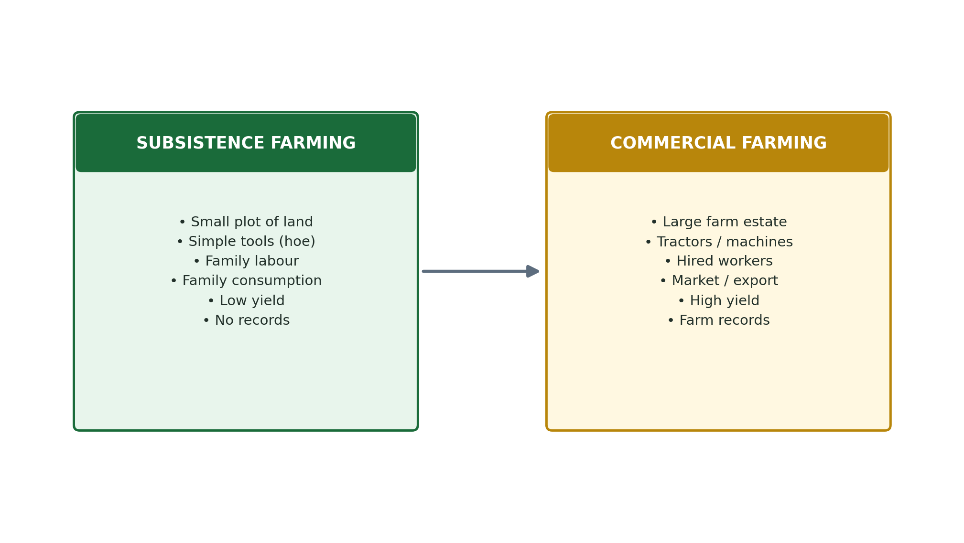

REVIEW QUESTIONS
- 1. Define subsistence agriculture and give TWO examples of subsistence crops grown in Nigeria.
- 2. What is commercial agriculture? How is it different from subsistence farming?
- 3. List THREE advantages and TWO disadvantages of commercial agriculture.
- 4. State TWO features that distinguish subsistence farming from commercial farming.
- 5. Why do you think most Nigerian farmers still practise subsistence agriculture?

WEEK 4
Role of Government in Agricultural Development

A. Introduction
The Nigerian government recognises that agriculture is the backbone of the economy. For this reason, the government has put in place many programmes, policies, and institutions to help farmers and improve food production in the country.

B. Ways the Government Supports Agriculture
1. Agricultural Finance and Credit
The government provides money (finance) and loans (credit) to farmers through:
- The Bank of Agriculture (BOA) — gives low-interest loans to farmers.
- Agricultural Credit Guarantee Scheme Fund (ACGSF) — encourages banks to lend money to farmers by guaranteeing repayment.
- Anchor Borrowers Programme (ABP) — provides loans and farm inputs to smallholder farmers.

2. Agricultural Subsidies
- The government subsidises (reduces the cost of) farm inputs such as fertilizers, improved seeds, and pesticides so that poor farmers can afford them.
- The Presidential Fertilizer Initiative (PFI) ensures cheap fertilizers are available to farmers.

3. Agricultural Education
- The government establishes colleges and universities of agriculture to train agricultural scientists, technicians, and graduates.
- Examples: Federal University of Agriculture Abeokuta (FUNAAB), Michael Okpara University of Agriculture Umudike.
- Agricultural science is taught in all secondary schools to give students farming knowledge.

4. Agricultural Extension Services
- The government employs agricultural extension officers (agents) who visit farmers in their communities to teach them better farming methods.
- The Agricultural Development Programme (ADP) in each state is responsible for this service.
- Extension workers demonstrate how to use fertilizers, control pests, and adopt modern farming techniques.

5. Agricultural Programmes and Policies
The Nigerian government has launched many programmes over the years to develop agriculture:

Programme/Policy | What It Did
Operation Feed the Nation (OFN) — 1976 | Launched by Gen. Obasanjo to encourage Nigerians to farm and produce their own food
Green Revolution — 1980 | Launched by Shagari government to boost food production using improved seeds and fertilizers
Agricultural Development Programme (ADP) — 1975 | Established in each state to provide extension services, inputs, and rural development
River Basin Development Authorities (RBDA) | Developed irrigation schemes along rivers to support dry-season farming
National Accelerated Food Production Programme (NAFPP) | Aimed at rapid increase in production of rice, maize, wheat, and cassava
Anchor Borrowers Programme (ABP) — 2015 | Provides loans and inputs to smallholder farmers growing specific crops

6. Provision of Infrastructure
- The government builds rural roads to connect farms to markets.
- Irrigation dams and canals are built to supply water to farms in dry seasons.
- Storage facilities (silos and warehouses) are built to reduce post-harvest losses.

SUMMARY: GOVERNMENT ROLES IN AGRICULTURE
- Providing agricultural finance and subsidies
- Establishing agricultural schools and universities
- Providing extension services through ADP
- Launching agricultural programmes (OFN, Green Revolution, ABP etc.)
- Building rural roads, dams, irrigation systems, and storage facilities
- Making policies that protect farmers and encourage food production

REVIEW QUESTIONS
- 1. List FOUR ways the Nigerian government supports agricultural development.
- 2. What is Operation Feed the Nation (OFN)? When was it launched and by whom?
- 3. Explain the role of Agricultural Development Programme (ADP) in Nigeria.
- 4. What is an agricultural extension worker? What does he/she do?
- 5. How does the government use subsidies to help farmers?

WEEK 6
Role of NGOs in Agricultural Development

A. What is a Non-Governmental Organisation (NGO)?
A Non-Governmental Organisation (NGO) is an organisation that operates independently of the government. It is usually non-profit (not set up to make money) and focuses on helping people and solving social or developmental problems. Many NGOs work in agriculture to help poor farmers improve their livelihoods.

KEY DEFINITION
- An NGO is a non-profit organisation that works independently of government to provide support, services, and advocacy for development.

B. Important NGOs and International Organisations in Nigerian Agriculture
Organisation | Full Name & Role in Agriculture
FAO | Food and Agriculture Organisation — UN body that fights hunger worldwide; provides technical support, seeds, and training to farmers in Nigeria
IFAD | International Fund for Agricultural Development — provides loans and grants to improve rural farming and reduce poverty
CGIAR | Consultative Group on International Agricultural Research — develops improved crop varieties (e.g. improved cassava, maize) for African farmers
IITA | International Institute of Tropical Agriculture (Ibadan) — conducts research on tropical crops and helps Nigerian farmers adopt better varieties
World Bank | Provides funding for large agricultural projects and rural development in Nigeria
USAID | United States Agency for International Development — supports agricultural projects and training in Nigeria
Heifer International | Provides livestock (cattle, goats, chickens) to poor farming families to help them become self-sufficient

C. Contributions of NGOs to Agricultural Development
- Capacity building: NGOs train farmers on modern farming techniques, post-harvest handling, and business skills.
- Provision of farm inputs: Some NGOs provide seeds, fertilizers, tools, and livestock free of charge or at reduced prices to poor farmers.
- Research and development: NGOs like IITA develop improved crop varieties that are disease-resistant and high-yielding.
- Credit and microfinance: Some NGOs provide small loans (micro-credit) to rural farmers who cannot access bank loans.
- Extension services: NGOs send field agents to farming communities to demonstrate better methods.
- Environmental advocacy: NGOs campaign for sustainable farming practices that protect the soil and environment.
- Food aid: During droughts and famines, NGOs like the World Food Programme (WFP) provide emergency food to communities.
- Women empowerment: Many NGOs train women farmers, who are responsible for much of the food production in Nigeria.

D. Importance of NGO Interventions in Agriculture
NGO interventions are very important because:
- They reach remote farming communities that government services do not reach.
- They bring in foreign money and expertise to develop Nigerian agriculture.
- They fill the gap left by insufficient government funding and extension services.
- They help link Nigerian farmers to international markets.
- They protect the rights and welfare of smallholder farmers.

REMEMBER
- FAO — Food and Agriculture Organisation (United Nations)
- IFAD — International Fund for Agricultural Development
- IITA — International Institute of Tropical Agriculture (based in Ibadan, Nigeria)
- CGIAR — Consultative Group on International Agricultural Research
- WFP — World Food Programme

REVIEW QUESTIONS
- 1. What is an NGO? Give the full meaning of the abbreviation.
- 2. Name THREE international organisations that contribute to agricultural development in Nigeria.
- 3. Explain FOUR ways in which NGOs help farmers in Nigeria.
- 4. What is IITA? Where is it located and what does it do?
- 5. Why are NGO interventions important in countries like Nigeria?

WEEK 8
Agricultural Laws and Reforms

A. The Land Tenure System in Nigeria
Land tenure refers to the system by which people hold, own, or use land. In Nigeria, land tenure has been one of the biggest challenges to agricultural development. Before the Land Use Decree of 1978, land was owned in different ways:
- Communal ownership: Land belonged to the whole community and was managed by village heads or chiefs.
- Family ownership: Land was owned by families and passed from parents to children (inheritance).
- Individual ownership: In some areas, individuals could own land privately.
- Government ownership: Government owned land used for public purposes.

Problems of the old land tenure system:
- Land was fragmented into small scattered pieces that were hard to farm efficiently.
- Communal land could not be used as collateral (security) for bank loans.
- Land disputes were common and often led to conflict among families.
- Large tracts of land were idle (unused) because no single person could develop them.

B. The Land Use Decree (Act) of 1978
The Land Use Decree was enacted (made into law) in 1978 under the military government of General Olusegun Obasanjo. It was later renamed the Land Use Act in the 1979 Constitution.

KEY PROVISION OF THE LAND USE ACT
- All land in Nigeria is vested in (belongs to) the Governor of each State, who holds it in trust for the Nigerian people.
- Individuals can only be given a Right of Occupancy (certificate of use) — they do not fully own the land.
- Urban land is controlled by the State Government; rural land is controlled by Local Government Authorities.
- Farmers must apply to the government for a Certificate of Occupancy (C of O) to use land legally.

C. Advantages of the Land Use Act
- It brought all land under government control, reducing land disputes and conflicts.
- It made it easier for government to acquire land for public agricultural projects.
- It gave the government power to protect land from being left idle (unused).
- It attempted to make land more equally available to all citizens.

D. Disadvantages of the Land Use Act
- It removed individual ownership of land, which discourages long-term investment in farm land.
- Farmers cannot use their Certificate of Occupancy easily as collateral for bank loans.
- The bureaucracy involved in getting a Certificate of Occupancy is long, expensive, and corrupt.
- It has not effectively stopped land speculation and abuse by powerful individuals.
- Rural farmers are often not aware of their rights under the Act.

E. Government Reforms to Support Agriculture
Apart from the Land Use Act, the government has made other reforms:
- Agricultural Credit Guarantee Scheme (ACGS): Encourages banks to give loans to farmers.
- Commodity Boards: Set up to buy agricultural products from farmers at fixed prices.
- River Basin Development Authorities: Manage water resources for irrigation.
- National Agricultural Land Development Authority (NALDA): Re-established to develop agricultural land and support smallholder farmers.

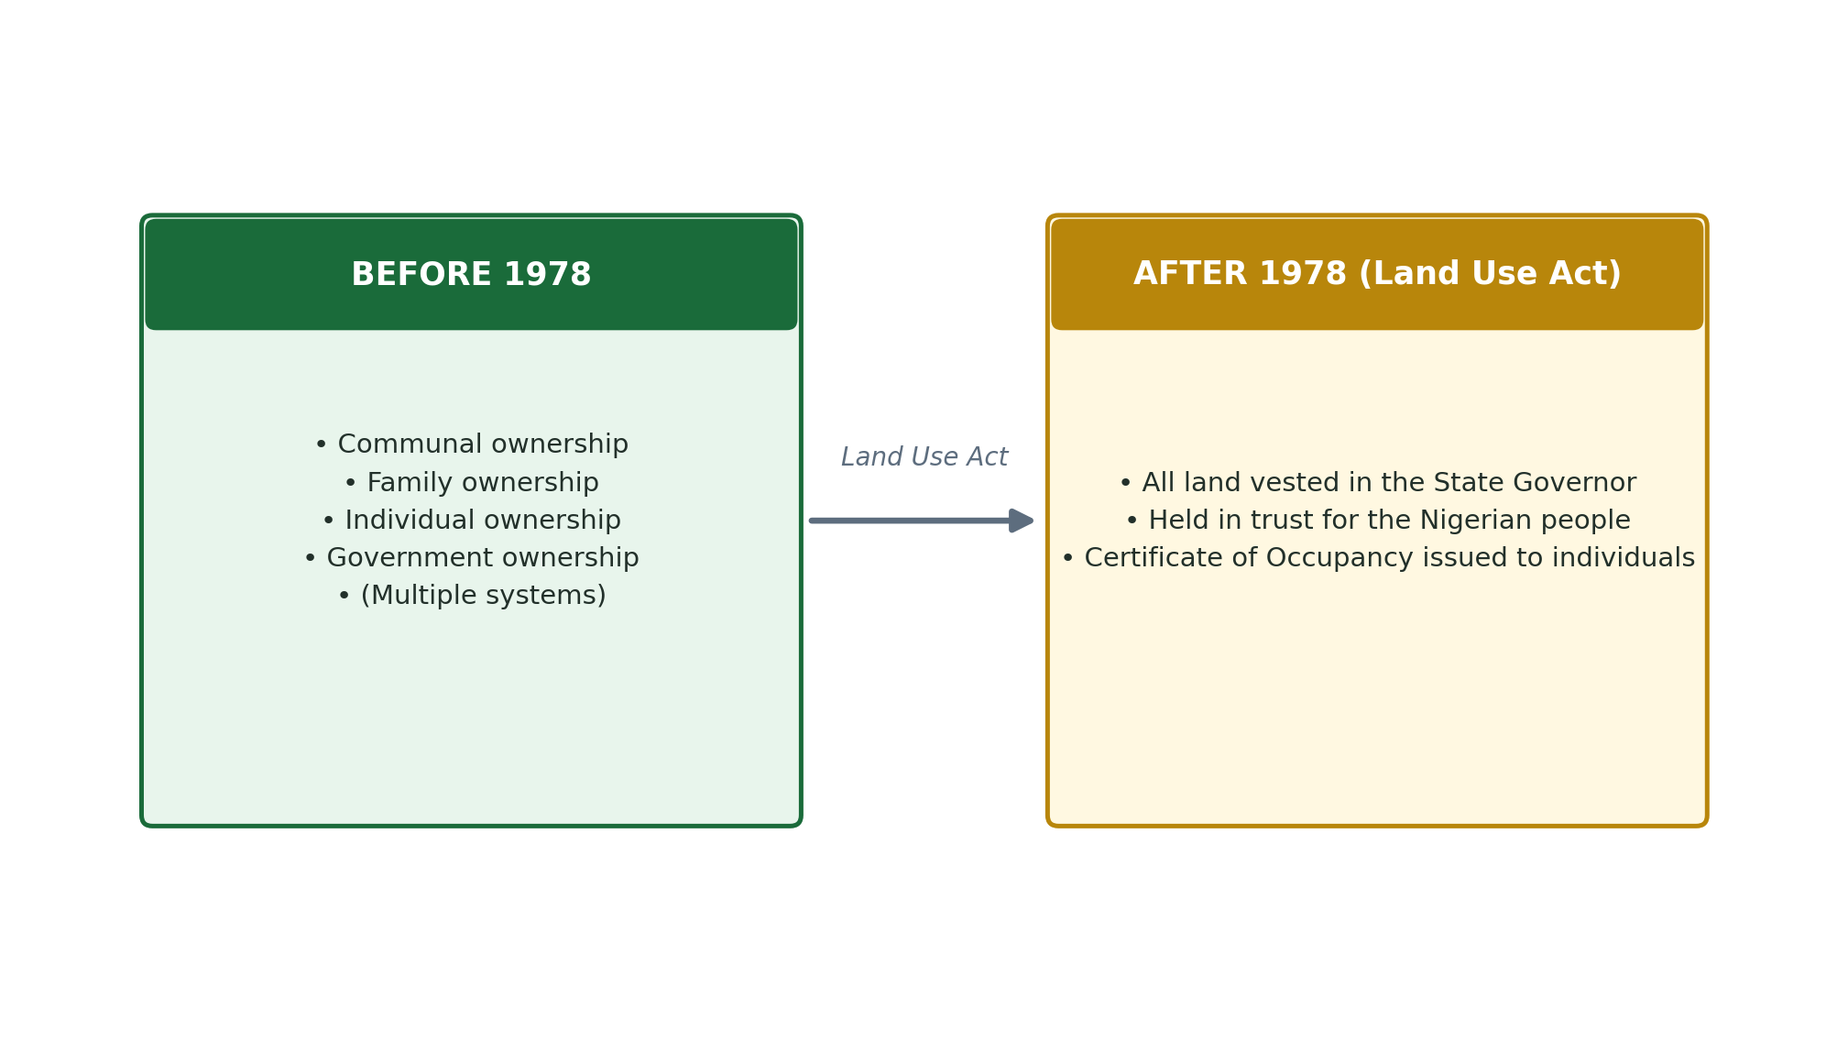

REVIEW QUESTIONS
- 1. What is land tenure? Name FOUR types of land tenure that existed in Nigeria before 1978.
- 2. When was the Land Use Decree enacted and under whose government?
- 3. State TWO advantages and TWO disadvantages of the Land Use Act of 1978.
- 4. What is a Certificate of Occupancy and why is it important to a farmer?
- 5. Explain how the land tenure system affects agricultural production in Nigeria.

WEEK 9
Land and Its Uses

A. Meaning of Land
In agriculture and economics, land is defined as all natural resources found on the surface, below the surface, and above the surface of the earth. Land includes the soil, forests, water bodies, minerals, and everything that nature has provided. Land is one of the four factors of production (land, labour, capital, and entrepreneurship).

KEY DEFINITION
- Land = All natural gifts of nature used in the production of goods and services, including the soil, vegetation, minerals, and water bodies.

B. Characteristics of Land
- Land is a free gift of nature — it was not made by man.
- Land is immobile — it cannot be moved from one place to another.
- Land is limited in supply — there is only a fixed amount of land on earth.
- Land is permanent — it does not wear out or depreciate like machines.
- Land has no cost of production — it exists naturally.
- Land differs in quality — some land is very fertile while some is poor.

C. Agricultural Uses of Land
Land can be used for many different agricultural purposes:
- Crop production: Land is used to grow food crops (yam, rice, maize, vegetables) and cash crops (cocoa, groundnut, palm oil, cotton).
- Livestock production: Grassland and pastures are used for grazing cattle, sheep, goats, and horses.
- Fishery: Water bodies (rivers, ponds, lakes) are used for fish farming and fishing.
- Forestry: Forest land is used for timber production, firewood, and conservation.
- Wildlife conservation: Game reserves and national parks protect wild animals and biodiversity.
- Horticulture: Land is used for growing fruits, vegetables, flowers, and ornamental plants.

D. Non-Agricultural Uses of Land
Land is also used for purposes outside agriculture:
- Housing and settlement: Land is used to build homes, schools, hospitals, and offices.
- Industry: Factories and manufacturing companies are built on land.
- Transportation: Roads, railways, airports, and ports occupy large areas of land.
- Mining: Land is excavated (dug up) for minerals such as coal, iron ore, limestone, and crude oil.
- Recreation: Parks, stadiums, golf courses, and resort centres use land.

Agricultural Uses of Land | Non-Agricultural Uses of Land
Crop farming (food and cash crops) | Housing and residential buildings
Animal grazing and livestock farming | Industrial factories and warehouses
Fish ponds and aquaculture | Road, rail, and airport construction
Forest reserves and timber production | Mining of minerals and crude oil
Wildlife conservation (game reserves) | Recreation parks and stadiums
Fruit orchards and vegetable gardens | Schools, hospitals, and markets

E. Importance of Land in Agriculture
- Land is the primary resource for agriculture — without land, no farming is possible.
- The quality of land (soil fertility) determines the type and quantity of crops that can be grown.
- Land provides the physical space for building farm structures like barns, silos, and farmhouses.
- Natural water on land (rivers, streams) provides water for irrigation of crops.
- Land provides grazing pasture for animals, which is essential for livestock production.

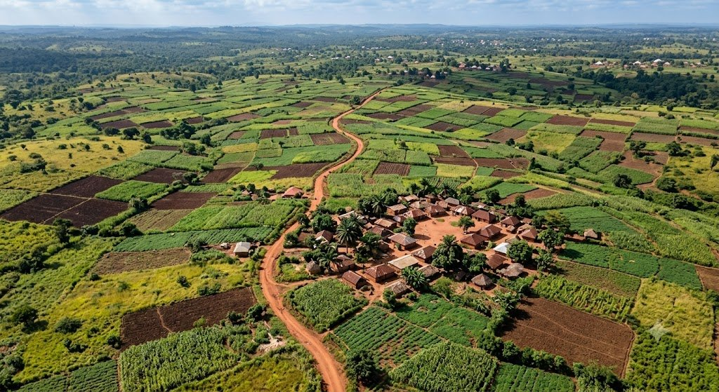
Aerial view of patchwork farmland — land is one of the most important agricultural resources.

REVIEW QUESTIONS
- 1. Define land as used in agricultural economics.
- 2. List FOUR characteristics of land that make it different from other factors of production.
- 3. Give FOUR agricultural uses of land.
- 4. Give THREE non-agricultural uses of land.
- 5. Why is land considered the most important factor of production in agriculture?

WEEK 10
Agricultural Ecology

A. What is Ecology?
Ecology is the scientific study of the relationships between living organisms (plants and animals) and their environment. The environment includes all the non-living (abiotic) factors such as soil, water, temperature, light, and air, as well as all the living (biotic) organisms around them.

B. What is Agricultural Ecology?
Agricultural ecology (also called Agroecology) is the study of how crops, livestock, and other farm organisms interact with each other and with the environment in which they are produced. It helps farmers understand how to use natural resources wisely to produce food without harming the environment.

KEY DEFINITION
- Agricultural Ecology = The study of ecological relationships within agricultural systems, including the interactions between crops, animals, soil, water, climate, and human activities.

C. What is an Ecosystem?
An ecosystem is a community of living organisms (plants, animals, microorganisms) together with the non-living environment (soil, water, air, sunlight) in which they all interact and depend on each other. In agriculture, the farm itself is an ecosystem.

D. Components of the Farm Ecosystem
The farm ecosystem has TWO main components:

1. Biotic Components (Living things)
- Producers (Autotrophs): Green plants and crops that manufacture their own food through photosynthesis. Examples: maize, cassava, grasses.
- Consumers (Heterotrophs): Animals that feed on plants or other animals. Examples: cattle (eat grass), insects (eat leaves), humans (eat crops and animals).
- Decomposers: Microorganisms (bacteria and fungi) that break down dead plants and animals into simple nutrients that enrich the soil. Examples: earthworms, bacteria, fungi.

2. Abiotic Components (Non-living things)
- Sunlight: Provides energy for photosynthesis in plants.
- Water: Essential for plant growth, animal life, and soil processes.
- Temperature: Affects how fast crops grow and how animals develop.
- Soil: The medium in which crops grow; provides nutrients, water, and support.
- Air (Carbon dioxide and Oxygen): Plants use CO2 for photosynthesis; all organisms need oxygen.
- Minerals/Nutrients: Elements like nitrogen, phosphorus, and potassium that plants absorb from the soil.

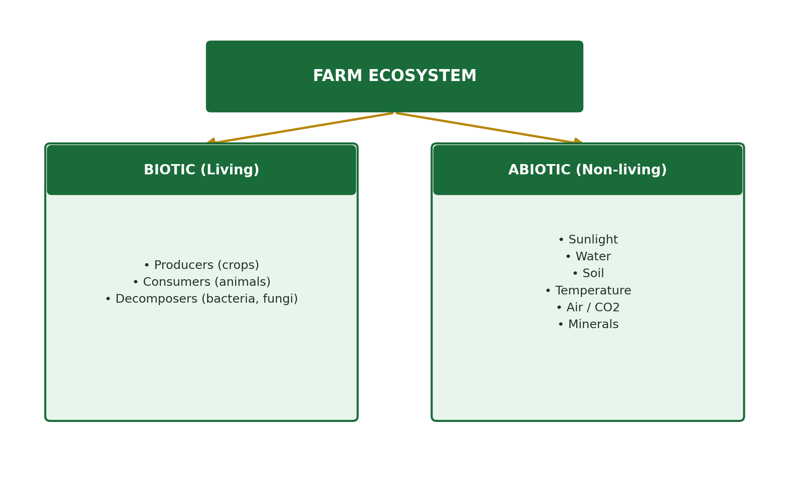

E. Interactions in the Farm Ecosystem
In the farm ecosystem, organisms interact in several important ways:
- Crop-animal interaction: Animals feed on crops; their dung fertilises the soil for better crop growth. This is called Mixed Farming.
- Predator-prey: Some insects (pests) eat crops, while other insects (predators like ladybirds) eat the pests.
- Symbiosis: Legumes (beans, cowpea) have bacteria on their roots that fix nitrogen from the air into the soil — benefiting both the plant and the soil.
- Competition: Plants compete with weeds for sunlight, water, and nutrients.
- Decomposition: When plant residues are ploughed into the soil, bacteria break them down into humus that improves soil fertility.

F. Types of Farming Systems as Ecosystems
Farming System | Description
Sole/Mono-cropping | One type of crop is grown alone on the farm at a time
Mixed cropping | Two or more crops are grown together on the same land at the same time
Mixed farming | Crops and animals are raised together on the same farm
Fish ponds (Aquaculture) | Fish are raised in controlled water environments
Agroforestry | Trees are grown together with crops or livestock on the same land

REVIEW QUESTIONS
- 1. Define agricultural ecology in your own words.
- 2. What is an ecosystem? Give ONE example from a farm.
- 3. Distinguish between biotic and abiotic components of a farm ecosystem. Give THREE examples of each.
- 4. Explain the term 'decomposers' and state their importance to the farm ecosystem.
- 5. Describe TWO types of interactions that occur in a farm ecosystem.

WEEK 11
Factors Affecting Land Availability for Agricultural Purposes

A. Introduction
Not all available land can be used for agriculture. Several factors determine whether a piece of land can be farmed or not, and whether enough land is available for farmers to use. Understanding these factors is important for planning agricultural production in Nigeria.

B. Factors Affecting Land Availability for Agriculture
1. Land Tenure System
The way land is owned and controlled greatly affects its availability for farming.
- Communal land ownership restricts individuals from acquiring large areas for commercial farming.
- Land fragmentation (small scattered plots) makes it impossible to use farm machines efficiently.
- The Land Use Act of 1978 placed all land under government control, making access difficult for some farmers.
- Land inheritance disputes often lead to land lying idle (unused) for years.

2. Population Pressure
- As the population grows, more land is needed for housing, schools, hospitals, and roads — reducing land available for farming.
- Urban sprawl (cities expanding outward) takes over formerly agricultural land.
- In densely populated areas like Enugu, Lagos, and Kano, farmland is becoming very scarce.

3. Soil Type and Topography (Landscape)
- Not all soils are suitable for farming. Sandy, rocky, or waterlogged soils cannot easily support crop production.
- Steep slopes (hills and mountains) are prone to soil erosion and are difficult to farm.
- Flat, fertile plains are more suitable for large-scale mechanised farming.
- Areas with very poor soils need expensive treatment (lime, fertilizer) before they can be farmed.

4. Climate and Vegetation
- Very dry areas (deserts and semi-arid zones) have limited water for crops, reducing the land available for rain-fed agriculture.
- Tropical rainforest areas may have very dense vegetation that is expensive to clear for farming.
- Flood-prone lowlands may be unusable for farming during rainy seasons.

5. Environmental Degradation
- Soil erosion: Heavy rains wash away topsoil, making land infertile and unusable.
- Desertification: The Sahara Desert is advancing southward, turning formerly productive farmland in northern Nigeria into desert.
- Oil pollution: In the Niger Delta, crude oil spills have permanently damaged thousands of hectares of farmland.
- Deforestation: Cutting down trees leads to soil degradation and reduces land for agroforestry.

6. Government Policies and Competing Land Uses
- Government may acquire land for game reserves, military zones, mining, or infrastructure — reducing farmland.
- Land zoned for industrial or residential use cannot be farmed.
- Poor government policies may not adequately protect farmland from being converted to other uses.

Factor | How It Reduces Agricultural Land
Land tenure system | Communal ownership, fragmentation, and disputes leave land idle
Population pressure | Urban expansion and housing development take over farmland
Soil type & topography | Rocky, sandy, or steep land cannot be cultivated
Climate | Drought and flooding make large areas unsuitable for farming
Environmental degradation | Erosion, desertification, and oil spills destroy productive land
Government policies | Land zoned for industry or reserves cannot be farmed

C. How to Improve Land Availability for Agriculture
- Reform land tenure laws to give farmers easier and secure access to land.
- Reclaim degraded land through afforestation (tree planting), erosion control, and soil conservation.
- Implement irrigation to make dry and semi-arid lands productive.
- Enforce environmental protection laws to prevent pollution and land degradation.
- Adopt land-use planning that protects agricultural land from urban encroachment.

REVIEW QUESTIONS
- 1. List SIX factors that affect the availability of land for agricultural purposes.
- 2. Explain how population pressure affects the availability of farmland in Nigeria.
- 3. How does soil type and topography limit agricultural land use? Give TWO examples.
- 4. What is desertification? How is it affecting farmland in northern Nigeria?
- 5. Suggest THREE ways the government can improve land availability for agriculture.

END OF FIRST TERM LESSON NOTES

Prepare well for your First Term Examination.

Best of luck! — Kenneth Chiakwa

SS1 AGRICULTURAL SCIENCE
SECOND TERM
LESSON NOTES eBOOK

SS1 AGRICULTURAL SCIENCE

SECOND TERM LESSON NOTES

Compiled by:

Kenneth Chiakwa

B.Sc. Agricultural Economics | M.Sc. Agricultural Economics

Enugu State University of Science and Technology (ESUT)

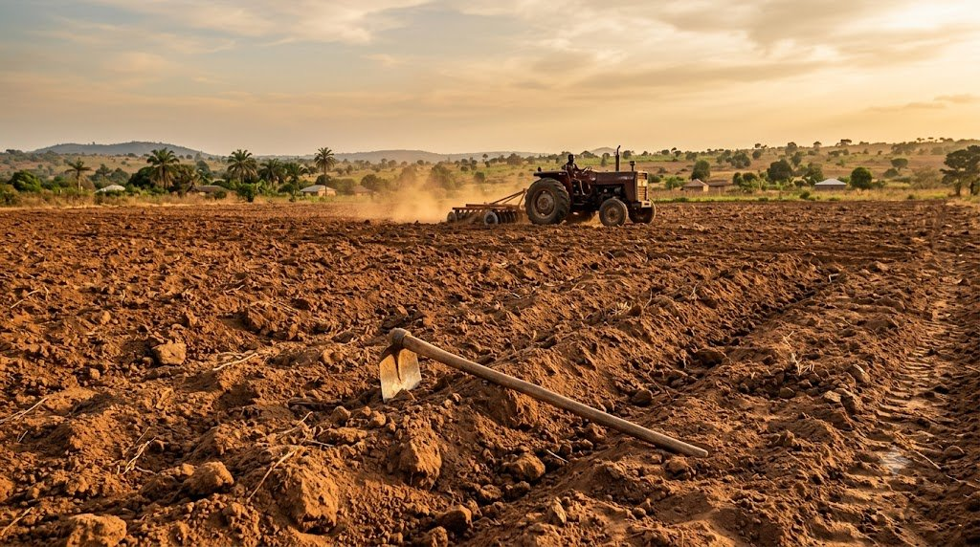
TOPICS COVERED IN THIS BOOK

Week 1: Agro-Allied Industries
Week 2: Environmental Factors Affecting Agriculture
Week 3: Rock Formation
Week 4: Soil Formation and Profile Development
Week 5: Mid-Term Examination
Week 6: Soil Types, Composition and Properties
Week 7: Mid-Term Break
Week 8: Simple Farm Tools
Week 9: Farm Machinery and Implements
Week 10: Maintenance of Farm Machinery
Week 11: Problems of Agricultural Mechanization
Week 12: Examination

MESSAGE TO THE STUDENT

Dear Student,

Welcome to your SS1 Agricultural Science Second Term Lesson Notes. This book covers important topics from agro-allied industries and environmental factors all the way to farm tools, machinery, and mechanization.

To get the best results from this book:
- Study each week's lesson before class — this prepares your mind.
- Pay attention to the KEY DEFINITIONS and learn them by heart.
- Study the DIAGRAMS and TABLES carefully — they summarise important information visually.
- Answer every REVIEW QUESTION in your exercise book after each week.
- Relate what you read to real farm experiences around you.
- Ask your teacher to clarify anything you do not understand.

Remember: Knowledge of agriculture is knowledge of life. What you learn here will help you, your family, and your community for years to come.

Study hard and succeed!

Kenneth Chiakwa
B.Sc., M.Sc. Agricultural Economics, ESUT

WEEK 1
Agro-Allied Industries

A. Meaning of Agro-Allied Industries
Agro-allied industries are industries that depend directly on agricultural products as their main raw materials. They process raw farm produce into finished goods that people can use. Without agriculture, these industries cannot operate. They are the link between the farm and the consumer.

KEY DEFINITION
- Agro-Allied Industries are industries that use agricultural products as raw materials to produce goods for human use.

B. Examples of Agro-Allied Industries
Industry | Agricultural Raw Material / Product
Textile/Cotton Industry | Cotton from cotton plants is processed into fabric, clothing and thread
Breweries | Sorghum, barley, and maize are used to brew beer, malt drinks, and soft drinks
Oil Mills / Palm Oil Industry | Palm fruits are processed into palm oil, palm kernel oil, and soap
Flour Mills | Wheat and maize are milled into flour for bread, noodles, and biscuits
Sugar Industry | Sugarcane is processed into refined sugar, molasses, and ethanol
Rubber Industry | Latex from rubber trees is processed into tyres, gloves, and footwear
Leather Industry | Animal hides and skins are tanned and made into bags, shoes, and belts
Fish Processing Plants | Fish is smoked, canned, or dried for preservation and sale
Cocoa/Chocolate Industry | Cocoa beans are processed into cocoa powder, chocolate, and beverages
Groundnut Oil Industry | Groundnuts are crushed to produce cooking oil and groundnut cake (animal feed)

C. Relationship Between Agro-Allied Industries and Agriculture
- Agriculture provides the raw materials (cocoa, cotton, groundnut, palm fruit, cassava) that agro-allied industries need to produce goods.
- Agro-allied industries create markets for farmers — when industries buy raw materials, farmers earn more income.
- Industries provide employment for people who work in processing plants, transportation, and marketing.
- Industries produce goods like fertilizers, pesticides, and farm machinery that help improve agricultural production.
- Agro-allied industries add value to farm produce — for example, cassava worth N500 as raw tubers may become N5,000 worth of starch or garri after processing.
- Foreign exchange is earned when processed agricultural products (cocoa, rubber, cotton) are exported.

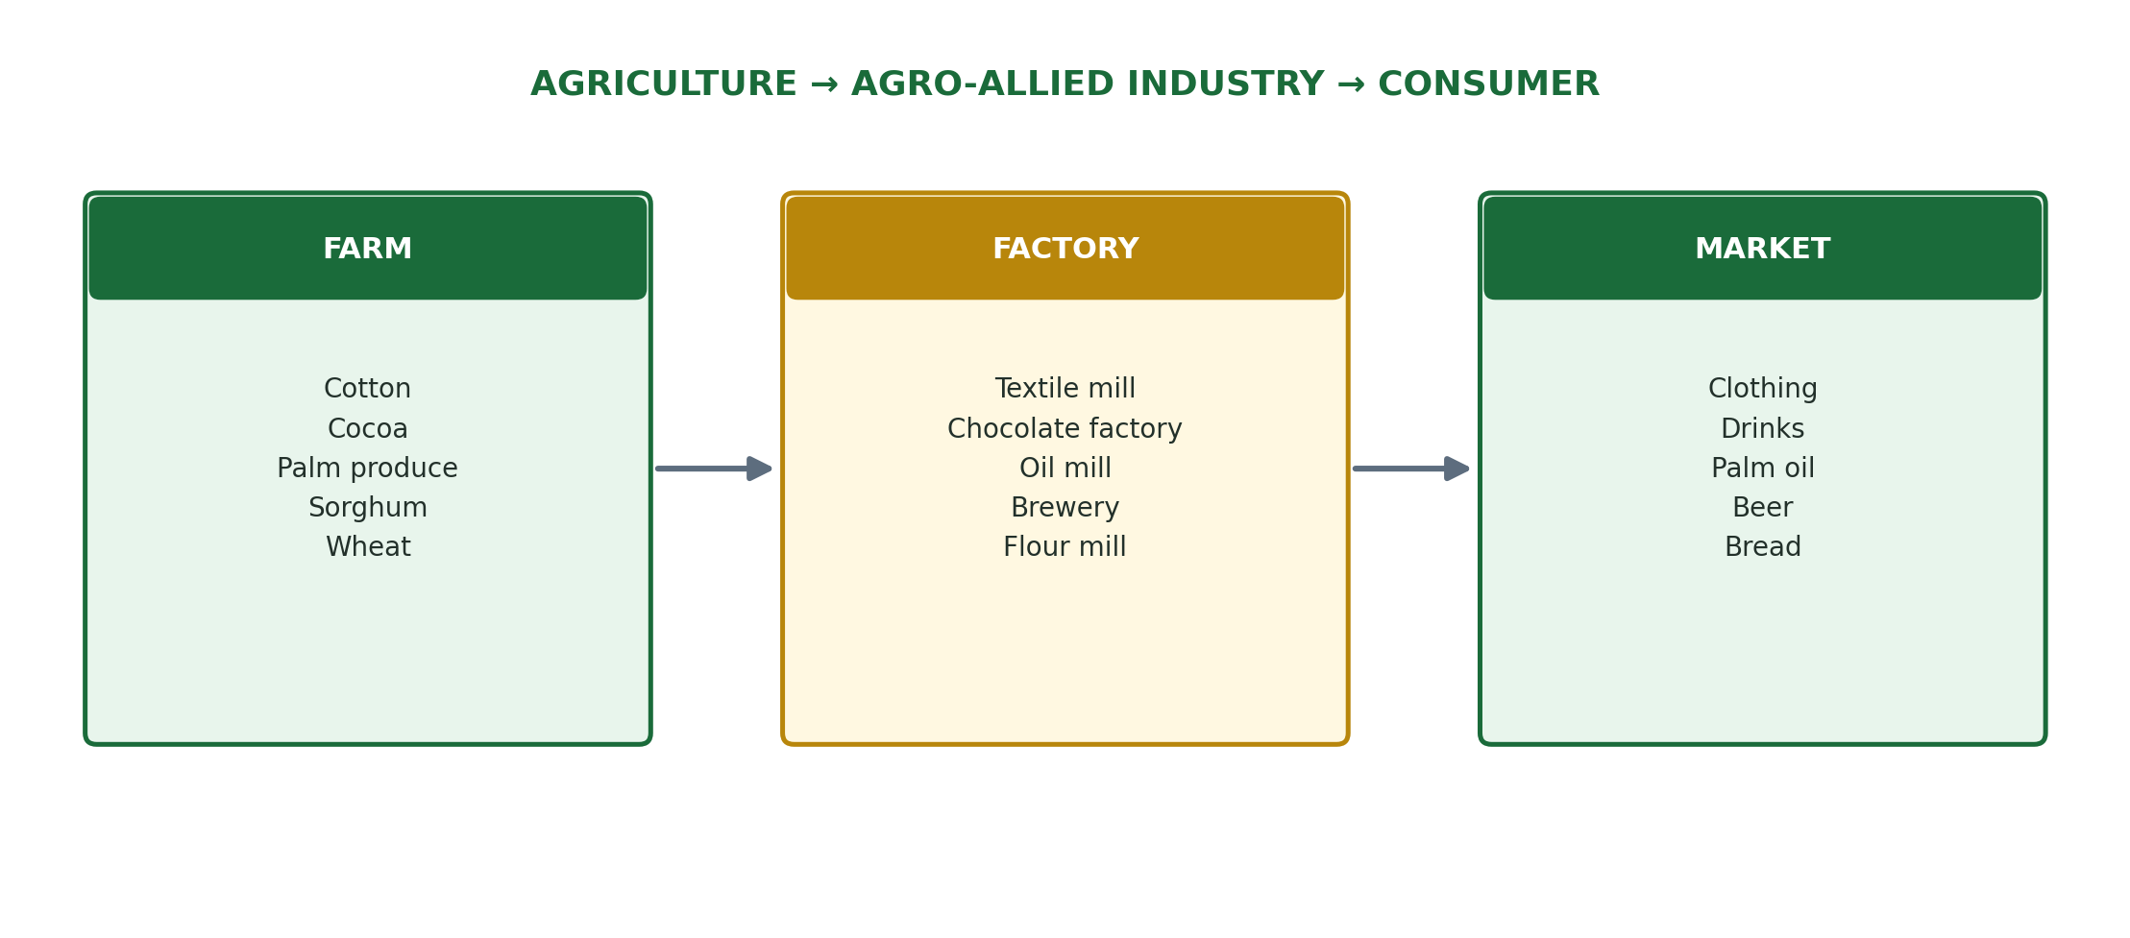

D. Importance of Agro-Allied Industries to Nigeria
- They create employment for millions of Nigerians in factories, transport, and marketing.
- They generate revenue for the government through taxes and levies.
- They earn foreign exchange through export of processed agricultural goods.
- They reduce post-harvest losses by processing and preserving farm produce.
- They stimulate rural development — industries attract roads, electricity, and schools to farming communities.
- They improve farmers' income by creating a ready market for farm produce.

REVIEW QUESTIONS
- 1. What is an agro-allied industry? Give TWO examples.
- 2. List FIVE agro-allied industries in Nigeria and state the agricultural raw material each one uses.
- 3. Explain the relationship between agriculture and agro-allied industries.
- 4. How do agro-allied industries help farmers earn more income?
- 5. State FOUR ways agro-allied industries are important to Nigeria's economy.

WEEK 2
Environmental Factors Affecting Agriculture

A. Introduction
The environment includes everything that surrounds a living organism — the air, water, soil, temperature, and other living things. Many environmental factors directly affect how well crops grow and animals develop. A good farmer must understand these factors in order to make the right decisions about what to plant, when to plant, and how to manage the farm.

Environmental factors can be grouped into TWO main categories:
- Abiotic (Non-living) factors — Rainfall, Temperature, Wind, Sunlight, Soil, Humidity, Topography
- Biotic (Living) factors — Pests, Diseases, Weeds, Microorganisms, Pollinators

B. Rainfall
Rainfall is the amount of water that falls from the sky as rain. It is one of the most important factors in agriculture because:
- Water is essential for germination of seeds, growth of crops, and nutrient absorption.
- Areas with adequate and well-distributed rainfall (1000–2000 mm per year) support the growth of food and cash crops.
- Too little rainfall causes drought, wilting, and crop failure.
- Too much rainfall causes flooding, soil erosion, leaching of nutrients, and waterlogging.
- Seasonal distribution of rainfall determines the planting calendar — when farmers plant and harvest.

NOTE ON RAINFALL IN NIGERIA
- Southern Nigeria receives 1500–4000 mm of rain per year — suitable for crops like yam, cassava, palm oil, rubber, and cocoa.
- Northern Nigeria receives 500–1000 mm of rain per year — suitable for groundnut, sorghum, millet, and cotton.
- Areas near Lake Chad receive as little as 250 mm — mostly desert conditions.

C. Temperature
Temperature is the measure of how hot or cold the environment is. It affects all biological activities in plants and animals.
- Most crops in Nigeria grow best at temperatures between 20°C and 35°C.
- High temperatures speed up water loss from leaves (transpiration), causing wilting.
- Low temperatures can kill tropical crops but are needed for some temperate crops like Irish potatoes, wheat, and strawberries.
- Temperature determines the altitude at which crops can grow — highland areas of Jos Plateau are cooler and support vegetables and temperate fruits.
- In animals, extreme heat reduces feed intake, milk production, and fertility.

D. Wind
Wind is the movement of air from one place to another. Its effects on agriculture include:
- Pollination: Wind carries pollen from one flower to another, enabling fertilisation of crops like maize, sorghum, and millet.
- Water loss: Strong winds increase the rate of evaporation from soil and transpiration from leaves, causing drought stress.
- Soil erosion: Strong winds blow away the topsoil, especially in dry areas of Northern Nigeria (this is called wind erosion or deflation).
- Crop damage: Strong winds (storms and gales) break branches, uproot trees, and lodge (flatten) crops like maize and sugarcane.
- Seed dispersal: Wind carries seeds of some plants (e.g. dandelion) to new areas where they become weeds.
- Windbreaks: Rows of trees planted to protect crops from wind are called windbreaks or shelterbelts.

E. Soil
Soil is the upper layer of the earth in which plants grow. It is one of the most critical environmental factors in agriculture.
- Soil provides physical support (anchorage) for plant roots.
- Soil contains nutrients (nitrogen, phosphorus, potassium) that plants absorb for growth.
- Soil stores water for plant use between rainfalls.
- Soil type determines what crops can be grown — loamy soil is best for most crops; clay soil holds water but can become waterlogged; sandy soil drains quickly but loses nutrients fast.
- Soil pH (acidity or alkalinity) affects nutrient availability — most crops prefer a slightly acidic to neutral pH of 6.0–7.0.

F. Biotic Factors
Biotic factors are living organisms that affect agricultural production:
- Pests: Insects, rodents, and birds that damage or eat crops and livestock (e.g. stem borers, locusts, rats, weaver birds).
- Diseases: Caused by bacteria, fungi, viruses, and parasites that attack crops and animals (e.g. cassava mosaic virus, maize streak virus, Newcastle disease in poultry).
- Weeds: Unwanted plants that compete with crops for water, light, and nutrients (e.g. spear grass, water hyacinth, striga).
- Beneficial organisms: Bees pollinate flowers; earthworms improve soil structure; nitrogen-fixing bacteria in legume roots enrich the soil.
- Predators: Some insects (e.g. ladybirds) eat crop pests and help control them naturally.

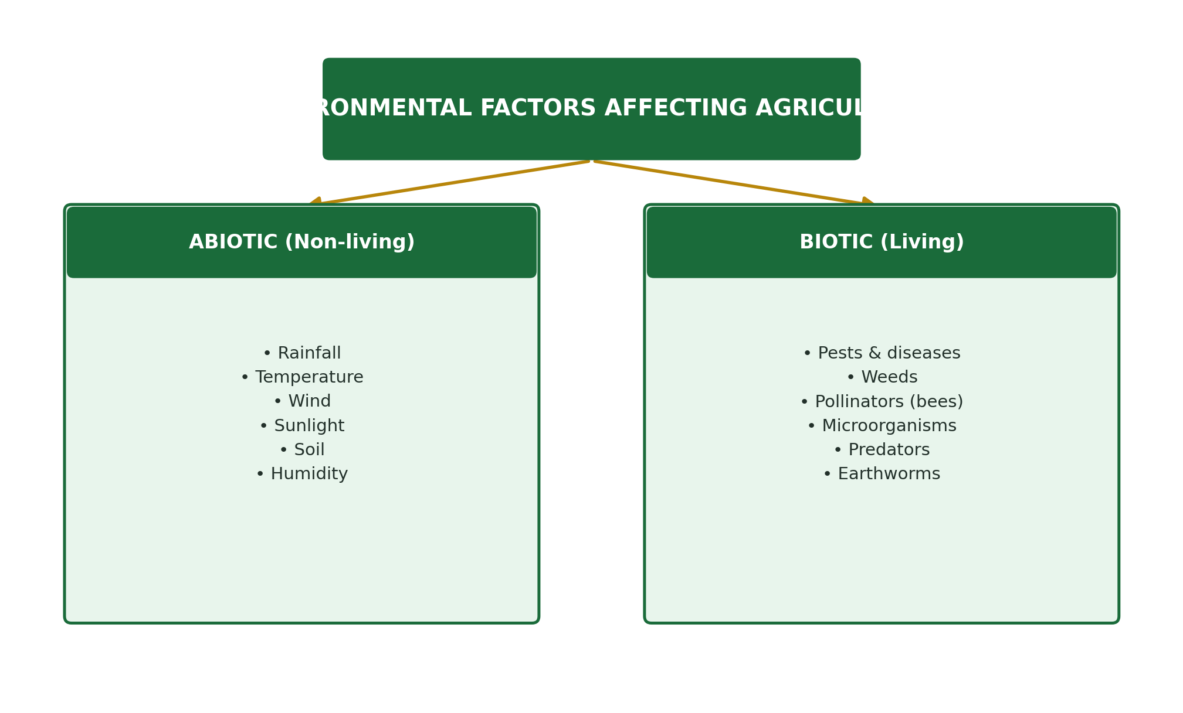

Environmental Factor | Effect on Agriculture
Rainfall | Determines crop type, planting season, and water availability
Temperature | Affects germination, growth rate, and animal productivity
Wind | Aids pollination but causes erosion and crop damage
Soil | Provides nutrients, water, and support for crops
Sunlight | Powers photosynthesis — essential for all plant growth
Pests & diseases | Reduce yield and kill crops and animals
Weeds | Compete with crops for resources, reducing productivity

REVIEW QUESTIONS
- 1. Name FOUR abiotic and THREE biotic environmental factors that affect agriculture.
- 2. How does rainfall affect agricultural production in Nigeria? Give THREE specific effects.
- 3. Explain the importance of temperature to crop production.
- 4. State FOUR ways in which wind affects farming.
- 5. How do weeds affect crop production? Name TWO common weeds found on Nigerian farms.

WEEK 3
Rock Formation

A. What are Rocks?
Rocks are the solid, hard materials that make up the earth's crust (the outer layer of the earth). Rocks are made up of one or more minerals. Over millions of years, rocks are broken down into smaller and smaller pieces by weather, water, and temperature changes — a process called weathering. This broken-down rock material eventually becomes the mineral part of soil. This is why understanding rocks is important in agriculture.

KEY CONNECTION
- Rocks → Weathering → Rock particles → Mixed with humus → SOIL
- The type of rock in an area largely determines the type of soil and its fertility.

B. Types of Rocks
There are THREE main types of rocks:

1. Igneous Rocks
Igneous rocks are formed when hot molten rock (called magma or lava) from deep inside the earth cools and solidifies. The word 'igneous' comes from the Latin word for fire.
- Examples: Granite, Basalt, Obsidian, Pumice
- Features: Usually hard and crystalline; formed from cooled magma
- Agricultural importance: Granite weathers to form coarse, sandy soils. Basalt weathers to form fertile, fine-grained soils rich in minerals like iron and magnesium.

2. Sedimentary Rocks
Sedimentary rocks are formed when particles of sand, clay, silt, and the remains of plants and animals (called sediments) are deposited in layers and compressed (pressed) over millions of years.
- Examples: Sandstone, Limestone, Shale, Coal, Chalk
- Features: Usually found in layers (strata); may contain fossils of ancient organisms
- Agricultural importance: Limestone is used to make lime, which farmers apply to acidic soils to improve fertility. Shale weathers to form clay soils. Sandstone weathers into sandy soils.

3. Metamorphic Rocks
Metamorphic rocks are formed when existing rocks (igneous or sedimentary) are changed by extreme heat and pressure deep inside the earth. The word 'metamorphic' means 'changed in form.'
- Examples: Marble (from limestone), Slate (from shale), Quartzite (from sandstone), Schist
- Features: Usually very hard; may have a banded or foliated (layered) appearance
- Agricultural importance: Marble and quartzite weather slowly and produce coarse, mineral-poor soils. Schist weathers to form fine-grained soils with some nutrients.

Rock Type | Examples | Agricultural Importance
Igneous | Granite, Basalt, Obsidian | Basalt gives fertile mineral-rich soil; Granite gives coarse sandy soil
Sedimentary | Limestone, Sandstone, Shale, Coal | Limestone used to correct soil acidity; Shale gives clay soil
Metamorphic | Marble, Slate, Quartzite, Schist | Weather slowly; form coarse or fine mineral soils depending on type

C. Weathering of Rocks
Weathering is the process by which rocks are broken down into smaller particles by natural forces. There are THREE types:

1. Physical (Mechanical) Weathering
- Rocks expand and contract due to heating (day) and cooling (night), causing cracks.
- Water enters cracks, freezes, expands, and breaks rocks apart.
- Wind, water, and glaciers physically grind rocks into smaller pieces.

2. Chemical Weathering
- Rainwater combines with carbon dioxide to form weak carbonic acid that dissolves rocks.
- This is especially effective on limestone rocks.
- Chemical weathering releases mineral nutrients from rocks into the soil.

3. Biological Weathering
- Plant roots grow into rock cracks and widen them.
- Earthworms and burrowing animals break rocks apart.
- Acids produced by decaying plant material chemically attack rocks.

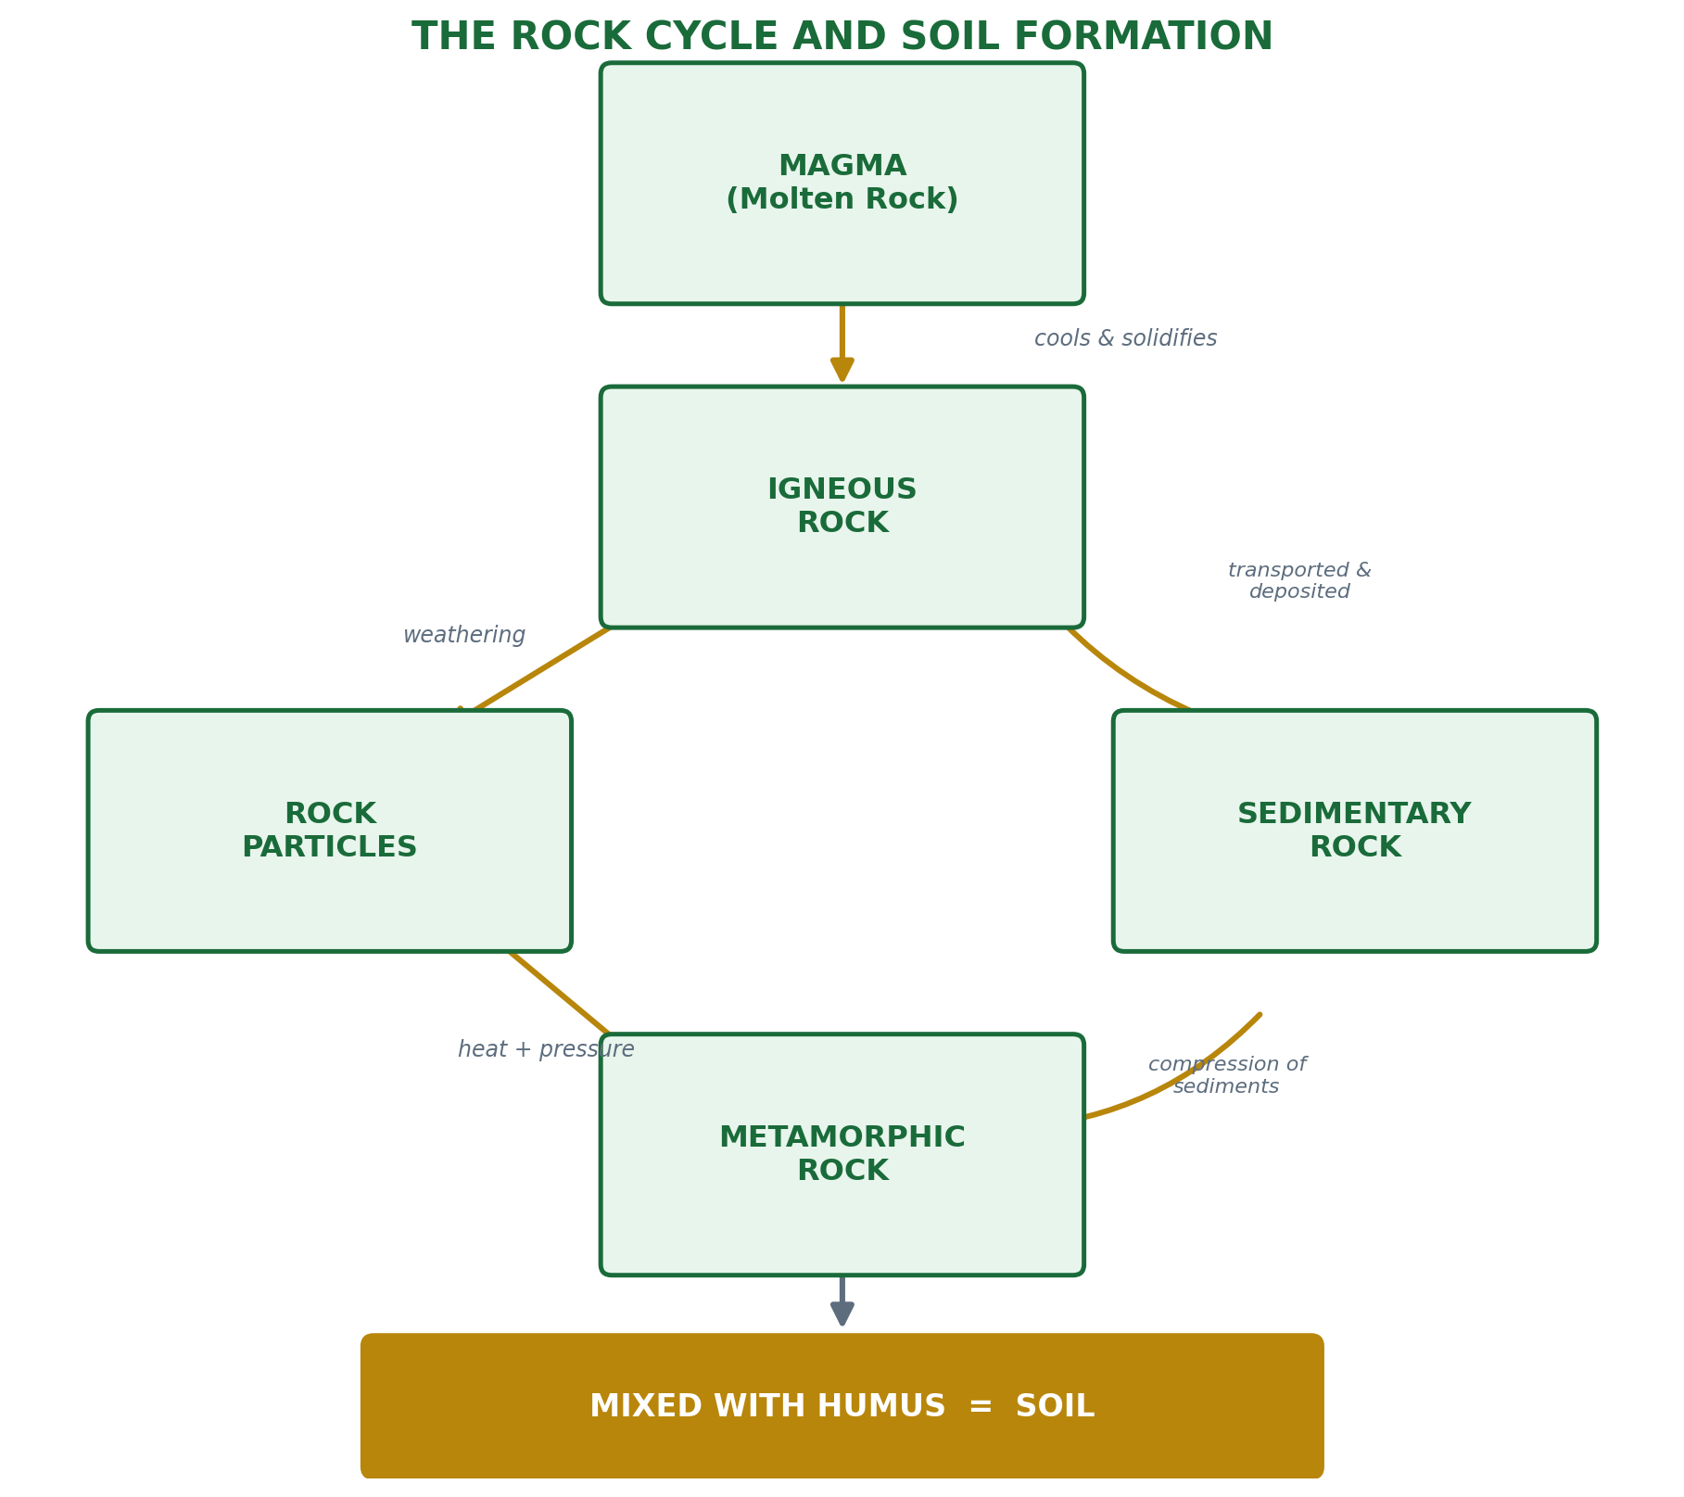

REVIEW QUESTIONS
- 1. What is a rock? How are rocks related to soil formation?
- 2. Name and describe the THREE types of rocks. Give TWO examples of each.
- 3. What are metamorphic rocks? How are they formed?
- 4. Explain THREE types of weathering and give ONE example of each.
- 5. Why is limestone important to farmers? How is it used on the farm?

WEEK 4
Soil Formation and Profile Development

A. What is Soil?
Soil is the thin upper layer of the earth's surface in which plants grow. It is a mixture of mineral particles (from weathered rocks), organic matter (humus from decayed plants and animals), water, air, and living organisms (bacteria, earthworms, fungi). Soil is the most important natural resource for agriculture.

COMPONENTS OF SOIL
- Mineral particles (sand, silt, clay) — from weathered rocks — about 45%
- Organic matter (humus) — from decayed plants and animals — about 5%
- Water — held in pores between soil particles — about 25%
- Air — in pore spaces — about 25%
- Living organisms — bacteria, fungi, earthworms, insects

B. Processes of Soil Formation
Soil does not form overnight — it takes hundreds to thousands of years to form. The process involves:

1. Weathering of Parent Rock
- Physical, chemical, and biological weathering break down parent rocks into smaller particles.
- These particles form the mineral framework of the soil.

2. Organic Matter Accumulation
- Plants grow in the weathered material. When they die, their remains are broken down by bacteria and fungi into humus.
- Humus gives soil its dark colour, improves water-holding capacity, and provides nutrients.

3. Leaching
- Rainwater carries dissolved minerals downward through the soil profile.
- Some nutrients are lost to deeper layers or groundwater.

4. Movement of Materials (Translocation)
- Clay particles and minerals are moved from upper to lower layers by water movement.
- This creates distinct layers (horizons) in the soil over time.

5. Activity of Living Organisms
- Earthworms, insects, bacteria, and fungi help break down organic matter and mix soil layers.
- Earthworms improve soil aeration and drainage by their burrowing activities.

C. Soil Profile
A soil profile is a vertical cross-section (cut) through the soil from the surface down to the parent rock. When you dig a deep trench on a farm, you can see distinct layers called soil horizons. Each horizon has different colour, texture, and properties.

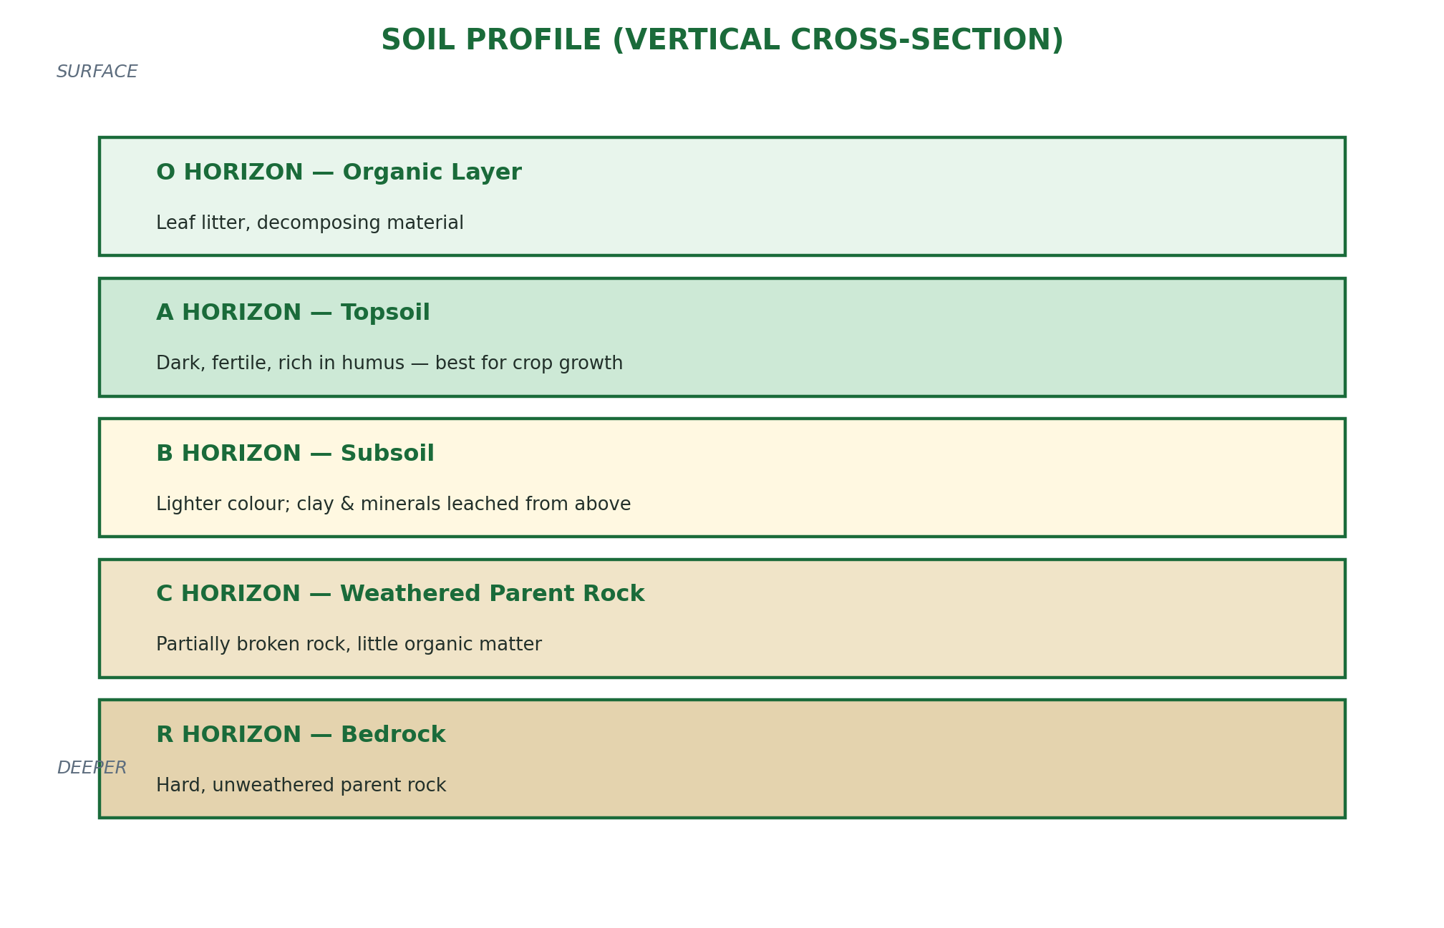

D. Description of Soil Horizons
Horizon | Name | Description
O Horizon | Organic Layer | Topmost layer made of leaf litter and decomposing organic material; dark and loose
A Horizon | Topsoil | Darkest, most fertile layer; rich in humus and nutrients; most roots grow here; best for farming
B Horizon | Subsoil | Lighter in colour; contains clay and minerals washed down from A horizon; less organic matter
C Horizon | Regolith / Weathered Rock | Partially weathered parent material; few organisms; little organic matter
R Horizon | Bedrock | Hard, solid, unweathered parent rock; no plant roots can penetrate

E. Importance of the Soil Profile to Agriculture
- The depth of the A horizon (topsoil) determines how fertile a soil is — deeper topsoil means more nutrients and better crop growth.
- Soil profile analysis helps farmers understand drainage — a B horizon with a lot of clay can trap water and waterlog crops.
- Profile study reveals whether subsoil drainage is good or poor.
- It helps determine how deep farmers should plough and which crops are suitable.
- A shallow soil profile (thin topsoil over hard rock) is unsuitable for deep-rooted crops like yam and cassava.

REVIEW QUESTIONS
- 1. Define soil and list its FIVE main components.
- 2. Explain FOUR processes involved in soil formation.
- 3. What is a soil profile? Draw and label a typical soil profile showing all horizons.
- 4. Describe the A horizon (topsoil) and explain why it is the most important layer for farming.
- 5. How does the activity of living organisms help in soil formation?

WEEK 6
Soil Types, Composition and Properties

A. Types of Soil
Soil is classified according to its texture — the relative proportions of sand, silt, and clay particles it contains. The THREE main soil types are:

1. Sandy Soil
- Contains large particles with big air spaces between them.
- Drains water very quickly — does not hold water well.
- Warms up quickly and is easy to till (cultivate).
- Low in nutrients because water washes them away fast (leaching).
- Best crops: Groundnut, sweet potato, watermelon, and yam (in some areas).

2. Clay Soil
- Contains very fine, small particles with tiny pore spaces.
- Holds water very well — can become waterlogged in wet conditions.
- Sticks together when wet and cracks when dry.
- Rich in nutrients but nutrients may not be easily available to plants when waterlogged.
- Heavy and difficult to till; needs drainage improvement.
- Best crops: Rice and sugarcane (which need a lot of water).

3. Loamy Soil
- A mixture of sand, silt, and clay — the ideal soil for agriculture.
- Holds enough water but also drains well — no waterlogging.
- Rich in organic matter and nutrients.
- Easy to till and supports a wide variety of crops.
- Best crops: Maize, yam, cassava, vegetables, rice, and most food crops.

Property | Sandy Soil | Clay Soil
Particle size | Large (coarse) | Very small (fine)
Water retention | Very poor (drains fast) | Very high (waterlogging risk)
Nutrient content | Low — easily leached | High but may be locked up
Drainage | Excellent | Poor
Ease of tilling | Easy | Difficult when wet/dry
Fertility | Low | Moderate to high
Suitable crops | Groundnut, sweet potato | Rice, sugarcane

Loamy soil = BEST for agriculture because it has balanced properties of sand and clay.

B. Composition of Soil
Regardless of type, all soils are made up of the same basic components in varying proportions:
Component | Percentage (Ideal Loamy Soil)
Mineral particles (sand, silt, clay) | About 45%
Organic matter (humus) | About 5%
Water (soil moisture) | About 25%
Air (in pore spaces) | About 25%

C. Physical Properties of Soil
1. Soil Texture
Soil texture refers to the relative proportion of sand, silt, and clay particles in the soil. It determines how the soil feels when rubbed between the fingers.
- Sandy soil: Feels gritty and rough.
- Clay soil: Feels smooth and sticky when wet; hard when dry.
- Loamy soil: Feels smooth but not sticky; holds shape slightly when squeezed.

2. Soil Structure
Soil structure refers to how soil particles are grouped or arranged into larger masses called aggregates or peds. Good soil structure has many pore spaces for water and air movement and root penetration.
- Granular structure: Small, rounded aggregates — ideal for crop production.
- Blocky structure: Large angular blocks — common in subsoil.
- Platy structure: Flat, plate-like layers — can restrict root growth.
- Single-grain structure: No aggregates — loose sand particles.

3. Soil Colour
- Dark/black soil: High organic matter (humus) — usually very fertile.
- Red or yellow soil: High iron oxide content — common in tropical soils.
- Grey or pale soil: Waterlogged or poor drainage conditions.
- White soil: High calcium carbonate (limestone) content.

4. Soil Porosity and Permeability
- Porosity: The amount of pore space in the soil — affects how much water and air the soil can hold.
- Permeability: How fast water moves through the soil — sandy soils are highly permeable; clay soils have low permeability.

D. Chemical Properties of Soil
1. Soil pH (Reaction)
Soil pH measures how acidic or alkaline (basic) the soil is, on a scale of 0 to 14.
- pH below 7 = Acidic soil (sour). Most tropical Nigerian soils are acidic due to heavy leaching.
- pH of 7 = Neutral soil (ideal for most crops).
- pH above 7 = Alkaline/Basic soil (common in dry northern Nigeria).
- Most crops grow best at pH 6.0–7.0. Correction: Add lime (calcium carbonate) to raise pH of acidic soils.

2. Soil Nutrients
- Soil contains macronutrients (nitrogen N, phosphorus P, potassium K) and micronutrients (iron, manganese, zinc, copper) that plants need for growth.
- Nitrogen promotes leafy green growth. Phosphorus promotes root growth and fruiting. Potassium improves disease resistance.
- Nutrient deficiency shows as yellowing of leaves, stunted growth, and poor yield.

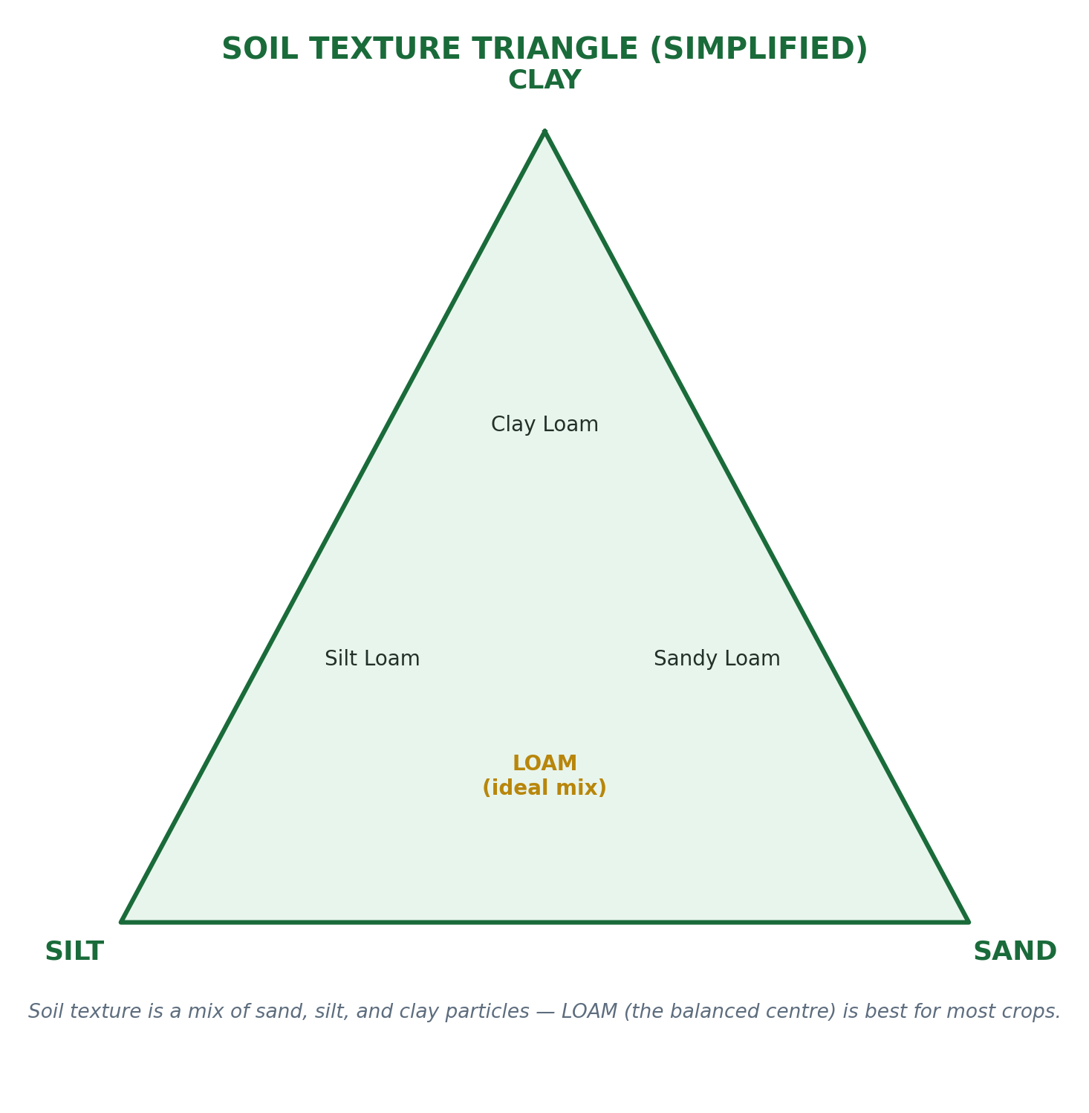

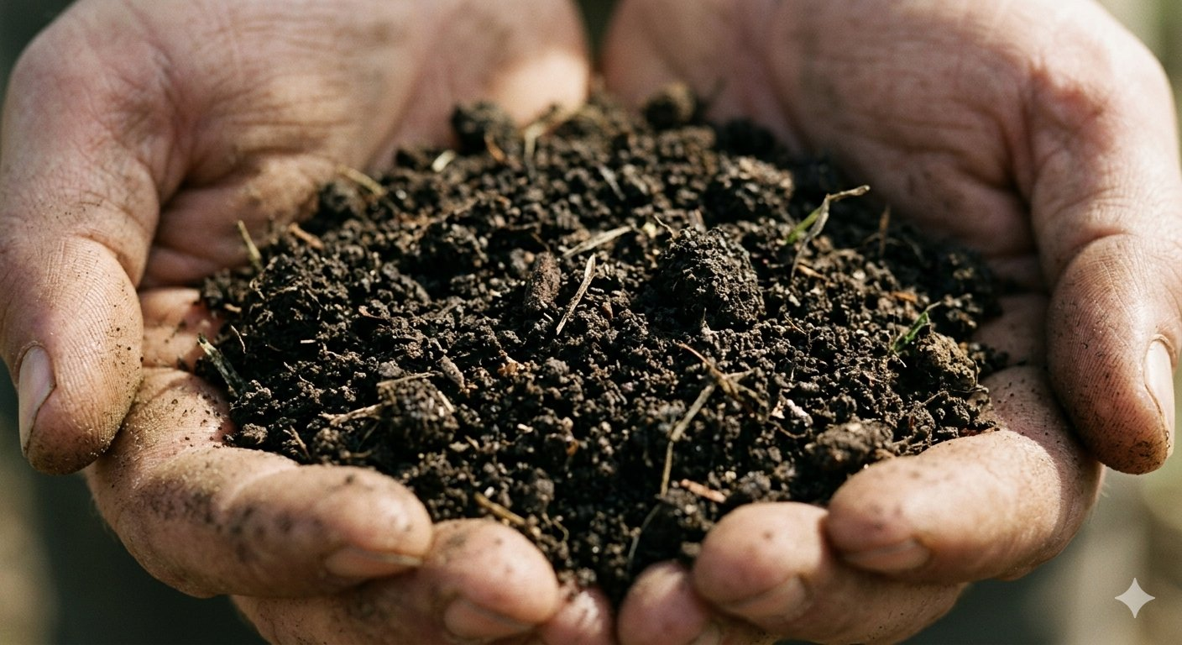
Rich, dark loamy soil — the foundation of healthy crop growth.

REVIEW QUESTIONS
- 1. Name and describe the THREE main types of soil based on texture.
- 2. What is the best type of soil for agriculture and why?
- 3. Explain the difference between soil texture and soil structure.
- 4. What is soil pH? How does it affect crop production?
- 5. List the FIVE components of soil and state the ideal percentage of each in a good loamy soil.

WEEK 8
Simple Farm Tools

A. What are Farm Tools?
Farm tools are simple hand-held implements (instruments) used by farmers to carry out various farm operations. They are operated manually — using the farmer's own physical energy. Simple farm tools are different from farm machinery because they do not use engines or motors.

KEY DEFINITION
- Farm tools are simple hand-operated implements used to carry out farm operations such as land preparation, planting, weeding, and harvesting.

B. Examples of Simple Farm Tools and Their Uses
Farm Tool | Uses
Hoe (hand hoe) | Digging, tilling, ridging, mounding, weeding, earthing up crops
Cutlass (machete) | Clearing bush, cutting down plants, harvesting, splitting palm fruits
Rake | Gathering cut grass, levelling soil surface, removing stones and weeds
Spade | Digging trenches, turning soil, transplanting seedlings, mixing manure
Fork (garden fork) | Breaking up clods of soil, turning compost, aerating soil
Trowel | Transplanting seedlings, scooping soil, digging small holes
Wheelbarrow | Transporting farm produce, soil, manure, and farm inputs within the farm
Watering can | Watering seedlings and nursery plants in small-scale farming
Knapsack sprayer | Applying liquid pesticides, herbicides, and fungicides on crops
Axe | Felling trees, cutting firewood, clearing land
Shovel | Scooping loose soil, sand, gravel, and loading manure
Harvesting knife/sickle | Cutting and harvesting crops like rice, wheat, and sugarcane
Dibber (dibble) | Making holes in soil for planting seeds or seedlings
Measuring tape | Measuring farm land and spacing between plants

C. Parts of a Hoe
The hoe is the most common and important farm tool in Nigeria. It has two main parts:
- The blade (head): The flat metal part that cuts into the soil.
- The handle (helve): The long wooden stick used to hold and swing the hoe.

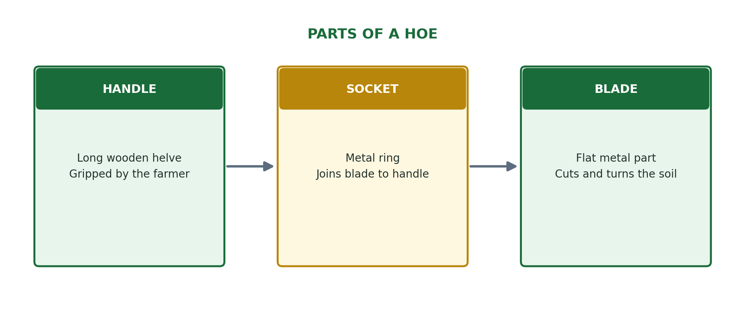

D. Classification of Farm Tools
Farm tools can be classified based on the farm operation they are used for:
Operation | Tools Used
Land clearing | Cutlass, axe, slasher
Soil tillage (digging) | Hoe, spade, fork, ridger
Planting | Dibber, trowel, planting stick
Weeding | Hoe, cutlass, rake
Watering/Irrigation | Watering can, bucket, hosepipe
Spraying | Knapsack sprayer, hand sprayer
Harvesting | Sickle, cutlass, harvesting knife, basket
Transportation | Wheelbarrow, basket, head pan

E. Maintenance of Farm Tools
Proper care and maintenance of farm tools makes them last longer, work better, and remain safe to use. Here is how to maintain common tools:

General Maintenance Rules:
- Clean all tools after use — remove soil, plant material, and moisture.
- Dry tools before storage to prevent rusting.
- Oil or grease metal parts to prevent rust.
- Sharpen blades of hoes, cutlasses, and sickles regularly using a sharpening stone or file.
- Replace broken or cracked handles (helves) immediately.
- Store tools in a dry, sheltered place — a tool shed or store room.
- Hang tools on racks or hooks — do not leave them lying on the ground.

Tool | Specific Maintenance
Hoe | Sharpen blade with file; replace handle if cracked; oil metal part
Cutlass | Sharpen regularly; oil blade; wrap blade when not in use for safety
Rake | Clean teeth after use; replace loose or missing teeth; store off ground
Spade | Remove soil after use; oil the blade; tighten the handle if loose
Knapsack sprayer | Rinse tank after use to remove chemical residue; check for leaks; dry before storage
Wheelbarrow | Pump tyres regularly; grease the wheel axle; remove soil after use

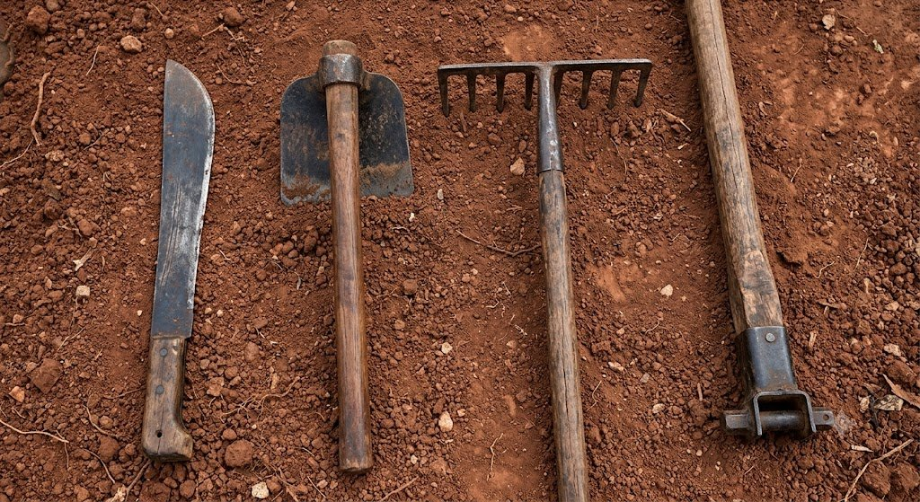
Common simple farm tools: cutlass, hoe, rake, and wheelbarrow handle.

REVIEW QUESTIONS
- 1. What is a farm tool? How is it different from farm machinery?
- 2. List FIVE farm tools and state the specific use of each.
- 3. Name and describe the TWO main parts of a hoe.
- 4. Classify farm tools under the following operations: land clearing, planting, and harvesting.
- 5. State SIX general rules for maintaining farm tools properly.

WEEK 9
Farm Machinery and Implements

A. Meaning of Farm Machinery and Implements
Farm machinery refers to complex, engine-powered equipment used to perform farm operations on a large scale. Farm implements are attachments or accessories that are connected to machines (especially tractors) to carry out specific farm operations.

KEY DEFINITIONS
- Farm Machinery = Engine-powered equipment used to carry out farm operations (e.g. tractor, combine harvester, irrigation pump).
- Farm Implements = Tools or attachments connected to machines to perform specific operations (e.g. plough, harrow, ridger, planter).

B. Examples of Farm Machines and Their Functions
Machine | Function / Use on the Farm
Tractor | The most important farm machine; pulls implements for ploughing, harrowing, ridging, planting, and transportation
Combine Harvester | Harvests, threshes, and cleans grain crops (maize, wheat, rice, sorghum) in one operation
Planter / Seed Drill | Plants seeds at correct depth and spacing automatically, covering large areas quickly
Irrigation Pump | Pumps water from rivers, boreholes, or reservoirs to irrigate crops in dry season
Threshing Machine | Separates grains from their stalks and pods (e.g. rice, maize, cowpea)
Power Tiller / Walk-behind Tractor | Small machine for tilling soil in small/medium farms; easier to use than full tractor
Crop Sprayer (Tractor-mounted) | Sprays large amounts of pesticides, herbicides, and fungicides on large farms
Grain Dryer | Dries harvested grains to safe moisture levels for storage
Feed Mill | Grinds and mixes animal feed ingredients for livestock farming
Milking Machine | Extracts milk from dairy cows mechanically and hygienically

C. Tractor Implements and Their Uses
The tractor is the most versatile farm machine. It works with many different implements:
Implement | Operation / Use
Mouldboard Plough | Primary tillage — turns over and breaks up soil to bury weeds and crop residues
Disc Plough | Cuts through hard or trashy soil; turns soil over for planting
Disc Harrow | Secondary tillage — breaks up clods and levels soil after ploughing
Ridger | Makes ridges (mounds) in the soil for planting yam, cassava, and sweet potato
Planter/Seed Drill | Places seeds at correct depth and spacing in prepared soil
Cultivator | Controls weeds between crop rows and aerates the soil during growing season
Trailer | Transports farm produce, equipment, and inputs within and outside the farm
Sprayer (mounted) | Applies pesticides and herbicides over large farm areas

D. Functions and Advantages of Farm Machinery
Functions of farm machinery:
- Land preparation: Tractors with ploughs and harrows prepare land faster than human hands.
- Planting: Planters and seed drills ensure accurate, uniform spacing of seeds.
- Irrigation: Pumps deliver water to crops in dry seasons, enabling year-round farming.
- Crop protection: Mechanical sprayers cover large areas with chemicals quickly.
- Harvesting: Combine harvesters complete harvesting within days instead of weeks.
- Processing: Threshers, dryers, and mills add value to farm produce.

Advantages of farm machinery:
- Saves time: Large areas are covered in hours rather than days.
- Saves labour: Fewer workers are needed, reducing labour costs.
- Increases productivity: More land is farmed, producing more food.
- Improves accuracy: Seeds planted at uniform depth and spacing germinate evenly.
- Reduces drudgery: Heavy, tiring work is done by machines instead of human muscles.
- Enables timely operations: Planting and harvesting are done at exactly the right time.

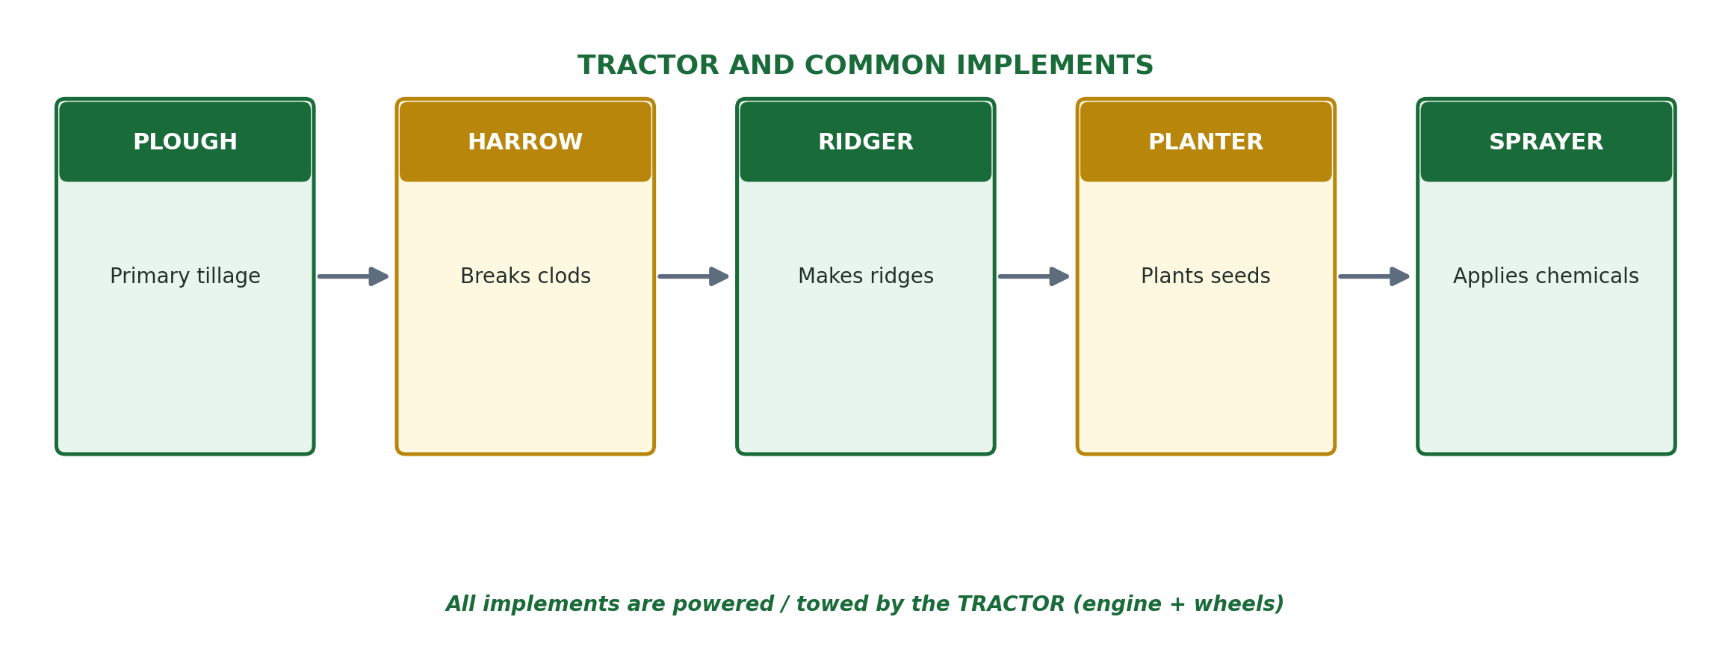

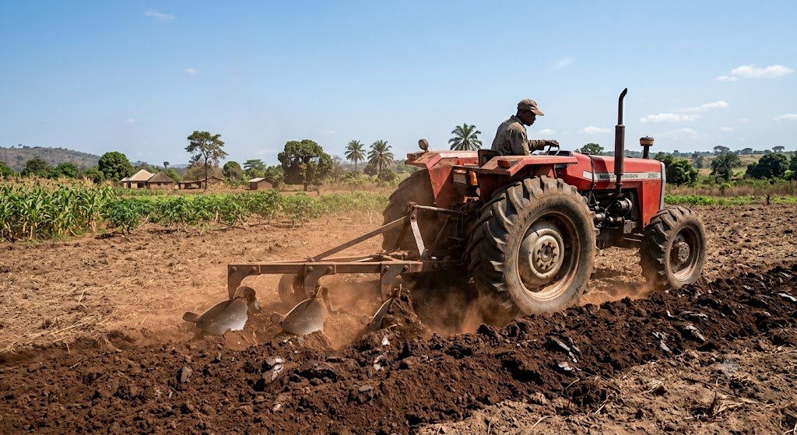
A tractor and plough at work — modern mechanized tillage.

REVIEW QUESTIONS
- 1. Distinguish between farm machinery and farm implements. Give TWO examples of each.
- 2. What is a combine harvester? What THREE operations does it perform in one pass?
- 3. List FIVE tractor implements and state the specific function of each.
- 4. State FOUR advantages of using farm machinery over simple farm tools.
- 5. Why is the tractor considered the most important farm machine? Give FOUR reasons.

WEEK 10
Maintenance of Farm Machinery

A. Why Maintain Farm Machines?
Farm machines are very expensive to buy and replace. If they are not properly cared for, they break down frequently, costing more money in repairs and causing delays in farm operations. Regular maintenance keeps machines in good working condition, extends their life, and ensures the safety of the operator.

IMPORTANCE OF MAINTENANCE
- Prevents unexpected breakdowns during critical farm operations.
- Extends the working life of machines — saving money on replacement.
- Ensures machines work efficiently and at full capacity.
- Protects the safety of the machine operator.
- Reduces the cost of major repairs by catching small problems early.

B. Types of Farm Machinery Maintenance
There are THREE main types of maintenance:

1. Routine / Daily Maintenance
These are simple checks and tasks done every day before and after using a machine:
- Check and top up engine oil level before starting the machine.
- Check the coolant (water) level in the radiator.
- Check tyre pressure and inflate if necessary.
- Clean the air filter to remove dust that can damage the engine.
- Remove mud, soil, and plant material from the machine body and implements.
- Check fuel level and fill up before starting work.
- Check that all nuts and bolts are tight before operation.

2. Periodic (Scheduled) Maintenance
These are done at regular intervals — after every 50, 100, 250, or 500 hours of use:
- Change engine oil and oil filter at recommended intervals (usually every 100–250 hours).
- Replace fuel filter and air filter regularly.
- Grease all moving parts (bearings, joints, pivot points) using a grease gun.
- Check and adjust fan belts — replace if worn or cracked.
- Inspect brake system and adjust or replace brake pads if worn.
- Check the battery — clean terminals, check water level (in non-sealed batteries).

3. Repair / Corrective Maintenance
This is done when a machine breaks down or a part fails:
- Replace broken or worn-out parts such as spark plugs, fan belts, tyres, and hydraulic hoses.
- Fix oil and fuel leaks immediately to prevent damage to the engine.
- Overhaul (completely disassemble and rebuild) engines or gearboxes that are worn out.
- Weld cracked frames or implement parts.

C. Servicing a Tractor — Step by Step
Service Item | How to Do It
Engine oil | Check dipstick daily; change oil and filter every 100–250 hours as per manual
Radiator coolant | Check level daily; top up with clean water or antifreeze; flush and replace yearly
Air filter | Clean dry-type filters by tapping to remove dust; replace when damaged
Fuel filter | Drain water from fuel-water separator daily; replace filter every 250 hours
Tyres | Check pressure with a gauge; inflate to recommended PSI; inspect for cuts or wear
Battery | Keep terminals clean and tight; check electrolyte level monthly
Grease nipples | Apply grease with grease gun to all fittings every 50 hours
Implement blades | Sharpen plough discs and cultivator tines; replace worn-out parts

D. Safety Precautions When Using Farm Machines
SAFETY RULES — ALWAYS FOLLOW THESE
- Read the operator's manual before using any machine for the first time.
- Never start a machine when someone is standing behind it or near moving parts.
- Switch off the engine before making adjustments or fixing problems.
- Wear protective clothing: overalls, safety boots, gloves, and goggles.
- Never allow untrained or underaged persons to operate farm machines.
- Keep the area around machines clear of bystanders, especially children.
- Check that all guards and shields are in place before starting.
- Do not refuel a running or hot engine — switch off and allow to cool first.
- Park machines on flat ground and apply the handbrake before leaving.

REVIEW QUESTIONS
- 1. Why is it important to maintain farm machinery regularly? Give FOUR reasons.
- 2. Name and describe THREE types of maintenance carried out on farm machines.
- 3. List SIX daily maintenance checks that should be performed on a tractor before use.
- 4. What is periodic maintenance? Give FOUR examples of periodic maintenance tasks.
- 5. State SIX safety precautions that must be observed when operating farm machinery.

WEEK 11
Problems of Agricultural Mechanization

A. Meaning of Agricultural Mechanization
Agricultural mechanization is the use of machines and mechanical equipment to carry out farming operations in place of human or animal labour. While mechanization has many benefits (as studied in the First Term), it also faces serious problems — especially in developing countries like Nigeria.

B. Problems of Agricultural Mechanization in Nigeria

1. High Cost of Farm Machines
- Tractors, combine harvesters, irrigation pumps, and planters are extremely expensive to purchase.
- A new tractor can cost between N15 million and N50 million in Nigeria — far beyond what most farmers can afford.
- Even second-hand machines are too expensive for smallholder farmers.

2. Lack of Trained Operators and Technicians
- Operating farm machines requires special training and skill.
- There are very few trained tractor operators, mechanics, and technicians in rural Nigeria.
- Machines operated by unskilled persons break down faster and cause accidents.
- There are not enough vocational training schools that teach agricultural mechanization skills.

3. Poor Infrastructure (Roads and Fuel Supply)
- Many farming communities in Nigeria have bad roads or no roads at all.
- Tractors and heavy machines cannot reach farms located in remote areas or swampy terrain.
- Fuel (diesel and petrol) is expensive and not always available in rural areas.
- Irregular electricity supply makes electric-powered farm equipment difficult to use.

4. Small and Fragmented Farmlands
- Most Nigerian farmers own small, scattered plots of land (subsistence farmers).
- Farm machines like tractors are designed for large, open, flat fields.
- It is not economical (cost-effective) to use an expensive tractor on a small half-acre plot.
- Irregular, hilly, or tree-dotted land also makes machine use difficult or impossible.

5. High Cost of Maintenance and Spare Parts
- Farm machines require regular servicing, spare parts, and lubricants.
- Spare parts for tractors and other machines are often not available in rural markets.
- When a machine breaks down in a rural area, transporting it to a mechanic is costly and time-consuming.
- The cost of maintenance can sometimes exceed the farmer's income from the farm.

6. Inadequate Government Support and Policy
- Government subsidies for farm machines are insufficient or poorly targeted.
- Bureaucratic delays mean farmers wait too long to access government machines or loans.
- Corruption means that farm machines meant for poor farmers end up with wealthy individuals.
- Lack of policy coordination among government agencies leads to duplication and waste.

7. Soil Damage by Heavy Machines
- Repeated use of heavy tractors and equipment compacts (presses together) the soil.
- Soil compaction reduces pore spaces, making it hard for water and air to penetrate.
- Plant roots cannot grow easily in compacted soil, reducing crop yields.
- Compaction can take years to reverse through natural processes.

8. Cultural and Social Barriers
- Some farmers are resistant to change — they prefer traditional farming methods passed down from their ancestors.
- In some communities, it is believed that certain crops must be planted by hand for cultural or spiritual reasons.
- Elderly farmers may find it difficult to learn how to use modern machines.

SUMMARY — PROBLEMS OF AGRICULTURAL MECHANIZATION
- High cost of purchasing machines
- Lack of trained operators and mechanics
- Poor rural roads and fuel supply
- Small and fragmented farmlands
- Expensive maintenance and unavailable spare parts
- Inadequate government support and policy
- Soil compaction caused by heavy machines
- Cultural and social resistance to change

C. Possible Solutions to These Problems
Problem | Suggested Solution
High cost of machines | Government should provide subsidies and group ownership schemes (cooperatives)
Lack of trained operators | Establish vocational training centers for farm machine operation
Poor roads | Construct and maintain rural feeder roads to connect farms to markets
Small farmlands | Encourage land consolidation and cooperative farming on large shared plots
Costly spare parts | Establish local spare parts manufacturing and rural service centers
Poor government policy | Create transparent, farmer-friendly mechanization programmes
Soil compaction | Use conservation tillage (minimum tillage) and avoid over-use of heavy machines
Cultural barriers | Educate farmers through demonstrations and field days on benefits of mechanization

REVIEW QUESTIONS
- 1. Define agricultural mechanization.
- 2. List and explain FIVE problems facing agricultural mechanization in Nigeria.
- 3. How does soil compaction caused by machines affect crop production?
- 4. Why are small and fragmented farmlands a problem for agricultural mechanization?
- 5. Suggest FOUR solutions to the problems of agricultural mechanization in Nigeria.

END OF SECOND TERM LESSON NOTES

Prepare diligently for your Second Term Examination!

Best of luck! — Kenneth Chiakwa

SS1 AGRICULTURAL SCIENCE
THIRD TERM
LESSON NOTES eBOOK

SS1 AGRICULTURAL SCIENCE

THIRD TERM LESSON NOTES

Compiled by:

Kenneth Chiakwa

B.Sc. Agricultural Economics | M.Sc. Agricultural Economics

Enugu State University of Science and Technology (ESUT)

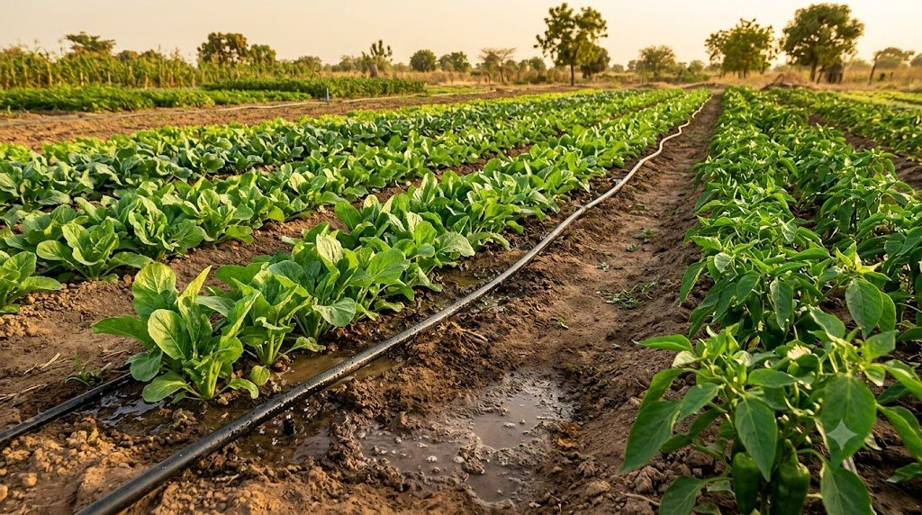
TOPICS COVERED IN THIS BOOK

Week 1: Prospects of Agricultural Mechanization
Week 2: Sources of Farm Power
Week 3: Classification of Crops
Week 4: Husbandry of Selected Crops (Maize, Cassava, Yam)
Week 5: Mid-Term Examination
Week 6: Pasture and Forage Crops
Week 7: Mid-Term Break
Week 8: Plant Nutrients and Nutrient Cycle
Week 9: Irrigation
Week 10: Drainage
Week 11: Agricultural Pollution
Week 12: Examination

A NOTE TO THE STUDENT

Dear Student,

Welcome to your SS1 Agricultural Science Third Term Lesson Notes — the final term for your SS1 studies! This book covers exciting and very practical topics including farm power, crop classification, husbandry of important Nigerian crops, irrigation, drainage, plant nutrients, and agricultural pollution.

How to get the best from this book:
- Read each week's lesson carefully — before and after class.
- Memorise all KEY DEFINITIONS in the green boxes — they are important for exams.
- Study every DIAGRAM and TABLE carefully — they make complex topics easy.
- Answer all REVIEW QUESTIONS in your notebook to prepare for examinations.
- Relate the topics to real life — visit a farm, observe crops, and ask experienced farmers questions.
- Form study groups and discuss difficult topics together.

You are almost at the end of your SS1 Agricultural Science journey. Study hard, enjoy the topics, and aim for excellence!

With best wishes,

Kenneth Chiakwa
B.Sc., M.Sc. Agricultural Economics, ESUT

WEEK 1
Prospects of Agricultural Mechanization

A. Meaning of Agricultural Mechanization
Agricultural mechanization is the use of machines, mechanical equipment, and technology to carry out farming operations instead of relying on human or animal labour. It includes the use of tractors, combine harvesters, irrigation pumps, planters, threshers, and other farm machines to improve the speed, efficiency, and scale of agricultural production.

KEY DEFINITION
- Agricultural Mechanization = The adoption and use of machines and modern technology to perform farm operations in place of manual (human) or animal effort.

B. Benefits of Agricultural Mechanization
Despite the challenges, agricultural mechanization has very important benefits:

1. Increases Speed of Farm Operations
- Machines complete in hours what would take many workers several days to do.
- A tractor can plough 5 hectares of land in one day; the same work would take 20 men with hoes 5–7 days.
- This allows farmers to meet critical planting and harvesting deadlines.

2. Increases Farm Output (Productivity)
- Machines enable farmers to cultivate larger areas of land, producing more food and cash crops.
- Greater output means more income for the farmer and more food for the nation.
- Nigeria can achieve food security faster when farming is mechanized.

3. Reduces Physical Stress and Drudgery
- Farm work by hand is very exhausting, especially land clearing and ploughing.
- Machines take over these heavy tasks, making farming less stressful and more attractive — especially to young people.
- This helps reduce rural-urban migration where young people leave villages for cities.

4. Reduces Cost of Labour in the Long Run
- Although machines are expensive to buy, they reduce the need to hire large numbers of workers.
- Over time, the cost per hectare farmed using machines is lower than the cost of hiring many workers.

5. Allows Timely Farm Operations
- In agriculture, timing is critical — planting at the right time and harvesting before rain or pests destroy crops.
- Machines allow all farm operations to be done at exactly the right time.
- Late planting reduces yield; machines prevent this by working fast.

6. Improves Quality and Accuracy of Work
- Planters place seeds at exactly the right depth and spacing, leading to even germination and better yields.
- Mechanical threshers reduce grain breakage compared to manual threshing.
- Sprayers apply chemicals uniformly, ensuring effective pest and disease control.

7. Enables Large-Scale (Commercial) Farming
- Without machines, only small plots of land can be farmed effectively.
- Mechanization makes it possible to farm thousands of hectares, achieving economies of scale.
- This transforms subsistence farming into profitable commercial agriculture.

8. Encourages Agricultural Investments
- When farming is mechanized, investors (private companies, banks, and government) are more willing to put money into agriculture.
- This brings in more capital, technology, and employment to the farming sector.

C. Limitations of Agricultural Mechanization
Despite its benefits, agricultural mechanization has significant limitations:

- High cost of purchasing machines — tractors cost millions of naira.
- Requires trained operators — unskilled use leads to breakdowns and accidents.
- Poor rural roads and fuel supply make machine use difficult in remote areas.
- Small and fragmented farmlands are not suitable for large machines.
- Costly maintenance, repairs, and unavailability of spare parts.
- Causes soil compaction — heavy machines press soil together, reducing fertility.
- Creates unemployment — machines replace farm workers.
- Farmers may become over-dependent on machines, making them vulnerable when machines break down.
- Environmental pollution — farm machines use fossil fuels that produce greenhouse gases.

Benefits | Limitations
Saves time — large areas covered fast | Machines are very expensive to buy
Increases farm output and food supply | Requires trained operators — not widely available
Reduces physical stress and drudgery | Poor roads limit access to remote farms
Enables large-scale commercial farming | Small farms cannot make effective use of machines
Timely planting and harvesting | Soil compaction damages long-term soil fertility
Improves quality and accuracy of work | Creates unemployment by replacing farm workers
Reduces long-run labour costs | Spare parts and fuel are expensive and scarce
Attracts investors to agriculture | Machines cause environmental pollution

D. Prospects (Future Outlook) of Agricultural Mechanization in Nigeria
Despite current challenges, the future of agricultural mechanization in Nigeria looks promising because:
- The Nigerian government has intensified efforts to provide subsidized tractors and equipment to farmers through programmes like the National Agricultural Mechanization Policy.
- Private sector companies are increasingly investing in the production and distribution of farm machines.
- More agricultural engineering graduates are being trained in Nigerian universities.
- Solar-powered irrigation and drones for crop spraying are being introduced as affordable options for small farmers.
- Cooperative farming groups allow small farmers to pool resources and share the cost of machines.
- Nigeria's large population and growing food demand make mechanized agriculture commercially attractive.

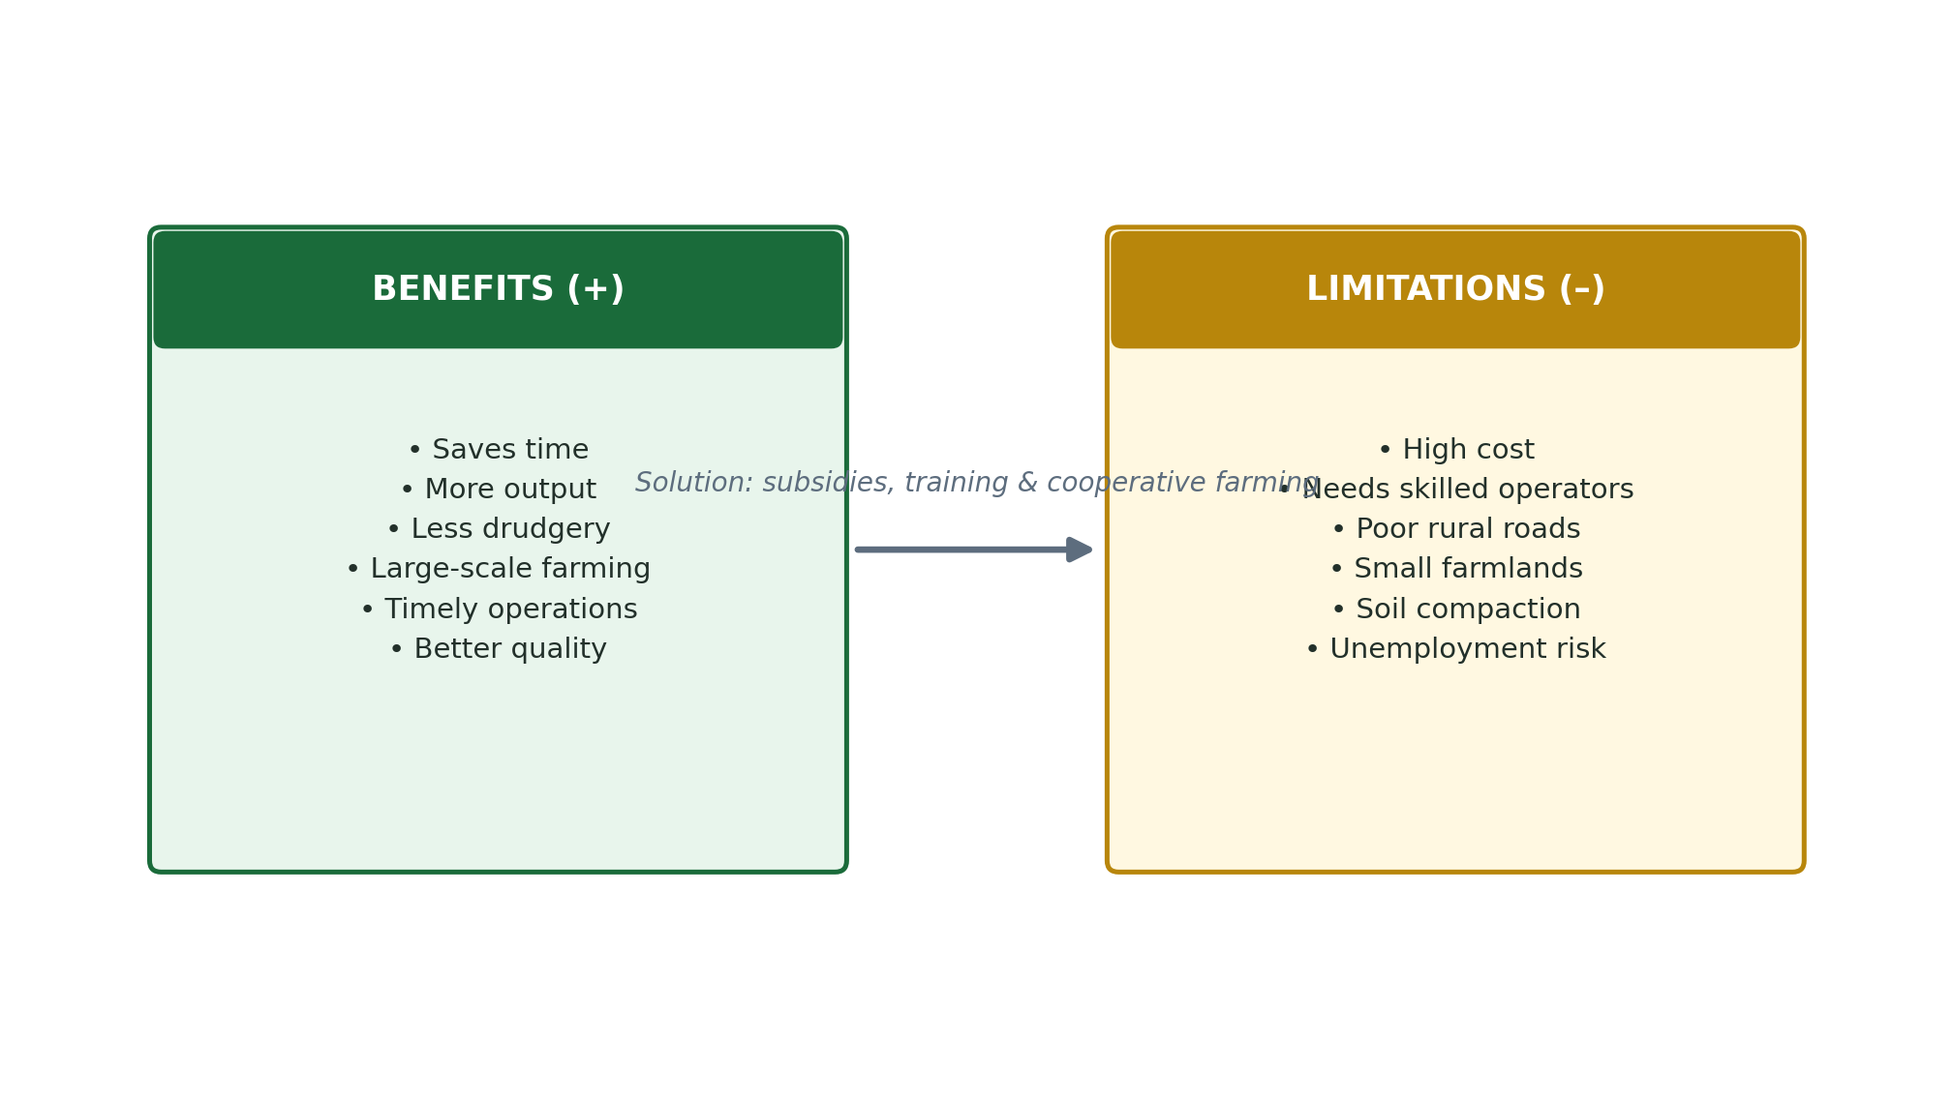

REVIEW QUESTIONS
- 1. Define agricultural mechanization in your own words.
- 2. List and explain FIVE benefits of agricultural mechanization.
- 3. State FIVE limitations of agricultural mechanization in Nigeria.
- 4. Why is timely farm operation important, and how does mechanization help achieve it?
- 5. Discuss TWO prospects (future developments) of agricultural mechanization in Nigeria.

WEEK 2
Sources of Farm Power

A. Meaning of Farm Power
Farm power refers to the energy or force used to carry out farm operations. Without power, no farm work can be done. Farming requires power for land clearing, tilling, planting, harvesting, irrigation, and processing of farm produce. Different sources of power are used depending on the location, wealth, and technology available to the farmer.

KEY DEFINITION
- Farm Power = The energy or force applied to carry out agricultural operations on the farm.

B. Sources of Farm Power
There are SIX main sources of farm power:

1. Human Power (Muscular Power)
This is the use of the farmer's own body energy (muscles) to do farm work. It is the oldest and most common source of farm power in Nigeria.
- Operations: Clearing, digging, planting, weeding, harvesting, and carrying farm produce.
- Tools used: Hoe, cutlass, rake, spade, fork, and watering can.
- Advantages: Cheap, no fuel needed, available anywhere, suitable for small farms.
- Disadvantages: Slow, tiring (drudgery), cannot cover large areas, limited by the farmer's physical strength and health.

2. Animal Power (Draught Animal Power)
This is the use of trained animals to provide energy for farm operations. It is common in the North of Nigeria and in many parts of Asia and Africa.
- Animals used: Oxen (bulls/cattle), horses, donkeys, camels, and mules.
- Operations: Ploughing, harrowing, ridging, transportation, and water lifting (in some places).
- Implements used: Animal-drawn plough, harrow, planter, ox-cart.
- Advantages: Stronger than human power; faster than manual work; cheaper than machines; animals also produce manure for the farm.
- Disadvantages: Animals are expensive to buy and maintain; they need food, water, and veterinary care; cannot work in wet, swampy, or very rocky terrain; slower than machines.

3. Mechanical Power
This is power derived from engines in farm machines. It is the most powerful and efficient source of farm power for large-scale farming.
- Sources of mechanical power: Diesel engines in tractors, petrol engines in generators and power tillers.
- Operations: All major farm operations — ploughing, planting, spraying, harvesting, threshing, and transportation.
- Machines: Tractor, combine harvester, power tiller, irrigation pump, thresher, and generator.
- Advantages: Very fast, handles large areas, can work day and night, reduces labour cost.
- Disadvantages: Very expensive to buy and maintain; needs fuel (diesel/petrol); requires trained operators; can pollute the environment.

4. Electrical Power
This is power generated from electricity (from the national grid, generators, or solar panels) and used to run electrically powered farm equipment.
- Uses on the farm: Poultry lighting and heating, milking machines, feed mills, irrigation pumps, electric fencing, cold storage facilities.
- Advantages: Clean, quiet, efficient, and can be used continuously.
- Disadvantages: In Nigeria, electricity supply is very unreliable; rural areas often have no electricity; connection and equipment costs are high.

5. Solar Power
This is energy harnessed from sunlight using solar panels (photovoltaic cells) and converted into electricity for farm use. It is an increasingly important source of clean, renewable energy for agriculture.
- Uses: Powering irrigation pumps, poultry lighting, cold storage, and grain dryers in areas without electricity.
- Advantages: Renewable and free source (sunlight); clean — no pollution; low running cost once installed; ideal for remote rural areas.
- Disadvantages: High initial installation cost of solar panels; works best in sunny areas; cannot power very heavy machinery; battery storage is expensive.

6. Wind Power
This is energy derived from wind using windmills or wind turbines to perform farm operations.
- Uses: Pumping water from wells for irrigation; generating electricity in windy areas; drying crops.
- Advantages: Renewable, clean, no fuel needed, low running cost.
- Disadvantages: Depends on wind availability — unreliable; wind turbines are expensive to install; not widely used in Nigeria.

7. Water Power (Hydro Power)
This is energy derived from the flow or fall of water, used to generate electricity (hydroelectric power) or directly run water wheels and mills.
- Uses in agriculture: Nigeria's hydroelectric dams (Kainji, Jebba, Shiroro) provide electricity that powers farm equipment and agro-processing industries.
- Direct use: Water wheels can power grain mills and water pumps.
- Advantages: Renewable, no pollution, reliable in areas with rivers.
- Disadvantages: Depends on availability of rivers; large dams are expensive to build; drought reduces water power.

Source of Power | Examples/Equipment | Advantages & Disadvantages
Human Power | Hoe, cutlass, spade | + Cheap, always available — Slow, tiring, limited area
Animal Power | Oxen, donkeys, horse-drawn plough | + Stronger than man, produces manure — Needs feeding, care, vet bills
Mechanical Power | Tractor, combine harvester | + Very fast, large scale — Expensive, needs fuel & skill
Electrical Power | Milking machine, feed mill, pumps | + Clean, efficient — Unreliable supply in Nigeria
Solar Power | Solar pumps, solar lighting | + Renewable, clean, rural use — High installation cost
Wind Power | Windmill, wind turbine | + Renewable, free — Unreliable, expensive turbines
Water Power | Hydroelectric dams, water wheels | + Renewable, reliable — Needs rivers, expensive dams

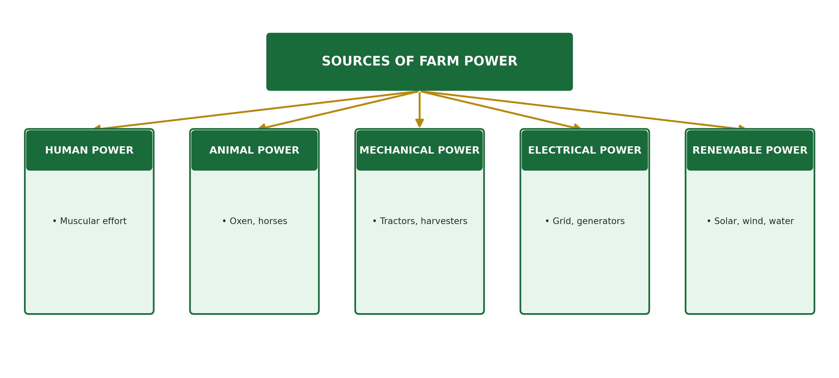

REVIEW QUESTIONS
- 1. What is farm power? Why is it important in agriculture?
- 2. Name SIX sources of farm power and give ONE example of each.
- 3. Explain the advantages and disadvantages of animal power as a source of farm energy.
- 4. Why is solar power becoming increasingly important in Nigerian agriculture?
- 5. Compare human power and mechanical power as sources of farm energy under the following headings: speed, cost, and area covered.

WEEK 3
Classification of Crops

A. Introduction
A crop is any plant that is grown or cultivated by a farmer for food, income, or industrial use. Nigeria has a wide variety of crops grown in its different ecological zones — from the humid rainforest in the south to the dry Sahel savanna in the north. Crops can be classified (grouped) in different ways.

B. Classification Based on Use
1. Food Crops
Food crops are crops grown mainly for human consumption (eating). They provide carbohydrates, proteins, vitamins, fats, and minerals for people's health and survival.
- Cereals: Maize, rice, wheat, sorghum, millet — provide carbohydrates and energy.
- Legumes: Cowpea (beans), groundnut, soyabean — provide protein and oil.
- Root and tuber crops: Yam, cassava, sweet potato, cocoyam — provide carbohydrates.
- Vegetables: Tomato, onion, okra, spinach, pepper — provide vitamins and minerals.
- Fruits: Mango, orange, banana, pawpaw, pineapple — provide vitamins and minerals.
- Oil crops (edible): Palm fruit, groundnut, soyabean, coconut — provide fats and oils.

2. Cash Crops (Industrial/Export Crops)
Cash crops are crops grown mainly for sale or for industrial use. They are often exported to earn foreign exchange for the country.
- Cocoa: Used to make chocolate and beverages — Nigeria's most important export crop.
- Rubber: Latex used to make tyres, gloves, and footwear.
- Cotton: Fibres used to make cloth and thread; seeds used for oil.
- Palm oil: Used for cooking, soap-making, and margarine production.
- Groundnut: Used for oil, animal feed, and groundnut paste.
- Sugarcane: Used to produce refined sugar, ethanol, and molasses.
- Coffee: Beans used to make coffee drinks — grown in Mambilla Plateau.

C. Classification Based on Life Cycle (Duration)
1. Annuals
Annual crops complete their entire life cycle (germination, growth, flowering, fruiting, and death) within ONE year (12 months) or less. Most Nigerian food crops are annuals.
- Examples: Maize, rice, wheat, millet, sorghum, cowpea, tomato, pepper, okra, watermelon.
- They are planted and harvested within the same farming season.

2. Biennials
Biennial crops take TWO years (two growing seasons) to complete their life cycle. In the first year they grow leaves and store food; in the second year they flower, produce seeds, and die.
- Examples: Cassava (harvested in 12–24 months), some varieties of yam, carrot, onion, sugar beet.
- Note: Cassava is sometimes treated as an annual in Nigeria when harvested at 8–12 months.

3. Perennials
Perennial crops live and produce for MANY years (more than two years) without being replanted. They are planted once and continue producing for decades. Most cash crops and tree crops are perennials.
- Examples: Cocoa (20–30 years), rubber (30+ years), oil palm (25+ years), coconut, coffee, mango, orange, banana, pawpaw.

Class | Duration | Examples
Annuals | Complete life in ≤ 1 year | Maize, rice, wheat, cowpea, tomato, millet, pepper
Biennials | Complete life in 1–2 years | Cassava, yam, carrot, onion, sugar beet
Perennials | Live and produce for many years (3+ years) | Cocoa, rubber, oil palm, coconut, mango, orange

D. Classification Based on Botanical Features
Group | Description & Examples
Cereals (Grasses) | Members of the grass family; produce starchy grains. Examples: Maize, rice, wheat, sorghum, millet, barley
Legumes (Pulses) | Plants with seeds in pods; fix nitrogen in soil. Examples: Cowpea, soyabean, groundnut, pigeon pea
Root & Tuber Crops | Store food underground in roots or tubers. Examples: Yam, cassava, sweet potato, cocoyam, carrot
Vegetables | Eaten as leaves, stems, or unripe fruits. Examples: Tomato, okra, garden egg, onion, spinach, cabbage
Fruits | Eaten as ripe fruits. Examples: Mango, orange, banana, pineapple, pawpaw
Oil Crops | Produce edible or industrial oils. Examples: Palm fruit, groundnut, soyabean, coconut, sunflower
Fibre Crops | Produce fibres for making cloth and rope. Examples: Cotton, jute, kenaf
Beverage Crops | Produce drinks or stimulants. Examples: Cocoa, coffee, tea, kola nut

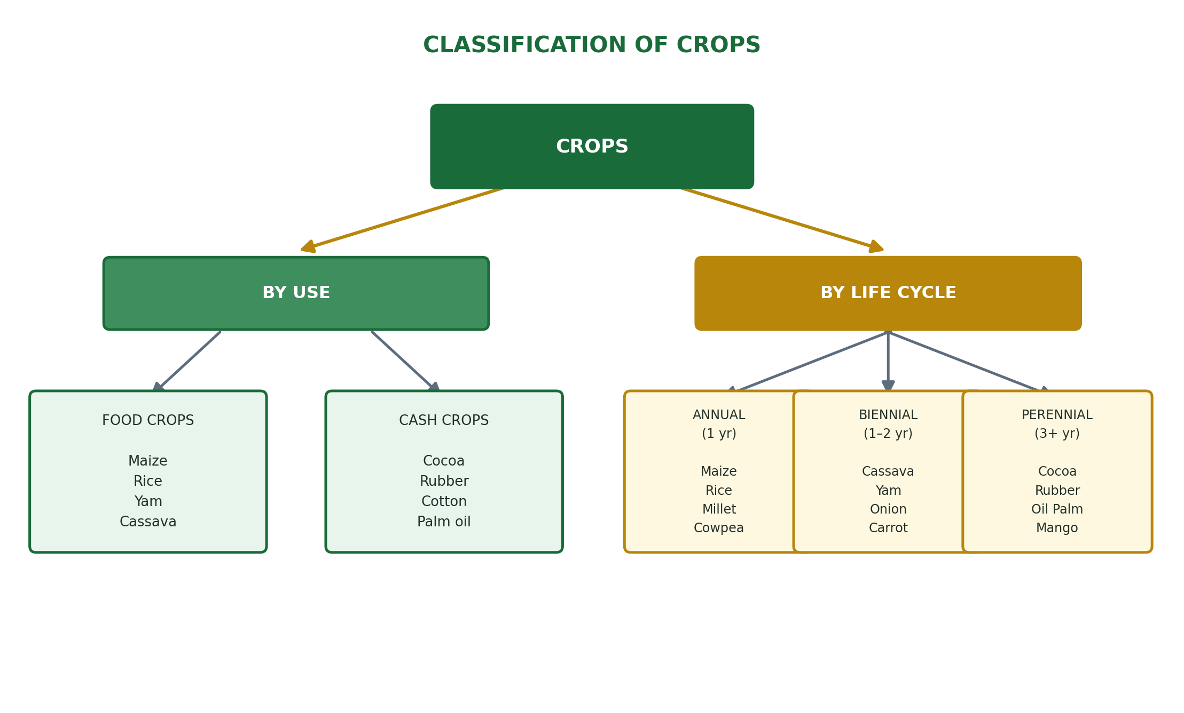

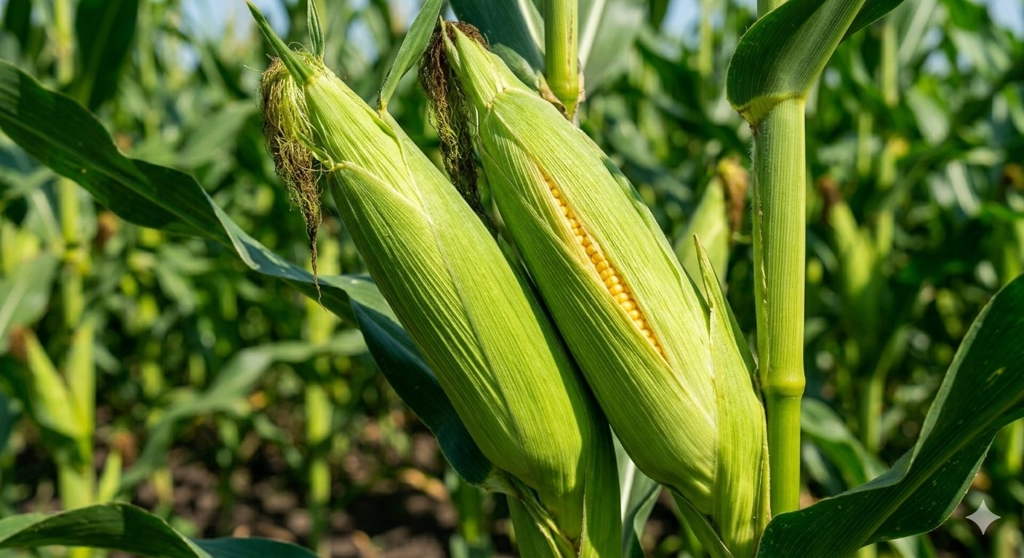  Maize — a staple food crop | 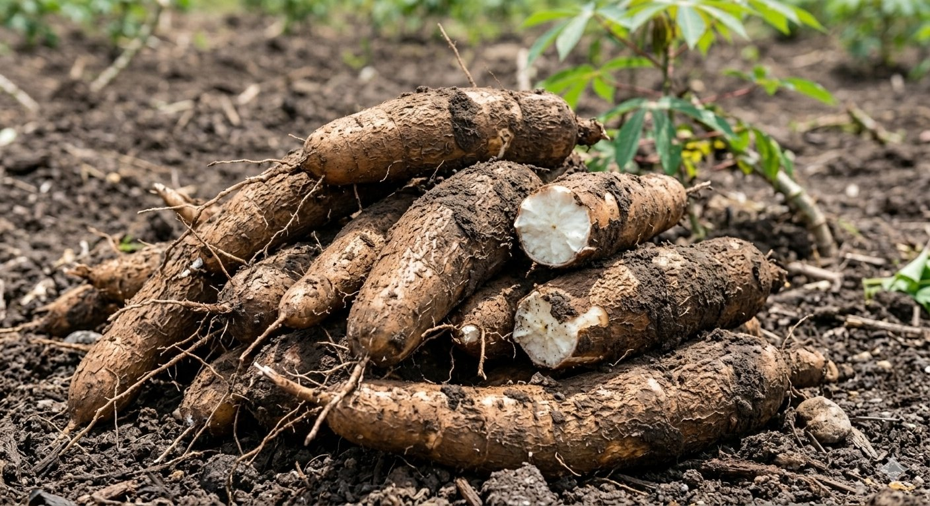  Cassava — a widely grown root crop
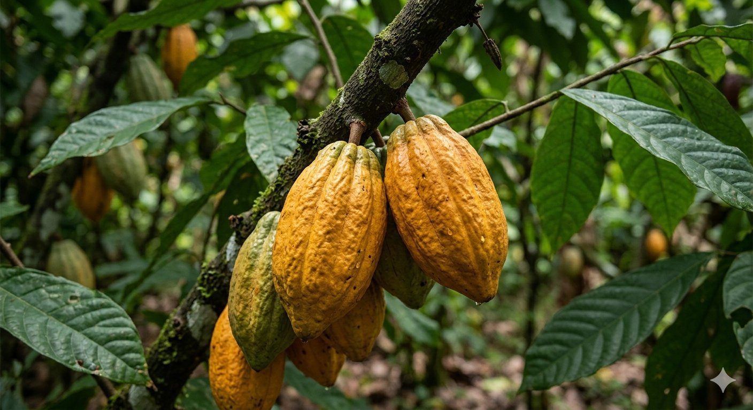  Cocoa pods — a major Nigerian cash crop | 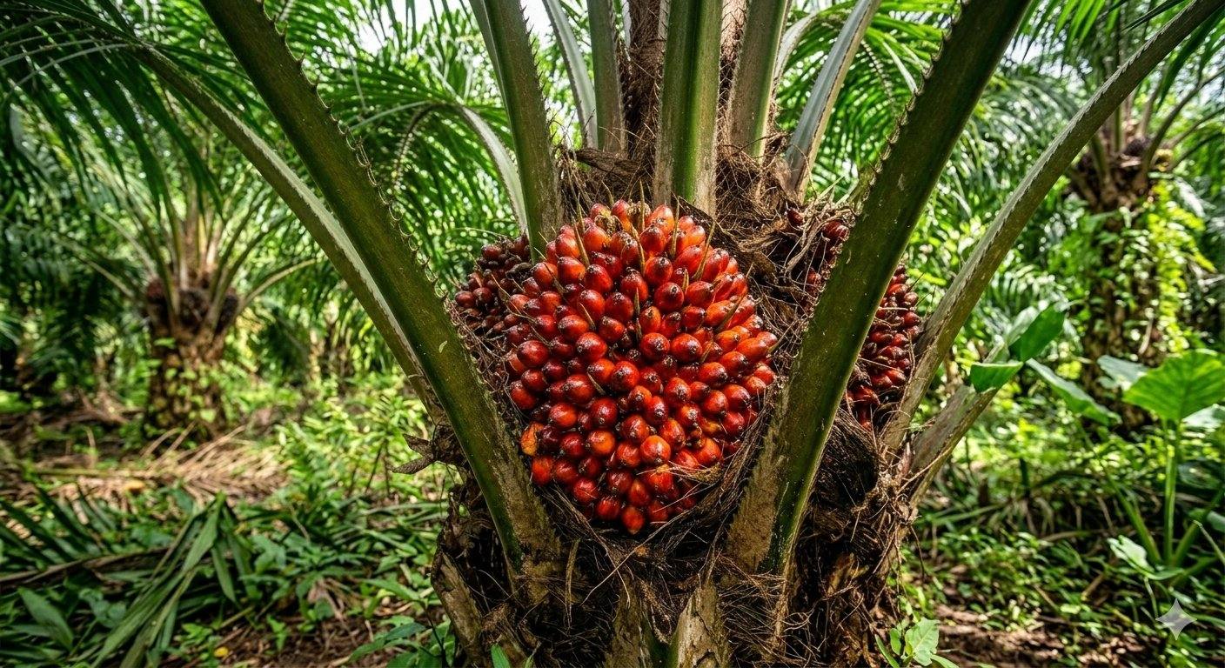  Oil palm fruits — source of palm oil

REVIEW QUESTIONS
- 1. What is a crop? Mention THREE ways in which crops can be classified.
- 2. Distinguish between food crops and cash crops. Give FOUR examples of each.
- 3. Define annual, biennial, and perennial crops. Give TWO examples of each.
- 4. List FOUR groups of crops based on botanical features and give TWO examples of each.
- 5. Why is cocoa referred to as a cash crop? What products are made from cocoa?

WEEK 4
Husbandry of Selected Crops

A. What is Crop Husbandry?
Crop husbandry refers to the science and practice of growing crops — from land preparation through planting, maintenance, and harvesting. Good husbandry ensures that crops are properly cared for at every stage of their growth, resulting in high yields and good quality produce. We will study three important crops: Maize, Cassava, and Yam.

B. Maize (Zea mays)
Maize is the most widely grown cereal crop in Nigeria. It is a food crop that provides carbohydrates and is used for making pap (ogi/akamu), corn flour, popcorn, animal feed, and industrial starch. It is an annual crop.

Stage | Husbandry Practice
Ecological Requirements | Rainfall: 500–1300 mm/year; Temperature: 20–30°C; Soil: well-drained fertile loam; Altitude: up to 2000 m
Land Preparation | Clear land of bush and weeds using cutlass and hoe or tractor; plough and harrow to loosen soil; form ridges or flat beds
Varieties | Local varieties: white and yellow corn; Improved varieties: TZEE-W, TZEE-Y (IITA developed); hybrid varieties for commercial farming
Planting | Time: April–May (south) or June–July (north); Spacing: 75 cm × 25 cm; Depth: 3–5 cm; Seeds per hole: 2 seeds per hole; Seed rate: 25 kg/ha
Fertilizer Application | Apply NPK 15:15:15 at 2–3 weeks after planting; Top-dress with urea or CAN at 4–6 weeks; Manure can be applied before planting
Weed Control | Weed 2–3 weeks and 6–8 weeks after planting; use hoe weeding or apply pre-emergence herbicide (Atrazine) before germination
Pest & Disease Control | Major pests: stem borers, army worms, aphids, weevils (in store); Diseases: maize streak virus, leaf blight; use insecticides and resistant varieties
Harvesting | Harvest at 90–120 days after planting when husks turn brown and dry; twist or cut the cobs from the stalk; dry grains to 12–13% moisture for storage
Storage | Store dry grains in silos, bags, or cribs; treat with approved grain protectants (e.g. Actellic dust) to prevent weevil damage

C. Cassava (Manihot esculenta)
Cassava is the most important root crop in Nigeria and a major source of carbohydrate for millions of people. It is processed into garri, fufu, starch, flour, and animal feed. Cassava is a biennial crop, though it is usually harvested between 8–18 months after planting.

Stage | Husbandry Practice
Ecological Requirements | Rainfall: 1000–1500 mm/year; Temperature: 25–29°C; Soil: well-drained sandy-loam; pH: 5.5–6.5; tolerates poor soils
Planting Material | Stem cuttings (not seeds) of 20–30 cm length from healthy, mature cassava stems (8–12 months old)
Land Preparation | Clear bush; plough and harrow; form ridges or mounds to improve drainage and allow tuber expansion; depth of ridge: 30 cm
Planting | Time: March–May (first rains); Spacing: 1 m × 1 m; Plant stem cuttings diagonally (at 45°) or vertically to 2/3 of their length in the ridge
Fertilizer Application | Apply NPK 15:15:15 at 6–8 weeks after planting; cassava responds well to potassium for tuber development; organic manure improves yield
Weed Control | Critical in first 3 months — weed at 3, 6, and 10 weeks; herbicides: Primextra or Roundup (after planting, before sprouting)
Pest & Disease Control | Major pests: cassava mealybug, green mite, whitefly; Diseases: cassava mosaic disease (CMD), cassava bacterial blight (CBB); use disease-resistant varieties (TMS 30572, TMS 4(2)1425)
Harvesting | Harvest at 8–24 months (depending on variety); pull or dig out tubers; harvest before or just after rains end to get starchy tubers
Processing | Process quickly after harvest (within 24–48 hours) as fresh tubers spoil fast; products: garri, fufu, starch, flour, chips

D. Yam (Dioscorea spp.)
Yam is one of the most important food crops in Nigeria and West Africa. It is a biennial crop that serves as a major source of carbohydrate, income, and cultural identity in many Nigerian communities — especially among the Igbo, Yoruba, and Tiv peoples. The main species grown is Dioscorea rotundata (white yam).

Stage | Husbandry Practice
Ecological Requirements | Rainfall: 1200–1500 mm/year; Temperature: 25–30°C; Soil: deep, well-drained, fertile loamy soil; pH: 5.5–6.5; needs long dry season to mature
Planting Material | Seed yams — small whole yams or cut pieces (setts) of 150–500 g from mature yam tubers; setts should be treated with wood ash or fungicide before planting
Land Preparation | Clear land; plough deeply to at least 30–40 cm; form very high mounds (50–100 cm high) or ridges to allow long tuber growth downwards; mounds improve drainage
Planting | Time: February–April (before first rains); Spacing: 1 m × 1 m (mounds); Plant setts 5–10 cm deep in top of mound; stake (provide sticks) for the climbing vine within 3–4 weeks
Staking | Provide 2–2.5 m sticks for the yam vines to climb — this improves leaf exposure to sunlight, increasing photosynthesis and yield
Fertilizer Application | Apply NPK 15:15:15 at 6–8 weeks; top-dress with sulphate of ammonia or CAN at 10–12 weeks; organic manure (compost or farmyard manure) improves soil structure
Weed Control | Weed at 3, 6, and 10 weeks after planting; hand hoe between mounds; avoid deep hoeing to prevent cutting young tubers
Pest & Disease Control | Pests: yam beetle, nematodes; Diseases: yam mosaic virus, dry rot, yam anthracnose; use healthy seed yams, approved fungicides, and resistant varieties
Harvesting | Harvest at 6–10 months; signs of maturity: leaves turn yellow and die back; carefully dig around mounds with a fork or hand; avoid cutting tubers
Storage | Store in yam barns (open-sided structures with good ventilation); treat with approved chemicals; do not stack directly on ground; check regularly to remove rotten tubers

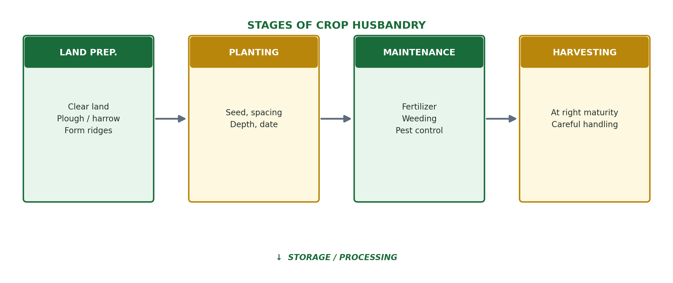

REVIEW QUESTIONS
- 1. What is crop husbandry? Why is it important for farmers?
- 2. Describe the land preparation and planting stages for maize production.
- 3. Why are stem cuttings used to plant cassava instead of seeds? Describe how to plant cassava.
- 4. Explain the importance of staking in yam production.
- 5. State the major pests and diseases of: (a) Maize (b) Cassava (c) Yam.

WEEK 6
Pasture and Forage Crops

A. Meaning of Pasture
A pasture is a piece of land that is covered with grass or other low-growing plants that are grazed (eaten directly) by livestock such as cattle, sheep, goats, and horses. Pastures provide fresh, natural feed for grazing animals and are essential for livestock production in Nigeria.

KEY DEFINITION
- Pasture = Land covered with grasses and other plants used for grazing by livestock.
- Forage Crops = Crops grown specifically to provide food (feed) for livestock, either by direct grazing or by cutting and feeding to animals.

B. Meaning of Forage Crops
Forage crops are crops that are grown specifically to provide animal feed. They can be fed to animals by:
- Direct grazing: Animals eat the plants growing in the field.
- Cutting and feeding fresh (soilage/zero grazing): Plants are cut and carried to animals kept in stalls.
- Hay making: Plants are cut, dried in the sun, and stored for use during the dry season.
- Silage making: Fresh plants are packed tightly in a pit or silo and allowed to ferment; used as preserved feed during dry season.

C. Types of Pasture
1. Natural (Native) Pasture
- These are grasslands that grow naturally without being planted by man.
- They consist of a mixture of local grass species and other plants found naturally in an area.
- Examples: Guinea savanna grassland, Sudan savanna grass, derived savanna in Nigeria.
- Advantages: No cost to establish; diverse plant species; ecologically balanced.
- Disadvantages: Low nutritive value; not uniform; often too dry in the dry season.

2. Improved (Artificial) Pasture
- These are pastures that are deliberately established by planting improved, high-yielding grass or legume species.
- They are managed with fertilizers, controlled grazing, and irrigation for better production.
- Examples: Planted pastures of Elephant grass (Napier grass), Guinea grass, Stylosanthes (legume).
- Advantages: Higher nutritive value; more uniform growth; can be managed to produce year-round.
- Disadvantages: Cost of establishment; needs management and inputs.

D. Common Pasture and Forage Grasses in Nigeria
Forage Grass/Legume | Scientific Name & Key Features
Elephant Grass (Napier grass) | Pennisetum purpureum; very tall (up to 4 m); high yield; very nutritious; widely grown in South Nigeria
Guinea Grass | Panicum maximum; medium height; good nutritive value; common in forest-savanna transition zone
Gamba Grass | Andropogon gayanus; drought resistant; common in Guinea savanna; good for dry areas
Spear Grass (a weed but grazed) | Imperata cylindrica; low nutritive value; considered a weed on farmland
Stylosanthes (Stylo) | Stylosanthes guianensis; a legume; fixes nitrogen; very nutritious; improves soil; mixed with grasses
Centrosema | Centrosema pubescens; a legume creeper; high protein; grows under trees; improves pasture quality
Rhodes Grass | Chloris gayana; drought tolerant; good yield; used for hay making

E. Importance of Pasture and Forage Crops in Livestock Production
- Pastures provide the most natural and cheapest source of feed for ruminant animals (cattle, goats, sheep).
- Good quality pasture improves animal growth rate, milk production, and fertility.
- Forage crops help maintain animal health by providing fibre, vitamins, and minerals not found in concentrated feeds.
- Hay and silage made from forage crops provide feed for animals during the long dry season when natural grass is scarce.
- Legume pastures (Stylosanthes, Centrosema) fix nitrogen into the soil, reducing the need for nitrogen fertilizers.
- Pastures protect the soil from erosion — grass roots hold the soil together.
- Well-managed pastures can increase the carrying capacity of a ranch — the number of animals the land can support.

F. Hay Making and Silage Making
Hay Making:
- Grass or forage crop is cut at the right stage (before flowering — most nutritious).
- Spread on the ground to dry in the sun for 2–4 days until moisture content drops to about 15–20%.
- Bale or bundle the dry hay and store in a dry, ventilated barn.
- Used to feed livestock during the dry season when fresh grass is not available.

Silage Making:
- Fresh green forage is cut and chopped into small pieces.
- Packed tightly into a pit (pit silage) or silo (tower silo) to remove air — anaerobic (no air) conditions.
- The packed forage ferments (lactic acid fermentation) over 4–6 weeks, preserving the feed.
- Silage has higher moisture content and nutritive value than hay.
- Opened and fed to animals during the dry season.

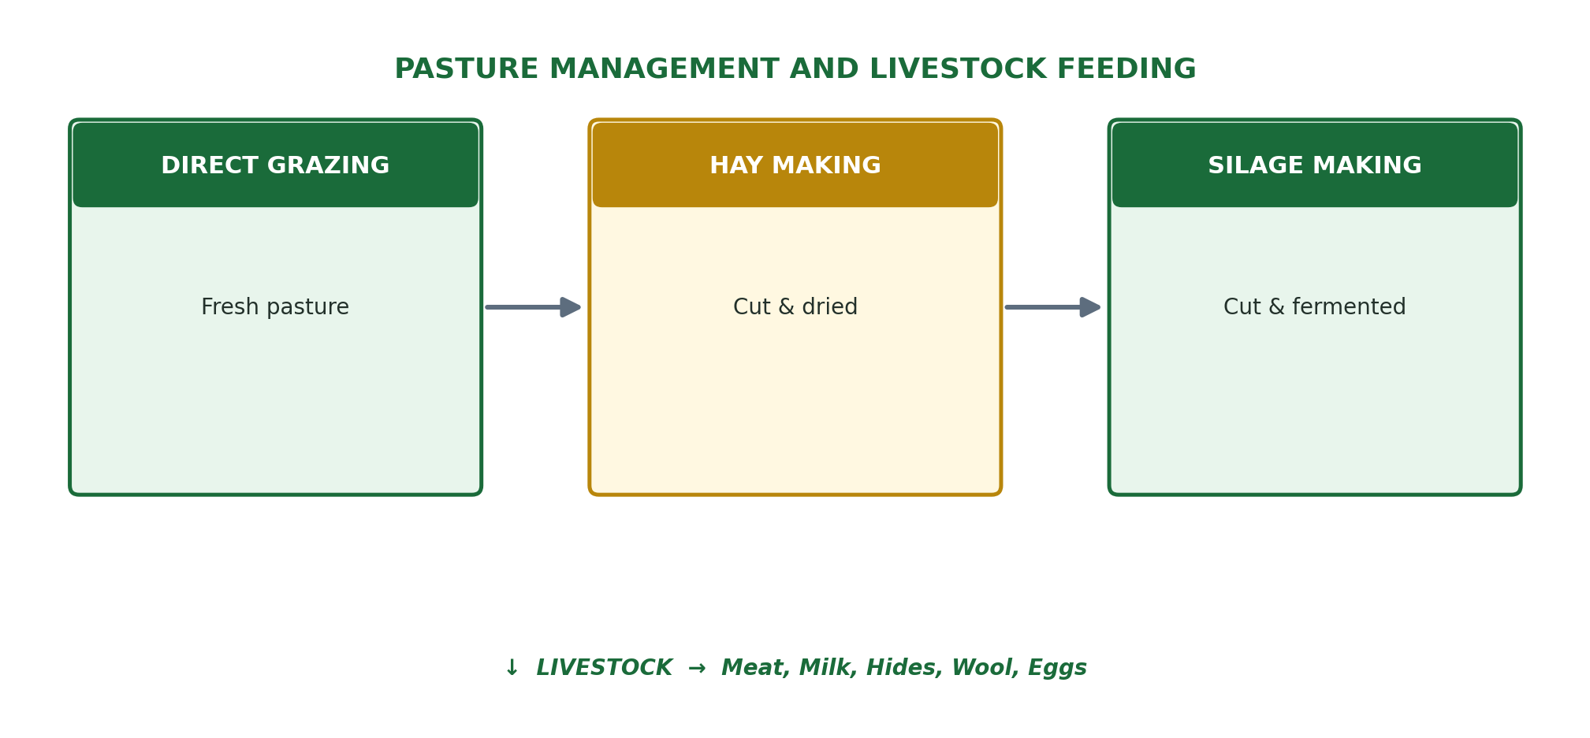

REVIEW QUESTIONS
- 1. Define pasture and forage crops. How are they different?
- 2. Distinguish between natural pasture and improved pasture.
- 3. Name FOUR forage grasses grown in Nigeria and state the importance of each.
- 4. What is hay? Describe the steps involved in making hay.
- 5. Explain the importance of pasture and forage crops in livestock production. Give FOUR points.

WEEK 8
Plant Nutrients and Nutrient Cycle

A. Meaning of Plant Nutrients
Plant nutrients are the chemical elements that plants need for their normal growth, development, reproduction, and production of food. Plants absorb most nutrients from the soil through their roots, and carbon dioxide from the air through their leaves during photosynthesis. A lack of any essential nutrient causes a nutrient deficiency which affects plant growth and reduces yield.

B. Classification of Plant Nutrients
Plant nutrients are divided into TWO groups based on the quantity needed by plants:

1. Macronutrients (Major Nutrients)
These are nutrients needed in LARGE quantities by plants. They include:
Nutrient | Symbol | Function in Plant / Deficiency Symptoms
Nitrogen | N | Promotes leafy, green vegetative growth; part of chlorophyll and protein Deficiency: yellowing of leaves (chlorosis), stunted growth
Phosphorus | P | Promotes root growth, flowering, fruiting, and seed formation; provides energy (ATP) Deficiency: purple/reddish leaves, poor root and fruit development
Potassium | K | Improves disease resistance, drought tolerance, and quality of fruit; regulates water Deficiency: brown scorched leaf edges, weak stems, poor fruit quality
Calcium | Ca | Strengthens cell walls; important for root development and cell division Deficiency: death of growing tips (die-back), blossom end rot in tomato
Magnesium | Mg | Central atom in chlorophyll molecule; needed for photosynthesis Deficiency: yellowing between leaf veins (interveinal chlorosis)
Sulphur | S | Part of some proteins and vitamins; important for nitrogen metabolism Deficiency: general yellowing of young leaves

2. Micronutrients (Minor/Trace Nutrients)
These are nutrients needed in VERY SMALL quantities but are still essential for plant growth. Deficiency of any micronutrient causes serious problems.
Micronutrient | Symbol & Key Role
Iron | Fe — needed for chlorophyll synthesis; deficiency causes yellowing of young leaves
Manganese | Mn — activates enzymes; deficiency causes interveinal chlorosis
Zinc | Zn — needed for growth hormones; deficiency causes small, malformed leaves (little leaf)
Copper | Cu — needed for photosynthesis and respiration; deficiency causes wilting
Boron | B — essential for cell wall formation and flowering; deficiency causes hollow stems
Molybdenum | Mo — needed for nitrogen fixation; deficiency causes cupping of leaves
Chlorine | Cl — involved in water regulation; deficiency causes wilting and leaf death

C. The Nitrogen Cycle
Nitrogen (N) is the most important plant nutrient and makes up 78% of the air. However, most plants cannot use nitrogen directly from the air — they need it in a form they can absorb from the soil. The nitrogen cycle describes how nitrogen moves through the environment.

Process | What Happens
Nitrogen Fixation | Bacteria (Rhizobium in legume roots, Azotobacter in soil) convert atmospheric nitrogen (N2) into ammonia (NH3) that plants can use
Nitrification | Nitrifying bacteria convert ammonia → nitrite (NO2) → nitrate (NO3); plants absorb nitrate through roots
Assimilation | Plants absorb nitrate from soil and use it to make amino acids and proteins
Ammonification | When plants and animals die, decomposers (bacteria, fungi) break down proteins into ammonia — returning nitrogen to soil
Denitrification | Denitrifying bacteria convert nitrate back into nitrogen gas (N2) which is released back into the atmosphere
Leaching | Nitrates dissolve in water and are washed deep into the soil, out of reach of plant roots — a loss of nitrogen

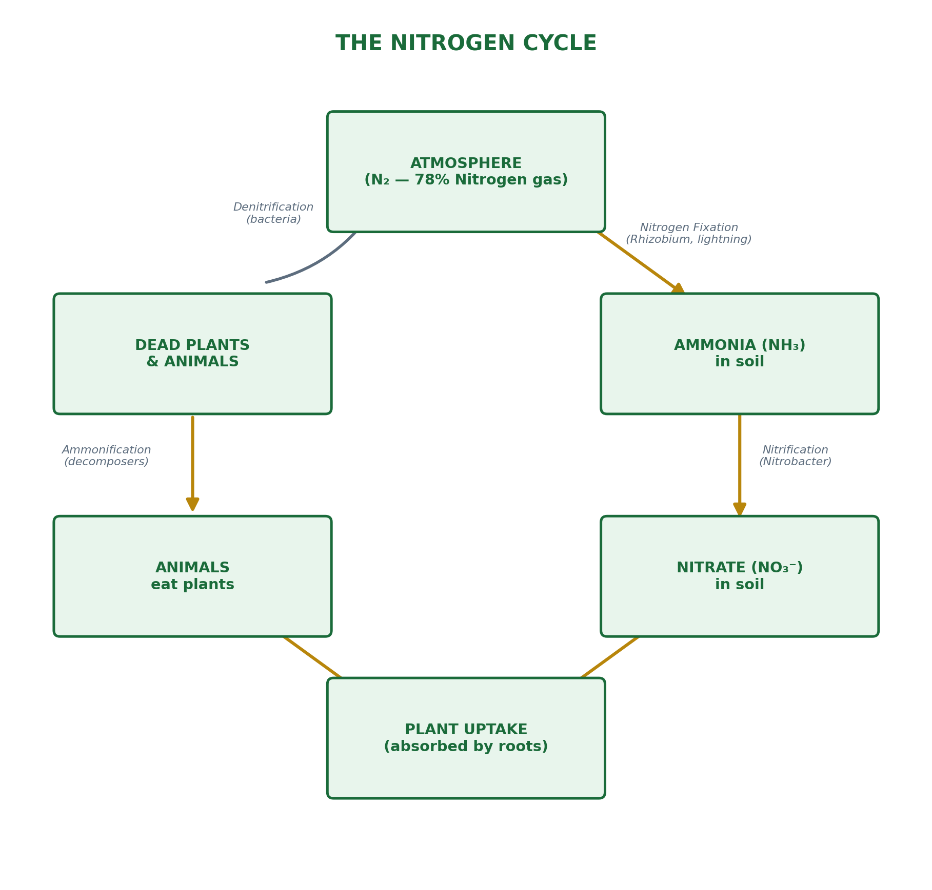

D. The Carbon Cycle
Carbon is an essential element in all living things — it forms the backbone of all organic molecules (sugars, proteins, fats, DNA). The carbon cycle describes how carbon moves between the atmosphere, living organisms, and the soil.

Process | What Happens
Photosynthesis | Plants absorb CO2 from the air and use sunlight to convert it into sugars (food); oxygen is released. CO2 + H2O + Sunlight → Glucose + O2
Respiration | Plants, animals, and microorganisms burn glucose for energy, releasing CO2 back into the atmosphere
Decomposition | When organisms die, decomposers (bacteria, fungi) break down organic matter, releasing CO2 into the air and carbon compounds into the soil (humus)
Combustion | Burning of wood, crop residues, fossil fuels, and biomass releases CO2 into the atmosphere
Fossilization | Over millions of years, carbon from dead organisms is locked up as coal, oil, and natural gas (fossil fuels)

WHY THE NUTRIENT CYCLE IS IMPORTANT FOR FARMING
- Understanding the nitrogen cycle helps farmers know when and how to apply fertilizers.
- Planting legumes (cowpea, soyabean) before or with cereals adds free nitrogen to the soil through nitrogen fixation.
- Adding organic matter (compost, manure) speeds up ammonification and adds nutrients to soil.
- Crop rotation prevents nutrient depletion — different crops take different nutrients from the soil.
- Understanding carbon cycling shows why organic matter (humus) is so important for soil fertility.

REVIEW QUESTIONS
- 1. What are plant nutrients? Distinguish between macronutrients and micronutrients.
- 2. State the function of nitrogen (N), phosphorus (P), and potassium (K) in plant growth.
- 3. What are the deficiency symptoms of: (a) Nitrogen (b) Phosphorus (c) Potassium?
- 4. Describe the nitrogen cycle with the aid of a diagram.
- 5. Explain how planting legumes improves soil nitrogen content.

WEEK 9
Irrigation

A. Definition of Irrigation
Irrigation is the artificial application of water to the soil to supply moisture for crop growth when rainfall is insufficient, unreliable, or absent. It enables farmers to grow crops throughout the year, including in the dry season.

KEY DEFINITION
- Irrigation = The deliberate and artificial supply of water to farmland to supplement rainfall and ensure crops have enough water for growth.

B. Importance of Irrigation
- Enables dry season farming: Farmers can grow crops during the dry season when there is no rainfall — increasing food production all year round.
- Prevents crop failure: During droughts, irrigated crops survive while rain-fed crops wilt and die.
- Increases yield: Crops with adequate water produce more than those dependent on irregular rainfall.
- Allows multiple cropping: With irrigation, farmers can grow 2–3 crops per year on the same land.
- Improves food security: Year-round farming means more consistent food supply for the population.
- Increases farmer income: More crops harvested means more produce to sell and higher income.
- Enables cultivation of water-demanding crops: Crops like rice, vegetables, and sugarcane need large amounts of water and grow best under irrigation.

C. Types of Irrigation
There are FIVE main types of irrigation used in Nigeria and around the world:

1. Surface (Flood) Irrigation
- Water is applied directly to the soil surface and allowed to flow (flood) over the field.
- Sub-types: Basin flooding (water fills a flat, level basin around trees or crops) and Furrow irrigation (water flows along furrows between crop rows).
- Advantages: Simple, cheap, no expensive equipment needed.
- Disadvantages: Wastes a lot of water through evaporation and runoff; can cause waterlogging and soil erosion.
- Suitable for: Rice paddies, sugarcane, and flat, level farmland.

2. Sprinkler Irrigation
- Water is pumped through pipes to sprinkler heads that spray water like rainfall over the crops.
- Types: Fixed sprinklers, rotating sprinklers (Rainbird), centre-pivot systems for very large farms.
- Advantages: More uniform water distribution; less water waste than surface irrigation; can cover large areas.
- Disadvantages: Expensive to install pipes and pumps; needs a power source; wind can displace spray.
- Suitable for: Vegetables, cereals, and fruit crops on medium to large farms.

3. Drip (Trickle) Irrigation
- Water is delivered directly to the root zone of individual plants through a network of pipes, tubes, and emitters (drippers) that release very small amounts of water slowly.
- Advantages: Most water-efficient method — saves up to 50% water compared to surface irrigation; reduces weed growth; prevents leaf diseases; suitable for arid areas.
- Disadvantages: Very expensive to install; emitters can get clogged; requires clean water and filtration.
- Suitable for: Tomatoes, peppers, fruits, vegetables, and high-value crops in dry areas.

4. Subsurface Irrigation
- Water is supplied below the soil surface through a network of underground pipes, allowing it to seep upward to the root zone by capillary action.
- Advantages: Almost no evaporation loss; very efficient; no surface disturbance.
- Disadvantages: Very expensive to install and maintain; pipes can clog or be damaged by roots.

5. Manual (Traditional) Irrigation
- Water is carried manually using buckets, calabashes, or watering cans from nearby streams, wells, or ponds to water crops.
- Advantages: Very cheap; no equipment cost; simple technology.
- Disadvantages: Very labour-intensive and time-consuming; can only irrigate very small plots.
- Common among small-scale vegetable farmers along river banks (fadama farming) in northern Nigeria.

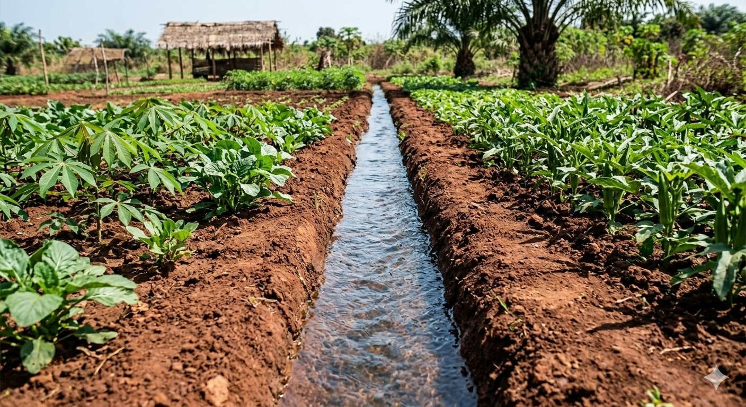
A simple earthen irrigation canal supplying water to crop rows.

Type of Irrigation | Method | Best For
Surface (Flood) | Water flows over soil surface | Rice, sugarcane, flat land
Sprinkler | Water sprayed like rain from pipes | Vegetables, cereals, large farms
Drip | Slow drip to individual plant roots | Tomato, pepper, arid areas
Subsurface | Water seeps up from underground pipes | High-value crops, dry areas
Manual | Buckets, watering cans carried by hand | Small vegetable plots

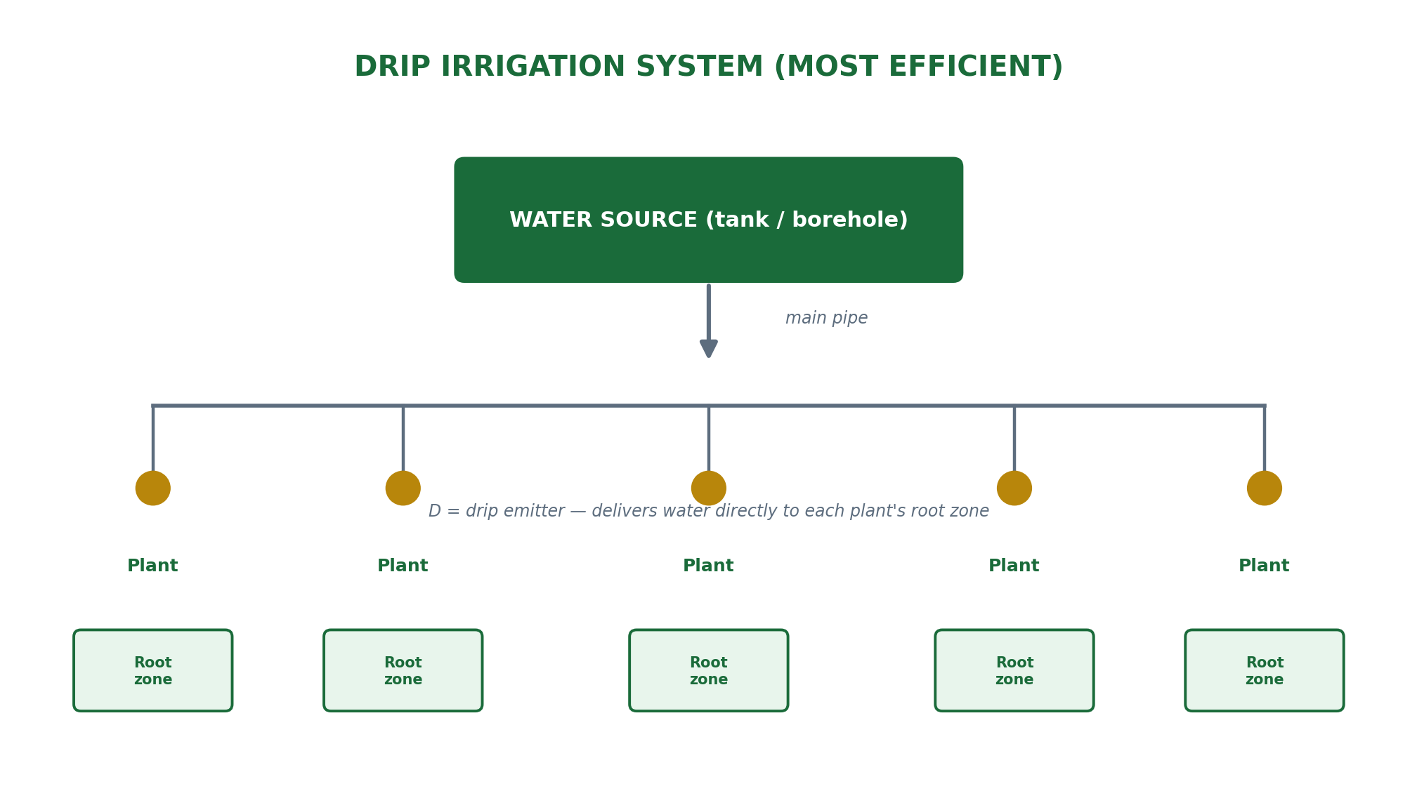

D. Sources of Water for Irrigation
- Rivers and streams: Main sources for large irrigation schemes (e.g. River Niger, Benue, Kaduna).
- Boreholes and wells: Groundwater pumped to the surface for irrigation.
- Reservoirs and dams: Water stored behind dams is released for irrigation (e.g. Kainji Dam, Tiga Dam).
- Ponds: Small farm ponds collect rainwater for dry-season irrigation.
- Treated wastewater: In some countries, treated municipal water is used for irrigation.

REVIEW QUESTIONS
- 1. Define irrigation. Why is it important for agricultural production in Nigeria?
- 2. Name and describe FOUR types of irrigation. Give ONE advantage and ONE disadvantage of each.
- 3. Why is drip irrigation considered the most efficient method of irrigation?
- 4. List FOUR sources of water used for irrigation in Nigeria.
- 5. How does irrigation contribute to food security in Nigeria?

WEEK 10
Drainage

A. Meaning of Drainage
Drainage is the removal of excess water from the soil to prevent waterlogging and create suitable conditions for crop growth. Just as irrigation adds water to dry soils, drainage removes too much water from wet soils. Both are essential for successful crop production in different environments.

KEY DEFINITION
- Drainage = The process of removing excess water from the soil surface and the root zone to prevent waterlogging and improve soil aeration for crop growth.

B. Importance of Drainage in Agriculture
- Prevents waterlogging: Excess water fills all soil pore spaces, preventing air from reaching roots — plants suffocate and die without oxygen.
- Improves soil aeration: Removing excess water allows air (oxygen) to enter the soil, which is essential for root respiration and nutrient uptake.
- Warms up the soil: Waterlogged soils are cold; drained soils warm up faster in the morning, promoting early plant growth.
- Enables use of farm machinery: Waterlogged fields cannot be entered by tractors and machines — drainage makes fields firm enough for mechanization.
- Reduces soil diseases: Many soil-borne diseases and fungi thrive in wet conditions; drainage reduces their occurrence.
- Improves nutrient availability: In waterlogged soils, toxic substances build up; drainage allows normal nutrient cycling.
- Allows deep root penetration: In well-drained soils, roots can grow deep, accessing more water and nutrients.
- Extends the farming season: Drainage allows earlier planting in wet areas because fields dry up faster after rain.

C. Types (Methods) of Drainage
There are TWO main types of drainage:

A. Surface Drainage
Surface drainage involves the removal of excess water from the soil surface by allowing it to flow away through channels, ridges, or slopes.

1. Open Ditch Drainage
- Ditches (channels) are dug around or across the field to collect and carry away excess surface water.
- Advantages: Cheap and easy to construct; very effective for removing large amounts of water.
- Disadvantages: Ditches take up valuable farmland; they can become blocked with weeds and silt; they can be dangerous (people and animals can fall in).

2. Land Forming / Shaping
- The land surface is shaped (graded) so that water flows naturally toward ditches or outlets.
- Forming ridges on flat or waterlogged land raises the planting surface above the water table.

3. Raised Beds and Ridges
- Crops are planted on raised ridges or beds so that their roots are above the waterlogged zone.
- Water collects in the furrows (channels) between ridges and can drain away.

B. Subsurface (Underground) Drainage
Subsurface drainage removes excess water from below the soil surface, allowing the water table to drop.

1. Tile (Pipe) Drainage
- Perforated pipes (clay tiles or plastic pipes) are buried below the soil surface.
- Excess water seeps into the pipes through the holes and is carried away to an outlet.
- Very effective and permanent; keeps the surface free for farming.
- Expensive to install but long-lasting.

2. Mole Drainage
- A bullet-shaped device is pulled through the soil to create underground channels (mole drains) through which water flows away.
- Cheaper than tile drainage but less permanent.

Type | Method | Advantages
Open Ditch | Channels dug on surface | Cheap; removes large amounts of water quickly
Ridging/Raised Beds | Crops planted on raised ridges | Simple; keeps roots above water; easy to do
Tile/Pipe Drainage | Perforated pipes buried underground | Permanent; keeps surface free; very effective
Mole Drainage | Bullet pulled through soil creates channels | Cheaper than pipes; good for clay soils

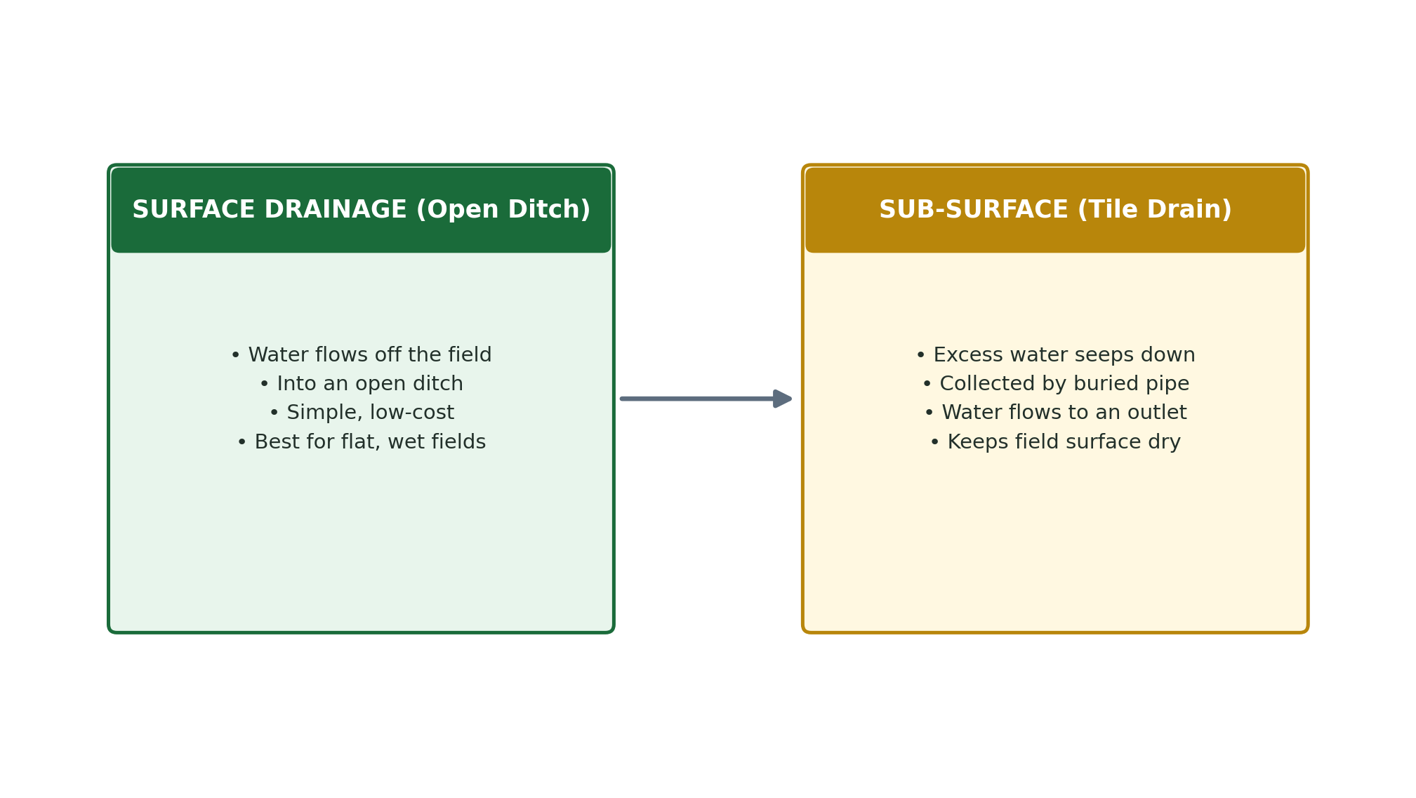

D. Differences Between Irrigation and Drainage
Irrigation | Drainage
Adds water to the soil when it is too dry | Removes water from the soil when it is too wet
Used in dry seasons and arid areas | Used in wet seasons and waterlogged areas
Supplies moisture for crop growth | Creates air space in the soil for root respiration
Examples: drip system, sprinklers, surface flood | Examples: ditches, tile pipes, ridging
Prevents drought stress in crops | Prevents waterlogging and root rot in crops

REVIEW QUESTIONS
- 1. Define drainage. Why is it important in crop production?
- 2. Distinguish between surface drainage and subsurface drainage. Give TWO examples of each.
- 3. How do ridges and raised beds help in draining waterlogged farmland?
- 4. What is tile (pipe) drainage? Describe how it works.
- 5. Differentiate between irrigation and drainage under FOUR headings.

WEEK 11
Agricultural Pollution

A. Meaning of Agricultural Pollution
Agricultural pollution refers to the contamination of the environment (soil, water, and air) caused by farming activities. When chemicals, waste materials, or harmful substances from farms enter the environment in quantities that are harmful to plants, animals, and humans, it is called agricultural pollution. It is a serious environmental problem in modern agriculture.

KEY DEFINITION
- Agricultural Pollution = The contamination of soil, water, and air as a result of farming activities, including the use of chemicals, poor waste management, and inappropriate land use practices.

B. Causes of Agricultural Pollution

1. Excessive Use of Chemical Fertilizers
- When farmers apply too much fertilizer, the excess nutrients (especially nitrates and phosphates) are washed off by rain into rivers, lakes, and streams.
- This causes eutrophication — excessive growth of algae in water bodies, which uses up oxygen and kills fish and other aquatic life.
- Fertilizer residues can also leach into groundwater, contaminating drinking water.

2. Excessive Use of Pesticides and Herbicides
- Pesticides sprayed on crops may kill non-target organisms (beneficial insects, birds, fish).
- Persistent pesticides (e.g. DDT — now banned) remain in the environment for years and accumulate in the food chain (bioaccumulation).
- Pesticide residues on food crops pose health risks to consumers.
- Herbicides can kill non-target plants and contaminate water sources.

3. Improper Disposal of Farm Wastes
- Animal wastes (manure from pig, cattle, and poultry farms) washed into water bodies cause water pollution.
- Burning of crop residues on the farm releases carbon dioxide, carbon monoxide, and ash particles into the air — causing air pollution.
- Rotting organic waste produces methane gas — a greenhouse gas that contributes to climate change.

4. Soil Erosion
- Erosion caused by heavy rain or poor farming practices washes soil (silt) and farm chemicals into rivers, causing siltation and water pollution.
- Turbid (muddy) water affects aquatic life and makes water unsuitable for drinking.

5. Oil Pollution (Niger Delta)
- Oil spills from pipelines crossing agricultural areas — especially in the Niger Delta — have permanently destroyed thousands of hectares of farmland and fishing ponds.
- Crude oil kills soil organisms, prevents plant growth, and contaminates rivers.

6. Use of Contaminated Irrigation Water
- When water from polluted rivers or industrial effluent is used for irrigation, heavy metals (lead, cadmium, mercury) and pathogens enter the soil and are absorbed by crops.
- People who eat these crops may suffer heavy metal poisoning or waterborne diseases.

7. Over-Grazing
- Too many animals grazing on a piece of land removes all vegetation, leaving the soil bare.
- Bare soil is easily eroded by wind and rain, causing dust storms and silting of rivers.

C. Effects of Agricultural Pollution
Effect | Explanation
Water pollution | Fertilizer runoff causes eutrophication; kills fish and aquatic life; contaminates drinking water
Soil degradation | Chemicals destroy soil microorganisms; repeated chemical use reduces soil organic matter and fertility
Air pollution | Burning crop residues and methane from animal waste contribute to greenhouse gases and global warming
Human health problems | Pesticide residues on food; nitrates in drinking water can cause 'blue baby syndrome' in infants
Loss of biodiversity | Pesticides kill beneficial insects (bees), birds, fish, and other wildlife
Destruction of farmland | Oil spills and chemical contamination render land unusable for many years
Climate change | Release of CO2, methane (CH4), and nitrous oxide (N2O) from farms contributes to global warming

D. Control of Agricultural Pollution
- Integrated Pest Management (IPM): Use biological, cultural, and mechanical pest control methods to reduce reliance on chemical pesticides.
- Proper fertilizer use: Apply fertilizers at the right rate, time, and method (split application) to reduce runoff and leaching.
- Buffer zones: Plant strips of vegetation (trees, grass) along rivers and water bodies to filter runoff before it reaches the water.
- Crop rotation: Rotate crops to maintain soil health and reduce the need for chemical inputs.
- Organic farming: Use compost, manure, and bio-pesticides instead of synthetic chemicals.
- Proper waste management: Treat and compost animal manure before use; do not dump raw waste near water sources.
- Enforce environmental laws: Government should strictly enforce laws against oil spills, indiscriminate burning, and excessive chemical use.
- Controlled irrigation: Use drip irrigation to minimize fertilizer and pesticide runoff.
- Agroforestry: Plant trees on farmland to reduce erosion and improve the environment.

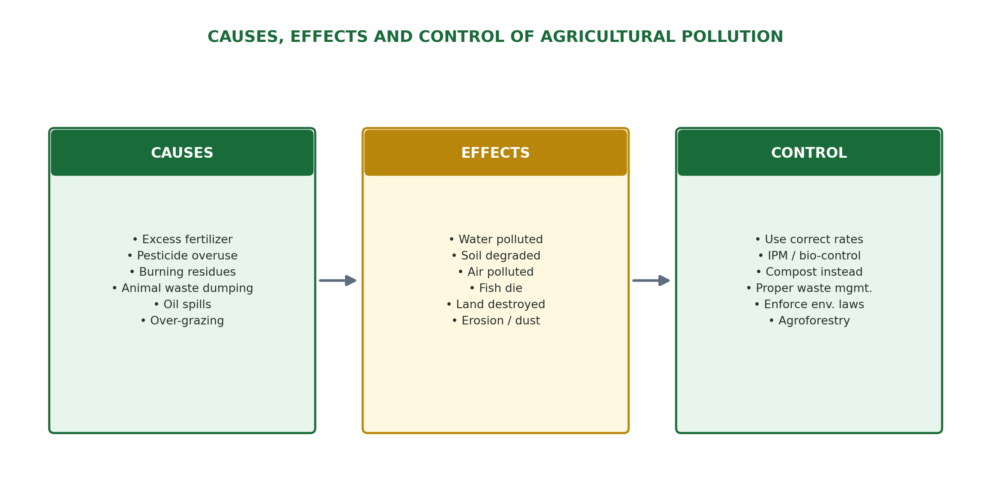

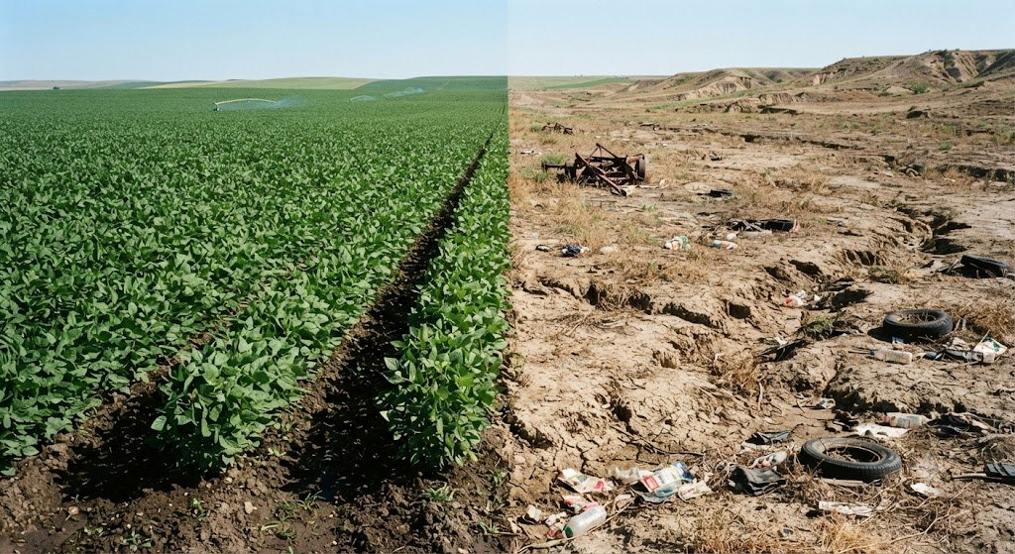
Contrast between a healthy managed field and degraded, polluted farmland.

SUMMARY — AGRICULTURAL POLLUTION
- Meaning: Contamination of soil, water, and air by farm activities.
- Main causes: Excess fertilizers, pesticides, animal wastes, burning, oil spills, over-grazing.
- Main effects: Water and soil pollution, health problems, loss of biodiversity, climate change.
- Control: IPM, correct fertilizer use, organic farming, buffer zones, environmental laws.

REVIEW QUESTIONS
- 1. Define agricultural pollution. Give TWO examples of how farming activities can cause pollution.
- 2. What is eutrophication? How does it happen and what are its effects on aquatic life?
- 3. List FIVE causes of agricultural pollution in Nigeria.
- 4. State FIVE effects of agricultural pollution on the environment and human health.
- 5. Suggest FIVE measures that can be taken to control agricultural pollution.

END OF THIRD TERM LESSON NOTES — SS1 COMPLETE!

Congratulations on completing your SS1 Agricultural Science course!

Prepare well for your Final Examination and advance confidently to SS2.

— Kenneth Chiakwa, B.Sc., M.Sc. Agricultural Economics, ESUT

REVISION QUESTIONS
The questions below are collected from every week of all three terms, arranged by term and week, for quick end-of-session revision.
FIRST TERM REVISION QUESTIONS
WEEK 1: Meaning and Importance of Agriculture
Define agriculture in your own words.
List FIVE branches of agriculture and explain TWO of them.
State THREE ways in which agriculture is important to an individual.
Explain how agriculture contributes to Nigeria's national development.
What does GDP mean? How does agriculture contribute to it?
WEEK 2: Problems of Agricultural Development and Solutions
List FIVE problems facing agricultural development in Nigeria.
Explain what 'land tenure' means and how it affects farming.
Why is poor storage a big problem for Nigerian farmers? Give TWO examples of its effects.
Suggest THREE ways the government can improve agriculture in Nigeria.
How do pests and diseases affect agricultural production?
WEEK 3: Subsistence and Commercial Agriculture
Define subsistence agriculture and give TWO examples of subsistence crops grown in Nigeria.
What is commercial agriculture? How is it different from subsistence farming?
List THREE advantages and TWO disadvantages of commercial agriculture.
State TWO features that distinguish subsistence farming from commercial farming.
Why do you think most Nigerian farmers still practise subsistence agriculture?
WEEK 4: Role of Government in Agricultural Development
List FOUR ways the Nigerian government supports agricultural development.
What is Operation Feed the Nation (OFN)? When was it launched and by whom?
Explain the role of Agricultural Development Programme (ADP) in Nigeria.
What is an agricultural extension worker? What does he/she do?
How does the government use subsidies to help farmers?
WEEK 6: Role of NGOs in Agricultural Development
What is an NGO? Give the full meaning of the abbreviation.
Name THREE international organisations that contribute to agricultural development in Nigeria.
Explain FOUR ways in which NGOs help farmers in Nigeria.
What is IITA? Where is it located and what does it do?
Why are NGO interventions important in countries like Nigeria?
WEEK 8: Agricultural Laws and Reforms
What is land tenure? Name FOUR types of land tenure that existed in Nigeria before 1978.
When was the Land Use Decree enacted and under whose government?
State TWO advantages and TWO disadvantages of the Land Use Act of 1978.
What is a Certificate of Occupancy and why is it important to a farmer?
Explain how the land tenure system affects agricultural production in Nigeria.
WEEK 9: Land and Its Uses
Define land as used in agricultural economics.
List FOUR characteristics of land that make it different from other factors of production.
Give FOUR agricultural uses of land.
Give THREE non-agricultural uses of land.
Why is land considered the most important factor of production in agriculture?
WEEK 10: Agricultural Ecology
Define agricultural ecology in your own words.
What is an ecosystem? Give ONE example from a farm.
Distinguish between biotic and abiotic components of a farm ecosystem. Give THREE examples of each.
Explain the term 'decomposers' and state their importance to the farm ecosystem.
Describe TWO types of interactions that occur in a farm ecosystem.
WEEK 11: Factors Affecting Land Availability for Agricultural Purposes
List SIX factors that affect the availability of land for agricultural purposes.
Explain how population pressure affects the availability of farmland in Nigeria.
How does soil type and topography limit agricultural land use? Give TWO examples.
What is desertification? How is it affecting farmland in northern Nigeria?
Suggest THREE ways the government can improve land availability for agriculture.
SECOND TERM REVISION QUESTIONS
WEEK 1: Agro-Allied Industries
What is an agro-allied industry? Give TWO examples.
List FIVE agro-allied industries in Nigeria and state the agricultural raw material each one uses.
Explain the relationship between agriculture and agro-allied industries.
How do agro-allied industries help farmers earn more income?
State FOUR ways agro-allied industries are important to Nigeria's economy.
WEEK 2: Environmental Factors Affecting Agriculture
Name FOUR abiotic and THREE biotic environmental factors that affect agriculture.
How does rainfall affect agricultural production in Nigeria? Give THREE specific effects.
Explain the importance of temperature to crop production.
State FOUR ways in which wind affects farming.
How do weeds affect crop production? Name TWO common weeds found on Nigerian farms.
WEEK 3: Rock Formation
What is a rock? How are rocks related to soil formation?
Name and describe the THREE types of rocks. Give TWO examples of each.
What are metamorphic rocks? How are they formed?
Explain THREE types of weathering and give ONE example of each.
Why is limestone important to farmers? How is it used on the farm?
WEEK 4: Soil Formation and Profile Development
Define soil and list its FIVE main components.
Explain FOUR processes involved in soil formation.
What is a soil profile? Draw and label a typical soil profile showing all horizons.
Describe the A horizon (topsoil) and explain why it is the most important layer for farming.
How does the activity of living organisms help in soil formation?
WEEK 6: Soil Types, Composition and Properties
Name and describe the THREE main types of soil based on texture.
What is the best type of soil for agriculture and why?
Explain the difference between soil texture and soil structure.
What is soil pH? How does it affect crop production?
List the FIVE components of soil and state the ideal percentage of each in a good loamy soil.
WEEK 8: Simple Farm Tools
What is a farm tool? How is it different from farm machinery?
List FIVE farm tools and state the specific use of each.
Name and describe the TWO main parts of a hoe.
Classify farm tools under the following operations: land clearing, planting, and harvesting.
State SIX general rules for maintaining farm tools properly.
WEEK 9: Farm Machinery and Implements
Distinguish between farm machinery and farm implements. Give TWO examples of each.
What is a combine harvester? What THREE operations does it perform in one pass?
List FIVE tractor implements and state the specific function of each.
State FOUR advantages of using farm machinery over simple farm tools.
Why is the tractor considered the most important farm machine? Give FOUR reasons.
WEEK 10: Maintenance of Farm Machinery
Why is it important to maintain farm machinery regularly? Give FOUR reasons.
Name and describe THREE types of maintenance carried out on farm machines.
List SIX daily maintenance checks that should be performed on a tractor before use.
What is periodic maintenance? Give FOUR examples of periodic maintenance tasks.
State SIX safety precautions that must be observed when operating farm machinery.
WEEK 11: Problems of Agricultural Mechanization
Define agricultural mechanization.
List and explain FIVE problems facing agricultural mechanization in Nigeria.
How does soil compaction caused by machines affect crop production?
Why are small and fragmented farmlands a problem for agricultural mechanization?
Suggest FOUR solutions to the problems of agricultural mechanization in Nigeria.
THIRD TERM REVISION QUESTIONS
WEEK 1: Prospects of Agricultural Mechanization
Define agricultural mechanization in your own words.
List and explain FIVE benefits of agricultural mechanization.
State FIVE limitations of agricultural mechanization in Nigeria.
Why is timely farm operation important, and how does mechanization help achieve it?
Discuss TWO prospects (future developments) of agricultural mechanization in Nigeria.
WEEK 2: Sources of Farm Power
What is farm power? Why is it important in agriculture?
Name SIX sources of farm power and give ONE example of each.
Explain the advantages and disadvantages of animal power as a source of farm energy.
Why is solar power becoming increasingly important in Nigerian agriculture?
Compare human power and mechanical power as sources of farm energy under the following headings: speed, cost, and area covered.
WEEK 3: Classification of Crops
What is a crop? Mention THREE ways in which crops can be classified.
Distinguish between food crops and cash crops. Give FOUR examples of each.
Define annual, biennial, and perennial crops. Give TWO examples of each.
List FOUR groups of crops based on botanical features and give TWO examples of each.
Why is cocoa referred to as a cash crop? What products are made from cocoa?
WEEK 4: Husbandry of Selected Crops
What is crop husbandry? Why is it important for farmers?
Describe the land preparation and planting stages for maize production.
Why are stem cuttings used to plant cassava instead of seeds? Describe how to plant cassava.
Explain the importance of staking in yam production.
State the major pests and diseases of: (a) Maize (b) Cassava (c) Yam.
WEEK 6: Pasture and Forage Crops
Define pasture and forage crops. How are they different?
Distinguish between natural pasture and improved pasture.
Name FOUR forage grasses grown in Nigeria and state the importance of each.
What is hay? Describe the steps involved in making hay.
Explain the importance of pasture and forage crops in livestock production. Give FOUR points.
WEEK 8: Plant Nutrients and Nutrient Cycle
What are plant nutrients? Distinguish between macronutrients and micronutrients.
State the function of nitrogen (N), phosphorus (P), and potassium (K) in plant growth.
What are the deficiency symptoms of: (a) Nitrogen (b) Phosphorus (c) Potassium?
Describe the nitrogen cycle with the aid of a diagram.
Explain how planting legumes improves soil nitrogen content.
WEEK 9: Irrigation
Define irrigation. Why is it important for agricultural production in Nigeria?
Name and describe FOUR types of irrigation. Give ONE advantage and ONE disadvantage of each.
Why is drip irrigation considered the most efficient method of irrigation?
List FOUR sources of water used for irrigation in Nigeria.
How does irrigation contribute to food security in Nigeria?
WEEK 10: Drainage
Define drainage. Why is it important in crop production?
Distinguish between surface drainage and subsurface drainage. Give TWO examples of each.
How do ridges and raised beds help in draining waterlogged farmland?
What is tile (pipe) drainage? Describe how it works.
Differentiate between irrigation and drainage under FOUR headings.
WEEK 11: Agricultural Pollution
Define agricultural pollution. Give TWO examples of how farming activities can cause pollution.
What is eutrophication? How does it happen and what are its effects on aquatic life?
List FIVE causes of agricultural pollution in Nigeria.
State FIVE effects of agricultural pollution on the environment and human health.
Suggest FIVE measures that can be taken to control agricultural pollution.

GLOSSARY
Key terms from across the First, Second, and Third Term lesson notes, arranged alphabetically.
Agricultural Ecology — The study of ecological relationships within agricultural systems, including the interactions between crops, animals, soil, water, climate, and human activities.
Agricultural Mechanization — The adoption and use of machines and modern technology to perform farm operations in place of manual (human) or animal effort.
Agricultural Pollution — The contamination of soil, water, and air as a result of farming activities, including the use of chemicals, poor waste management, and inappropriate land use practices.
Agriculture — The deliberate effort by man to cultivate crops and rear animals for the benefit of mankind.
Agro-Allied Industries — Industries that use agricultural products as raw materials to produce goods for human use.
Commercial Agriculture — Large-scale farming done primarily for sale and profit, using modern technology and large farmland.
Drainage — The process of removing excess water from the soil surface and the root zone to prevent waterlogging and improve soil aeration for crop growth.
Farm Power — The energy or force applied to carry out agricultural operations on the farm.
Farm Tools — Simple hand-operated implements used to carry out farm operations such as land preparation, planting, weeding, and harvesting.
Forage Crops — Crops grown specifically to provide food (feed) for livestock, either by direct grazing or by cutting and feeding to animals.
Irrigation — The deliberate and artificial supply of water to farmland to supplement rainfall and ensure crops have enough water for growth.
Land — All natural gifts of nature used in the production of goods and services, including the soil, vegetation, minerals, and water bodies.
NGO (Non-Governmental Organisation) — A non-profit organisation that works independently of government to provide support, services, and advocacy for development.
Pasture — Land covered with grasses and other plants used for grazing by livestock.
Subsistence Agriculture — Farming done mainly for family consumption, with little or no surplus for sale.

REFERENCES
• West African Examinations Council (WAEC). Agricultural Science Syllabus.
• National Examinations Council (NECO). Agricultural Science Syllabus.
• Nigerian Educational Research and Development Council (NERDC). Senior Secondary Education Curriculum — Agricultural Science.
• Federal Ministry of Agriculture and Rural Development, Nigeria. Agricultural policy and extension publications.
• Food and Agriculture Organization of the United Nations (FAO). Publications on crop production, soils, and farm mechanization.
• Chiakwa, K. O. Complete Broiler Production Guide. Kennessy Ebooks.
• Chiakwa, K. O. Natural Poultry Health Guide. Kennessy Ebooks.

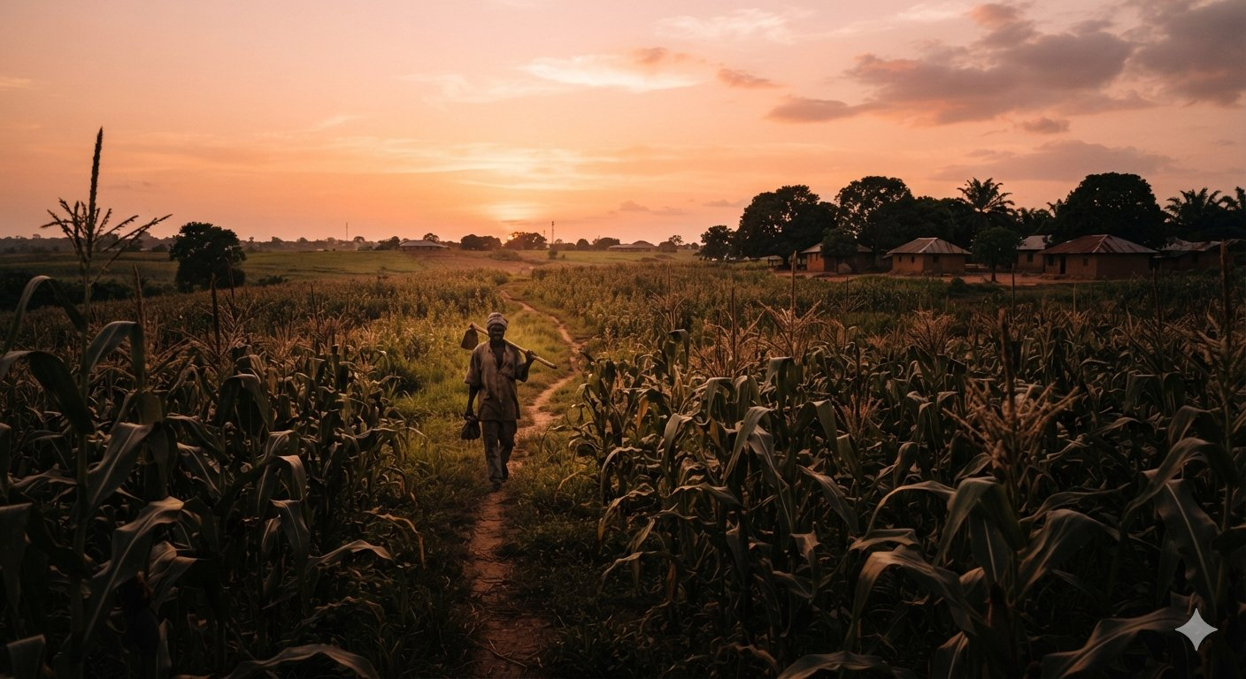
Until the next lesson — keep learning, keep growing.

