Homework Assignment 10

If a ball drops from the height *h* inches, it will hit the floor and bounce to the height ($\frac{3}{4}h-2$) inches, or it will not bounce if ($\frac{3}{4}h-2$) ≤ 0.

For example, if a ball drops from the height 12 inches, it will bounce to the height 3/4×12-2=7 inches, and then it will drop down and bounces again to the height 3/4×7-2=3.25 inches, and then it will drop down and bounces for the third time and reach the height 3/4×3.25-2=0.4375 inch. After that, the ball will drop down and hit the floor for the fourth time, however, it will not bounce because 3/4×0.4375-2 ≤ 0. The total times that the ball hit the floor is 4.

Write a program to compute how many times a ball will hit the floor.

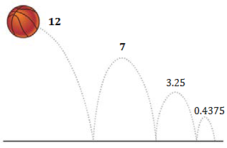

Requirement:

(1) You should write a function **get_height()** to let the user input the initial height of the ball and make sure it is a positive number. If the user types a non-positive number, your program must ask the user to input again. The program will repeat this as many time as necessary until the user finally inputs a positive number. The function should return the positive height.

(2) You should write a function **compute_bounce_height()** to calculate the height the ball can reach after it bounces for a single time. The input parameter of the function should be the height before the ball drops down. The function should return the height the ball can reach after it bounces off.

(3) You should write a function **count_times_bounced()** to count how many times the ball hits the floor. The input parameter of the function should be the initial height of the ball before it drops down for the very first time. The function should return how many times the ball hits the floor.

(4) Your main function should call **get_height()** and **count_times_bounced()** and display the times the ball will hit the floor. The main function is provided in the template.

(5) Please follow the coding style of the template.

The output of your program should look like this:

What is the initial height of the ball?

-1

Please enter a positive number. Try again:

8

The ball will hit the floor 3 time(s).

Hint: **count_times_bounced()** should call **compute_bounce_height()** in a loop.