In this AzureStorage sample, I collected these kinds of logs:

* Collect windows event logs:

config.WindowsEventLog.DataSources.Add("System!*")

* Collect Crash Dumps:

Diagnostics.CrashDumps.EnableCollection(true)

* Collect Performance counter logs:

let perfCounterConfig = new PerformanceCounterConfiguration()

        perfCounterConfig.CounterSpecifier <- @"\Processor(_Total)\% Processor Time"

        perfCounterConfig.SampleRate <- TimeSpan.FromSeconds(5.0)

        config.PerformanceCounters.DataSources.Add(perfCounterConfig)

* There are 3 other kinds of logs were collected by default

1. Diagnostic infrastructure logs
2. Windows Azure logs
3. IIS logs

* Failed request Logs:

This kind of log can just be generated in web role.

You can generate this log in Failed Request Page by click the button. If you transfer the log to storage , it will exists in FailedReqLogFile folder at below picture.

We need to config the Web.config file in Web role to generate the request log.

See the [tutorial](http://msdn.microsoft.com/en-us/library/windowsazure/gg433083.aspx).

These logs are stored under folder “directory\DiagnosticStore” when you run the sample locally.

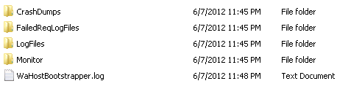

In this sample , transfer logs in on-demand way is implemented in Transfer Page, by click the button on the page , you can transfer the logs to storage.

Useful link :

<http://blogs.msdn.com/b/windowsazurestorage/archive/2011/08/03/windows-azure-storage-logging-using-logs-to-track-storage-requests.aspx>