EXPT: 2 TCP CLIENT-SERVER COMMUNICATION USING SOCKET PROGRAMMING IN PYTHON
Aim: K Kenneth Prathap
241901048
To study and implement socket programming in Python for establishing communication between a client and a server using the TCP/IP protocol.

Introduction:
Socket programming is a method used for communication between two programs running on a network.
It allows a client and a server to send and receive data through network connections.
Python provides a built-in module called socket that supports both TCP (Transmission Control Protocol) and UDP (User Datagram Protocol) communication.

Algorithm:
Server:
1. Import the socket module.
2. Create a socket object using socket.socket().
3. Bind the socket to a host address and port using bind().
4. Listen for incoming connections using listen().
5. Accept a connection using accept().
6. Receive data from the client using recv().
7. Send a response to the client using send().
8. Close the connection using close().
Client:
1. Import the socket module.
2. Create a socket object using socket.socket().
3. Connect to the server using connect((host, port)).
4. Send data to the server using send().
5. Receive a response from the server using recv().
6. Close the connection using close().

Code: : K Kenneth Prathap
241901048
SERVER:
import socket
sockfd=socket.socket(socket.AF_INET, socket.SOCK_STREAM)
print('Socket Created')
sockfd.bind(('localhost',55555))
sockfd.listen(3)
print('Waiting for connections')
while True:
clientfd,addr=sockfd.accept()
receivedMsg=clientfd.recv(1024).decode()
print("Connected with ",addr)
print("Message Received from Client: ",receivedMsg)
clientfd.send(bytes(receivedMsg,'utf-8'))
print("Message reply sent to Client!")
print("Do you want to continue(type y or n):")
choice=input()
if choice=='n':
break
CLIENT:
import socket
clientfd=socket.socket(socket.AF_INET, socket.SOCK_STREAM)
clientfd.connect(('localhost',55555))
name=input("Enter your message:")
clientfd.send(bytes(name,'utf-8'))
print("Message Received from Server: ",clientfd.recv(1024).decode())

: K Kenneth Prathap
241901048

Output: Server:
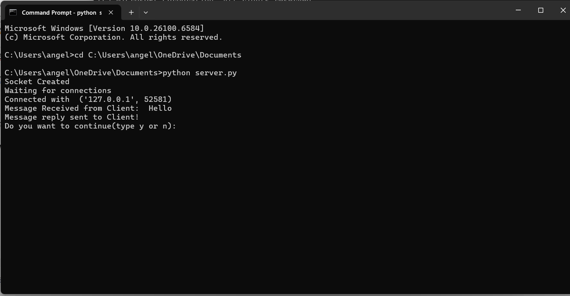
Client:
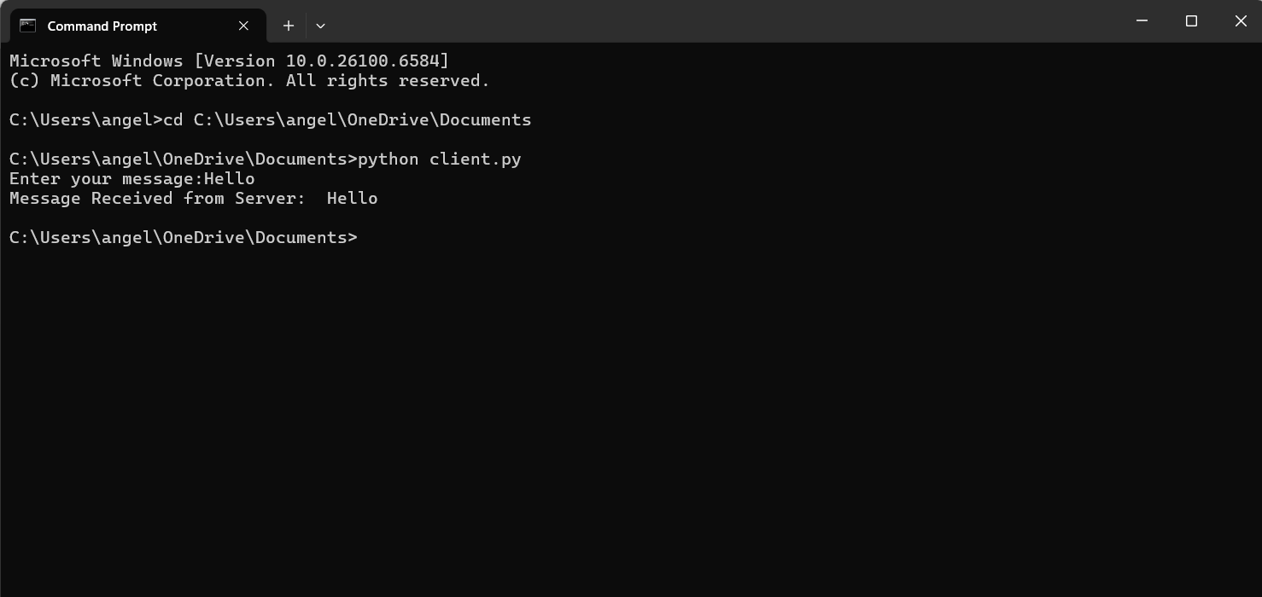
Result:
The implementation of socket programming in Python was successfully executed. A TCP connection was established between the client and the server, enabling successful message exchange.

