K Kenneth Prathap
241901048
EXPT: 4 DEVELOP A CUSTOMIZED PING COMMAND TO TEST THE SERVER CONNECTIVITY
Introduction:
A customized ping sends ICMP Echo Request packets to a target and waits for Echo Reply. It measures reachability and round-trip time (RTT). This script implements a basic ping in Python using raw sockets.
Aim:
Write a small Python program that sends ICMP Echo Requests to a server, receives replies, and shows RTT and packet info.
Algorithm :
- Build an ICMP Echo Request packet (type 8, code 0) with a checksum.
- Send the packet to the target via a raw socket.
- Wait for an ICMP Echo Reply (type 0).
- Measure time between send and receive and print result.
- Repeat N times or until interrupted.
Code:
import socket, time
host = "google.com"
port = 80
count = 4
times = []

for i in range(count):
try:
s = socket.socket()
start = time.time()
s.connect((host, port))
end = time.time()
s.close()
rtt = (end - start) * 1000
times.append(rtt) K Kenneth Prathap
print(f"Reply from {host}: time={rtt:.2f} ms") 241901048
except:
print("Request timed out")
if times:
print("\nMin RTT =", min(times), "ms")
print("Max RTT =", max(times), "ms")
print("Avg RTT =", sum(times)/len(times), "ms")
Output:
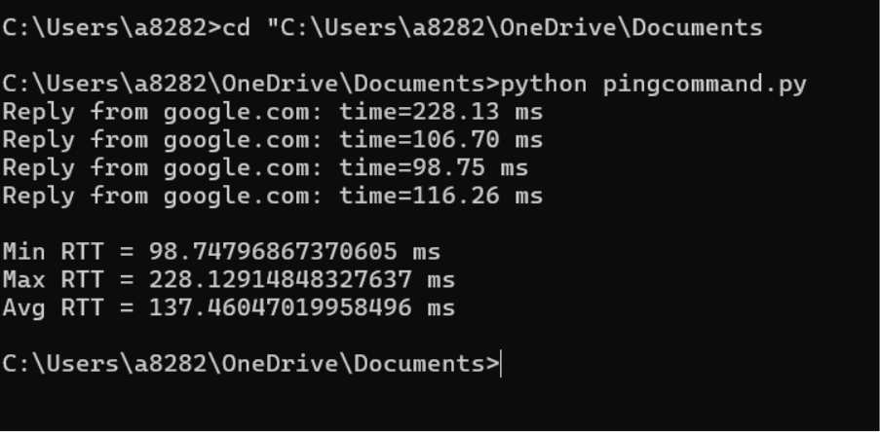Result:
The custom ping program successfully sent ICMP Echo Requests and received Echo Replies from the target.

