K Kenneth Prathap
241901048
EXPT: 7 NMAP TO DISCOVER LIVE HOSTS USING ARP SCAN AND TCP/UDP PING SCAN
Introduction:
Discovering live hosts is the first step in network enumeration. Different techniques find hosts in different situations: ARP scan discovers machines on the same Ethernet/LAN by asking “who has this IP?”, ICMP scan (Ping) asks hosts to respond to ICMP Echo Requests, and a tcpdump ping-style capture records the actual probe and reply packets on the network so you can verify what’s sent and received. Combining these methods gives a fuller picture because some hosts
block ICMP or TCP probes but still respond to ARP, and packet capture shows the raw traffic for troubleshooting and proof.
Aim:
- Use ARP scanning to detect live hosts on the local subnet.
- Use ICMP (ping) scanning to discover hosts that reply to echo requests.
- Use tcpdump to capture and inspect the probe and reply packets for verification.
- Compare results and explain why a host may appear in one scan but not another.

Tasks:
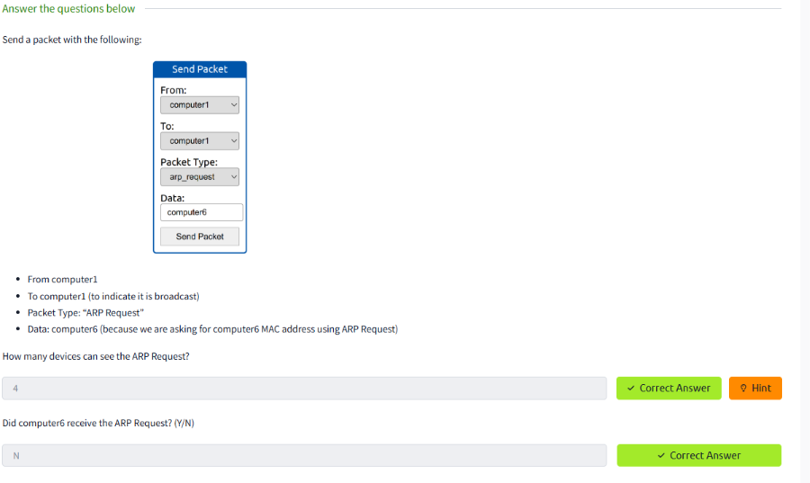
K Kenneth Prathap
241901048
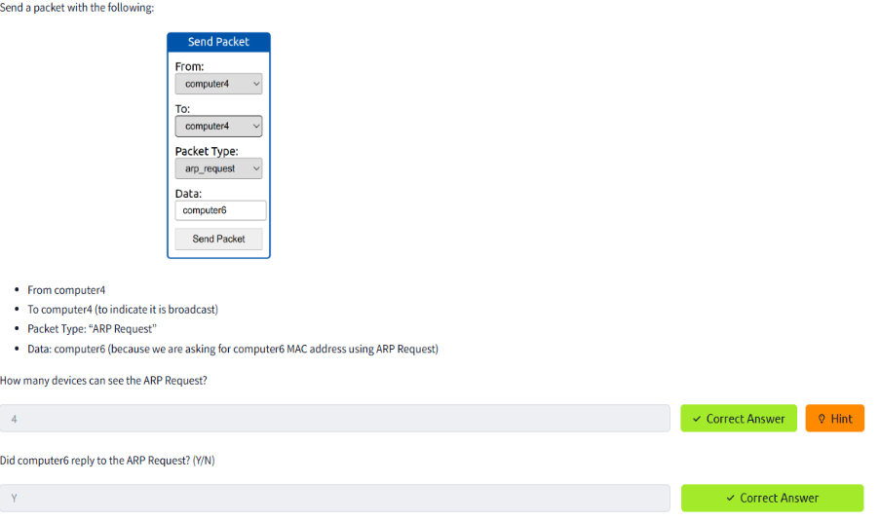
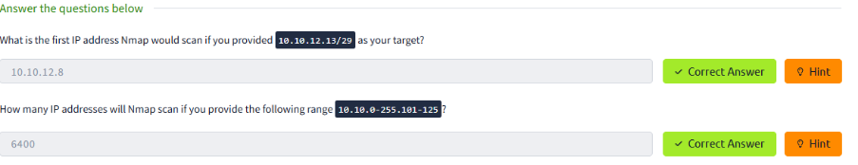
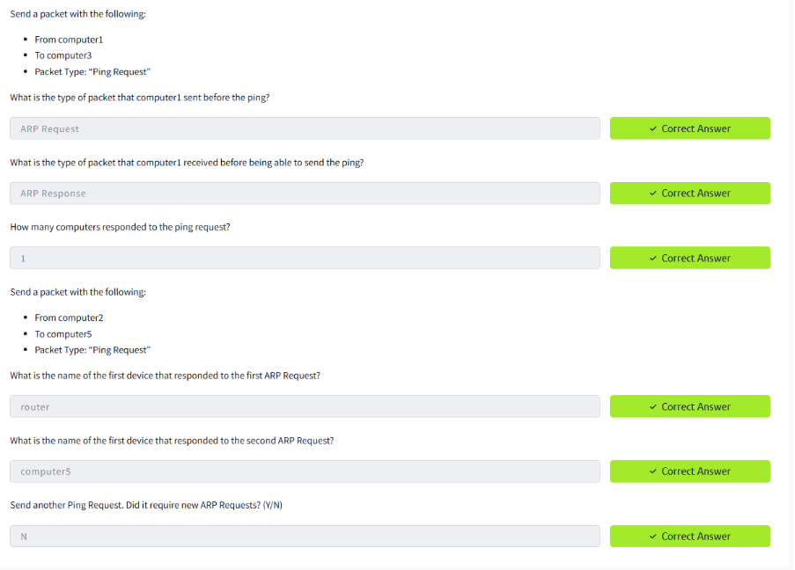
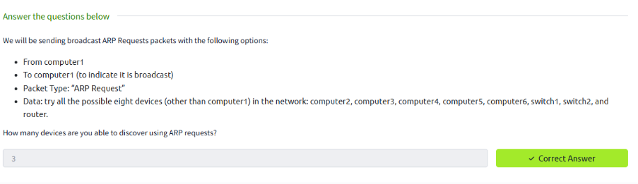
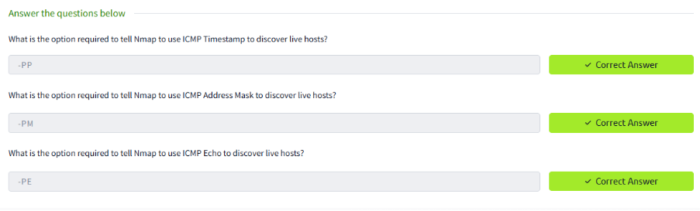
K Kenneth Prathap
241901048
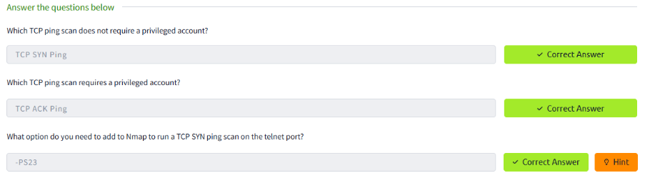
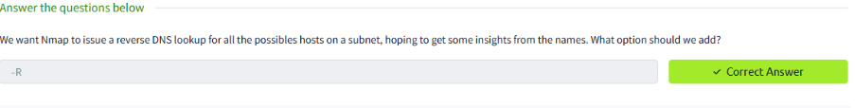Result:
Ran an ARP scan on the local network (e.g. arp-scan or nmap -PR) and noted responsive IPs/MACs.
Performed an ICMP ping-scan (e.g. nmap -PE or fping) and recorded which hosts replied.
Started tcpdump during the ping scan to capture ICMP Echo Requests/Replies (and ARP requests/replies) for later inspection.
Performed an ICMP ping-scan (e.g. nmap -PE or fping) and recorded which hosts replied.

