**Introduction the DS4 and Functions**

**LAB 03**

**SECTION 6**

**Kenneth Schueman**

**SUBMISSION DATE:**

**9/23/2021**

**9/23/2021**

# Problem: DualShock 4 Data Collection

Move the DS4 around and notice how the values output by the program changes based on the controller orientation and direction. Collect some data samples.

# Analysis

The step-by-step instructions made this a simple task

# Design

No design necessary

# Testing

Getting my values to look like the ones presented on the instructions took some testing.

# Comments

Instructions were incomplete in order to achieve what was asked needed outside knowledge.

# Screen Shots

# 

Figure

# 

Figure

# 

Figure

## Problem: Introduction to Functions and the DualShock 4

Modify the line in SECTION 0 so that the milliseconds are printed out as SECONDS as a real number in an 8-character area with 3 decimal digits precision. Also modify the line so acceleration values are shown in a 7-character area with 4 digits of precision.

# Analysis

This problem took way longer than it should have simply because I had a function dividing t by a 1000 and forgot to comment it out.

# Design

Wrote three separate functions to handle the arithmetic of converted milliseconds

# Testing

Once my math was correct there was a error were I was only getting 0 back because I had two separate inputs declared.

# Comments

This was way harder then it should have been for me, but on the plus side I know understand functions very well.

# Screen Shots

Figure

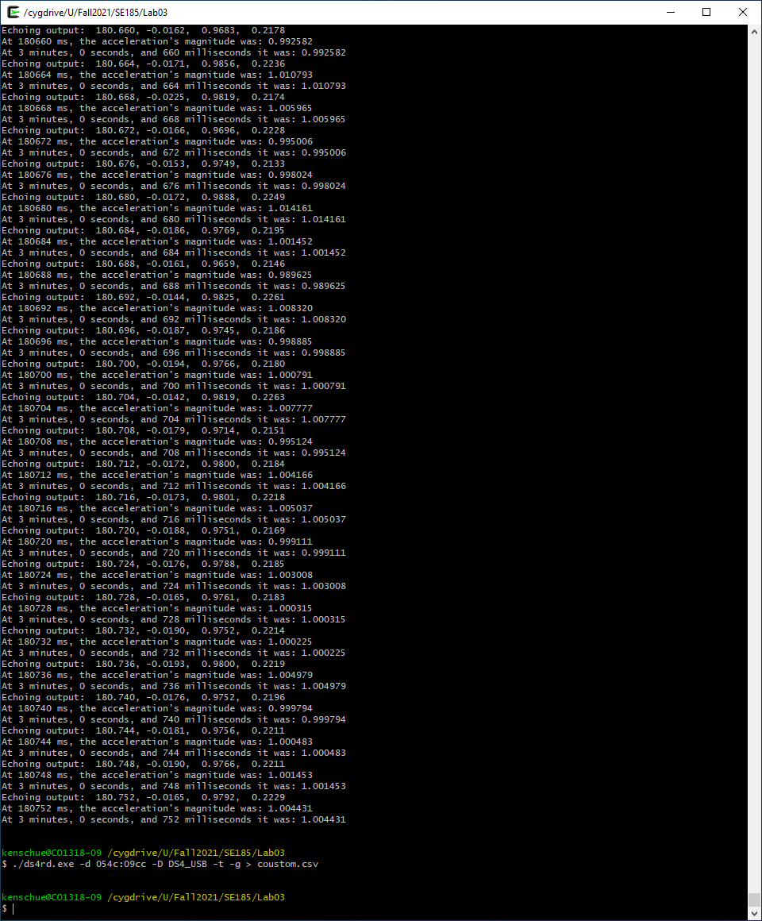

Figure

## Problem: Counting Buttons

Never was able to achieve a working program ☹