**Conditionals**

**LAB #05**

**SECTION #06**

**Kenneth Schueman**

**SUBMISSION DATE: 10/07/2021**

**10/02/2021**

# Problem

Developing a program that can detect where and how the ps4 controller is moving. Using the flags, we must output, up, down, left, right, front and back. Also, we must include a delay for when the controller is moving outside of out parameters.

# Analysis

Since the inputs are given, we must develop tolerances and flags for the inputs to output the right conditions, only three functions will be needed along with 6 if statements as seen in figure 1.

# Design

Moving the controller around and watching the outputs will give me my tolerances.

# Testing

Repeatedly moving the controller is how I will test my tolerances.

# Comments

This lab was worded very poorly and was hard to understand what was being asked of me. Once explained I had no problem figuring out what to do.

# Screen Shots

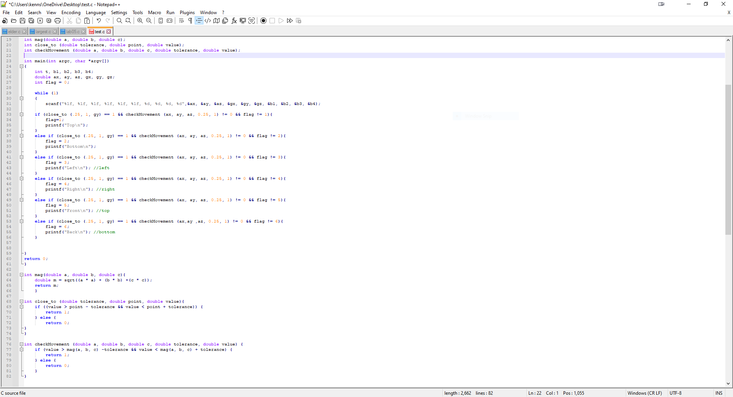

Figure 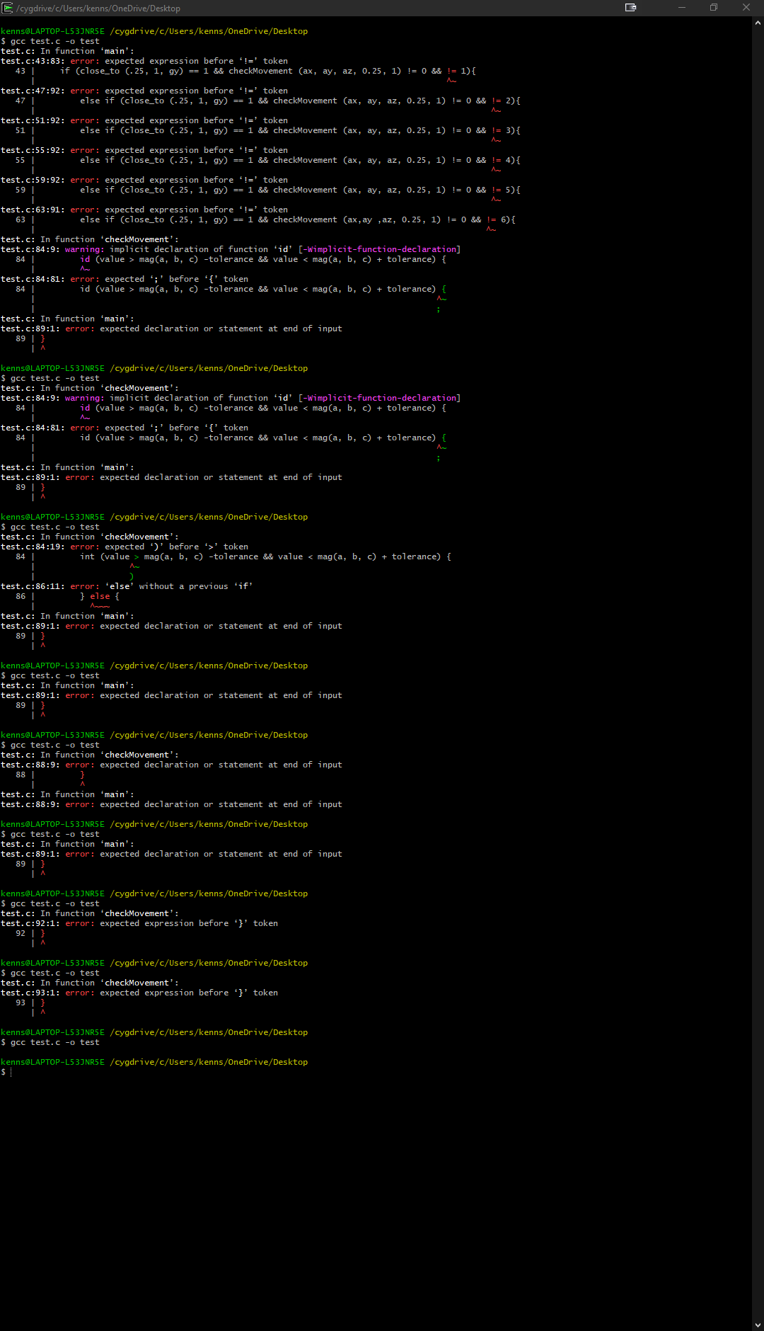

Figure