Skin Vision AI :
Revolutionising skin cancer detection

A PROJECT REPORT
BY
TEAM NO. 02

Soham Das (E23CSE1412)
Kennett Lobo (E23CSE1418)


SUBMITTED TO

SCHOOL OF COMPUTER SCIENCE ENGINEERING AND TECHNOLOGY, BENNETT UNIVERSITY
GREATER NOIDA, 201310, UTTAR PRADESH, INDIA

April 2025

DECLARATION

I/We hereby declare that the work which is being presented in the report entitled “Skin Vision AI”, is an authentic record of my/our own work carried out during the period from JAN, 2025 to April, 2025 at School of Computer Science and Engineering and Technology, Bennett University Greater Noida.
The matters and the results presented in this report has not been submitted by me/us for the award of any other degree elsewhere.

Signature of Candidate

Name of Soham Das
(Enroll. No. E23CSE1412)

Name of Kenneth Lobo
(Enroll. No. E23CSE1418)

ACKNOWLEDGEMENT

I/We would like to take this opportunity to express my/our deepest gratitude to my/our mentor, Dr. Shashi Shreya for guiding, supporting, and helping me/us in every possible way. I/we was/were extremely fortunate to have her as my/our mentor as he provided insightful solutions to problems faced by me/us thus contributing immensely towards the completion of this capstone project. I/We would also like to express my/our deepest gratitude to VC, DEAN, HOD, faculty members and friends who helped me/us in successful completion of this capstone project.

Signature of Candidate

Soham Das
(Enroll. No. E23CSEU1412)

Kenneth Lobo
(Enroll. No. E23CSEU1418)

TABLE OF CONTENTS
<<Right click on the heading and click update flied. Your heading will be pulled here. Same goes with all the table of content in the subsequent pages>>
LIST OF TABLES vi
LIST OF FIGURES vii
LIST OF ABBREVIATIONS viii
ABSTRACT ix
1. INTRODUCTION 1
1.1. Problem Statement 1
2. Background Research 2
2.1. Proposed System 2
2.2. Goals and Objectives 2
3. Project Planning 3
3.1. Project Lifecycle 3
3.2. Project Setup 3
3.3. Stakeholders 4
3.4. Project Resources 4
3.5. Assumptions 5
4. Project Tracking 5
4.1. Tracking 5
4.2. Communication Plan 6
4.3. Deliverables 7
5. SYSTEM ANALYSIS AND DESIGN 8
5.1. Overall Description 8
5.2. Users and Roles 8
5.3. Design diagrams/ UML diagrams/ Flow Charts/ E-R diagrams 9
5.3.1. Use Case Diagrams 9
5.3.2. Class Diagram 10
5.3.3. Activity Diagrams 11
5.3.4. Sequence Diagram 12
5.3.5. Data Architecture 13
6. User Interface 14
6.1. UI Description 14
6.2. UI Mockup 14
7. Algorithms/Pseudo Code 15
8. Project Closure 16
8.1. Goals / Vision 16
8.2. Delivered Solution 16
8.3. Remaining Work 16
REFERENCES 17

LIST OF TABLES
Table Page
Table 1: Goal and Objectives 2
Table 2: Sample 2 3
Table 3: Sample 3 4
Table 4: Sample 4 4
Table 5: Sample 4 5
Table 6: Sample 6 5
Table 7: Regularly Scheduled Meetings 6
Table 8: Information To Be Shared Within Our Group 6
Table 9: Information To Be Provided To Other Groups 6
Table 10: Information Needed From Other Groups 7
Table 11: Deliverables 7
Table 12: Sample 12 8

LIST OF FIGURES
Figure Page
Figure 1: Sample use-case diagram 9
Figure 2: sample 2 11
Figure 3: sample 3 12
Figure 4: Sample 4 13
Figure 5: Sample 5 13
Figure 6: Sample 6 14

LIST OF ABBREVIATIONS
Abbreviation Explanation of the Abbreviation
AAA Authentication Authorization and Access Control
CSP Cloud Service Provider
DNS Domain Name System
IAM Identity and Access Management
CNN Convolutional Neural Network

ABSTRACT
We have developed a web-based skin cancer detection system that combines the cutting-edge of web development with artificial intelligence to deliver a fast, easy-to-use, and accessible early-diagnosis solution. The main purpose of the system is to help the user to detect suspicious features of skin lesions that might be malignant with an image-based input to lessen the time of waiting to consult for a specialist.
Frontend application developed using HTML, CSS, and Javascript. Built to be clean and responsive, the interface easily accommodates different screen sizes and devices. A main component is the modified user interface with an easy image-upload and preview system making it possible for users to drag and drop or select an image of a skin lesion for analysis. This makes the analysis process very clear allowing the user to follow and not feel alienated in the analysis.

The backend consists of a CNN model that was trained on thousands of dermoscopic images of various skin conditions. The convolutional Neural Network (CNN) model made use of Python and utilized various deep learning frameworks to accomplish precise and efficient classification. A CNN trained on image features can learn to identify patterns present in benign and malignant skin lesions. It is specifically trained on more than 10K labeled images which provided a strong understanding of diverse types of lesions.
All results are shown in a small, visual way to help users better understand the information. Moreover, suggestions are also included with predictions to assist the user in determining if medical attention is required. The synergy of AI and user-centered design here is intended to both connect tech and healthcare to inspire one-path solutions for early detection and preventive skin health.

- INTRODUCTION
Skin cancers are common cancers worldwide, and it is important to diagnose them early for effective treatment and better outcomes. Recently, there are some great things happening in the area of artificial intelligence (AI) entering the medical field, particularly diagnostic purposes. AI has a very powerful tool- Convolutional Neural Networks (CNNs)- which has proven to be very useful in classifying images and is thus very suitable for analyzing skin lesions.
With smartphones and digital photography, one can take high-quality images of skin irregularities. In fact, the advances in web technology have made it possible for online applications to employ AI models for initial diagnosis. These applications are about convenience, speed, and privacy, so that a user can perform a preliminary check at home.
This project capitalizes upon the intersection of deep learning and web development to develop a web-based skin cancer diagnosis system. This system is made easy-to-use in uploading skin images, analyzing images using a trained CNN model, and predicting those for relevant guidance. Using HTML, CSS, and JavaScript for the frontend and python-based

1.1 Problem Statement
Skin cancer is mostly diagnosed and accurately treated with medical experts and their specialized equipment that are not available to everyone, especially in faraway or under-resourced areas. Although dermatologists are trained to identify malignant lesions by physical examination as well as dermatoscopic analysis, the limited availability of dermatologists, very long appointment waiting time, and exorbitant consultation fees usually keep people from visiting the doctor and getting diagnosed sooner or later.
Moreover, many individuals are unable to spot signs of skin abnormalities at an early stage or are simply unaware that these signs even exist; hence, they ignore them or simply do not have access to a professional screening. Delay in detecting skin abnormalities may lead to cancer progressing to a severe stage, thereby giving a lesser chance of success in treatment.
In the present day, plenty of health-related mobile apps and websites are available. However, very few of them integrate advanced AI models capable of providing serious diagnostic support. That is, something cheap and accessible that empowers users to take better control of their own skin health.
This project, therefore, addresses an open problem that involves developing a web-based AI system that allows users to upload images of their skin lesion(s) that will then undergo real-time analysis using Convolutional Neural Network (CNN) technology. The goal is to act as a supportive diagnostic tool for enhancing early detection, bridging the gap of accessibility, and advocate for a timely medical consultation, when necessary.
- Background Research
Skin cancer is among the types of neoplasm that are most frequently diagnosed in the world. According to WHO estimates, there are between 2 and 3 million new cases of non-melanoma skin cancer globally per year and 132,000 cases of melanoma skin cancers. Early detection of the disease can significantly impact treatment, but the reliance on clinical and dermatoscopic examinations leaves many cases, especially in rural or underserved areas, undiagnosed until later stages. This has led to a growing interest in Artificial Intelligence (AI) and Deep Learning (DL) technologies in helping dermatological diagnostics.

2.1 Existing Literature and Technologies
Countless studies have proven the efficiency of Convolutional Neural Networks (CNNs) in medical imaging, particularly dermatology. As a case, a study published in Nature in 2017 by Esteva et al. called "Dermatologist-level classification of skin cancer with deep neural networks," which proved that such CNN trained on over 129,000 clinical images could perform like board-certified dermatologists in distinguishing different skin cancers [1]. This is a breakthrough that goes toward the democratization of access to early diagnostic assistance.

Other literatures include the Brinker et al. 2019 paper entitled Comparative performance of artificial intelligence systems and human dermatologists published in Lancet Oncology, which reported that well-trained AI models outperformed human clinicians in the task of malignant melanoma detection [2]. Such revelations gave a major boost to the number of mobile apps and web tools developed for diagnosis but most still remain privileged or only limitedly available.

There was considerable progress, but hindrances remain, such as high-end GPU installation, large data set accessibility, and low awareness from the public. The HAM10000 dataset-a very-well-acclaimed AI dermatology dataset-consists of over 10,000 dermatoscopic images capturing the most common pigmented lesions and forms a standard benchmark for training classifiers for skin lesions [3].

2.2 Reasons Behind This Project
The motivation comes from the meeting of technical maturity and societal needs. Most existing systems have thrown up one of the following categories:
• Diagnosis through high-end developed artificial intelligence integrated clinical setups.
• Mobile applications that either oversimplify the problem or require paid access.

Therefore, the research aimed at bridging this gap by developing a web-based diagnostic tool in a format that:
• Accessible through browser and no installation is required.
• Free access as a sharable resource for healthcare justice.
• Coupled with a robust CNN model trained using real dermatoscopic data.
• Web standards as HTML, CSS, and JavaScript in the frontend coupled with Python, on the backend side, for AI processing.

The background research also witnessed a significant quantity of misinformation on lesions, poorly classified lesions in many apps, and that were not trained on verified datasets as part of our motivation.
References:
[1] Esteva, Andre, et al. "Dermatologist-level classification of skin cancer with deep neural networks." nature 542.7639 (2017): 115-118.
[2] Salinas, Maria Paz, et al. "A systematic review and meta-analysis of artificial intelligence versus clinicians for skin cancer diagnosis." NPJ Digital Medicine 7.1 (2024): 125.
[3] Tschandl, Philipp, Cliff Rosendahl, and Harald Kittler. "The HAM10000 dataset, a large collection of multi-source dermatoscopic images of common pigmented skin lesions." Scientific data 5.1 (2018): 1-9.

  - Proposed System
The project proposes the establishment of a web platform powered AI for the early detection of skin cancer by image analysis. The system identifies and classifies different types of skin lesions by utilizing a Convolutional Neural Network (CNN) model which was trained using the HAM10000 dataset. Users upload their image of skin conditions and get a diagnosis prediction with some explanations. This system intends to take these initial steps toward providing an accessible and rapid preliminary diagnostic tool in detecting possible skin cancer at an early stage, especially where dermatological services are unavailable. By incorporating this model in a user-friendly web interface, applying HTML, CSS, and JavaScript, this innovation is to bring the world of medical expertise closer to that of public awareness.
Our vision is to enable users to take proactive steps in planning for their skin health, thereby fundamentally reducing the cases of diagnosis of late-stage cancers with timely screening. This system would complement existing healthcare services by offering a non-invasive, low-cost, and widely available diagnostic aid from home. It also provides avenues for future integration into telemedicine and professional dermatological consultations.

  - Goals and Objectives
The primary objective of this project is to build an accurate and accessible AI-powered skin cancer detection tool that empowers users to self-screen for potential skin abnormalities. The goals outlined below define the technical, usability, and development targets for the system.

Table 1: Goal and Objectives
# | Goal or Objective
1 | Achieve a model accuracy of at least 85% on test data using CNN-based classification
2 | Build a responsive and user-friendly web interface requiring no technical training
3 | Integrate the model with a FastAPI backend and HTML/CSS/JS frontend
4 | Ensure the system is modular and easily extensible for future upgrades
5 | Document the codebase, deployment steps, and usage instructions thoroughly
6 | Enable easy navigation and accessibility for users of all technical backgrounds
7 | Ensure image upload and prediction result process takes less than 10 seconds
8 | Collaborate effectively within the team and enjoy the process of creating impact

- Project Planning
  - Project Lifecycle
The Agile Development Lifecycle was adopted by the team to properly track and manage the attitude towards this project. Chosen for its intended flexibility: iterative delivery and collaboration, all qualities deemed required to render the AI-based application more technically valid and user-friendly.
There were four major deliverable phases in the project which could act as a milestone in the development lifecycle:
- Requirement Gathering & Planning:
The team primarily identified project scope, technical feasibility, and user requirements. This entailed the study of CNN-based classification techniques, existing dermatology datasets, and an evaluation of technology stacks suitable for a web-based deployment.
- Model Development & Training:
The CNN model is developed and trained to classify seven skin lesions from the HAM10000 dataset. This stage entails data preprocessing, oversampling, remodeling, and reaching target accuracy.
- Frontend and Backend Integration:
From then, the web interface developed had grown into a fully working system by HTML, CSS, and JS, while back-end rationale and model inference API were built using FastAPI and integrated at real-time frontend uploading for images and predictions.
- Testing, Deployment & Feedback:
Most of the tests on this system passed with great variety of input cases in the course of the robustness test. And feedback collected from peers on the UI design improvement.

  - Project Setup

Table 2: Project Setup
# | Decision Description
1 | The system was developed using Windows 11, with the backend implemented in Python (FastAPI) and the frontend using HTML, CSS, JavaScript. The AI model was built using TensorFlow/Keras. GitHub was used for version control.
2 | Standard coding practices and PEP 8 (Python Enhancement Proposal) were followed for backend development. For frontend styling, W3C-compliant HTML/CSS practices were maintained.
3 | No special access or nondisclosure forms were required, as the dataset used (HAM10000) is publicly available. However, medical advisory was maintained for model interpretation accuracy.
4 | The system was deployed and tested on a local development environment closely simulating the target deployment scenario. The virtual environment used Python 3.10 and relevant libraries.

  - Project Resources
<< Identify the anticipated resources required for this project. This can include staff members who will work on the project, equipment needed for the project, special software that will need to be acquired, or any other resource necessary for the project. >>
Example:

Table 4: Sample 4
Resource | Resource Description | Quantity
Development Team | 2 students responsible for full-stack development, AI modeling, and documentation | 2
AI Model Training | Computer with GPU support for model training (used TensorFlow with CNN) | 1
HAM10000 Dataset | Publicly available dataset for training/testing skin cancer classification model | 1
Visual Studio Code | IDE used for frontend and backend development | 2
Python Libraries | TensorFlow, NumPy, pandas, scikit-learn, matplotlib, PIL, FastAPI, etc. | N/A
Web Technologies | HTML, CSS, JavaScript used for designing user interface | 3
Browser for Testing | Used to test the UI/UX and user interaction | 2
Medical Expert | Consultation for accurate model explanation (optional/future collaboration) | 1

  - Assumptions

Table 5: Assumptions
# | Assumption
A1 | The team will have regular weekly meetings to collaborate and update progress.
A2 | All necessary Python libraries (TensorFlow, NumPy, etc.) will remain compatible throughout the development.
A3 | The HAM10000 dataset will be sufficient in quality and quantity for model training and validation.
A4 | Team members are capable of learning and applying both frontend and backend technologies within the timeline.
A5 | The FastAPI framework will handle model integration and image analysis without major compatibility issues.
A6 | Users will upload clear, properly lit, and correctly formatted images for accurate predictions.
A7 | The final AI model will be deployable locally for demo purposes without needing cloud infrastructure.

- Project Tracking
  - Tracking

Table 6: Project Tracking
Information | Description | Link
Code Storage | Project code and version control are managed using GitHub. | Link
Bug Tracking | Bug tracking and issues are logged using GitHub Issues. | Private GitHub repo
Project Documents and Assignments | Weekly progress reports, meeting notes, and deliverables are shared via Google Drive. | Shared Google Drive
Continuous Integration | No dedicated CI pipeline was used; manual integration and testing were performed. | Link
Regression Testing | Functional testing was done manually on different images; no automated testing tool used. | Link

  - Communication Plan
Table 7: Regularly Scheduled Meetings
Meeting Type | Frequency/Schedule | Who Attends
Project Sync (Google Meet / Zoom) | Weekly | Project team and mentor
Team Meeting | Weekly | Project team
Short Meeting | Weekly in class | Project team
Sprint Planning Meeting | Start of each sprint | Project team and mentor
Sprint Retrospective Meeting | End of each sprint | Project team
Sprint Review Meeting | End of each sprint | Project team, mentor, and sponsor

Table 8: Information To Be Shared Within Our Group
Who? | What Information? | When? | How?
Project team | Task assignments & General scrum information | Weekly | Team meetings, shared docs, project schedule

  - Deliverables
Table 11: Deliverables
# | Deliverable
1 | Study results (analysis of skin cancer detection trends and model findings)
2 | Full source code (HTML, CSS, JS, Python, FastAPI, CNN model)
3 | Test cases and results from validation and verification of predictions
4 | Build and deployment instructions
5 | Installation setup guide for frontend and backend
6 | User manual for using the web app and uploading scans
7 | Postmortem document (reflection on team performance and process)
8 | Final report (final PowerPoint presentation, 3 minute video, and final sprint)

- SYSTEM ANALYSIS AND DESIGN
  - Overall Description
The current study is about deep learning- specifically utilizing Convolutional Neural Networks (CNNs) for multiclass image classification in dermatology. The major requirement is to classify dermatoscopic skin lesion images accurately. This model is trained with the help of HAM10000 dataset which comprises over 10,000 RGB images annotated for seven classes as follows: melanocytic nevi (nv), melanoma (mel), benign keratosis-like lesions (bkl), basal cell carcinoma (bcc), actinic keratoses (akiec), vascular lesions (vasc), and dermatofibroma (df). The developed model architecture is made using TensorFlow and Keras that is kept under multiple Conv2D layers, ReLU activations, MaxPooling, Dropout regularization, and dense layers for final classification. Then oversampling techniques are applied under dataset imbalance by means of scipy.utils.resample, after which, training is getting standardized before it gets tested.
There are amazing performance results achieved with the final model, validated using the accuracy metrics, confusion matrix visualizations, and thorough classification reports. The final model is saved under .keras format and integrated with FastAPI back-end for real-time image inference. The front end, made with HTML, CSS, and JavaScript, enables users to upload images of skin lesions, acquires results after classifications are interpreted using argmax of the model's softmax output. Additional explanation logic is embedded to display medically-informed reasons for each prediction. In total, the system is meant to serve as an adjunct or a non-invasive and accessible diagnostic assistant towards the early detection of skin cancer with technical robustness and a user-centered design.

  - Users and Roles
<< Provide a list and description of the different types of users or roles within the system. This may include different classes of users, such as administrator, instructor, student, etc. This list may also include autonomous agents that interact with the system as well. These may include users (or personas) that are used as part of any user stories produced for the project. >>
Example:
Table 12: Sample 12
User | Description
Full Stack Developer | Responsible for designing and developing the website's frontend and backend, integrating the AI model, setting up server-side routes, and ensuring a smooth user experience across devices.
AI Model Engineer | Handles the training, testing, and optimization of the convolutional neural network (CNN) model used for classifying skin lesion images. Also ensures data preprocessing and model deployment.
AI Model | A trained CNN that processes uploaded dermatoscopic images and classifies them into different skin lesion types (e.g., nv, mel, bkl, etc.). It provides predictions and explanations to end users.

  - Design diagrams/Architecture/ UML diagrams/ Flow Charts/ E-R diagrams
<<Provide all the design diagrams that were created during the design phase of your project. Those who love coding may use a tool https://liveuml.com/ to create UML diagrams. You may refer https://plantuml.com/ for commands/syntax of various diagrams. Some sample may be checked below:
- Use case: https://liveuml.com/view/6024c067492d8164f7df07a3
- Class: https://liveuml.com/view/6024c3e8492d8164f7df07a4
Some visual examples are in sections below:>>
    - Product Backlog Items
<<All features/services/functionalities are known as Product Backlog Items (PBIs). When some features are picked from PBIs to develop in a SPRINT of two weeks, then it is known as Sprint Backlog Items (SBIs). The features are then written as user stories, acceptance criteria, and tasks in a SPRINT.>>

Enlist all of your functionalities/requirements as user-stories in the format below:
As a <user type> I want <actions> So that <achieved goal>.
Examples:
"As Max, I want to invite my friends, so we can enjoy this service together."
"As Sascha, I want to organize my work, so I can feel more in control."
"As a manager, I want to be able to understand my colleagues' progress, so I can better report our success and failures."
"As a fitness enthusiast, I want to track my workouts and progress in an app so that I can monitor my improvements."
"As a frequent shopper, I want to save my payment information so that I can check out quickly on future purchases."
"As an online student, I want to receive notifications for upcoming classes so that I can easily manage my schedule."

    - Architecture Diagram
<< Provide the architecture diagram (may be a pattern selected) for your product>>.

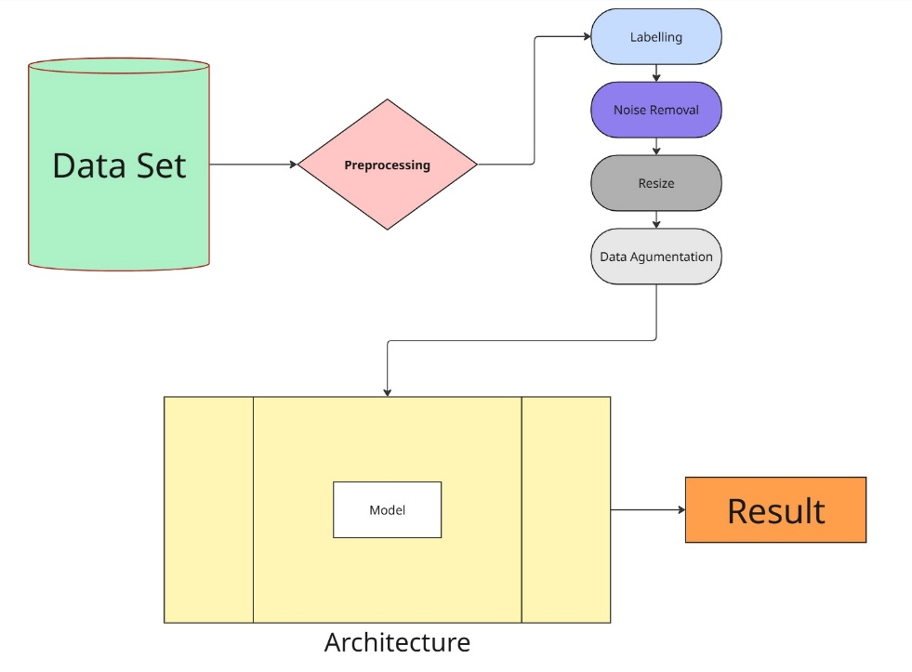

    - Use Case Diagram
<< Provide any use-case diagrams that are being used as part of the project. Uniquely label each use case so that if necessary, it is easy to reference from other parts of the document. >>
Example: Restaurant system
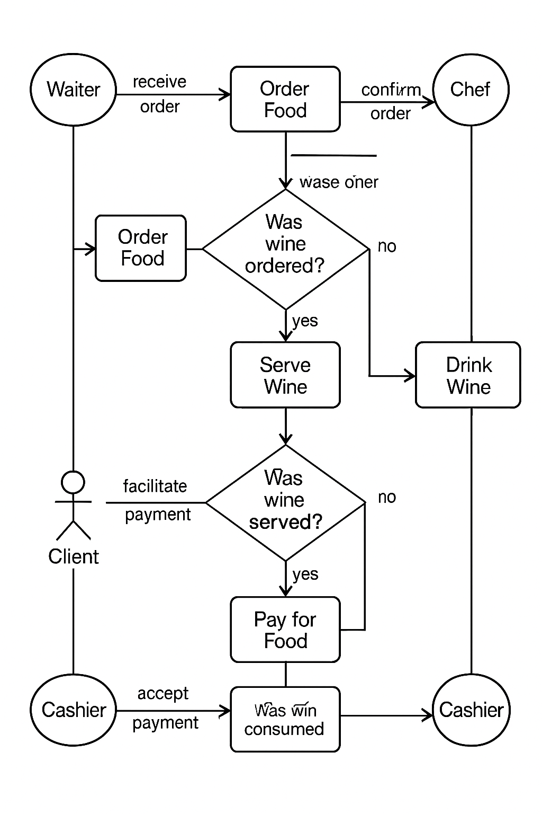

Figure 1: Sample use-case diagram
<<to insert caption for tables and figures, click on references on the top menu, under captions section click insert caption choose label as table
If you use a table, figure, or non-text item that is not your original design, you must cite the original source of the item. You may use an in-text citation in the text of the title or caption of the item, or you may include the citation as a footnote. Refer to the style manual of your discipline for more information about citations of non-text items.>>

    - Class Diagram
<< Include a class diagram for all classes to be designed. Optionally include major data elements of those classes and important methods and functions that will be used by other classes.>>
Example: Online Photo Collection
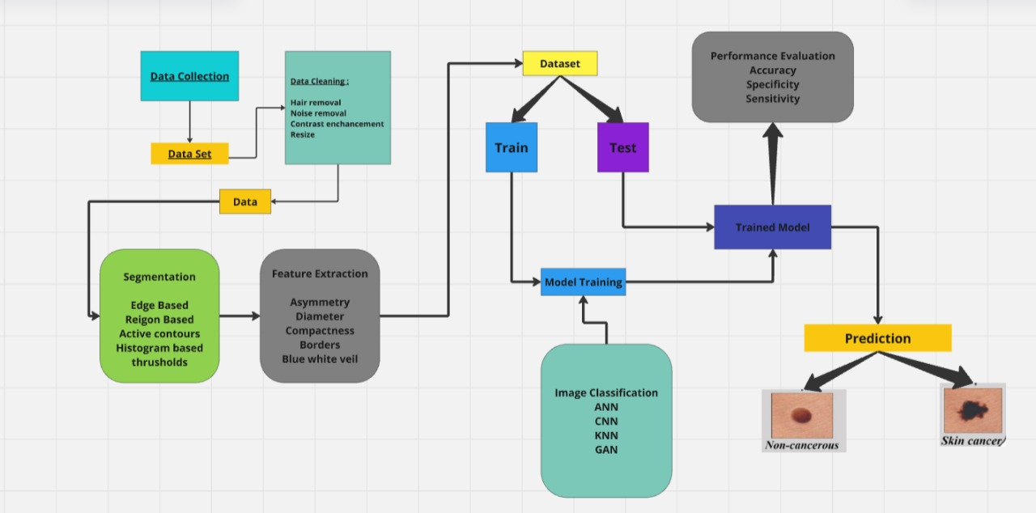

Figure 2: sample 2
    - Activity Diagrams
<< Include activity diagrams for important workflows in the program. At least one diagram should be included for the main workflow in the program. Optionally include labels that indicate which component is responsible for that part of the activity. Activity diagrams for components which perform complex tasks should also be included. >>
Example: View friend’s photo album
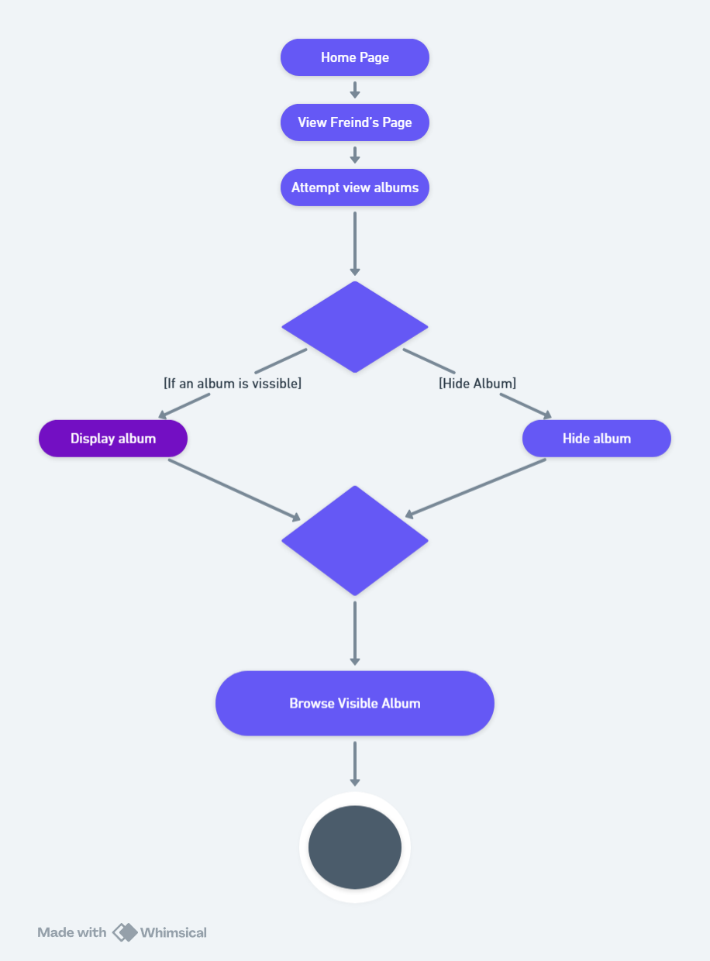
Figure 3: sample 3
    - Sequence Diagram
<< Include sequence diagrams for important functionality of the program to indicate control flow. These diagrams should include classes found in the class diagram and use the methods for those classes to show the interaction between them. >>
Example: Create new album
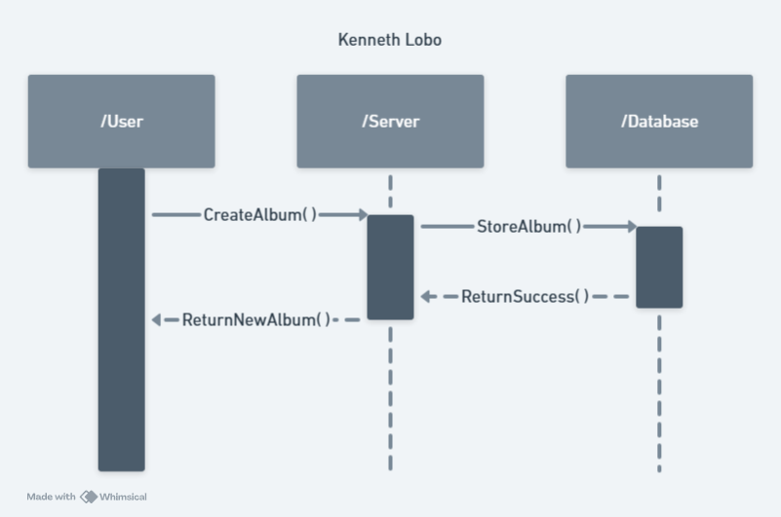
Figure 4: Sample 4
    - Data Architecture
<< Include any information or diagrams that provide details about databases, xml configuration files, or other data structures that are a part of the system. If a very specific format is required, it may be worthwhile to provide a more robust description or a detailed design such as a database schema. >>
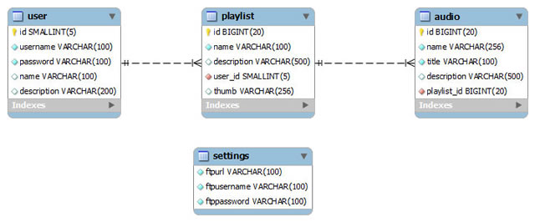
Figure 5: Sample 5

- User Interface
  - UI Description
The user interface for our skin cancer detection project has been developed using standard web technologies including HTML, CSS, and JavaScript. The frontend provides a clean, responsive, and intuitive design that allows users to easily upload skin lesion images for analysis. Users interact with the application primarily through a visually appealing upload page where they can drag and drop or select an image from their device.
Once an image is uploaded, the UI shows a real-time image preview, and users can initiate analysis by clicking the "Analyze" button. The prediction results are displayed alongside the image, including a detailed explanation of the predicted skin condition. The UI also includes a “Contact Medical Professional” button for follow-up action. The website has a fixed header with navigation links (Home, About, Contact, Detect) and a responsive layout for accessibility on all devices. The About page highlights team member profiles, and the footer includes image upload guidelines and contact details. Overall, the interface is optimized for usability, accessibility, and professional presentation.
  - UI Mockup
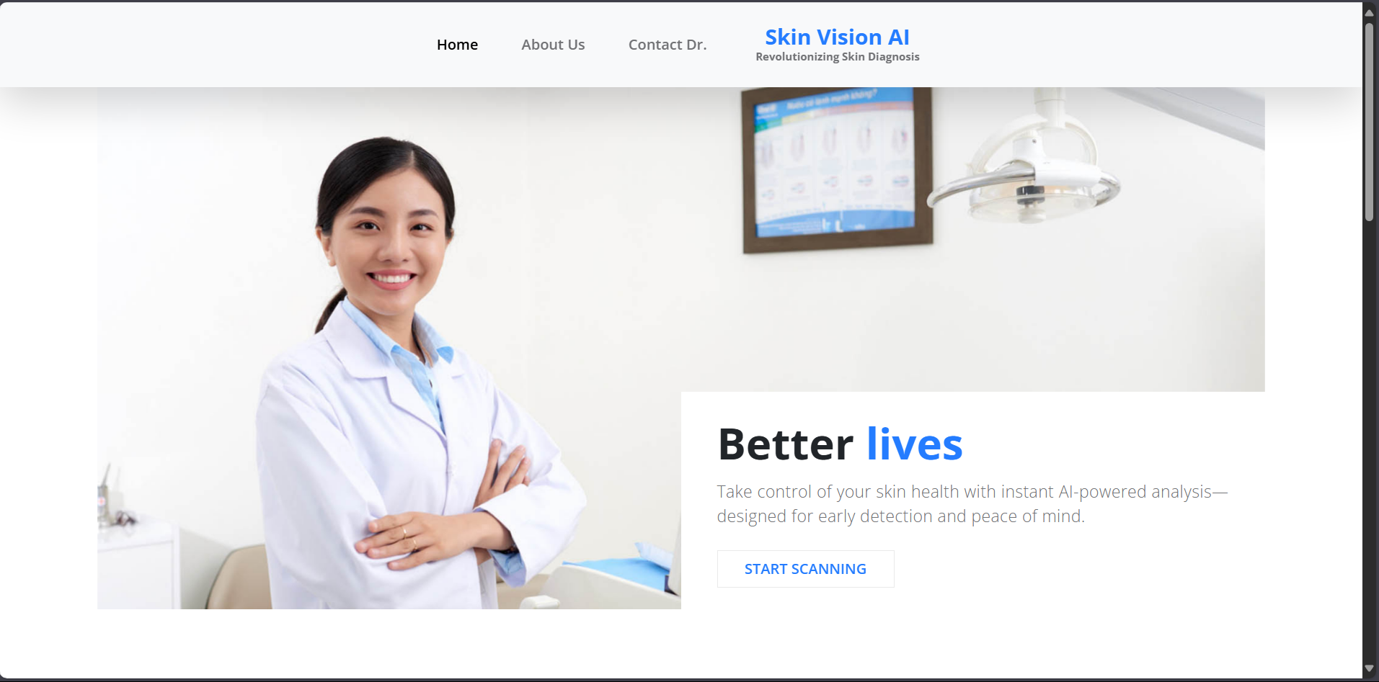
Figure 6: Sample 6
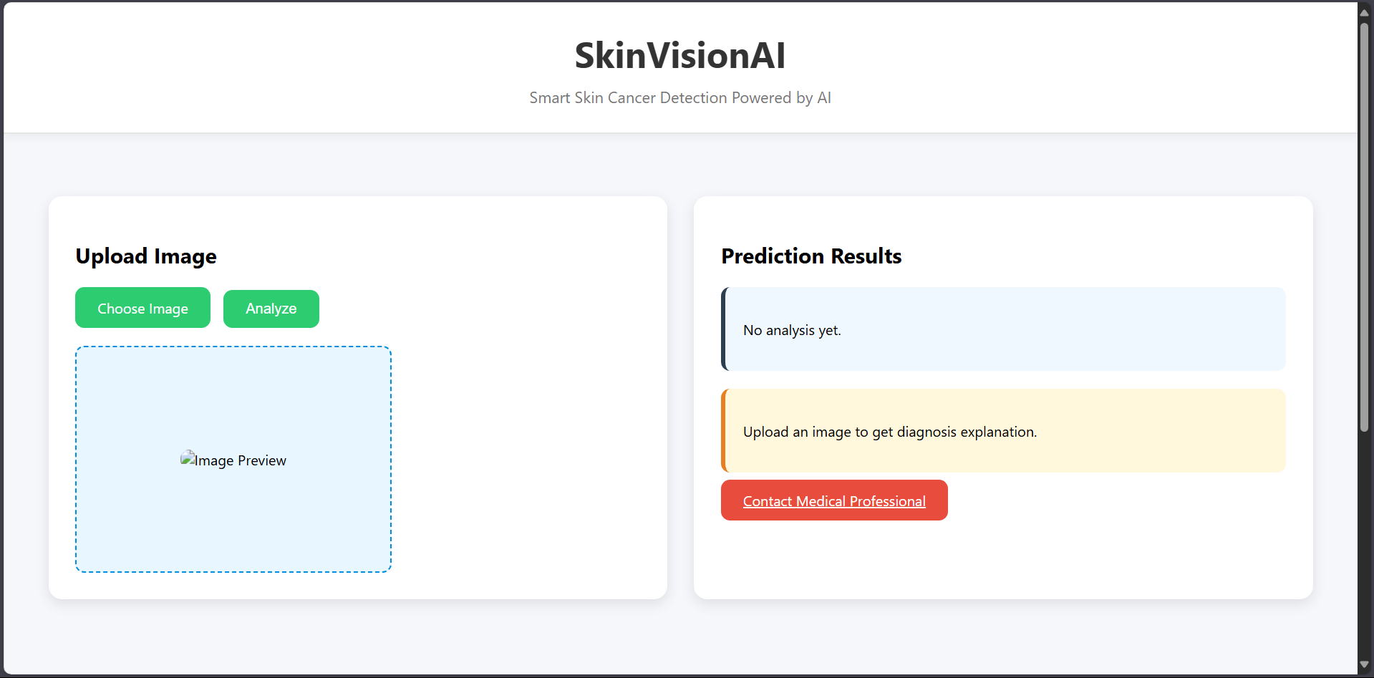
Figure 7: Sample 7

- Algorithms/Pseudo Code OF CORE FUNCTIONALITY
For webpage:
START

1. DISPLAY Webpage Header
- SHOW Website Name (e.g., "Skin Vision AI")
- SHOW Tagline (e.g., "Revolutionizing Skin Diagnosis")

2. NAVIGATION MENU
- Home
- About
- Detect (active link to upload page)
- Contact

3. MAIN CONTENT - Upload Section
a. DISPLAY title: "Upload Image"
b. HIDE native file input
c. SHOW custom "Choose Image" button
d. ON image selection:
- PREVIEW image inside a styled box
- UPDATE placeholder to selected image

4. ANALYZE SECTION
a. SHOW "Analyze" button
b. ON "Analyze" click:
- IF no image selected:
- ALERT user to select image
- ELSE:
- SEND image to FastAPI backend via POST
- WAIT for prediction response
- DISPLAY prediction result in a styled box
- DISPLAY reason based on prediction label
- ENABLE "Contact Medical Professional" button

5. RIGHT PANEL (Results Panel)
- DISPLAY Prediction Result (e.g., “Benign” or “Malignant”)
- DISPLAY Explanation (based on class label)
- BUTTON to Contact Medical Help (redirect to contact page)

6. IMAGE GUIDELINES (Footer Section)
- SHOW light-yellow box
- BULLETED instructions:
- Ensure clear lighting
- Focus only on skin lesion
- Avoid shadows
- Use high-quality images

7. FOOTER
- SHOW contact info
- SHOW collaboration message
- SHOW navigation links

END

For AI/ML model :

# Pie chart for diagnosis distribution # Pie chart for gender distribution

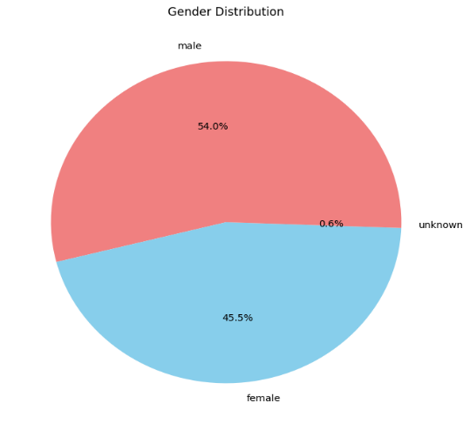
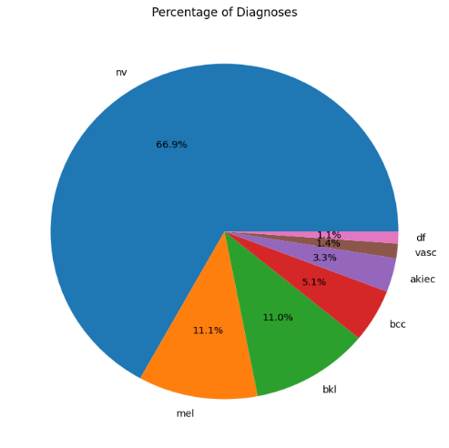

# Bar chart for body part localization distribution # Boxplot of Age Distribution by Diagnosis

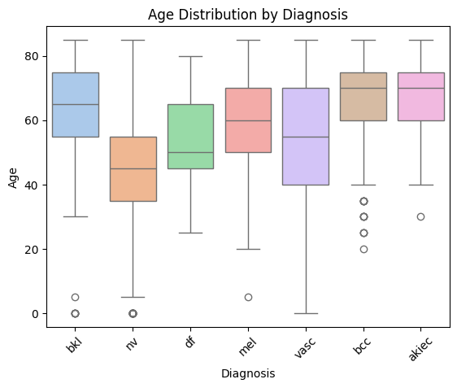
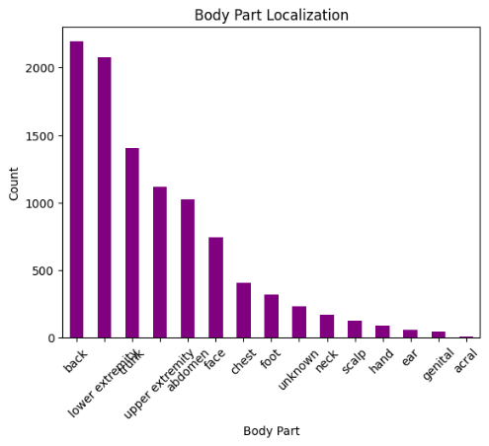

# Plot training and validation accuracy
'Model Accuracy' & 'Model Loss'
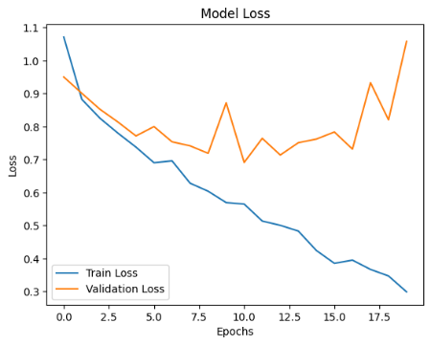
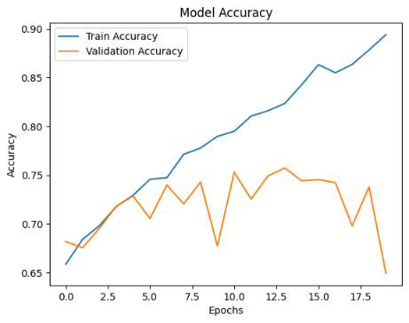

# Display the confusion matrix

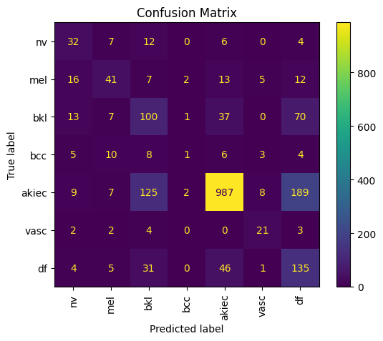

# Visualize some test images with predictions

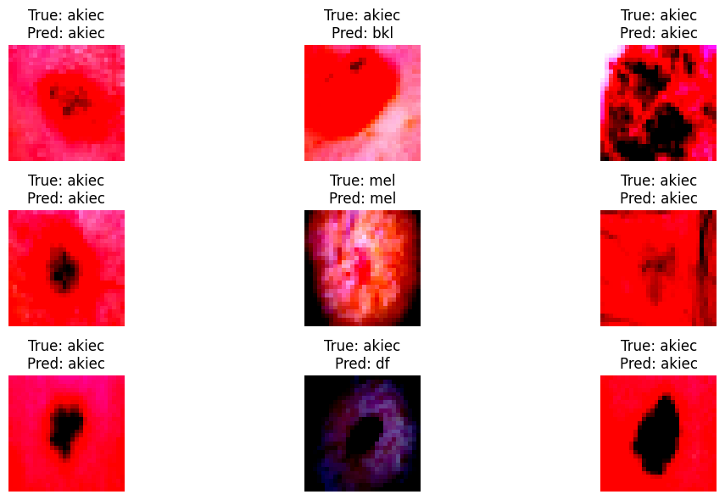

- Project Closure
This section elucidates the overall lookup at the project and some of the future works that may enhance the solution.
  - Goals / Vision
Initially, the main aim of the project was a system that is Android-based, and using a Convolutional Neural Network (CNN) model, it is able to detect different types of skin cancers from user-uploaded photos. The system should also have a very intuitive front end using HTML, CSS, and JavaScript removing all the hassle and should function alongside a FastAPI backend to serve predictions from a trained AI model.
Thus, as the project advanced into another stage, our idea changed and felt to cater in this direction-a complete user-centric experience, rather than making accurate diagnostic predictions, also give explanation and further medical consultation. Therefore, we worked on expanding our front end to include a guide for photo uploading instructions, an instant photo preview, and a straightforward presentation of AI-given results. Moreover, the backend is fine-tuned for optimal speed and accuracy classification using a model trained with the HAM10000 dataset.
In all, the platform is destined to equip users early enough with the tools for and access to an informative skin analysis-between AI and personal healthcare.

  - Delivered Solution
The primary project plan was to develop a web-based application for early detection of skin cancer via the use of AI. It was conceived to build a front end where the user puts in input images of skin lesions and produces diagnostic predictions using a convolutional neural network (CNN). The backend would process the images and return results, among other things, ultimately improving the accessibility of these tools for early detection.

The submitted output finally comprises an entire web application, completely functional and visually responsive; a standalone frontend, and a backend. The frontend was developed in HTML, CSS, and JavaScript and offered an extremely nice interface for uploading images, preview, and displaying result. Moreover, it offered some explanatory insight based on the classification of the AI model and advised how one can reach the medical professional. The backend uses FastAPI and Python to serve a trained CNN model that is built upon the HAM10000 dataset. The model has been trained and evaluated with reliable validation metrics to ensure it performs superbly. Combined, all of those elements provide complete working solutions through which the users can understand the risk of all skin types using AI.
8.3 Remaining Work
Although the current system works effectively for proof of concept, there are many improvements that can position it well for more real-world applications. For example, adding more data and retraining the AI model might enhance the prediction accuracy with more diverse skin tone and lesion types. Using explainable AI (XAI) frameworks can also empower users and medical professionals to understand the decision model better.
Additional features such as multiple languages, real-time consultation with dermatologists, and a login feature for users to track analysis history can all add to the accessibility and usability of the front end. From a deployment perspective, moving the backend onto a cloud-based service and then setting it up with heavy and serious security and privacy assurances would prepare the system to accommodate larger numbers of users for public consumption.
REFERENCES
[1] Esteva, Andre, et al. "Dermatologist-level classification of skin cancer with deep neural networks." nature 542.7639 (2017): 115-118.
[2] Salinas, Maria Paz, et al. "A systematic review and meta-analysis of artificial intelligence versus clinicians for skin cancer diagnosis." NPJ Digital Medicine 7.1 (2024): 125.
[3] Tschandl, Philipp, Cliff Rosendahl, and Harald Kittler. "The HAM10000 dataset, a large collection of multi-source dermatoscopic images of common pigmented skin lesions." Scientific data 5.1 (2018): 1-9.

