**DigiLedger (Financial Data Operation and processing System)**

**Chapter 1: Introduction**

* 1. **Introduction**

The Financial Data Operation and Processing System was created to help small businesses move away from manual financial tracking and make day-to-day tasks easier and more efficient. It focuses on simplifying financial processes by automating tasks like recording transactions, generating reports, and organizing documents, all in one place.

Tahanan Crafts & Curios is a local business known for handmade products. The company’s finances are managed manually by the owner, who keeps detailed records in ledgers. The owner is supported by someone who helps collect and sort receipts and invoices. While some online sales are tracked using Excel, most of the accounting work is still done by hand.

This manual setup takes a lot of time and effort. It also makes it difficult to track sales and expenses in real time, increases the chance of mistakes, and slows down the process of creating reports or checking the business’s overall performance. Managing payroll and keeping inventory records up to date adds to the workload.

The proposed system aims to automate these tasks such as recording sales, generating financial statements, and organizing data. It also makes it easier to manage both in-store and online transactions, track inventory, and store all information in one secure location. Real-time access to data helps the team make faster and more informed decisions.

By using this system, Tahanan Crafts & Curios can save time, reduce errors, and have a clearer picture of how the business is doing without relying on handwritten records or switching between different tools.

* 1. **Background of the Study**
     1. *History*
* The company previously relied on manual processes for handling cash sales, requiring employees to check and file receipts, banknotes, and transaction documents manually.
* With over 20 store locations, each maintaining monthly transaction folders, employees had to individually verify records and input data into the system, leading to inefficiencies.
* Although digital transactions have improved accessibility, manual receipt verification is still required, leading to delays and errors.
  + 1. *Vision*
* To develop a streamlined, automated system that minimizes manual document handling, enhances transaction accuracy, and reduces delays in financial reporting
  + 1. *Mission*
* To implement a system that allows for digital transaction storage and retrieval.
* To eliminate the dependency on hard copies and automate data verification processes.
* To enhance operational efficiency and minimize workload on employees
  + 1. *Current Processes*

The current financial document processing system relies heavily on manual operations, making it time-consuming and prone to errors. The process begins with obtaining a hard copy of the document, which is then manually scanned. Relevant data is extracted and recorded by hand, increasing the risk of inaccuracies and inefficiencies. In data operation and processing, all documents and data are gathered, and users must manually determine the type of processing required. The selected documents undergo manual processing, and the output is recorded manually, further slowing down workflow. Similarly, for payments, invoices, and POS transactions, received financial documents are processed manually, requiring human intervention for data operations and transaction storage. This approach leads to delays, inconsistencies, and inefficiencies in financial management.

* 1. **System Overview**
     1. **System Overview**

The proposed **DigiLedger** system is designed to modernize and streamline financial document processing by automating tasks that are currently manual, time-consuming, and error-prone. It will address key operational challenges such as delayed document handling, manual receipt verification, transaction discrepancies, and inefficient storage methods. The system integrates automated document processing, enhanced financial management, workflow optimization, and secure document handling to improve efficiency and accuracy in financial operations.

**DigiLedger's Automated Document Processing,** DigiLedger incorporates integrated endpoints that automatically gather data. This information flows directly into a digital journal where it's streamlined, stored, categorized, and recorded without manual intervention. This simplified approach to accounting reduces manual effort, and once all data is collected, users can choose the required processing. The automated system then generates output and records the information efficiently, leading to more accurate and reliable financial records.

For **Enhanced Financial Management**, DigiLedger offers **real-time transaction tracking** and continuous record updates. It automates financial reconciliation to minimize discrepancies and ensures **secure, centralized storage** for quick access to historical records. The system also enhances efficiency in **payments, invoices, and POS transactions** by automatically recording, processing, and storing transaction data. Upon receiving payment invoices or any financial transactions, the system performs automated data operations, ensuring seamless record-keeping without human intervention.

To improve **Workflow Optimization & User Access Control**, the system enforces **role-based access**, ensuring that only authorized personnel can view or modify financial records. It provides task assignment and tracking features to enhance accountability, allowing users to monitor pending and completed processes efficiently.

By combining these automated processes, DigiLedger significantly enhances financial workflow efficiency, accuracy, and security, reducing operational costs and eliminating the risks associated with manual data handling.

* 1. **Statement of the Problem**
     1. *General Problem*

- The current manual process of document handling and verification results in inefficiencies, delays, and potential errors in financial reporting

* + 1. *Specific Problems*
* Delays in document transfer from store locations to head office, often taking weeks to a month.
* No existing ways to automatically retrieve transactions from POS or any relevant sources.
* Difficulty in retrieving past transaction records and processing hard copies of documents, leading to increased workload and employee frustration.
* Errors in transaction records due to human mistakes and lack of automation.
  1. **Objective of the Problem**
     1. *General Objective*
* To eliminate inefficiencies, delays, and potential errors in financial reporting by automating document handling and verification.
  + 1. *Specific Objectives*
* To ensure timely document transfer and accessibility by implementing a centralized digital storage system.
* To develop an automated transaction retrieval system that integrates with POS and other relevant sources.
* To simplify record retrieval and reduce employee workload through automated document processing and operation.
* To minimize human errors in transaction records by integrating automated verification tools.
  1. **Scope and Delimitation**
     1. Scope

**Admin**

**User Access & Permissions Module**

The authentication and access control module ensures that only authorized users with valid login credentials can access the system. It enforces role-based access control, where a user's role type determines the content and features they can access. Additionally, permission management allows higher roles to unlock or enable specific features for other roles, ensuring controlled access, modification, and execution of certain actions within the system.

**User Management Module**

The user profiling and information management module collects and stores user details, including personal information, for profiling purposes. It also allows for managing user profiles by updating their details or deleting them as needed

**Manager**

**User Access & Permissions Module**

The authentication and access control module ensures that only authorized users with valid login credentials can access the system. It enforces role-based access control, where a user's role type determines the content and features they can access. Additionally, permission management allows higher roles to unlock or enable specific features for other roles, ensuring controlled access, modification, and execution of certain actions within the system.

**User Management Module**

The user profiling and information management module collects and stores user details, including personal information, for profiling purposes. It also allows for managing user profiles by updating their details or deleting them as needed.

**Record Generation Module**

This module is responsible for compiling processed data into formal financial records such as journals, reports, and statements. Once data is input and categorized, the system automatically generates structured records based on predefined formats and user selections. These records are stored securely and can be reviewed or exported as needed for auditing or reporting purposes.

**Supervisor**

**User Access & Permissions Module**

The authentication and access control module ensures that only authorized users with valid login credentials can access the system. It enforces role-based access control, where a user's role type determines the content and features they can access. Additionally, permission management allows higher roles to unlock or enable specific features for other roles, ensuring controlled access, modification, and execution of certain actions within the system.

**User Management Module**

The user profiling and information management module collects and stores user details, including personal information, for profiling purposes. It also allows for managing user profiles by updating their details or deleting them as needed.

**Record Generation Module**

This module is responsible for compiling processed data into formal financial records such as journals, reports, and statements. Once data is input and categorized, the system automatically generates structured records based on predefined formats and user selections. These records are stored securely and can be reviewed or exported as needed for auditing or reporting purposes.

**Account Associate**

**User Access & Permissions Module**

The authentication and access control module ensures that only authorized users with valid login credentials can access the system. It enforces role-based access control, where a user's role type determines the content and features they can access. Additionally, permission management allows higher roles to unlock or enable specific features for other roles, ensuring controlled access, modification, and execution of certain actions within the system.

**User Management Module**

The user profiling and information management module collects and stores user details, including personal information, for profiling purposes. It also allows for managing user profiles by updating their details or deleting them as needed.

**Document Processing Module**

The automated financial management module streamlines record-keeping by allowing users to manually input key details from receipts, invoices, and documents. Once entered, the data is automatically stored, categorized, and used to generate organized financial records, known as journals. Additionally, financial records are automatically updated whenever a transaction is made or edited, ensuring accurate and up-to-date financial tracking.

* + 1. Delimitation
  + The system will not replace the core accounting software but will complement existing financial processes.
  + It will primarily be used by company employees.
  1. **Significance of the Study**
  + The implementation of this system will provide a more efficient and streamlined process for handling financial records and transactions. Employees will experience reduced workload and improved productivity, while the company will benefit from enhanced accuracy and faster reporting. By eliminating manual inefficiencies, the system will contribute to improved customer service and operational efficiency.

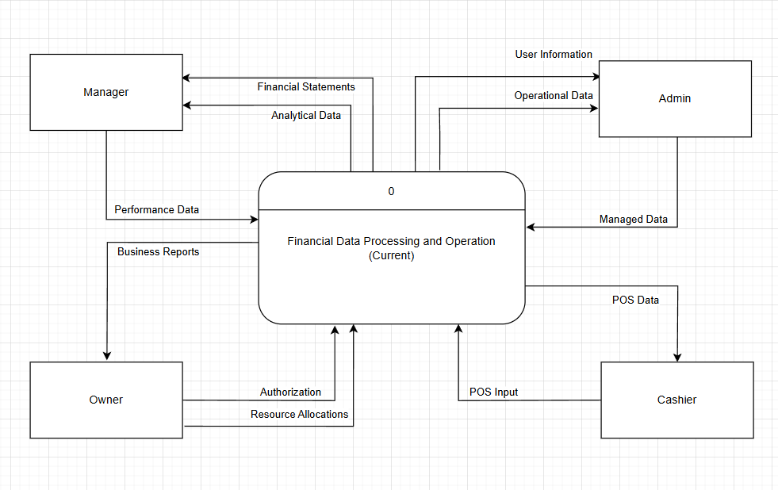

Group members

Amboya, Kenneth E.

Dela Cruz, March Enrico O.

Perez, Jhude Christoper L.

Sicat, Arvey F.