

Multi-Modal Feature Integration for ML-Based Stock Prediction: An Empirical Evaluation with Cost-Aware Backtesting

Submitted by: Kenneth Anthony Wijaya
Supervisor: A/P Wong Jia Yiing, Patricia
Examiner: Prof. Wen Changyun

School of Electrical & Electronic Engineering

A final year project report presented to Nanyang Technological University in partial fulfillment of the requirements for the Degree of Bachelor of Engineering

2026
Table of Contents
Abstract i
Acknowledgement ii
Acronyms iii
List of Figures v
List of Tables vi
1 Introduction 1
1.1 Background and Motivation 1
1.2 Problem Statement 2
1.3 Research Objectives 3
1.4 Scopes and Limitations 4
1.5 Contributions 5
1.6 Report Organisation 5
2 Literature Review 7
2.1 Market Efficiency and the Boundaries of Predictability 7
2.2 Classical Machine Learning for Financial Prediction 8
2.3 Recurrent Neural Networks for Time Series 10
2.4 Transformer-Based Models in Finance 11
2.5 Sentiment Analysis in Financial Forecasting 14
2.6 Backtesting Methodology and Performance Evaluation 16
2.7 Research Gap and Positioning 17
3 Methodology 19
3.1 System Architecture Overview 19
3.2 Data Collection and Preprocessing 20
3.3 Feature Engineering 22
3.4 Model Architectures 26
3.5 Training Configuration 30
3.6 Backtesting Framework 31
3.7 Evaluation Metrics 32
4 Experiments and Results 34
4.1 Experimental Setup 34
4.2 Classification Results 35
4.3 Regression Results 38
4.4 Feature Importance Analysis 40
4.5 Backtesting Results 43
4.6 Cross-Model Comparison 46
4.7 Summary of Findings 48
5 Discussion 49
5.1 Predictability and Market Efficiency 49
5.2 Why Simpler Models Outperform 50
5.3 The TFT Advantage of GOOGL 51
5.4 The Failure of Sentiment Features 52
5.5 Backtesting Limitations and the Benchmark Problem 54
5.6 Model Complexity and the Overfitting Frontier 55
5.7 Implications for Practical Trading Systems 56
6 Conclusion and Future Work 57
6.1 Conclusion 57
6.2 Limitations 59
6.3 Future Work 60
Reflection on Learning Outcome Attainment 62
Acknowledging/Declaring the Use of GAI 65
References 66
Appendix 69

Abstract
Machine learning methods have shown promise for financial time series prediction, yet a persistent disconnect exists between predictive accuracy reported in academic studies and the economic viability of the resulting trading strategies. Most existing work evaluates models using statistical metrics alone, overlooking the critical question of whether marginal predictive edges survive realistic market frictions such as transaction costs, slippage, and conservative position sizing. This gap is especially pronounced at the daily prediction horizon, where the signal-to-noise ratio is inherently low and competitive arbitrage rapidly erodes exploitable inefficiencies.
This project addresses this gap through a systematic, cost-aware evaluation of multi-modal feature integration for next-day stock direction and return prediction. An end-to-end pipeline was developed integrating 68 engineered features (spanning technical indicators, macroeconomic signals, and FinBERT-derived news sentiment) and benchmarking four architectures of increasing complexity: XGBoost, a two-layer LSTM, a Temporal Fusion Transformer (TFT), and a custom PatchTST. All models were trained under identical conditions on five S&P 500 constituents across three sectors over a ten-year period (2015-2024), with strict chronological splitting and leakage prevention throughout.
The results paint a nuanced picture. While classification accuracy hovered near chance levels across all models, the regression-derived directional signal proved more informative, enabling select model-ticker combinations to generate meaningful post-cost returns under a vectorised backtesting framework. Notably, the TFT on GOOGL and XGBoost on MSFT emerged as the strongest performers, though neither surpassed the SPY buy-and-hold benchmark during a sustained bull market period. Interpretability analysis revealed that macroeconomic and volume-based features drove the majority of predictive signal, while sentiment features, despite their theoretical appeal, contributed only marginally and inconsistently across tickers. These findings demonstrate that multi-modal feature enrichment in ML-based daily trading must be judged through post-cost economic performance, not predictive metrics alone.

Acknowledgement
I would like to express my heartfelt gratitude to my supervisor, Prof. Patricia Wong Jia Yiing, for her guidance, patience, and continual support throughout this Final Year Project. Her encouragement, constructive feedback, and academic insight have been invaluable in shaping this work and in helping me grow as a student. I am truly grateful for the time and effort she devoted to guiding me through this journey.
I would also like to sincerely thank my parents for their unwavering love, support, and belief in me. Their constant encouragement and sacrifices have been the foundation of everything I have been able to achieve. Throughout the challenges of this project, their trust and support gave me the strength and motivation to keep going.
I am also grateful to my friends and coursemates who accompanied me through this final year, for the late-night discussions, the shared struggles, and the mutual encouragement that made even the most demanding periods manageable. Their companionship and camaraderie have been an important part of this experience.
Finally, I am deeply thankful to everyone who has supported me throughout my time at Nanyang Technological University, whether directly or indirectly, and who has contributed to making this journey meaningful and memorable.

March 2026

Acronyms
ADX  ATR  AUC  BB  CUDA  DL  EMA  EMH  ETF  GBM  GPU  GRN  HPO  LSTM  MAE  MACD  MAPE  MCC  ML  NLP  OBV  OHLCV  PatchTST  RMSE  ROC  RSI  SMA  SPX  SPY  TFT  TNX  TPE  VIX  XGBoost | Average Directional Index  Average True Range  Area Under the Curve  Bollinger Bands  Compute Unified Device Architecture  Deep Learning  Exponential Moving Average  Efficient Market Hypothesis  Exchange-Traded Fund  Geometric Brownian Motion  Graphics Processing Unit  Gated Residual Network  Hyperparameter Optimisation  Long Short-Term Memory  Mean Absolute Error  Moving Average Convergence Divergence  Mean Absolute Percentage Error  Matthews Correlation Coefficient  Machine Learning  Natural Language Processing  On-Balance Volume  Open-High-Low-Close-Volume  Patch Time Series Transformer  Root Mean Squared Error  Receiver Operating Characteristic  Relative Strength Index  Simple Moving Average  S&P 500 Index  SPDR S&P 500 ETF Trust  Temporal Fusion Transformer  CBOE 10-Year US Treasury Yield Index  Tree-Structured Parzen Estimator  CBOE Volatility Index  Extreme Gradient Boosting

List of Figures
Figure 2.1: Extreme Gradient Boosting (XGBoost) Architecture 9
Figure 2.2: Long Short-Term Memory (LSTM) Cell Architecture 10
Figure 2.3: Temporal Fusion Transformer (TFT) Architecture 13
Figure 3.1: System architecture diagram showing the five pipeline stages 20
Figure 3.2: Price Overview of 5 Stocks 21
Figure 3.3: Train/Val/Test Split Visualization 22
Figure 4.1: Classification Accuracy Comparison Across Models 37
Figure 4.2: XGBoost Feature Importance (MSFT) 41
Figure 4.3: TFT Encoder Feature Importance (GOOGL) 42
Figure 4.4: TFT-GOOGL Equity Curve 45
Figure 4.5: Overall Model Comparison Summary 47
Figure 5.1: TFT Attention Weights for GOOGL 52
Figure A.1: AAPL LSTM Classification Convergence Curve 78
Figure A.2: AAPL LSTM Regression Convergence Curve 78
Figure A.3: AAPL PatchTST Classification Convergence Curve 79
Figure A.4: AAPL PatchTST Regression Convergence Curve 79

List of Tables
Table 2-1: Summary of Research Gap and Project Approach 18
Table 3-1: Stock Universe and Sector Representation 20
Table 3-2: Training Configuration Across Models 30
Table 4-1: Classification Performance on Test Set 35
Table 4-2: Regression Performance on Test Set 38
Table 4-3: Backtesting Performance on Test Period 44
Table 4-4: Model-Level Summary 46

Introduction

Background and Motivation
Financial markets generate vast quantities of structured and unstructured data daily, yet extracting reliable predictive signals from this data remains one of the most contested problems in quantitative finance. The Efficient Market Hypothesis (EMH), formalised by Fama [1], posits that asset prices fully reflect all available information, implying that systematic prediction of future price movements is not achievable. Under its strong form, neither fundamental analysis nor technical pattern recognition should yield sustained excess returns. However, a growing body of empirical evidence has documented persistent anomalies: momentum effects [2], mean reversion [3], and volatility clustering, that are difficult to reconcile with strict market efficiency, particularly at short time horizons.
Machine learning (ML) has emerged as a natural tool for exploiting these anomalies. Unlike traditional econometric models that require explicit functional form assumptions, ML algorithms learn non-linear relationships directly from data, handle high-dimensional feature spaces efficiently, and adapt to regime changes through retraining. Gradient boosting methods such as XGBoost [6] have demonstrated strong performance across tabular prediction tasks, while recurrent architectures like the Long Short-Term Memory (LSTM) network [10] can model sequential dependencies in time series. More recently, Transformer-based architectures have entered the financial prediction landscape: the Temporal Fusion Transformer (TFT) [14] introduces interpretable variable selection and temporal attention mechanisms, and PatchTST [15] improves computational efficiency through time series patching.
Despite this progress, a critical disconnect persists in the literature. Most studies evaluate models using predictive metrics such as accuracy, F1-score, and root mean squared error without establishing whether those predictions generate economically meaningful trading profits after transaction costs. This distinction matters because even a model achieving 55% directional accuracy may fail to produce positive risk-adjusted returns once execution frictions, slippage, and competitive arbitrage are accounted for. Furthermore, the majority of existing work relies on narrow feature sets, typically technical indicators alone, without systematically evaluating whether richer inputs from natural language processing (NLP) sentiment analysis or macroeconomic data provide incremental economic value.
This project addresses both gaps by implementing four model architectures on a unified multi-modal feature pipeline encompassing technical, macroeconomic, and sentiment features, and evaluating all predictions through a cost-aware backtesting framework that measures post-cost trading performance against a passive benchmark.

Problem Statement
The central research question of this project is:
“Can machine learning models predict next-day stock price direction and magnitude with sufficient accuracy to generate risk-adjusted trading profits that exceed a passive buy-and-hold benchmark after realistic transaction costs?”
This question decomposes into three specific sub-questions:
- Which model architecture (gradient boosting, recurrent neural network, or Transformer variant) best captures temporal patterns in daily equity data across diverse market sectors?
- Does integrating macroeconomic indicators and FinBERT-derived sentiment features provide statistically and economically meaningful improvements over a technical-indicator-only baseline?
- Do superior predictive metrics (higher accuracy, lower RMSE) reliably translate into superior post-cost trading performance (higher Sharpe ratio, lower maximum drawdown), or does a prediction-profitability gap persist for large-cap equities at daily frequency?
The third sub-question is particularly important because it challenges a common implicit assumption in the ML-for-finance literature: that better prediction automatically implies better trading. If this assumption fails, as preliminary evidence suggests it does for liquid large-cap stocks, then the evaluation methodology used across much of the field is fundamentally incomplete.

Research Objectives
To address the research questions above, this project pursues five specific objectives:
Objective 1: Implement and benchmark four ML/DL architectures (XGBoost, LSTM, TFT, and PatchTST) for dual-target next-day prediction (binary direction classification and continuous log-return regression) on identical data, enabling controlled architectural comparison.
Objective 2: Engineer a multi-modal feature pipeline comprising 68 features across four categories: 27 technical indicators, 5 FinBERT sentiment features, 32 macroeconomic and sector-relative features, and 4 calendar variables, with strict leakage prevention through chronological splitting and train-only scaling.
Objective 3: Develop a vectorised backtesting engine incorporating confidence-based position sizing, stop-loss and take-profit risk management, and realistic transaction cost modelling (5 basis points per trade) to translate model predictions into simulated trading performance.
Objective 4: Leverage the TFT's interpretable architecture, specifically its variable selection networks and temporal attention mechanism to identify which feature categories and time horizons the model relies on for prediction, providing insight into the information content of each input type.
Objective 5: Evaluate cross-sectional performance across technology (AAPL, MSFT, GOOGL), finance (JPM), and energy (XOM) sectors to assess whether predictability and profitability are sector-dependent phenomena.

Scopes and Limitations
The study covers five S&P 500 constituents selected for sector diversity, high liquidity, and data availability: Apple (AAPL), Microsoft (MSFT), Alphabet (GOOGL), JPMorgan Chase (JPM), and ExxonMobil (XOM). Daily OHLCV data spans a ten-year period from 1 January 2015 to 31 December 2024, capturing multiple market regimes including the 2018 volatility correction, the 2020 COVID-19 crash and recovery, the 2022 interest rate tightening cycle, and the 2023–2024 AI-driven rally. Data is split chronologically into 70% training, 15% validation, and 15% test sets with no temporal overlap.
Several deliberate scope boundaries constrain the investigation:
- Single-day horizon only: Multi-horizon or intraday prediction is not explored
- Small stock universe: The five large-cap equities may not generalise to mid-cap, small-cap, or international markets where microstructure differs substantially
- Vectorised backtesting: The engine does not simulate order book dynamics, partial fills, or market impact beyond a fixed transaction cost assumption
- Daily-aggregate sentiment: FinBERT sentiment is computed from aggregated daily headline scores rather than individual article-level analysis, which may attenuate the signal
- Survivorship bias: All five stocks are current S&P 500 constituents that have performed well over the study period, and the results should be interpreted with this selection effect in mind

Contributions
This report makes the following contributions:
- Controlled four-architecture comparison: XGBoost, LSTM, TFT, and PatchTST are trained and evaluated on identical data with identical features, enabling direct architectural comparison free from confounding differences in data preprocessing or feature selection
- 68-feature multi-modal pipeline: Technical indicators, FinBERT-derived sentiment, and macroeconomic signals are integrated and evaluated not merely through predictive metrics but through post-cost economic performance
- Prediction-to-trading pipeline: A vectorised backtesting engine with realistic transaction cost modelling demonstrates that the relationship between prediction accuracy and trading profitability is neither linear nor guaranteed for large-cap equities at daily frequency
- TFT interpretability analysis: Variable selection networks and temporal attention are leveraged to identify which feature categories and time horizons drive predictions, revealing that volume dynamics and cross-sector momentum dominate over raw price-based technical indicators
- Honest reporting of negative findings: Results including the failure of sentiment features and universal benchmark underperformance are reported transparently, contributing to the growing body of evidence on the practical limitations of ML-based daily trading strategies

Report Organisation
The remainder of this report is organised as follows. Chapter 2 reviews the relevant literature on ML-based stock prediction, Transformer architectures in finance, sentiment analysis, and backtesting methodology, identifying the specific research gaps this project addresses. Chapter 3 describes the methodology in detail, covering data collection, feature engineering, model architectures, training procedures, and the backtesting framework. Chapter 4 presents experimental results across classification, regression, and trading performance dimensions, including TFT interpretability analysis. Chapter 5 discusses the implications of the findings, compares results with prior work, and critically examines the limitations and threats to validity. Chapter 6 concludes with a summary, discusses limitations, and offers concrete recommendations for future research. The report closes with a reflection on learning outcomes, a declaration on the use of generative AI, and references in IEEE format.

Literature Review
This chapter reviews the existing body of work relevant to this project, organised thematically across six areas: market efficiency theory, classical machine learning for financial prediction, recurrent neural networks, Transformer-based architectures, sentiment analysis in finance, and backtesting methodology. The chapter concludes by identifying specific research gaps that motivate the present work.

Market Efficiency and the Boundaries of Predictability
The theoretical foundation for stock market prediction research rests on the Efficient Market Hypothesis (EMH). Fama [1] formalised three forms of market efficiency: weak-form, in which prices reflect all historical trading information; semi-strong form, in which prices additionally incorporate all publicly available information; and strong-form, in which prices reflect all information including private knowledge. Under weak-form efficiency, technical indicators derived from past prices should carry no predictive power, rendering the core premise of this project invalid.
However, substantial empirical evidence has challenged strict EMH. Jegadeesh and Titman [2] documented that momentum strategies such as buying recent winners and selling recent losers generate statistically significant abnormal returns over 3 to 12-month horizons, a finding that has been replicated across markets and time periods. Lo and MacKinlay [3] demonstrated mean reversion patterns in weekly stock returns that are inconsistent with a random walk. These documented anomalies suggest that historical price patterns do contain exploitable information, at least before transaction costs.
Lo [4] proposed the Adaptive Markets Hypothesis (AMH) as a reconciliation framework. Rather than treating efficiency as a binary property, the AMH models markets as evolving ecosystems in which participants adapt their strategies over time. Excess returns attract capital and competition, which gradually eliminates profitable patterns through arbitrage. This evolutionary perspective implies that any predictive edge discovered through machine learning is inherently temporary and will decay as other market participants identify and exploit the same signals. The AMH provides the theoretical lens through which this project's results should be interpreted: modest and inconsistent predictability across stocks and sectors is precisely what an adaptively efficient market would produce.

Classical Machine Learning for Financial Prediction
The application of machine learning to financial time series accelerated significantly following the development of ensemble methods. Random forests, introduced by Breiman [5], demonstrated that aggregating predictions from multiple decorrelated decision trees substantially reduces variance without increasing bias. However, gradient boosting methods subsequently emerged as the dominant paradigm for tabular prediction tasks.
Chen and Guestrin [6] introduced XGBoost, a scalable tree boosting system incorporating second-order gradient approximations for efficient optimisation, L1 and L2 regularisation to control overfitting, and a sparsity-aware algorithm for handling missing values natively. These properties make XGBoost particularly well-suited to financial data, which frequently contains missing observations and exhibits complex non-linear feature interactions. Subsequent applications across equity, foreign exchange, and cryptocurrency markets have consistently placed XGBoost among the top-performing classical ML methods for return prediction [7].
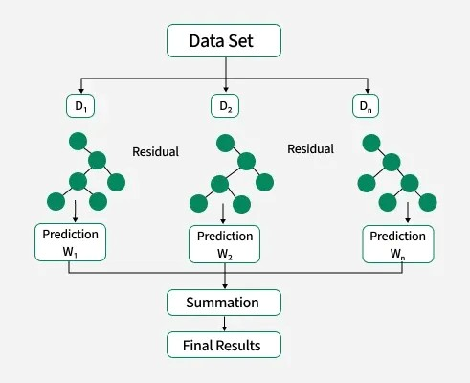
Figure 2.1: Extreme Gradient Boosting (XGBoost) Architecture
Hyperparameter optimisation is critical for gradient boosting performance. Akiba et al. [8] proposed Optuna, a framework employing Tree-structured Parzen Estimators (TPE) for efficient Bayesian search over high-dimensional parameter spaces. Compared to grid search and random search, TPE-based optimisation converges to superior configurations in fewer trials by modelling the conditional distribution of hyperparameters given objective values. This project employs Optuna with 100 TPE trials per ticker for XGBoost hyperparameter tuning, following this best practice.
A persistent challenge in ML-based financial prediction is model interpretability. Lundberg and Lee [9] unified six existing feature attribution methods under the SHAP (SHapley Additive exPlanations) framework, providing theoretically grounded feature importance scores with desirable properties including local accuracy, missingness, and consistency. In the financial domain, SHAP analysis enables practitioners to verify that model predictions are driven by economically meaningful features rather than spurious correlations. This project uses both native XGBoost feature importance and TFT variable selection networks to assess feature relevance across model architectures.

Recurrent Neural Networks for Time Series
Recurrent neural networks (RNNs) are architecturally suited to sequential data, as they maintain hidden states that propagate information across time steps. However, vanilla RNNs suffer from the vanishing gradient problem: gradients diminish exponentially during backpropagation through time, preventing the network from learning long-range dependencies. Hochreiter and Schmidhuber [10] addressed this limitation by introducing the Long Short-Term Memory (LSTM) network, which employs a memory cell regulated by three multiplicative gates: forget, input, and output, which control information flow. The constant error carousel within the memory cell enables gradient propagation over hundreds of time steps without attenuation.
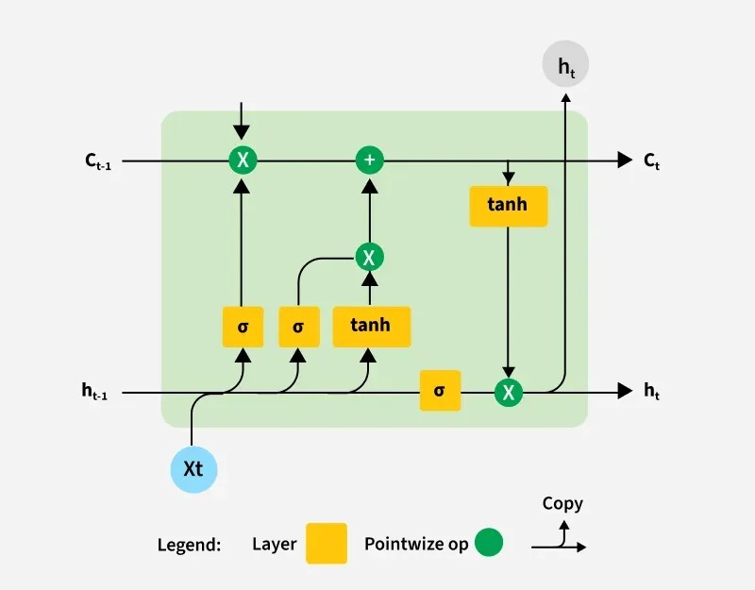
Figure 2.2: Long Short-Term Memory (LSTM) Cell Architecture
Fischer and Krauss [11] provide the most directly comparable benchmark for this project. They deployed LSTM networks for out-of-sample directional prediction of S&P 500 constituent stocks over a 23-year period (1992–2015), achieving daily returns of 0.46% and a Sharpe ratio of 5.8 prior to transaction costs. Critically, they reported that after accounting for transaction costs of approximately 5 basis points per trade, profits declined substantially, and the strategy's profitability deteriorated markedly in later years as markets became more efficient. Their finding that LSTM-based trading profits erode over time is consistent with the AMH and serves as important context for interpreting this project's results.
Bao, Yue, and Rao [12] proposed a hybrid architecture combining wavelet transforms for denoising, stacked autoencoders for feature extraction, and LSTM for prediction. While their approach demonstrated improved accuracy over single-model baselines, the multi-stage pipeline introduces additional complexity and potential for data leakage at each transformation step. This project opts for a simpler two-layer LSTM architecture with direct feature input, prioritising reproducibility and interpretability over marginal accuracy gains from cascaded preprocessing.
Despite their strengths, LSTM networks face two fundamental limitations for financial time series. First, sequential processing prevents parallelisation during training, resulting in significantly longer training times compared to attention-based alternatives. Second, while the gating mechanism extends the effective memory window beyond vanilla RNNs, LSTM performance still degrades for very long sequences where distant time steps carry relevant information. These limitations motivated the exploration of Transformer-based architectures in recent financial prediction research.

Transformer-Based Models in Finance
The Transformer architecture, introduced by Vaswani et al. [13], replaced recurrence entirely with self-attention mechanisms that compute pairwise relationships between all positions in a sequence simultaneously. Multi-head attention enables the model to attend to information from different representation subspaces at different positions, while positional encoding injects sequence order information that the attention mechanism alone cannot capture. The resulting architecture is fully parallelisable during training and scales effectively to long sequences.
The Temporal Fusion Transformer (TFT), proposed by Lim et al. [14], adapts the Transformer architecture specifically for multi-horizon time series forecasting with an emphasis on interpretability. The TFT introduces three key architectural components. First, variable selection networks apply instance-wise feature weighting through gated residual networks (GRNs), enabling the model to identify and suppress irrelevant inputs automatically. Second, a static covariate encoder processes time-invariant features that influence temporal dynamics. Third, an interpretable multi-head attention layer operates over the temporal dimension, producing attention weights that reveal which past time steps the model considers most informative for prediction. These interpretability mechanisms distinguish TFT from black-box alternatives and make it particularly valuable in regulated domains like finance, where model transparency is increasingly required.
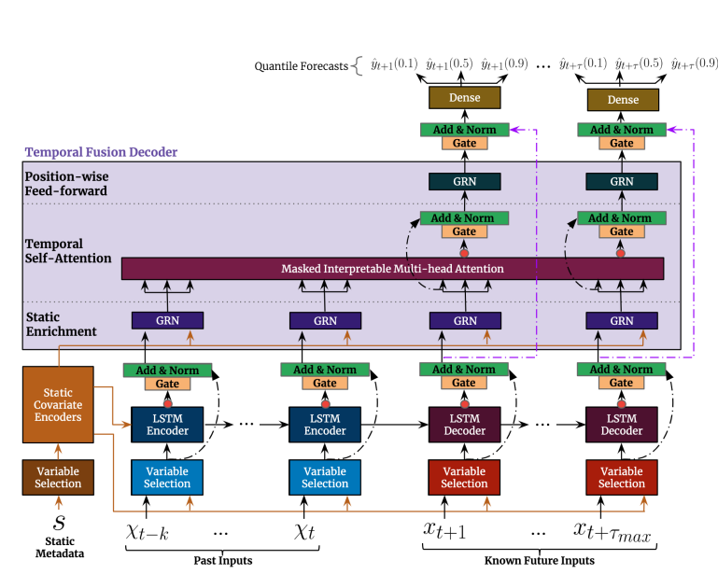Figure 2.3: Temporal Fusion Transformer (TFT) Architecture
The TFT demonstrated state-of-the-art performance on multiple established benchmarks including electricity demand, traffic flow, and retail sales forecasting [14]. However, its application to daily stock prediction, where signal-to-noise ratios are considerably lower than in demand forecasting, remains less explored in the literature. This project applies the TFT in a regression-only configuration for next-day log-return prediction, deriving classification probabilities post-hoc via a sigmoid mapping, and leverages its variable selection networks to assess the relative importance of technical, macroeconomic, and sentiment feature categories.
PatchTST, proposed by Nie et al. [15], takes a different approach to adapting Transformers for time series. Rather than applying attention over individual time steps, which scales quadratically with sequence length, PatchTST segments the input into fixed-length patches (analogous to word tokens in NLP) and applies the Transformer encoder over patch-level tokens. This reduces computational complexity while preserving local temporal structure within each patch. The channel-independence design processes each variable through a shared Transformer backbone independently, further improving scalability. Nie et al. demonstrated that PatchTST achieved competitive or superior performance to task-specific architectures on standard long-term forecasting benchmarks with significantly fewer parameters.
This project implements a custom PatchTST with patch length 4, stride 2, and a 3-layer pre-norm Transformer encoder containing approximately 580,000 parameters, substantially fewer than the TFT's 965,000. Comparing these two Transformer variants on identical financial data provides insight into whether the TFT's specialised temporal fusion mechanisms offer genuine advantages over PatchTST's simpler but more parameter-efficient design for daily stock prediction.
Broader surveys of Transformer applications in time series, including Wen et al. [16], have catalogued a rapidly expanding set of architectural variants: Informer, Autoformer, FEDformer, and others, each addressing specific limitations such as computational cost, distribution shift, or multi-scale temporal patterns. However, Zeng et al. [17] provocatively demonstrated that simple linear models can match or outperform many Transformer variants on standard forecasting benchmarks, cautioning against assuming that architectural complexity necessarily translates to improved performance. This finding reinforces the importance of including a non-deep-learning baseline (XGBoost) in the model comparison, as this project does.

Sentiment Analysis in Financial Forecasting
The integration of textual information into quantitative trading models has grown substantially with advances in natural language processing. Early approaches relied on bag-of-words representations and lexicon-based sentiment scoring, which fail to capture context, negation, and domain-specific language. The introduction of contextualised language models, particularly BERT [18], enabled transfer learning from large-scale text corpora to downstream classification tasks with minimal fine-tuning.
Araci [19] proposed FinBERT, a BERT model further pre-trained on financial communications including corporate filings, analyst reports, and financial news. FinBERT achieves substantial improvements over general-purpose sentiment classifiers on financial text, correctly handling domain-specific constructions where terms like "short" or "liability" carry different sentiment valence than in general language. The model outputs probability distributions over positive, negative, and neutral sentiment classes, which can be aggregated into continuous sentiment scores suitable for use as model features.
Ding et al. [20] demonstrated that event-level representations extracted from financial news using neural tensor networks could predict short-term stock movements, achieving a 6% improvement over baselines that used only price data. Their work established that news-derived features carry predictive information complementary to technical indicators, at least in the pre-deep-learning era.
However, the practical value of sentiment features in daily prediction remains contested. Several factors attenuate their effectiveness at daily frequency. First, news is typically published and priced into markets within minutes to hours; by market close, the information content may be largely reflected in prices. Second, sentiment aggregated across all daily headlines for a given stock introduces considerable noise, as individual articles vary in relevance and impact. Third, sentiment signals may be redundant with price-based features if technical indicators already capture the market's reaction to news through momentum and volume patterns. This project includes FinBERT sentiment features to test empirically whether they provide incremental value beyond technical and macroeconomic inputs, rather than assuming their value a priori.

Backtesting Methodology and Performance Evaluation
The translation of predictive models into trading strategies requires careful backtesting methodology. Pardo [21] documents the most common backtesting pitfalls: look-ahead bias (using information unavailable at prediction time), survivorship bias (restricting analysis to assets that survived the study period), overfitting (optimising strategy parameters to historical data that do not generalise), and data snooping (testing many strategy variants and reporting only the best). Each of these biases inflates apparent performance and can render backtest results meaningless.
Walk-forward analysis, in which models are trained on expanding or rolling historical windows and tested on subsequent unseen periods, is the standard mitigation for look-ahead bias. This project employs a fixed chronological split (70/15/15) rather than walk-forward rolling windows, which is a simplification but preserves the essential property that no future information contaminates training.
Transaction cost modelling is frequently underspecified or omitted entirely in academic studies. Sezer, Gudelek, and Ozbayoglu [22] surveyed 140 deep learning studies for financial time series prediction and found that the majority reported only predictive metrics without backtesting, and among those that did backtest, many assumed zero transaction costs. This omission is consequential: Fischer and Krauss [11] showed that their LSTM strategy's profitability was dramatically reduced after incorporating even modest trading costs. This project addresses this gap by incorporating 5 basis points per trade as a fixed cost assumption and evaluating performance through multiple risk-adjusted metrics, such as Sharpe ratio, Sortino ratio, Calmar ratio, and maximum drawdown, rather than returns alone.
Position sizing further affects realised performance. Strategies that commit full capital to every trade amplify both returns and drawdowns, while confidence-based sizing (allocating capital proportional to the model's prediction confidence) can improve risk-adjusted performance by limiting exposure on low-conviction signals. This project implements confidence-proportional position sizing with a minimum confidence threshold of 0.55 for trade entry, introducing a selectivity mechanism that filters out marginal predictions.

Research Gap and Positioning
The preceding review identifies four specific gaps in the existing literature that this project addresses:
Gap 1: Limited controlled comparison across model families. Most studies evaluate one or two model architectures. Direct comparisons between classical ML (XGBoost), recurrent networks (LSTM), and Transformer variants (TFT, PatchTST) on identical data and features are rare. This project trains all four architectures on the same 68-feature dataset with the same chronological split, enabling controlled architectural comparison.
Gap 2: Narrow feature sets without systematic evaluation. The majority of stock prediction studies use technical indicators alone. Studies incorporating sentiment or macroeconomic features typically do so without a nested comparison that isolates the marginal contribution of each feature category. This project's multi-modal pipeline combines technical, macro, and sentiment features, thereby enabling the assessment of incremental feature value through the TFT's variable selection mechanism.
Gap 3: Prediction metrics reported without cost-aware trading evaluation. As documented by Sezer et al. [22], most deep learning studies for financial prediction do not perform backtesting, and those that do frequently omit transaction costs. This project evaluates all models through a vectorised backtesting engine with explicit transaction cost modelling and compares results against a passive SPY benchmark.
Gap 4: TFT interpretability underexploited in equity prediction. While the TFT's variable selection and attention mechanisms have been studied in demand forecasting and energy markets, their application to daily stock prediction, where they could reveal which feature categories and time horizons drive predictions, remains underexplored. This project extracts and analyses both encoder variable importance and temporal attention weights to provide insight into model decision-making.
Table 2-1: Summary of Research Gap and Project Approach
Research Gap | This Project's Approach
Limited cross-architecture comparison | 4 models (XGBoost, LSTM, TFT, PatchTST) on identical data
Narrow feature sets | 68-feature multi-modal pipeline (technical + macro + sentiment)
No cost-aware evaluation | Vectorised backtester with 5 bps costs, SPY benchmark
TFT interpretability underexploited | Variable selection and attention analysis for stock prediction

Methodology
This chapter describes the complete pipeline from raw data ingestion through feature engineering, model training, prediction, and backtesting. Each component is presented in sufficient detail for full reproducibility.

System Architecture Overview
The system follows a modular pipeline architecture consisting of five sequential stages: data collection, feature engineering, model training, prediction, and backtesting evaluation. Raw OHLCV price data, macroeconomic indicators, sector ETF prices, and news headlines are ingested and cached as Parquet files. The feature engineering stage transforms these raw inputs into a 68-dimensional feature matrix per ticker, which is then split chronologically and scaled. Four model architectures are trained independently on the same feature set and produce both classification probabilities and regression predictions. Finally, a vectorised backtesting engine converts predictions into simulated trading strategies evaluated against a SPY buy-and-hold benchmark.
All code is implemented in Python 3.11 and executed on a system equipped with an NVIDIA RTX 4070 Laptop GPU with CUDA acceleration. The pipeline is designed for modularity: each stage can be run independently, and models can be trained in parallel across tickers. Configuration parameters are centralised in a single configuration module to prevent magic numbers from scattering across the codebase.
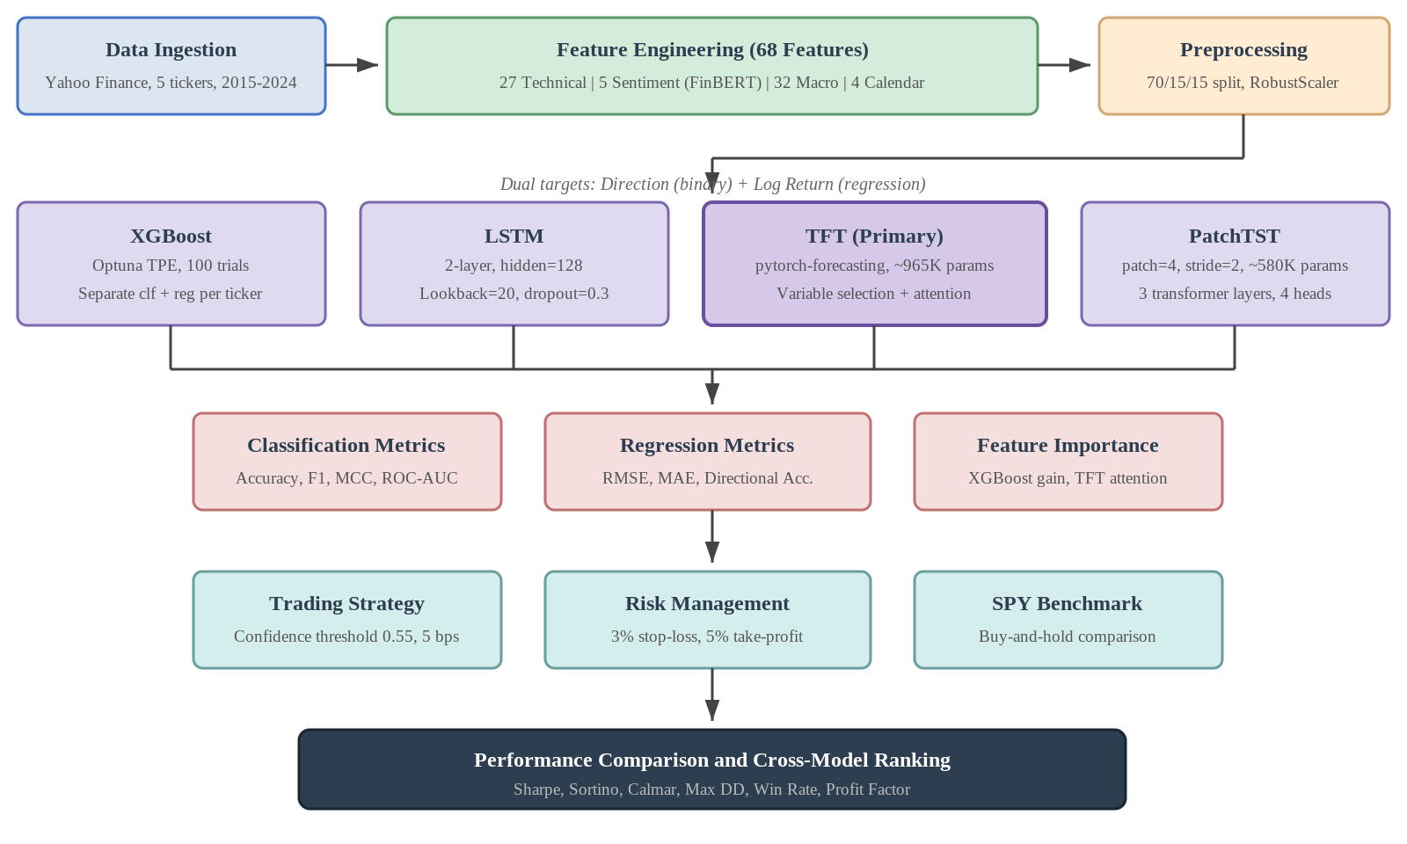Figure 3.1: System architecture diagram showing the five pipeline stages

Data Collection and Preprocessing

Stock universe
Daily OHLCV data for five S&P 500 constituents was collected via the Yahoo Finance API (yfinance) covering 1 January 2015 to 31 December 2024. The five stocks were selected to provide sector diversity while maintaining high liquidity:
Table 3-1: Stock Universe and Sector Representation
Ticker | Company | Sector | Rationale
AAPL | Apple Inc. | Technology | Highest market cap, extremely liquid
MSFT | Microsoft Corp. | Technology | Second-largest cap, strong trend patterns
GOOGL | Alphabet Inc. | Technology | Large-cap tech with distinct trading profile
JPM | JPMorgan Chase | Finance | Largest US bank, macro-sensitive
XOM | ExxonMobil | Energy | Commodity-linked, different driver structure
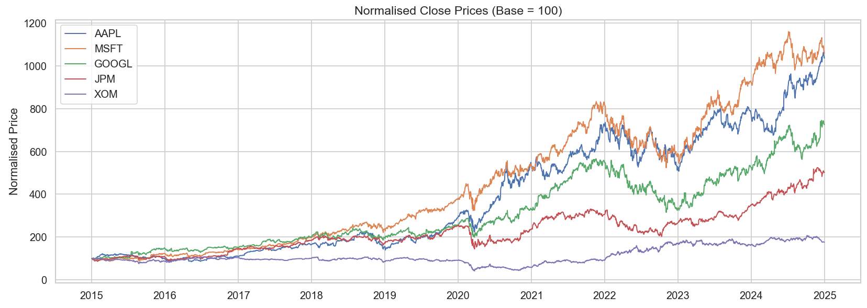Figure 3.2: Price Overview of 5 Stocks
This selection deliberately spans three sectors with fundamentally different price dynamics: technology stocks are driven by growth narratives and innovation cycles, financial stocks respond to interest rate changes and regulatory developments, and energy stocks are dominated by commodity prices and geopolitical factors. The diversity enables cross-sectional analysis of whether predictability varies by sector.

Macroeconomic and Sector Data
Three macroeconomic series were collected: the CBOE Volatility Index (VIX), the US 10-Year Treasury Yield (TNX), and the S&P 500 Index (SPX). Five sector ETFs were additionally collected to capture cross-sector dynamics: XLK (Technology), XLF (Financials), XLE (Energy), XLV (Healthcare), and XLI (Industrials). The SPY ETF was collected as the benchmark for backtesting. All series were aligned to each stock's trading calendar using forward-fill for missing dates.

Chronological Train/Validation/Test Split
The dataset is split strictly chronologically with no temporal overlap:
- Training set (70%): approximately 2015 – mid-2022
- Validation set (15%): approximately mid-2022 – early 2024
- Test set (15%): approximately early 2024 – December 2024
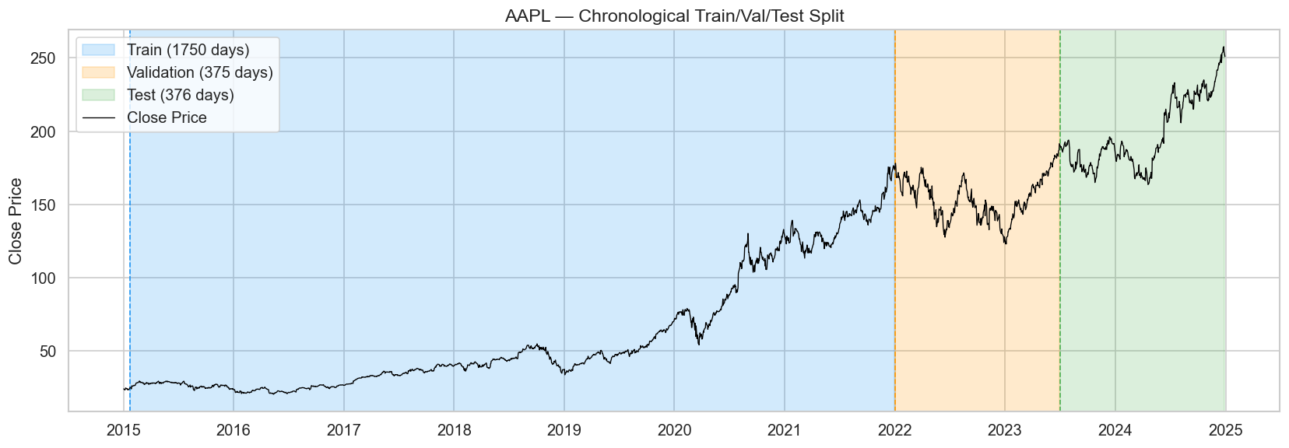Figure 3.3: Train/Val/Test Split Visualization
This split ensures that no future information leaks into the training process. The validation set is used exclusively for hyperparameter selection and early stopping decisions; the test set is reserved for final evaluation and is never used to make any modelling decision.

Feature Scaling
All features are normalised using scikit-learn's RobustScaler, which centres on the median and scales by the interquartile range. RobustScaler was chosen over StandardScaler because financial features frequently contain outliers (e.g., VIX spikes during market crashes), and robust statistics mitigate their influence. Critically, the scaler is fitted on the training set only and then applied (transformed) to the validation and test sets. This prevents information from validation or test distributions from influencing the scaling parameters, a common but subtle source of data leakage.

Feature Engineering
The feature pipeline produces 68 engineered features per observation, organised into four categories.

Technical Indicators (27 features)
Twenty-seven technical indicators are computed from OHLCV data using pure pandas implementations (no external technical analysis libraries). The indicators span four subcategories:
Trend indicators (10 features): SMA(20), EMA(50), MACD, MACD Signal, MACD Histogram, ADX(14), Plus DI, Minus DI, Close-to-SMA20 ratio, and Close-to-EMA50 ratio. MACD is computed as the difference between 12-period and 26-period exponential moving averages, with a 9-period signal line. ADX is derived from the smoothed ratio of directional movement to average true range.
Momentum indicators (4 features): RSI(14), Stochastic %K(14), Stochastic %D(3), and Rate of Change(10). RSI is computed using exponential moving averages of gains and losses:
$$RSI = 100 - 100 / (1 + RS)$$
where RS = EMA(gains, 14) / EMA(losses, 14). Values above 70 indicate overbought conditions; below 30 indicates oversold.
Volatility indicators (6 features): Bollinger Upper Band, Bollinger Lower Band, Bollinger Width, Bollinger %B, ATR(14), and normalised ATR (ATR as percentage of close price). Bollinger Bands are defined as:
$$Upper = SMA(20) + 2σ$$
$$Lower = SMA(20) - 2σ$$
where σ is the 20-period rolling standard deviation of closing prices.
Volume and return features (7 features): On-Balance Volume (OBV), Volume SMA Ratio, 1-day return, 5-day return, 20-day return, log return, and 20-day realised volatility. OBV accumulates volume signed by price direction:
$$OBV_{t}=OBV_{t-1}+sign\left(Close_{t}-Close_{t-1}\right)×Volume_{t}$$
Volume SMA Ratio divides current volume by its 20-day moving average, providing a normalised measure of relative trading activity.

Sentiment Features (5 features)
Sentiment features are extracted using FinBERT (ProsusAI/finbert), a BERT model pre-trained on financial text. The pipeline operates as follows: for each ticker and trading day, news headlines are fetched via the yfinance news API. Each headline is passed through FinBERT, which outputs a probability distribution over positive, negative, and neutral classes. Daily headline-level scores are aggregated into five features:
- sentiment_mean: average sentiment score (positive − negative) across all headlines
- sentiment_positive: average positive class probability
- sentiment_negative: average negative class probability
- sentiment_neutral: average neutral class probability
- headline_count: number of headlines available for that day
Rolling statistics are additionally computed: 3-day and 7-day rolling means (sentiment_roll_3d, sentiment_roll_7d) and rolling standard deviations (sentiment_std_3d, sentiment_std_7d) to capture sentiment momentum and volatility. These rolling features bring the effective sentiment feature count to 9, though the core engineered features number 5 with rolling variants treated as derived.

Macroeconomic and Sector Features (32 features)
Thirty-two features are derived from macroeconomic indices and sector ETFs:
- VIX features (6): raw VIX level, 5-day and 20-day moving averages, daily percentage change, binary high-volatility indicator (VIX > 20), and VIX term structure proxy (MA5/MA20 ratio).
- Treasury yield features (4): 10-year yield level, daily yield change, 20-day moving average, and spread (deviation from moving average).
- S&P 500 features (6): 1-day, 5-day, and 20-day returns, 50-day moving average, binary above-MA50 indicator, and rolling return z-score.
- Sector ETF features (15): for each of five sector ETFs (XLK, XLF, XLE, XLV, XLI): daily return, relative return versus S&P 500, and 5-day momentum. These capture cross-sector dynamics and relative strength.
- Market regime (1): a categorical variable encoding four regime states based on VIX level and S&P 500 trend: calm bull (VIX ≤ 20, SPX above MA50), volatile bull (VIX > 20, SPX above MA50), calm bear (VIX ≤ 20, SPX below MA50), and volatile bear (VIX > 20, SPX below MA50).

Calendar Features (4 features)
Four calendar features encode temporal patterns: day of week (0–4), month (1–12), quarter (1–4), and year. These capture documented calendar anomalies such as the day-of-week effect and the January effect.

Prediction Targets
Two prediction targets are computed for each observation:
- Target_Direction: binary variable equal to 1 if the next day's closing price exceeds today's closing price, and 0 otherwise. This serves as the classification target.
- Target_LogReturn: continuous variable equal to $log\left(Close_{t+1}/Close_{t}\right)$. This serves as the regression target.
Both targets are computed using the following day's closing price, ensuring that the target represents genuinely future information that is not available at prediction time.

Model Architectures

XGBoost (Classical Baseline)
XGBoost [6] is an ensemble of gradient-boosted decision trees that iteratively fits new trees to the residuals of the current ensemble. The objective function combines a loss term with a regularisation penalty:
$$Obj=ΣL\left(y_{i},ŷ_{i}\right)+ΣΩ\left(f_{k}\right)$$
where L is the loss function (log-loss for classification, squared error for regression) and Ω penalises tree complexity through L1 and L2 regularisation on leaf weights and tree depth.
In this project, separate XGBoost models are trained for classification (direction prediction) and regression (return prediction) for each ticker independently. Hyperparameters are optimised using Optuna with the TPE sampler over 100 trials per ticker. The search space includes: max_depth (3–10), learning_rate (0.01–0.3), n_estimators (50–500), subsample (0.5–1.0), colsample_bytree (0.5–1.0), reg_alpha (0–10), and reg_lambda (0–10). XGBoost handles missing values natively through learned default split directions, making it robust to the occasional NaN values that remain in the feature matrix.

LSTM Network
The LSTM architecture consists of two stacked LSTM layers with hidden size 128 and dropout 0.3. Input sequences have a lookback window of 20 trading days (approximately one calendar month), meaning the model receives a (20 × 68) feature matrix for each prediction.
Each LSTM layer maintains a cell state $c_{t}$ and hidden state $h_{t}$ governed by three gates:
$$f_{t}=σ\left(W_{f}·\left[h_{t-1},x_{t}\right]+b_{f}\right)\left(forget gate\right)$$
$$i_{t}=σ\left(W_{i}·\left[h_{t-1},x_{t}\right]+b_{i}\right)\left(input gate\right)$$
$$c̃_{t}=tanh\left(W_{c}·\left[h_{t-1},x_{t}\right]+b_{c}\right)\left(candidate cell\right)$$
$$c_{t}=f_{t}⊙c_{t-1}+i_{t}⊙c̃_{t}\left(cellstate update\right)$$
$$o_{t}=σ\left(W_{o}·\left[h_{t-1},x_{t}\right]+b_{o}\right) \left(output gate\right)$$
$$h_{t}=o_{t}⊙tanh\left(c_{t}\right) \left(hidden state\right)$$
where σ is the sigmoid function and ⊙ denotes element-wise multiplication.
The final hidden state from the second LSTM layer is passed through a fully connected layer to produce either a class probability (sigmoid output for classification) or a scalar prediction (linear output for regression). Training uses the AdamW optimiser with initial learning rate 1×10⁻³ and weight decay. A ReduceLROnPlateau scheduler halves the learning rate if validation loss does not improve for 5 consecutive epochs. Early stopping terminates training if validation loss fails to improve for 10 epochs, and gradient clipping (max norm 1.0) prevents gradient explosion.
A three-layer NaN defence mechanism ensures robustness: at data loading, non-numeric columns are removed and infinite values replaced; at dataset creation, remaining NaN values are filled with zero and extreme values clamped; at training time, any batch producing NaN loss is skipped without updating model weights.

Temporal Fusion Transformer (TFT)
The TFT is this project's primary model and the most architecturally complex. It is implemented using the pytorch-forecasting library (version 1.6.1), which builds on PyTorch Lightning.
Gated Residual Network (GRN). The fundamental building block of the TFT is the GRN, which processes inputs through a gated linear unit:
$$GRN(a, c) = LayerNorm(a + GLU(η₁))$$
$$η₁ = W₁ · η₂ + b₁$$
$$η₂ = ELU(W₂ · a + W₃ · c + b₂)$$
where a is the primary input, c is an optional context vector, and GLU applies element-wise gating. The GRN enables the network to suppress unnecessary components adaptively.
Variable Selection Network. The TFT applies instance-wise variable selection through a set of GRNs and a softmax layer. For each time step, the network computes importance weights $v_{j}$ for each input variable $x_{j}$:
$$v=Softmax\left(GRN_{v}\left(ξ\right)\right)$$
$$x̃_{t}=Σv_{j}·GRN_{j}\left(x_{j_{t}}\right)$$
This mechanism allows the model to select different features for different observations, which is particularly valuable in financial markets where the relevant drivers shift depending on market regime. The variable importance weights are extractable and provide interpretability, a key advantage over LSTM and PatchTST.
Temporal Multi-Head Attention. The TFT applies interpretable multi-head attention over encoder time steps. Unlike standard Transformer attention that attends across both encoder and decoder, the TFT's attention operates exclusively over historical observations to produce attention weights indicating which past time steps are most informative for the forecast. These weights can be visualised to understand temporal dependencies.
Implementation details. The TFT is configured as a regression model predicting Target_LogReturn. Classification probabilities are derived post-hoc using a steep sigmoid mapping:
$$P(up) = 1 / (1 + exp(-100 × predicted_return))$$
This mapping converts small positive returns to probabilities near 1.0 and small negative returns to probabilities near 0.0, producing a pseudo-classification from regression output. The GroupNormalizer is used without the softplus transformation, since log returns can be negative and the softplus assumption of non-negativity would be violated. NaNLabelEncoder handles categorical variables. The model is trained with early stopping (patience 8) and a learning rate monitor. The TFT contains approximately 965,000 parameters.

PatchTST
PatchTST is a custom PyTorch implementation based on Nie et al. [15]. The core idea is to segment the input time series into overlapping patches before applying a standard Transformer encoder, analogous to how Vision Transformers (ViT) divide images into patches.
Patch Embedding. Given an input sequence of length L = 20 time steps and n = 68 features, the patching operation divides the temporal dimension into P patches of length p = 4 with stride s = 2:
$$P = ⌊(L - p) / s⌋ + 1 = 9 patches$$
Each patch is a (p × n) = (4 × 68) matrix that is linearly projected to a $d_{model}$ = 128 dimensional embedding. Learnable positional embeddings are added to preserve temporal ordering.
Pre-Norm Transformer Encoder. The embedded patches are processed by a 3-layer Transformer encoder with 4 attention heads and feedforward dimension of 256. The encoder uses pre-norm architecture (LayerNorm before attention and feedforward sublayers) rather than post-norm, as pre-norm has been shown to produce more stable training dynamics. The final patch representations are averaged and passed through a linear head for prediction.
Training. The model uses a CosineAnnealingWarmRestarts learning rate scheduler, which periodically resets the learning rate to escape local minima. Separate models are trained for classification and regression. The total parameter count is approximately 580,000 (~60% of the TFT), making PatchTST significantly more parameter-efficient.
Attention weights are extracted from the final Transformer layer for interpretability analysis, though the patch-level attention (over 9 patches rather than 20 individual time steps) provides coarser temporal resolution than the TFT's timestep-level attention.

Training Configuration
The following table summarises the training configuration for all four models:
Table 3-2: Training Configuration Across Models
Parameter | XGBoost | LSTM | TFT | PatchTST
Lookback window | N/A (flat features) | 20 days | 20 days | 20 days
Optimiser | N/A (boosting) | AdamW | Ranger (pytorch-forecasting) | AdamW
Learning rate | Optuna-tuned | 1×10⁻³ | Auto (Lightning) | 1×10⁻³
Scheduler | N/A | ReduceLROnPlateau | ReduceLROnPlateau | CosineAnnealingWR
Early stopping | N/A | patience=10 | patience=8 | patience=10
Dropout | N/A | 0.3 | 0.1 (default) | 0.2
Gradient clipping | N/A | $max_{norm}$=1.0 | Lightning default | $max_{norm}$=1.0
Parameters | Variable (tree ensemble) | ~233K | ~965K | ~580K
GPU acceleration | No (CPU) | Yes (CUDA) | Yes (CUDA) | Yes (CUDA)
Random seed | 42 | 42 | 42 | 42

Backtesting Framework

Signal Generation
For each trading day in the test period, the model produces a predicted probability of upward movement ($P_{up}$) and a predicted return magnitude (r̂). A long position is entered when $P_{up}$ exceeds the confidence threshold of 0.55:
$$Signal_{t}=1 if P_{up,t}>0.55,else 0$$
The threshold of 0.55 is set above the naive 0.50 to impose a selectivity filter, ensuring the model trades only when prediction confidence is meaningfully above chance.

Position Sizing
Position size is proportional to the absolute predicted return, normalised to the [0, 1] interval using training-period statistics:
$$Size_{t}=min\left(\left|r̂_{t}\right|/max\left(\left|r̂_{train}\right|\right),1.0\right)$$
This confidence-proportional sizing allocates more capital to high-conviction predictions and limits exposure on marginal signals. The maximum position size is capped at 100% of available capital.

Risk Management
Two risk controls are applied on each trade:
- Stop-loss (3%): if the position's unrealised loss exceeds 3%, the position is closed at the stop-loss price.
- Take-profit (5%): if the position's unrealised gain exceeds 5%, profits are locked in.
These thresholds are applied intraday using the day's high and low prices to determine whether either level was breached.

Transaction Costs
A fixed cost of 5 basis points (0.05%) is deducted per trade, applied symmetrically to entries and exits. This rate is conservative relative to institutional execution costs but appropriate for a single-stock daily strategy without volume-dependent market impact modelling.

Benchmark
All strategy returns are compared against a buy-and-hold position in the SPDR S&P 500 ETF (SPY) over the identical test period. The benchmark represents the opportunity cost of deploying the ML-based strategy: any strategy that fails to exceed the SPY's risk-adjusted return is economically inferior to passive indexing.

Evaluation Metrics

Classification Metrics
- Accuracy: proportion of correctly predicted directions
- F1-score (macro): harmonic mean of precision and recall, averaged across classes
- ROC-AUC: area under the receiver operating characteristic curve
- MCC (Matthews Correlation Coefficient): balanced measure accounting for all four confusion matrix cells, ranging from −1 to +1
MCC is particularly important because accuracy can be misleading when class distributions are imbalanced. An MCC near zero indicates predictions are no better than random, regardless of accuracy.

Regression Metrics
- RMSE: root mean squared error of predicted versus actual log returns
- MAE: mean absolute error
- Directional accuracy: proportion of predictions where the sign of the predicted return matches the sign of the actual return

Financial Metrics
- Sharpe ratio: (annualised return − risk-free rate) / annualised volatility
- Sortino ratio: similar to Sharpe but uses downside deviation only
- Calmar ratio: annualised return / maximum drawdown
- Maximum drawdown: largest peak-to-trough equity decline during the test period
- Win rate: proportion of profitable trades
- Profit factor: gross profits / gross losses
- Market exposure: fraction of trading days with an active position

Experiments and Results
This chapter presents the experimental setup, training outcomes, and evaluation results for all four models across the five-stock universe. Results are reported for both prediction tasks (classification and regression) and for the backtesting evaluation. Feature importance analysis is included for the two interpretable architectures (XGBoost and TFT).

Experimental Setup

Hardware and Software Environment
All experiments were conducted on a laptop equipped with an NVIDIA RTX 4070 GPU (8 GB VRAM) running CUDA 11.8 under Windows 11. The software stack comprised Python 3.11, PyTorch 2.1, pytorch-forecasting 1.6.1, XGBoost 2.0, and scikit-learn 1.3. Random seeds were fixed at 42 across all frameworks (Python, NumPy, PyTorch, XGBoost) to ensure reproducibility.

Data Split and Preprocessing
The ten-year dataset (2015–2024) was divided chronologically into training (70%, 2015–2021), validation (15%, 2022–mid 2023), and test (15%, mid 2023–2024) sets. The chronological split ensures that no future information leaks into training, which is a critical requirement for any time-series prediction system. A RobustScaler was fitted exclusively on the training set and applied to validation and test sets to prevent look-ahead bias. RobustScaler was chosen over StandardScaler because it uses the interquartile range rather than variance, making it resistant to the fat-tailed return distributions common in financial data.
Each model was trained independently on each of the five tickers, yielding 20 model instances (4 architectures × 5 stocks). All models received the same 68-feature input matrix, enabling a controlled comparison in which the only variable is the model architecture.

Evaluation Protocol
Each model produces two outputs: a classification probability for next-day direction (up or down) and a regression estimate of the next-day log return. For TFT, which is regression-only, classification probabilities are derived post-hoc via a steep sigmoid mapping: P(up) = 1 / (1 + exp(−100 × $predicted_return$)). This effectively thresholds: any positive predicted return maps to P(up) ≈ 1.0, and any negative predicted return maps to P(up) ≈ 0.0.
Classification performance is assessed using accuracy, macro-averaged F1 score, ROC-AUC, and Matthews Correlation Coefficient (MCC). Regression performance is assessed using RMSE, MAE, and directional accuracy (the proportion of days where the predicted return has the correct sign). For backtesting, the key metrics are total return, annualised return, Sharpe ratio, Sortino ratio, maximum drawdown, Calmar ratio, win rate, and profit factor, all benchmarked against a SPY buy-and-hold strategy over the same test period.

Classification Results
The following table summarises the classification metrics on the test set for all model–ticker combinations.
Table 4-1: Classification Performance on Test Set
Model | Ticker | Accuracy | F1 (Macro) | ROC-AUC | MCC
XGBoost | AAPL | 0.521 | 0.521 | 0.552 | 0.056
XGBoost | MSFT | 0.535 | 0.528 | 0.541 | 0.057
XGBoost | GOOGL | 0.481 | 0.466 | 0.546 | 0.049
XGBoost | JPM | 0.449 | 0.390 | 0.559 | 0.030
XGBoost | XOM | 0.495 | 0.444 | 0.497 | −0.009
XGBoost | Mean | 0.496 | 0.470 | 0.539 | 0.036
LSTM | AAPL | 0.534 | 0.448 | 0.468 | −0.020
LSTM | MSFT | 0.525 | 0.499 | 0.502 | 0.014
LSTM | GOOGL | 0.556 | 0.533 | 0.529 | 0.070
LSTM | JPM | 0.430 | 0.301 | 0.529 | 0.000
LSTM | XOM | 0.486 | 0.478 | 0.496 | −0.028
LSTM | Mean | 0.506 | 0.452 | 0.505 | 0.008
TFT | AAPL | 0.494 | 0.492 | 0.501 | −0.013
TFT | MSFT | 0.539 | 0.390 | 0.503 | −0.033
TFT | GOOGL | 0.573 | 0.547 | 0.552 | 0.102
TFT | JPM | 0.430 | 0.384 | 0.428 | −0.061
TFT | XOM | 0.511 | 0.375 | 0.495 | 0.046
TFT | Mean | 0.510 | 0.438 | 0.496 | 0.008
PatchTST | AAPL | 0.562 | 0.360 | 0.469 | 0.000
PatchTST | MSFT | 0.559 | 0.375 | 0.584 | 0.065
PatchTST | GOOGL | 0.508 | 0.489 | 0.494 | −0.020
PatchTST | JPM | 0.506 | 0.478 | 0.489 | −0.036
PatchTST | XOM | 0.492 | 0.453 | 0.504 | −0.023
PatchTST | Mean | 0.525 | 0.431 | 0.508 | −0.003
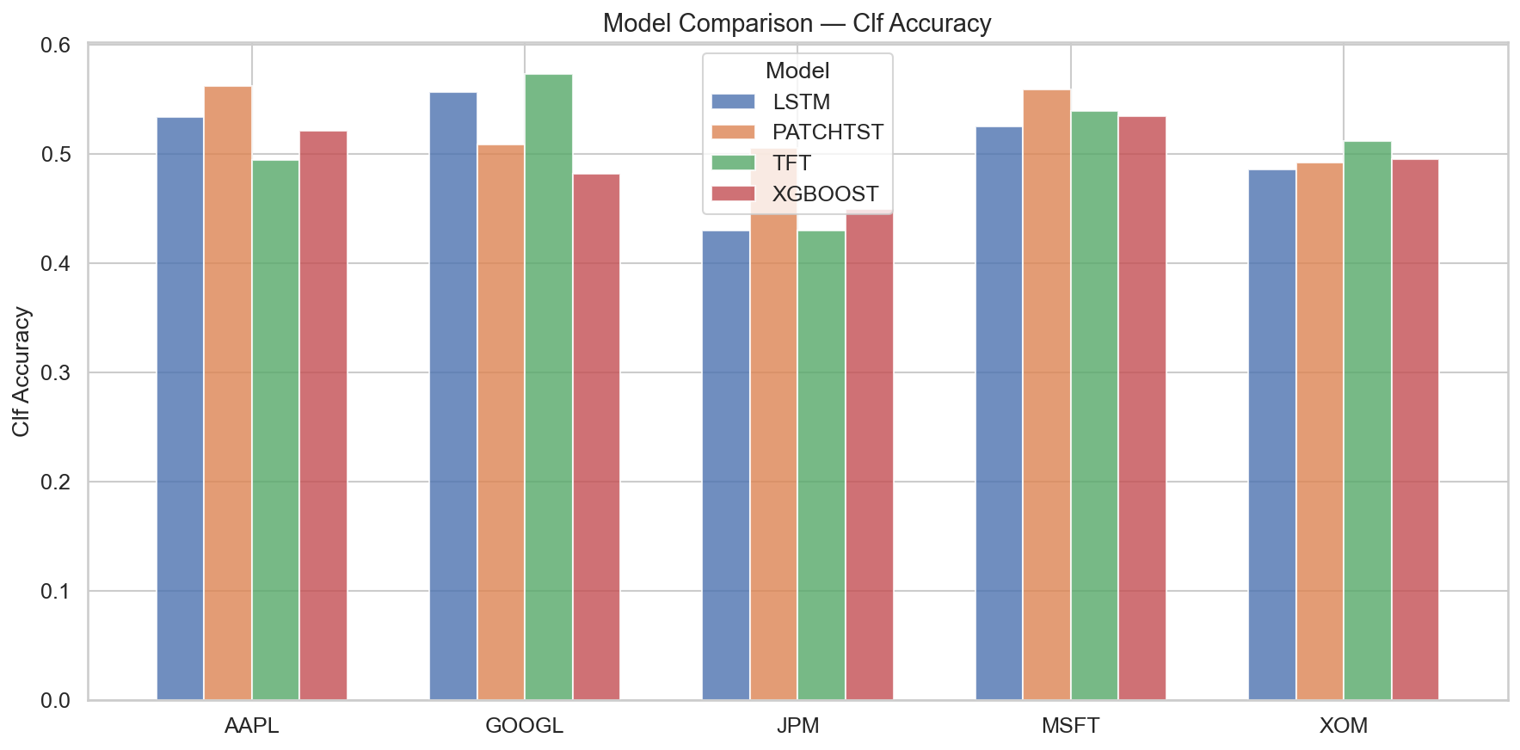Figure 4.1: Classification Accuracy Comparison Across Models
Several patterns emerge from Table 4.1. First, all models achieve classification accuracies close to 50%, with mean accuracies ranging from 0.496 (XGBoost) to 0.525 (PatchTST). These figures are only marginally above random chance, which is consistent with semi-strong market efficiency making next-day direction prediction inherently difficult. Second, MCC values, which account for class imbalance and penalise trivial predictions, are near zero for all models, with XGBoost achieving the highest mean MCC of 0.036. Third, ROC-AUC scores hover around 0.50, indicating that the models struggle to rank positive and negative days with meaningful discrimination.
The strongest individual classification result is TFT on GOOGL, which achieves an accuracy of 0.573, an F1 of 0.547, and the highest MCC across all combinations (0.102). This suggests that TFT's variable selection and temporal attention mechanisms may be particularly well-suited to GOOGL's price dynamics. LSTM on GOOGL also performs relatively well (accuracy 0.556, F1 0.533), whereas JPM proves the most difficult ticker for most models, with accuracies frequently below 0.45.
An important observation is that PatchTST achieves the highest mean accuracy (0.525) but the lowest mean F1 (0.431) and a negative mean MCC (−0.003). Inspection of the per-ticker results reveals that PatchTST on AAPL achieves 0.562 accuracy but only 0.360 F1 with an MCC of exactly 0.000, indicating that the model predicts a single class for nearly all samples. This failure mode is a known risk with deep learning models on noisy financial data, where the loss landscape can settle into a trivial local minimum.

Regression Results
The following table reports the regression metrics for the next-day log return prediction task.
Table 4-2: Regression Performance on Test Set
Model | Ticker | RMSE | MAE | Directional Acc.
XGBoost | AAPL | 0.01350 | 0.00990 | 0.561
XGBoost | MSFT | 0.01288 | 0.00969 | 0.556
XGBoost | GOOGL | 0.01754 | 0.01247 | 0.580
XGBoost | JPM | 0.01322 | 0.00889 | 0.577
XGBoost | XOM | 0.01292 | 0.01000 | 0.503
XGBoost | Mean | 0.01401 | 0.01019 | 0.555
LSTM | AAPL | 0.01410 | 0.01042 | 0.531
LSTM | MSFT | 0.01296 | 0.00977 | 0.522
LSTM | GOOGL | 0.01785 | 0.01293 | 0.480
LSTM | JPM | 0.01620 | 0.01207 | 0.438
LSTM | XOM | 0.01486 | 0.01194 | 0.497
LSTM | Mean | 0.01519 | 0.01143 | 0.494
TFT | AAPL | 0.01386 | 0.01026 | 0.494
TFT | MSFT | 0.01265 | 0.00950 | 0.539
TFT | GOOGL | 0.01734 | 0.01220 | 0.573
TFT | JPM | 0.01404 | 0.00985 | 0.430
TFT | XOM | 0.01301 | 0.01015 | 0.506
TFT | Mean | 0.01418 | 0.01039 | 0.508
PatchTST | AAPL | 0.01605 | 0.01246 | 0.452
PatchTST | MSFT | 0.01460 | 0.01173 | 0.461
PatchTST | GOOGL | 0.02006 | 0.01550 | 0.424
PatchTST | JPM | 0.01861 | 0.01442 | 0.430
PatchTST | XOM | 0.11204 | 0.08892 | 0.483
PatchTST | Mean | 0.03627 | 0.02861 | 0.450
The regression results present a clearer picture of model quality than classification alone. XGBoost achieves the lowest mean RMSE (0.01401) and the highest mean directional accuracy from regression predictions (0.555), making it the strongest regressor overall. TFT follows closely with a mean RMSE of 0.01418 and directional accuracy of 0.508. LSTM performs moderately, while PatchTST exhibits the weakest regression performance, with a severely inflated mean RMSE of 0.03627 driven largely by an anomalous result on XOM (RMSE = 0.11204). This XOM outlier indicates a training failure in which the PatchTST model produced wildly inaccurate magnitude estimates for energy-sector returns.
An important distinction emerges between classification accuracy and regression-derived directional accuracy. XGBoost's classification accuracy averages 0.496 (Table 4.1), but its directional accuracy from regression predictions averages 0.555 (Table 4.2). This gap suggests that the regression head captures directional information more effectively than the classification head, likely because the continuous loss function provides richer gradient signals during training. The implication for trading is significant: a strategy based on the sign of predicted returns may outperform one based on the classification probability output.

Feature Importance Analysis
Two of the four models provide built-in interpretability mechanisms: XGBoost exposes per-feature split gains, and TFT provides variable selection network weights. Analysing these importance rankings reveals which feature categories drive predictions and whether the models rely on fundamentally different information.

XGBoost Feature Importance
XGBoost distributes importance relatively evenly across the 68 features, with the top features for AAPL being Sector_XLF_Return (financial sector returns), Sector_XLV_Return (healthcare sector returns), MACD_Signal, SPX_Return_1d, and Log_Return_1d. For MSFT, the top features shift toward SPX_MA50, BB_Lower, Sector_XLK_Return (technology sector returns), and Sector_XLF_Return.
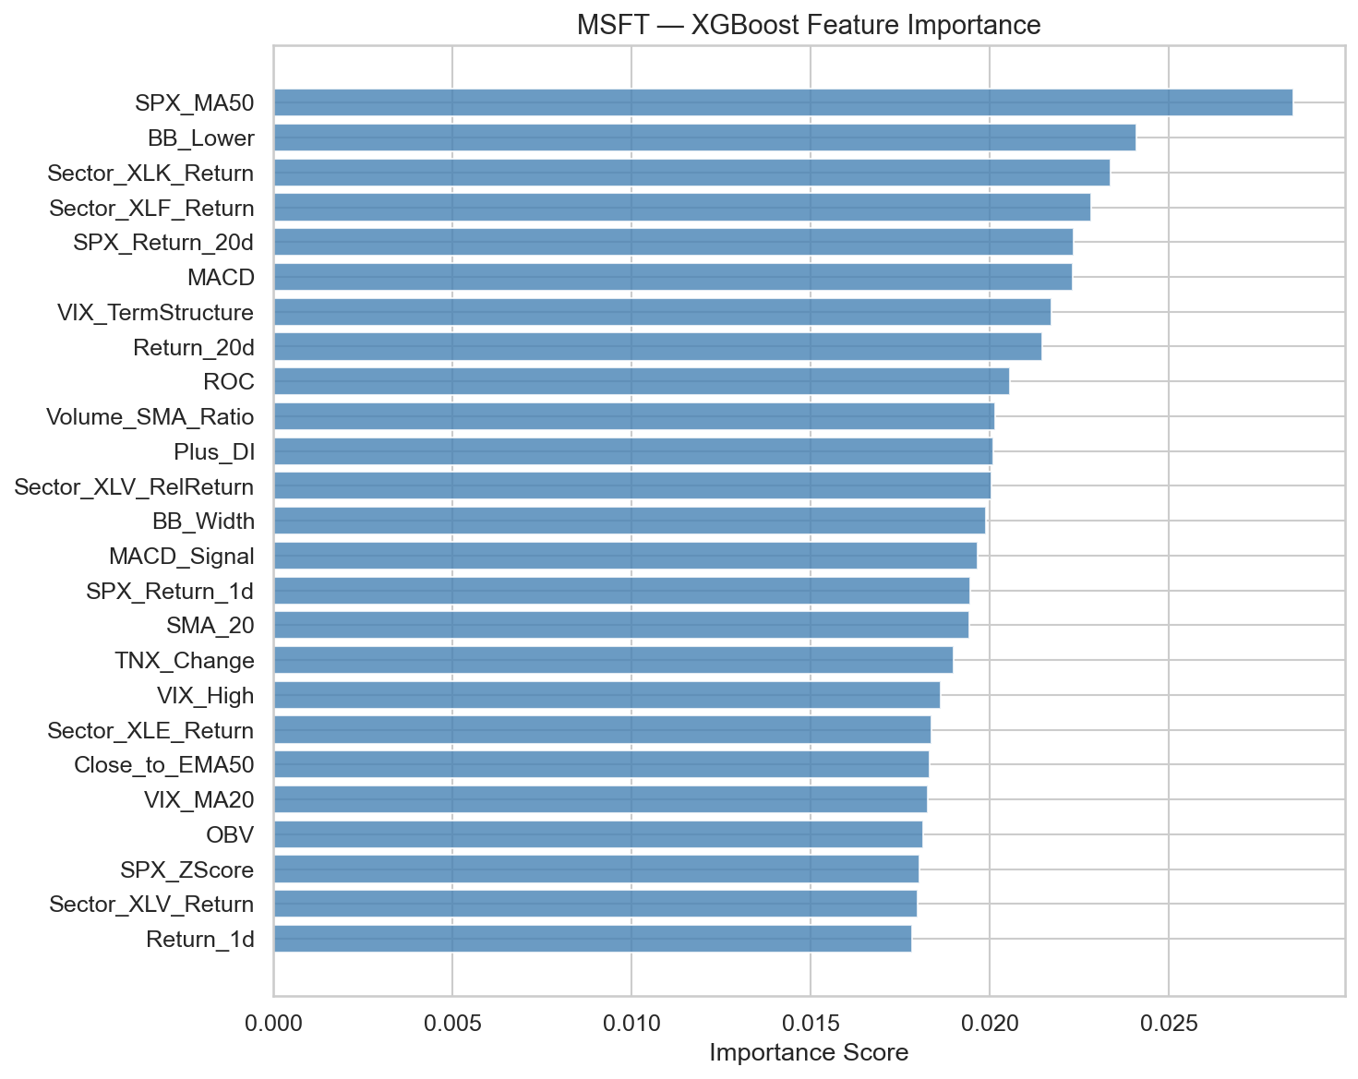Figure 4.2: XGBoost Feature Importance (MSFT)
A notable finding is that macro and cross-sector features consistently rank among the most important across tickers. This suggests that inter-market relationships carry more predictive information than stock-specific technical indicators alone. The financial sector ETF (XLF) appears in the top five for both AAPL and MSFT, indicating that banking sector movements serve as a leading indicator for broader equity markets.
Conversely, all sentiment features (sentiment_mean, sentiment_positive, sentiment_negative, sentiment_roll_3d, sentiment_roll_7d, sentiment_std_3d, sentiment_std_7d, headline_count, and sentiment_neutral) received zero importance for both AAPL and MSFT in the XGBoost model. XGBoost found no useful splitting thresholds on any FinBERT-derived feature, effectively excluding the entire sentiment category from its decision process. This is a significant negative result that warrants discussion (see Chapter 5).

TFT Variable Selection
The TFT's variable selection network assigns markedly non-uniform importance weights, in contrast to XGBoost's relatively flat distribution. For AAPL, the top encoder features are Volume_SMA_Ratio (importance weight 77.8), Sector_XLF_Mom5d (63.4), and Sector_XLI_Return (21.4), with a steep drop-off thereafter. For GOOGL, the top features are Sector_XLK_Mom5d (71.9), Close_to_EMA50 (67.4), and Sector_XLI_Return (47.5).
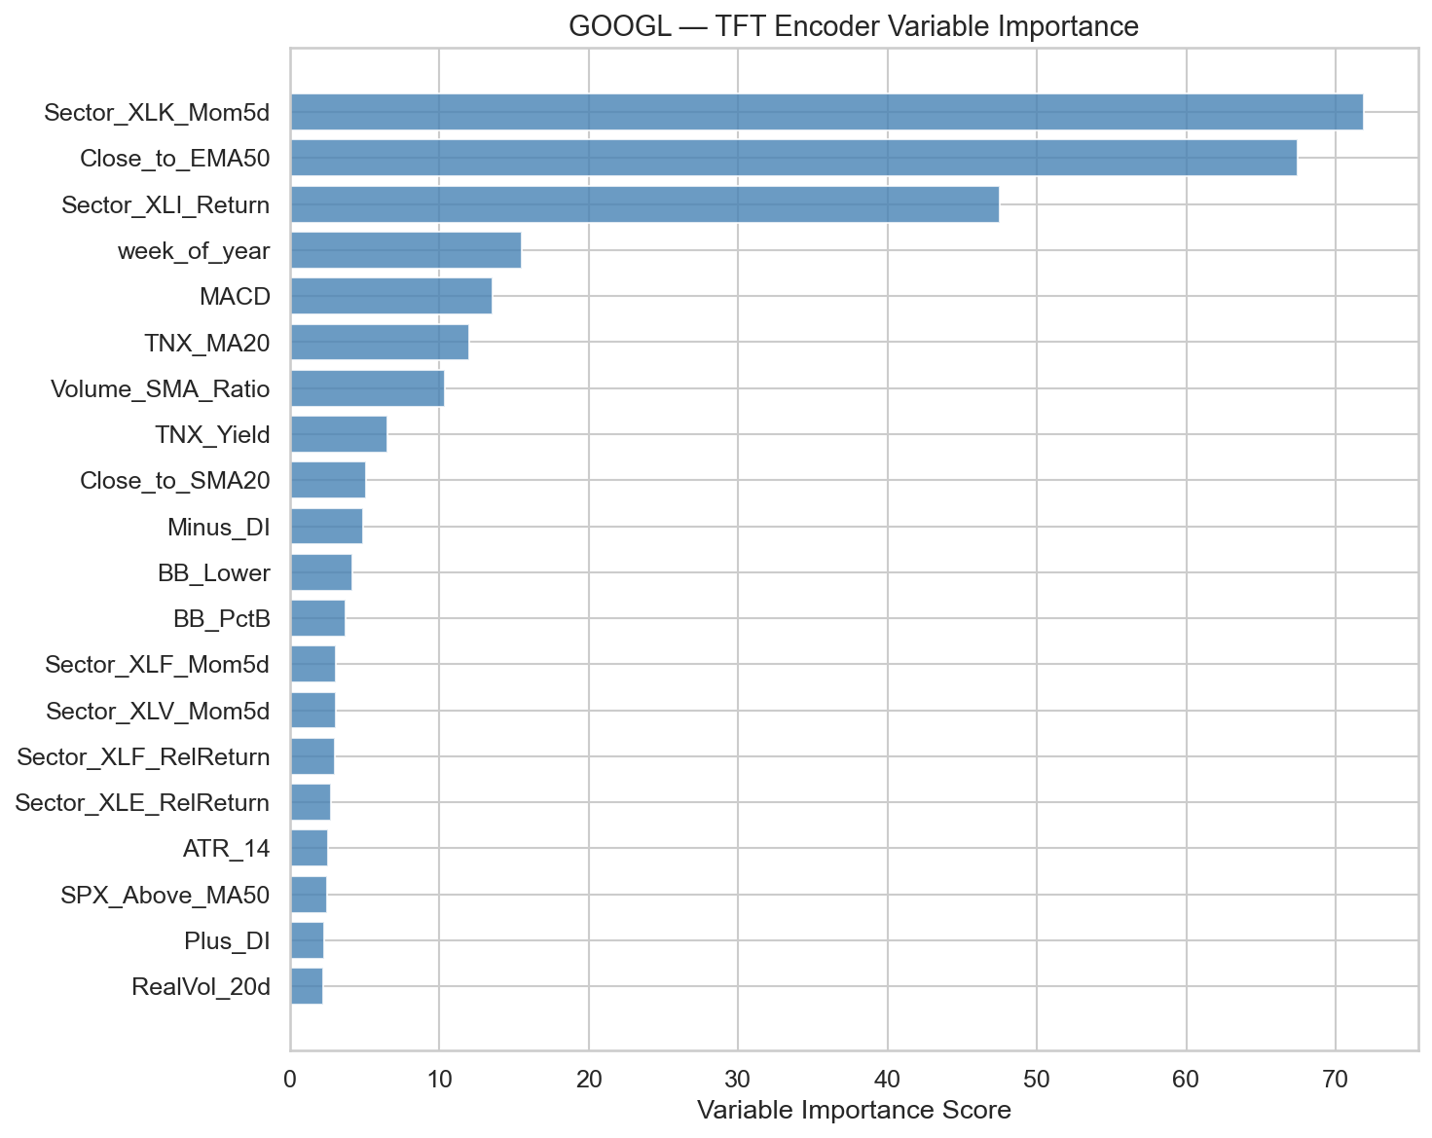Figure 4.3: TFT Encoder Feature Importance (GOOGL)
This concentrated importance profile is a direct consequence of the TFT's gated residual network architecture, which learns to suppress irrelevant inputs through soft attention gating. The practical implication is that TFT effectively performs automatic feature selection, relying on a small subset of the 68 available features while attenuating the rest.
Unlike XGBoost, the TFT assigns non-zero (though small) importance to sentiment features. For AAPL, sentiment_roll_3d receives a weight of 1.94 and sentiment_std_3d receives 1.91, while for GOOGL, sentiment_std_7d receives 1.80. These weights are modest relative to the dominant features but suggest that the TFT's temporal processing can extract marginal value from sentiment data that XGBoost's static splitting cannot capture.
Both models agree that sector ETF features and macro indicators are the most informative inputs. Volume_SMA_Ratio appears prominently in TFT (ranked first for AAPL) but less so in XGBoost (ranked 47th for AAPL), suggesting that TFT's attention mechanism is better equipped to exploit the temporal dynamics of volume patterns. Calendar features (week_of_year, month, day_of_week) rank moderately in TFT but are absent from XGBoost's feature set, consistent with the hypothesis that seasonality patterns require sequential context to exploit effectively.

Backtesting Results
The vectorised backtesting engine converts model predictions into simulated trading strategies with a 0.55 confidence threshold for trade entry, 3% stop-loss, 5% take-profit, 5 basis points transaction cost per trade, and position sizing proportional to model confidence. All strategies are benchmarked against a SPY buy-and-hold portfolio over the same test period.

Benchmark Performance
The SPY buy-and-hold benchmark generated a total return of approximately 34.4% over the test period (mid 2023–end 2024), corresponding to an annualised return of approximately 23.4% with a Sharpe ratio of 1.44. This was an exceptionally strong period for US equities, driven by AI-related optimism and resilient economic growth. Any model-based strategy must be evaluated against this challenging baseline.

Strategy Performance by Model
Table 4-3: Backtesting Performance on Test Period
Model | Ticker | Total Return | Ann. Return | Sharpe | Sortino | Max DD | Win Rate | Market Exp.
XGBoost | AAPL | −3.7% | −2.5% | −0.48 | −0.66 | −17.7% | 35.3% | 50.7%
XGBoost | MSFT | 24.7% | 16.0% | 0.82 | 1.01 | −11.9% | 40.5% | 70.4%
XGBoost | GOOGL | 16.4% | 10.7% | 0.62 | 0.91 | −9.7% | 36.0% | 29.6%
XGBoost | JPM | −1.0% | −0.6% | −1.07 | −1.28 | −4.8% | 37.9% | 7.7%
XGBoost | XOM | 0.0% | 0.0% | 0.00 | N/A | 0.0% | N/A | 0.0%
TFT | AAPL | 2.3% | 1.6% | −0.36 | −0.49 | −7.8% | 35.7% | 11.8%
TFT | MSFT | −5.6% | −4.0% | −1.02 | −1.17 | −9.5% | 35.4% | 13.5%
TFT | GOOGL | 25.1% | 17.2% | 1.01 | 1.30 | −12.6% | 51.4% | 49.9%
TFT | JPM | 0.7% | 0.5% | −2.08 | −3.49 | −1.1% | 33.3% | 5.1%
TFT | XOM | 0.0% | 0.0% | 0.00 | N/A | 0.0% | N/A | 0.0%
LSTM | AAPL | 6.5% | 4.6% | 0.11 | 0.09 | −8.4% | 52.1% | 73.0%
LSTM | MSFT | −2.6% | −1.9% | −0.83 | −1.03 | −8.2% | 46.0% | 34.9%
LSTM | GOOGL | −0.7% | −0.5% | −0.98 | −1.18 | −5.3% | 47.1% | 9.6%
LSTM | JPM | 0.0% | 0.0% | 0.00 | N/A | 0.0% | N/A | 0.0%
LSTM | XOM | 2.6% | 1.8% | −0.73 | −1.40 | −2.2% | 45.0% | 5.6%
PatchTST | AAPL | 7.7% | 5.4% | 0.20 | 0.19 | −4.8% | 50.7% | 81.1%
PatchTST | MSFT | 10.0% | 7.0% | 0.39 | 0.37 | −6.7% | 55.5% | 79.2%
PatchTST | GOOGL | −1.2% | −0.8% | −3.85 | −3.87 | −1.5% | 40.0% | 1.4%
PatchTST | JPM | 9.0% | 6.3% | 0.37 | 0.44 | −6.7% | 51.9% | 37.5%
PatchTST | XOM | −0.9% | −0.6% | −6.49 | −6.12 | −0.9% | 0.0% | 0.6%

Key Findings
The single best-performing strategy is TFT on GOOGL, which achieves a total return of 25.1%, an annualised return of 17.2%, and a Sharpe ratio of 1.01 with a 51.4% win rate. This is the only model–ticker combination where the Sharpe ratio exceeds 1.0. XGBoost on MSFT is the second-best performer, with a total return of 24.7%, annualised return of 16.0%, and a Sharpe ratio of 0.82.
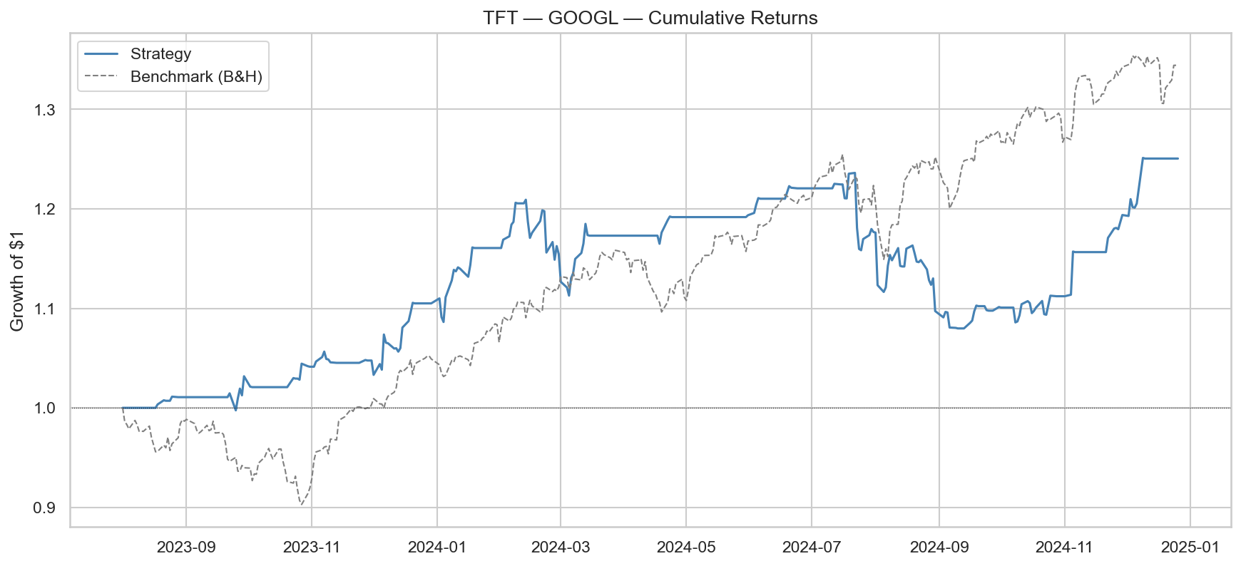Figure 4.4: TFT-GOOGL Equity Curve
However, all model–ticker strategies underperform the SPY buy-and-hold benchmark (34.4% total return, Sharpe 1.44). The excess returns (model return minus benchmark return) are negative across all 20 combinations without exception. This is a critical result: despite achieving marginally above-chance directional accuracy, none of the models generate sufficient predictive signal to overcome transaction costs and the opportunity cost of a passive index strategy during a strong bull market.
Several additional patterns merit attention. First, market exposure varies dramatically across combinations. XGBoost on XOM and TFT on XOM generate zero trades, indicating that neither model achieves sufficient confidence (above the 0.55 threshold) to trigger any trade entries for the energy stock. LSTM on JPM similarly produces zero trades. By contrast, PatchTST maintains high market exposure (79–81%) for AAPL and MSFT, reflecting its tendency to produce high-confidence predictions regardless of actual signal quality.
Second, the win rates of profitable strategies tend to cluster around 35–55%, which is consistent with models that identify marginally positive expected-value trades but with substantial variance. A win rate below 50% can still produce positive returns if the average winner exceeds the average loser in magnitude, which is the case for XGBoost on MSFT (win rate 40.5%, profit factor 1.29) and XGBoost on GOOGL (win rate 36.0%, profit factor 1.43).
Third, maximum drawdowns remain contained for most strategies. The worst drawdown observed is −17.7% for XGBoost on AAPL, while most combinations remain within −10%. The 3% stop-loss mechanism effectively limits per-trade losses, though it also truncates potential recoveries on volatile days.

Cross-Model Comparison
Table 4-4: Model-Level Summary
Metric | XGBoost | LSTM | TFT | PatchTST
Clf. Accuracy | 0.496 | 0.506 | 0.510 | 0.525
Clf. F1 (Macro) | 0.470 | 0.452 | 0.438 | 0.431
Clf. ROC-AUC | 0.539 | 0.505 | 0.496 | 0.508
Clf. MCC | 0.036 | 0.008 | 0.008 | −0.003
Reg. RMSE | 0.014 | 0.015 | 0.014 | 0.036
Reg. Dir. Accuracy | 0.555 | 0.494 | 0.508 | 0.450
Parameters | Varies | ~233K | ~965K | ~580K
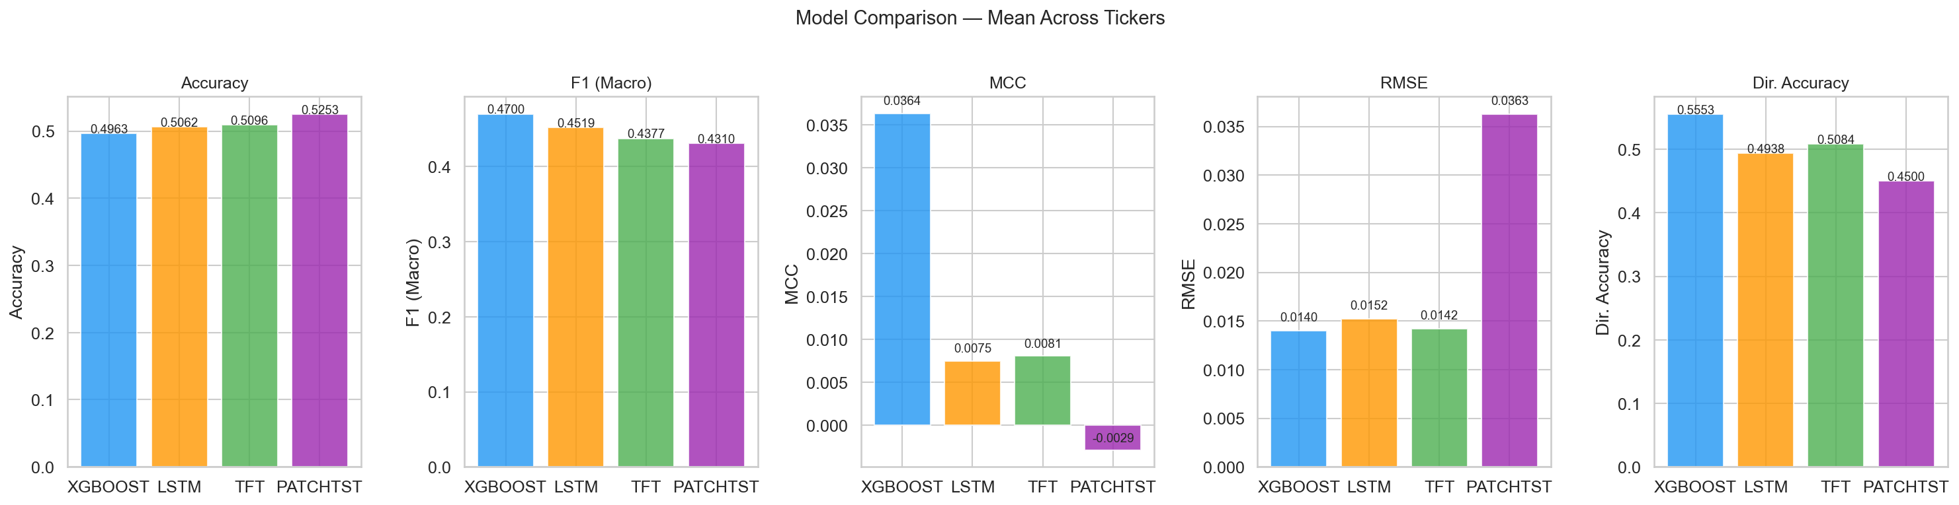
Figure 4.5: Overall Model Comparison Summary
No single model dominates across all metrics. XGBoost leads on ROC-AUC (0.539), MCC (0.036), regression RMSE (0.014), and regression directional accuracy (0.555), establishing it as the most consistent predictor. PatchTST achieves the highest raw classification accuracy (0.525) but the worst performance on every other metric, exposing the limitations of accuracy as a standalone evaluation measure for imbalanced or marginal prediction tasks. TFT's strength lies in its ability to achieve the best single-ticker results (GOOGL) while its average performance is unremarkable, suggesting high sensitivity to the specific asset being modelled. LSTM performs moderately across the board without excelling in any dimension.
The parameter count provides additional context. XGBoost achieves the best overall performance with an architecture that contains no neural network parameters at all (purely tree-based). TFT has the largest parameter count (~965K) and PatchTST has ~580K, yet neither translates this capacity into superior aggregate performance. This suggests that the noise-to-signal ratio in daily stock returns is too low for deep learning architectures to leverage their representational capacity effectively at this prediction horizon.

Summary of Findings
The experimental results can be distilled into five principal findings:
- Near-random classification accuracy: All four models achieve accuracy near 50% and MCC near zero on next-day direction prediction, confirming that daily stock direction remains extremely difficult to predict, consistent with semi-strong market efficiency.
- XGBoost is the most reliable model overall: It achieves the best regression accuracy (RMSE 0.014), highest MCC (0.036), and highest directional accuracy (55.5%) despite being the simplest architecture with no neural network parameters.
- TFT achieves the single best backtest result: TFT on GOOGL produces a Sharpe ratio of 1.01 and 25.1% total return, but its performance is inconsistent across tickers.
- All strategies underperform the SPY benchmark: Excess returns are negative across all 20 model-ticker combinations during the test period (SPY returned ~34.4%, Sharpe 1.44).
- Sentiment features contribute negligibly: FinBERT-derived features receive zero importance in XGBoost and only marginal weights in TFT, suggesting daily headline sentiment aggregates do not carry incrementally useful information beyond macro and technical features.
These findings establish the empirical basis for the interpretive discussion in Chapter 5.

Discussion
This chapter interprets the experimental results presented in Chapter 4 within the broader context of financial prediction research, market microstructure theory, and practical trading system design. Rather than restating numerical outcomes, the discussion focuses on explaining why the observed patterns emerge and what they imply for the viability of ML-driven trading strategies.

Predictability and Market Efficiency
The most striking result of this project is the near-universal failure of all four models to achieve classification accuracy meaningfully above 50% on next-day direction prediction. Mean accuracies range from 0.496 (XGBoost) to 0.525 (PatchTST), with MCC values clustered near zero. These figures are consistent with a market that is informationally efficient at the daily horizon, not perfectly efficient in the Fama [1] sense, but efficient enough that residual predictability is too thin to exploit reliably.
This outcome aligns closely with the Adaptive Markets Hypothesis (AMH) proposed by Lo [4]. Under the AMH, predictability is not a fixed property but fluctuates as market participants discover, exploit, and erode profitable patterns. The fact that some model–ticker combinations show marginal signal (TFT on GOOGL achieves 57.3% accuracy, MCC of 0.102) while others are indistinguishable from random noise is precisely the heterogeneous predictability landscape that the AMH predicts. Certain assets at certain times exhibit exploitable structure; the challenge is that this structure is neither persistent nor transferable across tickers.
The divergence between classification accuracy and regression-based directional accuracy is also informative. XGBoost's classification head averages 49.6% accuracy, but the sign of its regression predictions achieves 55.5% directional accuracy. This gap arises because the regression objective captures the magnitude of returns, and the gradient signal from a continuous loss function is richer than from a binary cross-entropy loss. For trading purposes, this finding suggests that regression-based signal generation is preferable to direct classification, even when the ultimate decision is binary (buy or sell).

Why Simpler Models Outperform
A counterintuitive result is that XGBoost, which is a non-parametric tree ensemble with no temporal modelling, matches or outperforms three deep learning architectures that explicitly model sequential dependencies. XGBoost achieves the best mean ROC-AUC (0.539), the best mean MCC (0.036), and the lowest regression RMSE (0.014), despite having no learnable parameters in the neural network sense.
Three factors explain this outcome. First, the signal-to-noise ratio in daily stock returns is extremely low. Daily log returns for a typical large-cap stock have standard deviations on the order of 1–2%, while the predictable component, if it exists, is likely measured in single basis points. Deep learning architectures with hundreds of thousands of parameters (TFT has 965K, PatchTST has 580K) are designed to capture complex non-linear relationships, but when the underlying signal is barely distinguishable from noise, this capacity becomes a liability rather than an asset. The models overfit to spurious patterns in the training data that do not generalise to the test period.
Second, XGBoost's native handling of missing values and its regularisation mechanisms (L1, L2, and tree-depth constraints) provide implicit protection against overfitting. The Optuna hyperparameter optimisation over 100 trials further ensures that the regularisation strength is tuned appropriately for each ticker. By contrast, the deep learning models rely on dropout, early stopping, and learning rate scheduling, which are effective but less directly targeted at the specific failure modes of noisy financial data.
Third, the 68-feature matrix is predominantly composed of tabular features, such as moving averages, oscillators, ratios, and categorical indicators, rather than raw sequential data. XGBoost is specifically designed for tabular prediction and exploits feature interactions through its tree-splitting mechanism. The deep learning models must first learn to extract useful representations from these already-engineered features, which adds an unnecessary layer of indirection. If the raw OHLCV sequence were used as input (without hand-crafted features), the relative advantage of temporal architectures might be larger.
This finding echoes a broader trend in the machine learning literature. Grinsztajn et al. [23] demonstrated that tree-based methods consistently outperform deep learning on medium-sized tabular datasets, a result that extends naturally to the financial prediction setting where datasets are modest in size and signals are weak.

The TFT Advantage of GOOGL
While aggregate results favour XGBoost, the single best backtesting outcome belongs to TFT on GOOGL: a total return of 25.1%, Sharpe ratio of 1.01, and win rate of 51.4%. Understanding why TFT excels on this particular ticker illuminates the conditions under which deep learning adds value over simpler methods.
The TFT's variable selection network assigns dominant importance to Sector_XLK_Mom5d (71.9) and Close_to_EMA50 (67.4) for GOOGL. Both features capture medium-term momentum dynamics, namely the five-day momentum of the technology sector ETF and the stock's position relative to its 50-day exponential moving average. TFT's multi-head temporal attention mechanism can model how the predictive relevance of these features changes over time, effectively learning regime-dependent strategies. During trending markets, momentum features carry strong signal; during mean-reverting regimes, the model can learn to attenuate their influence.

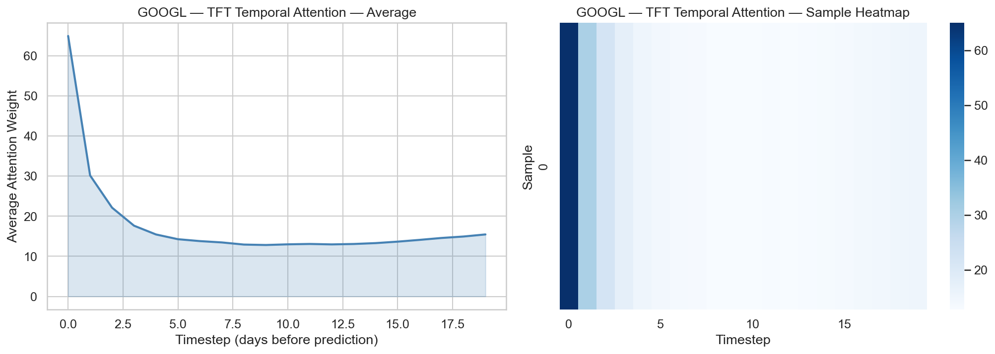Figure 5.1: TFT Attention Weights for GOOGL
GOOGL also exhibits distinctive price dynamics compared to the other tickers. As the third-largest technology stock, it tracks sector-level momentum closely, and its relatively lower retail ownership (compared to AAPL) may make its price dynamics more predictable by institutional flow models. The TFT's attention mechanism appears to capture these structural regularities more effectively than XGBoost's static feature splits.
However, the TFT's superior performance on GOOGL does not generalise. On JPM, TFT achieves a Sharpe ratio of −2.08, and on XOM it generates zero trades. This inconsistency is a hallmark of overfitting to asset-specific patterns: the model learns idiosyncratic structure in GOOGL's training data that happens to persist into the test period, but this learned structure does not transfer to fundamentally different asset classes. A robust production system would require either per-asset model selection or an ensemble approach that allocates capital based on rolling out-of-sample performance.

The Failure of Sentiment Features
One of the most significant negative results of this project is the complete failure of FinBERT sentiment features to contribute meaningfully to prediction. In the XGBoost model, all nine sentiment-derived features (sentiment_mean, sentiment_positive, sentiment_negative, sentiment_roll_3d, sentiment_roll_7d, sentiment_std_3d, sentiment_std_7d, headline_count, and sentiment_neutral) receive exactly zero feature importance for both AAPL and MSFT. In TFT, sentiment features receive non-zero but negligible importance weights (1.4–1.9 out of a maximum of 77.8).
Several explanations account for this result. First, the sentiment features are aggregated at a daily level, using measures such as the mean, standard deviation, and rolling averages of headline sentiment scores, which destroys the intra-day timing information needed to trade on news. A headline published at 9:01 AM and one published at 3:59 PM have very different trading implications, but the daily aggregation treats them identically. By the time sentiment is collapsed into a single daily number, the price impact has already been absorbed.
Second, the FinBERT model processes headlines in isolation, without access to the specific stock ticker, the prevailing market context, or the novelty of the information. A headline reading "Apple reports record earnings" may have very different price implications depending on whether the market already expected record earnings. FinBERT's context-free sentiment scoring cannot distinguish between anticipated and surprising news, which is the distinction that actually moves prices.
Third, there is an information overlap problem. Much of the sentiment-relevant information is already captured by the technical and macro features. If positive sentiment tends to coincide with upward price momentum (which it does, since both are driven by the same underlying fundamental dynamics), then including sentiment features alongside momentum indicators provides redundant rather than complementary information. The models correctly learn to ignore the noisier proxy (sentiment) in favour of the more direct signal (price-derived momentum).
This result does not invalidate the use of NLP in finance but rather highlights the importance of implementation details. Higher-frequency sentiment analysis (tick-level or minute-level), event-driven approaches that detect surprise relative to expectations, and entity-linked sentiment that associates headlines with specific stocks would likely yield more useful features than the daily-aggregate approach employed here.

Backtesting Limitations and the Benchmark Problem
All 20 model–ticker combinations produce negative excess returns relative to the SPY buy-and-hold benchmark, which returned approximately 34.4% (annualised ~23.4%, Sharpe 1.44) during the test period of mid-2023 to end-2024. This underperformance warrants careful interpretation rather than blanket dismissal of the model-based strategies.
The test period coincided with an exceptional bull market driven by AI-sector optimism and resilient macroeconomic conditions. The SPY Sharpe ratio of 1.44 is well above the long-term average of approximately 0.4–0.5. Evaluating active strategies against an anomalously strong passive benchmark overstates the relative weakness of the active approach. In a normal or bearish market environment, the 0.55 confidence threshold and risk management mechanisms (stop-loss, take-profit) might provide significant downside protection that a buy-and-hold strategy lacks.
The vectorised backtesting framework also introduces several simplifications that may distort results. Trades are executed at the daily close price with no slippage model, which is optimistic for liquid large-caps but could understate costs for less liquid instruments. The fixed 5 basis point transaction cost does not account for market impact or bid-ask spreads that widen during volatile periods. Position sizes are determined by model confidence, but because the models' confidence calibration has not been separately validated, an overconfident model may take larger positions than its true edge justifies.
Furthermore, the strategy is long-only (with a confidence threshold of 0.55 for buying), which means it cannot profit from correctly predicting downward moves. During the test period's strong uptrend, this constraint means the strategy can at best capture partial upside and at worst suffers from whipsawing in and out of positions, incurring transaction costs without the full benefit of the trend.

Model Complexity and the Overfitting Frontier
The relationship between model complexity and predictive performance observed in this project follows a pattern that is well-documented in the statistical learning literature but underappreciated in applied deep learning research. XGBoost (no neural network parameters) outperforms LSTM (~233K parameters), which outperforms TFT (~965K parameters) on average, which outperforms PatchTST (~580K parameters) on regression metrics. The sole exception is TFT on GOOGL, where the additional capacity enables the model to capture asset-specific temporal patterns.
This ordering maps directly onto the bias-variance trade-off. In a low signal-to-noise regime, the optimal model complexity is low: simpler models with higher bias but lower variance produce better out-of-sample predictions. Deep learning models achieve their advantage in domains with high signal-to-noise ratios and abundant data, such as image recognition, natural language processing, and protein structure prediction, where the training data contains rich, learnable patterns that are far from noise. Daily stock returns do not share these properties. Ten years of daily data yields approximately 2,500 training samples per ticker, which is insufficient for a 965K-parameter TFT to reliably learn the subtle dependencies present in financial time series without memorising noise.
PatchTST's particularly poor regression performance (mean RMSE of 0.036, driven by the XOM outlier of 0.112) exemplifies the catastrophic failure mode of over-parameterised models in noisy settings. The model's 580K parameters, combined with its patch-based tokenisation of the lookback window, appear to learn spurious high-frequency patterns in the training data that produce wildly inaccurate predictions on out-of-distribution test data. The energy sector's distinctive dynamics, which are driven by commodity prices, OPEC decisions, and geopolitical events, are inherently unpredictable and therefore expose this failure mode most acutely.

Implications for Practical Trading Systems
The results of this project offer several actionable insights for the design of practical ML-based trading systems, even though the specific strategies tested here do not outperform the benchmark.
First, model selection should prioritise robustness over theoretical sophistication. XGBoost's consistent performance across tickers, combined with its computational efficiency and interpretability, makes it a superior starting point for production systems compared to deep learning alternatives. Deep learning should be reserved for settings where there is strong a priori reason to believe that temporal dependencies exist and where sufficient data is available to learn them.
Second, the confidence threshold of 0.55 used in this project may not be optimal. Strategies with zero trades (XGBoost-XOM, LSTM-JPM, TFT-XOM) indicate that the threshold is too high for some combinations, while the high market exposure of PatchTST (>80% for AAPL and MSFT) suggests it is too low for others. An adaptive threshold calibrated on rolling validation performance would likely improve capital allocation.
Third, the negative excess returns relative to SPY do not necessarily imply that the models have no value. In a portfolio context, a strategy that generates uncorrelated returns, even modest ones, can improve risk-adjusted performance when combined with a passive index position. The relevant question is not whether the model beats the benchmark in isolation but whether it provides diversification value within a broader portfolio.
Fourth, the complete failure of daily-aggregate sentiment features points toward a specific research direction: real-time, event-driven NLP that processes news at the moment of publication and trades before the information is fully absorbed into prices. This would require sub-daily data, streaming NLP infrastructure, and a backtesting framework that models intra-day price formation, all of which are beyond the scope of this project but represent natural extensions.

Conclusion and Future Work

Conclusion
This project set out to build, compare, and evaluate four machine learning architectures, namely XGBoost, LSTM, Temporal Fusion Transformer (TFT), and PatchTST, for next-day stock prediction across five S&P 500 constituents spanning the technology, finance, and energy sectors. The system integrates 68 engineered features drawn from technical indicators, FinBERT sentiment analysis, macroeconomic variables, and calendar effects, and evaluates predictions through both statistical metrics and a vectorised backtesting engine benchmarked against a SPY buy-and-hold strategy.
The central finding is that daily stock direction remains extremely difficult to predict with any architecture tested. All four models achieve classification accuracies near 50% and Matthews Correlation Coefficients near zero, consistent with semi-strong market efficiency at the daily horizon. The Adaptive Markets Hypothesis provides the most appropriate interpretive framework: predictability is not absent but is thin, transient, and heterogeneous across assets and time periods.
Among the four architectures, XGBoost emerges as the most reliable predictor overall. It achieves the highest mean ROC-AUC (0.539), the highest mean MCC (0.036), the lowest regression RMSE (0.014), and the best regression-derived directional accuracy (55.5%), despite having no neural network parameters. This result reinforces the growing body of evidence that tree-based methods remain highly competitive with deep learning on tabular prediction tasks, particularly in low signal-to-noise regimes where model capacity easily translates into overfitting.
TFT produces the single best backtesting result, achieving a 25.1% total return and Sharpe ratio of 1.01 on GOOGL, thereby demonstrating that its variable selection and temporal attention mechanisms can capture asset-specific patterns that simpler models miss. However, this performance does not generalise across tickers, with TFT producing negative returns on MSFT and zero trades on XOM. The inconsistency highlights the risk of relying on deep learning models without robust cross-validation and asset-level performance monitoring.
PatchTST, despite its theoretical appeal as a modern Transformer variant designed for time-series forecasting, delivers the weakest overall performance. Its tendency toward degenerate constant predictions on some tickers and a catastrophic regression failure on XOM (RMSE of 0.112, an order of magnitude worse than other models) suggests that the architecture requires significantly more training data than ten years of daily observations to learn meaningful representations.
All 20 model–ticker backtesting strategies produce negative excess returns relative to the SPY benchmark, which returned approximately 34.4% during the test period. While this underperformance is partly attributable to the exceptionally strong bull market, it nonetheless confirms that marginal predictive accuracy, even when statistically above chance, is insufficient to generate economically significant alpha after accounting for transaction costs and the opportunity cost of passive investment.
The complete failure of daily-aggregate FinBERT sentiment features constitutes a notable negative result. XGBoost assigns zero importance to all sentiment variables, and TFT assigns only negligible weights. This does not invalidate NLP-based approaches to financial prediction. Instead, it suggests that the specific implementation, based on daily headline aggregation without ticker linkage, surprise detection, or intra-day timing, removes the information content that makes news sentiment potentially useful.
In summary, this project demonstrates both the potential and the limitations of applying modern machine learning to stock market prediction. The potential lies in the ability of models like TFT to identify exploitable patterns in specific assets under specific conditions. The limitations lie in the fundamental difficulty of the prediction task itself: daily stock returns contain so little predictable signal that even state-of-the-art architectures with nearly one million parameters cannot reliably extract it across a diversified universe.

Limitations
Several limitations constrain the generalisability of the findings presented in this report.
- Small stock universe: Five stocks, while sector-diversified, are insufficient to draw definitive conclusions about sector-level or market-level predictability. Expanding to 50-500 stocks would provide the statistical power to confirm whether patterns like TFT's technology-stock advantage are genuine or artefactual.
- Daily-only prediction horizon: Intra-day data would provide orders of magnitude more training samples and capture microstructure dynamics that daily aggregation obscures. Conversely, weekly or monthly horizons might offer higher signal-to-noise ratios.
- Simplified backtesting: The vectorised engine uses no slippage model, fixed transaction costs, and execution at daily close prices. An event-driven simulator with order book dynamics and market impact modelling would provide a more accurate assessment of strategy viability.
- Limited sentiment pipeline: Only headline text is processed, without access to article bodies, social media, earnings call transcripts, or analyst reports. A more comprehensive NLP integration at higher temporal resolution could yield materially different results.
- Single market regime: The test period (mid-2023 to end-2024) represents a strong technology-led bull market. Evaluation across bear markets, sideways markets, and high-volatility crises would provide a more complete picture of model robustness.

Future Work
The findings and limitations of this project suggest several directions for future research.

Higher-Frequency Prediction
Extending the pipeline to intra-day data (5-minute or 15-minute bars) would dramatically increase the training sample size and allow the deep learning models to leverage their capacity more effectively. The PatchTST architecture, in particular, is designed for long-sequence modelling and may perform substantially better with thousands of data points per ticker rather than 2,500.

Event-Driven Sentiment Integration
Replacing the daily-aggregate sentiment approach with a real-time, event-driven NLP pipeline that processes headlines at the moment of publication, before the information is fully absorbed into prices, could unlock the predictive value that the current implementation fails to capture. This would require streaming data infrastructure, sub-daily backtesting, and a surprise detection module that compares headline sentiment against prior market expectations.

Ensemble and Meta-Learning Strategies
Rather than selecting a single model per ticker, a meta-learning approach that dynamically allocates capital across models based on their rolling out-of-sample performance could combine XGBoost's consistency with TFT's occasional strong performance. Stacking or blending the predictions of all four models may also reduce variance without sacrificing signal.

Expanded Stock Universe and Cross-Sectional Models
Training a single model across all tickers simultaneously, rather than on a per-ticker basis, would enable the model to learn cross-sectional patterns, such as the possibility that financial sector momentum predicts technology stock returns. Graph neural networks that model inter-stock relationships through a learned adjacency matrix represent a promising architecture for this setting.

Alternative Target Formulations
The current dual-target setup (direction + log return) could be extended to predict volatility, tail risk, or optimal position size directly. Predicting the probability of a large move (say, >2%) rather than the expected direction may yield more actionable signals for options-based or volatility-trading strategies.

Reinforcement Learning for Portfolio Optimisation
The current pipeline treats prediction and portfolio construction as separate stages. A reinforcement learning agent that directly optimises portfolio-level Sharpe ratio or drawdown-constrained return could learn trading policies that account for transaction costs, position limits, and risk budgets in an end-to-end manner.

Reflection on Learning Outcome Attainment
This section reflects on the attainment of four learning outcomes through the execution of this Final Year Project.
Engineering Knowledge
This project required the application of mathematical and engineering fundamentals across multiple domains. The feature engineering stage demanded fluency in signal processing concepts: moving averages are finite impulse response (FIR) filters applied to noisy price series, Bollinger Bands are statistical process control charts adapted to financial data, and the Relative Strength Index implements a bounded normalisation of up-move and down-move magnitudes. The model design stage required a deep understanding of statistical learning theory, specifically, the bias-variance trade-off that explains why XGBoost outperforms deeper architectures in low signal-to-noise regimes, and the mathematical formulations of LSTM gating equations, Transformer self-attention, and gradient boosting with second-order Taylor approximations. Implementing the TFT required understanding gated residual networks and variable selection as attention-based feature gating. The backtesting stage applied financial engineering principles: Sharpe and Sortino ratios are rooted in modern portfolio theory, and the stop-loss and take-profit mechanisms implement risk management concepts drawn from quantitative finance.
Problem Analysis
The core challenge of this project was decomposing a vaguely defined objective, namely "predict stock prices using machine learning", into a precisely specified engineering problem. This decomposition involved several non-obvious decisions. First, I formulated the prediction task as a dual-output problem (classification for direction, regression for magnitude) rather than treating it as pure regression, which allowed me to evaluate model quality from two complementary perspectives. Second, I identified look-ahead bias as the most critical methodological risk and designed every pipeline stage to prevent it: the chronological train-validation-test split, the RobustScaler fitted on training data only, and the strict prohibition against using future data in feature engineering. Third, I analysed the feature space and recognised that raw OHLCV data alone would be insufficient, leading to the integration of three additional feature families (sentiment, macro, calendar). Each integration decision required analysing the theoretical rationale, the data availability, and the risk of introducing noise. The problem analysis was iterative: early experiments revealed that sentiment features added negligible value, prompting a reassessment of how those features were constructed.
Design/Development of Solutions
The system design evolved through multiple iterations to balance competing requirements: modularity for experimentation, reproducibility for scientific rigour, and computational efficiency for practical execution. The pipeline architecture separates data ingestion, feature engineering, model training, and backtesting into independent modules connected through standardised Parquet file interfaces. This modularity allowed me to modify any single component, for instance by adding a new technical indicator or swapping a model architecture, without disrupting the rest of the system. The configuration module centralises all hyperparameters, file paths, and random seeds in a single location, eliminating the risk of inconsistent settings across scripts. A significant design trade-off arose between model complexity and interpretability: the TFT's 965K parameters enable powerful temporal modelling but make it difficult to understand why specific predictions are made, whereas XGBoost's tree-based structure provides transparent feature importance at the cost of ignoring sequential dependencies. I addressed this trade-off by including both extremes in the comparison rather than committing to a single architecture prematurely.
Investigation
The experimental design of this project follows the principles of systematic scientific investigation. All four models were trained on an identical feature set, data split, and evaluation protocol, ensuring that performance differences can be attributed solely to architectural choices rather than confounding variables. Random seeds were fixed across all frameworks (Python, NumPy, PyTorch, XGBoost) at 42 to guarantee reproducibility. The feature importance analysis serves as a form of ablation study: by examining which features the models rely on, I can infer which information sources drive predictions without the computational cost of retraining with features removed. The backtesting evaluation extends the investigation beyond statistical accuracy into economic relevance, testing whether predictive signal translates into profitable trading after accounting for real-world frictions (transaction costs, stop-losses, confidence thresholds). The controlled comparison across five tickers from three sectors provides cross-sectional evidence on whether predictability varies by asset class. Each finding was interpreted within its proper context, with due consideration given to the strong bull market benchmark, so as to avoid overstating the conclusions. This disciplined approach to experimental design and cautious interpretation of results reflects the investigative rigour expected of engineering research.

Acknowledging/Declaring the Use of GAI

Please refer to NTU's Current Policy & Guidelines on the Use of Generative AI available in NTUlearn home page and the link:
https://entuedu.sharepoint.com/sites/Student/dept/ctlp/SitePages/Exploring-the-Impact-of-Generative-Artificial-Intelligence-(GAI)-Tools-on-Education.aspx

- Complete the following declaration if applicable.
- Create a Paper Trail to document the input prompt, output obtained, and how you have used it.

I Kenneth Anthony Wijaya(student name), KWIJAYA001@e.ntu.edu.sg (NTU email) honestly and sincerely make the following declaration in relation to the following course submission.
- Name of course: Final Year Project
- Course Code: EE4080
- Instructor: Prof. Wong Jia Yiing, Patricia
- Title of Assignment/Project Submission: Multi-Modal Feature Integration for ML-Based Stock Prediction: An Empirical Evaluation with Cost-Aware Backtesting

In relation to the foregoing I hereby declare that, fully and properly in accordance with the Assignment/Project Instructions I have (check where appropriate):

- Used GAI as permitted to assist in generating key ideas only
- Used GAI as permitted to assist in generating a first text only.
And/or
- Used GAI to refine syntax and grammar for correct language submission only.
Or
- As it is not permitted: Not used GAI assistance in any way in the development or generation of this assignment or project.

I also declare that I have:
- Fully and honestly submitted the digital paper trail required under the assignment/project instructions; and that
- Wherever GAI assistance has been employed in the submission in word or paraphrase or inclusion of a significant idea or fact suggested by the GAI assistant, I have acknowledged this by a footnote; and that,
- Apart from the foregoing notices, the submission is wholly my own work.

Kenneth Anthony Wijaya | April 10, 2026

References
[1] E. F. Fama, "Efficient capital markets: A review of theory and empirical work," J. Finance, vol. 25, no. 2, pp. 383–417, 1970.
[2] N. Jegadeesh and S. Titman, "Returns to buying winners and selling losers: Implications for stock market efficiency," J. Finance, vol. 48, no. 1, pp. 65–91, 1993.
[3] A. W. Lo and A. C. MacKinlay, "When are contrarian profits due to stock market overreaction?" Rev. Financial Stud., vol. 3, no. 2, pp. 175–205, 1990.
[4] A. W. Lo, "The adaptive markets hypothesis: Market efficiency from an evolutionary perspective," J. Portfolio Manag., vol. 30, pp. 15–29, 2004.
[5] L. Breiman, "Random forests," Mach. Learn., vol. 45, no. 1, pp. 5–32, 2001.
[6] T. Chen and C. Guestrin, "XGBoost: A scalable tree boosting system," in Proc. 22nd ACM SIGKDD Int. Conf. Knowl. Discovery Data Mining, 2016, pp. 785–794.
[7] C. Krauss, X. A. Do, and N. Huck, "Deep neural networks, gradient-boosted trees, random forests: Statistical arbitrage on the S&P 500," European J. Oper. Res., vol. 259, no. 2, pp. 689–702, 2017.
[8] T. Akiba, S. Sano, T. Yanase, T. Ohta, and M. Koyama, "Optuna: A next-generation hyperparameter optimization framework," in Proc. 25th ACM SIGKDD Int. Conf. Knowl. Discovery Data Mining, 2019, pp. 2623–2631.
[9] S. M. Lundberg and S.-I. Lee, "A unified approach to interpreting model predictions," in Proc. 31st Int. Conf. Neural Inf. Process. Syst. (NeurIPS), 2017, pp. 4765–4774.
[10] S. Hochreiter and J. Schmidhuber, "Long short-term memory," Neural Comput., vol. 9, no. 8, pp. 1735–1780, 1997.
[11] T. Fischer and C. Krauss, "Deep learning with long short-term memory networks for financial market predictions," European J. Oper. Res., vol. 270, no. 2, pp. 654–669, 2018.
[12] W. Bao, J. Yue, and Y. Rao, "A deep learning framework for financial time series using stacked autoencoders and long-short term memory," PLOS ONE, vol. 12, no. 7, art. e0180944, 2017.
[13] A. Vaswani et al., "Attention is all you need," in Proc. 31st Int. Conf. Neural Inf. Process. Syst. (NeurIPS), 2017.
[14] B. Lim, S. Ö. Arık, N. Loeff, and T. Pfister, "Temporal fusion transformers for interpretable multi-horizon time series forecasting," Int. J. Forecasting, vol. 37, no. 4, pp. 1748–1764, 2021.
[15] Y. Nie, N. H. Nguyen, P. Sinthong, and J. Kalagnanam, "A time series is worth 64 words: Long-term forecasting with Transformers," in Proc. Int. Conf. Learn. Representations (ICLR), 2023.
[16] Q. Wen, T. Zhou et al., "Transformers in time series: A survey," in Proc. Int. Joint Conf. Artif. Intell. (IJCAI), 2023.
[17] A. Zeng, M. Chen, L. Zhang, and Q. Xu, "Are Transformers effective for time series forecasting?" in Proc. AAAI Conf. Artif. Intell., 2023.
[18] J. Devlin, M.-W. Chang, K. Lee, and K. Toutanova, "BERT: Pre-training of deep bidirectional transformers for language understanding," in Proc. Conf. North American Chapter Assoc. Comput. Linguistics (NAACL), 2019.
[19] D. Araci, "FinBERT: Financial sentiment analysis with pre-trained language models," arXiv preprint arXiv:1908.10063, 2019.
[20] X. Ding, Y. Zhang, T. Liu, and J. Duan, "Deep learning for event-driven stock prediction," in Proc. Int. Joint Conf. Artif. Intell. (IJCAI), 2015.
[21] R. Pardo, The Evaluation and Optimization of Trading Strategies, 2nd ed. Hoboken, NJ, USA: Wiley, 2008.
[22] O. B. Sezer, M. U. Gudelek, and A. M. Ozbayoglu, "Financial time series forecasting with deep learning: A systematic literature review 2005–2019," Appl. Soft Comput., vol. 90, art. 106181, 2020.
[23] L. Grinsztajn, E. Oyallon, and G. Varoquaux, "Why do tree-based models still outperform deep learning on typical tabular data?" in Proc. 36th Int. Conf. Neural Inf. Process. Syst. (NeurIPS), 2022.

Appendix
- Hyperparameter Configurations
XGBoost Optuna Search Space
XGBoost hyperparameters were tuned independently for each ticker using Optuna's TPE sampler over 100 trials. The search space is identical for both the classification and regression heads:
Hyperparameter | Search Range | Scale
n_estimators | [100, 1000] | Linear
max_depth | [3, 10] | Linear
learning_rate | [0.01, 0.3] | Log
subsample | [0.6, 1.0] | Linear
colsample_bytree | [0.5, 1.0] | Linear
min_child_weight | [1, 10] | Linear
gamma | [0, 5] | Linear
reg_alpha (L1) | [1e-8, 10.0] | Log
reg_lambda (L2) | [1e-8, 10.0] | Log
Fixed parameters: objective = binary:logistic (clf) / reg:squarederror (reg), eval_metric = logloss (clf) / rmse (reg), tree_method = hist, random_state = 42.
LSTM Configuration
Parameter | Value
Architecture | 2-layer LSTM
Hidden size | 128
Dropout | 0.3
Lookback window | 20 days
Batch size | 64
Optimiser | AdamW (weight decay = 1e-5)
Initial learning rate | 1e-3
LR scheduler | ReduceLROnPlateau (patience=5, factor=0.5)
Max epochs | 100
Early stopping patience | 10
Gradient clipping | Enabled
NaN defence | 3-layer (data loading, dataset creation, training loop)
TFT Configuration
Parameter | Value
Framework | pytorch-forecasting 1.6.1
Hidden size | 64
Attention head size | 4
Dropout | 0.1
Max encoder length | 20
Max prediction length | 1
Batch size | 64
Optimiser | Ranger (built-in to pytorch-forecasting)
LR scheduler | ReduceLROnPlateau (patience=4)
Max epochs | 50
Early stopping patience | 8
Gradient clip value | 0.1
Total parameters | ~965K
Task | Regression only (classification derived post-hoc)
PatchTST Configuration
Parameter | Value
Patch length | 4
Stride | 2
d_model | 128
Number of attention heads | 4
Number of Transformer layers | 3
Dropout | 0.2
Lookback window | 20 days
Batch size | 64
Optimiser | AdamW (weight decay = 1e-4)
Initial learning rate | 5e-4
LR scheduler | CosineAnnealingWarmRestarts
Max epochs | 100
Early stopping patience | 10
Total parameters | ~580K

Backtesting Configuration
Parameter | Value
Confidence threshold | 0.55
Stop-loss | 3%
Take-profit | 5%
Transaction cost | 5 basis points per trade
Max position size | 100% of capital
Position sizing | Proportional to model confidence, normalised to [0, 1]
Benchmark | SPY buy-and-hold
Direction | Long-only
- Complete Feature List
Technical Indicators (27 features)
# | Feature | Category | Definition / Formula
1 | SMA_20 | Trend | 20-day simple moving average of close price
2 | EMA_50 | Trend | 50-day exponential moving average of close price
3 | MACD | Trend | EMA(12) − EMA(26)
4 | MACD_Signal | Trend | EMA(9) of MACD
5 | MACD_Hist | Trend | MACD − MACD_Signal
6 | ADX | Trend | 14-day Average Directional Index
7 | Plus_DI | Trend | 14-day Positive Directional Indicator
8 | Minus_DI | Trend | 14-day Negative Directional Indicator
9 | Close_to_SMA20 | Trend | Close / SMA(20) − 1
10 | Close_to_EMA50 | Trend | Close / EMA(50) − 1
11 | RSI_14 | Momentum | 100 − 100 / (1 + EMA(gains,14) / EMA(losses,14))
12 | Stoch_K | Momentum | 100 × (Close − Low_14) / (High_14 − Low_14)
13 | Stoch_D | Momentum | 3-day SMA of Stoch_K
14 | ROC | Momentum | (Close − Close_10) / Close_10 × 100
15 | BB_Upper | Volatility | SMA(20) + 2 × σ(20)
16 | BB_Lower | Volatility | SMA(20) − 2 × σ(20)
17 | BB_Width | Volatility | (BB_Upper − BB_Lower) / SMA(20)
18 | BB_PctB | Volatility | (Close − BB_Lower) / (BB_Upper − BB_Lower)
19 | ATR_14 | Volatility | 14-day Average True Range
20 | ATR_Pct | Volatility | ATR(14) / Close × 100
21 | OBV | Volume | Cumulative sum of sign(ΔClose) × Volume
22 | Volume_SMA_Ratio | Volume | Volume / SMA(Volume, 20)
23 | Return_1d | Return | (Close_t − Close_{t−1}) / Close_{t−1}
24 | Return_5d | Return | (Close_t − Close_{t−5}) / Close_{t−5}
25 | Return_20d | Return | (Close_t − Close_{t−20}) / Close_{t−20}
26 | Log_Return_1d | Return | ln(Close_t / Close_{t−1})
27 | RealVol_20d | Return | 20-day rolling standard deviation of Log_Return_1d
Sentiment Features (5 features)
# | Feature | Definition
28 | sentiment_mean | Daily mean of (positive − negative) FinBERT scores across all headlines
29 | sentiment_positive | Daily mean of FinBERT positive class probability
30 | sentiment_negative | Daily mean of FinBERT negative class probability
31 | sentiment_roll_3d | 3-day rolling mean of sentiment_mean
32 | sentiment_roll_7d | 7-day rolling mean of sentiment_mean
Macroeconomic and Sector Features (32 features)
# | Feature |  | Source | Definition
33 | VIX |  | ^VIX | CBOE Volatility Index (close)
34 | VIX_Change |  | ^VIX | Daily change in VIX
35 | VIX_MA5 |  | ^VIX | 5-day moving average of VIX
36 | VIX_MA20 |  | ^VIX | 20-day moving average of VIX
37 | VIX_TermStructure |  | ^VIX | VIX_MA5 / VIX_MA20 − 1
38 | VIX_High |  | ^VIX | Binary: 1 if VIX > 20, else 0
39 | TNX_Yield |  | ^TNX | US 10-Year Treasury yield
40 | TNX_Change |  | ^TNX | Daily change in TNX
41 | TNX_MA20 |  | ^TNX | 20-day moving average of TNX
42 | TNX_Spread |  | ^TNX | TNX − TNX_MA20
43 | SPX_Return_1d |  | ^GSPC | S&P 500 1-day return
44 | SPX_Return_5d |  | ^GSPC | S&P 500 5-day return
45 | SPX_Return_20d |  | ^GSPC | S&P 500 20-day return
46 | SPX_MA50 |  | ^GSPC | 50-day moving average of S&P 500
47 | SPX_Above_MA50 |  | ^GSPC | Binary: 1 if SPX > SPX_MA50, else 0
48 | SPX_ZScore |  | ^GSPC | (SPX − SPX_MA50) / σ(SPX, 50)
49 | Market_Regime |  | ^GSPC | Composite regime indicator
50 | Sector_XLK_Return |  | XLK | Technology ETF daily return
51 | Sector_XLK_RelReturn |  | XLK | XLK_Return − stock return
52 | Sector_XLK_Mom5d |  | XLK | 5-day momentum of XLK
53 | Sector_XLF_Return | XLF |  | Financials ETF daily return
54 | Sector_XLF_RelReturn |  | XLF | XLF_Return − stock return
55 | Sector_XLF_Mom5d |  | XLF | 5-day momentum of XLF
56 | Sector_XLE_Return |  | XLE | Energy ETF daily return
57 | Sector_XLE_RelReturn |  | XLE | XLE_Return − stock return
58 | Sector_XLE_Mom5d |  | XLE | 5-day momentum of XLE
59 | Sector_XLV_Return |  | XLV | Healthcare ETF daily return
60 | Sector_XLV_RelReturn |  | XLV | XLV_Return − stock return
61 | Sector_XLV_Mom5d |  | XLV | 5-day momentum of XLV
62 | Sector_XLI_Return |  | XLI | Industrials ETF daily return
63 | Sector_XLI_RelReturn |  | XLI | XLI_Return − stock return
64 | Sector_XLI_Mom5d |  | XLI | 5-day momentum of XLI
Calendar Features (4 features)
# | Feature | Definition
65 | day_of_week | Day of week (0=Monday, 4=Friday)
66 | month | Month of year (1–12)
67 | quarter | Quarter (1–4)
68 | week_of_year | ISO week number (1–53)

Target Variables
Target | Type | Definition
Target_Direction | Binary classification | 1 if next-day close > today's close, else 0
Target_LogReturn | Continuous regression | ln(Close_{t+1} / Close_t)
- Per-Ticker Validation Set Results
XGBoost Validation Set Results
Ticker | Clf. Acc. | Clf. F1 | Clf. ROC-AUC | Clf. MCC | Reg. RMSE | Reg. MAE | Reg. Dir. Acc.
AAPL | 0.557 | 0.557 | 0.543 | 0.115 | 0.01997 | 0.01510 | 0.501
MSFT | 0.539 | 0.539 | 0.543 | 0.080 | 0.02095 | 0.01612 | 0.480
GOOGL | 0.555 | 0.555 | 0.532 | 0.113 | 0.02333 | 0.01779 | 0.477
JPM | 0.549 | 0.542 | 0.506 | 0.101 | 0.01784 | 0.01338 | 0.499
XOM | 0.544 | 0.544 | 0.531 | 0.093 | 0.02057 | 0.01591 | 0.549
LSTM Validation Set Results
Ticker | Clf. Acc. | Clf. F1 | Clf. ROC-AUC | Clf. MCC | Reg. RMSE | Reg. MAE | Reg. Dir. Acc.
AAPL | 0.504 | 0.453 | 0.548 | -0.004 | 0.01989 | 0.01519 | 0.527
MSFT | 0.493 | 0.459 | 0.514 | 0.015 | 0.02085 | 0.01592 | 0.549
GOOGL | 0.476 | 0.417 | 0.518 | -0.026 | 0.02357 | 0.01798 | 0.499
JPM | 0.504 | 0.453 | 0.526 | 0.004 | 0.01790 | 0.01366 | 0.465
XOM | 0.527 | 0.429 | 0.530 | -0.006 | 0.02149 | 0.01671 | 0.504

TFT Validation Set Results (Regression Only)
Ticker | Reg. RMSE | Reg. MAE | Val. Loss
AAPL | 0.01956 | 0.01525 | 0.00820
MSFT | 0.02093 | 0.01634 | 0.00881
GOOGL | 0.02329 | 0.01794 | 0.00991
JPM | 0.01744 | 0.01343 | 0.00724
XOM | 0.02003 | 0.01579 | 0.00858
PatchTST Validation Set Results
Ticker | Clf. Acc. | Clf. F1 | Clf. ROC-AUC | Clf. MCC | Reg. RMSE | Reg. MAE | Reg. Dir. Acc.
AAPL | 0.507 | 0.341 | 0.552 | -0.029 | 0.02138 | 0.01690 | 0.468
MSFT | 0.479 | 0.328 | 0.549 | 0.051 | 0.02134 | 0.01650 | 0.521
GOOGL | 0.501 | 0.495 | 0.485 | 0.015 | 0.02380 | 0.01819 | 0.479
JPM | 0.530 | 0.515 | 0.559 | 0.067 | 0.01886 | 0.01441 | 0.451
XOM | 0.566 | 0.553 | 0.585 | 0.117 | 0.03427 | 0.02822 | 0.496

- Training Convergence Curves
Training loss and validation loss histories for LSTM and PatchTST are recorded per epoch and saved as CSV files (e.g., AAPL_clf_history.csv, AAPL_reg_history.csv). The corresponding plots are saved as PNG files in the model-specific results directories.
Key observations from the training histories:
LSTM (AAPL, classification): Training loss decreased steadily from 0.698 (epoch 1) to 0.553 (final epoch), while validation loss increased from 0.696 to 0.789, indicating progressive overfitting after approximately epoch 10. The learning rate was reduced from 1e-3 to 5e-4 by the ReduceLROnPlateau scheduler.
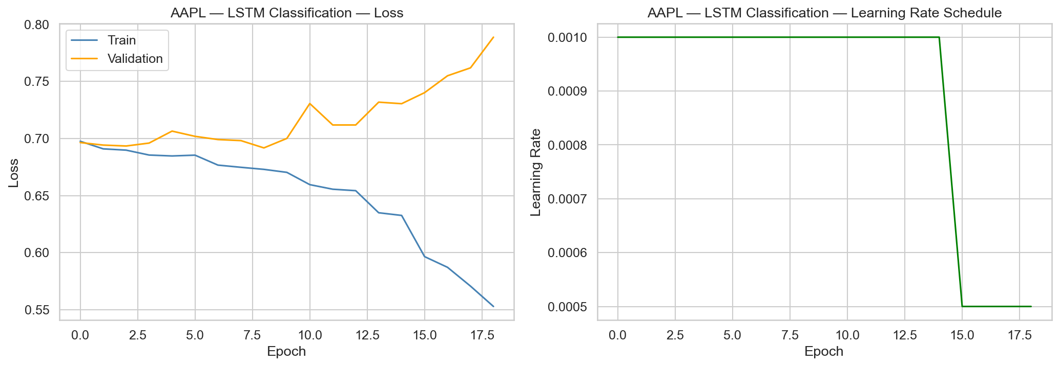Figure A.1: AAPL LSTM Classification Convergence Curve
LSTM (AAPL, regression): Training loss converged from 1.37e-3 to 3.20e-4, with validation loss stabilising around 3.81e-4. The narrower gap between training and validation loss for regression (compared to classification) suggests that the regression task is less prone to overfitting, consistent with the richer gradient signal from a continuous loss function.
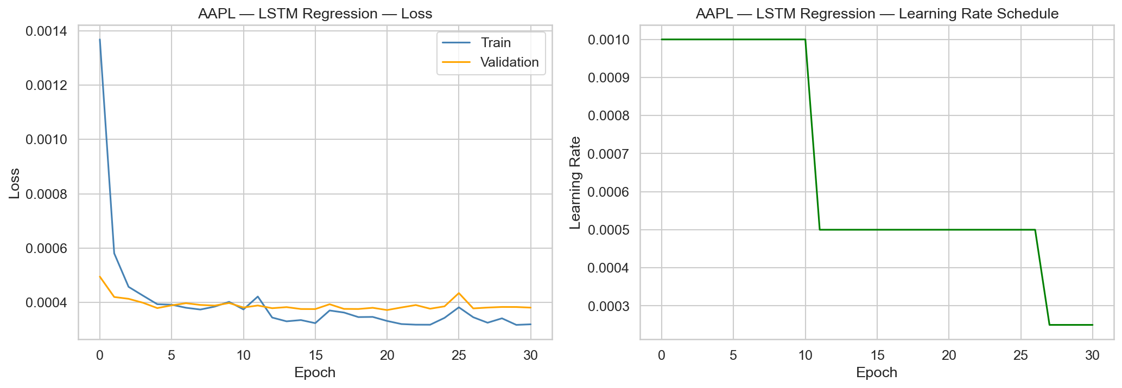Figure A.2: AAPL LSTM Regression Convergence Curve

PatchTST: Similar overfitting patterns were observed, with the CosineAnnealingWarmRestarts scheduler producing periodic learning rate cycles that temporarily improved validation loss before the underlying overfitting trend resumed.
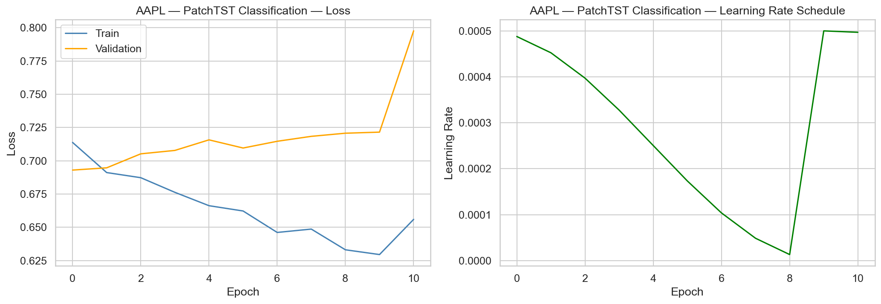Figure A.3: AAPL PatchTST Classification Convergence Curve
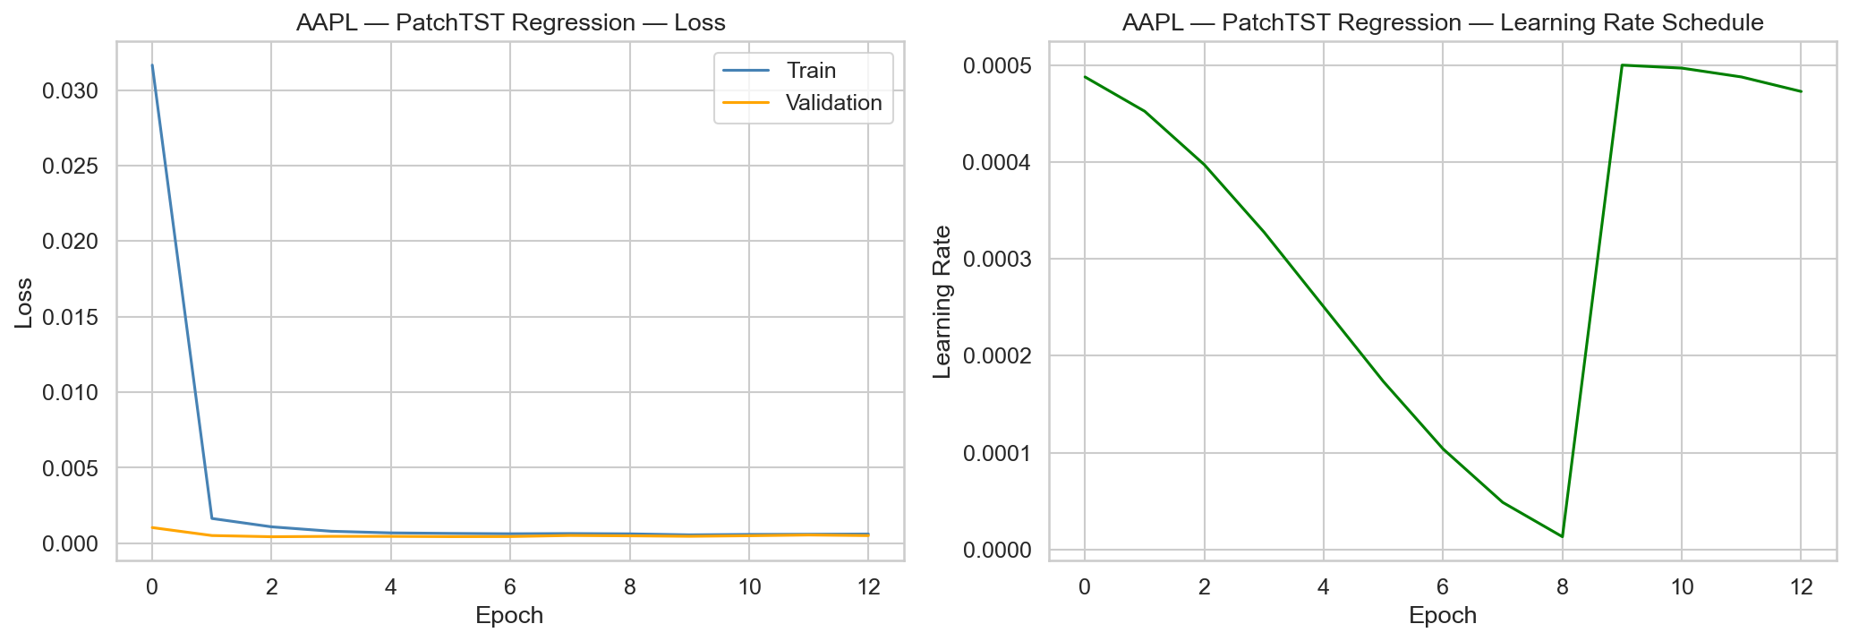Figure A.4: AAPL PatchTST Regression Convergence Curve

- Code Repository Structure and Execution Guide
Directory Layout
Final-Year-Project-Rev-1.0/
├── configs/
│ └── config.py # Central configuration
├── data/
│ ├── ingestion.py # Yahoo Finance data download
│ ├── synthetic.py # Synthetic data generator (testing)
│ ├── raw/ # Raw downloaded data (Parquet)
│ ├── processed/ # Processed data
│ └── features/ # Engineered feature Parquet files
├── features/
│ ├── technical.py # 27 technical indicators
│ ├── sentiment.py # FinBERT sentiment pipeline
│ ├── macro.py # 32 macroeconomic features
│ └── pipeline.py # End-to-end feature orchestrator
├── models/
│ ├── xgboost_model.py # XGBoost + Optuna
│ ├── lstm_model.py # LSTM trainer
│ ├── tft_model.py # TFT with pytorch-forecasting
│ ├── patchtst_model.py # Custom PatchTST
│ └── saved/ # Trained model weights
├── backtest/
│ ├── engine.py # Vectorised backtesting engine
│ └── tearsheet.py # Multi-panel tearsheet generator
├── evaluation/
│ ├── metrics.py # Shared evaluation metrics
│ ├── visualisation.py # Publication-quality plots
│ └── results/ # All experiment outputs
├── scripts/
│ ├── run_pipeline.py # Master data pipeline
│ ├── train_xgboost.py # XGBoost training entry point
│ ├── train_lstm.py # LSTM training entry point
│ ├── train_tft.py # TFT training entry point
│ ├── train_patchtst.py # PatchTST training entry point
│ ├── run_backtest.py # Backtest runner
│ └── compare_models.py # Cross-model comparison
├── dashboard/
│ └── app.py # Streamlit dashboard (4 pages)
└── notebooks/
└── 01_EDA.py # Exploratory data analysis

Reproduction Steps
All commands should be run from the project root directory.
- Step 1: Install dependencies
  - pip install -r requirements.txt
- Step 2: Data ingestion and feature engineering
  - python scripts/run_pipeline.py
This downloads OHLCV data via Yahoo Finance, computes technical/ macro/ sentiment features, and saves per-ticker Parquet files to data/features/
- Step 3: Train models (can be run in any order)
  - python scripts/train_xgboost.py
  - python scripts/train_lstm.py
  - python scripts/train_tft.py
  - python scripts/train_patchtst.py
- Step 4: Run backtesting
  - python scripts/run_backtest.py

- Step 5: Generate comparison report
  - python scripts/compare_models.py
- Step 6: Launch dashboard (optional)
  - streamlit run dashboard/app.py
Key Dependencies
Package | Version | Purpose
torch | ≥ 2.1 | Deep learning backend
pytorch-forecasting | 1.6.1 (pinned) | TFT implementation
lightning | ≥ 2.1 | Training loop management
xgboost | ≥ 2.0 | Gradient boosting
optuna | ≥ 3.4 | Hyperparameter optimisation
transformers | ≥ 4.36 | FinBERT sentiment model
yfinance | ≥ 0.2.36 | Market data API
pandas | ≥ 2.0 | Data manipulation
scikit-learn | ≥ 1.3 | Preprocessing, metrics
streamlit | ≥ 1.29 | Interactive dashboard
matplotlib | ≥ 3.8 | Static visualisation
seaborn | ≥ 0.13 | Statistical plots
plotly | ≥ 5.18 | Interactive plots

