**NOTE: This template is shareware downloaded from** [**www.processimpact.com**](http://www.processimpact.com)**. All shareware payments are donated to the Norm Kerth Benefit Fund to help a consultant who is disabled with a brain injury. Please visit** [**http://www.processimpact.com/norm_kerth.html**](http://www.processimpact.com/norm_kerth.html)**to make a shareware payment ($10 suggested). Thank you!**

Software Requirements Specification

for

Chirocare Reservation System

**Version 2.2 approved**

**Prepared by: John Kim Kenneth Dimabuyu  
John De Leon  
Abner Zabala  
Rangel Macapagal**

**Feb 5 2018**

eLearning versions of several popular Process Impact training seminars are available at [www.processimpact.com/elearning.shtml](http://www.processimpact.com/elearning.shtml), including “In Search of Excellent Requirements,” “Exploring User Requirements with Use Cases,” “Writing High-Quality Requirements,” “Software Inspections and Peer Reviews,” and “Project Management Best Practices”. Single-user and corporate-wide site licenses are both available.

**Table of Contents**

**Table of Contents ii**

**Revision History ii**

**1. Introduction 1**

1.1 Purpose 1

1.2 Document Conventions 1

1.3 Intended Audience and Reading Suggestions 1

1.4 Project Scope 1

1.5 References 1

**2. Overall Description 2**

2.1 Product Perspective 2

2.2 Product Features 2

2.3 User Classes and Characteristics 2

2.4 Operating Environment 2

2.5 Design and Implementation Constraints 2

2.6 User Documentation 2

2.7 Assumptions and Dependencies 3

**3. System Features 3**

3.1 System Feature 1 3

3.2 System Feature 2 (and so on) 4

**4. External Interface Requirements 4**

4.1 User Interfaces 4

4.2 Hardware Interfaces 4

4.3 Software Interfaces 4

4.4 Communications Interfaces 4

**5. Other Nonfunctional Requirements 5**

5.1 Performance Requirements 5

5.2 Safety Requirements 5

5.3 Security Requirements 5

5.4 Software Quality Attributes 5

**6. Other Requirements 5**

**Appendix A: Glossary 5**

**Appendix B: Analysis Models 6**

**Appendix C: Issues List 6**

**Revision History**

|  |  |  |  |
| --- | --- | --- | --- |
| **Name** | **Date** | **Reason For Changes** | **Version** |
| Initial development | 02/5/18 | N/A | 1.0 |
| Reschedule Option Patch | 02/08/18 | Adding Reschedule Reservation Option | 1.1 |
| Edit Information Patch | 02/14/18 | Adding Edit Information Option | 1.2 |
| User Roles Patch | 02/16/18 | Adding User Roles | 1.3 |
| Code Restructuring | 02/20/18 | Making Code More Aligned to Requirements | 2.0 |
| Midway Debugging | 03/03/18 | Initial Debugging of Codes | 2.1 |
| E-mail service Patch | ongoing | Email Service is Being Added | 2.2 |

# Introduction

## Purpose

The product of the development is Chirocare Online Reservation System v1.0. this Software Requirements Specification will cover the whole components of the system ranging from the main functionalities up to the other sub functions of the system.

## Document Conventions

*Acronyms* – Text in italics are the acronyms that usually used.

**User Classes** – Text in bold are the primary user classes of the system.

## Intended Audience and Reading Suggestions

The intended readers of this document are the instructor, the client and the developers. This document will explain the components of the whole system to be developed, starting from the basic idea of the system down to the more specific components of the system. It is suggested to read this document from the overall description down continuously without skip the end to be able to have a clear view of the project that the developers are going to develop.

## Project Scope

The product to be made by this development is a web application mainly for the online reservation of Chirocare clients. The web app’s main purpose is for clients not around the location of Chirocare to be able to set reservation without the need to go to the physical location just for it. The web app will also include the ability to reschedule and cancel the scheduled reservation. Services offered and basic information about Chirocare will also be added to aid the customers in choosing the right product for them.

## References

* facebook.com/chirocarehmt

# Overall Description

## Product Perspective

The product being developed is a new system that is intended and aim is to adapt and eventually surpass the manual booking and reservation currently being used.

## Product Features

* Reservation for Appointment about Chiro Care

1. For Customer

* Available Schedule for Appointment
* Choosing what Time, they want for Appointment
* Viewing their reservations

1. For Admin

* Receive Notification about a recent reservation
* Cancelation of a Reserved Appointment
* Rescheduling Customer Reservation

## User Classes and Characteristics

The products include 2 user classes; Admin and Customer, The **Admin** can access the administrator page which he can add, reschedule or cancel an appointment if it’s needed or requested by the user. **Customer** is the most important user classes. They can set an appointment themselves, however they need to contact the admin by making a phone call.

## Operating Environment

The system is a web application software, which is supposed to run on desktop browsers. The developers also plan on making the web app run responsively on mobile browsers which will make it easy for on-the-go clients.

## Design and Implementation Constraints

The only constrain that the developers can identify is time constraint because of other parallel projects the developers are also responsible on working on. The client’s company will be responsible in maintaining the system once it is in service.

## User Documentation

* User manual (word document)

## Assumptions and Dependencies

**Assumptions**

* Framework
* Database that will be used
* Business process

**Dependencies**

* Mailing service for notification

# System Features

## Online Booking Reservation

3.1.1 Description and Priority

* This Feature is responsible for Reservation of Appointment about Chiro Care, and this features gives schedule for appointment for customer and what time they want for appointment for Chiro Care
* Component Ratings: Benefit
* Scale: 9

3.1.2 Stimulus/Response Sequences

* User Action

- Log In

- Choosing Schedule that fit for them

- Notify them before the Appointment

* System Responses

- Save Automatic Their Email after Log In

- Reserve the time they choose for Appointment

- Notify the Manager for Schedule of Appointment

3.1.3 Functional Requirements

- TBD

# External Interface Requirements

## User Interfaces

The system has 2 main views that differ with the user

**Manager**

* The manager will have access to all information regarding the reservations.
* A button next to each reservation to cancel reservation.
* Ability to modify and update info on the website.

**Customer**

* A button that redirects to registration and login
* Ability to make reservations
* Access to other parts of the site via sidebar/header bar
* Ability to login or logout

## Hardware Interfaces

The system will run on any desktop or laptop and mobile device (not required but hopefully). To be able to use it, internet connection is needed so modem will be needed to be able to access the system through the Internet. The “server” needed to handle all the traffic will be handled by the hosting company.

## Software Interfaces

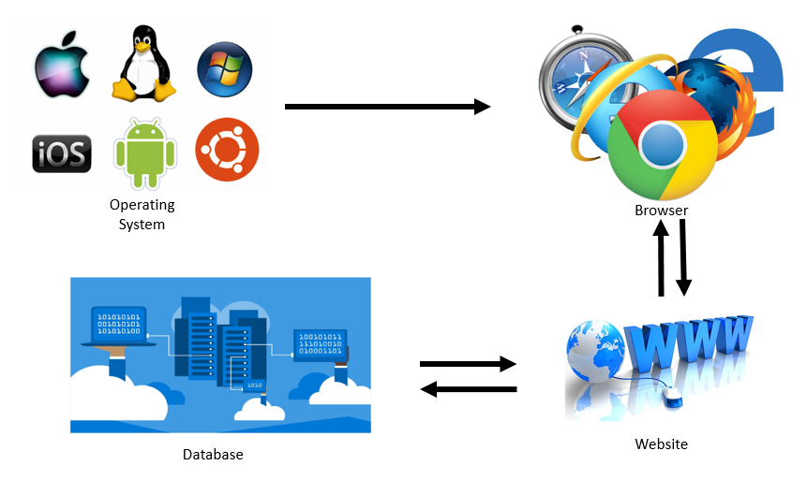

## Communications Interfaces

The main communication interface of this software is the web browser (preferably Google Chrome) to be able to access the system. For the notification system, E-mail (preferably Gmail) will be used for notifying the manager for new reservation and the client on his/her upcoming reservation.

# Other Nonfunctional Requirements

## Performance Requirements

* Good Browser (Google Chrome recommended) - A browser that is stable and can read the code properly is required to be able to view the system the way the developers made it to be.
* Good System Unit – A good system unit is needed to be able to handle the stress of multitasking because it is imperative that the system is not the one that they will use.

## Safety Requirements

. SPAM Reservation – this happen if customer SPAM the reservation system

Solution: limit to two the reservation per customer for appointment about Chiro Care

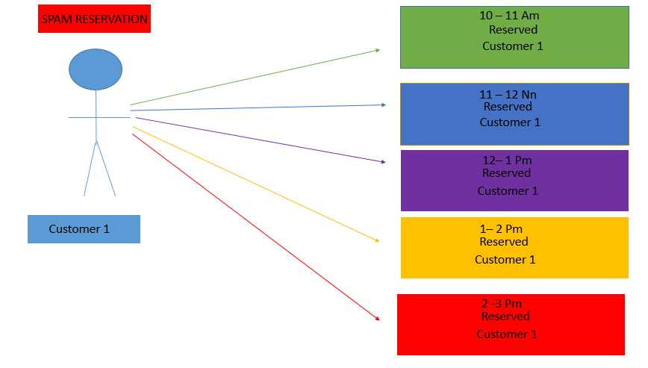

2. Password Encrypting - password leaks could hinder or even compromise the security of the system.

Solution: password concerning the system (user, employee, admin, etc.) are encrypted to safeguard against possible theft and hacking.

3. Power Outage – this is when the supply of electricity is interrupted or cut off.

Solution: regarding power outage, we recommend using UPS (Uninterruptable power supply) to allow the employee enough time to safely shut down the system.

4. Disconnection from Server – this is when the unit is separated and cannot connect to the server, i.e. System maintenance and system crash.

Solution: The client-side is issued logs or backups of information concerning reservations to be viewed offline.

## Security Requirements

* Data access control – every system user will be given different level of data access to the clients’ data
* Reservation limiting – this will prevent spam reservations of the client
* User access control – this will differentiate the level of access (things that can be done by the user) in the system.

## Software Quality Attributes

The Chiropractic System includes:

* Correctness
* Availability
* Adoptability
* Maintainability
* Reliability
* Usability

# Other Requirements

**Appendix A: Glossary**

* *UPS (Uninterruptable power supply)*
* *Mailing Service (for the password reset links, and mail notifications)*
* *TBA (To be Added)*

**Appendix B: Analysis Models**

TBA

**Appendix C: Issues List**

* More references that are yet to be added in further development.
* Analysis Models are yet to be added in further research and planning.