Name: **CIS4655 - Module 1 Activity Rubrics**

Description: **CIS4655 - Module 1 Activity Rubrics**

### Student: Kenneth Janssen

GitHub - <https://github.com/KennethJanssen/CIS4655-Summer2019/tree/master/Module_1/activity>

Sotd.us Index Page: <http://sotd.us/kennethjanssen/CIS4655-Summer2019/>

Sotd.us Assignment : <http://sotd.us/kennethjanssen/CIS4655-Summer2019/Module_1/activity/kjanssen_mod1_activity_8-8-2019.html>

# **REQ#1 – Tools Setup**

I have installed ATOM, Filezilla and GitHub (desktop) as well as SOTD access.

ATOM

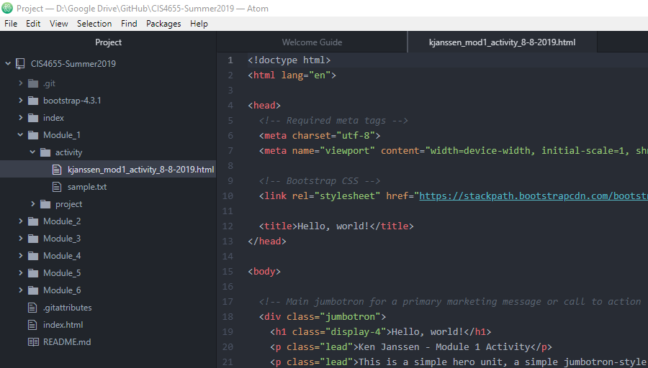

Github (web)

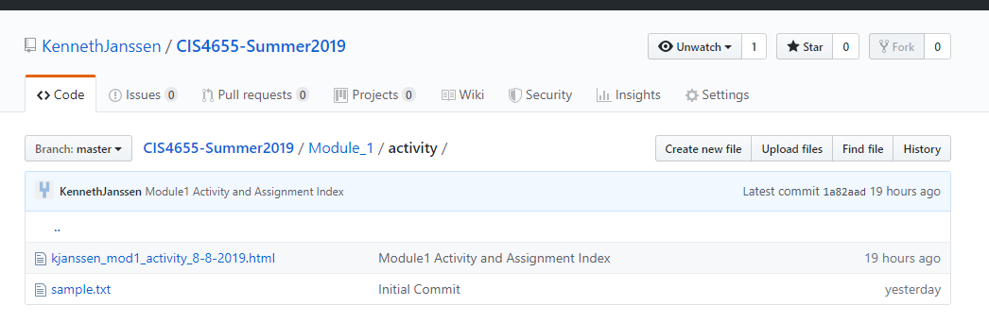

Filezilla

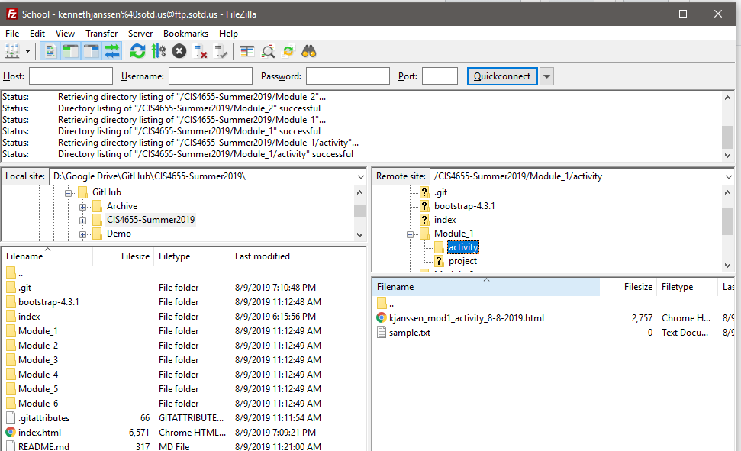

# **REQ#2 – Hello World using Bootstrap. See code via URL in next REQ.**

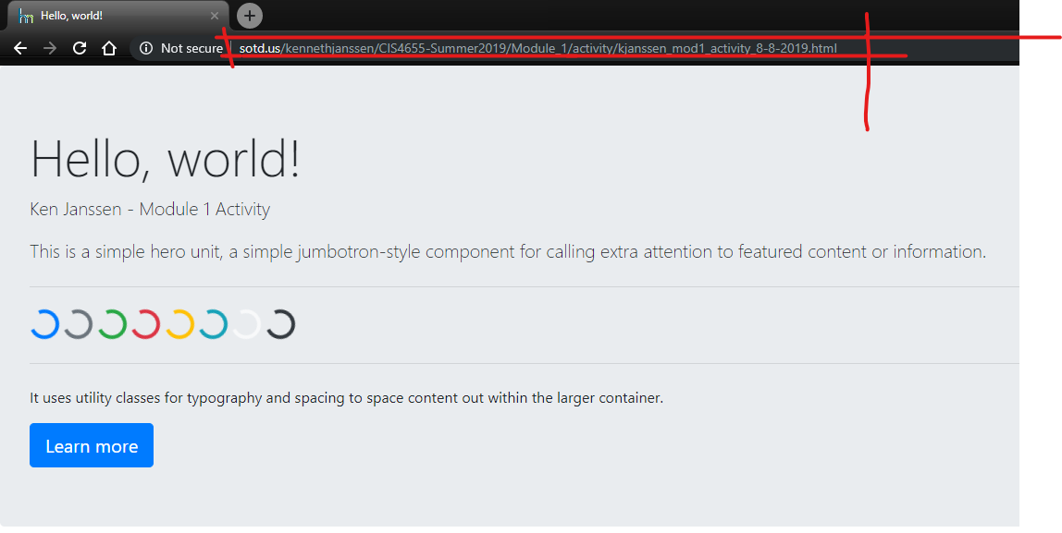

# **REQ#3 – Provide URL to working page accessible via SOTD.US**

Index: <http://sotd.us/kennethjanssen/CIS4655-Summer2019/>

Assignment : <http://sotd.us/kennethjanssen/CIS4655-Summer2019/Module_1/activity/kjanssen_mod1_activity_8-8-2019.html>

