### Name: CIS4655 - Module 2 Course Project

### Description: CIS4655 -  Module 2 Course Project

### Student: Kenneth Janssen

Github: <https://github.com/KennethJanssen/CIS4655-Summer2019/tree/master/Module_2/project>

Sotd.us URL:

Issues:

Two major issues caused me a lot of hassle – 1 Slider & 2 Using an Advanced Template as a base.

1. Starting with a fancy template caused more problems than it helped. I should have focused less on impressive features and just started from scratch.
   1. Issues like the ‘owl-carosual’ just never quite worked out so I had to use the generic slider from Bootstrap.
2. Styling issues with Slider – It was taking up the entire screen instead of just the center column. This caused issues with scaling because the image was always stuck to left side.
3. Wireframe tried too much all at once… I know you mentioned it but I feel like this would have gone better if I didn’t have such high ambitions right out the gate. I wanted a table with ratings but realistically I don’t have a database setup to pull the values from so I just made a generic table to hold the items for now.
4. Images – The size differences got kind of annoying. If you crop the images to same size and aspect for the slider it is far easier to wrangle.
5. Slider – I had to add d-none and d-sm-block to prevent the Slider captions from showing up on very tiny devices as it looked terrible.

# Landing Page – Large

Note the Captions & Menu

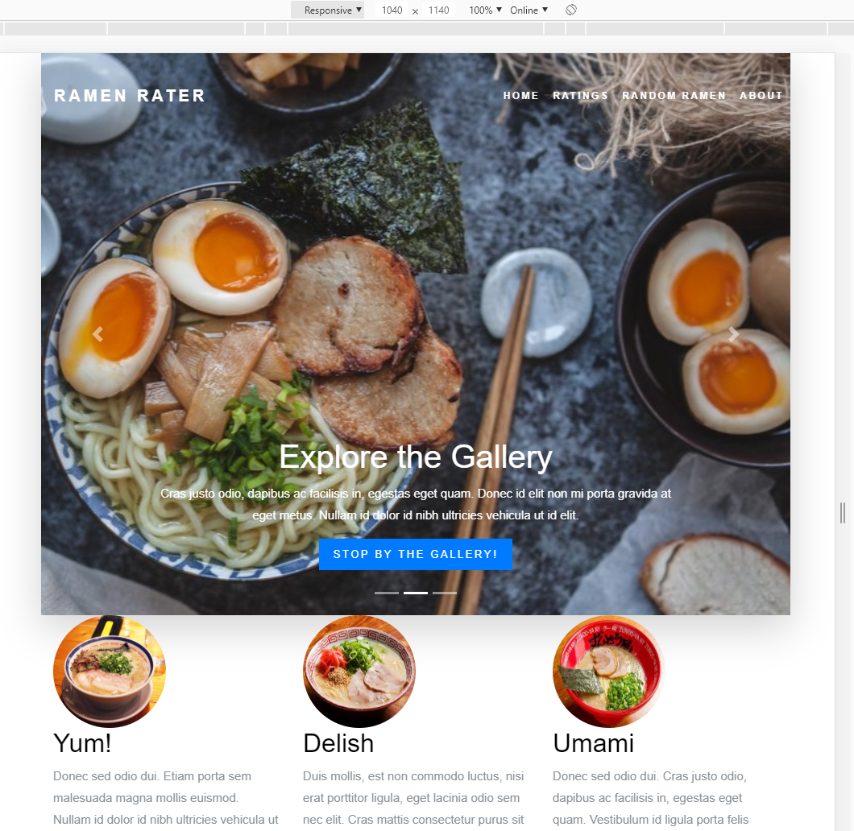

# Landing Page – Small

# 

# Ratings – Large

Really nothing special going on here since its really a single col-12

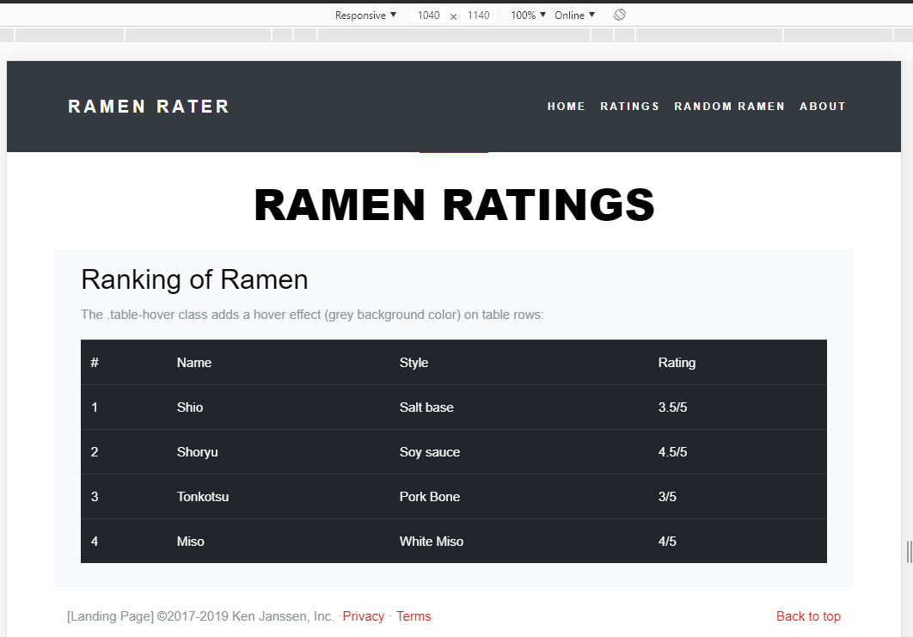

# Ratings – Small

It is responsive but no stacking required.

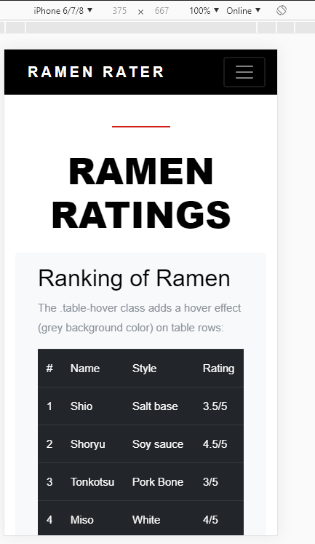

# Random – Large

Two md 6 columns. Difference is that text and image are flipped to make it appear offset.

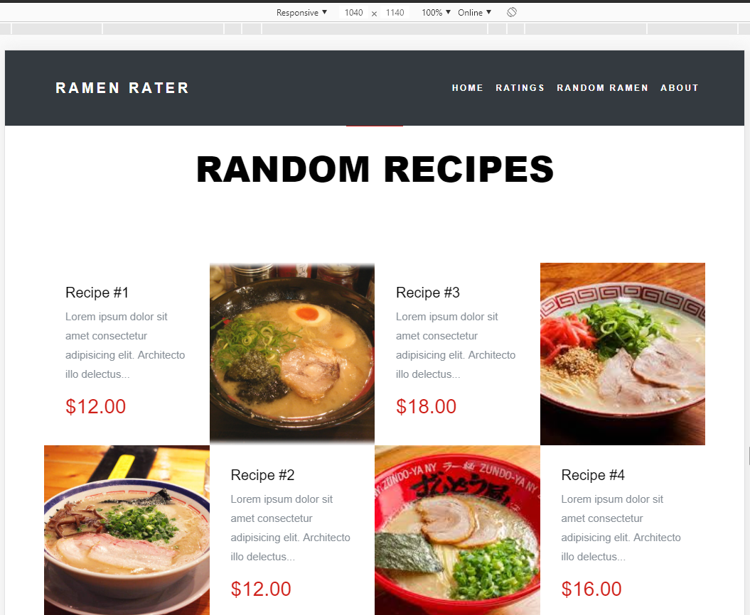

# Random – small

The 2 columns stack

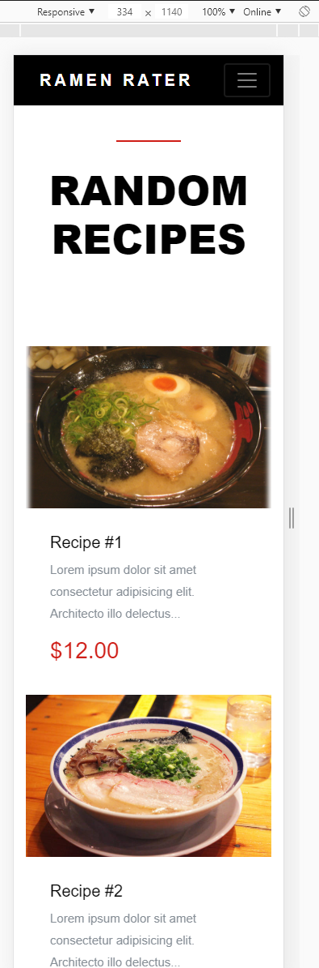

# About Us – Large

3 Columns

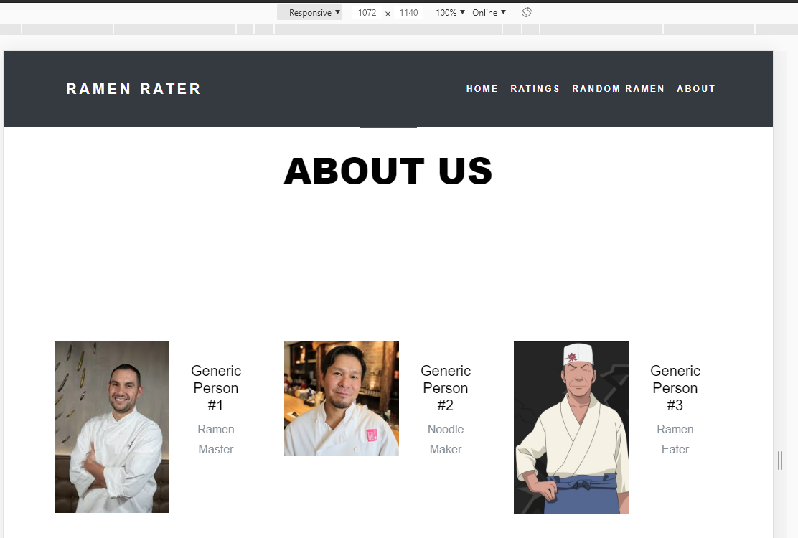

# About Us – Small

