### Name: CIS4655 - Module 3 Assignment

### Description: Nav Bar – Wireframe + Site

### Student: Kenneth Janssen

Github: <https://github.com/KennethJanssen/CIS4655-Summer2019/tree/master/Module_3/activity>

Sotd.us URL: <http://sotd.us/kennethjanssen/CIS4655-Summer2019/Module_3/activity/index.html>

# Wireframe – Adobe XD

Comments: XD seems very much like Visio in how you move objects around but there are so many ‘UI kits’ slash assets that its makes creating Web/Mobile UIs pretty easy right out the gate. The bootstrap UI asset kit lets you just grab and paste the item in. I played around more this time and found there is “repeat grid’ which would make responsive items or lists really easy to mock up. For example the first ‘col-med-6’ of Image + Text is done using ‘Repeat Grid’ so if you drag it you will end up with a 3rd or fourth instance of ‘img + text’.

XD Plugin – Layout feature

There was also a plug in for ‘grids’ so I set it up for 2 columns. There didn’t seem to be a way to create more than 1 row so the feature seems less than ideal but it still would be easier if you wanted to mock up something uneven such as col-4-med, col-6-md and col-2-md. This is the ‘Blue colored’ highlight in the image on next page.

Wireframe – Intentionally dragged the repeat down a bit to demo how it would create extra row of items.  
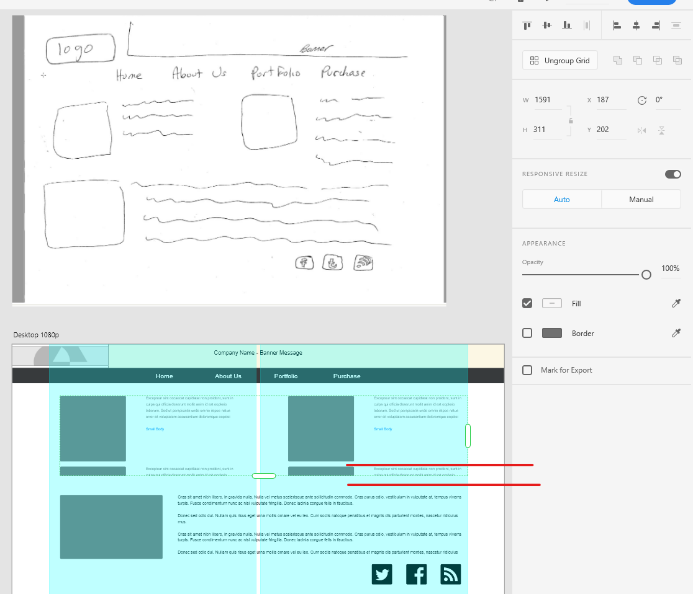

Website

Comments:

* Bootstrap 4 does not have the icon library like Bootstrap 3.0 did so I had to pull in Awesomefont CDN to get the social media icons.
  + <https://www.w3schools.com/icons/icons_reference.asp>
* Footer – I had added my name / page name even though wireframe didn’t because first assignment asked for it. I made the assumption that the social media buttons were to go in the footer.
* Added the card style and some padding to my grid items to make them pop out a bit more.
* The clearfix thing issue with footer & social media was good learning because it helped with getting Image to float-left along side text but took a few examples to find coding that made sense and worked.
* Nav Bar – Active – After duplicating the index page, I altered the ‘Active class’ so the nav bar would highlight the correct active page.
* Added Page name to footer for easy way to tell it was on correct page.

Index Page – 1080p (Desktop)

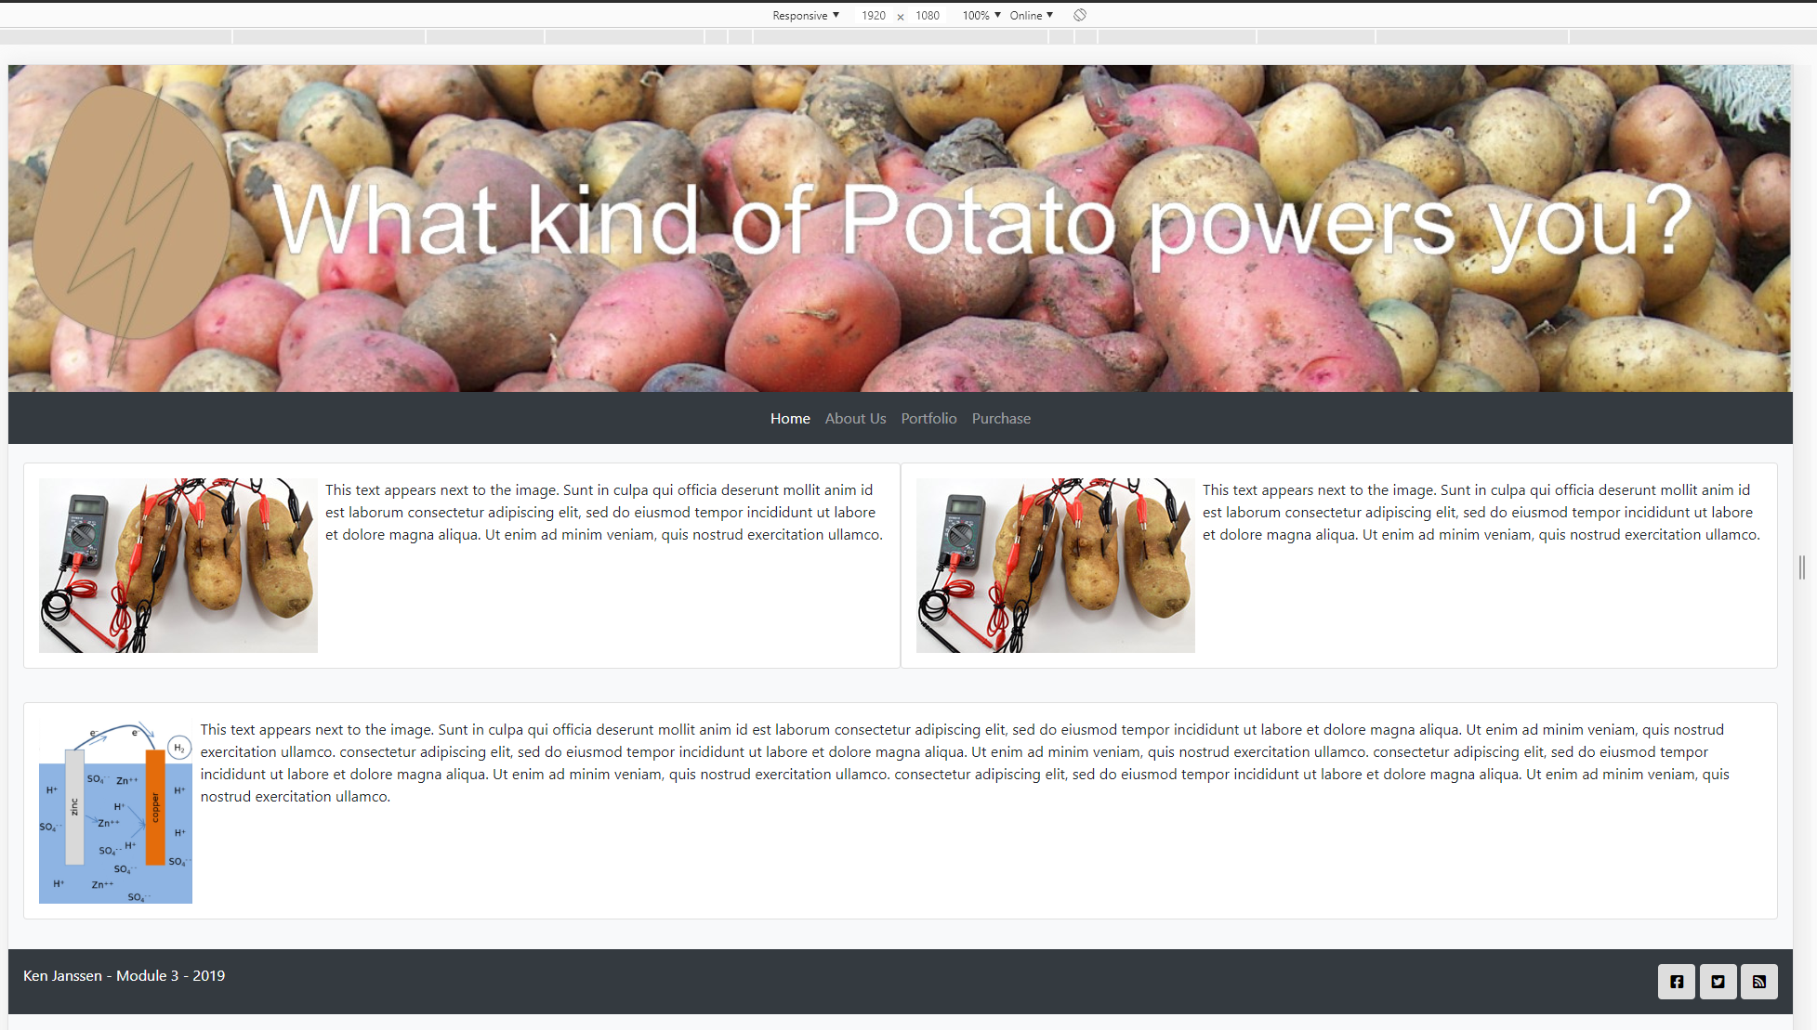

Index Page – iPhone 6 (736p)

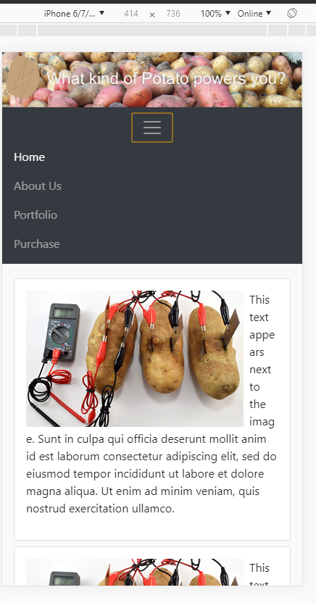

Index Page – iPhone 5 (568p)

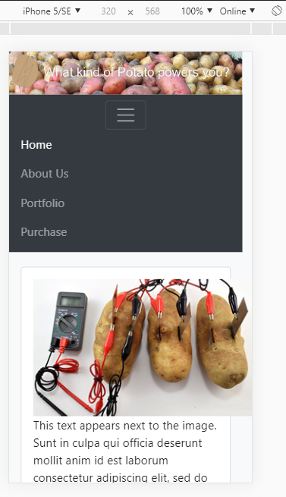

About Page (Demo of Navigation – ACTIVE class)

