### Name: CIS4655 - Module 4 Assignment

### Description: Nav Bar – Wireframe Addon

### Student: Kenneth Janssen

Github: <https://github.com/KennethJanssen/CIS4655-Summer2019/tree/master/Module_4/activity>

# Wireframe – Adobe XD

Comments: Doing the Functional Wireframe seems extremely easy in Adobe XD vs something else. I turned on Prototype mode and was able to add a transition from Nav Item (About Us) to the 2nd Wireframe Layout for the About Us page. Also being able to use Bootstrap Styled UI Asset Pack allows for easily depiction of styles like btn-primary being blue or overall Card layout.

I decided to add an “About Us’ page to the Activity 3 Wireframe since the original 1-page sketch does not depict labels buttons or other items anyway. Also added a person 1 & person 2 page to show ‘full details’ of person’s profile.

# Wireframes – About.html

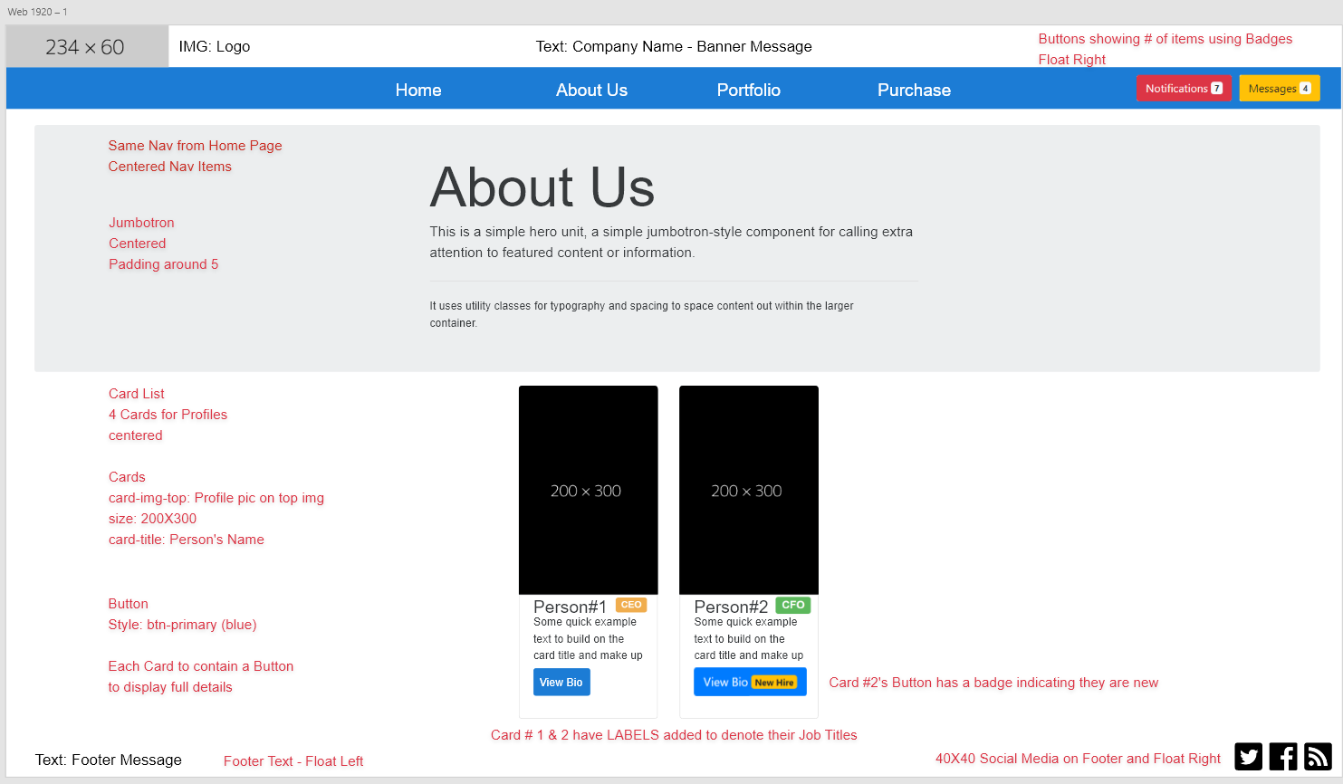

# Wireframes – Person Profile (details page)

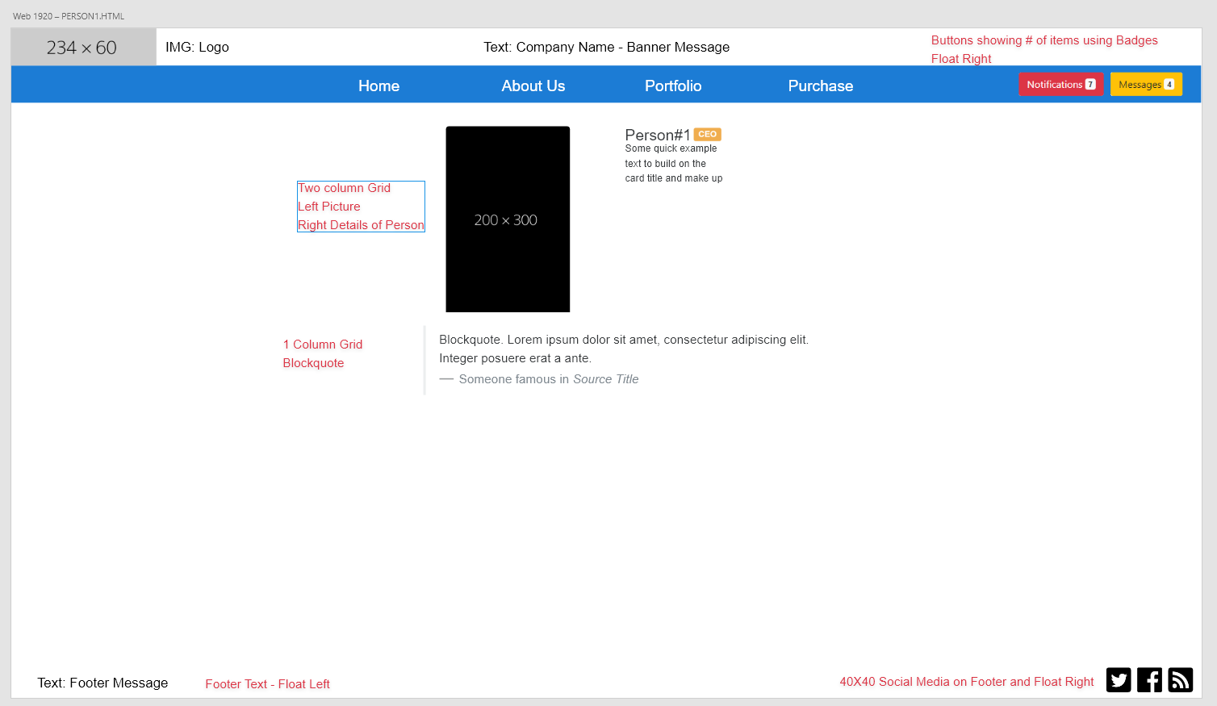

# Rubric Requirements:

* At least 3 buttons that have badges. They can be any size you choose, as well as any style.  
  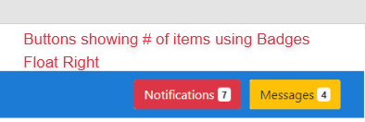  
  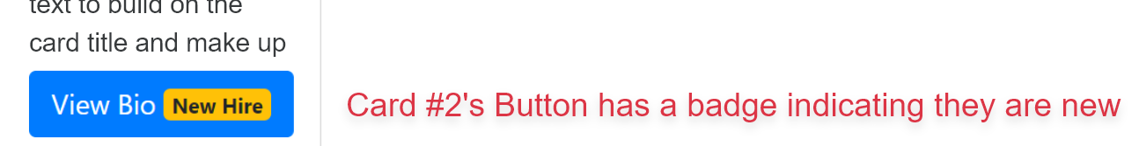
* At least 2 labels.
  + Not very creative but I added labels next to Person 1 and Person 2 name to show their Job Titles – Chief Executive Officer and Chief Financial Officer.  
    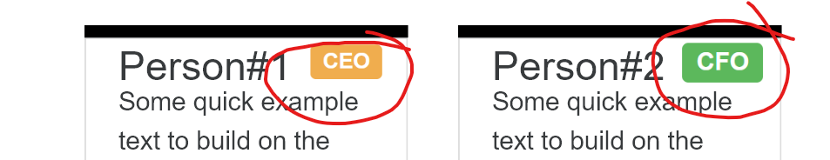
* At least 1 jumbotron.
  + Main text displaying About Us  
    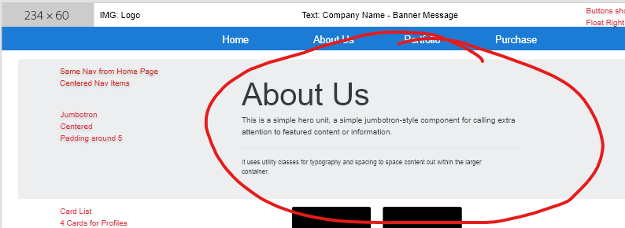
* At least 1 card. he button on the card must link to another page of content.
  + Profiles for CEO & CFO  
    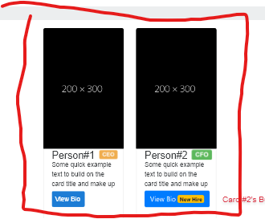
  + Bio buttons would link to person1 & person2 pages.
  + Adobe XD showing the Transitions in Prototype mode

