### Name: CIS4655 - Module 4 Assignment

### Description: Nav Bar – Wireframe Addon

### Student: Kenneth Janssen

Github: <https://github.com/KennethJanssen/CIS4655-Summer2019/tree/master/Module_4/>project

Sotd.us: <http://sotd.us/kennethjanssen/CIS4655-Summer2019/Module_4/project/index.html>

Since most of the new Wireframe stuff is on About page here is a direct link:  
About Page: <http://sotd.us/kennethjanssen/CIS4655-Summer2019/Module_4/project/about.html>

# **Changes (from Activity 3)**

* Pages Updated:
  + index.html
    - Nav Bar updated for ‘Badges’
    - Redid the Banner to be Image + Text overlay. Think this turned out better than putting the Text within the Image.
  + about.html
    - Updated to have Cards, Jumbotron, Labels, badges
* Pages Created:
  + person1.html
    - Button requirement needed to link to another page
  + person2.html
    - Button requirement needed to link to another page

*Note: From my research Bootstrap 4 has renamed ‘Labels’ to Badges. Therefore, I have used the Class Badges instead to provide the same functionality.

Reference: <https://www.quackit.com/bootstrap/bootstrap_4/tutorial/bootstrap_labels.cfm>

Screenshots of Requirements: (These have more detail pictures on the Wireframe assignment)

* At least 3 buttons that have badges. They can be any size you choose, as well as any style.
* At least 2 labels (Done as Badges).
* At least 1 jumbotron.
* At least 1 card. The button on the card must link to another page of content.

About Page – Desktop

Issue: Cards didn’t have a max-size and were huge! Had to set it smaller a few times to get all the content on 1 page and still show the footer.  
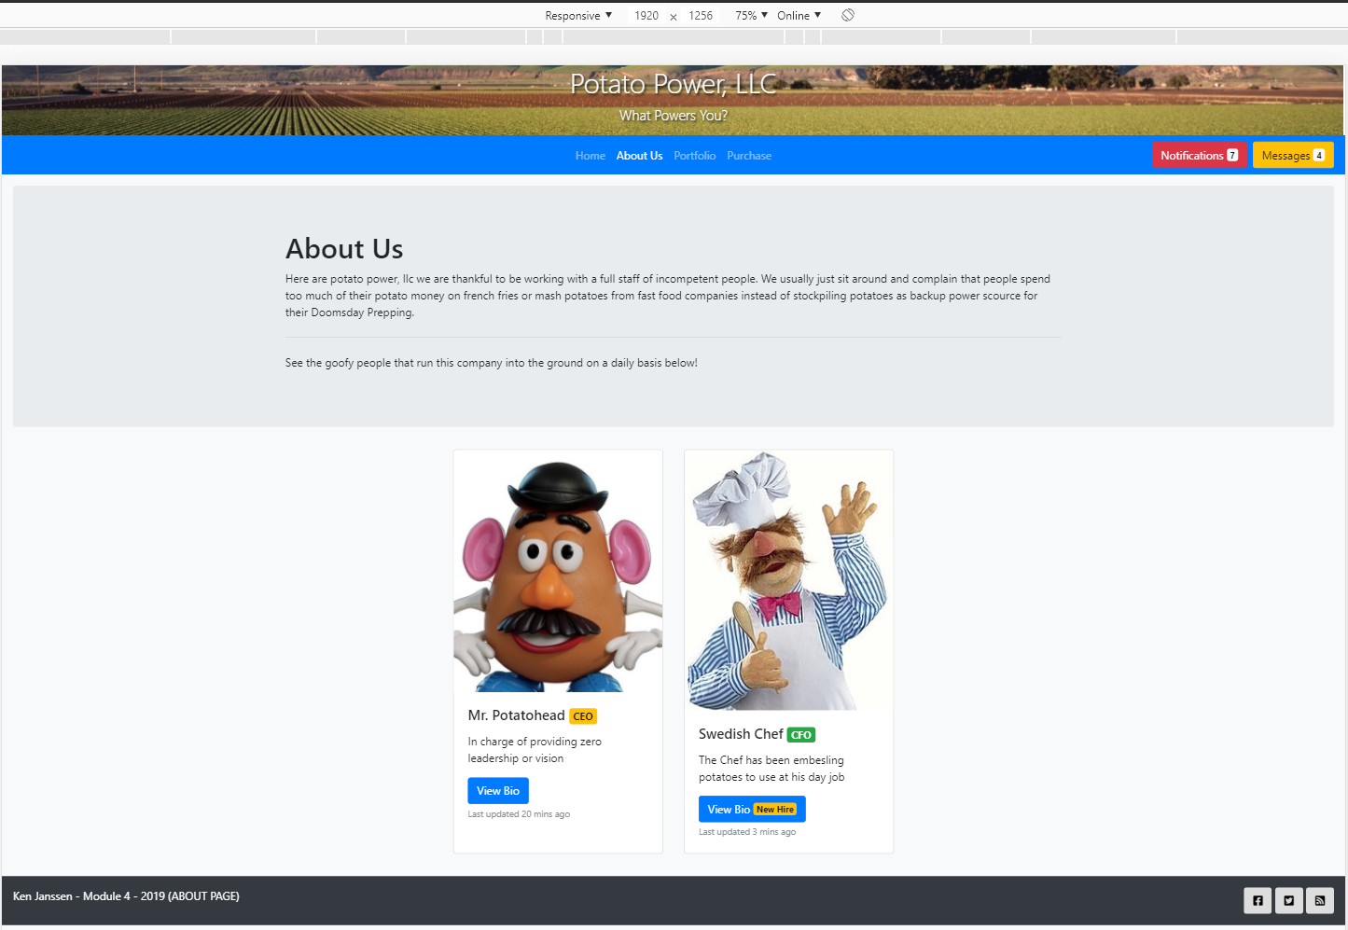

About Page – iPad (smaller)

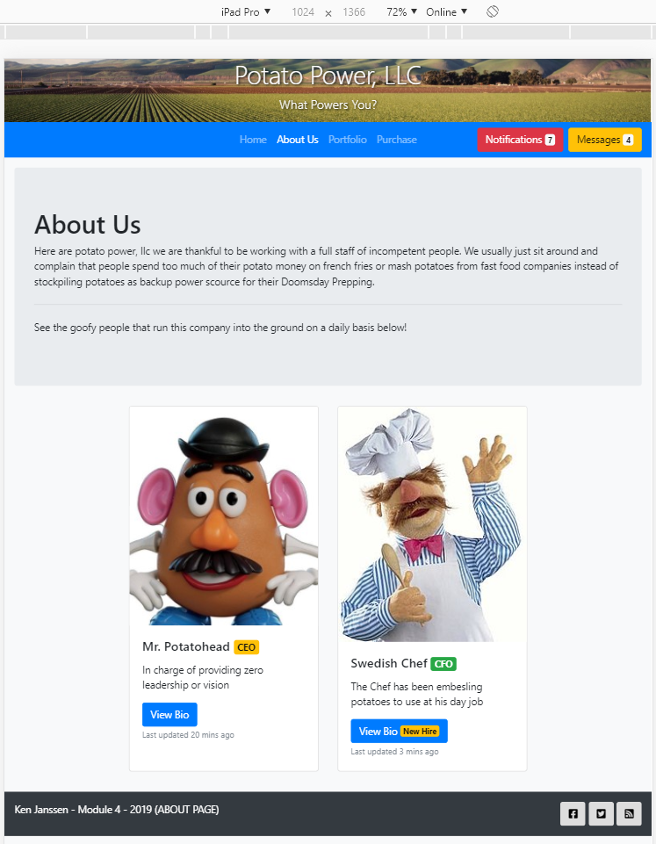

About Us – iPhone (open/closed Menu)

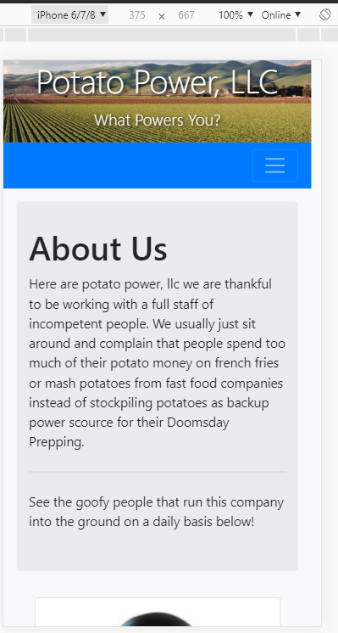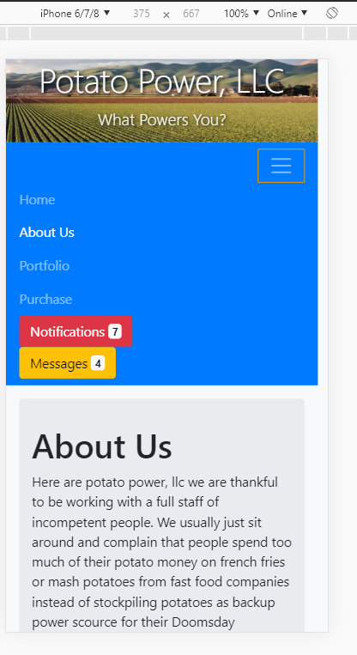

Person 1 – Bio (Desktop)

Requirement – Button must lead somewhere

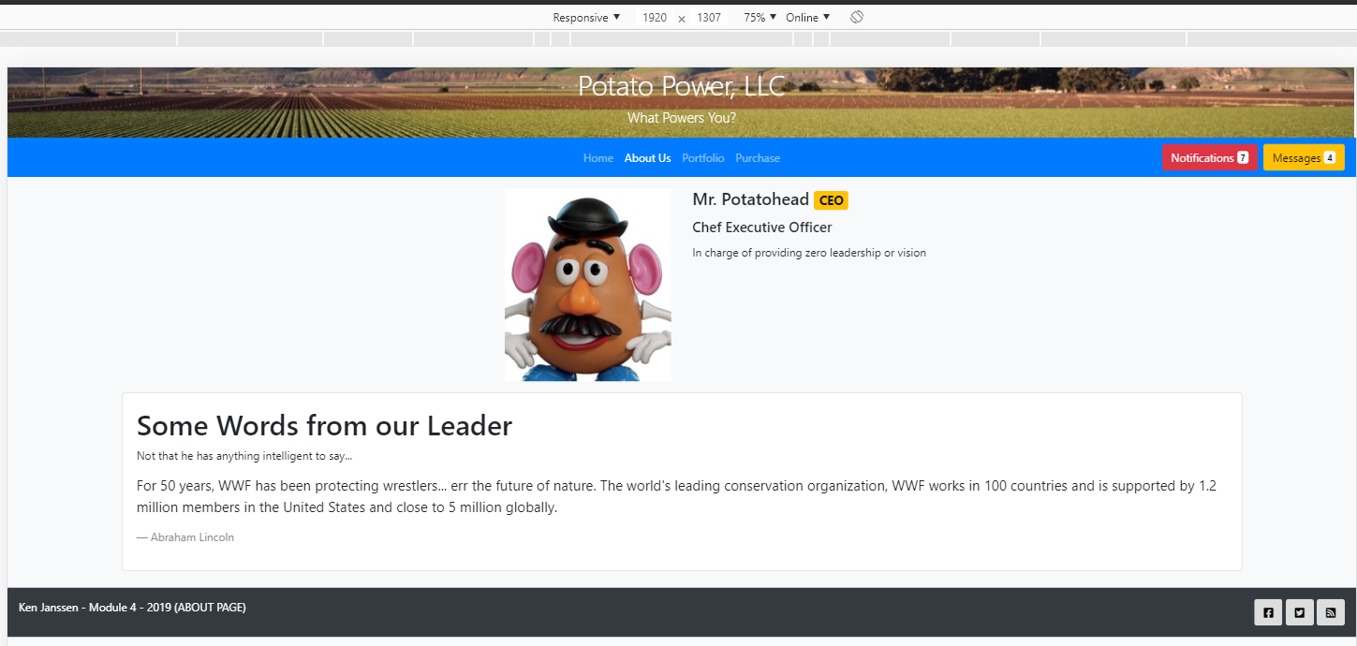

Person1.html & 2.html – iPad

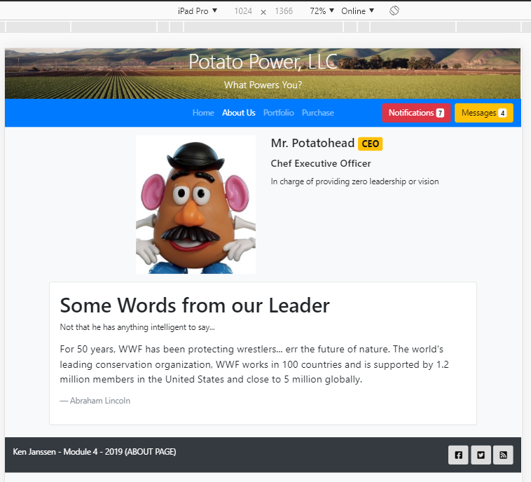 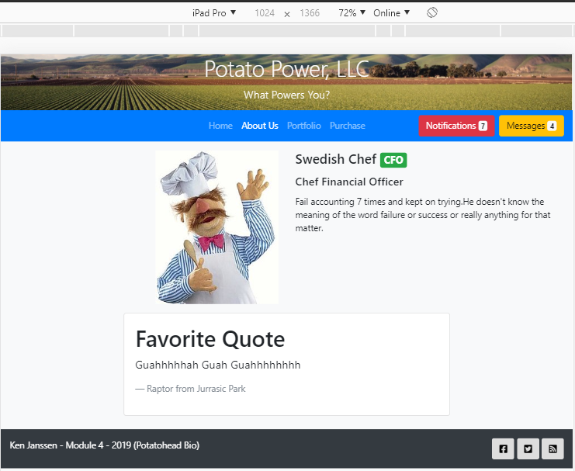

Person1.html & 2.html – iPhone

