### Name: CIS4655 - Module 5 Course Project

### Description: Adding Form to Course Project

### Student: Kenneth Janssen

Github: <https://github.com/KennethJanssen/CIS4655-Summer2019/tree/master/Module_5/project>

Sotd.us URL: <http://sotd.us/kennethjanssen/CIS4655-Summer2019/Module_5/project/submitreview.html>

Comments: I added a Submit Review Page that has a form that visitors can submit their own review.

Changes:

* Ratings.html (Updated)
  + Added ‘Submit Rating’ link button -> navigates to submitReview.html (demos Forms)
* submitReview.html (NEW)
  + Initial creation. Added Form to meet requirements.
    - At least 2 text boxes
      * Product Name
      * Brand Name
    - At least 1 text area
      * Comments text area
    - At least 1 set of check boxes
      * Agreement checkbox
    - At least 1 set of radios
      * Rating (1-5)
    - At least one dropdown with 3 options
      * Product Style
    - A submit button
      * Submit button
    - The form must have form validation to disallow submission when the submit button is clicked.
      * Scripted added to page

Desktop Form – Before Submit

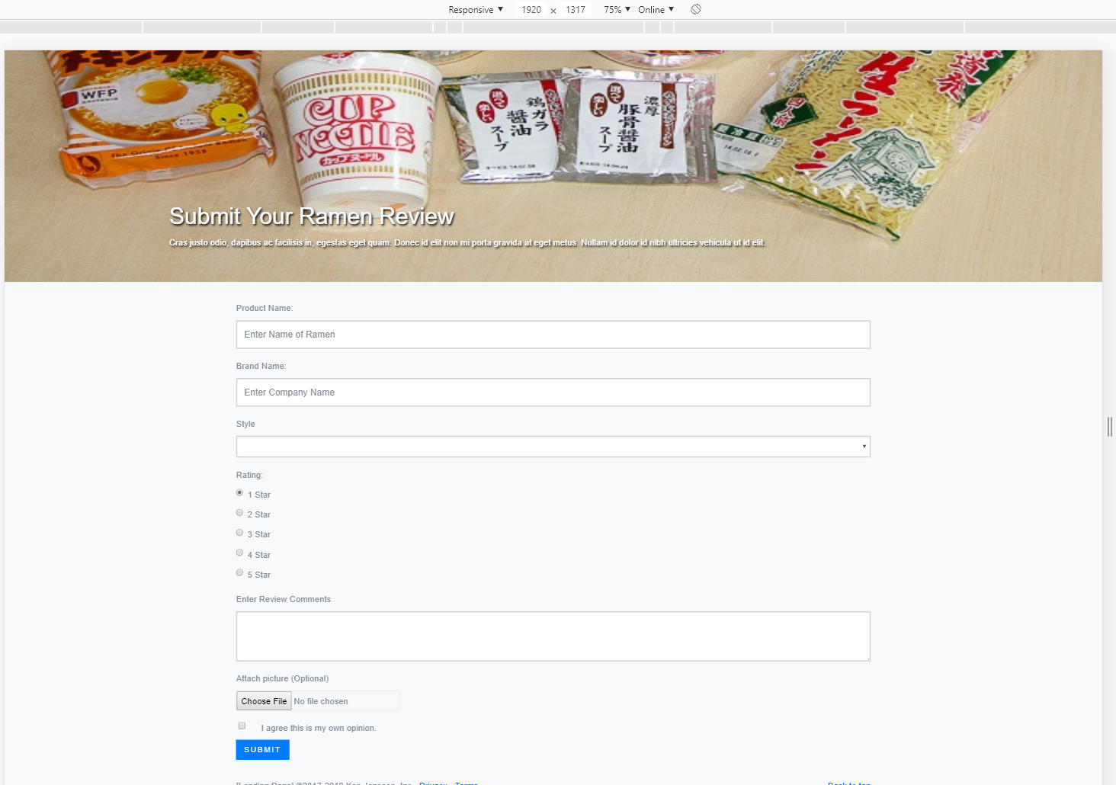

Desktop After Submit (failures)

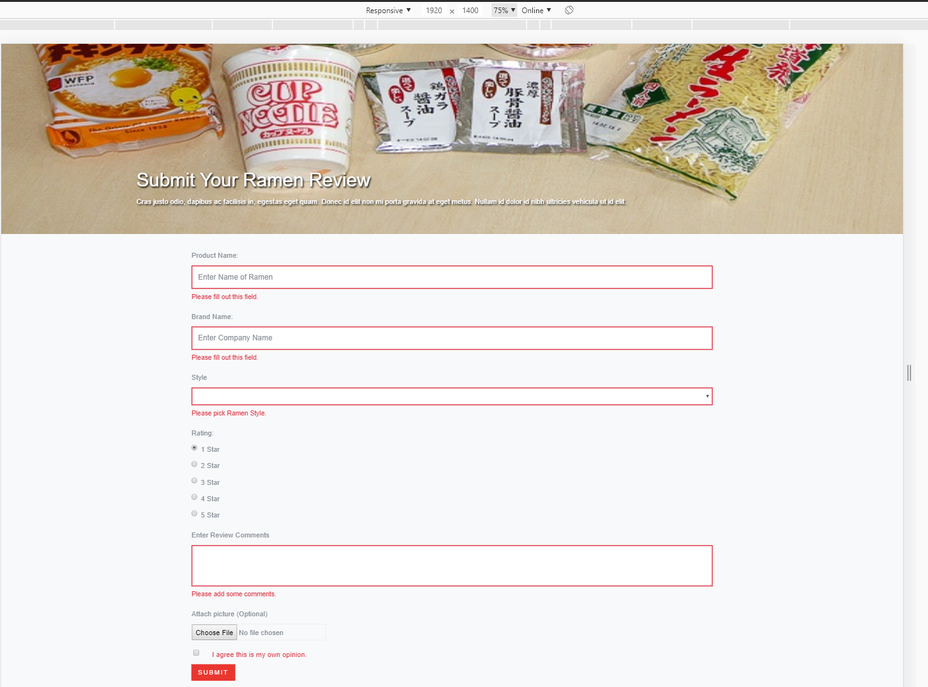

Desktop – After filling in values  
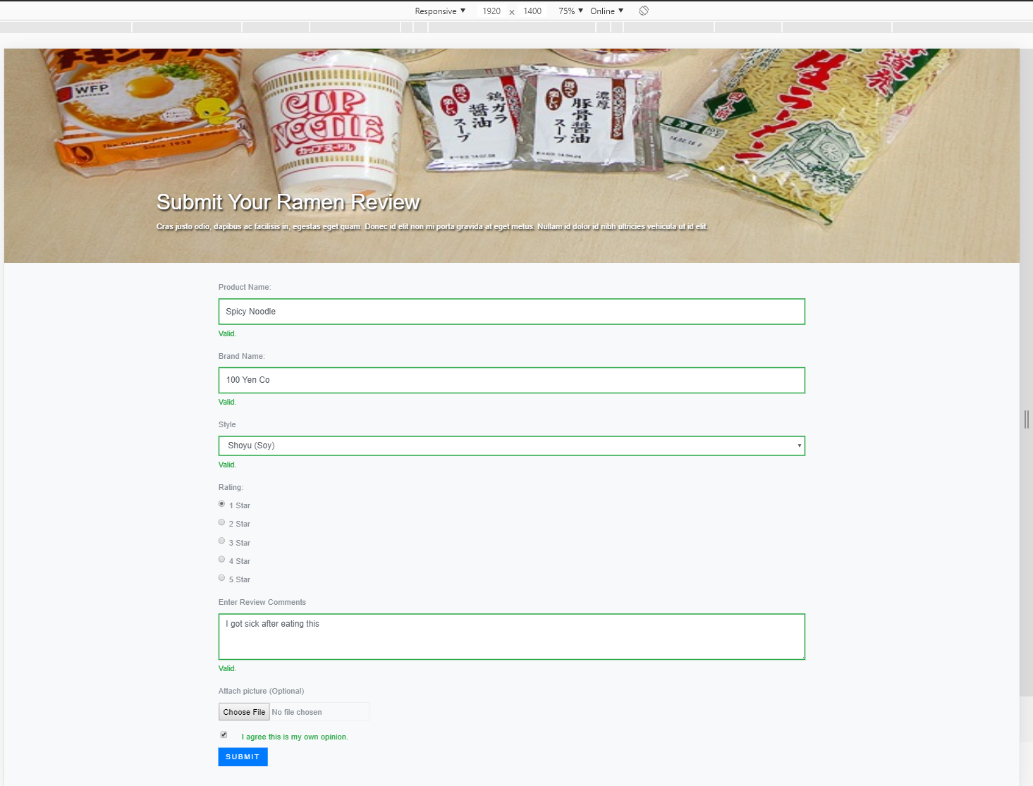

iPad – After typing in values

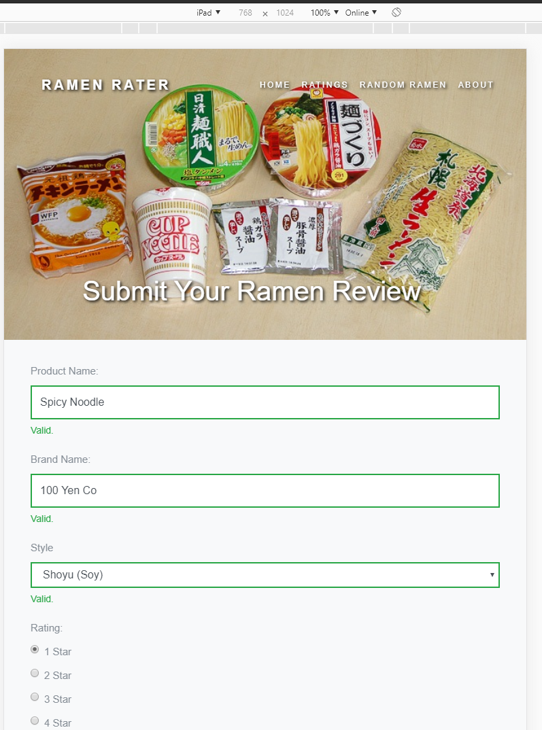

Pixel 2 – After typing in values

