BAIS:6050
Homework 4: SQL Queries

Specifications
- This assignment is worth 25 points
- Submit a SQL script file (.sql) with code for each question
  - Add a comment to the top of the script with your name (--) and comments for each question number
  - If you have trouble saving or submitting a SQL script file, you can paste your code into a Word or PDF file
  - Your file names should contain your last name and the assignment name (e.g., “lastname_homework4.sql”)

Download LIBRARIES.SQL from ICON. Upload the SQL script file into APEX, and then run it. This script contains 1741 SQL statements to create and populate a database about public libraries in Iowa. This data was sourced from the State Library of Iowa (https://www.statelibraryofiowa.gov/) and Carnegie Libraries of Iowa Project (https://carnegielibrariesiowa.org/) and is current as of June 1, 2023. The normalized database contains 4 tables:

- LIBRARIES contains basic information about 565 accredited public libraries, including a unique ID, name, contact information (address, phone, website), and the district where the library is located. Some records are missing a unit number and/or website. In addition, this table tracks when a library is a branch of another larger library. A library may be a branch of at most 1 other library (e.g., the Farley branch of the Dubuque County Library), but is not required to be a branch. A library can have many branches, but may not have any (e.g., Coralville Public Library is a single location that does not have any branches).
- DISTRICTS records data about the 6 districts administered by the State Library of Iowa. Each district has a unique ID, name, total population, and total area (measured in square miles). All districts have at least 1 library.
- CITIES tracks which city(ies) each library serves (1063 rows), with each row containing the library ID and the name of a city that the library serves. Each library provides service to at least 1 city.
- GRANTS stores information about 99 grants given by Andrew Carnegie and the Carnegie Corporation to build public libraries in Iowa. Each grant has a unique ID, date awarded, amount, and a binary field (0/1) tracking whether the building constructed with the grant funds is still used by the library today. Each grant belongs to a single library. Each library may have 1 grant or may not have received any Carnegie grant funds.

Note: The script may take a minute to run in APEX. Don’t click “Run Now” multiple times if nothing happens right away.

You should review each table in the Object Browser and inspect the DDL code to make sure that you understand the field definitions, constraints, primary key(s), foreign key(s), and relationships. A graphical relational schema is shown below:

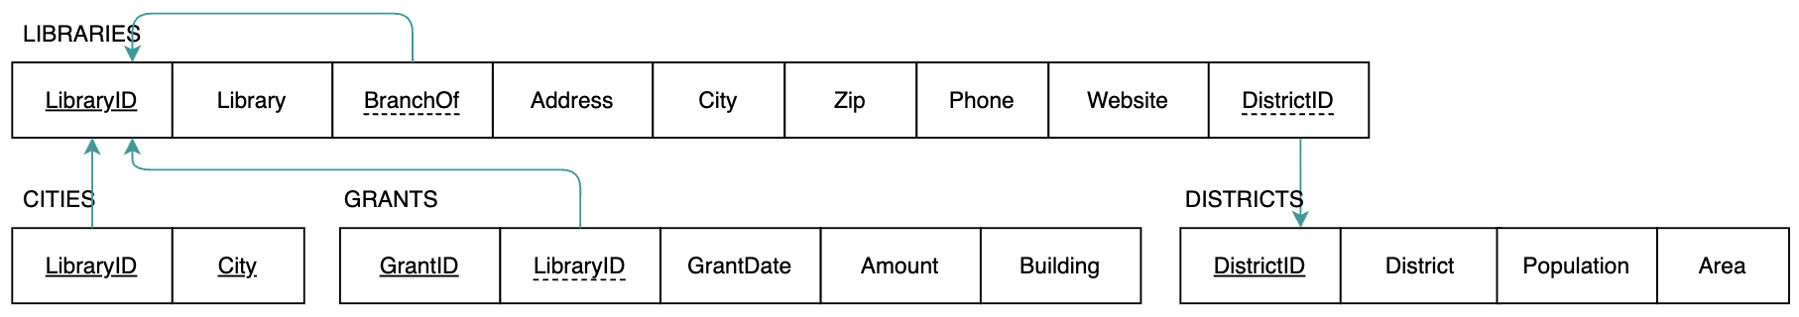

Then write SQL queries to answer the following questions. Submit all code as a SQL script (.sql). Add a comment at the top of the script with your name and comments to denote each question.

- (4 points) A library is an integral part of the idealized vision of “Main Street, USA”, but how many of Iowa’s public libraries are actually on Main Street? Write a simple query that returns the name and full address for libraries that are located on Main Street in their respective towns (i.e., street address contains some form of “Main St”). Format the full address as one field (e.g., 146 Main St, Juno, IA 50003). Make sure to rename any new, derived fields.

- (5 points) What were the largest Carnegie grants given to Iowa libraries? Write a simple query that finds the top 5 largest Carnegie grants (i.e., highest amount). For each, return the ID of the library awarded the grant, the grant date, and the amount formatted as currency (e.g., $45,900). Make sure to rename any new, derived fields.

- (6 points) Which Carnegie library buildings are still in use? Write a join query that returns the library name and the grant age (in years). Include only libraries that still use the building constructed with the grant funds and had a grant amount of $10,000 or less. Make sure to rename any new, derived fields.

- (10 points) Which libraries serve multiple cities? Write a join query that returns the name and website for libraries that serve more than one city. In addition, if the library is branch of a larger library, return the name of the head library that it is a branch of. Exclude libraries that do not have a website. Make sure to rename any ambiguous columns in the final results.

