BAIS:6050
Homework 5: Advanced SQL Queries

Specifications
- This assignment is worth 25 points
- Submit a SQL script file (.sql) with code for each question
  - Add a comment to the top of the script with your name (--) and comments for each question number
  - If you have trouble saving or submitting a SQL script file, you can paste your code into a Word or PDF file
  - Your file names should contain your last name and the assignment name (e.g., “lastname_homework4.sql”)

Download DDD.SQL from ICON. Upload the SQL script file into APEX, and then run it. The script contains 3443 SQL statements to create and populate a database about the first 30 seasons of Guy Fieri’s Diners, Drive-Ins, and Dives. This data was collected from several sources, including Food Network, Kaggle, and the US Census Bureau. The normalized database contains 4 tables:

- RESTAURANT (1126 rows) contains basic information about the US restaurants that appeared on the show, including a unique ID, name, cuisine type (e.g., Italian), Yelp rating (out of 5 stars), and website. Some restaurants do not have a Yelp rating or website. Each restaurant is located in 1 locale.
- LOCALE (701 rows) records the unique ID, city name, state abbreviation, population, population density, and economic statistics (proportion of population living under the poverty line, median monthly household income, and median monthly housing cost) for US cities. Each locale may have multiple restaurants featured on the show, but the database also includes some that have not had any restaurants featured.
- EPISODE (409 rows) stores the unique ID, season number, episode number, title, and original air date for each episode of the show.
- APPEARANCE (1199 rows) tracks the restaurant(s) appearing in each episode. Restaurants may appear in multiple episodes and episodes may feature multiple restaurants. Since the database contains only US restaurants, some episodes that were filmed abroad are not associated with any restaurants.

Note: The script may take a minute to run in APEX. Don’t click “Run Now” multiple times if nothing happens right away.

You should review each table in the Object Browser and inspect the DDL code to make sure that you understand the field definitions, constraints, primary key(s), foreign key(s), and relationships. A graphical relational schema is shown below:

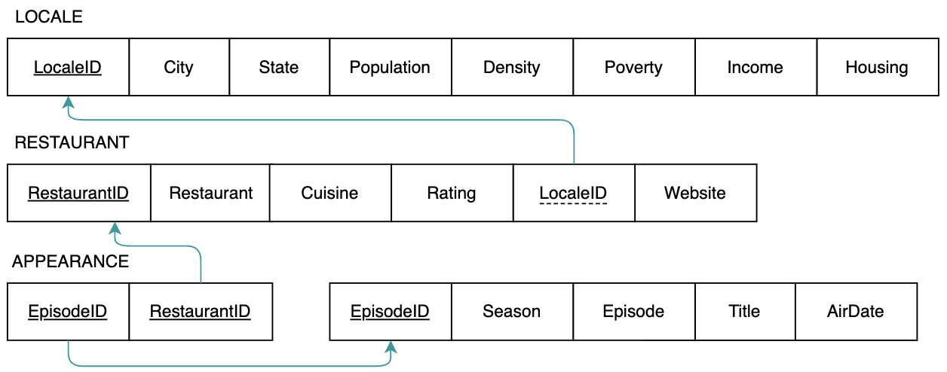

Then write SQL queries to answer the following questions. Submit all code as a SQL script (.sql). Add a comment at the top of the script with your name and comments to denote each question:

- (3 points) You probably imagine Guy’s road trips as occurring during the summer, but which seasons of the show are more winter-oriented? Write a compound query that returns the season numbers that had episodes airing in the winter (December, January, or February) but none in the summer (June, July, or August).

- (5 points) The database includes all 50 US states plus the District of Columbia, but which have never had a visit from the Mayor of Flavortown? Write a subquery that returns the abbreviations for all state(s) that have never had any restaurants featured on the show.

- (10 points) The titular Diners, Drive-Ins, and Dives represent a diverse array of cuisines, but which are associated with the very best restaurants every to appear on the show? Write a CASE query that categorizes cuisine type according to the following rules:

- Classic: American and Barbeque restaurants
- Latin: Argentinian and Venezuelan restaurants
- European: Swiss and Polish restaurants
- Other: all other cuisine types

For all 5-star rated restaurants, return their name, website, cuisine type category, as well as the episode when they were featured on the show. Combine the season number, episode number, and title together as one field in the following format: “Season 1, Episode 10: Worth the Trip”. Note that the same restaurant may repeat in the results if they were on more than one episode. Make sure to rename any new derived fields.

- (7 points) How do the locales in the database compare in terms of cost of living? Write a window query that ranks each locale within each state based on the ratio of housing cost to income. Return the rank, city, state, population (formatted with commas, e.g., 6,240,309), and housing cost ratio (formatted as a percent, e.g., 31%). If there is a tie, the ranking should continue with the next value in the sequence. For example, if there is a 2-way tie for the first in a given state, then the next rank value should be 2. Make sure to rename any new derived fields.

