BAIS:6050
Homework 2: Relational Schema and Normalization

Specifications
- This assignment is worth 25 points
- Submit a draw.io file with sheets for each question
  - Your file names should contain your last name and the assignment name (e.g., “lastname_homework2.drawio”)
  - Remember that draw.io files are saved in an encoded XML format, so they cannot be rendered in a plain-text editor (e.g., by double-clicking on the file in your file directory). Instead, draw.io files must be opened and edited from within the draw.io web site
  - If you have trouble saving or submitting a draw.io file, you can paste screenshots of your diagrams into a Word or PDF file

- (10 points) The ER diagram below illustrates a database system that records the fashions worn by royal family members. Note that a “piece” refers to a general style of clothing item from a brand like the “Melanie” sandals from the brand Hugo Boss, and not the individual pair of sandals owned by Queen Letizia of Spain.

Different people can attend the same events and wear the same pieces. For example, Queen Mary of Denmark has the same dress from the brand Zimmermann as Zara Tindall. The same person can re-wear the same piece to multiple events. A royal family member may even own the same piece in many colors (e.g., Kate Middleton has the same dress from the brand Emilia Wickstead in green, lavender, and blue), so whenever someone wears a piece to an event, the database tracks the color. Assume that a single person cannot wear duplicates of the same piece at the same time.

The database also stores information about each royal family member’s title(s). A royal family member may have no titles, but may also have multiple (e.g., Prince Daniel of Sweden is also the Duke of Västergötland). For everyone that has a title, it will include a rank and geographic area. A single royal family member may have multiple titles of the same rank, and different royals may hold titles over the same area. But each title held by an individual royal will have a different geographic area.

Transform the ER diagram into a graphical relational schema using draw.io. Make sure to include primary keys, foreign keys, and relationships. Do not include dependency arrows, and do not create any surrogate keys (i.e., no new ID fields that are not present in the diagram).

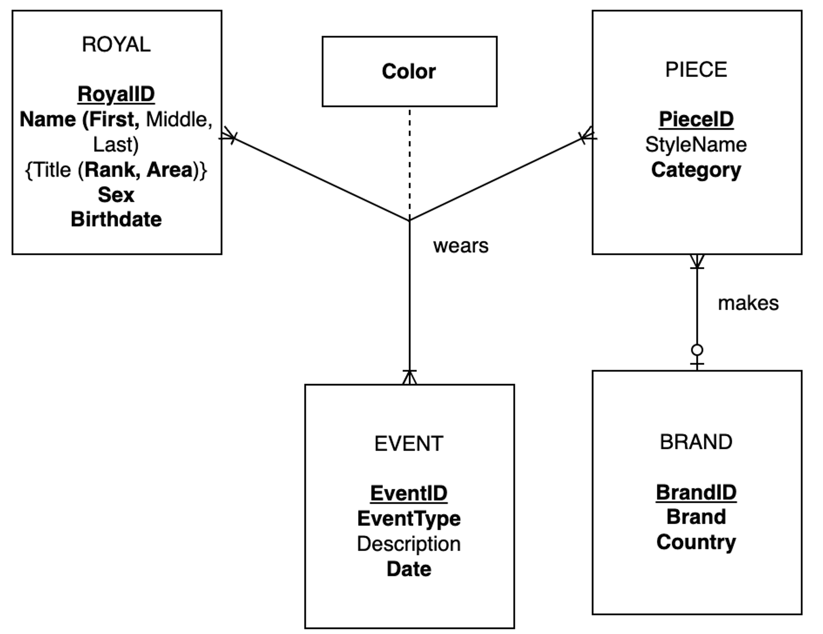

- (13 points) The file “castles.xlsx” contains 60 visitor reviews for European castles. This data is adapted from a Kaggle dataset posted by user Data Science Donut.

  - Construct a single graphical relation (one row of boxes) to represent the entire dataset. Make sure to denote the primary key(s) and diagram all functional dependencies. Do not create any surrogate keys (i.e., no new ID fields that are not present in the data).

  - What is the normal form of the raw data (before any normalization)? Be specific with your reasoning. Why is it in X normal form and not in Y? Give your answer as a text box in the same sheet as part a.

  - Break down the data into third normal form and draw a graphical relational schema using draw.io. Make sure to include primary keys, foreign keys, relationships, and dependencies. Diagram the functional dependencies and relationships using arrows with different color or style. Do not create any surrogate keys. Place this diagram on the same sheet as part a.

- (2 points) Think of an information system or business transaction from your professional life and describe how different integrity constraints work in that context as well as their benefits. Add your answer as a text box to your draw.io file (do not create any diagrams). You can be as detailed as you’d like, but at a minimum, make sure that your answer addresses the three types of integrity constraints (domain integrity, entity integrity, referential integrity). Do not copy an example that we’ve already seen in class. Here’s a template you can use for guidance:

- Domain Integrity: At the University of Iowa, the course catalog stores information about each course, like number of credits. All values in this field must be positive and numeric. This allows us to add up the number of credits taken by each student and prevents errors (e.g., trying to insert text values or a course with negative credits).
- Entity Integrity: In the course catalog, each course has can be uniquely identified using a combination of the department code and course number. This allows us to differentiate courses that are offered within the same department (e.g., BAIS 3005 vs. BAIS 6050), courses with the same number (e.g., BAIS 3005 and CW 3005) and even courses that have the same title (e.g., different courses called Database Management might be offered in Business Analytics and Computer Science).
- Referential Integrity: In the course catalog, every course must belong to a department, and there is a text field tracking the department code (e.g., BAIS). This allows us to correctly match departments and courses. Additionally, the values stored in this field must refer to a real department at the University. This prevents the entry of courses that do not have a valid department. In the event that a department is closed (i.e., deleted from the database), the courses belonging to that department will also be removed from the catalog.

