SPEAKER NOTES
Machine-Learning Trading Signals
A comparative study against technical baseline strategies · mini-project viva
Ishan Singh · Kenneth Martin | Mentors: Dr. Narendra V G · Dr. Ashwath Rao B
HOW TO USE THIS HANDBOOK
- One page per slide: what is on the slide, what to say, the numbers to remember and likely questions.
- 'What to say' is the same text as the speaker notes inside the PowerPoint (Presenter View shows it).
- Every number here is generated from the project's results files, the same source as the slides.
- Appendix A: glossary · Appendix B: live-demo script · Appendix C: numbers cheat sheet.
TIMING PLAN · ABOUT 17 MINUTES OF TALK AT 130 WORDS/MINUTE, PLUS DEMO AND QUESTIONS
# | Slide | Time | Clicks | Presenter
1 | Machine-Learning Trading Signals | 38 s
2 | Can a model learn when to be in the market? | 54 s
3 | Four easy ways to fool yourself in a backtest | 47 s
4 | Small evaluation choices flip the conclusion | 63 s
5 | What we set out to do | 48 s
6 | A leakage-safe, cost-aware comparison framework | 44 s
7 | System architecture: from raw prices to decisions | 51 s | 2
8 | Built on the open-source Python stack | 34 s
9 | Time only flows forward: chronological splits | 47 s
10 | Walk-forward: retrain every year, trade the next | 51 s
11 | 42 point-in-time features, one executable target | 50 s
12 | Five model families, tuned without peeking | 51 s
13 | From probability to position, net of costs | 45 s
14 | Engineered like research software | 38 s
15 | The working system: an interactive dashboard | 42 s
16 | Retrain live, with ten more months of data | 52 s
17 | Accuracy: none reliably beat 'always predict Up' | 38 s
18 | Trading: none of the 15 reliably beat buy-and-hold | 59 s
19 | Walk-forward and robustness checks agree | 55 s
20 | Challenges we handled, limitations we report | 46 s
21 | Where this goes next | 32 s
22 | What we can claim | 40 s
23 | Thank you | 18 s
Fill in the Presenter column to split the talk between the two of you.

Slide 1 · Machine-Learning Trading Signals
~38 s · Fade · builds automatically
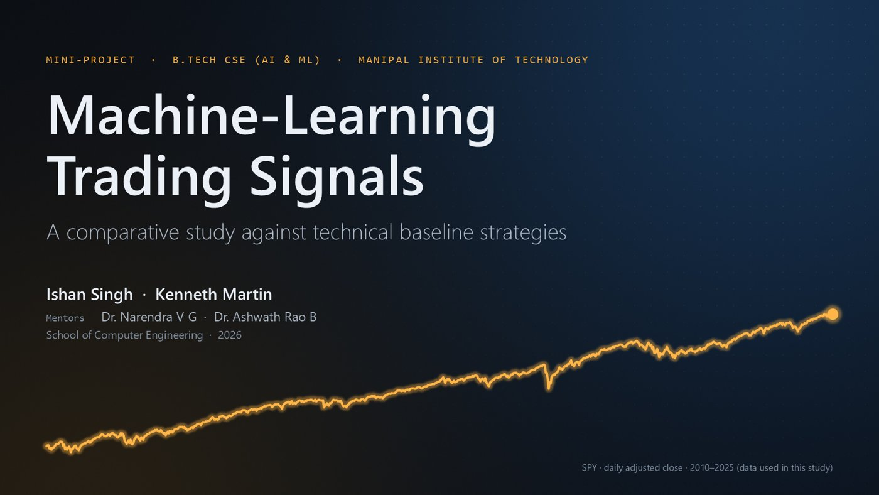
WHAT'S ON THE SLIDE
- The project title, subtitle, the two presenters and the two mentors.
- The amber line is real data: SPY's daily adjusted closing price from 2010 to 2025, the same series the models were trained and tested on. It draws itself left to right when the slide opens and comes back on the last slide.
WHAT TO SAY
Good morning. We are Ishan Singh and Kenneth Martin, and our mini-project asks a simple question: can machine learning produce better trading signals than the simple rules traders have used for decades? The amber line is real data: the daily SPY price from 2010 to 2025, the same data our models were trained and tested on. Over the next fifteen minutes we will show how we built the system, how we tested it honestly, a live demo, and what the evidence actually says.
NUMBERS TO REMEMBER
- Data: Yahoo Finance daily prices, 2010-01-01 to 2025-12-31
- Instruments: SPY (S&P 500 ETF), Apple (AAPL), Microsoft (MSFT)
IF THEY ASK
Q: Why SPY, Apple and Microsoft? They are very liquid, have long, clean daily histories that are free to download, and SPY represents the whole US market. The honest caveat: we picked them knowing they did well, which is survivorship bias (slide 20).

Slide 2 · Can a model learn when to be in the market?
~54 s · Morph from the previous slide · builds automatically
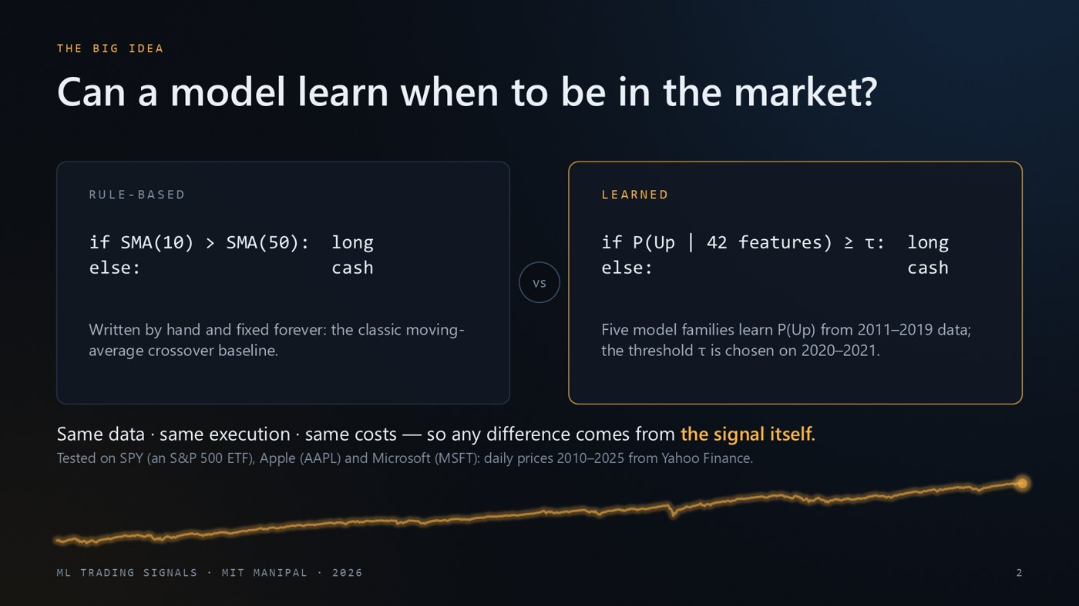
WHAT'S ON THE SLIDE
- Left card: the classic hand-written rule (moving-average crossover). Buy when the 10-day average is above the 50-day average, otherwise stay in cash.
- Right card: the learned rule. A model looks at 42 features and estimates P(Up), the probability that the next move is up. We buy only when P(Up) is at least a threshold τ (tau).
- Bottom line: both approaches get identical data, execution timing and costs, so any difference comes from the signal. The grey line names the three instruments.
- The amber line from slide 1 morphs down to the bottom of this slide.
WHAT TO SAY
Here is the core idea. On the left is a rule a human writes once: buy when the 10-day average is above the 50-day average. On the right, instead of a fixed rule, a model looks at 42 features and estimates the probability that the next move is up, and we invest only when that probability clears a threshold tau. The important design decision is fairness: both approaches get exactly the same data, the same execution timing and the same trading costs, so any difference really comes from the signal. We test this on three liquid instruments: SPY, an exchange-traded fund that tracks the S&P 500, plus Apple and Microsoft, using daily prices from 2010 to 2025.
NUMBERS TO REMEMBER
- τ is chosen from 14 values between 0.30 and 0.65
- Training data 2011–2019, threshold chosen on 2020–2021
IF THEY ASK
Q: What exactly is τ? A probability cut-off. If the model says P(Up) ≥ τ we are invested the next day, otherwise in cash. It is chosen on the 2020–21 validation period by Sharpe ratio, never on the test period.
Q: Why cash instead of short-selling? Long-only is the default because it is realistic for a retail investor and avoids borrow costs. The dashboard can also show long/short.

Slide 3 · Four easy ways to fool yourself in a backtest
~47 s · Fade · builds automatically
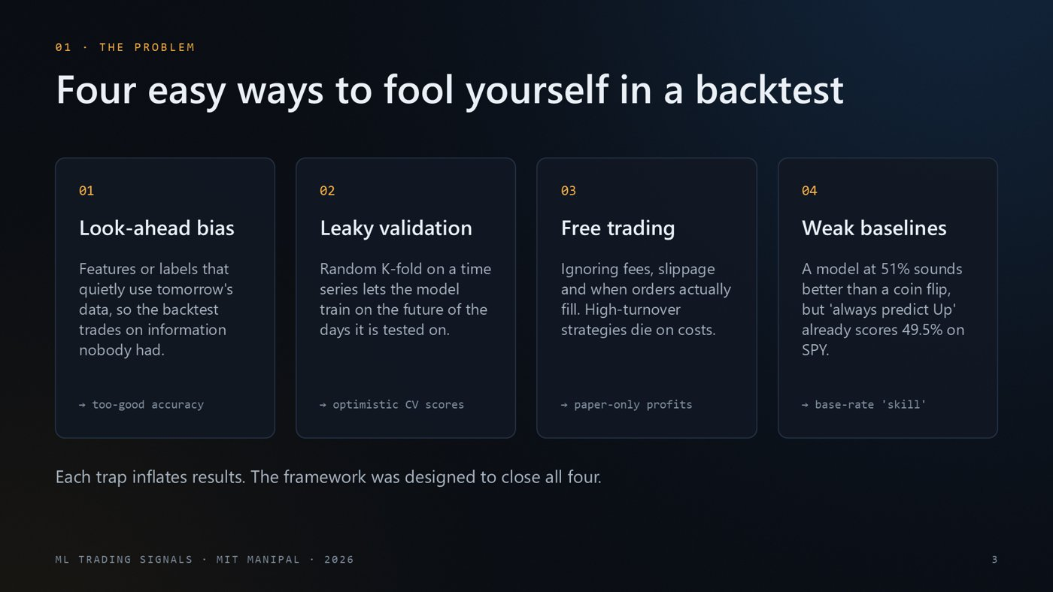
WHAT'S ON THE SLIDE
- Four cards, each a common way a trading backtest gives falsely good results. The small grey line at the bottom of each card is the symptom you would see.
- 01 Look-ahead bias: using information that was not available at decision time.
- 02 Leaky validation: random K-fold cross-validation on time series trains on the future.
- 03 Free trading: ignoring fees, slippage and when orders really fill.
- 04 Weak baselines: a model at 51% accuracy sounds good, but 'always predict Up' already scores 49.5% on SPY.
WHAT TO SAY
Why is this hard? Because a trading backtest is very easy to get wrong in ways that make results look better than they are. First, look-ahead bias, where some feature or label secretly uses future data. Second, random cross-validation on time series, which lets the model learn from the future of the days it is tested on. Third, ignoring trading costs and execution timing. And fourth, weak baselines: a model at 51 percent sounds better than a coin flip, but simply predicting 'up' every day already scores 49.5% on SPY. Our framework was designed to close all four of these traps.
NUMBERS TO REMEMBER
- 'Always predict Up' accuracy on SPY test: 49.5%
IF THEY ASK
Q: Give a concrete example of look-ahead bias. Normalising a feature with the mean of the whole dataset (which includes future years), or deciding with today's close and assuming you also traded at today's close.
Q: Why is K-fold wrong for time series? Random folds put days from the future into the training set of earlier test days, so the model learns about regimes it should not know yet.

Slide 4 · Small evaluation choices flip the conclusion
~63 s · Fade · builds automatically
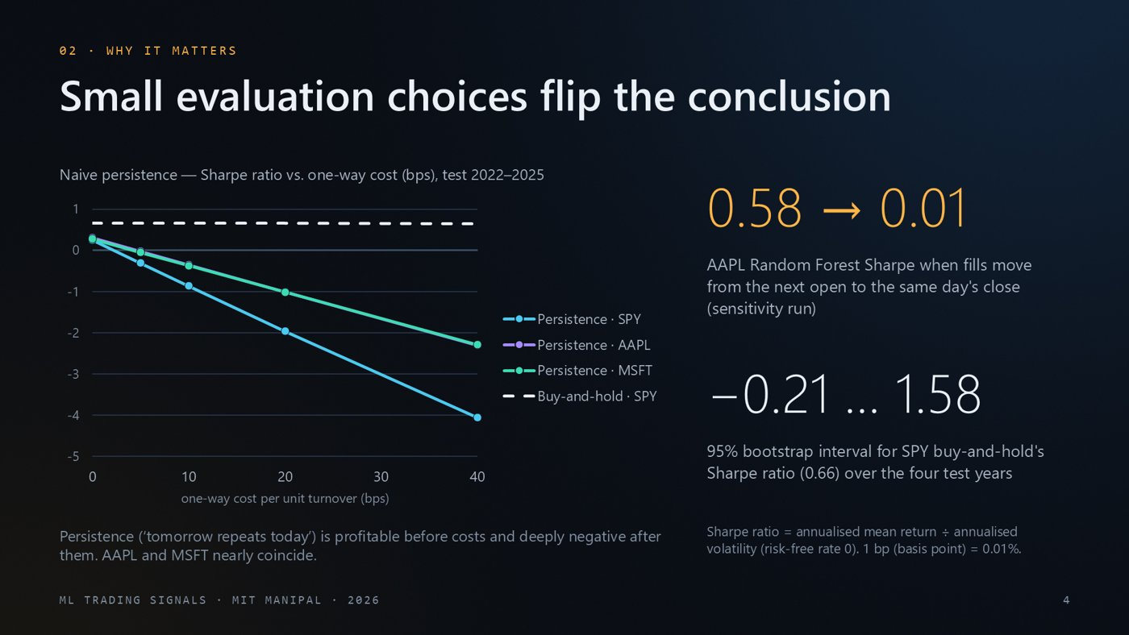
WHAT'S ON THE SLIDE
- Chart: a deliberately naive strategy, 'persistence' (tomorrow repeats today). The x-axis is the trading cost in basis points, drawn to scale from 0 to 40. The y-axis is the Sharpe ratio. Cyan = SPY, violet = AAPL, teal = MSFT (AAPL and MSFT nearly overlap). The dashed white line is buy-and-hold on SPY, flat because it trades only once.
- Top-right number 0.58 → 0.01: the same Random Forest on AAPL, with only the fill price changed from next open to the same day's close (a sensitivity run).
- Second number -0.21 … 1.58: the 95% bootstrap interval for buy-and-hold's Sharpe ratio on SPY (0.66). Four years of data is a small sample.
- Footnote: definitions of the Sharpe ratio and of a basis point.
WHAT TO SAY
Here is why this matters, using our own results. The chart shows a naive 'tomorrow repeats today' strategy. A quick definition first: the Sharpe ratio is the annualised return divided by the annualised volatility, so it measures return per unit of risk, and a basis point is a hundredth of a percent. With zero costs this strategy actually has a positive Sharpe ratio on all three tickers; at realistic costs it becomes deeply negative. On the right: the same Random Forest on Apple goes from a Sharpe of 0.58 to 0.01 just by changing the assumed fill price from the next open to the same day's close. And the 95 percent interval on buy-and-hold's own Sharpe ratio runs from −0.21 to 1.58. Four years of data is a small sample, so we need statistics, not single numbers.
NUMBERS TO REMEMBER
- Persistence Sharpe at 0 bps: SPY 0.25, AAPL 0.31, MSFT 0.28
- At 40 bps: SPY -4.06, AAPL -2.31, MSFT -2.29
- 1 bp (basis point) = 0.01%
IF THEY ASK
Q: What is a Sharpe ratio? Annualised average return divided by annualised volatility, roughly return per unit of risk. We use a risk-free rate of 0, so it is simply return divided by volatility.
Q: Why does the fill price matter so much? With a same-day-close fill you trade at the price you used to compute the signal, which is not really achievable. Next-open fills are realistic, and overnight gaps change the return you get.

Slide 5 · What we set out to do
~48 s · Fade · builds automatically
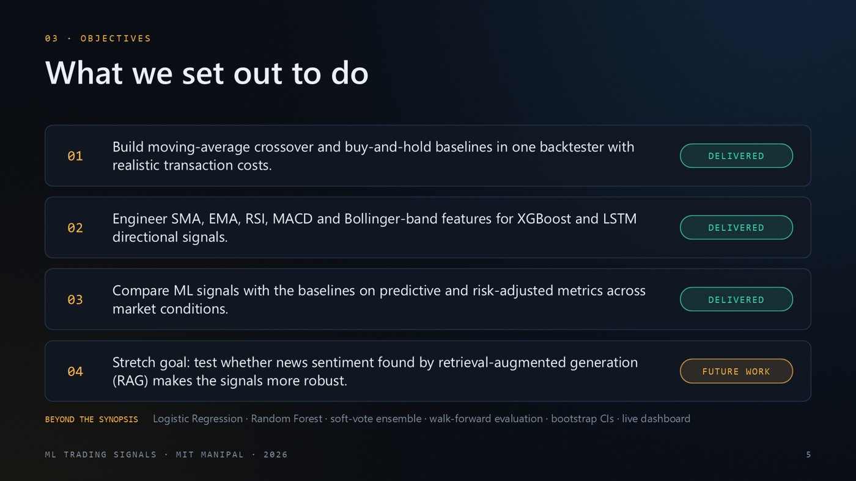
WHAT'S ON THE SLIDE
- The four objectives copied from our synopsis, each with a status chip. Objectives 1–3 are delivered. Objective 4 (news sentiment via retrieval-augmented generation, RAG) is future work.
- Bottom line: what we added beyond the synopsis.
WHAT TO SAY
These are the four objectives from our synopsis. The first three are delivered in full: technical baselines in one cost-aware backtester, technical-indicator features for XGBoost and an LSTM, and a comparison on both prediction and trading metrics. The fourth, a news-sentiment layer built with retrieval-augmented generation, or RAG, was a stretch goal. We deliberately did not implement it, because doing it correctly needs a time-stamped news archive for 2010 to 2025; fake or leaky sentiment would invalidate the whole comparison. We return to it in future scope. We also went beyond the synopsis with three extra models, walk-forward testing, bootstrap intervals and a live dashboard.
NUMBERS TO REMEMBER
- Extra models: Logistic Regression, Random Forest, soft-vote ensemble
- Extra evaluation: walk-forward, bootstrap confidence intervals, live dashboard
IF THEY ASK
Q: Why didn't you build the RAG part? Doing it correctly needs a time-stamped news archive for 2010–2025, which is not reliably available for free. News published after the decision time would leak the future and invalidate the comparison. We designed it instead (slide 21).

Slide 6 · A leakage-safe, cost-aware comparison framework
~44 s · Fade · builds automatically
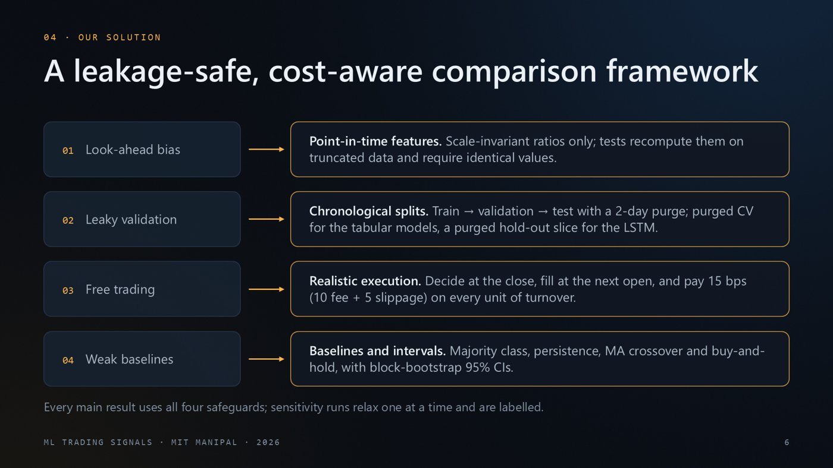
WHAT'S ON THE SLIDE
- Left column: the four traps from slide 3. Arrows lead to our countermeasure for each.
- Point-in-time features; chronological splits with a 2-day purge; next-open execution with 15 bps costs; four baselines plus bootstrap confidence intervals.
- Footer: the main results use all four safeguards. Sensitivity runs relax one at a time and are labelled.
WHAT TO SAY
Our solution maps one safeguard to each trap. Against look-ahead bias, every feature is a point-in-time, scale-invariant ratio, and our tests recompute features on truncated data and require identical values. Against leaky validation, splits are strictly chronological with a two-day purge, and tuning uses purged time-series cross-validation for the tabular models and a purged hold-out slice for the LSTM. Against free trading, we decide at the close, fill at the next open, and charge 15 basis points on every unit of turnover. Against weak baselines, we compare with four baselines and report bootstrap confidence intervals.
NUMBERS TO REMEMBER
- Costs: 10 bps fee + 5 bps slippage = 15 bps per unit of turnover
- Purge: 2 rows before each boundary
IF THEY ASK
Q: What does 'purge' mean? Each label uses the open two days ahead, so the last two rows before a boundary have labels that reach into the next segment. Those rows are dropped.
Q: Where does 15 bps come from? It is an illustrative retail cost (10 fee + 5 slippage). Slide 19 shows results from 0 to 40 bps.

Slide 7 · System architecture: from raw prices to decisions
~51 s · Fade · 2 clicks to build
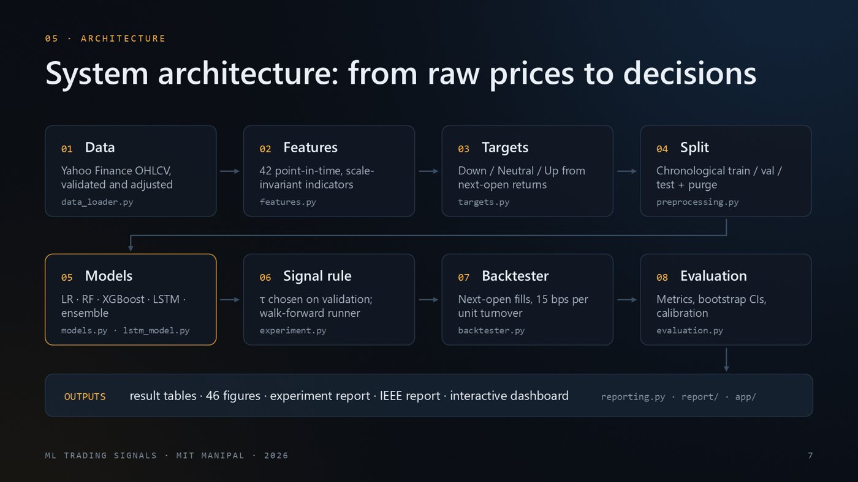
WHAT'S ON THE SLIDE
- Each box is one stage of the pipeline, with the Python file it lives in.
- Row 1 (appears automatically): data, features, targets, split.
- Click 1 shows row 2: models, signal rule, backtester, evaluation.
- Click 2 shows the outputs band: tables, figures, reports, dashboard.
WHAT TO SAY
This is the architecture; each box maps to modules in our src folder. The first row prepares the data: download and validate daily prices from Yahoo Finance, compute 42 point-in-time features, build the Down, Neutral, Up target, and split chronologically with a purge. [CLICK] The second row is learning and verification: five model families produce probabilities, a threshold rule turns them into positions, the backtester simulates next-open fills with costs, and the evaluation module computes metrics, bootstrap intervals and calibration; the experiment runner also drives the walk-forward and robustness runs. [CLICK] Everything ends in generated outputs: tables, figures, reports and the dashboard. Nothing in the results is typed by hand.
NUMBERS TO REMEMBER
- 42 features · 5 model families · 46 generated figures
IF THEY ASK
Q: How long does it take to run? About 24 minutes on a laptop CPU for all three tickers, including walk-forward and robustness runs.
Q: Is anything typed by hand? No. Every table, figure and report, including this deck, is generated from the saved results.

Slide 8 · Built on the open-source Python stack
~34 s · Fade · builds automatically
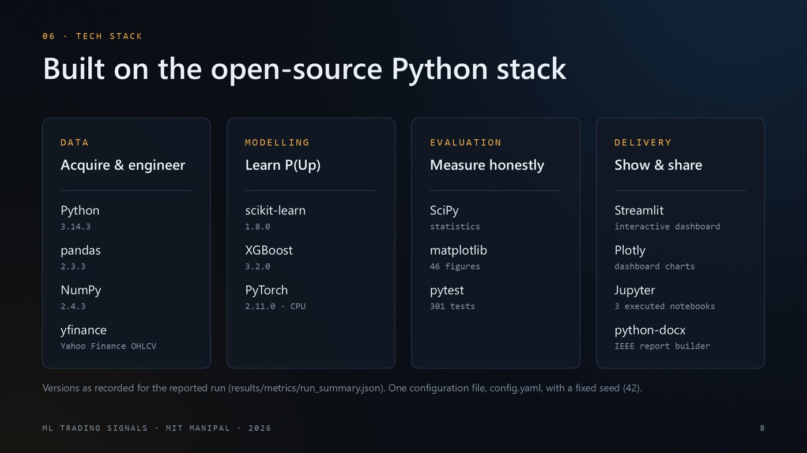
WHAT'S ON THE SLIDE
- Four columns: data, modelling, evaluation and delivery tools, with the exact versions recorded for the reported run.
WHAT TO SAY
The stack is entirely open source. pandas and NumPy for data, scikit-learn for Logistic Regression and Random Forest, XGBoost for gradient boosting and PyTorch for the LSTM. Evaluation uses SciPy and matplotlib, and the code is covered by 301 pytest tests. For delivery we built a Streamlit dashboard with Plotly charts, executed Jupyter notebooks, and a script that generates the IEEE report. The versions shown are exactly those recorded for the reported run.
NUMBERS TO REMEMBER
- Python 3.14.3, pandas 2.3.3, scikit-learn 1.8.0, XGBoost 3.2.0, PyTorch 2.11.0
- 301 pytest tests · fixed seed 42
IF THEY ASK
Q: Why XGBoost and PyTorch? XGBoost is the strongest standard tool for tabular data. PyTorch implements the LSTM sequence model that the synopsis proposed.

Slide 9 · Time only flows forward: chronological splits
~47 s · Fade · builds automatically
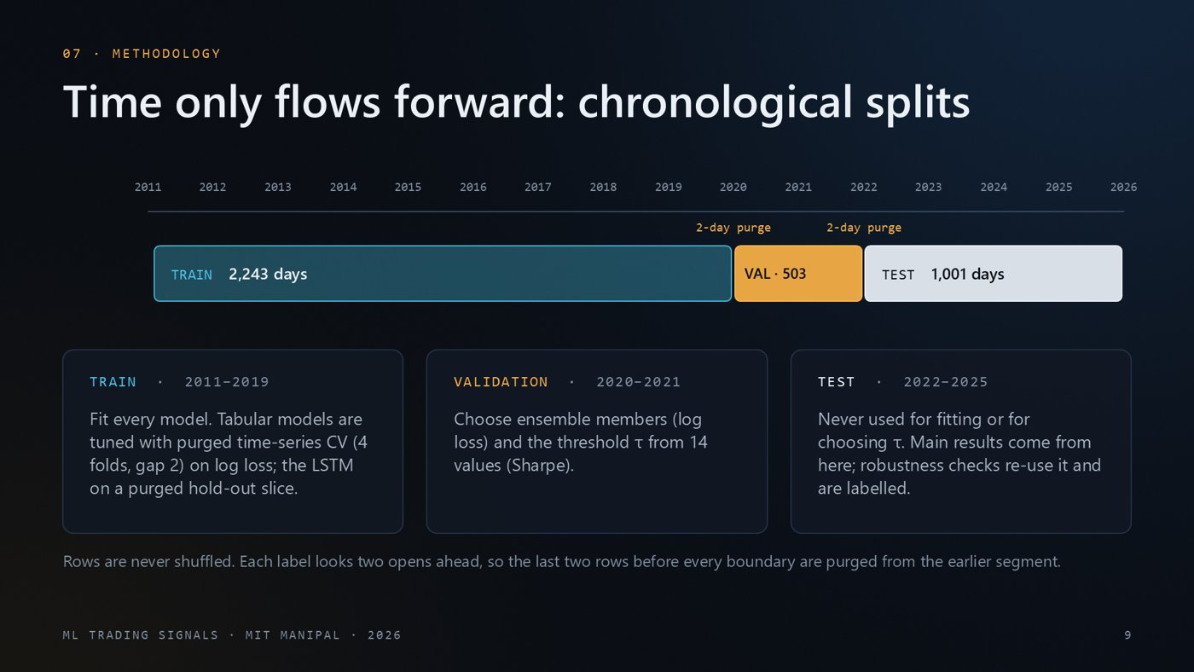
WHAT'S ON THE SLIDE
- A time axis from 2011 to 2026. The three bars wipe in left to right: train (teal), validation (amber), test (white). 'Purge' markers sit at the boundaries.
- The cards below say what each period is used for.
WHAT TO SAY
Time only flows forward, so our splits do too. We train on 2011 to 2019, which is 2,243 trading days, validate on 2020 and 2021, and keep 1,001 test days from 2022 to 2025 that are never used for fitting or for choosing anything. Hyperparameters are tuned inside the training period only: purged time-series cross-validation for the tabular models, and a purged hold-out slice for the LSTM. The validation period chooses the trading threshold and the ensemble members. Because each label looks two opens ahead, we purge the last two rows before each boundary so no label overlaps the next segment.
NUMBERS TO REMEMBER
- Train 2011-01-31 → 2019-12-27: 2,243 days
- Validation 2020-01-02 → 2021-12-29: 503 days
- Test 2022-01-03 → 2025-12-29: 1,001 days
IF THEY ASK
Q: Why does training start in 2011 if the data starts in 2010? The longest features (200- and 252-day windows) need about a year of history before their first complete value.
Q: Wasn't 2020–21 an unusual validation period? Yes. It was a strong bull market, so τ was often chosen low enough to stay invested every day. We report that openly on slides 18 and 20.

Slide 10 · Walk-forward: retrain every year, trade the next
~51 s · Morph from the previous slide · builds automatically
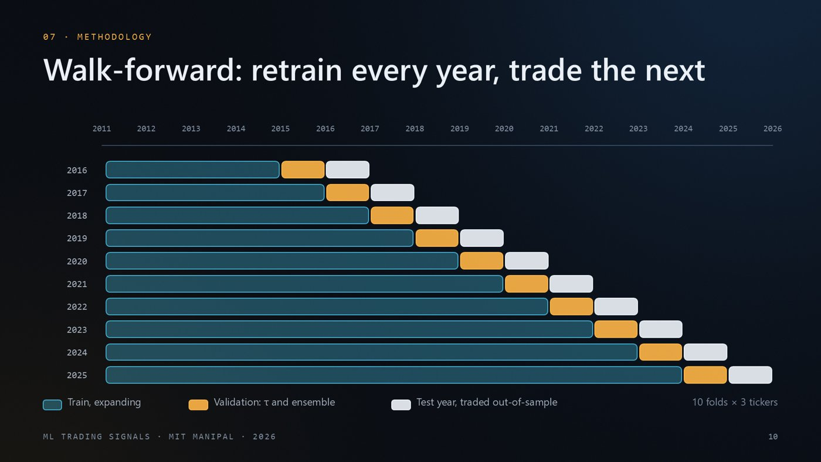
WHAT'S ON THE SLIDE
- The three bars from slide 9 morph into the last of ten rows. Each row is one walk-forward fold, labelled with its test year: training data (expanding), the validation year just before it, and the test year traded out-of-sample.
WHAT TO SAY
A single split could just be lucky, so we also ran a walk-forward test. The bars you just saw move to the bottom row and become one of 10 folds. For every test year from 2016 to 2025, we retrain on all data up to two years before it, choose the threshold and the ensemble on the year just before it, and then trade the test year out-of-sample. The tabular models are re-tuned in every fold; the LSTM keeps its architecture and re-tunes only its class weighting. The training window grows each year, like a real trader who keeps learning. This gives ten years of out-of-sample trading for each ticker.
NUMBERS TO REMEMBER
- 10 folds (2016–2025) × 3 tickers
- Train up to Y−2, validate on Y−1, trade Y
IF THEY ASK
Q: How is this different from the hold-out test? It is a separate check: ten one-year out-of-sample periods instead of one four-year period. The tabular models are re-tuned in every fold (smaller grids); the LSTM keeps its architecture and only re-tunes class weighting.

Slide 11 · 42 point-in-time features, one executable target
~50 s · Fade · builds automatically
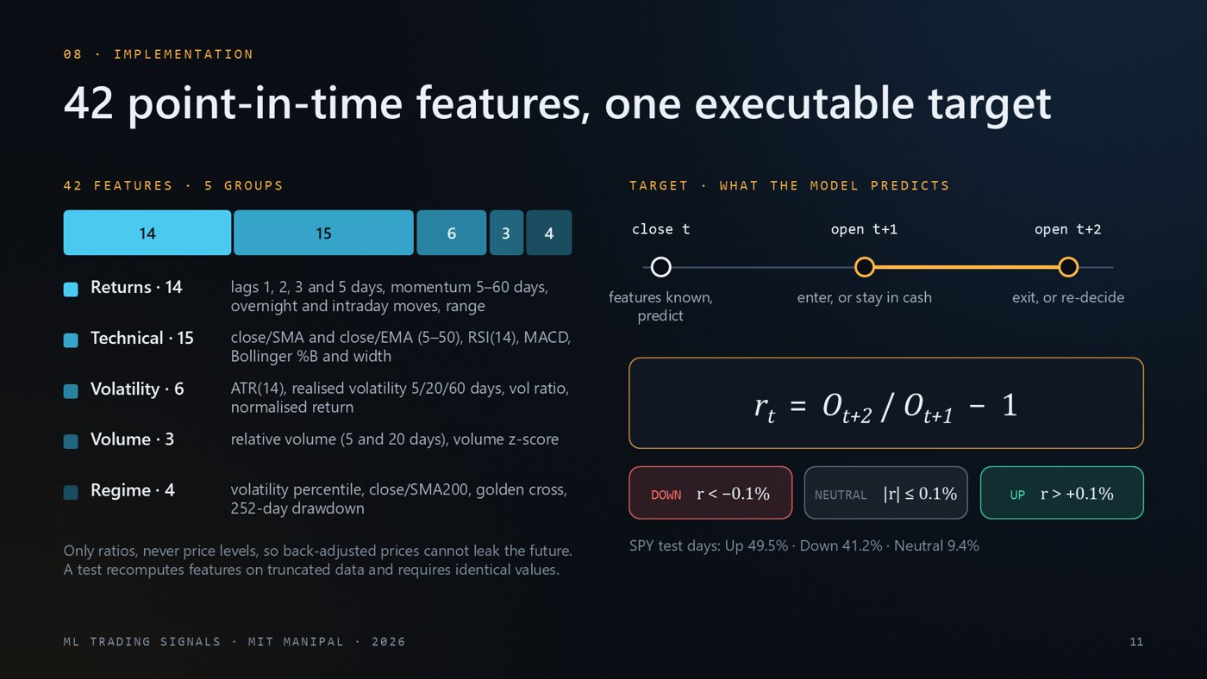
WHAT'S ON THE SLIDE
- Left: the 42 features split into 5 groups (bar segment widths are the counts), with examples.
- Right: the timing of one decision. Features at close t, enter at open t+1, exit or re-decide at open t+2.
- The equation is the return we predict. The three chips are the classes (±0.1% neutral band).
- Bottom line: how often each class occurred on SPY in the test period.
WHAT TO SAY
On the left are the 42 features in five groups: returns, technical indicators such as RSI, MACD and Bollinger bands, volatility, volume and market regime. All of them are ratios rather than price levels, so adjusted prices cannot leak future information, and a test checks this. On the right is the target. After the close on day t we compute features and predict; we can only trade at the next open, t plus one, and the position is held until the following open. So the return we predict is open t+2 over open t+1, split into Down, Neutral and Up with a plus or minus 0.1 percent band.
NUMBERS TO REMEMBER
- Groups: returns 14, technical 15, volatility 6, volume 3, regime 4
- SPY test days: Up 49.5%, Down 41.2%, Neutral 9.4%
IF THEY ASK
Q: Why three classes and not just up/down? The ±0.1% neutral band removes tiny moves that are mostly noise. A binary up/down variant was also tested (slide 19).
Q: Why only ratios? Adjusted prices are rewritten backwards after splits and dividends, so raw price levels can carry future information. Ratios are unaffected, and a test checks that features never change when future rows are removed.

Slide 12 · Five model families, tuned without peeking
~51 s · Fade · builds automatically
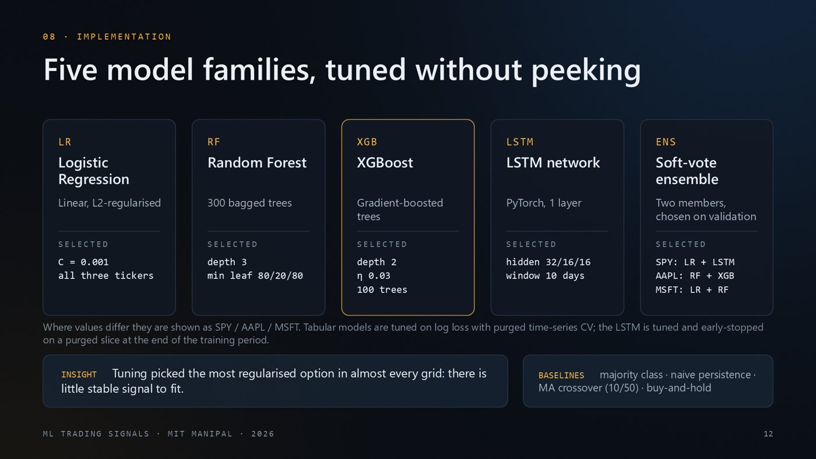
WHAT'S ON THE SLIDE
- Five cards, one per model family, with the hyperparameters that tuning selected. The amber card (XGBoost) is one of the two core models named in the synopsis.
- Values that differ by ticker are written SPY / AAPL / MSFT. The ensemble lists its two members per ticker.
- Bottom: the main insight, and the four baselines.
WHAT TO SAY
We trained five model families: Logistic Regression, Random Forest, XGBoost, a small LSTM in PyTorch, and a soft-vote ensemble whose two members are chosen on the validation set. All tuning used log loss inside the training period: purged time-series cross-validation for the tabular models, and a purged hold-out slice for the LSTM. The selected values are telling: Logistic Regression chose C = 0.001, the strongest regularisation in its grid, the trees chose depth 2 or 3, and the LSTM chose a short window. When tuning keeps choosing the simplest model, it usually means there is little stable signal to learn, which already hints at the results. We also built four baselines.
NUMBERS TO REMEMBER
- LR C = 0.001 (strongest regularisation in the grid)
- RF depth 3, 300 trees; XGB depth 2, η 0.03, 100 trees
- LSTM: 1 layer, hidden 32/16/16, 10-day window
IF THEY ASK
Q: Why tune on log loss instead of accuracy? Trades are driven by probabilities. Log loss rewards well-calibrated probabilities, while accuracy only checks the most likely class.
Q: Why such a small LSTM? There are only about 2,200 training days. Bigger networks memorise noise, so we use one small layer with early stopping on a purged slice of the training period.

Slide 13 · From probability to position, net of costs
~45 s · Fade · builds automatically
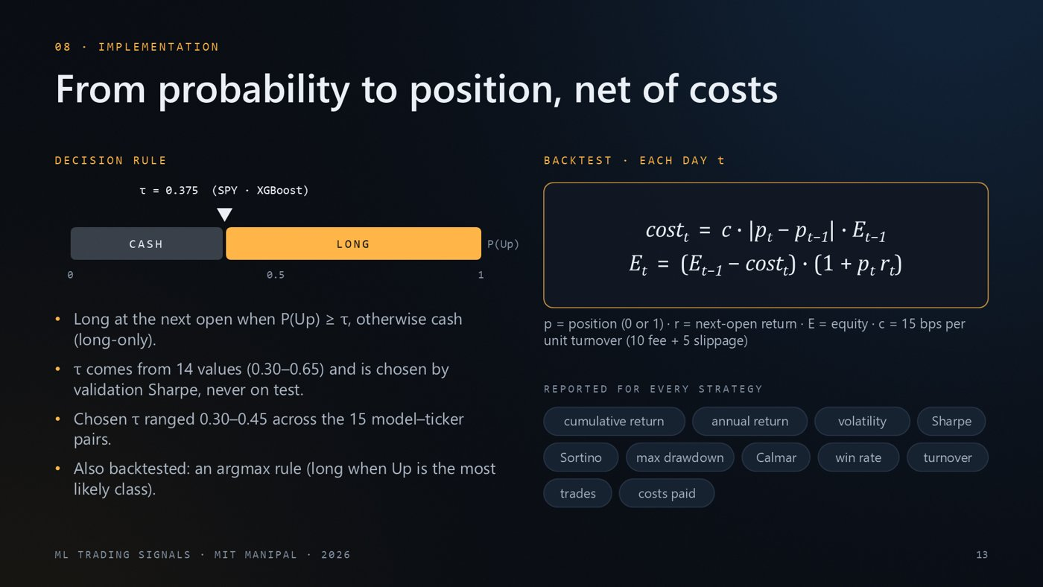
WHAT'S ON THE SLIDE
- Left: a probability bar from 0 to 1. Below τ = cash, above τ = long. The marker shows SPY XGBoost's τ.
- Right: the two backtest equations applied every day. Costs are charged on the change in position, then the day's return is applied.
- Chips: every metric reported for every strategy.
WHAT TO SAY
Here is how a probability becomes a trade. If the model's probability of an up move is at least tau, we go long at the next open; otherwise we hold cash. Tau is picked from 14 values using validation Sharpe only; the test set never influences it. The backtester on the right charges costs on every change in position, 15 basis points per unit of turnover, before applying the day's return, and it compounds equity day by day. Every strategy, baselines included, goes through exactly this code, and we report the full set of metrics for each.
NUMBERS TO REMEMBER
- SPY XGBoost τ = 0.375
- Chosen τ across all 15 model–ticker pairs: 0.30–0.45
- Starting capital 100,000
IF THEY ASK
Q: Why decide at the close but fill at the next open? You only know the close once the market has closed. The earliest realistic trade is the next morning's open.
Q: What is the argmax rule? A simpler rule without τ: invest whenever Up is the most likely of the three classes.

Slide 14 · Engineered like research software
~38 s · Fade · builds automatically
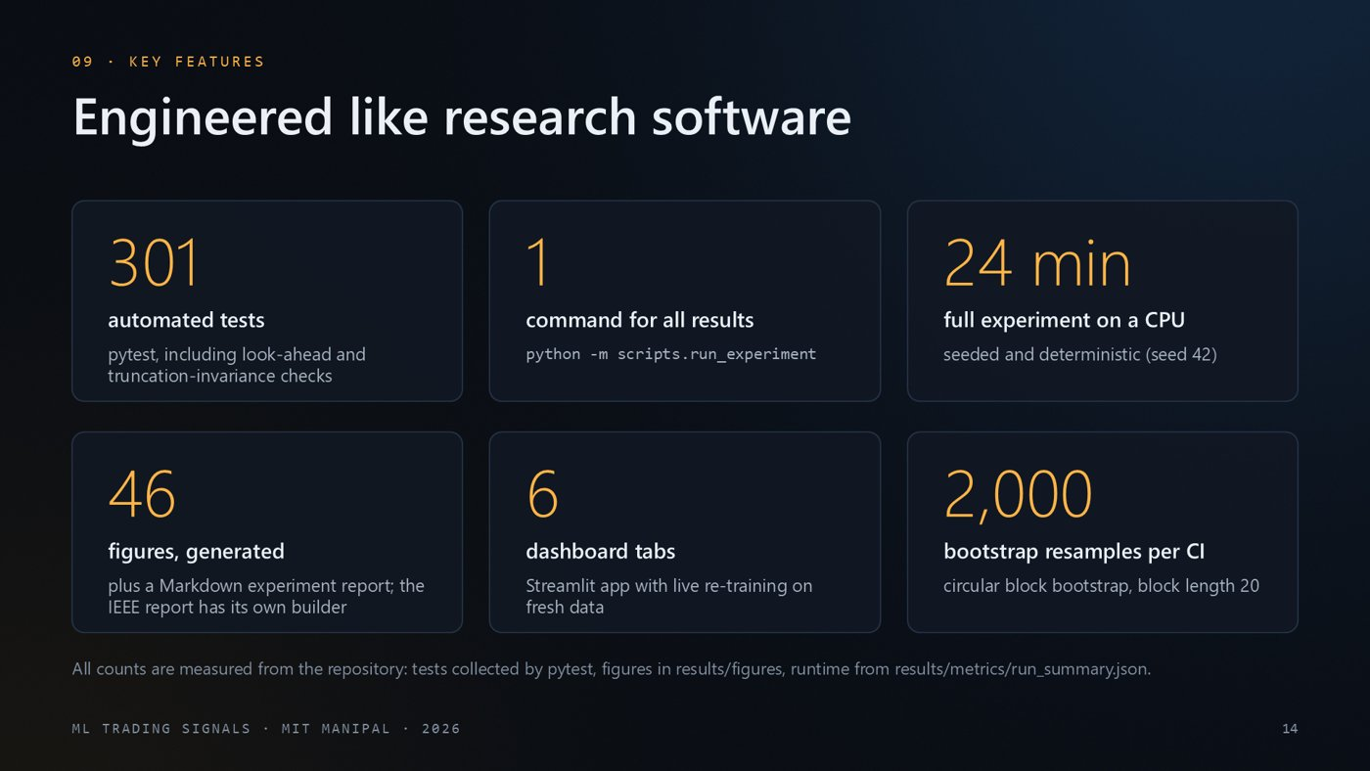
WHAT'S ON THE SLIDE
- Six tiles of facts about the engineering: tests, one-command reproducibility, runtime, generated figures, dashboard and bootstrap resamples.
WHAT TO SAY
We built this like research software rather than a one-off notebook. There are 301 automated tests, including tests that check that features never use future data. One command reproduces every result, figure and the experiment report, and the IEEE report has its own build script. The full run takes about 24 minutes on a CPU and is seeded, so it is repeatable. It generates 46 figures and the reports, there is a six-tab dashboard, and every confidence interval uses 2,000 block-bootstrap resamples.
NUMBERS TO REMEMBER
- 301 tests · 24 min full run · 46 figures · 2,000 bootstrap resamples (block 20)
- Rebuild command: python -m scripts.run_experiment
IF THEY ASK
Q: What does a truncation-invariance test do? It computes the features on the full history and again on history cut at a date t. The values at t must be identical; if not, a feature used future data.
Q: Is the run deterministic? Yes on the same machine and library versions (seed 42). Other versions can change late decimals.

Slide 15 · The working system: an interactive dashboard
~42 s · Fade · builds automatically
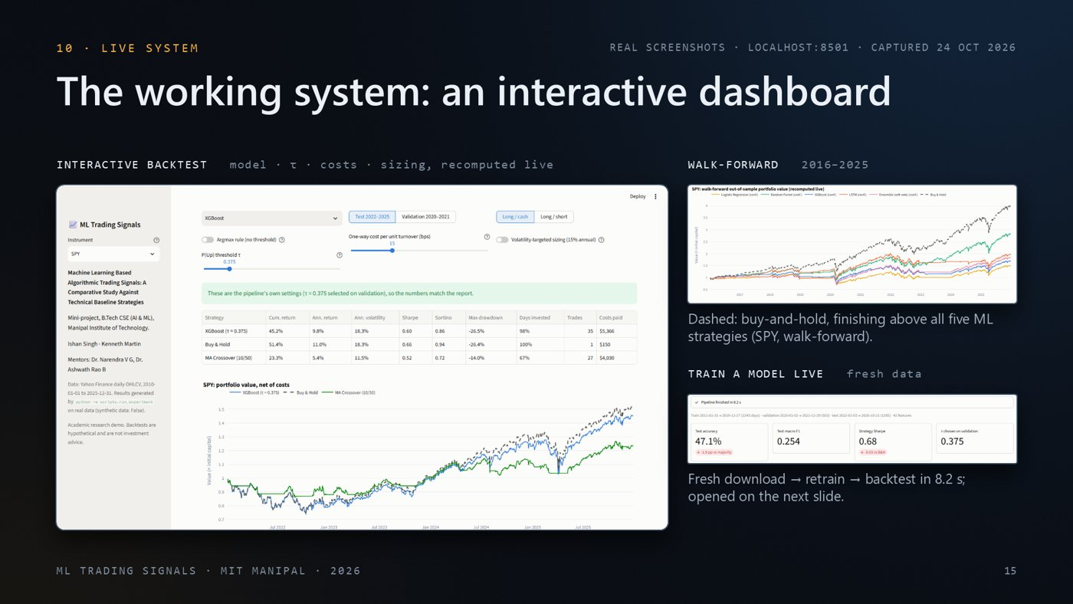
WHAT'S ON THE SLIDE
- Three real screenshots of our Streamlit dashboard, captured 24 Oct 2026.
- Large: the interactive backtest (pick a model, move τ, change costs or sizing; numbers recompute live).
- Right top: the walk-forward chart. The dashed line (buy-and-hold) finishes above all five ML strategies.
- Right bottom: the metric cards from a live training run, which the next slide opens.
- Good moment for the live demo: see Appendix B.
WHAT TO SAY
This is the working system: a Streamlit dashboard, and these are real screenshots of it running. The large view is the interactive backtest. You pick a model, move the threshold, change costs or turn on volatility sizing, and our own backtester recomputes every number from the saved out-of-sample probabilities. On the right are the walk-forward tab, where buy-and-hold finishes above all five ML strategies, and the live-training tab, which the next slide opens. There are six tabs in total, and if time permits I can switch to the running app now.
NUMBERS TO REMEMBER
- Six tabs: Overview, Interactive backtest, Predictions, Walk-forward & robustness, Train a model live, Figures & docs
IF THEY ASK
Q: Are these numbers recomputed or pre-saved? The backtest is recomputed live by our own backtester from saved out-of-sample probabilities. The 'Train a model live' tab downloads fresh data and retrains.

Slide 16 · Retrain live, with ten more months of data
~52 s · Morph from the previous slide · builds automatically
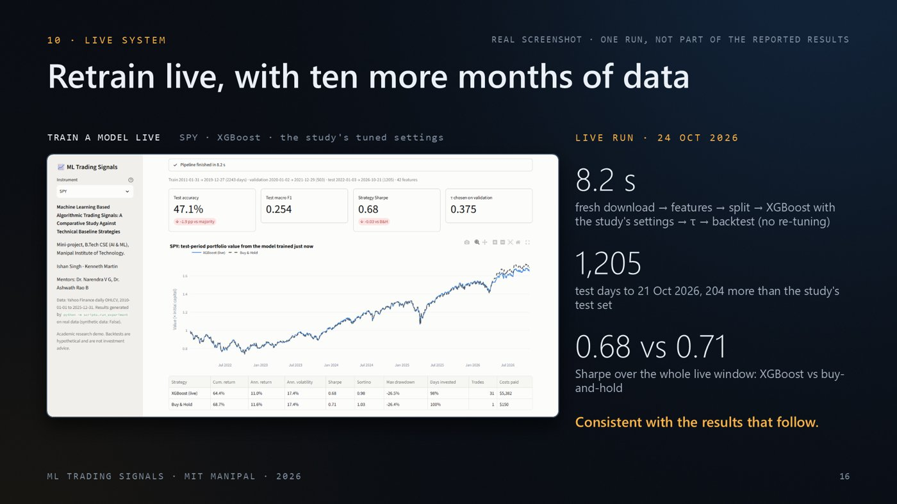
WHAT'S ON THE SLIDE
- The live screenshot grows from the thumbnail into full size (Morph).
- Right: three facts from that one live run on 24 Oct 2026, and the takeaway.
- The header says clearly that this is one run, not part of the reported results.
WHAT TO SAY
This tab runs the core pipeline live for one model. It downloads fresh data, builds the features, splits the data, trains XGBoost with the hyperparameters we tuned in the study, picks tau on validation and backtests, all in about 8 seconds because nothing is re-tuned. Because the data are current, the test window now runs to 21 Oct 2026, which adds 204 test days beyond our study's test set. Over the whole window XGBoost reached a Sharpe ratio of 0.68 against 0.71 for buy-and-hold, and its accuracy was 1.9 points below the majority class, consistent with the results we show next. This is one live run, kept separate from the reported results.
NUMBERS TO REMEMBER
- Pipeline time 8.2 s
- Test window to 21 Oct 2026: 1,205 days (204 more than the study's test set)
- Sharpe 0.68 vs buy-and-hold 0.71; accuracy 1.9 points below the majority class
IF THEY ASK
Q: If you press the button today, will the numbers match the slide? Not exactly. The data updates every trading day, so the test window grows and the numbers move slightly. The slide records the run of 24 Oct 2026.
Q: Is the live window 'unseen data'? Only partly. 1,001 of its 1,205 test days are the study's own test period, which is why the title says 'ten more months of data' and not 'unseen data'.

Slide 17 · Accuracy: none reliably beat 'always predict Up'
~38 s · Fade · builds automatically
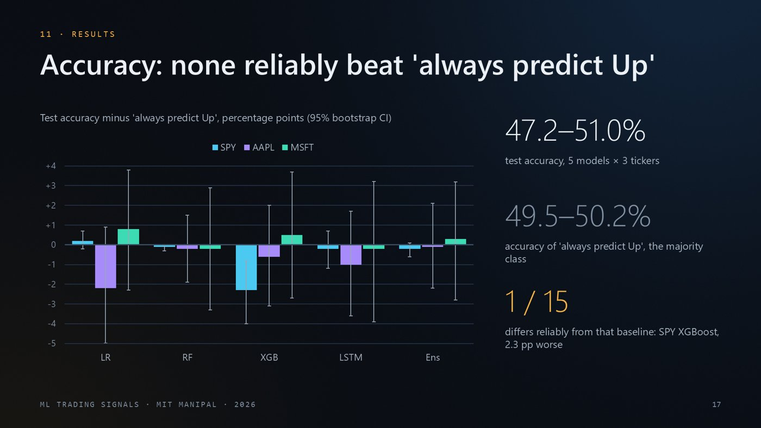
WHAT'S ON THE SLIDE
- Each bar = a model's test accuracy minus the accuracy of 'always predict Up' (the majority class), in percentage points. Colours are tickers. The thin whiskers are 95% bootstrap intervals.
- Almost every whisker crosses zero: no reliable difference.
- Right: the accuracy range of our models, the baseline's range, and the one reliable difference (which is worse).
WHAT TO SAY
Now the results, starting with prediction. Each bar is a model's test accuracy minus the accuracy of always predicting up, which is the most common class, with 95 percent bootstrap intervals. The models scored between 47.2 and 51.0%, while the trivial majority-class predictor scored 49.5 to 50.2%. Almost every interval crosses zero. The only model that is reliably different is SPY XGBoost, and it is worse. At a daily horizon, none of our models predicted direction reliably better than the base rate.
NUMBERS TO REMEMBER
- Model accuracy 47.2–51.0% vs baseline 49.5–50.2%
- Only reliable difference: SPY XGBoost, 2.3 pp worse
IF THEY ASK
Q: Isn't 51% better than 50%? Only by about 1 point, and the 95% interval for that difference includes zero. It is indistinguishable from the baseline.
Q: What is a bootstrap confidence interval? We resample the test days in blocks of 20 days (to keep their time structure) 2,000 times and recompute the metric each time. The middle 95% of those values is the interval.

Slide 18 · Trading: none of the 15 reliably beat buy-and-hold
~59 s · Fade · builds automatically
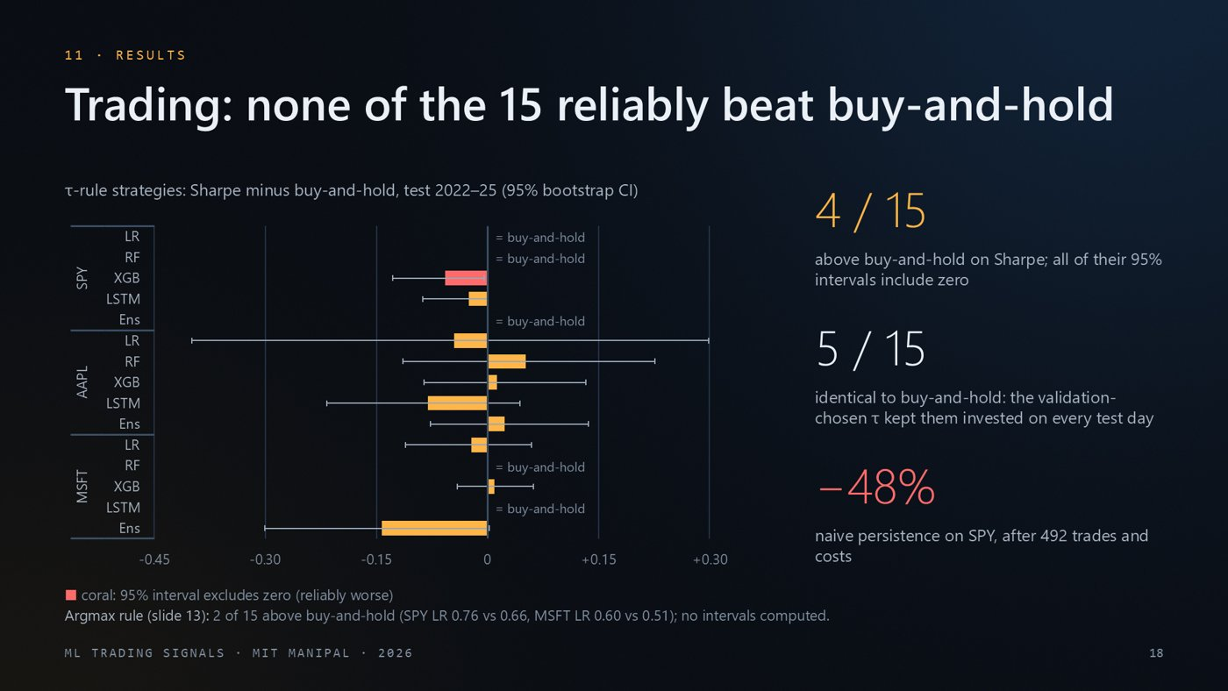
WHAT'S ON THE SLIDE
- Each bar = one τ-rule strategy's Sharpe ratio minus buy-and-hold's, grouped by ticker. Whiskers are 95% bootstrap intervals. Bars to the right are better than buy-and-hold.
- '= buy-and-hold' marks strategies that were invested every single day, so they are identical to it.
- The coral bar is the only reliable difference, and it is worse.
- The note under the chart discloses the argmax rule's results.
WHAT TO SAY
Trading results. Each bar is how much a strategy's Sharpe ratio beat or trailed buy-and-hold over the test period, with bootstrap intervals. 4 of the 15 ML strategies had a slightly higher Sharpe, but every one of those intervals includes zero. 5 strategies were literally identical to buy-and-hold, because the threshold chosen on the bullish 2020-21 validation period kept them invested every day. The only reliable difference is SPY XGBoost, in red, which was worse. For contrast, the naive persistence baseline lost 48 percent on SPY once costs were included. One caveat, shown under the chart: with the simpler argmax rule, 2 of 15 strategies were above buy-and-hold, both Logistic Regression, but we did not compute intervals for that rule, so we make no claim either way.
NUMBERS TO REMEMBER
- Higher Sharpe than buy-and-hold (4/15, none reliable): AAPL RF, AAPL XGB, AAPL Ens, MSFT XGB
- Identical to buy-and-hold (5/15): SPY LR, SPY RF, SPY Ens, MSFT RF, MSFT LSTM
- Reliably worse: SPY XGBoost
- Naive persistence on SPY: -48% after 492 trades
- Argmax rule: 2 of 15 above buy-and-hold (SPY LR 0.76 vs 0.66, MSFT LR 0.60 vs 0.51), no intervals
IF THEY ASK
Q: Why are five strategies exactly equal to buy-and-hold? The τ chosen on the bullish 2020–21 validation period was low enough that P(Up) always cleared it, so they never left the market.
Q: Two argmax strategies beat buy-and-hold. Doesn't that contradict the title? The title is about the 15 τ-rule strategies we tested with intervals. For argmax we did not compute intervals, so we make no claim either way. Gaps of about 0.1 in Sharpe sat well inside the intervals of the τ-rule strategies, but we did not test the argmax ones.

Slide 19 · Walk-forward and robustness checks agree
~55 s · Fade · builds automatically
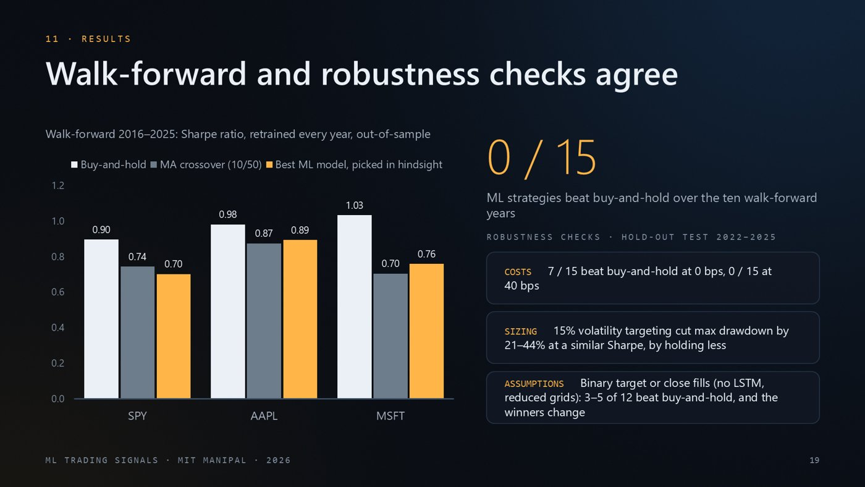
WHAT'S ON THE SLIDE
- Chart: walk-forward 2016–2025 Sharpe ratios for buy-and-hold (white), MA crossover (grey) and the best ML strategy per ticker chosen with hindsight (amber), the most favourable comparison for ML.
- Big number: how many ML strategies beat buy-and-hold over the ten years.
- Cards: robustness checks run on the 2022–2025 hold-out test (costs, sizing, alternative target and fill).
WHAT TO SAY
The walk-forward test tells the same story over ten years. Buy-and-hold is the white bar, the moving-average crossover is grey, and amber is the best ML model for each ticker, picked with hindsight. Even with that cherry-picking, ML never beat buy-and-hold: 0 of 15. The robustness checks on the right use the 2022 to 2025 hold-out test, and they agree. With zero costs, 7 strategies edge ahead, but at 40 basis points none do. Volatility targeting cut drawdowns by 21 to 44 percent at a similar Sharpe ratio, simply by holding less when markets are volatile; that is risk control, not prediction. And changing the target or the fill price changes which strategies 'win', a classic sign of noise.
NUMBERS TO REMEMBER
- Walk-forward Sharpe (B&H / MA / best ML): SPY 0.90/0.74/0.70; AAPL 0.98/0.87/0.89; MSFT 1.03/0.70/0.76
- ML beating buy-and-hold in walk-forward: 0/15
- Costs: 7/15 above B&H at 0 bps, 0/15 at 40 bps
- Volatility targeting: max drawdown −21 to −44% at a similar Sharpe
- Alternative target or fills: 3–5 of 12 above B&H
IF THEY ASK
Q: Why pick the best ML model with hindsight? To give ML every advantage. Even the cherry-picked model loses to buy-and-hold.
Q: Doesn't volatility targeting just reduce exposure? Yes, that is the point. It lowers drawdowns by holding less when markets are volatile, at a similar Sharpe and a lower return. It is risk control, not prediction.

Slide 20 · Challenges we handled, limitations we report
~46 s · Fade · builds automatically
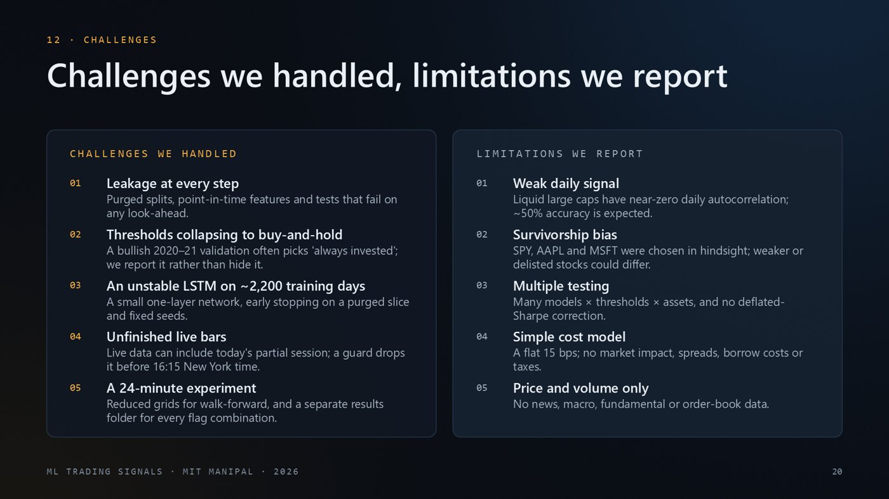
WHAT'S ON THE SLIDE
- Left: engineering challenges we handled. Right: limitations we state openly. These are the points an examiner is most likely to probe.
WHAT TO SAY
On the left, the main engineering challenges we handled. Leakage can creep in at every step, so we built tests that fail on any look-ahead. Thresholds chosen on a bull-market validation period often collapse to buy-and-hold, and we report that honestly. The LSTM is unstable with only about 2,200 training days, so we kept it small. Live data can include today's unfinished bar, which we now drop. On the right are the limitations we state openly: a weak daily signal, survivorship bias from choosing successful stocks, many comparisons without a multiple-testing correction, a simple cost model, and price data only.
NUMBERS TO REMEMBER
- ~2,200 training days per ticker · flat 15 bps cost model · no news or macro data
IF THEY ASK
Q: What is survivorship bias here? SPY, Apple and Microsoft are known winners. Strategies tested on companies that later failed could behave differently.
Q: What is the multiple-testing problem? When you try many models × thresholds × assets, some look good by chance. A correction such as the deflated Sharpe ratio would adjust for that; we list it as future work.

Slide 21 · Where this goes next
~32 s · Fade · builds automatically
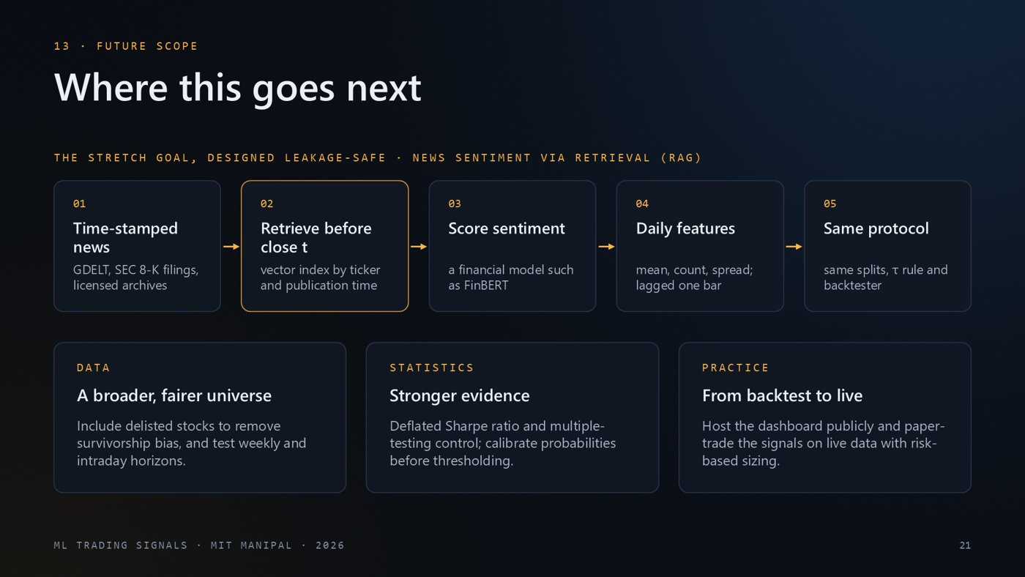
WHAT'S ON THE SLIDE
- Top: the five-step design for the news-sentiment (RAG) extension, built to avoid look-ahead.
- Bottom: three directions for future work: data, statistics and practice.
WHAT TO SAY
Future work starts with the stretch goal. A correct news-sentiment layer needs time-stamped articles, retrieval that only sees documents published before the decision time, a financial sentiment model such as FinBERT, daily features lagged by one bar, and then exactly the same evaluation protocol. Beyond that: a broader universe including delisted stocks, stronger statistics such as the deflated Sharpe ratio, and moving from backtest to paper trading on live data.
NUMBERS TO REMEMBER
- Key rule: only retrieve news published before the close of day t
IF THEY ASK
Q: What is RAG? Retrieval-augmented generation. For a ticker and date, relevant documents (news) are retrieved and fed to a model. Here, a financial sentiment model such as FinBERT scores them, and the scores become daily features.
Q: What is FinBERT? A BERT language model fine-tuned on financial text to classify sentiment as positive, negative or neutral.

Slide 22 · What we can claim
~40 s · Fade · builds automatically
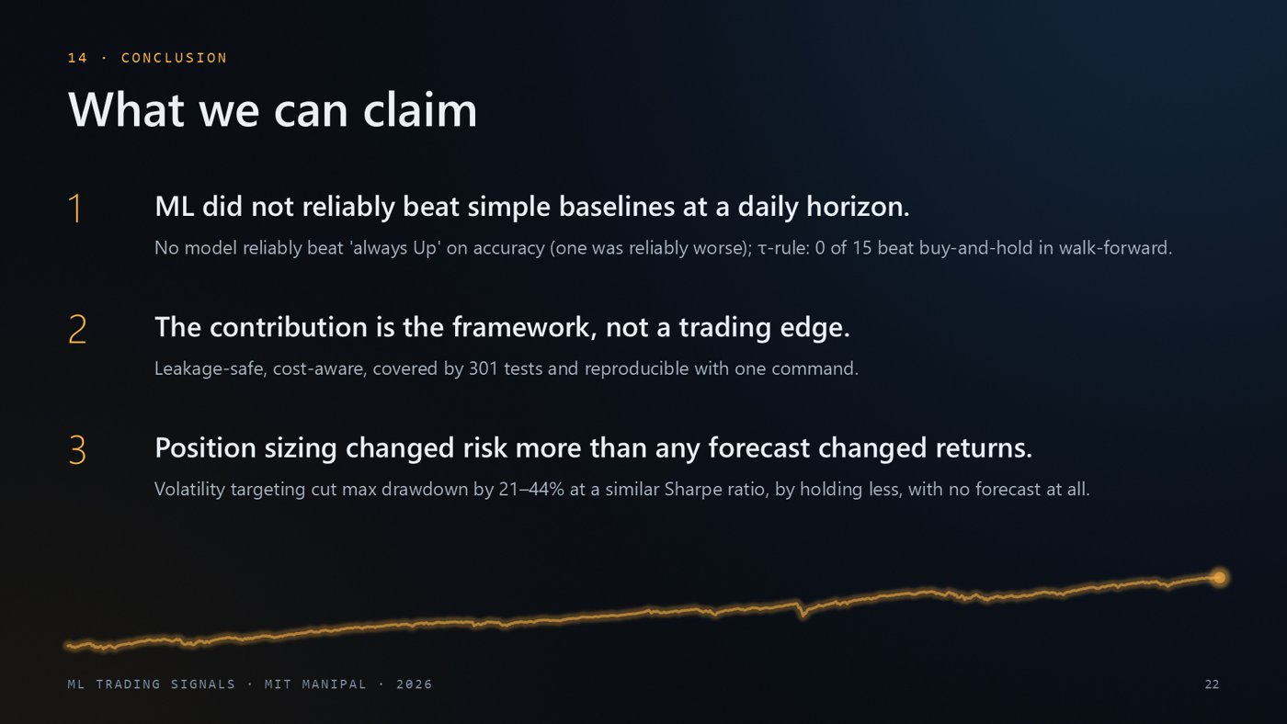
WHAT'S ON THE SLIDE
- The three claims we can defend, each with its evidence underneath.
WHAT TO SAY
To conclude, three claims we can defend. First, at a daily horizon, machine learning did not reliably beat simple baselines, either on accuracy or on risk-adjusted returns, which is consistent with how efficient liquid large caps are. Second, our real contribution is the framework: leakage-safe, cost-aware, tested and reproducible, so a negative result here is trustworthy. Third, position sizing mattered more than prediction: volatility targeting cut drawdowns by a fifth to almost a half at a similar Sharpe ratio, simply by holding less when markets are volatile.
NUMBERS TO REMEMBER
- 0 of 15 walk-forward strategies beat buy-and-hold · 301 tests · drawdown −21 to −44% with volatility targeting
IF THEY ASK
Q: So is machine learning useless for trading? That is not our claim. At a daily horizon, with price-and-volume features on three very liquid instruments and after realistic costs, it did not reliably beat simple baselines. Other horizons, data (news, order books) or markets may differ; that is the future work.
Q: Then what is the contribution? An evaluation framework that makes a negative result trustworthy: leakage-safe, cost-aware, tested and reproducible. Many published positive results do not survive these checks.

Slide 23 · Thank you
~18 s · Morph from the previous slide · builds automatically
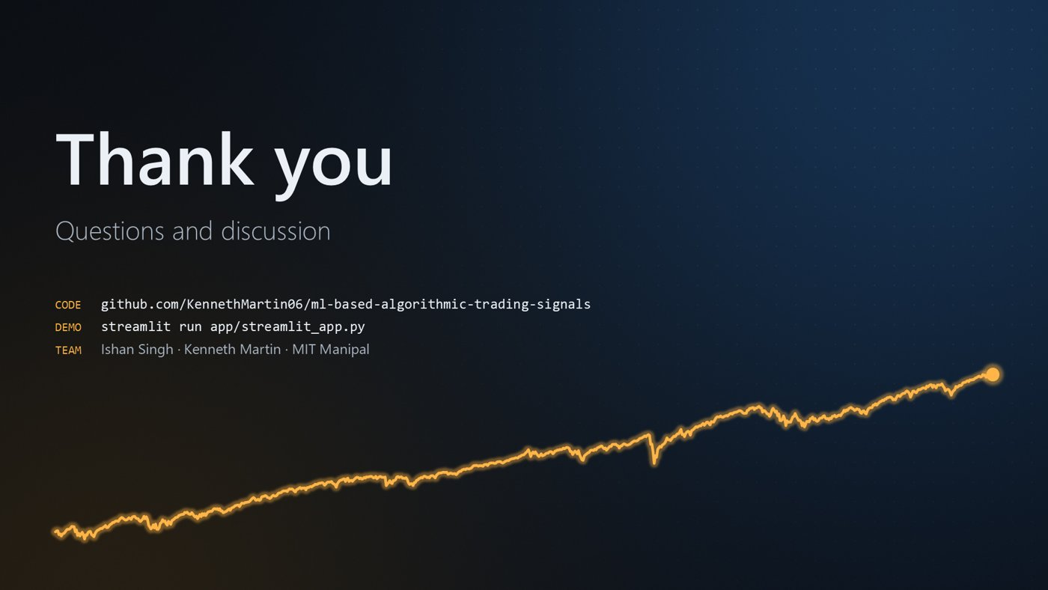
WHAT'S ON THE SLIDE
- Thank you, the repository, the command that starts the demo, and the team. The price line morphs back to full size.
WHAT TO SAY
Thank you. The code, results and reports are in our repository, and the dashboard runs with a single Streamlit command. We are happy to take questions, and we can open the live dashboard to explore any result in more detail.
NUMBERS TO REMEMBER
- Demo: streamlit run app/streamlit_app.py (http://localhost:8501)

Appendix A · Glossary
Sharpe ratio | Annualised mean return ÷ annualised volatility (risk-free rate 0 here). Return per unit of risk; higher is better.
Basis point (bp) | 0.01%. 15 bps = 0.15% of the traded amount.
Turnover | How much of the portfolio changes hands. Going from cash to fully invested is 1 unit.
Buy-and-hold | Buy on the first day and hold to the end. The benchmark to beat.
MA crossover (10/50) | Invested when the 10-day average price is above the 50-day average.
Majority class | Always predicting the most common class (Up). The accuracy baseline.
Naive persistence | Predict that tomorrow moves like today.
τ (tau) | Probability threshold. Invest when P(Up) ≥ τ. Chosen on validation.
Argmax rule | Invest when Up is the most likely class (no threshold).
Look-ahead bias | Using information that was not available at decision time.
Purge | Dropping the last rows before a split boundary whose labels reach into the next period.
Walk-forward | Repeatedly retrain on the past and test on the next year, moving forward in time.
Bootstrap CI | Resample the test days (in blocks) many times and recompute the metric; the middle 95% is the confidence interval.
Log loss | Scores predicted probabilities; punishes confident wrong predictions. Used for tuning.
LSTM | Long short-term memory network, a recurrent neural network for sequences.
Soft-vote ensemble | Average the probabilities of several models.
Volatility targeting | Scale the position so the portfolio's volatility stays near a target (15%/yr).
Max drawdown | Largest fall from a previous peak, in %.
Survivorship bias | Testing only on assets that survived and did well.
RAG | Retrieval-augmented generation: retrieve relevant documents and feed them to a model.

Appendix B · Live demo script (about 3–4 minutes)
Best placed at slide 15. Every number on screen is recomputed by the project's own code.
Before the viva. Start the dashboard (see the launch line at the end of this appendix) and open http://localhost:8501. The first load takes about 10–20 seconds. The live-training tab needs internet; everything else runs offline from saved results.
1 · Overview tab. Point at the headline cards: buy-and-hold Sharpe, best ML Sharpe, best ML accuracy vs the majority class. Change the instrument in the left sidebar (SPY → AAPL → MSFT) to show that everything updates.
2 · Interactive backtest. Select XGBoost. The green box confirms the settings match the report. Then: move the τ slider down (more days invested; at the bottom of the range several models simply stay invested every day, like buy-and-hold) and up (fewer days invested). Move the cost slider from 15 to 0 and to 40 bps and watch the Sharpe change. Switch on volatility-targeted sizing and show the max drawdown falling.
3 · Predictions. Show the metrics table against the majority class, then the confusion matrix and the calibration curve for one model.
4 · Walk-forward & robustness. Show the 2016–2025 out-of-sample equity curves. The dashed buy-and-hold line ends on top.
5 · Train a model live. Keep XGBoost and 'Use the hyperparameters tuned in the study' on, then press the Download-and-train button (about 10 seconds). Say: 'this downloads today's data and runs the whole pipeline; the numbers differ slightly from slide 16 because the data now runs to the latest trading day.'
6 · Figures & docs. Browse a few generated figures to show that every chart in the report comes from code.
If something fails. No internet: skip step 5 and show slide 16 instead. Dashboard not responding: refresh the page; if needed restart it with the launch line below.
LAUNCH (WINDOWS, FROM THE ML_BASED_ALGORITHMIC_TRADING FOLDER)
.venv\Scripts\python.exe -m streamlit run app\streamlit_app.py
Then open http://localhost:8501. First-time setup on a new machine (needs internet): py -3.12 -m venv .venv then .venv\Scripts\python.exe -m pip install -r app\requirements.txt

Appendix C · Numbers cheat sheet
Data | SPY, AAPL, MSFT · Yahoo Finance daily OHLCV 2010–2025
Splits | train 2,243 · validation 503 · test 1,001 days (2-day purge)
Features / target | 42 features in 5 groups · Down/Neutral/Up, ±0.1% band, next-open return
Costs | 15 bps per unit turnover (10 fee + 5 slippage)
Accuracy | models 47.2–51.0% vs 'always Up' 49.5–50.2% · only reliable difference SPY XGBoost (worse)
Test Sharpe (B&H) | SPY 0.66, AAPL 0.51, MSFT 0.51 · SPY 95% CI -0.21 to 1.58
τ-rule vs B&H | 4/15 higher (none reliably) · 5/15 identical · 1 reliably worse
Walk-forward | 0/15 beat B&H · B&H Sharpe SPY 0.90, AAPL 0.98, MSFT 1.03
Robustness | 0 bps: 7/15 above B&H · 40 bps: 0/15 · vol targeting cuts max DD 21–44%
Engineering | 301 tests · 24 min full run · 46 figures · seed 42
Live run (24 Oct) | 8.2 s · 1,205 test days · Sharpe 0.68 vs 0.71

