 | Ministry of Environment  Information Management Branch

Community Energy and Emissions Inventory (CEEI)
Software Design Specification

Last Updated: | October 14, 2014
Version: | 2.2.0
Document: | CEEI_Software_Design_v2.2.doc
Revision History
This section lists the various versions or releases of the document.

Version | Details/Description | Distribution | Date | Author
1.0.0 | Detailed design of the CEEI data model and report. | All |  | IMB
1.0.1 | Updates to reflect recent changes | All | 2010/01/14 | IMB
1.0.2 | Update to reflect developed system | All | 2010/06/15 | IMB
2.0.0 | Updates to reflect the changes for Phase 2 of the developed system | All | 2014/04/30 | PGTS
2.1.0 | Updates to reflect the requirements for SOL tool | All | 2014/09/15 | PGTS
2.2.0 | Updates to include the transportation SOL process diagrams | All | 2014/10/14 | PGTS

Contents
Revision History 2
Introduction 2
1.1 Document Purpose 2
1.2 Audience 2
1.3 System Overview 2
1.4 References 2
1.5 Document Overview 2
1.6 Design Methodology 2
1.7 Quality Assurance 2
1.8 System Background 2
1.9 System Objectives 2
1.10 System Constraints 2
1.11 Measures of Success 2
1.12 Guiding Principles 2
1.13 Revision of System Design to Match As-Built System 2
2. System Architecture 2
2.1 Architectural Design 2
2.2 Decomposition Description 2
2.3 Design Rationale 2
3. Process Design 2
3.1 Load Data from Data Provider 2
3.2 DRM Runs Summary Processes 2
3.3 DRM Runs Reports Annually 2
3.4 Add / Update Emissions Factors 2
3.5 Add / Update methods / Calculations 2
4. Data Design 2
4.1 High-level Data Interactions 2
4.2 Data Security 2
4.3 Spatial Considerations 2
4.4 Warehouse Publication and Consumption 2
5. Human Interface Design 2
5.1 Overview 2
5.2 Screen Images 2
5.3 Report Layout 2
5.4 Help 2
5.5 Error Messages 2
6. Technical Requirements 2
6.1 Capacity 2
6.2 Software 2
6.3 Hardware 2
6.4 Communication protocols 2
6.5 Interoperability Requirements 2
6.6 Performance 2
6.7 Operation and Support 2
6.8 Implementation 2
6.9 Hardware/Software Interfaces 2
Sign-Off 2
Appendix A. Definitions, Acronyms, and Abbreviations 2
Appendix B. Data Dictionary 2
Appendix C. Server Model Diagram 2
Appendix D. Screen Images 2
Appendix E. Report Layouts 2
Appendix F. Known Issues 2

Introduction

Document Purpose
This document describes the software design specifications for the Community Energy and Emissions Inventory (CEEI). It describes how the application will be constructed, by specifying the components to be used, how they will be organized in relation to each other, and the general principles of the application's internal construction.
This document also serves as a systems reference manual for the running system once it is implemented, and is the primary reference for application migrations, support and maintenance.

Audience
The intended audience for the document is technically proficient, but does not necessarily have specific knowledge of the business areas involved.
During application development and implementation, it will be used primarily by:
- Ministry staff responsible for approval of the CEEI’s specifications, presentation standards, intended architecture, and deployment context;
- Development staff responsible for developing, documenting, and delivering the CEEI application.
After implementation, it will serve as the authoritative description of the application as built, and will be used primarily by operations and maintenance staff.

System Overview
The purpose of the CEEI project is to establish a cost-effective provincially-sponsored, rigorous yet flexible, data collection, analysis, and reporting system (the ‘community energy and emissions inventory’ system) to provide local governments in British Columbia (BC) with greenhouse gas (GHG) baseline inventory reports.
The high level project goals include:
- Standardize the raw data format from the different sector data providers;
- Automate the data integration to eliminate the manual loading process into the appropriate staging area;
- Apply appropriate methods and calculations in accordance with existing and emerging protocols:
  - WRI/WBCSD GHG Protocol
  - FCM PCP Inventory Standards and Methods document
  - ICLEI U.S.A. draft International Local Government Emissions Analysis Protocol
  - CCAR Scoping Paper: GHG Emissions Inventories for Local Government Operations and Activities;
- Enable the summarization of the staging data into sector specific reporting table which can be spatially referenced for reporting purposes;
- Allow for the bi-annual creation of standardized inventory reports for local governments (municipalities and regional districts); and
- Allow for the bi-annual creation of province-wide summary reports for provincial government.
The final reports must meet agreed-to standards, be consistent and reproducible across communities and time, and be available to local and provincial governments in BC in a user-friendly, transparent format.

Initial Scope
Within this, the initial scope of the CEEI is as follows:
- Conduct workshops for requirements and design;
- Document the requirements of the pilot system;
- Document the design of the pilot system;
- Create the logical and physical model of the staging data structures along with the summary reporting data structures;
- Create spatial associations to each summary structure for reporting purposes; and
- Generate the reports from the summary structures by the spatial areas.
The major deliverables and associated proposed timings will therefore be:
Milestone | Target Date
Initiation
Software Requirements Specification
Software Design Description
Build
Implementation

References
To date the following system project tasks have been completed:
- A project Working Group and advisory group were established in May 2007. The role of the working group includes providing oversight on the work of successful consultants, providing relevant advice from their agencies’ perspective, and approving any outstanding memorandums of understanding that may be required between the province and the data providers.
- A project charter was drafted in May 2007 for the full initiative. This project charter has been revised as the direction of the initiative changed over time. The latest version can be found here:
http://sharepoint.env.gov.bc.ca/comind/Shared%20Documents/Previous%20CEEI%20Documents%20and%20Reports/Project%20Charter%20and%20Plans/Project%20Charter%20V1.doc
- A Software Needs Assessment was completed by Jacques Whitford resources in January 2008.
http://sharepoint.env.gov.bc.ca/comind/Shared%20Documents/Previous%20CEEI%20Documents%20and%20Reports/Requirements/CEEI_Software_Needs_Assessment_FINAL.docx
- A Request for Information (RFI) was issued in May 2008 to determine if there was an existing Commercial Off-The-Shelf (COTS) product that met the basic needs identified in the Software Needs Assessment. This resulted in the determination that there was not a suitable COTS solution available but there are a number of Software-As-A-Service (SaaS) providers willing to take on this project.
..\..\..\..\..\..\PROCUREMENT\RFIs(1070-25)\IMB20101_CEEI\RFI IMB20101.pdf
- A Notice of Intent was issued in June 2008 for Hyla Environmental Services to provide the 2007 reports using their existing FileMakerPro application as a service to the Ministry
..\..\..\..\..\..\PROCUREMENT\NOIs(1070)\NOI IMB20103 - CEEI 2007 Inventory Report Service\NOI_IMB20103 CEEI Reporting Services.doc
- A Business Case was created in January 2009 which identified that proceeding with a Custom Built In-House solution would be the optimum solution.
http://sharepoint.env.gov.bc.ca/comind/Shared%20Documents/Business%20Case/CEEI%20Business%20Case%20Final%20June2009.docx

Document Overview
This document is broken down as follows:
- Introduction
- System Architecture
- Process Design
- Data Design
- Human Interface Design
- Technical Requirements

Design Methodology
The CEEI system will be built according to standard Ministry SDLC methodology.

Quality Assurance
As a joint IMB / ILMB build, the project will be subject to standard Ministry testing and QA protocols

System Background
The provincial government has established targets for both province wide greenhouse gas emissions and energy efficiency in buildings, as well as will be requiring greenhouse gas emission targets at the local government level. Bill 27, the new Green Communities legislation, requires that “ghg targets, policies and actions” will be required in Official Community Plans (OCPs) by 2010 and in Regional Growth Strategies (RGSs) by 2011. To assist the local governments in verifying that they are achieving their targets, the initial baseline inventory needs to be available to them.
Some communities hire environmental consultants to assist them in doing their own inventory reports. These may be cost prohibitive for some communities and the methods and calculations used may be inconsistent between communities. As such, this initiative is viewed as the leveller for all communities as it will be consistent and provided free to each local government. This initiative also assists the data providers in reducing the number of requests they will receive from the local governments for the provision of their community information.
Prior to the establishment of the CEEI project, several pilot inventories were undertaken by Hyla Environmental Services Ltd. (HES) and a temporary data repository was created to house province-wide datasets that were acquired. A CEEI Working Group was established in May 2007 to oversee consultants’ work, coordinate subgroup activities, and provide relevant advice as necessary. Subsequently a CEEI Project Charter was drafted by the Ministry of Environment’s Information Management Branch and finalized in consultation with the Working Group.
To date several studies have been undertaken by consultants as part of the CEEI project, including a scan of inventory practices in BC by the Sheltair Group, a review of national and international best practices in community inventories by the Holland Barrs Planning Group, and a user needs analysis by Elevate Consulting.

System Objectives
- Standardize the raw data format acquired from various data providers and automate the data integration into the appropriate staging data structure on a bi-annual basis. This will include data from:
  - Terasen Gas
  - ICBC
  - BC Hydro
  - Fortis BC
  - Pacific Northern Gas
  - Nelson Hydro
  - New Westminster Electric
  - Ministry of Environment – Climate Action Secretariat (Solid Waste, Deforestation)
  - Ministry of Agriculture (Agriculture)
  - Ministry of Community and Rural Development (BC Stats data for Supporting Indicators)
- Apply appropriate methods and calculations in accordance with existing and emerging protocols to convert received data into equivalent GHG values:
  - WRI/WBCSD GHG Protocol
  - FCM PCP Inventory Standards and Methods document
  - ICLEI U.S.A. draft International Local Government Emissions Analysis Protocol
  - CCAR Scoping Paper: GHG Emissions Inventories for Local Government Operations and Activities;
- Enable the summarization of the staging data into sector specific reporting table which can be spatially referenced for reporting purposes;
- Allow for the annual creation of standardized inventory reports for local governments (municipalities and regional districts); and
- Allow for the annual creation of province-wide summary reports for provincial government.
The final reports must meet agreed-to standards, be consistent and reproducible across communities and time, and be available to local and provincial governments in BC in a user-friendly, transparent format.

System Constraints
In line with the Project Charter and governing protocols, the CEEI system must meet the following general principles:
- Consistency and reproducibility
  - Methodological approaches should be consistent across communities and over time to allow for comparability. The system should be able to reproduce any inventory report previously generated.
- Transparency and verifiability
  - Full disclosure on methods and calculations, data and reference sources, and assumptions should be provided for the purpose of leaving an audit trail, if required.
- Confidentiality
  - Information generated by the system that may reveal personal information by being too specific will be aggregated into larger groupings in order to respect the confidentiality needs of data providers and their clients. Only summary level data will be released for public consumption.
- Adaptability
  - The system should be able to incorporate new approaches and modifications over time to keep abreast of emerging protocols and/or frameworks for the purpose of continual improvement.

Measures of Success
The only measure of success is that upon implementation of the system, users be able to generate and post reports for the current year as well as years gone by.

Guiding Principles
“To establish a cost-effective provincially-sponsored, rigorous yet flexible, data collection, analysis and reporting system (the ‘community energy and emissions inventory’ system) to provide local governments in British Columbia (BC) with greenhouse gas (GHG) baseline inventory reports.”

Revision of System Design to Match As-Built System
As the system development is now complete, this design document is being updated to reflect the actual implementation methods used and database objects created to support it.
The largest change implemented from the original design was the creation of an interim table to contain the transportation details that allows for the quick summarization of this data. The population of this table is via a database package called ceei_transportation_load_pkg. The package also contains a procedure called PostalAllocation which is used to apportion the vehicle information over the appropriate organization units based on the postal code it is associated with and the values contained in the CEEI_POSTAL_CODE_ORG_UNIT_XREF table.
The CEEI database schema contains a number of tables and sequences with three database packages used for the summarization of the data into the reporting summary tables.
Due to the size of data involved in the ICBC loading and the summarization to the ceei_transportation_detail table, the final data was completed in GEODLV and will be exported for import/load into the GEOTEST and GEOPROD instances.

System Architecture
The proposed approach is identified as follows:
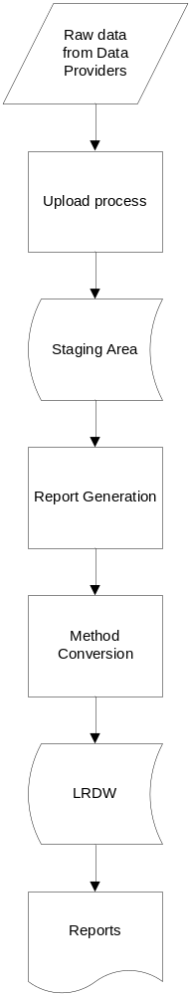 | - Receive data from data providers in standardized format  - Upload data into the ETL tool and perform validation upon exporting data into the appropriate staging area  - Summary process is run to load the summary data table with the information that will be used on the reports (Database Package)  - Periodically, reports are generated that:  - Use data specific methods to convert raw data into GHG equivalents.  - Calculated values are then loaded into the warehouse.  - Reports are then published based on the calculated values for posting to the Ministry website.

Architectural Design
The implementation of the CEEI In-House Build project requires skills and resources from both the MoE Information Management Branch and GEOBC/ILMB. As the resulting databases will be stored on GEOBC, the designer repository utilized will be that of GEOBC as well as DA, DBA, and Application Delivery resources.
The Design of CEEI allows for the secure loading of the core data tables in the GEO staging databases before the summary processes are created to load the Summary Data for use in the reports. The resulting Summary data and required code tables will be replicated to the GEOWarehouse for public access once approval has been received from all data providers
Following Tech Whiteboard 8/7/2009

Decomposition Description
Break out of 2. System Architecture Following Tech Whiteboard 8/7/2009

Data Access Model
There is only one level of DATA access required for CEEI in the staging database:
CEEI_data_admin | Requires full access to staging area.
 | Requires full access to Reporting tables in LRDW.
 | Required for the purpose of uploading raw data into the staging Area and in turn generating reports.
 | Required for doing queries against the raw tables for data verification when questioned by the local governments.
CEEI Schema | Owning account for the tables, sequences, triggers and packages of the database.
The summary and code tables replicated to the GeoWarehouse only require one level of DATA access for public viewing of the data. Only the data which has been approved for release will be replicated to the GeoWarehouse and this will only be performed on demand when new data has been loaded and summarized for a reporting year.

Application Security Model
In the absence of any custom interfaces / screens, application security amounts to security around data access as specified above.

Domain Model
The initial domain model for the CEEI system is described below and presented in the following subsections as a class list and a high-level class diagram.
The CEEI system will provide emissions inventory reports for local governments in BC, at both the municipality and regional district level. In BC, regional districts are defined by census divisions (CD) and are comprised of census subdivisions (CSD), which are municipalities or areas equivalent to municipalities for statistical reporting purposes (e.g. electoral areas).
Emitters or emissions sources to be included in the inventory reports are defined by sector and scope, although possibly constrained by the availability of data. Sectors to be included in community-wide CEEI inventories are as follows:
- Buildings (by Energy Type)
  - Residential
  - Commercial
  - Industrial
- Transportation (By Fuel Type)
  - Small Passenger Car
  - Large Passenger Car
  - Light Duty Trucks, Vans and SUVs
  - Heavy Duty Trucks
  - Buses
  - Motor Homes
  - Motorcycles
- Solid Waste
- Agriculture
  - Enteric Emissions
  - Soil
  - Manure Management
- Deforestation (Land Use)
  - Settlement
  - Agriculture
The CEEI system will include Scope 1 and Scope 2 emitters as defined by WRI/WBCSD’s GHG Protocol. Emission sources are quantified by their consumption and types of energy, or, in cases such as the waste sector, by mass. Activity data tiers, as defined by ICLEI’s draft Emissions Analysis Protocol, will be used to track the Consumption data uploaded to the CEEI system will likely be organized by census subdivision. In some cases, data may only be available at the census division level. Regional district inventories may therefore be not only an aggregation of their constituent CSDs, but also contain distinct emissions sources.
Methods and calculations will be applied to annual consumption data using emissions factors and global warming potentials (GWP) in order to populate inventory reports with resulting GHG emissions. Emissions for the three most abundant GHGs (carbon dioxide - CO2, methane - CH4 and nitrous oxide - N2O) will be calculated, where applicable, and reported as carbon dioxide equivalents (CO2e) for each emitter.

Class Diagram
The high-level Class Diagram shown in Figure 1 below graphically depicts the classes and their associations within the CEEI domain.
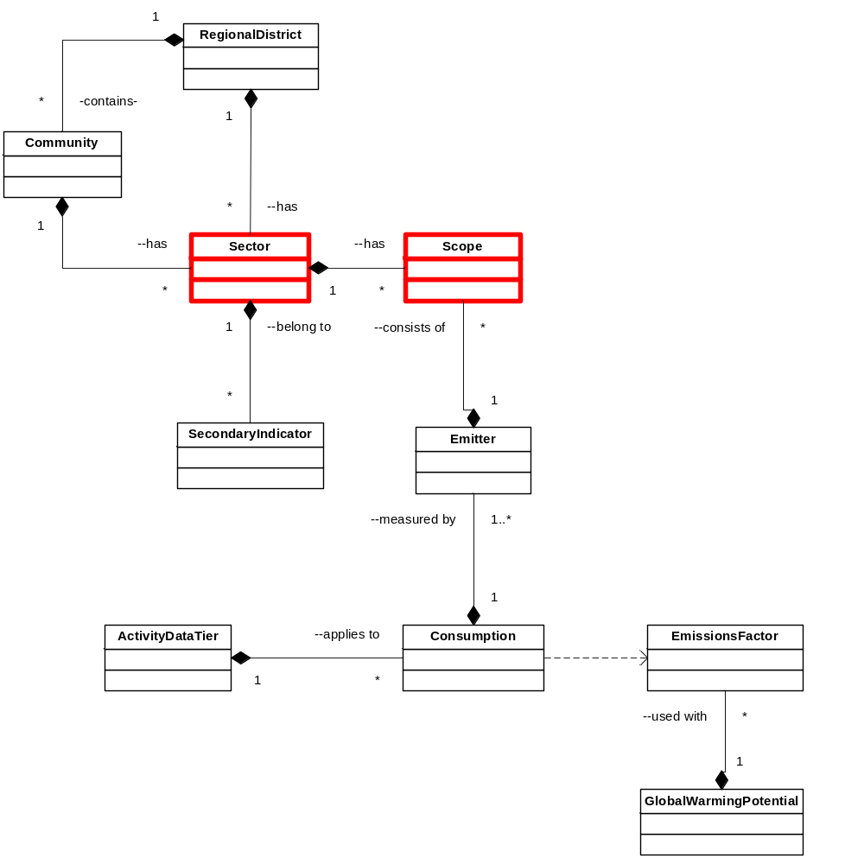Figure 1: High-Level CEEI Class Diagram

Class Specifications
Brief descriptions of the classes in the initial domain model are provided in the table below.
Table 1: CEEI Class List
Class | Description
Community | A Community is a census subdivision in BC that represents either a legal entity (e.g. municipality) or unorganized area (e.g. electoral area) and contains emissions sources.
RegionalDistrict | A RegionalDistrict is a census division in BC consisting of municipalities and electoral areas (i.e., census subdivisions) and that contains emissions sources.
Sector | A Sector is a category of emissions sources or emitters for community inventories (e.g. buildings – residential, commercial and industrial, transportation, waste, other – agriculture and land use).
Scope | A Scope defines operational categorization of emissions to be included in GHG calculations (e.g. Scope 1 - Direct, Scope 2 - Indirect) as defined by WRI/WBCSD’s GHG Protocol.
Emitter | An Emitter can be a physical unit, process or activity that results in release of GHG into the atmosphere; attributed to a Scope and Community or Regional District may be disaggregated by sub-sector categories (e.g. Electric Heat in Building; Natural Gas Heating in Building; Automobiles in Transportation)
EmissionSourceConsumption | An EmissionSourceConsumption is the type and amount of consumption (e.g. energy or mass) associated with emission source; uploaded annually
ActivityDataTier | An ActivityDataTier is the level of methodological complexity and accuracy associated with consumption data, as defined by ICLEI’s draft Emissions Analysis Protocol. This may include the following:  electricity and natural gas use in residential, commercial and industrial buildings within the community;  gasoline, diesel and propane consumption by vehicle classes within the community; and  tonnage of solid waste going to landfills
EmissionsFactor | Factors and coefficients used to calculate resulting GHG emissions based on consumption; updated annually (e.g. the amount of CO2e released from one litre of gasoline)
GlobalWarmingPotential | A GlobalWarmingPotential is the conversion factors to calculate CO₂e from constituent GHGs; updated annually
SupportingIndicator | A SupportingIndicator is an alternative value which may be used to complement or broaden the values identified for the sector. E.g. Housing Density, Commute Method, Commute Distance, Greenspace and Housing Type are dataset currently available to provide further information about the structure of the local government in support of the CO2e values being produced.

Design Rationale
The CEEI pilot is in part a trial of an in-house, collaborative development between IMB and GEOBC supported by the private sector. It is an approach driven in part by a lack of capital funds and the need to get the CEEI project off the ground.

Process Design
Key processes within CEEI are as follows:
- Load data from Data provider
- Run Summary Processes
- Run Annual Reports
- Add / Update Emissions Factors
- Add Update Methods and Calculations

Load Data from Data Provider
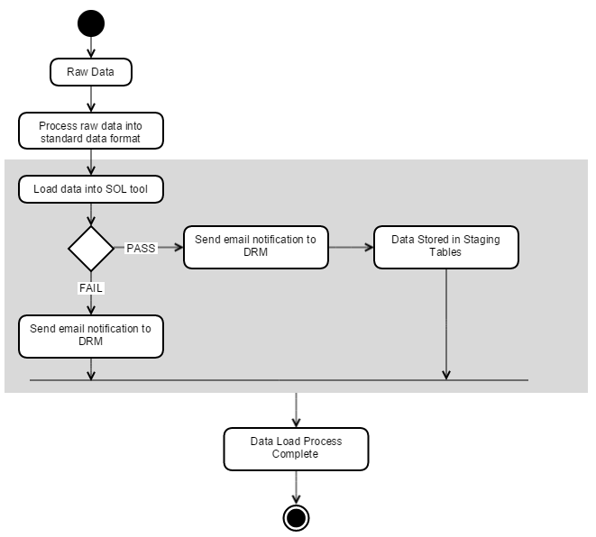

Raw Data
Raw data is received from one of the Data Providers ready to be loaded into the system.

Process Raw Data into Standard Data Format
Raw data is pre-processed to fit into the standardized data format.

Load Data
The Data Resource Manager (DRM) loads the standardized data formats into the SOL dropbox.

Data Validation
System carries out validation based on the data type.

Email Notification
System sends out a notification email to the DRM confirming the data has been loaded successfully or unsuccessfully.

Stores Raw Data in Staging Tables
Subject to passing validation, the data is automatically exported into the appropriate staging area (CEEI Oracle table).

DRM Runs Summary Processes
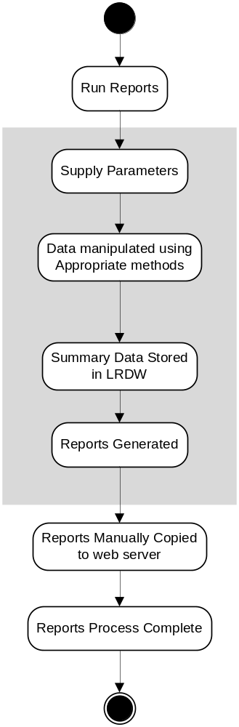

Run Summary Process for Reporting Year
DRM initiates a sql session and runs both of the summary routines:
Ceei_report_si_summary_pkg
Ceei_report_summary_pkg

Specifies Reporting Year Parameters
DRM specifies report parameters, to include:
- Reporting Year
- Sector Type (or ALL)

DRM Runs Reports Annually

Run Reports
DRM initiates a crystal report session.

Specifies Report Parameters
DRM specifies report parameters, to include:
- Reporting Year

Data Manipulation using Appropriate Methods for Data Type
Key to the process of generating reports is the process of summarizing raw data. This is done according to a series of technical methods and guidelines that are specific to each data type, a summary of which is provided below:
  - Residential, Commercial and Industrial Buildings – Data provided by Terasen / BC Hydro / Fortis BC / Pacific Northern Gas / Michael Wilson
    - Uses basic formula:
Energy consumption x emissions factor/coefficient x global warming potential= CO₂e
    - Excludes data where the consumption by one account within the reporting group (Building Classification) is > 50% of the total for that local government.
    - Processes for each local government as well as for the Unassigned Areas.
    - Calculates a provincial total based on all data provided.
  - On the Road Transportation – Data provided / derived from ICBC / National averages / Jim Johnson
    - Uses Resident Based Methodology
      - Within this it uses a complex approach to derive GHG emissions that includes first calculating the vehicle fuel consumption:
      - Vehicle x fuel consumption rate x vehicle kilometres traveled = fuel consumed
        - Combining quarterly datasets from ICBC into annual datasets
        - Identify the vehicles from VIN where possible
        - Identify vehicle consumption rate based on vehicle characteristics as derived from VIN. Rate of Consumption data in turn provided by Natural Resources of Canada Fuel Consumption tables.
        - Put vehicles into classes
        - Use vehicle class to derive estimated vehicle KM travelled as derived from national averages as supplied by Translink
        - Place vehicles into Geopolitical boundaries based on the postal code supplied in the ICBC data
      - Consumption data is then used to calculate GHG using the following formula:
Energy consumption x emissions coefficient x global warming potential= CO₂e
      - An Adjustment factor of 7.5 is used to increase fuel consumption rates to allow US EPA fuel efficiency data to be used where it is not available from NRCAN.
    - Masks data where the number of connections in a vehicle class and fuel type < 10 for the reporting local government.
  - Solid Waste
    - Data provided by Regional District Solid Waste Managers using newly created reporting spreadsheet.
      - mass of solid waste disposed which is in turn compiled from
        - Provincial Solid Waste Management Plans (SWMP)
        - Provincial l Operations and monitoring plans
        - Report by Golders Associates
        - Municipal Solid Waste Tracking Report from Recycling Council of BC
      - estimates of landfill gas production
      - 2007 population estimates for local government
        - Landfill Gas (LFG) production was calculated using one of two methods:
        - Waste commitment method where possible
          - Tonnes of MSW x Emissions factor = C0₂e
    - No data is excluded.
  - Deforestation
    - Data provided by Canadian Forestry Sector and Environment Canada
    - Data is separated into two classifications:
      - Settlement
      - Agriculture
    - No data is excluded.
  - Agriculture – Soil and Livestock
    - Data is provided by Agriculture Canada and the Ministry of Agriculture and Lands
    - Data is separated into three classifications:
      - Enteric Fermentation
      - Manure Management
      - Soil Management (nitric oxide)
For full details of this methodology, please refer to the Technical Methods and Guidance Document.

Summary Data Stored in LRDW
Once the data has been successfully transformed and summarized, it will be stored in the GeoWarehouse(IDW) in publicly accessible materialized views.

Reports Generated
Reports are generated to a common location in PDF format.

Reports Posted to Web Server
Reports are manually copied across to the web site and links implemented on the CEEI Reporting web page.

Add / Update Emissions Factors
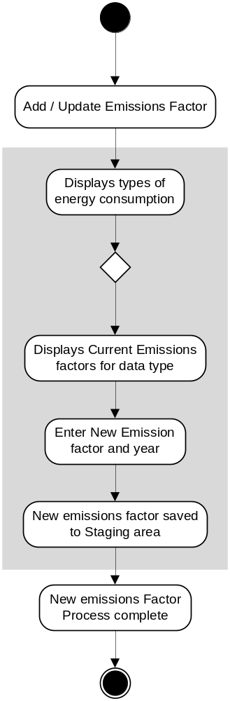
This function was not built for the pilot database. Emission factors are stored within the data source table to allow for quick changes when factors are updated. For back casting data in future years, the intent is that the data will be reloaded with a new factor and the summary process re-run.

Displays types of Energy Consumption

Displays Current Emissions factors for data type

DRM enters new emission factor

New Emissions factor is saved to staging area

Add / Update methods / Calculations
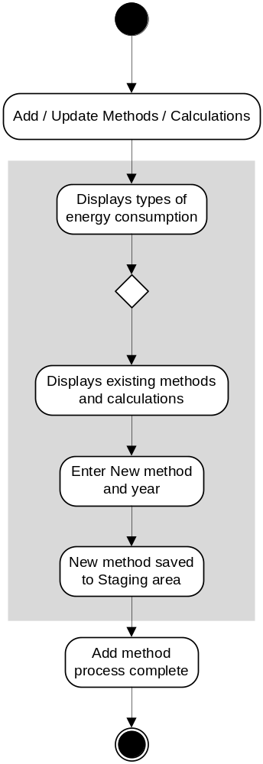
This function was not built for the pilot database. The majority of the calculations used are stored within the summary packages. Code changes will be required to change methodologies used.

Displays types of Energy Consumption

Displays existing methods and calculations

DRM enters new method / calculation

New method / calculation is saved to staging area

Data Design
See Appendix C for supplied data structures.

High-level Data Interactions
CEEI houses the raw data and resulting summary structures for all reporting sectors and supporting indicators. The data is received from the data providers in a standardized excel format. The raw tables are loaded into the SOL tool for validation and association to the appropriate org units and the data is then exported into the CEEI Oracle tables.

Data Security
To respect confidentiality needs, raw data should only be accessible to the Data Resource Manager. The summary information would be publicly accessible as the reports are posted for open consumption.
CEEI_data_admin | Requires full access to staging area.
 | Requires full access to Reporting tables in LRDW.
 | Required for the purpose of uploading raw data into the staging Area and in turn generating reports.
 | Required for doing queries against the raw tables for data verification when questioned by the local governments.
CEEI Schema | Owning account for the tables, sequences, triggers, and packages of the database.

Spatial Considerations
Spatial requirement for the project is to be able to group points / areas by various geo political boundaries for reporting purposes. The data model supports the identification of appropriate spatial layers to aid in the definition of the administrative boundaries of each reporting area. These spatial pointers are contained within the CEEI_ORG_UNIT table.

Warehouse Publication and Consumption
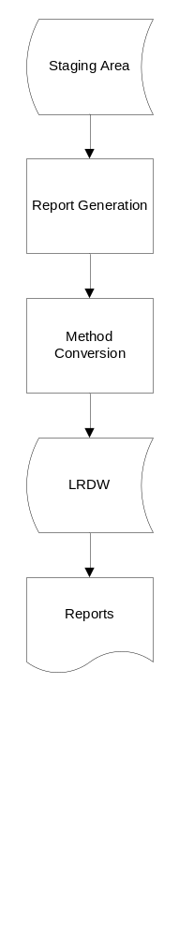 | From the staging area, the data is consumed by the general public as follows:  - receive in data from data providers in a standardized excel format  - Reports are generated that:  - Use data specific methods to convert raw data into GHG equivalents.  - Calculated values are then loaded into the warehouse  - Reports are then published based on the calculated values  - Reports are then posting to the Ministry website for general consumption.

Human Interface Design
N/A

Overview
N/A

Application Screen Flow Design
N/A

Screen Images
N/A

Screen/Form Objects and Actions
N/A

Report Layout
The Community Energy and Emissions Inventory report is generated for each local government as well as for the Regional District roll-up. Calculations are performed on summarization of the data so the reports can generate quickly without having to recalculate complex values like the transportation numbers every time it is run. There are two content flavours of the report; one for Regional Districts and one for local governments. Which report is generated is controlled via the reporting_level column in the CEEI_ORG_UNIT table. A 1 indicates a RD report (which includes Agriculture and Deforestation details) a 2 indicates a basic local government report.
A sample report is included in Appendix E

Report Objects and Actions
Crystal Reports is the tool used to generate the report. It is a complex report containing multiple sub-reports in order to support the various sectors, supporting indicators, graphs and text that is contained in the report. The reports are generated to one pdf file which bookmarks by local government unit. A pdf utility is then used to split the large report into individual reports for posting.

Help
N/A

Error Messages
N/A

Technical Requirements

Capacity
The system should be able to handle the addition of the approx 200 reports which is thought to equate be in the region 25MB per year.

CPU usage
N/A

Disk space
In line with the above, incremental disk space for the purpose of the reports is thought to be in the region of 25MB / year.

Concurrent usage
N/A

Database Performance
As there is no direct usage by public users to the GEO transactional database, response time and performance measures are irrelevant. Once the materialized views are defined to publish the data in the GEOWarehouse, normal access times will be expected from the warehouse in that users should be able to query the tables and get results in 5 seconds or less 95% of the time.

Software

Server software
N/A

Software Dependencies
Reports are being generated using ILMB standards tool – Crystal Reports in a PDF format that will then be posted to the CAS reporting website.

Hardware
N/A

Communication protocols
N/A

Interoperability Requirements
The CEEI data will be stored within the GEOBC database instances and the summary data will reside in the Geospatial Warehouse. Emission factors, formulas, and methodologies used in calculating the GHG values must be comparable and compatible with those used by the Climate Action Secretariat.

Performance
The system should be able to run queries and generate inventory reports for 189 BC local governments at least once a year (more frequently if recalculations are required). Performance should be such that it can generate all 189 reports within 24 hours.

Operation and Support
Application availability at a minimum will be 8.30-4.30pm Monday – Friday with support available within this time. There has been no requirement specified for support outside of this window.

Implementation
The CEEI system will be implemented according to GEOBC standards.

Hardware/Software Interfaces
N/A

Sign-Off
<Commencing on a new page, the last section of the document must be a sign-off page where appropriate members of the Ministry and contract team can accept and approve the System Design deliverable.>
Name | Signature |  | Date
Lorelei Solomon
 | Ministry IMB Project Manager
Name | Signature |  | Date
Susan Westmacott
 | Project Manager, GEOBC
Name | Signature |  | Date
Matt Brandwood
 | Business Analyst, IMB
Name | Signature |  | Date
Tim Lilburn
 | Business Analyst, GEOBC
Name | Signature |  | Date
???
 | Head, Architecture & Technical Consulting, GEOBC
Name | Signature |  | Date
Peter Friesen
 | Head, Data Administration, GEOBC

Appendix A. Definitions, Acronyms, and Abbreviations
<Provide a list of all acronyms and abbreviations used in the document, other than the utterly obvious (e.g., “BC”, “IMB”). Include definitions of any terms that may not be clear to parts of the primary or secondary audiences.>
Appendix B. Data Dictionary
Primary Tables Standard Data Input Formats for: Solid Waste, Livestock, Deforestation, Transportation, and Buildings
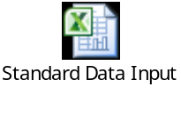

Supporting Indicators Standard Data Input Formats for: Proximity to Transit, Commute by Mode, Commute Duration, Housing by Type, Parks and Protected Green-space, Residential Density, Walkscore, and Floor Area.
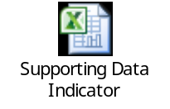
Appendix C. Server Model Diagram
http://sharepoint.env.gov.bc.ca/comind/Shared%20Documents/CEEI%20Pilot/Software%20Design/SMD_CEEI.1.0.0.pdf
'CEEI Table Descriptions'
CEEI_BCSTATS_POPULATION
Name Null? Type
-------------------------- -------- -----------------
YEAR NOT NULL NUMBER(4)
POPULATION_SIZE NOT NULL NUMBER(10)
ORG_UNIT_ID NOT NULL NUMBER(10)

CEEI_BUILDING_ENERGY_USE
Name Null? Type
-------------------------- -------- -----------------
BUILDING_ENERGY_USE_ID NOT NULL NUMBER(10)
CONNECTIONS NOT NULL NUMBER(10)
ENERGY_CONSUMPTION NOT NULL NUMBER(10)
REPORTING_YEAR NOT NULL NUMBER(4)
ORG_UNIT_ID NOT NULL NUMBER(10)
DATA_SOURCE_ID NOT NULL NUMBER(10)
HOUSING_TYPE_CODE VARCHAR2(4)
SUBSECTOR_TYPE_CODE NOT NULL VARCHAR2(8)
EXCLUDED_IND VARCHAR2(1)

CEEI_DATA_PROVIDER
Name Null? Type
-------------------------- -------- -----------------
DATA_PROVIDER_ID NOT NULL NUMBER(10)
PROVIDER_NAME NOT NULL VARCHAR2(200)
CONTACT_NAME VARCHAR2(200)
CONTACT_TELEPHONE VARCHAR2(14)
CONTACT_EMAIL VARCHAR2(200)
EFFECTIVE_DATE NOT NULL DATE
EXPIRY_DATE DATE

CEEI_DATA_SOURCE
Name Null? Type
-------------------------- -------- -----------------
DATA_SOURCE_ID NOT NULL NUMBER(10)
RECEIVED_DATE DATE
RECEIVED_FROM VARCHAR2(500)
PROCESS_DATE NOT NULL DATE
EMISSION_FACTOR_CO2 NUMBER(13,4)
EMISSION_FACTOR_N20 NUMBER(13,4)
EMISSION_FACTOR_CO2E NUMBER(13,4)
EMISSION_FACTOR_CH4 NUMBER(13,4)
FILE_NAME VARCHAR2(200)
PRE_PROCESSED_FILE BLOB
COMMENTS VARCHAR2(2000)
DATA_PROVIDER_ID NOT NULL NUMBER(10)
MEASUREMENT_TYPE_CODE VARCHAR2(6)

CEEI_DEFORESTATION_EMISSION
Name Null? Type
-------------------------- -------- -----------------
DEFORESTATION_EMISSION_ID NOT NULL NUMBER(10)
DEFORESTATION_AREA_HA NUMBER(10)
GHG_EMISSION NOT NULL NUMBER(10)
REPORTING_YEAR NOT NULL NUMBER(4)
ORG_UNIT_ID NOT NULL NUMBER(10)
DATA_SOURCE_ID NOT NULL NUMBER(10)
SUBSECTOR_TYPE_CODE NOT NULL VARCHAR2(8)

CEEI_FUEL_CONSUMPTION_RATING
Name Null? Type
-------------------------- -------- -----------------
VEHICLE_FUEL_EFFICIENCY_ID NOT NULL NUMBER(10)
VEHICLE_CLASS_CODE NOT NULL VARCHAR2(10)
QUARTER1_CONSUMPTION_RATING NUMBER(5,2)
QUARTER2_CONSUMPTION_RATING NUMBER(5,2)
QUARTER3_CONSUMPTION_RATING NUMBER(5,2)
QUARTER4_CONSUMPTION_RATING NUMBER(5,2)
MEASUREMENT_TYPE_CODE NOT NULL VARCHAR2(6)
MODEL_YEAR NOT NULL NUMBER(4)
PERSONAL_WORK_IND NOT NULL VARCHAR2(1)
ORG_UNIT_ID NOT NULL NUMBER(10)
REPORTING_YEAR NOT NULL NUMBER(4)

CEEI_FUEL_FACTOR_XREF
Name Null? Type
-------------------------- -------- -----------------
FUEL_FACTOR_ID NOT NULL NUMBER(10)
MEASUREMENT_TYPE_CODE NOT NULL VARCHAR2(6)
SUBSECTOR_TYPE_CODE NOT NULL VARCHAR2(8)
MODEL_YEAR_START NOT NULL NUMBER(4)
MODEL_YEAR_END NOT NULL NUMBER(4)
CO2_FACTOR NUMBER(8,4)
CH4_FACTOR NUMBER(8,4)
N2O_FACTOR NUMBER(8,4)
CO2E_FACTOR NUMBER(8,4)
GLOBAL_WARMING_FACTOR NUMBER(8,5)
EFFECTIVE_DATE NOT NULL DATE
EXPIRY_DATE DATE

CEEI_HOUSING_TYPE_CODE
Name Null? Type
-------------------------- -------- -----------------
HOUSING_TYPE_CODE NOT NULL VARCHAR2(4)
HOUSING_TYPE_DESC NOT NULL VARCHAR2(40)
EFFECTIVE_DATE NOT NULL DATE
EXPIRY_DATE DATE

CEEI_INDICATOR_DETAIL
Name Null? Type
-------------------------- -------- -----------------
INDICATOR_DETAIL_ID NOT NULL NUMBER(10)
INDICATOR_VALUE NOT NULL NUMBER(10,2)
REPORTING_YEAR NOT NULL NUMBER(4)
DATA_SOURCE_ID NOT NULL NUMBER(10)
INDICATOR_DETAIL_TYPE NOT NULL VARCHAR2(5)
ORG_UNIT_ID NOT NULL NUMBER(10)
SUBSECONDARY_INDICATOR_CODE NOT NULL VARCHAR2(6)

CEEI_INDICATOR_DETAIL_TYPE
Name Null? Type
-------------------------- -------- -----------------
INDICATOR_DETAIL_TYPE NOT NULL VARCHAR2(5)
UNIT_OF_MEASURE_CODE NOT NULL VARCHAR2(6)
UNIT_DESCRIPTION NOT NULL VARCHAR2(50)
EFFECTIVE_DATE NOT NULL DATE
SECONDARY_INDICATOR_CODE NOT NULL VARCHAR2(6)
EXPIRY_DATE DATE

CEEI_INSURANCE_TRANSACTION
Name Null? Type
-------------------------- -------- -----------------
INSURANCE_TRANSACTION_ID NOT NULL NUMBER(10)
REGISTRATION_NUMBER NUMBER(10)
VIN_NUMBER VARCHAR2(40)
POLICY_START_DATE DATE
POLICY_END_DATE DATE
POSTAL_CODE VARCHAR2(6)
DATA_SOURCE_ID NOT NULL NUMBER(10)
RATE_CLASS NUMBER(3)
POLICY_YEARS_EARNED NUMBER(5,4)
FUEL_DESCRIPTION VARCHAR2(1)
REPORTING_YEAR NUMBER(4)

CEEI_INS_TRANS_VHCL_CLS_XREF
Name Null? Type
-------------------------- -------- -----------------
REGISTRATION_NUMBER NOT NULL NUMBER(10)
VIN_NUMBER NOT NULL VARCHAR2(40)
FUEL_TYPE NOT NULL VARCHAR2(2)
MODEL_YEAR NOT NULL NUMBER(4)
DATA_SOURCE_ID NOT NULL NUMBER(10)
ORG_UNIT_ID NOT NULL NUMBER(10)
VEHICLE_CLASS_CODE VARCHAR2(10)
NEW_FUEL_TYPE VARCHAR2(2)
NEW_POSTAL_CODE VARCHAR2(6)
ORIGINAL_ORG_UNIT_ID NUMBER(10)
REPORTING_YEAR NUMBER(4)

CEEI_LIVESTOCK_EMISSION
Name Null? Type
-------------------------- -------- -----------------
LIVESTOCK_EMISSION_ID NOT NULL NUMBER(10)
LIVESTOCK_QUANTITY NOT NULL NUMBER(10)
ENTERIC_FERMENTATION_EMISSION NOT NULL NUMBER(10,2)
MANURE_MANAGEMENT_EMISSION NOT NULL NUMBER(10,2)
REPORTING_YEAR NOT NULL NUMBER(4)
ORG_UNIT_ID NOT NULL NUMBER(10)
LIVESTOCK_TYPE_CODE NOT NULL NUMBER(3)
DATA_SOURCE_ID NOT NULL NUMBER(10)
SUBSECTOR_TYPE_CODE NOT NULL VARCHAR2(8)

CEEI_LIVESTOCK_TYPE_CODE
Name Null? Type
-------------------------- -------- -----------------
LIVESTOCK_TYPE_CODE NOT NULL NUMBER(3)
LIVESTOCK_TYPE_DESC NOT NULL VARCHAR2(100)
EFFECTIVE_DATE NOT NULL DATE
EXPIRY_DATE DATE

CEEI_MEASUREMENT_TYPE_CODE
Name Null? Type
-------------------------- -------- -----------------
MEASUREMENT_TYPE_CODE NOT NULL VARCHAR2(6)
MEASUREMENT_TYPE_DESC NOT NULL VARCHAR2(50)
MEASUREMENT_UNIT VARCHAR2(5)
MEASUREMENT_UNIT_DESC VARCHAR2(50)
EFFECTIVE_DATE NOT NULL DATE
EXPIRY_DATE DATE
SORT_ORDER NOT NULL NUMBER(3)
ENERGY_CONVERSION_FACTOR NUMBER(8,4)

CEEI_ORG_UNIT
Name Null? Type
-------------------------- -------- -----------------
ORG_UNIT_ID NOT NULL NUMBER(10)
UNIT_NAME NOT NULL VARCHAR2(100)
SPATIAL_LINK_VALUE VARCHAR2(200)
EFFECTIVE_DATE NOT NULL DATE
EXPIRY_DATE DATE
ORG_UNIT_ID_IS_PART_OF NUMBER(10)
ORG_UNIT_TYPE_CODE NOT NULL NUMBER(10)
REPORTING_LEVEL NUMBER(1)

CEEI_ORG_UNIT_TYPE_CODE
Name Null? Type
-------------------------- -------- -----------------
ORG_UNIT_TYPE_CODE NOT NULL NUMBER(10)
ORG_UNIT_TYPE_DESC NOT NULL VARCHAR2(50)
SPATIAL_DATA_SOURCE VARCHAR2(200)
SPATIAL_LINK_FIELD VARCHAR2(200)
EFFECTIVE_DATE NOT NULL DATE
EXPIRY_DATE DATE

CEEI_POSTAL_CODE
Name Null? Type
-------------------------- -------- -----------------
POSTAL_CODE NOT NULL VARCHAR2(6)
EFFECTIVE_DATE NOT NULL DATE
EXPIRY_DATE DATE

CEEI_POSTAL_ORG_UNIT_XREF
Name Null? Type
-------------------------- -------- -----------------
ALLOCATION_FRACTION NOT NULL NUMBER(3,2)
EFFECTIVE_DATE NOT NULL DATE
EXPIRY_DATE DATE
ORG_UNIT_ID NOT NULL NUMBER(10)
POSTAL_CODE NOT NULL VARCHAR2(6)

CEEI_RATE_CLASS
Name Null? Type
-------------------------- -------- -----------------
RATE_CLASS NOT NULL NUMBER(3)
RATE_CLASS_MEANING NOT NULL VARCHAR2(120)
PERSONAL_WORK_INDICATOR VARCHAR2(1)
EFFECTIVE_DATE NOT NULL DATE
EXPIRY_DATE DATE

CEEI_SECONDARY_INDICATOR
Name Null? Type
-------------------------- -------- -----------------
SECONDARY_INDICATOR_CODE NOT NULL VARCHAR2(6)
DESCRIPTION NOT NULL VARCHAR2(50)
EFFECTIVE_DATE NOT NULL DATE
SECTOR_TYPE_CODE NOT NULL VARCHAR2(6)
INITIAL_DATA_YEAR NUMBER(4)
DATA_FREQUENCY_YEARS NUMBER(2)
REPORTING_FREQUENCY NUMBER(2)
EXPIRY_DATE DATE
REPORT_LEVEL NOT NULL VARCHAR2(6)
SORT_ORDER NOT NULL NUMBER(3)
PLACEHOLDER_TEXT VARCHAR2(250)

CEEI_SECONDARY_SUMMARY_DATA
Name Null? Type
-------------------------- -------- -----------------
SECONDARY_SUMMARY_DATA_ID NOT NULL NUMBER(10)
REPORTING_YEAR NOT NULL NUMBER(4)
ORG_UNIT_ID NOT NULL NUMBER(10)
SUBSECONDARY_INDICATOR_CODE NOT NULL VARCHAR2(6)
DATA_YEAR NUMBER(4)
REPORTING_VALUE NUMBER(10,2)
REPORTING_UNIT VARCHAR2(6)
PERCENT_OF_TOTAL NUMBER(5,2)
CHANGE_IMPACT_IND VARCHAR2(3)
TREND_IND VARCHAR2(4)

CEEI_SECTOR_TYPE_CODE
Name Null? Type
-------------------------- -------- -----------------
SECTOR_TYPE_CODE NOT NULL VARCHAR2(6)
SECTOR_TYPE_DESC NOT NULL VARCHAR2(50)
EFFECTIVE_DATE NOT NULL DATE
EXPIRY_DATE DATE
SORT_ORDER NUMBER(3)

CEEI_SOIL_EMISSION
Name Null? Type
-------------------------- -------- -----------------
SOIL_EMISSION_ID NOT NULL NUMBER(10)
SOIL_EMISSION_AREA_HA NOT NULL NUMBER(10)
GHG_EMISSION NOT NULL NUMBER(10)
REPORTING_YEAR NOT NULL NUMBER(4)
ORG_UNIT_ID NOT NULL NUMBER(10)
DATA_SOURCE_ID NOT NULL NUMBER(10)
SUBSECTOR_TYPE_CODE NOT NULL VARCHAR2(8)

CEEI_SOLID_WASTE_EMISSION
Name Null? Type
-------------------------- -------- -----------------
SOLID_WASTE_EMISSION_ID NOT NULL NUMBER(10)
SOLID_WASTE_MASS NOT NULL NUMBER(10)
GHG_EMISSION NOT NULL NUMBER(10)
REPORTING_YEAR NOT NULL NUMBER(4)
ORG_UNIT_ID NOT NULL NUMBER(10)
DATA_SOURCE_ID NOT NULL NUMBER(10)
SUBSECTOR_TYPE_CODE NOT NULL VARCHAR2(8)

CEEI_SUBSECONDARY_INDICATOR
Name Null? Type
-------------------------- -------- -----------------
SUBSECONDARY_INDICATOR_CODE NOT NULL VARCHAR2(6)
DESCRIPTION NOT NULL VARCHAR2(50)
EFFECTIVE_DATE NOT NULL DATE
SECONDARY_INDICATOR_CODE NOT NULL VARCHAR2(6)
EXPIRY_DATE DATE
SORT_ORDER NUMBER(3)
CHANGE_INCREASE_EFFECT VARCHAR2(3)
REPORT_SUBGROUP_CODE VARCHAR2(50)

CEEI_SUBSECTOR_TYPE_CODE
Name Null? Type
-------------------------- -------- -----------------
SUBSECTOR_TYPE_CODE NOT NULL VARCHAR2(8)
SUBSECTOR_DESC NOT NULL VARCHAR2(100)
EFFECTIVE_DATE NOT NULL DATE
EXPIRY_DATE DATE
SECTOR_TYPE_CODE NOT NULL VARCHAR2(6)
REPORT_LEVEL NOT NULL VARCHAR2(6)
SORT_ORDER NOT NULL NUMBER(3)

CEEI_SUMMARY_DATA
Name Null? Type
-------------------------- -------- -----------------
SUMMARY_DATA_ID NOT NULL NUMBER(10)
REPORTING_YEAR NOT NULL NUMBER(4)
CONNECTIONS NUMBER(10)
CONSUMPTION NUMBER(13)
ENERGY_VALUE NOT NULL NUMBER(13)
CO2E NOT NULL NUMBER(10)
ORG_UNIT_ID NOT NULL NUMBER(10)
SUBSECTOR_TYPE_CODE NOT NULL VARCHAR2(8)
MEASUREMENT_TYPE_CODE NOT NULL VARCHAR2(6)
AVERAGE_VALUE NUMBER(13,4)

CEEI_TRANSPORTATION_DETAIL
Name Null? Type
-------------------------- -------- -----------------
REPORTING_YEAR NOT NULL NUMBER(4)
REGISTRATION_NUMBER NOT NULL NUMBER(10)
ORG_UNIT_ID NOT NULL NUMBER(10)
SUBSECTOR_TYPE_CODE VARCHAR2(8)
MEASUREMENT_TYPE_CODE VARCHAR2(6)
CONNECTIONS NUMBER(10)
Q1_USE NUMBER(1)
Q1_PW_IND VARCHAR2(1)
Q1_FUEL NUMBER(5,2)
Q1_VKT NUMBER(16,4)
Q2_USE NUMBER(1)
Q2_PW_IND VARCHAR2(1)
Q2_FUEL NUMBER(5,2)
Q2_VKT NUMBER(16,4)
Q3_USE NUMBER(1)
Q3_PW_IND VARCHAR2(1)
Q3_FUEL NUMBER(5,2)
Q3_VKT NUMBER(16,4)
Q4_USE NUMBER(1)
Q4_PW_IND VARCHAR2(1)
Q4_FUEL NUMBER(5,2)
Q4_VKT NUMBER(16,4)
CO2E_FACTOR NUMBER(8,4)
GLOBAL_WARMING_FACTOR NUMBER(8,5)
NEW_POSTAL_CODE VARCHAR2(6)

CEEI_VEHICLE_CLASS
Name Null? Type
-------------------------- -------- -----------------
VEHICLE_CLASS_NAME NOT NULL VARCHAR2(100)
VEHICLE_CLASS_CODE NOT NULL VARCHAR2(10)
CLASS_SOURCE VARCHAR2(50)
EFFECTIVE_DATE NOT NULL DATE
EXPIRY_DATE DATE
SUBSECTOR_TYPE_CODE VARCHAR2(8)

CEEI_VEHICLE_KM_TRAVELLED
Name Null? Type
-------------------------- -------- -----------------
VEHICLE_KM_TRAVELLED_ID NOT NULL NUMBER(10)
QUARTER1_VKT NOT NULL NUMBER(10,3)
QUARTER2_VKT NUMBER(10,3)
QUARTER3_VKT NUMBER(10,3)
QUARTER4_VKT NUMBER(10,3)
MODEL_YEAR NOT NULL NUMBER(4)
PERSONAL_WORK_IND NOT NULL VARCHAR2(1)
REPORTING_YEAR NOT NULL NUMBER(4)
ORG_UNIT_ID NOT NULL NUMBER(10)
VEHICLE_CLASS_CODE NOT NULL VARCHAR2(10)
MEASUREMENT_TYPE_CODE NOT NULL VARCHAR2(6)

Appendix D. Data Mapping –Data Input to DB Tables
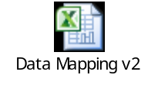
Appendix E. Screen Images
Not applicable

Appendix F. Report Layouts
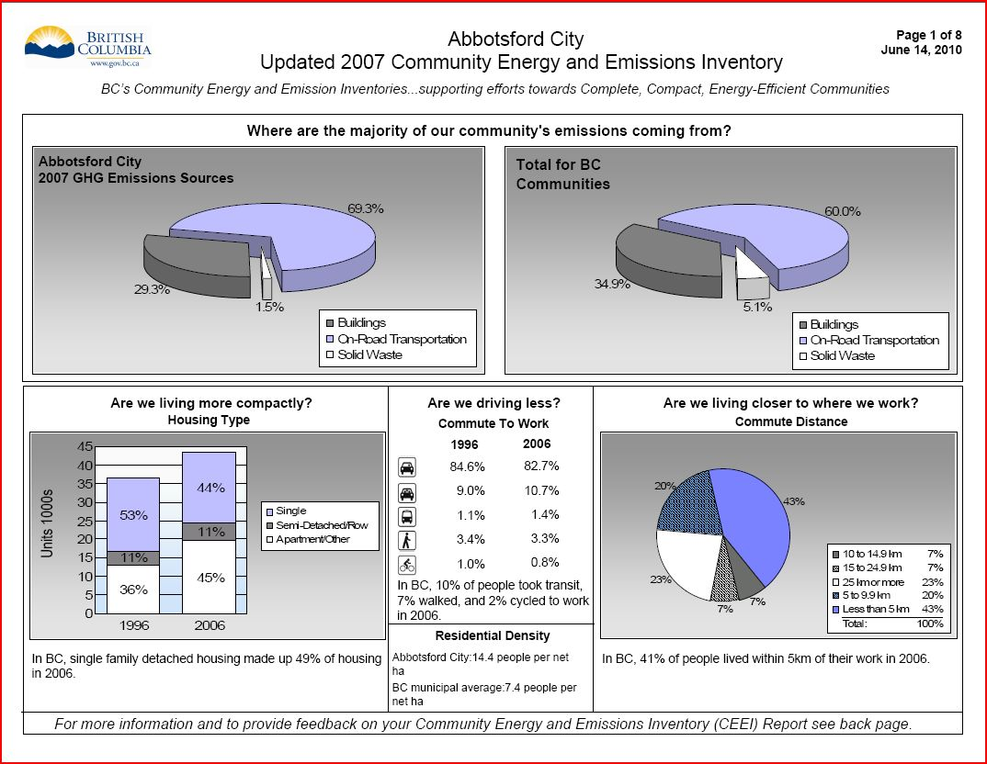
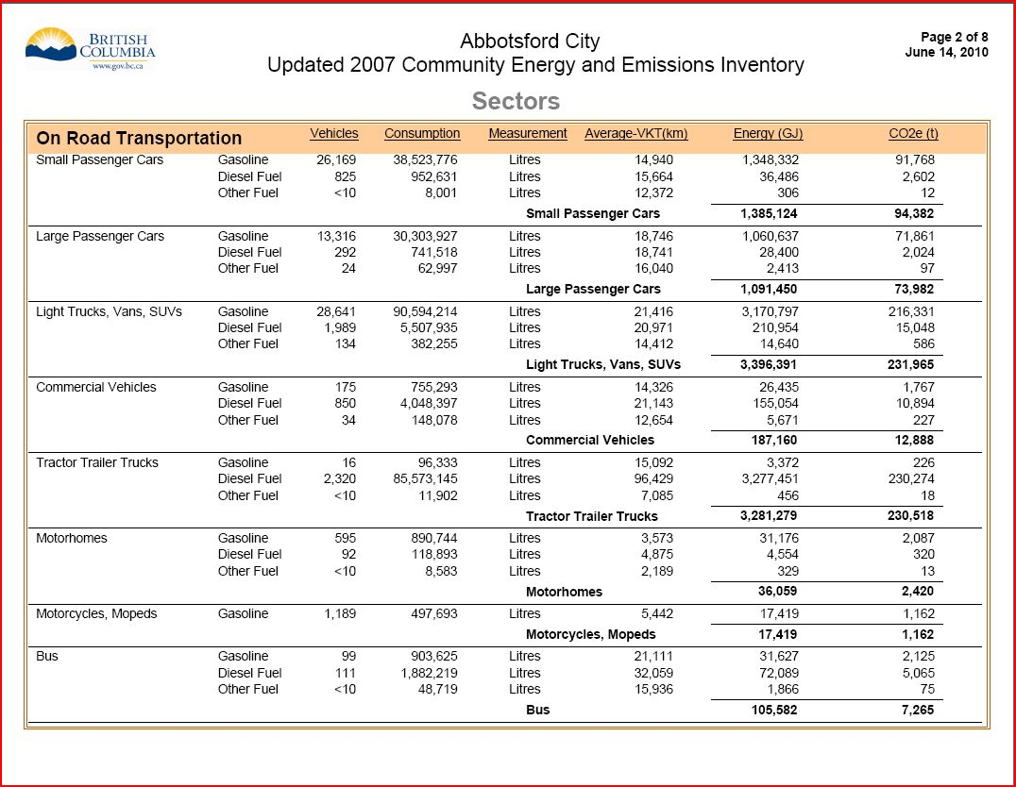
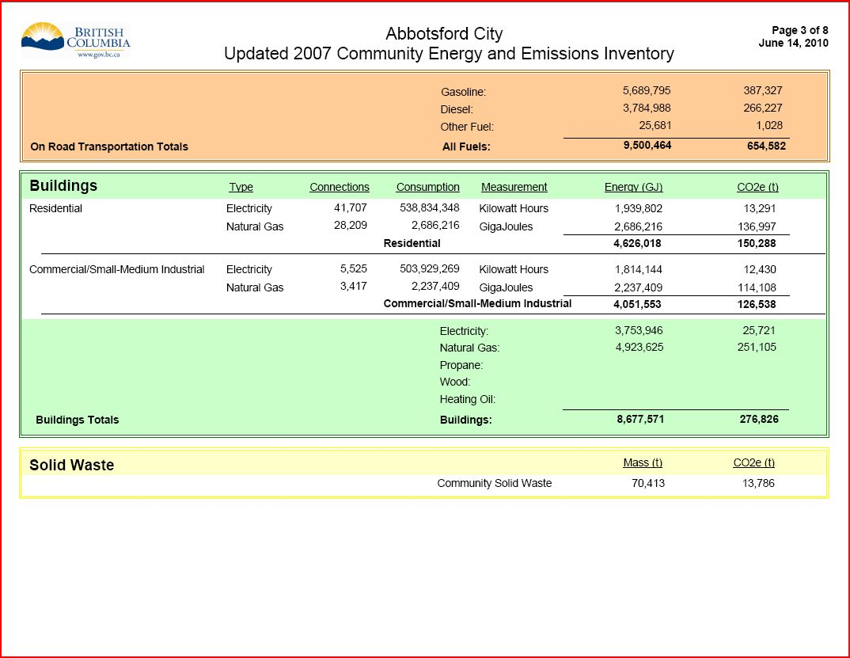
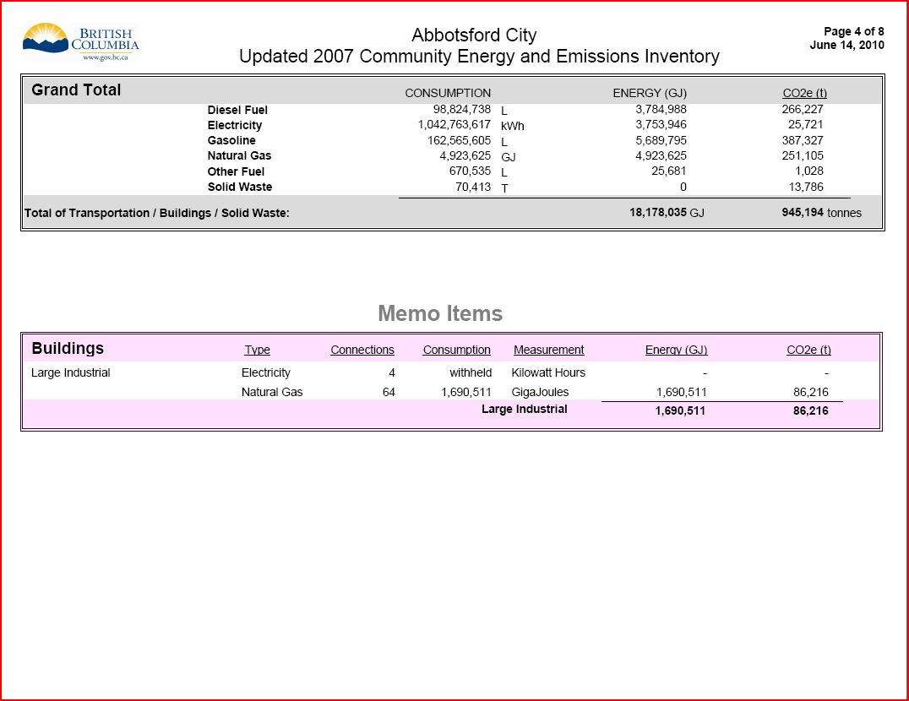
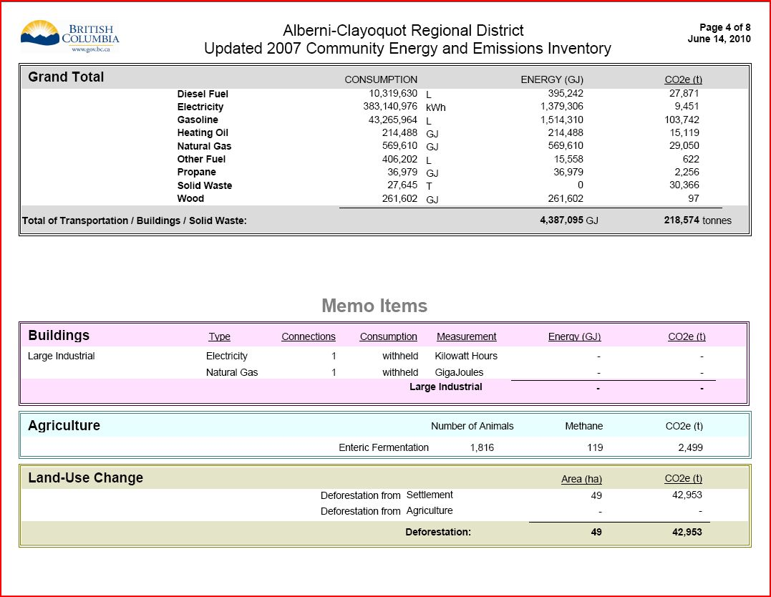
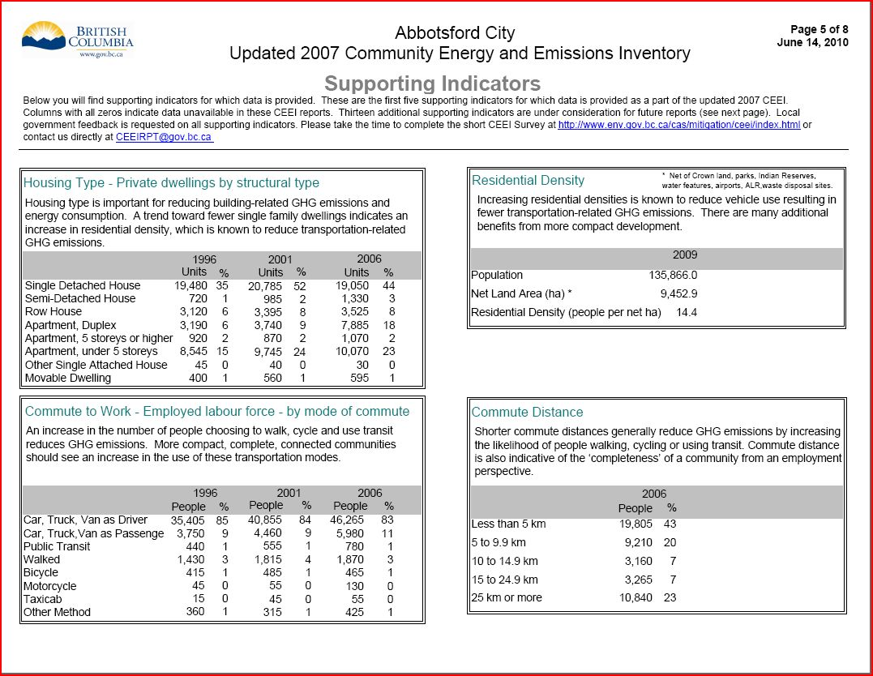
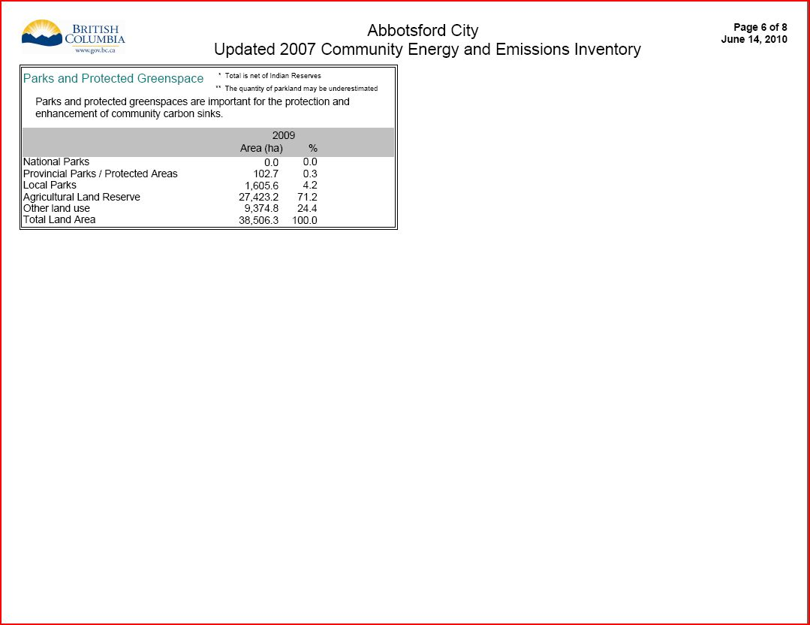
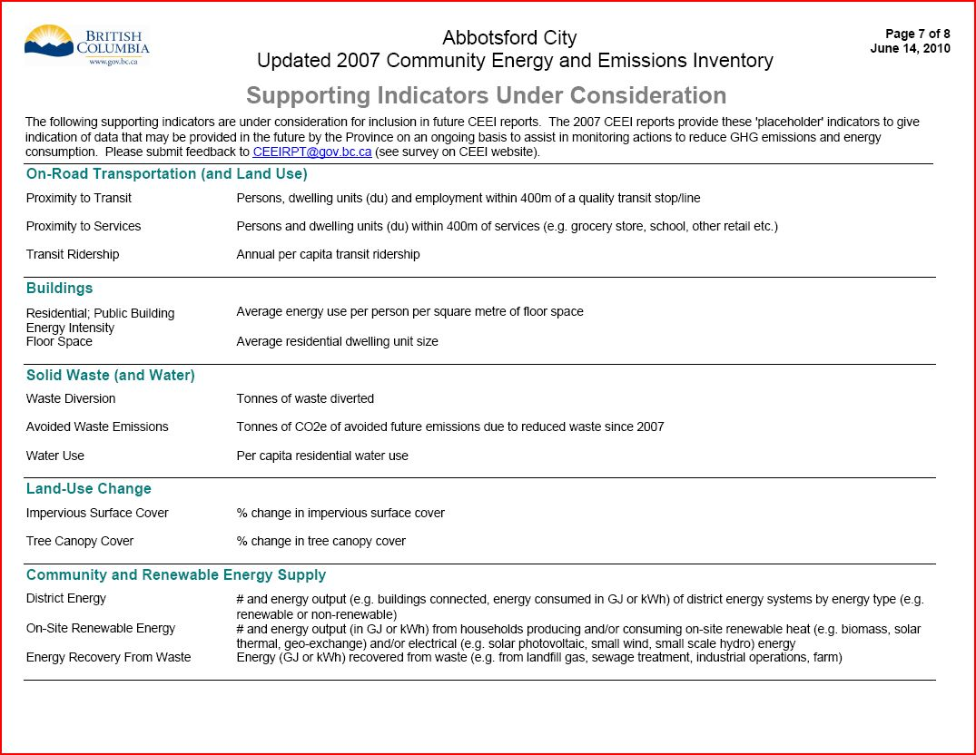
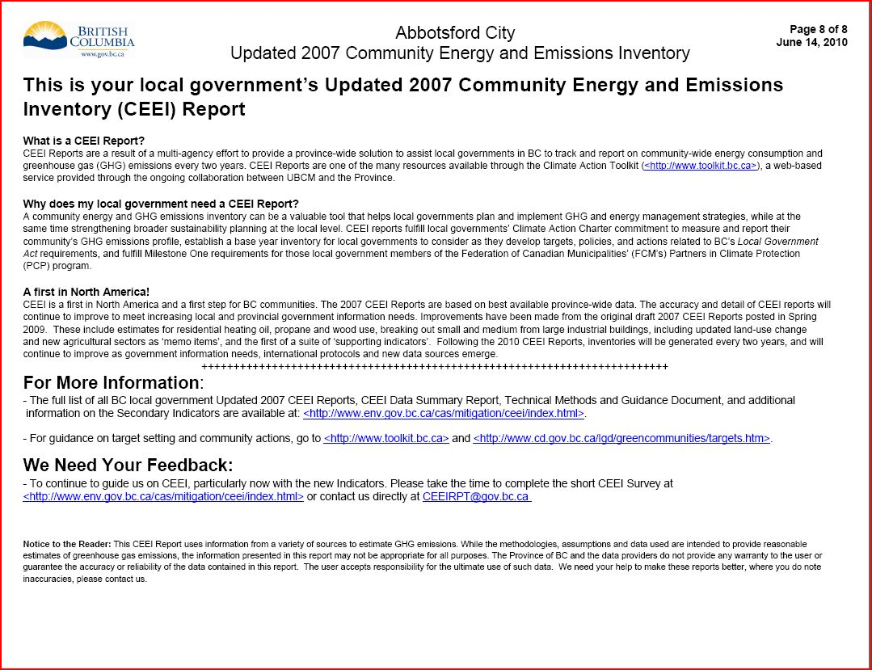

Appendix G. FME Scripts
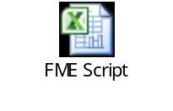
Appendix H. Transportation Logic Diagrams


