1. Halfmoon by LMS (& Newton’s Method)

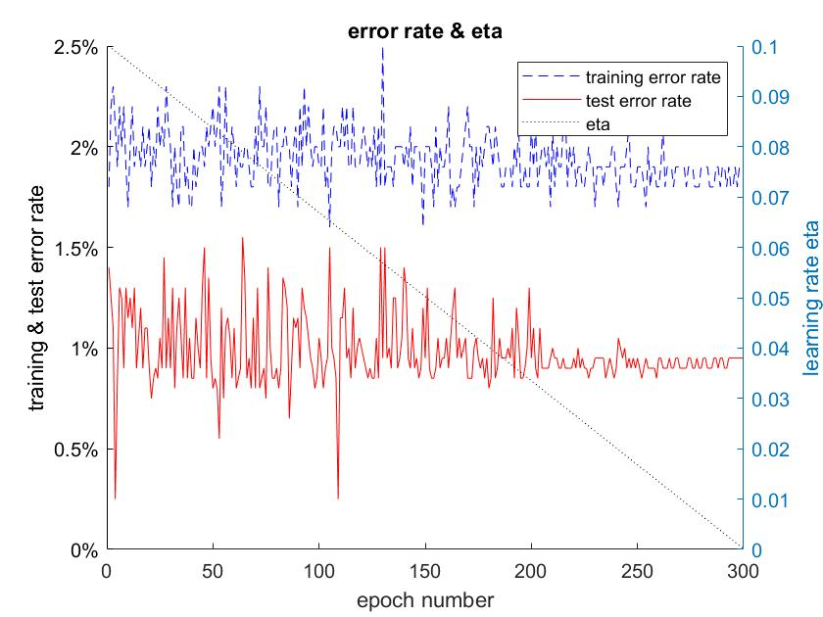

Figure 1. training / test error rate & learning rate eta of halfmoon

Usually, with the learning rate eta decreases linearly, the training and test error rate will fluctuate and finally stay at a value in range 1.5% - 2.5% and 1% - 1.5% respectively. All final test error rate in my 10 runs are lower than 2%.

Newton’s Method has also been run on halfmoon dataset(figures has not been presented here), the final test error rate is usually around 1%.

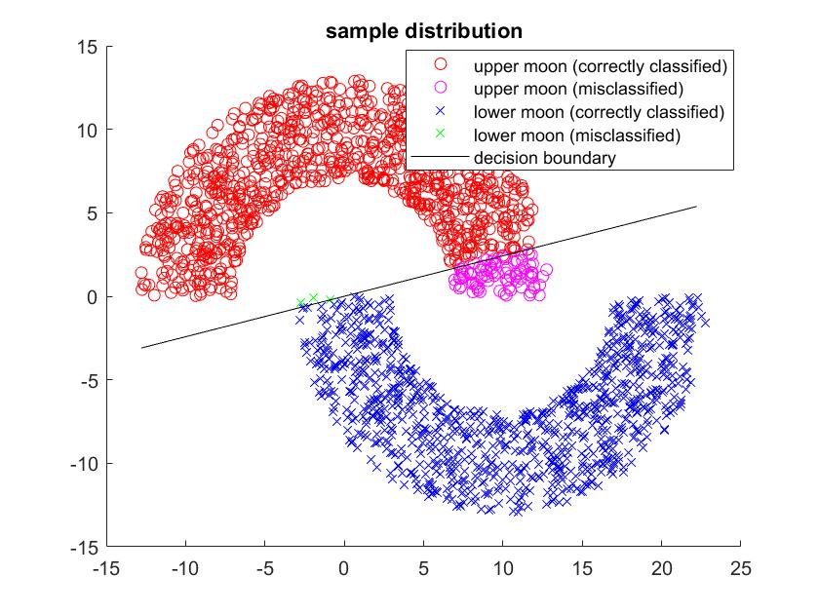

Figure 2. test sample distribution

1. UCI breast cancer by Newton’s Method

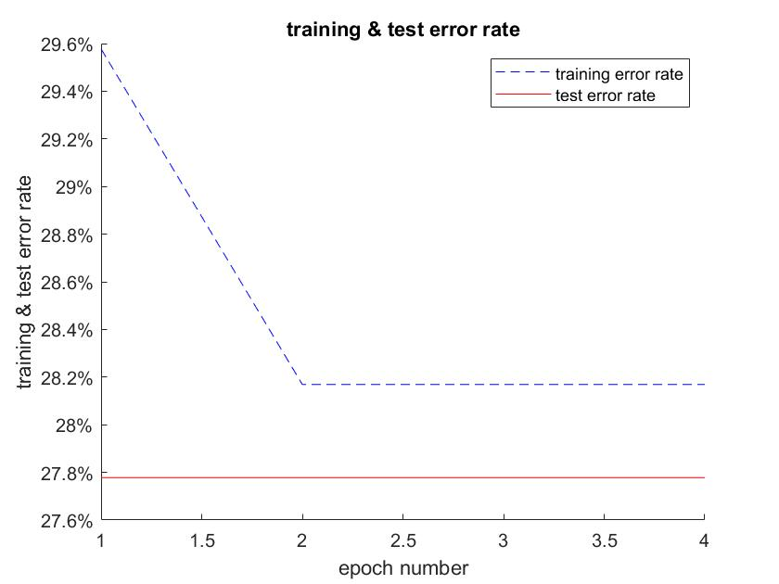

Figure 3. training / test error rate of breast cancer dataset

Newton’s Method always converges in just one epoch, and get a stable training error rate around 25% - 30%, while for test error rate the range is usually a bit lower. This fitting result is not as good as its counterpart in the halfmoon experiment. This is most likely because the data in the breast cancer dataset is not linear separable.