Project 1

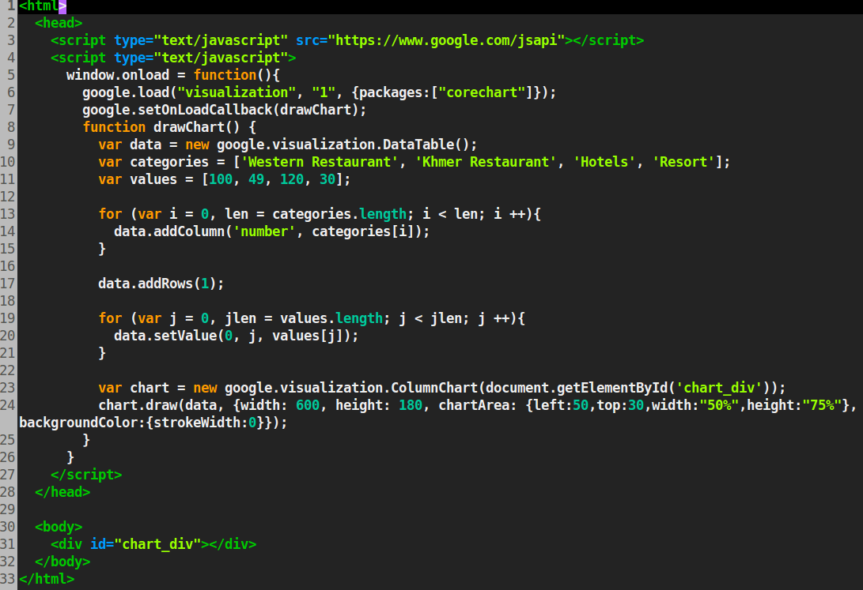

Description

What the program does.

What the purpose of making the project was.

Authors

Download Source

Project 2

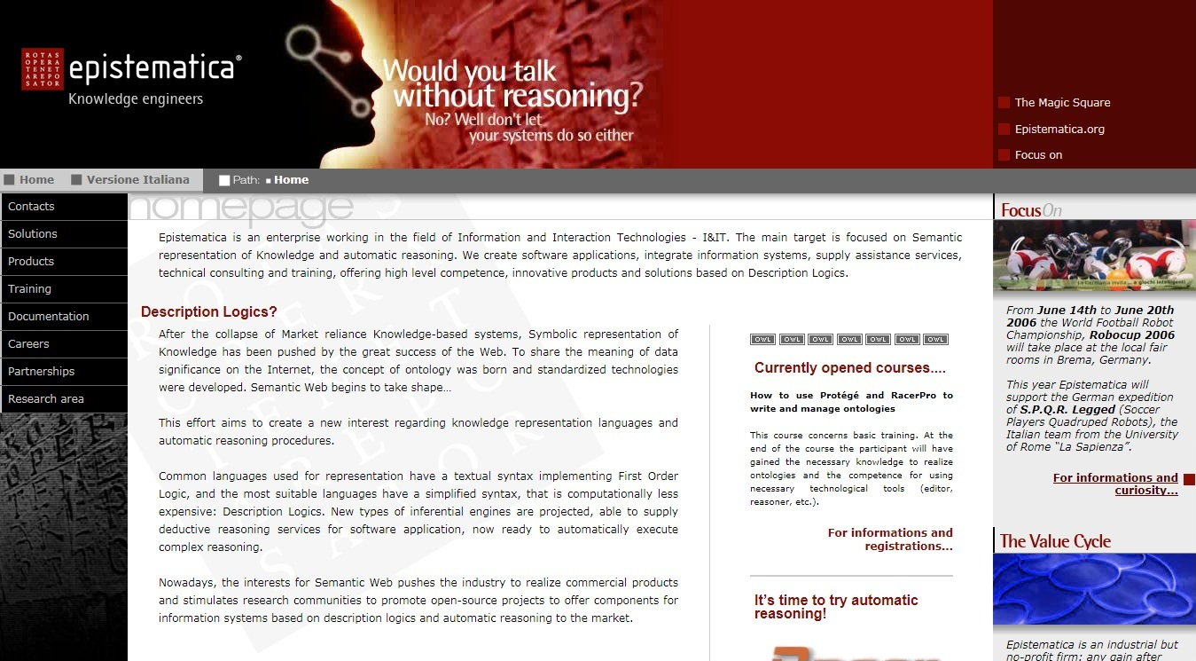

Description

What the program does.

What the purpose of making the project was.

Authors

Download Source

Project 3

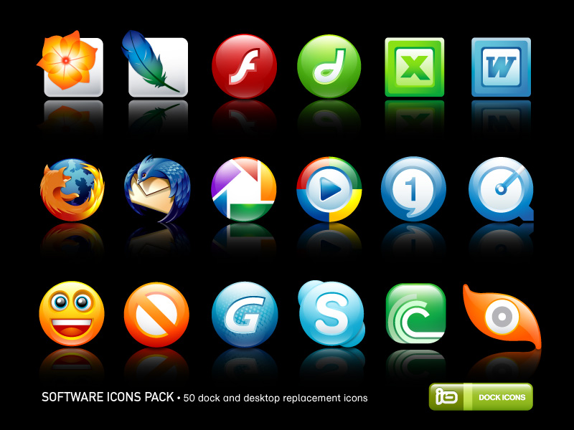

Description

What the program does.

What the purpose of making the project was.

Authors

Download Source

NameOfSite Link1 Link2 Link3 Link4

Copyright Logo1 Logo2 Logo3 Logo4