Heat

In this program I added a directive to make the program concurrent with thread at the level of the Jacobi function to optimize the speedup of the heat-map program.
This is the screenshot of he modification I did.

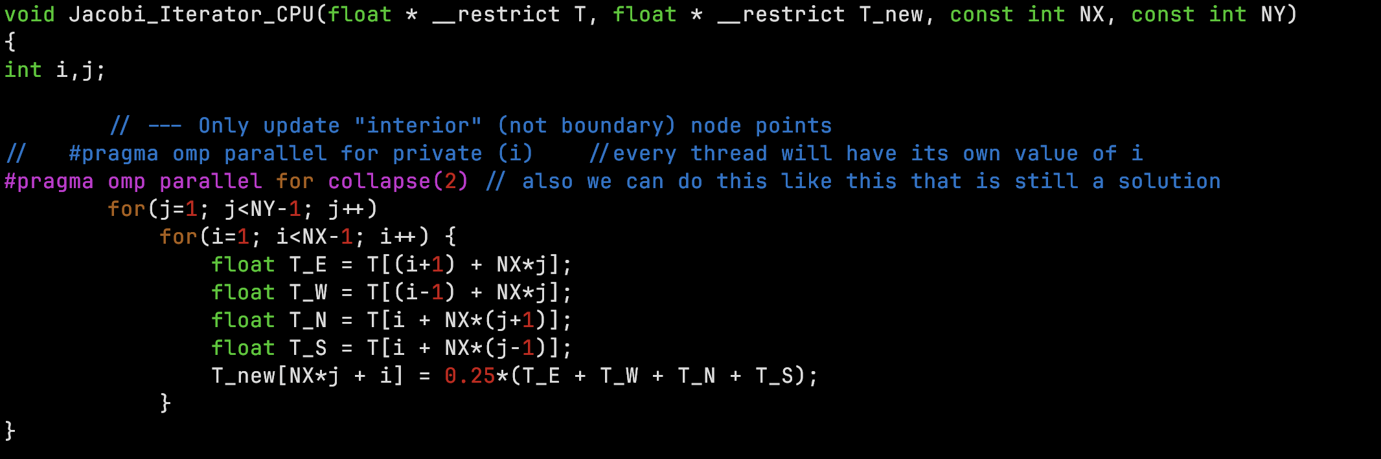
this is the output of the result obtain at the end of the compilation:
→We can see that as the array becomes big it takes more time to resolve the problem.
→ About the speedup we also observe that as from 8 threads it becomes liner the speedup
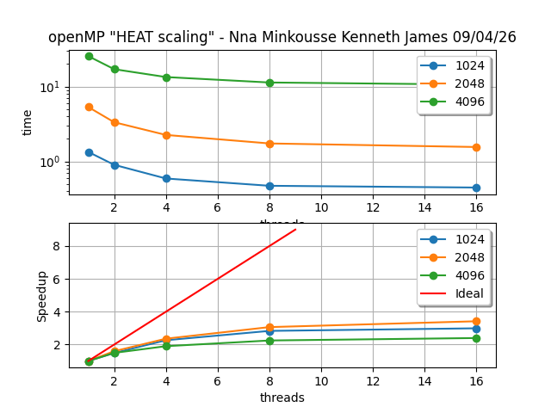

Also looking at the output of the python script we can se the time it takes to compute just on the Jacobi function (tj) and the total time of the whole program. With constant columns and rows. But increasing number of threads that help reduce the time of work.
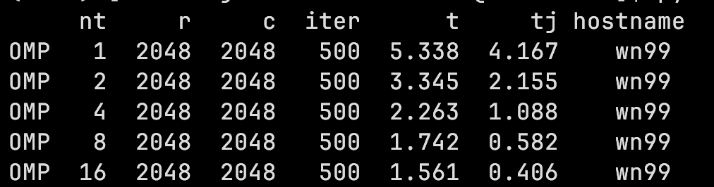

factorize
This is how I modified the code:
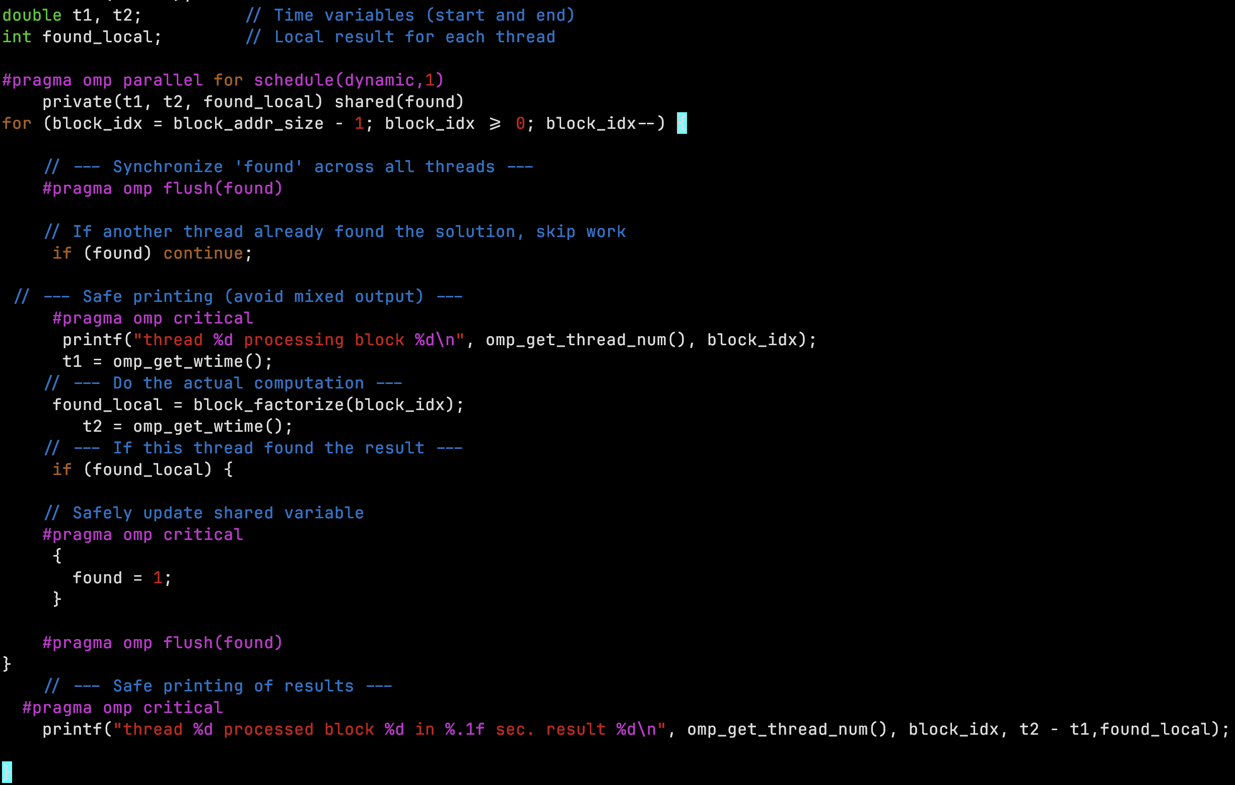
I preferred dynamic in the schedule because it will reduce the overhead that is when one thread finishes its work in its block let it take goes in another block to look for the prime number divisible by the modulus.
Also found is a shared variable between threads so when one thread changes the value of the variable found it notifies all other threads that the value have change and the value of the other prime number divisible by the modulus is found.
→ So I can say that adding dynamic, 1 on the schedule helps the threads to be synchronize between themself.

