Relazione-6a

mpirun :

First I entered the container and look if the compiler of mpi exist with the command
mpirun –version
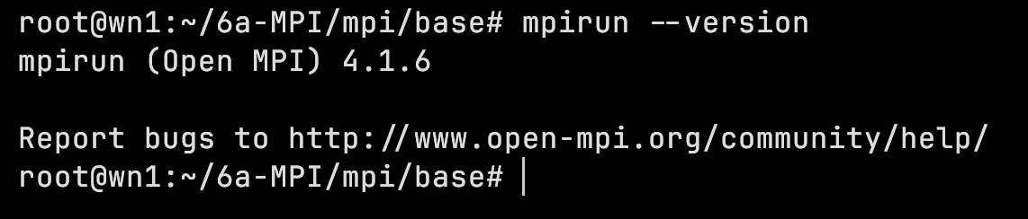
We can see that there exist the version 4.1.6 that is a good start.

Now lets work on the exercise given on the homework:

→ mpirun -n 4 date # crea 4 task sull’host locale in cui viene eseguito date.
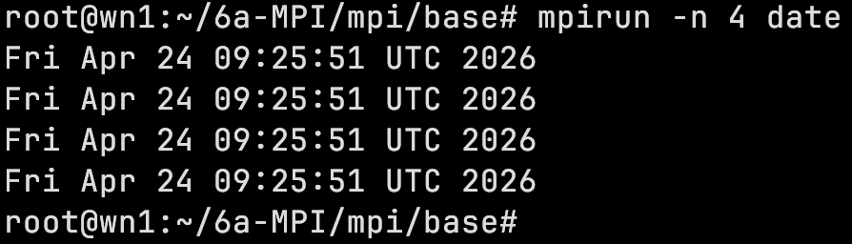
(That means we want 4 task to run the date of today)

→ mpirun -host wn1:4,wn2:2 -n 5 hostname

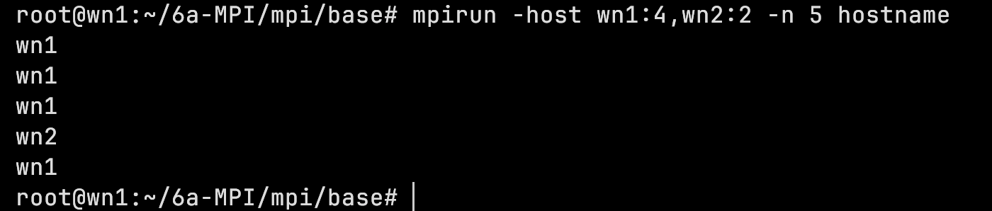
(This means use wn1 with 4 slots and wn2 with 2 slots and we have 5 tasks disponibile)

→ mpirun -hostfile hostfile.txt -n 2 hostname
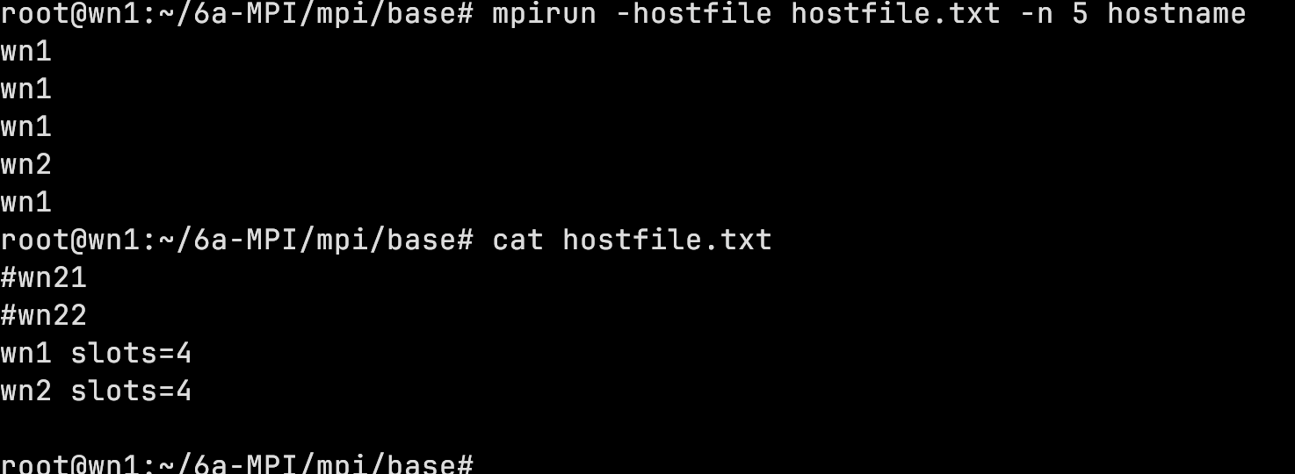
Here we are making use of a file called hostfile.txt where we have the number of slot to use. Using the command cat hostfile.txt you can see it.

→ mpirun -n 6 -hostfile hostfile.txt hostname
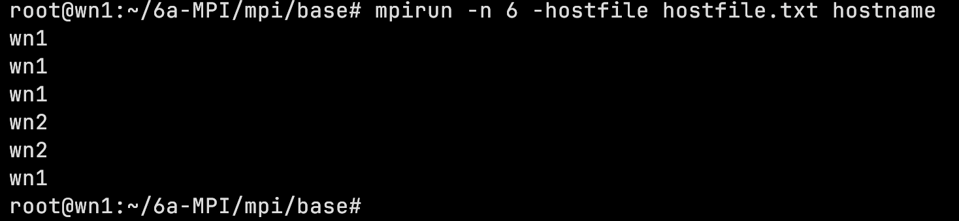

mpicc:
This compiler is the same like gcc put with openMPI directives in plus

Now lets work with mpicc on the CLUSTER with SLURM

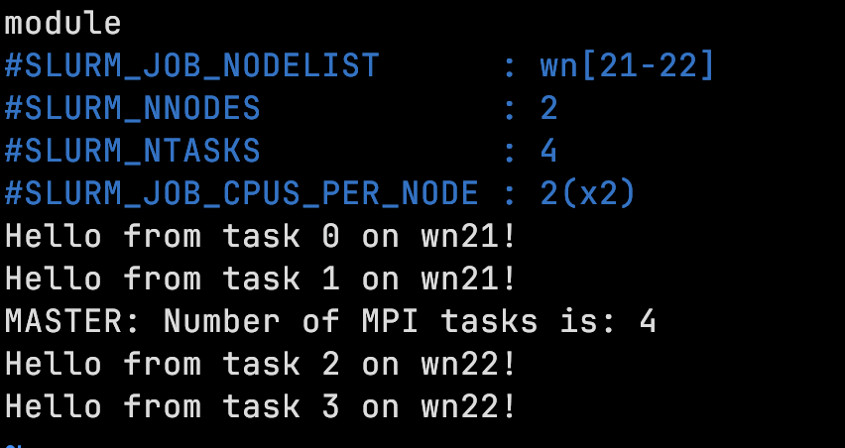
This is the output of the mpi1_helloworld.slurm :

We can see that the program used 2 working nodes and 4 tasks each node toke 2 tasks.

Using sendrecv this is the output (That is sendrecv in a ring of task that is task 0 send something to task 1, task 1 send to 2 and it goes on like a ring).
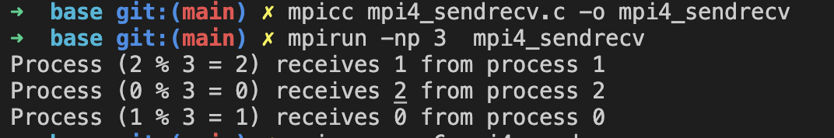

So the basics are well understood.

