Relazione 6b (MPI)

CPI(calcolo di pi-greco):
Here we know to calculate pi we need to divide the integration interval between each task (process because we are working with MPI), and each interval has its own starting and ending pointer that indicates its interval.
That is you can see the fragment of the source code below that shows these pointers interval.
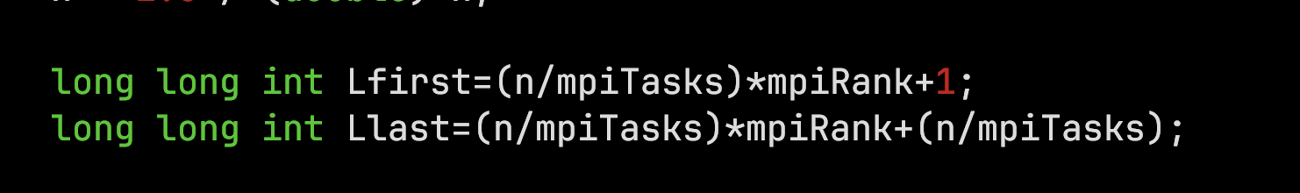
So when each process (task or rank) calculates in its interval with the use of the Reduce function from MPI, the result is summed and stored by the master or the root task (process). Below is the scenario:
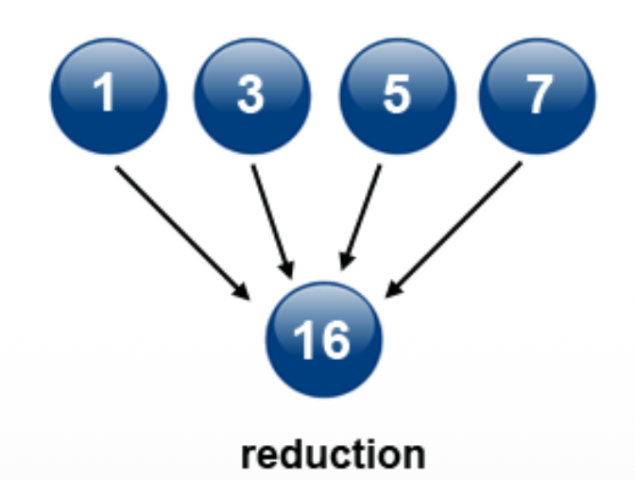

So every task will compute the value of pi and then send it to the root task that will sum the various result and return the result.

So going further, running the script that helps us have 2 different cases that is:
Case 1: 4 tasks running of 1 node to calculate pi (mpi_cpi-1n.slurm)
Output:
We can see that with an increase in the number of problem and the increasing number of task the are good performance. And also the speedup of the task with respect to the dimension of the problem we obtain the speedup almost ideal
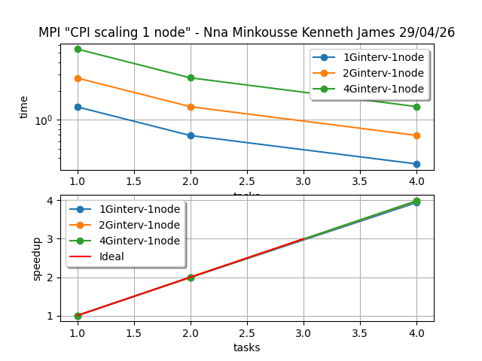

Case 2: 4 tasks and 2 nodes available whereby each node have 2 tasks that is 2 tasks per node
Output: (for this decided to work with up to 8 task to have a good look)

→ Here we can see that on a single node we obtain good performance compered to 2 working nodes because we spend some time on the communication between the task that is Overhead due to communication.
→ About the speedup wee see that on a single node we have a good performance while on 2 nodes we are a little bit away from the ideal speedup but not too bad.
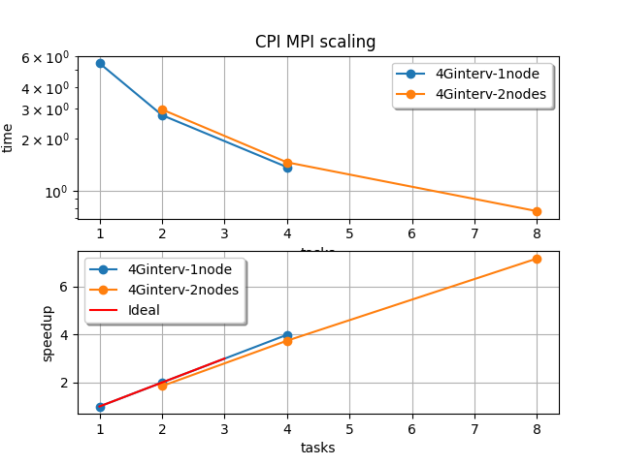

2) Heat:
Here using MPI we are going to brake down the work in to little problems and assign it to the tasks available.
This is a diagram that show us what happen:
So the functions MPI that help us here are :

1) MPI_Scatter(…) → Use to brake down the problem in to small and assign to each present task.
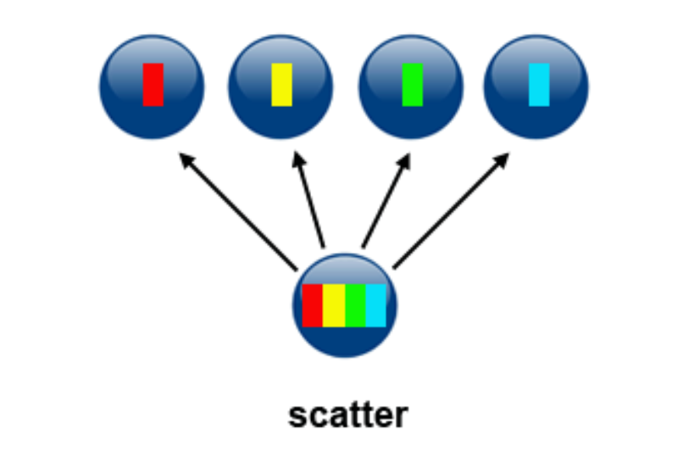

2) Init_top(...) → that help us initialize the top of the heatmap (done by task 0 only)
3) MPI_Gather(…) →Use to bring back the solved problem as one
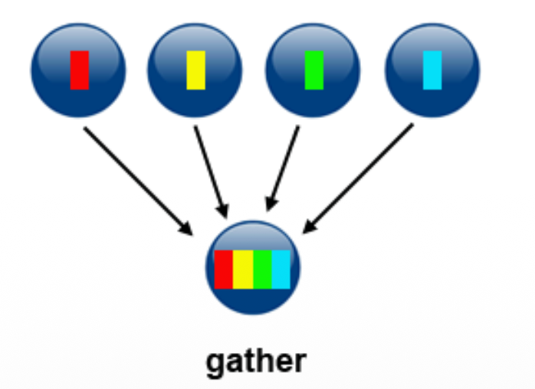

So now this is the corresponding source code:
MPI_Scatter(..), Init_top(..) and sendrecv(..) (downward and upward).
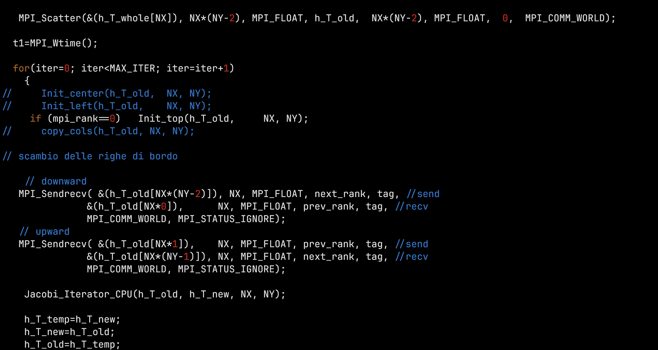

Then MPI_Gather:
Checkpoint
So here we make use of 2 functions that is save_heatmap() and load_heatmap() that are use to save and read the headmap from a text file heatmap.txt.
This is done to control the execution of the program with respect to the change on the heatmap and the MPI processes working across it.
So this is the main modification done on the code to achieve this goal:
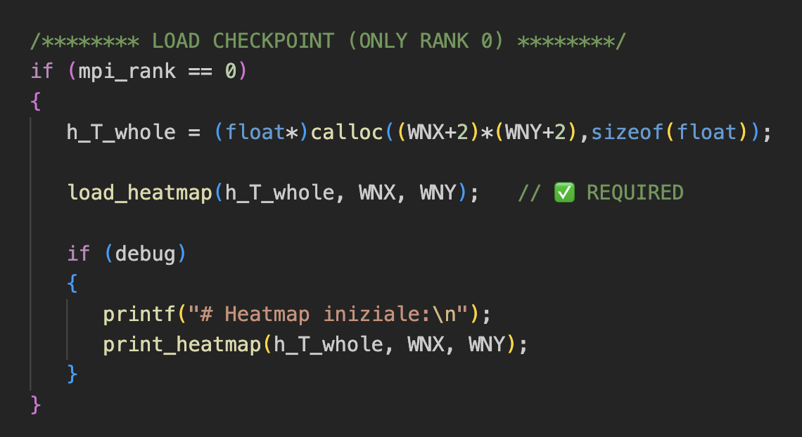
So form the screenshot of the code you can see at immediately when process 0 (task or rank 0) allocate memory for the 2D array, we read the file that is load_headmap.
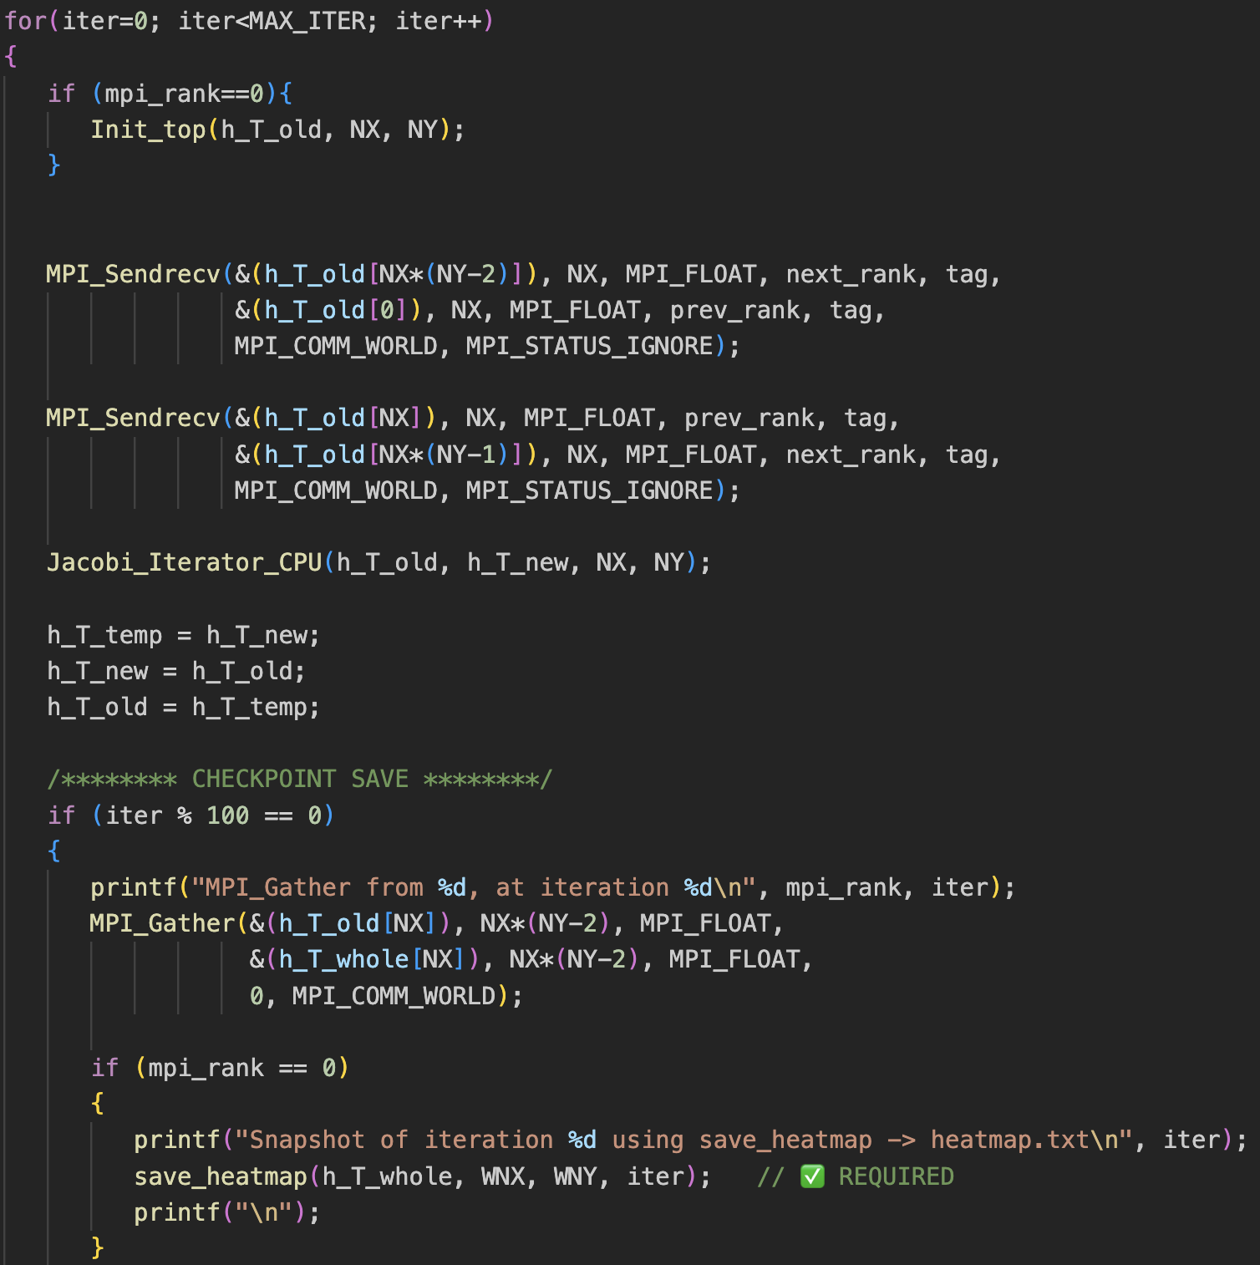
Now in the iterations after every 100 iterations we save a snapshot of the heatmap in heatmap.txt helping us dynamically on the execution of the program see the changes on the heatmap with the help of the heatmap.txt.
NB: using the following on the CLI
→ mpicc mpi_heat_checkpoint.c -o mpi_heat_checkpoint
→ mpirun -np 6 mpi_heat_checkpoint

Overlap comunicazione/computazione
Here I decided to have and Isend-Irecv for both top and bottom communications because it is non-blocking so communication can overlap without blocking so you can have the screenshot of the code below:
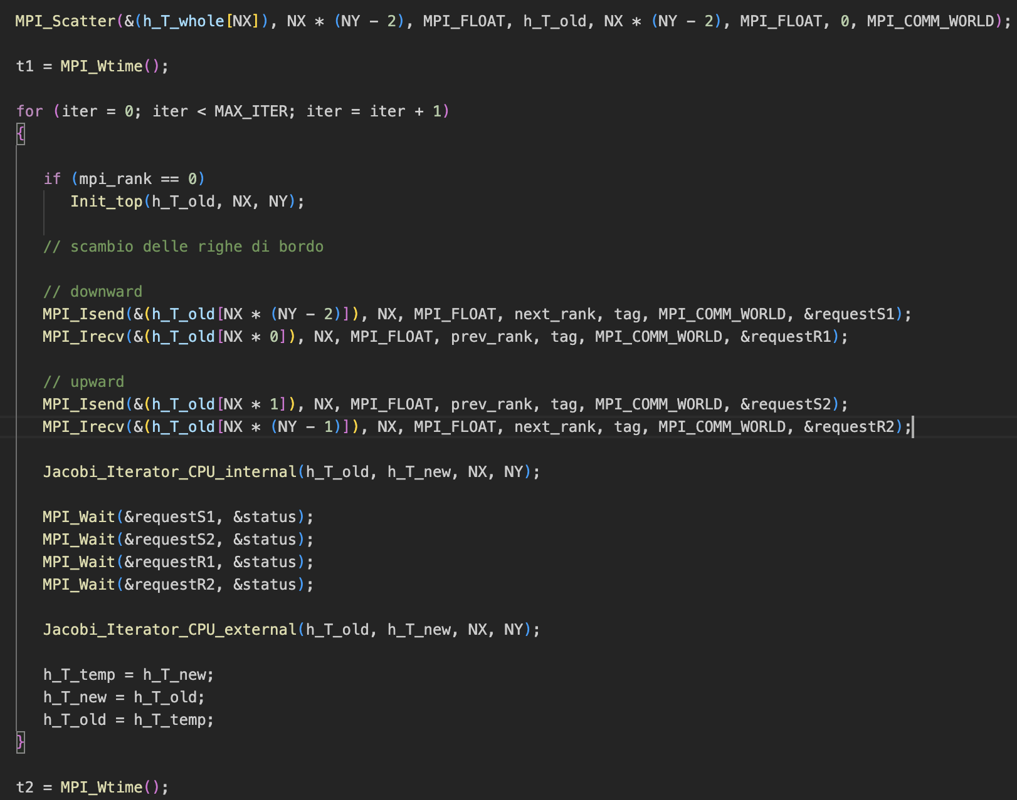
→ So after the MPI_Scatter we make task 0 to initialize the top of the heatmap and we continuous with the communication downward and upward of each task to communicate the number at the border while waiting the result of each other we compute jacobi internally and after the communications is done we compute jacobi at the exterior and swap.

This is the output of runing this program with one node:
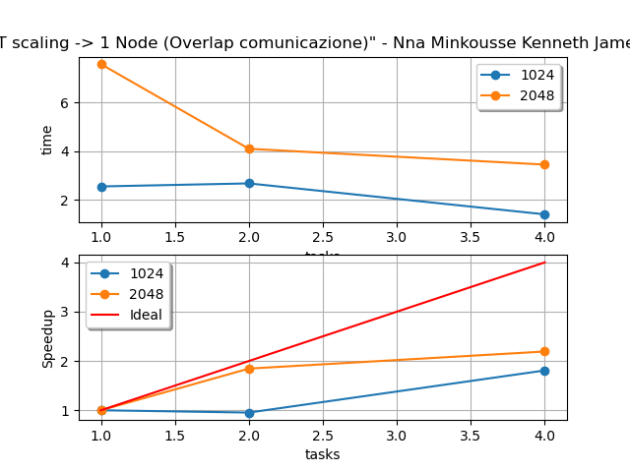

→ on 1 node from one to 2 task the speedup is good for a big problem put as from 2 to 4 task the is a bad scale of the speedup
→ while on the time taken we can see that on a small problem the time taken is small and with an increasing number of task the is a reduce in the computation time.

Now this is the output of 1 vs 2 working nodes :
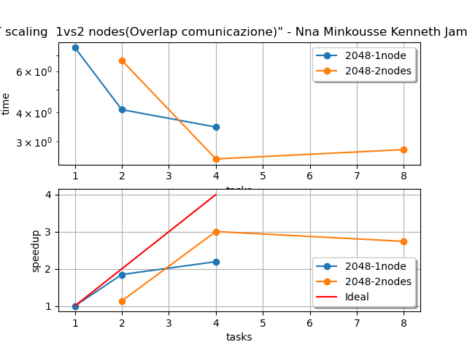

→ On 2 working nodes I intentionally added the number of task to 8.
Programmazione ibrida mpi+openMP
Here we make use of MPI and openMP on each task to make the computation of the heatmap more performant. This is the source code so you can look:
MPI
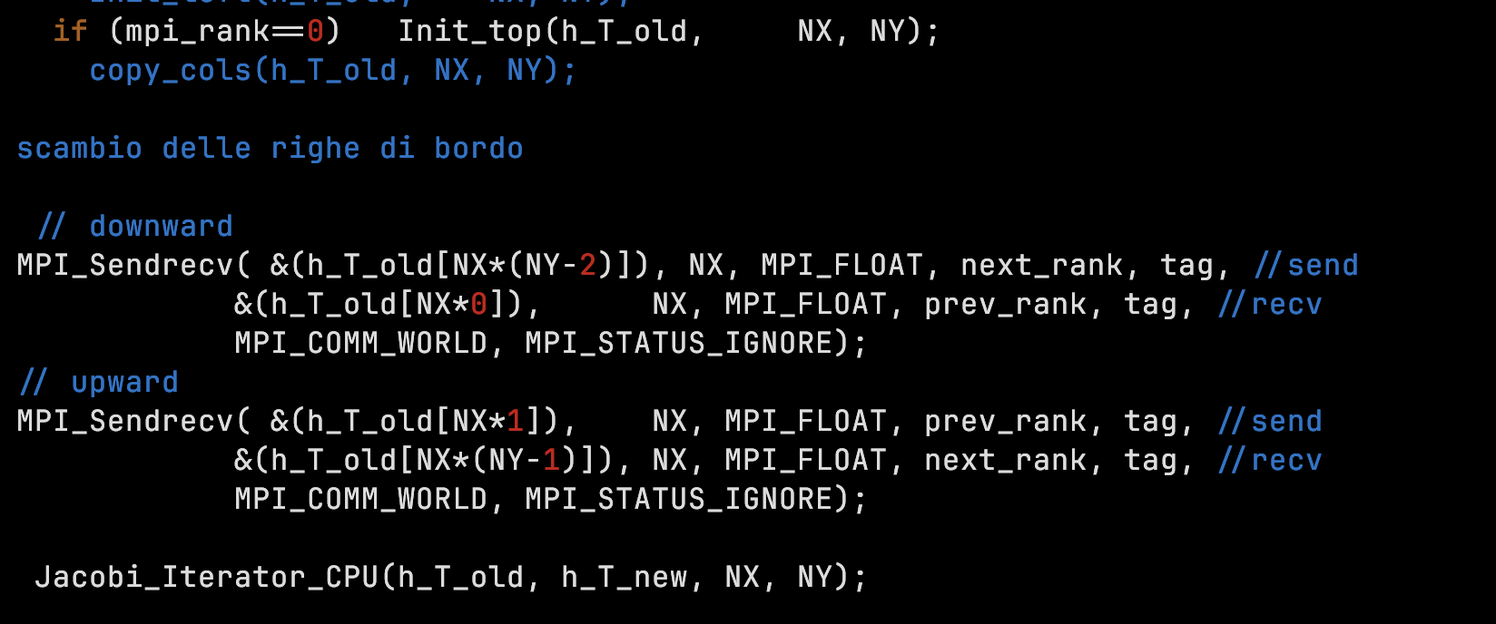
And then OpenMP in jacobi iterator
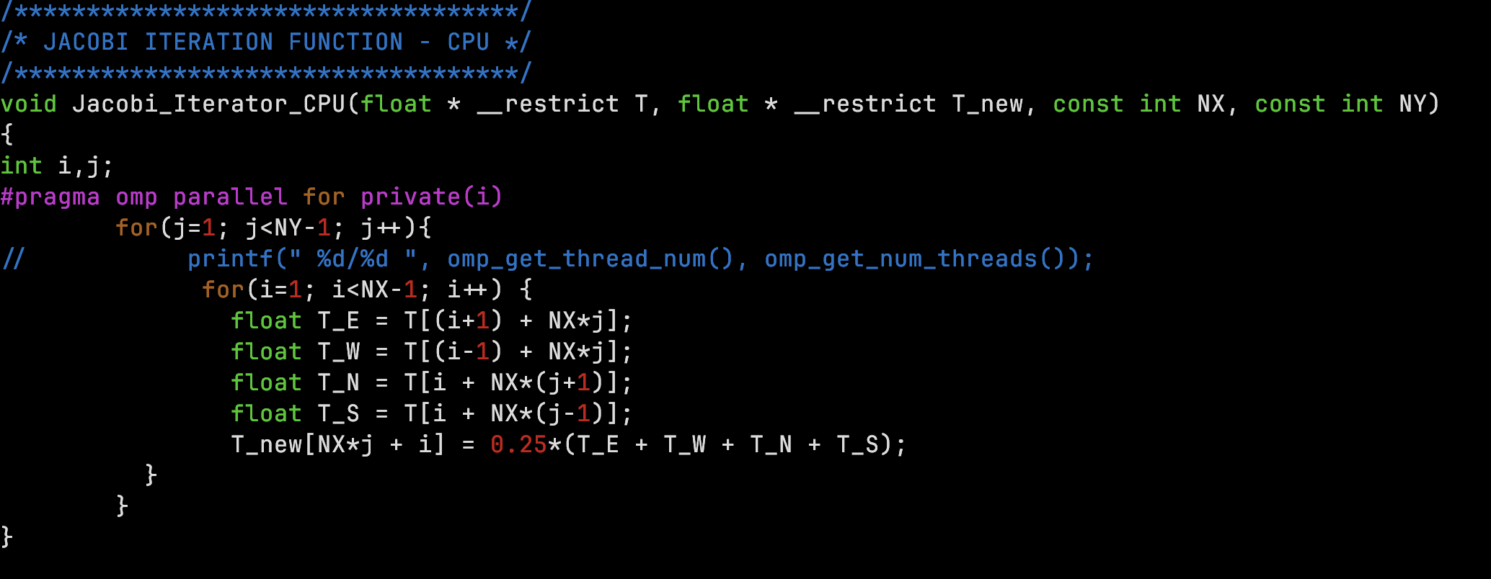

Output of comparing of serial code openMP, MPI on the heatmap:
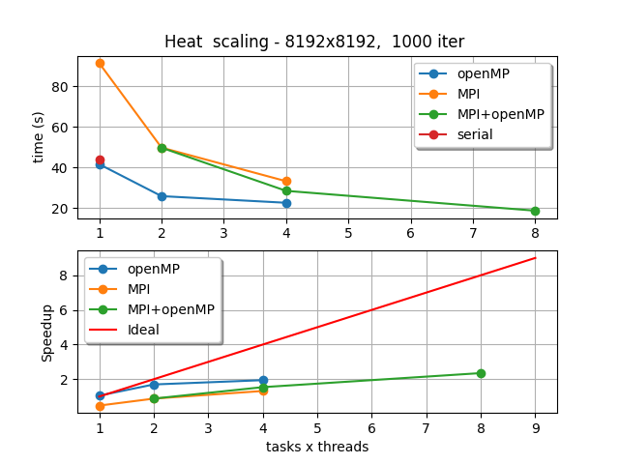
Do not forget that in all the heatmap programs the master task(rank 0) is in charge of initializing the top of the heatmap.

