Relazione-3

Directory cpi: (Calcolo di pi-greco)

cpi.c:
Usando prima il codice cpi.c(senza Parallelizzazione) Ecco I risultati al variare n (il numero di intervali).
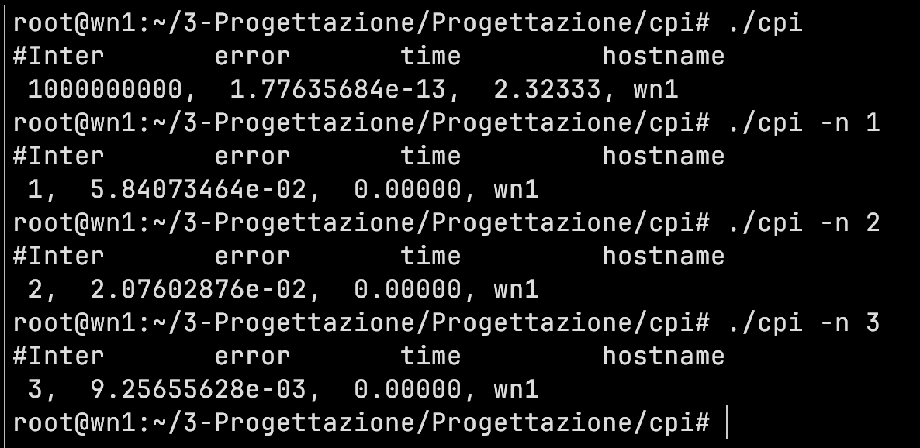
Output di cpi.c:

What we see is that increasing the number of interval reduces the time it takes for calculation and also reduces the error.

cpi+amdhal.c:
We have to know that amdahl is defines the total execution time of a program as the sum of the time of execution of the part not parallel and the time of the part parallel.
That is:
Ts = Tnp + Tp

Parallelism of the code is done by adding a sleep on the sequential time calculated when the parrallise part start is execution. This is a screenshot of the part here.

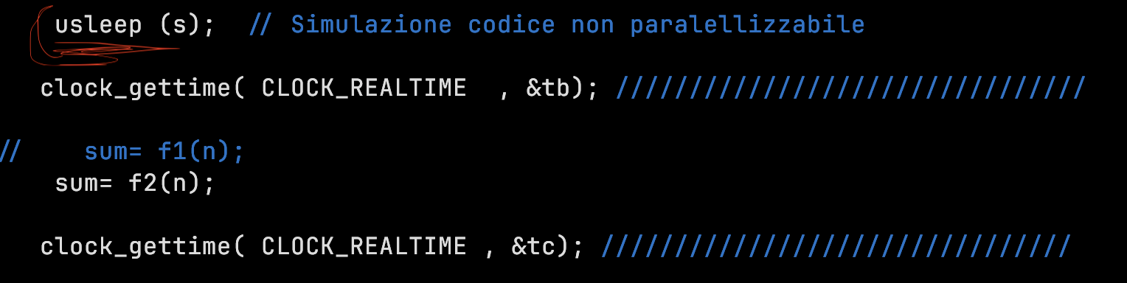
This is the result of the cpi+Amdhal:
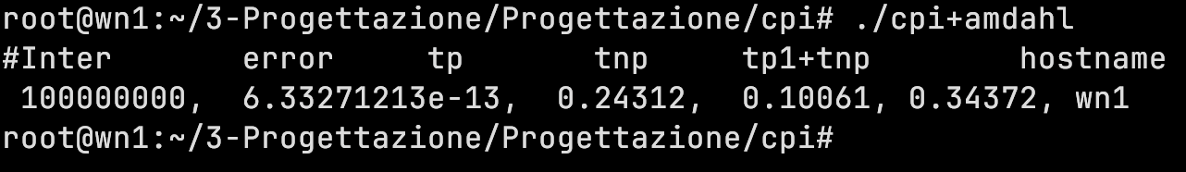
We can clearly see that the the total time that is tp +tnp is less that that of cpi.c which is all serial.

Now I added the result I got in the python code to get the .png this is where I added my values

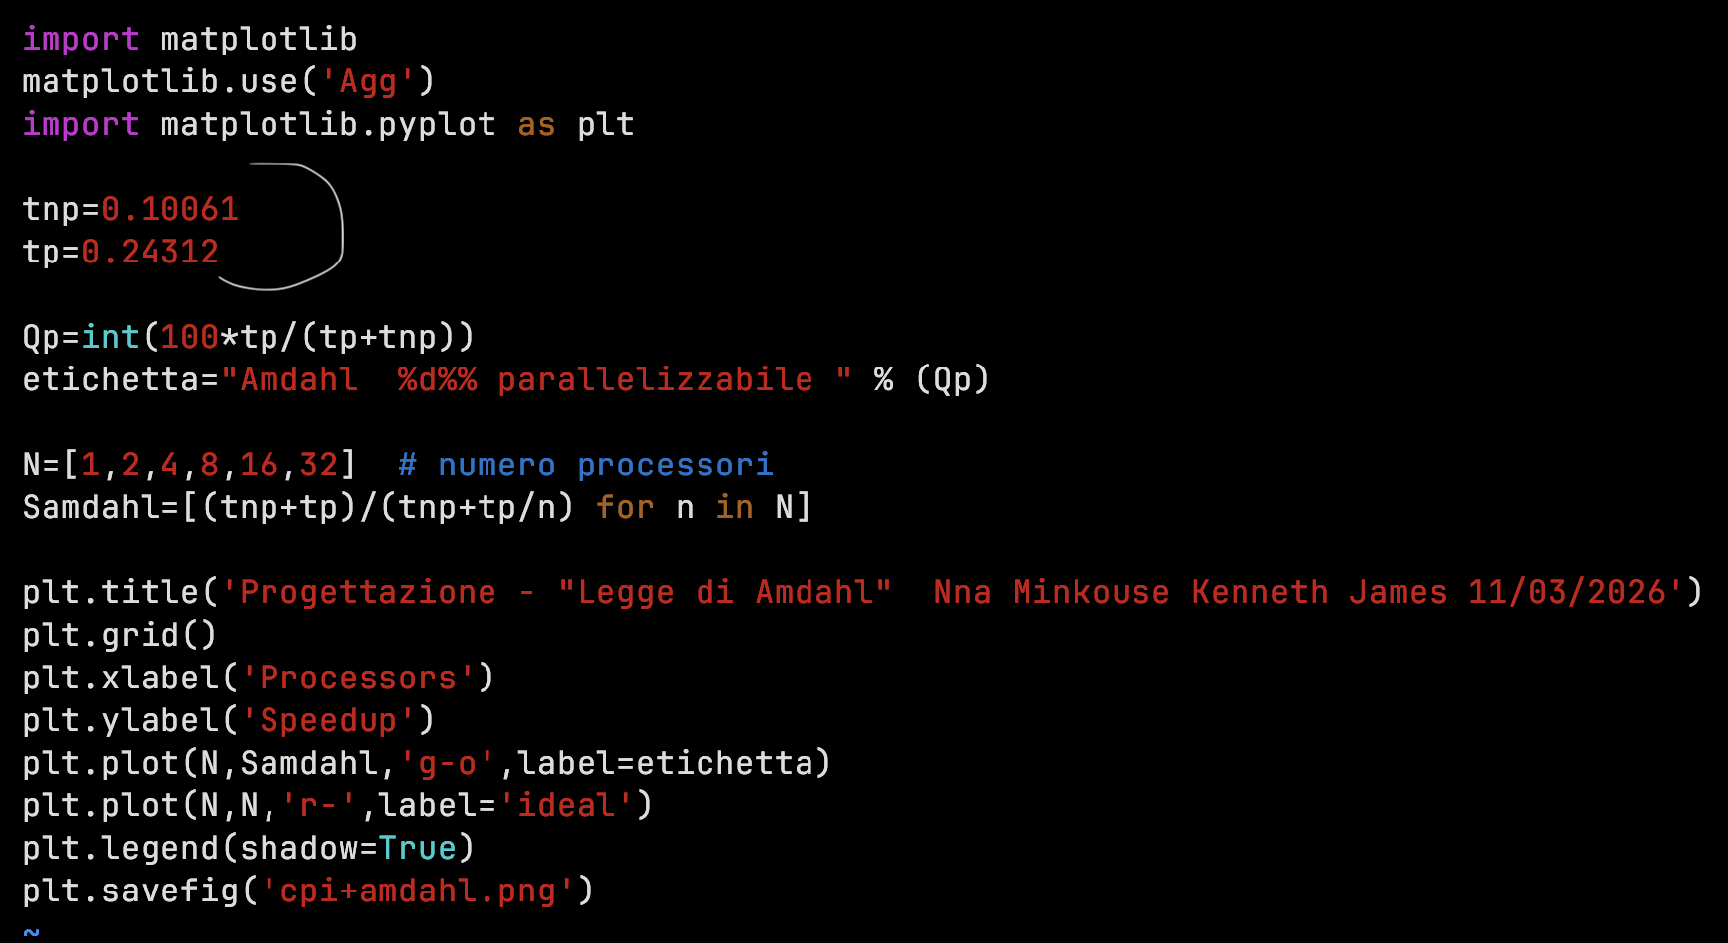
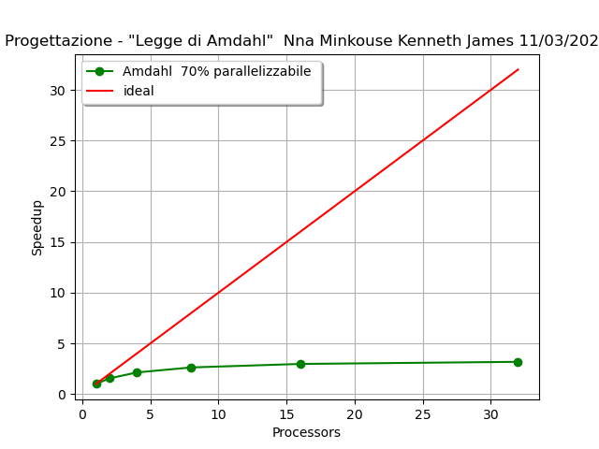

HEAT

→ Sulla heat ho fatto la run del programma heat.c con il commando:
gcc -O2 heat.c -o heat

→ Ho fatto generare il heatmap e ecco il resultato :



→ Si vede che I bordi e il cento hanno la temperatura costante.
→

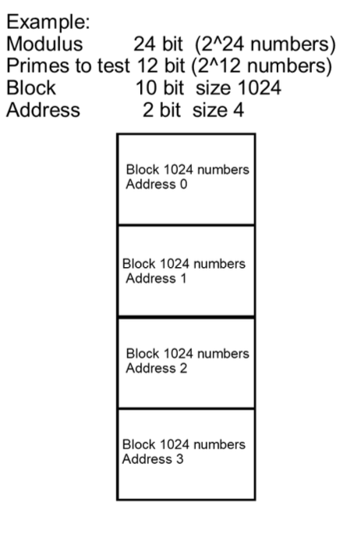
Esercizio Fattorizzazione

We know that in this problem we want to use brute force to obtain the modulus that is part of a private and public key.(the algorithm RSA of openssl uses modulus for encryption and is someone finds that the 2 big number that when multiply gives the modulus has cracked the keys).
=> modulus (n) = p * q
→ first we generate a modulus using openssl with the algorithm RSA
openssl genrsa -out rsa_key.pem 512
openssl rsa -in rsa_key.pem -modulus -noout
This is the modulus generated:
But as we want to generate a small sample for testing if the code fatoriza.c can actually find the p and q we are going to use a small modulus compiling the following executable.
./factorize -g 68
generating modulus of 68 bits
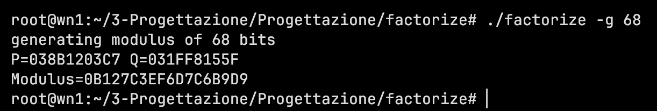
using 4 bit to represent 1 block address(index) it means in total we are going to have
2^4 = 16 blocks (so that is the numbers will be divided in to 16 blocks)
Since the numbers are very big it will take a longer time because we are having less range. Look the diagram below we can se that the time it takes is very large thats 354.2 sec …… etc just for one block
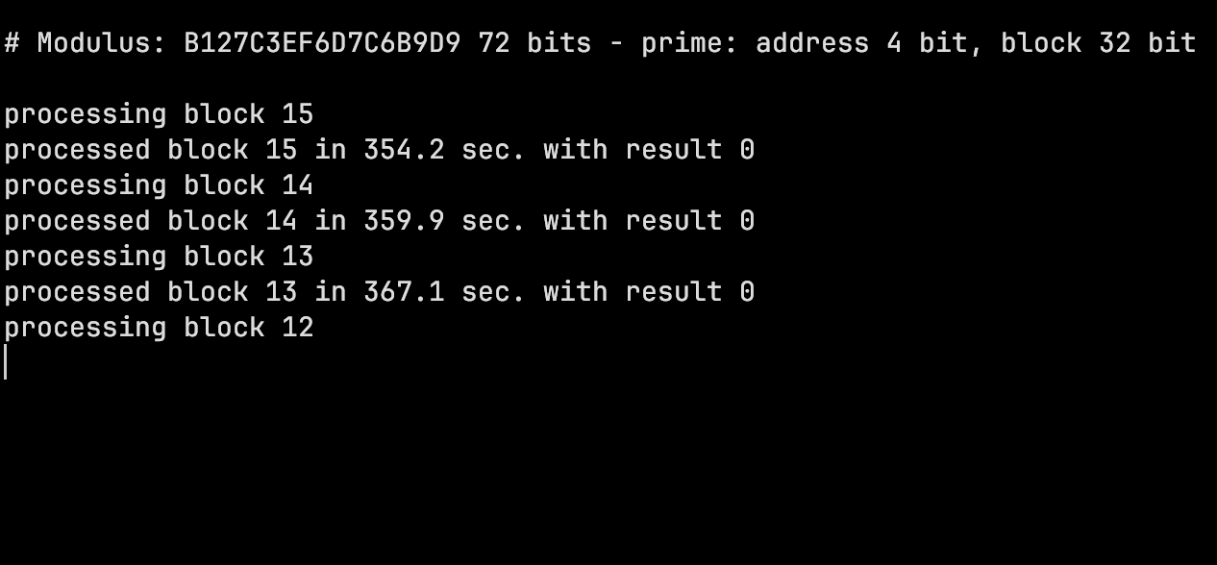
Looking for p and q using address block of 10bit that means 2^10 = 1024 blocks , the time is less per block look that the picture below.
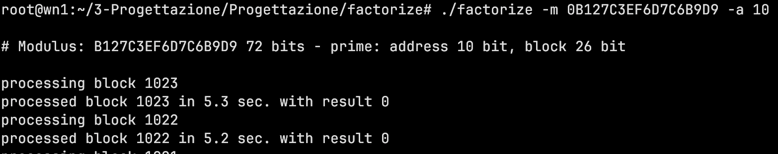
We see that it takes us 5.3 sec for a block much more faster that 16 blocks with very large numbers in.

