Relazione-7b

Factorize:
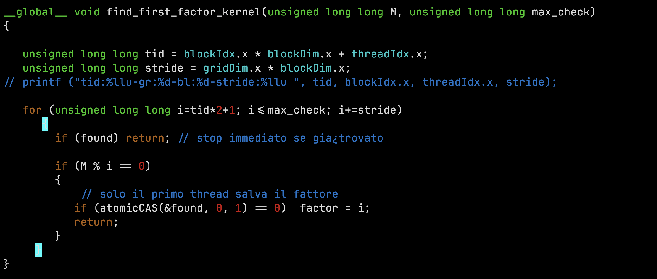
It uses a flag called found and also a semaphore that is atomicCAS that help a thread to put a value in found atomically.

Heat:
Here we make use of 3 matrix.\
→ one to copy the constant values of the heatmap
→ one for coping the old values to execute jacobi
→ The last one that contain the real heatmap

All this matrix are stored and allocated in the global memory of the GPU(device).
This is a screenshot:
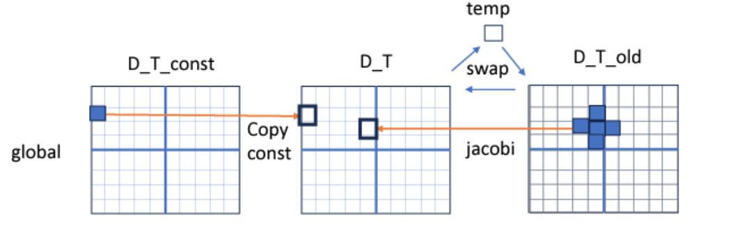

this is the source code :
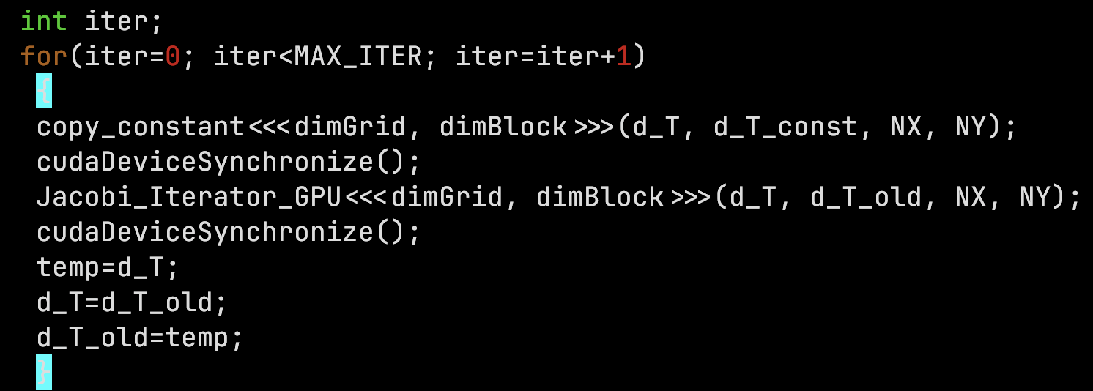

So we call the device function that copy the constant parts to the main matrix in the device, then we execute jacobi and then we swap the matrix at the end.

So we call the kernel 2 times.

This is the output adding the dimension of the problem with respect to the increase in the block size(threads)
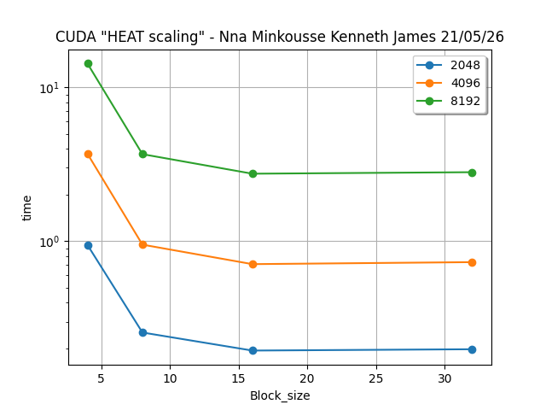

We can see that for a small number of thread in a block it takes more time but adding the block size in the GPU we get good performance.

Optimizing the code of Jacobi that is calling once the kernel

Now the problem was that in the host we had 2 kernel to optimize that I did the jacobi with the annotation __device__ that will help once the copy function is called by the kernel it will call the jacobi function in the kernel so it will work at the device side(GPU side).
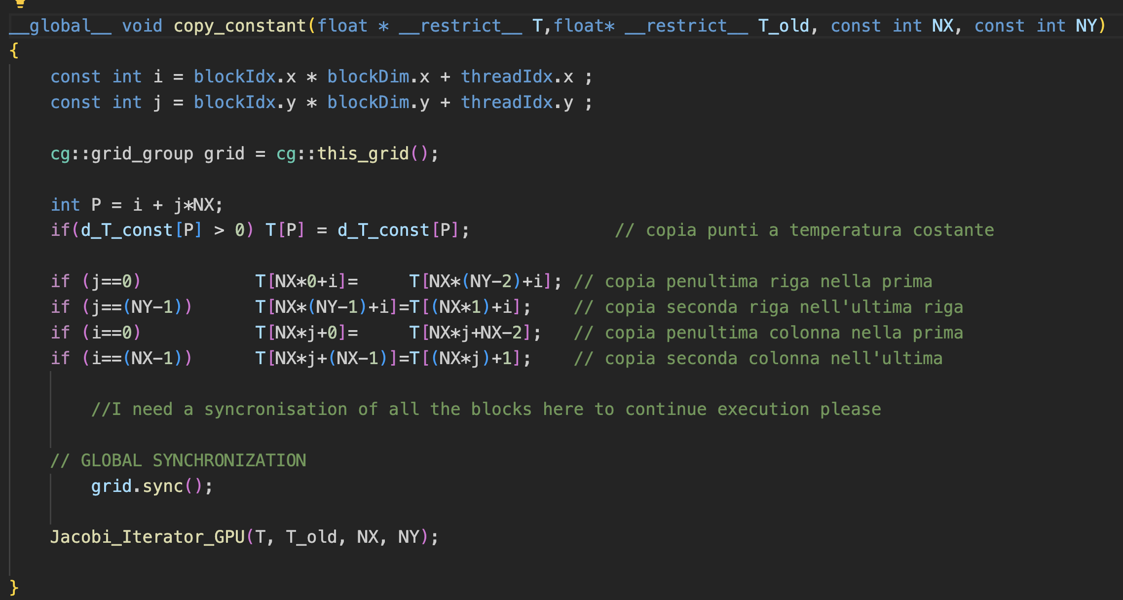

Also for the fact that we copy constant data a matrix I decided to use the constant memory which will be accessible faster in the kernel.

At the end I encounter a problem of synchronizing all blocks because I need a synchronization to occur and then compute jacobi. I made use of a library that helps synchronize all blocks in a grid

This is what my main looks like now after optimization(only one kernel):
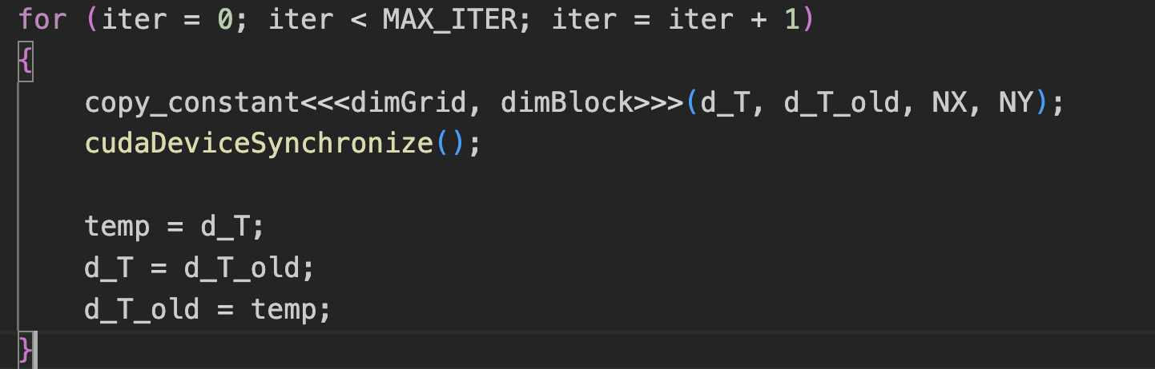
Now lets look some figures before and after optimization:

Before Optimizing:
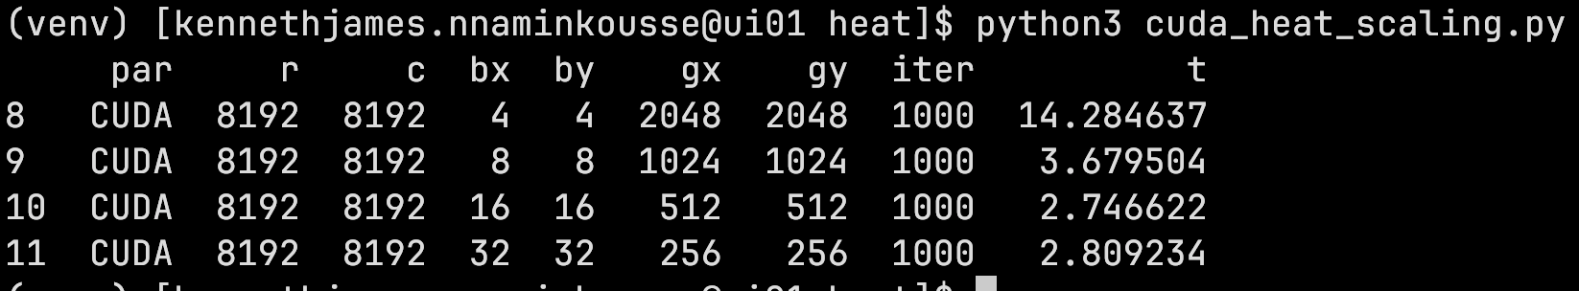
After Optimizing:
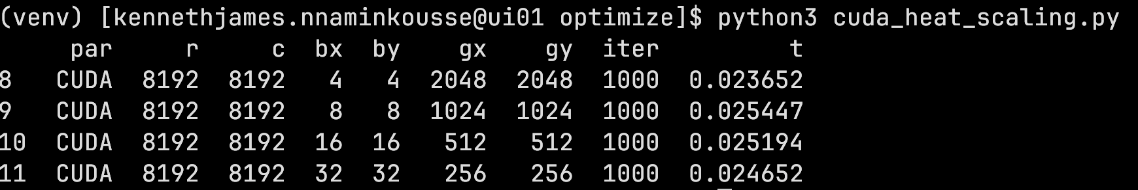
We can see that we get less time.

MPI+CUDA

Here we have a scenario where we have 1 GPU and we split the problem in 2 (that is we have 2 CPU with 1 task on each or 1 CPU and 2 tasks on it)and send it to the GPU to process the computation and at the end a communication is done between then using MPI on the CPU.
This is a figure that best explains that :

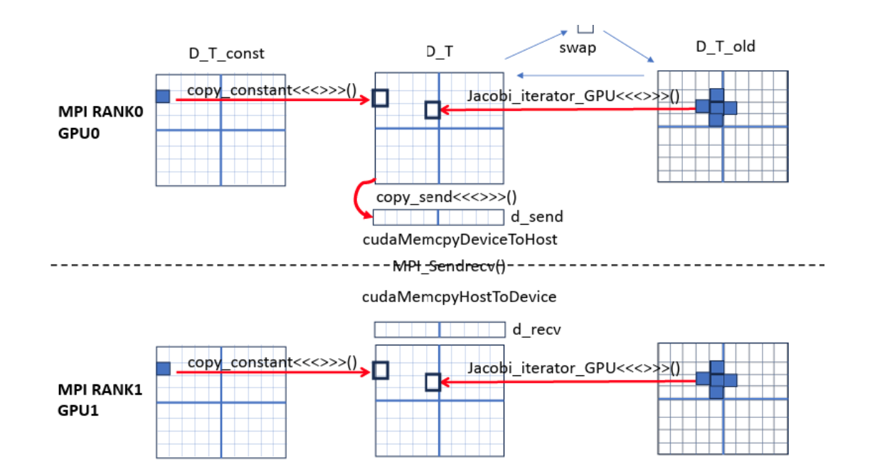
Now we executed this using 2 cases :
1→ 2x1 (2 CPU and 1 task on each):
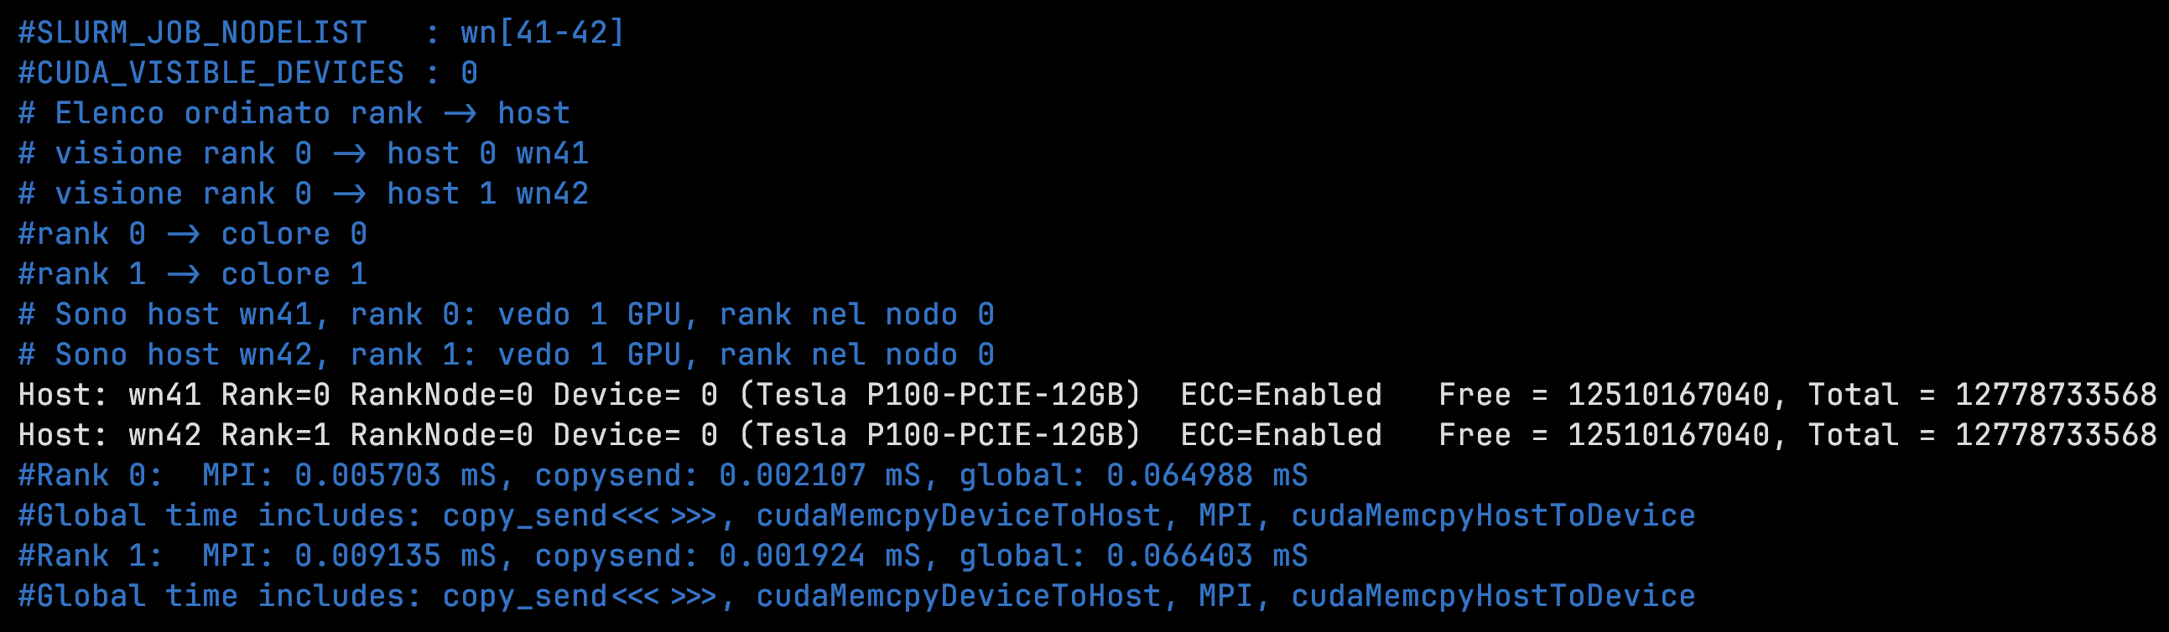
2 → 1x2 (1 CPU and 2 tasks on it):
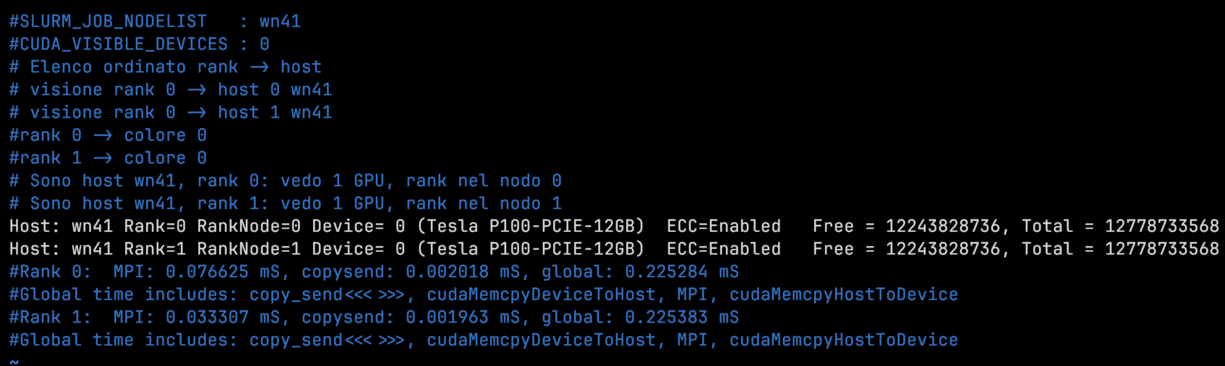
We can see that having 2 CPU and I task on each CPU core has better performance respect to one CPU with 2 tasks on it

