HTML(some little nodes to remember)
- Tags
All tags are done in HTML by opening and closing e.g <tag>contain</tag>
- Some tags
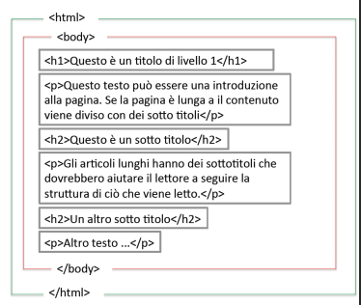

This is a structure of a HTML document with its various tags .

- Block tags
<div>,<form>,<table>,<p>, <h1>,...,<h6>,<ul>,<ol>
- Inline
<a>,<img>,<i>,<b>,<span>,<input>.

<link rel="icon" href="demo_icon.gif" type="image/gif« sizes="16x16">
<a href = "https://github.com/Kennethjames237">my git repository </a>

<img src="image/img2.png" alt="my profile pic" width="100" height="100" >
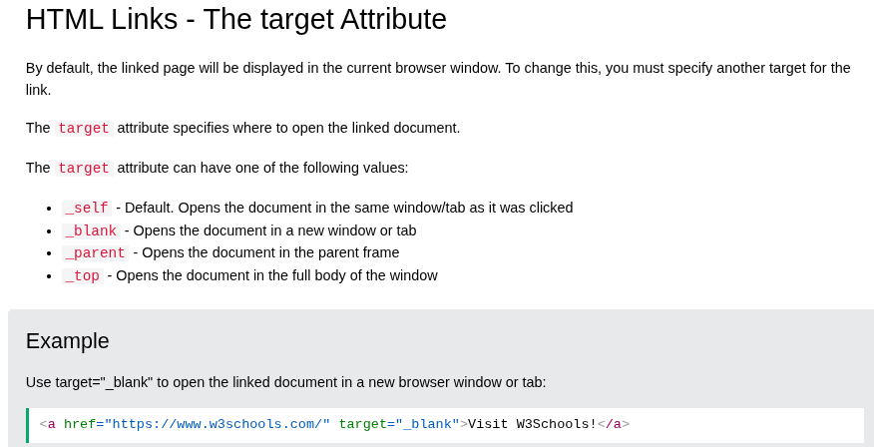

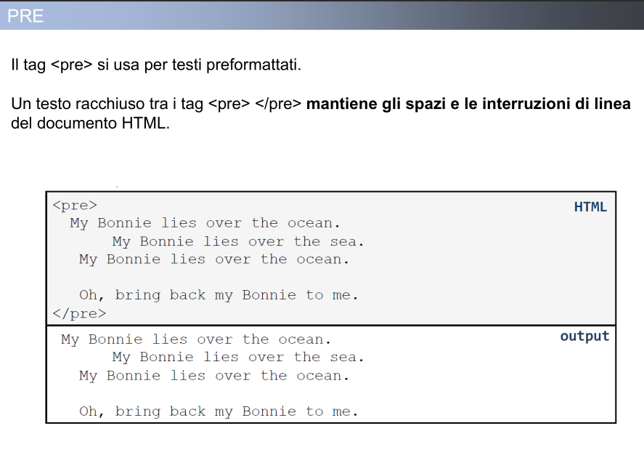
Structure of a website

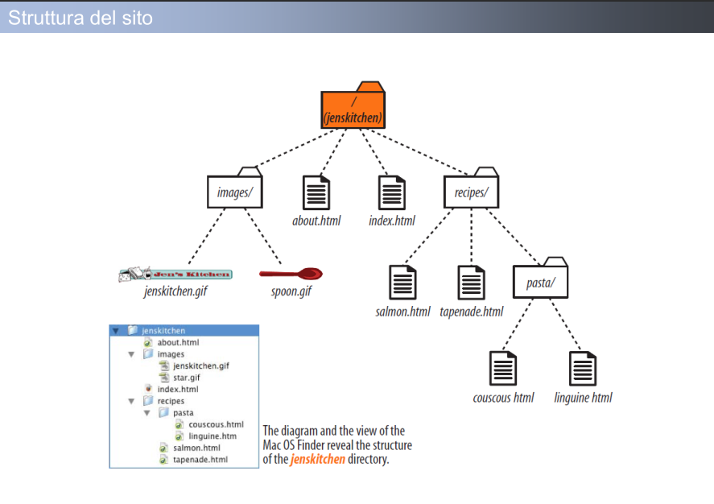
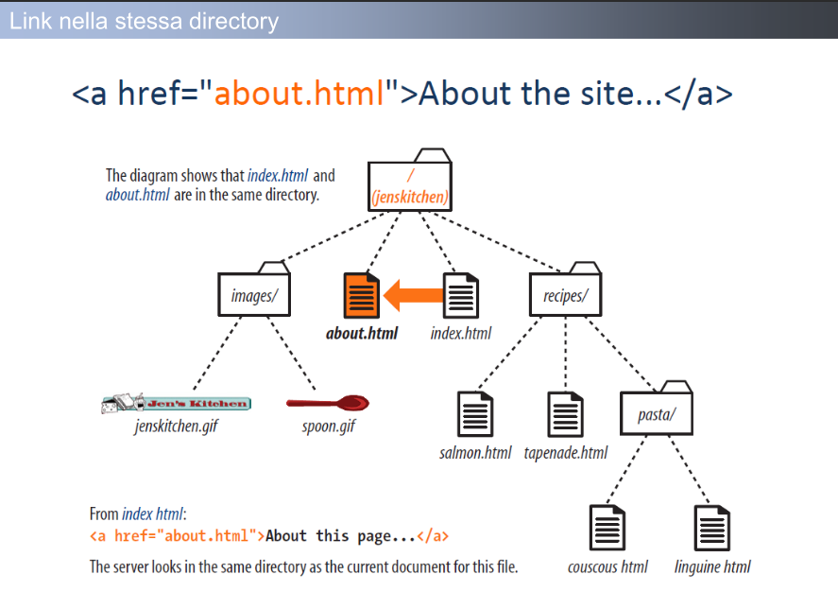

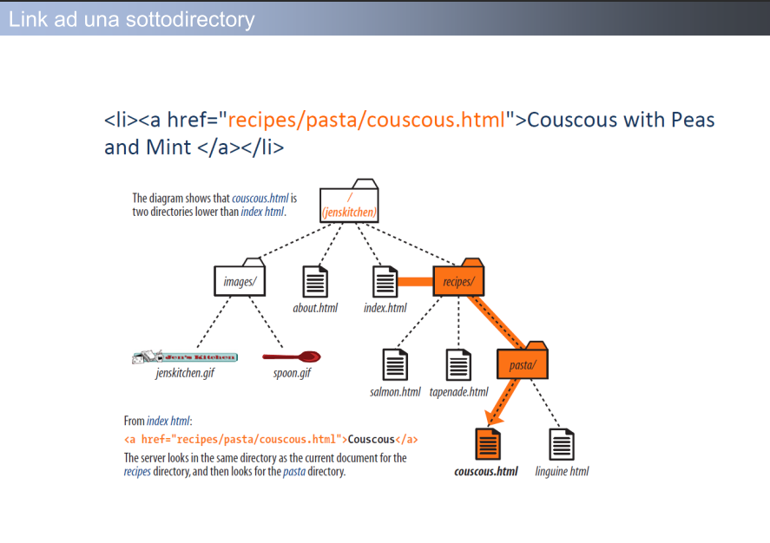
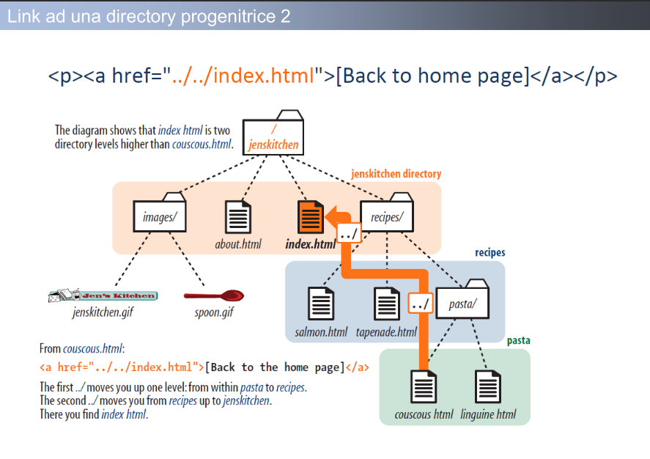

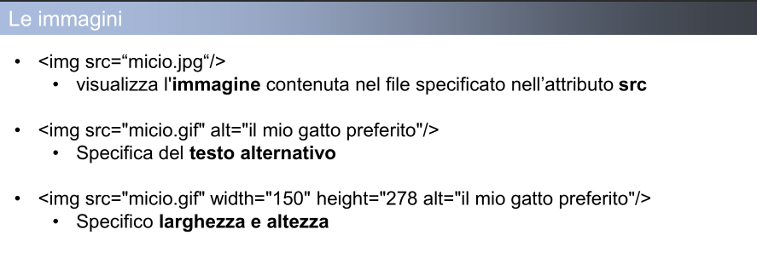

CSS

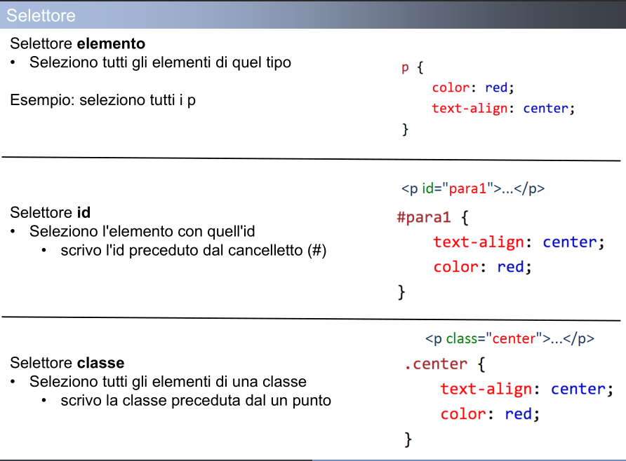
form a text : font-family
Unit measurement e.g px…..
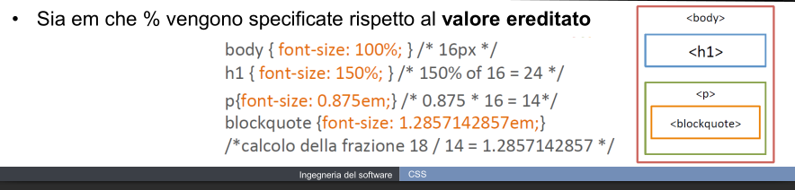

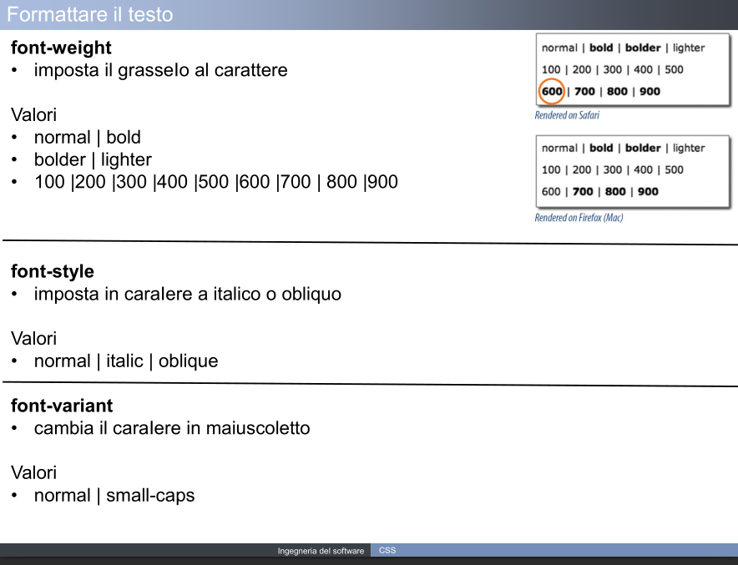
Take care of the way of putting colors (transparent)

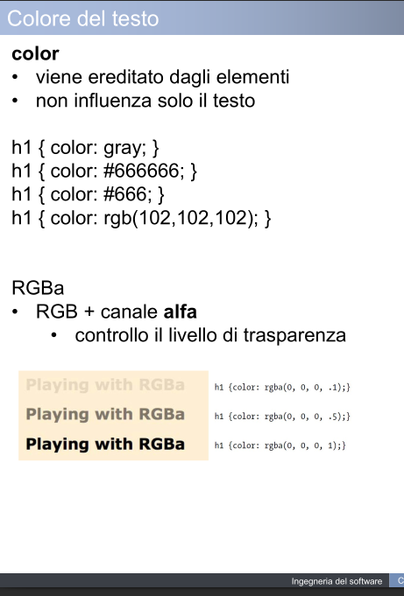

DIV e SPAN
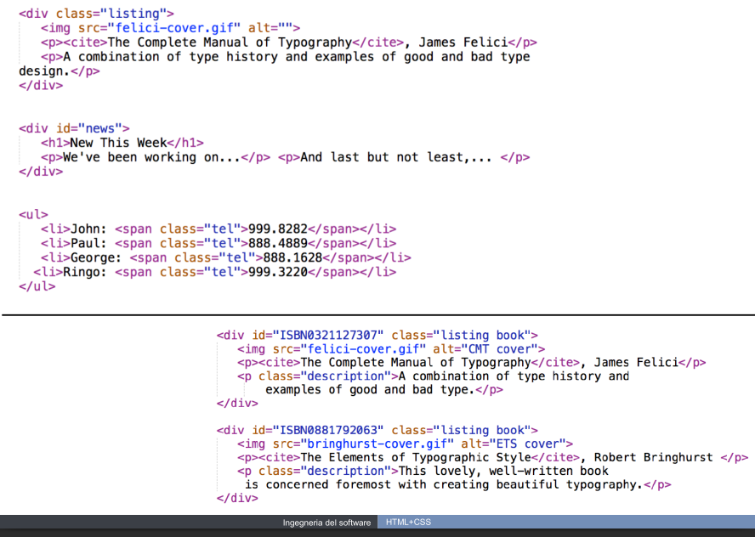
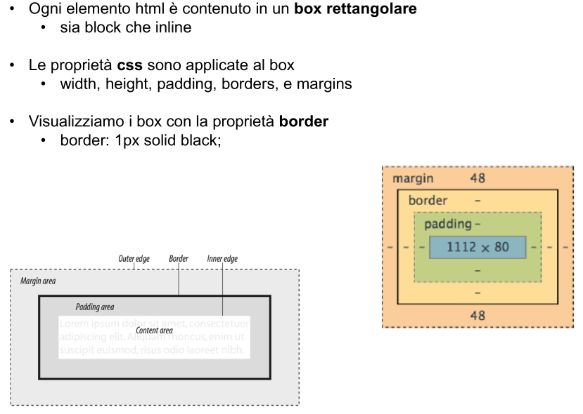
Every HTML element is viewed as a box.

This is a way of setting the any element in Html(specially div)

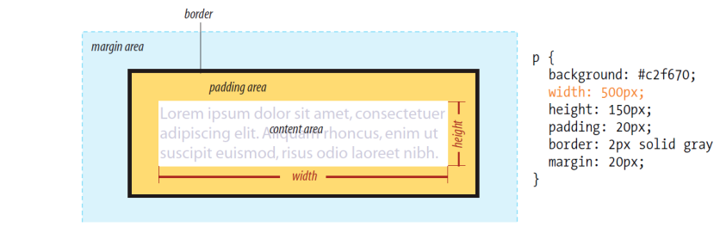
An overflow in a div that is the text is more than the div size
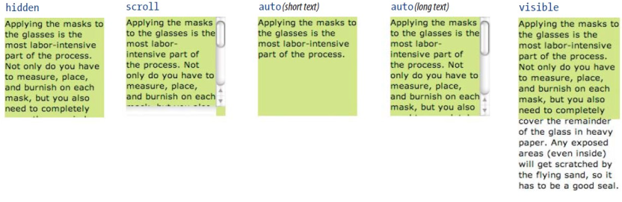
The padding of a div can be set as follows padding-top, padding-right, padding-bottom, padding-left
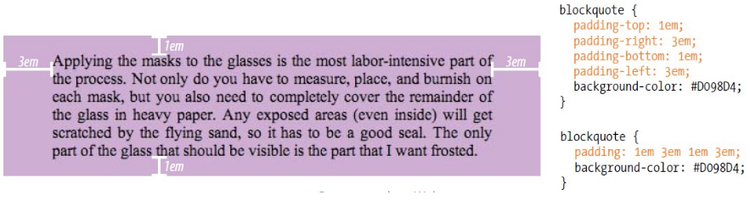

Now lets talk about the margin of a div

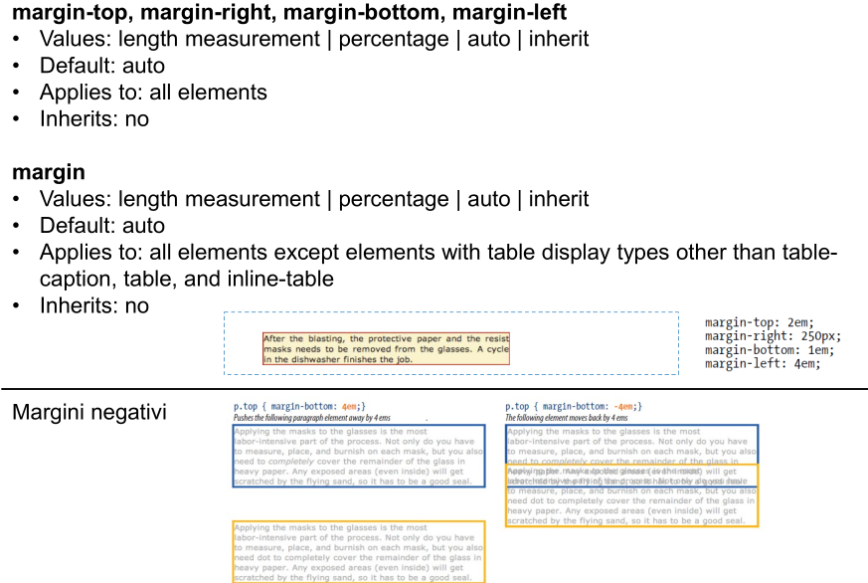
Borders

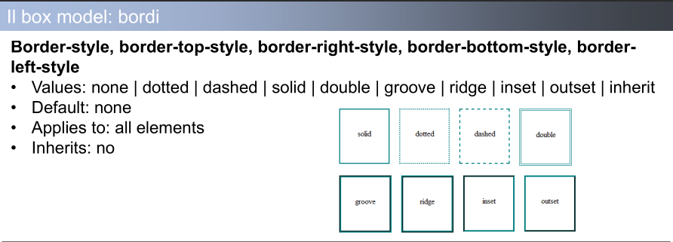

Background
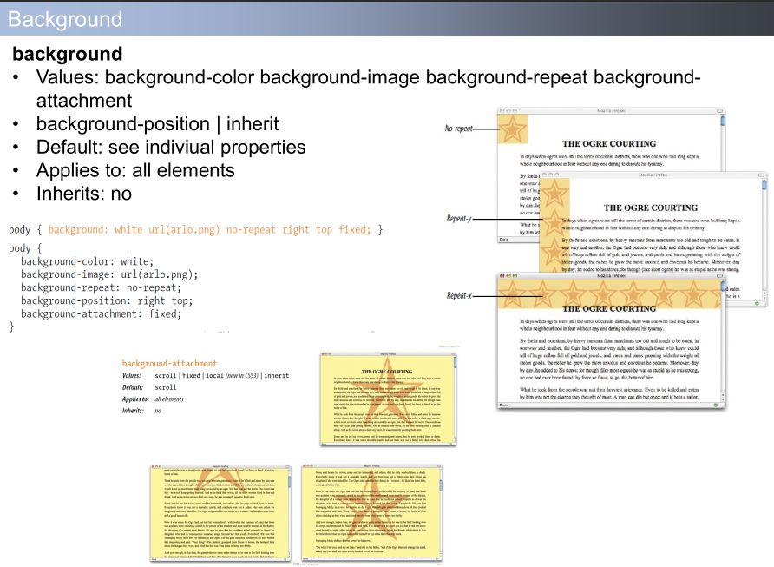

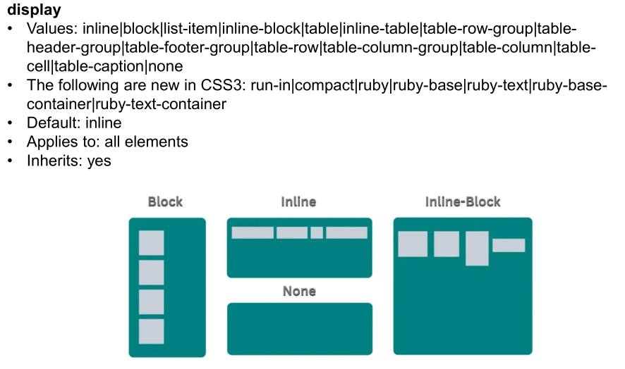

Float of image
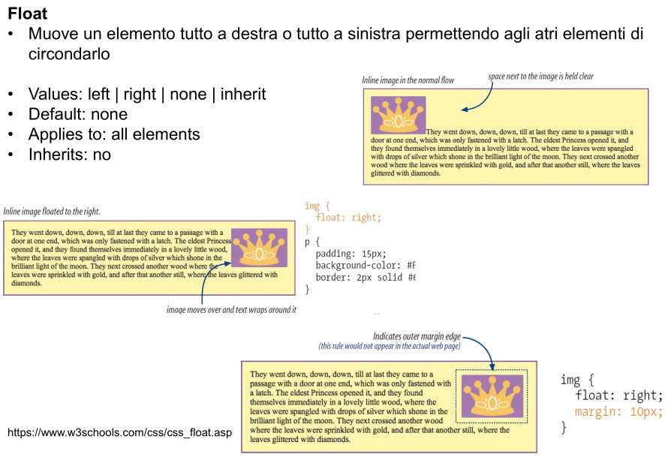
problemi del container spesso che accade
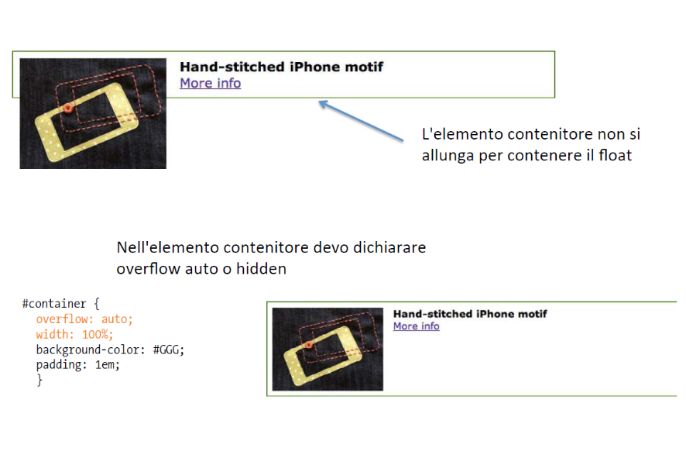

Importing css files that styles a particular feature
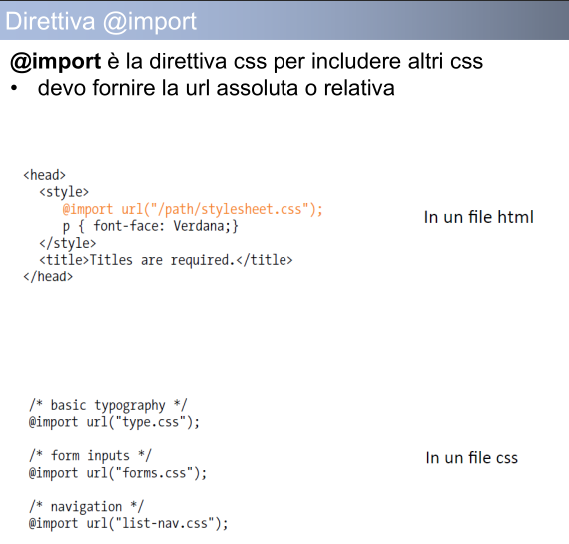
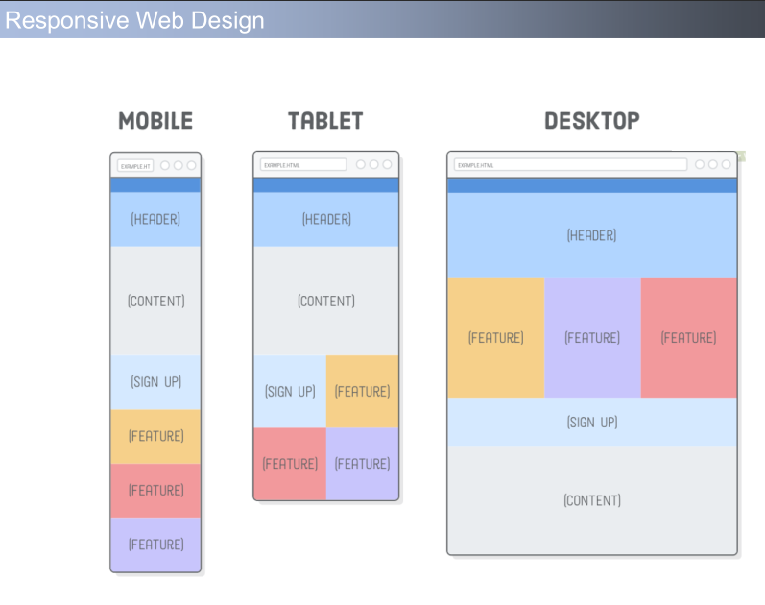
Responsive paging to adapt it to any device

What we want
