HTML(some little nodes to remember)
- Tags
All tags are done in HTML by opening and closing e.g <tag>contain</tag>
- Some tags
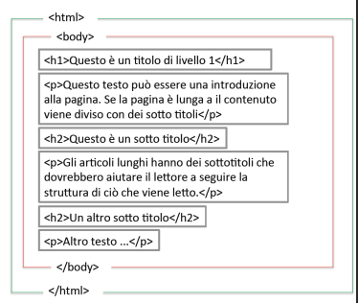

This is a structure of a HTML document with its various tags .

- Block tags
<div>,<form>,<table>,<p>, <h1>,...,<h6>,<ul>,<ol>
- Inline
<a>,<img>,<i>,<b>,<span>,<input>.

<link rel="icon" href="demo_icon.gif" type="image/gif« sizes="16x16">
<a href = "https://github.com/Kennethjames237">my git repository </a>

<img src="image/img2.png" alt="my profile pic" width="100" height="100" >
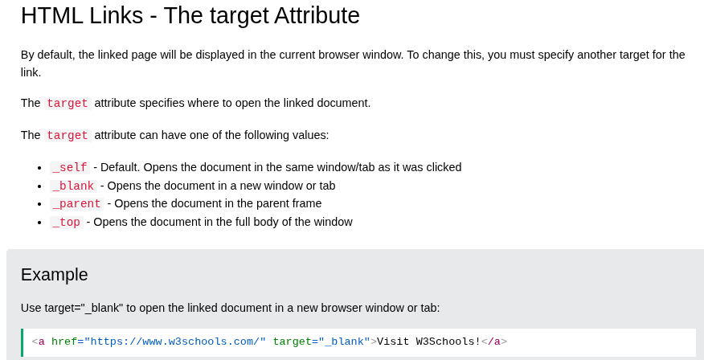

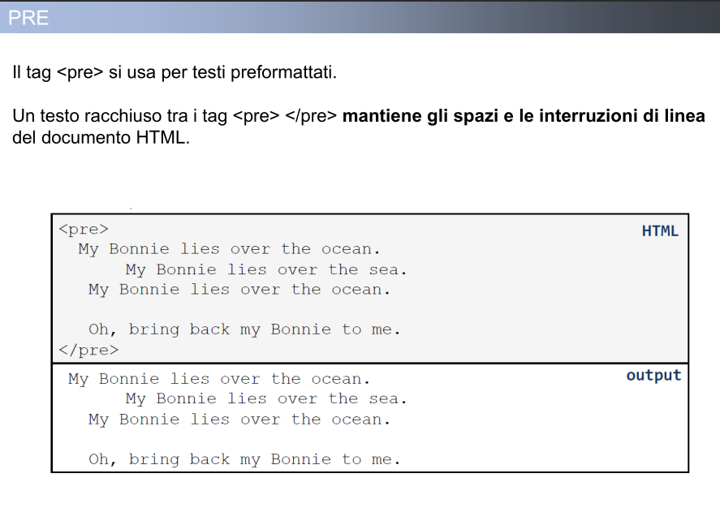
Structure of a website

