Architetture dei Sistemi di Elaborazione  02GOLYG | Computer Architectures  02LSEYG
Laboratory  0x02 | Expected submission:  SURNAME_NAME_MATRICOLA_lab_02.zip  Including:  - program_1  - lab_02.pdf (complete this file and export it as PDF)
Submission deadline: 13/10/2026

Please configure the in-order CPU with the Initial Configuration provided below (please note forwarding is NOT enabled) :

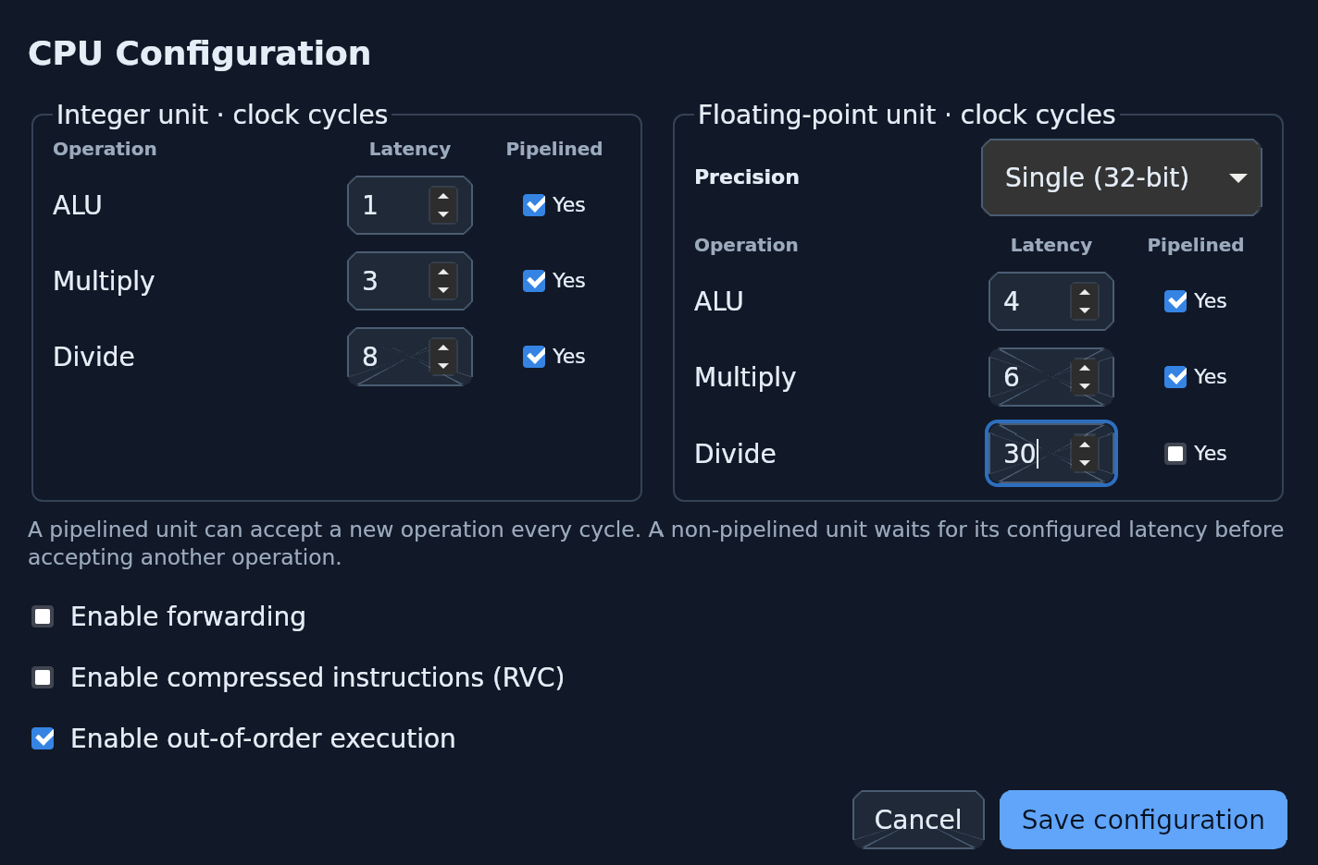

- Write a RISC-V assembly program (program_1.s) able to compute the output (y) of a neural computation (see the Fig. below):

x =
y = f(x)

The activation function f is defined as:

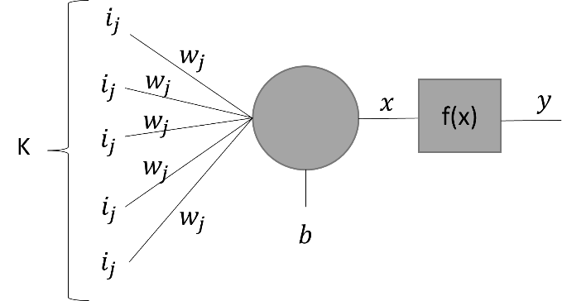

Assume the vectors i and w respectively store the inputs entering the neuron and the weights of the connections. They contain K=30 single precision floating point elements. Assume that b is a single precision floating point constant and is equal to 0xab, and y is a single precision floating point value stored in memory.
Compute y.

To easily identify the exponent of a floating-point number, the IEEE 754 single-precision binary floating-point format is shown below:

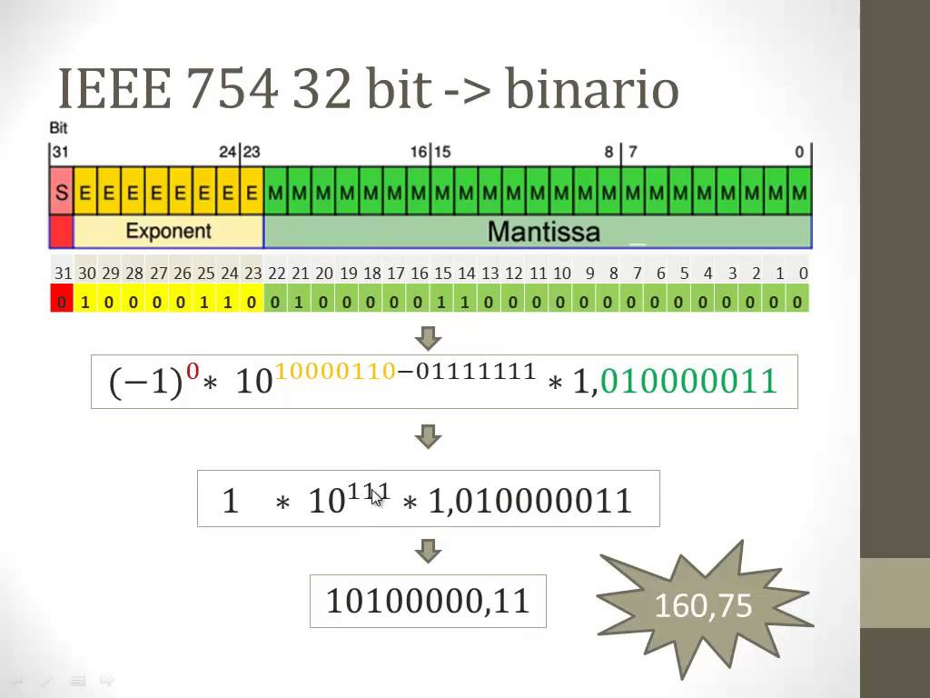

- Calculate (manually) the data memory footprint of your program:

Data | Number of bytes
Inputs | 30 * 4 = 120
Weights | 30 * 4 = 120
b | 1 * 4 = 4
x | 1 * 4 = 4
y | 1 * 4 = 4
Total | 252 bytes

- Calculate the CPU performance equation (CPU time) of the above program by assuming a clock frequency of 15 MHz:

By definition:
      - CPI is equal to the number of clock cycles required by the related functional unit to execute the instruction (EX stage).
      - IC_{i} is the number of times an instruction is repeated in the referenced source code.

Recalculate the CPU performance equation assuming that you can triple the speed by just one unit of your choice between the FP multiplier or the FP divider:
      - FP multiplier unit: 6 à 2 clock cycles
or
      - FP divider unit: 30 à 10 clock cycles

Table 1: CPU time by hand
 | Initial CPU time (a) | CPU time  (b – MUL speeded up) | CPU time  (b – DIV speeded up)
program_1.s | 3.527 * 10^ -5 | 2.727*10^-5 | 3.393 * 10^-5

Using the simulator, calculate the CPU time again and fill in the following table:

Table 2: CPU time using the simulator
 | Initial CPU time (a) | CPU time  (b – MUL speeded up) | CPU time  (b – DIV speeded up)
program_1.s | 4.311 * 10^-5 | 3.519 * 10^-5 | 4.311 * 10^-5

Are there any differences? If so, where and why? If not, please provide some comments in the box below:

Your answer: We have data dependency stall and I thing its because forwaring is not enable

- From the Initial Configuration, enable the Forwarding option and compute how many clock cycles the program takes to execute.

Table 3: forwarding enabled
 | Number of clock cycles | IPC (Instructions Per Clock)
program_1.s | 513 | 0.565

Are there any differences? If so, where and why? If not, please provide some comments in the box below:

Your answer: Enabling forwarding considerably reduces the clock cycle form 647 to 513.

- Enable forwarding on CPU configuration, then validate experimentally the Amdahl’s law, defined as follows:

- Using the program developed before: program_1.s

- Modify the processor architectural parameters related to multicycle instructions in the following way:

        - Configuration 1
          - Starting from the Initial Configuration, change the FP addition latency to 3
        - Configuration 2
          - Starting from the Initial Configuration, change the FP multiplier latency to 4
        - Configuration 3
          - Starting from the Initial Configuration, change the FP division latency to 10

Compute both manually (using the Amdahl’s Law) and with the simulator the speed-up for any one of the previous processor configurations. Compare the obtained results and complete the following table.

Table 5: program_1.s speed-up computed by hand and by simulation
Proc. Config.  Speed-up comp. | Initial config.  [c.c.] | Config. 1 | Config. 2 | Config. 3
By hand | 513 | 1.064 | 1.132 | 1.000
By simulation | 513 | 1.000 | 1.135 | 1.000

