Automated Climate Sensor System

Alvarez, Carlos Marcelo #1, Santiago, Emmanuel Joseph\*2, Sinsin Dean#3

School of Electrical Electronics and Computer Engineering, Mapua Institute of Technology  
Muralla St, Intramuros, Manila, Metro Manila, Philippines

1cmaalvarez@mymail.mapua.edu.ph

2ejjsantiago@mymail.mapua.edu.ph

3Dsinsin@mymail.mapua.edu.ph

Abstract— This project proposal is all about creating a system to sense the humidity, light, gas/alcohol and temperature inside a place a specific place and to be able to monitor and influence the temperature. The system programmed with the Arduino and Gizduino other supporting materials will play a big part on the output.

1. project background & Introduction

This chapter contains the background of the design project, its basic components and its different features.

* 1. Project Setting

A sensor is a device that responds to a physical stimulus and transmits a resulting impulse as for measurement or operating a control. Some example of sensors are Chemical sensors, acoustic/sound sensor, automotive sensors, electrical or magnetic sensors and the Thermal or temperature sensor.

Temperature sensor is the most common type of sensor used. There are many different types of Temperature Sensor available and all have different characteristics depending upon their actual application. A temperature sensor consists of two basic physical types. Temperature sensors measure the amount of hotness or coldness from a given system allowing it to detect any change in temperature.

The design which is being proposed can be in an enclosed placed, office or any places that needed a constant and controlled climate and environment.

the use of various control systems for operating equipment such as machinery, processes in factories, boilers and heat treating ovens, switching on telephone networks, steering and stabilization of ships, aircraft and other applications with minimal or reduced human intervention.. For this project, different kind of sensors will be programmed using an Arduino in order to come up with the desired output that is based on the configured codes.

For this particular project, in a house, office or warehouse hot ceiling temperatures cause more heat transfer through the roof of the structure and the hot air is stratified. This causes deformation or bending of the steel furniture, bulging of wooden items and weakening of the adhesiveness of the wood glues.

In order to develop an automatic room temperature control system, a microcontroller is needed to control the temperature measurement and ventilation depending on the current temperature within the loft. When the current temperature is above 25°C, the ventilators are automatically switched on to ventilate and cool the warehouse loft. When the current temperature is below 25°C, no control action is needed. The current temperature of the room must be continuously displayed on the Liquid Crystal Display (LCD).

* 1. Statement of the problem

In a today’s time, the climate of the world is changing and thus the temperature is unstable. It is either hot or cold outside or inside the room. The researchers, engineers and other companies are looking for a more easier way to detect and maintain the room temperature and can be comfortably safe and cheap with no hassle of adjusting every time the room feels uncomfortable.

In this case, the researchers developed a device that will help the people to detect whenever there are changes in the room temperature and other aspects inside the room. With this, we can save power and be more efficient at the same time be in a more comfortable place.

* 1. OBJECTIVES
* To design a system that would detect the parameters, namely light, humidity, Gas and temperature, using the Gizduino.
* To provide a working prototype using Ardiuno and Gizduino.
* To be able to understand how instrumentation and control systems works.
* To be able to perform what is needed and proposed in the project
  1. Scopes and Delimitation:

The design can only perform those that are listed below and the components that are presented in the design. Scopes of the design are as follows:

* The design composes of 4 sensors light, humidity, temperature and gas sensor to maintain safety and the conditioning of the room

The design’s delimitations are the things or conditions that it cannot perform or function. Delimitations of the design are as follows:

* It is only applicable inside a closed room.
* It only applicable in an air-conditioned room
* The sensors only have a certain amount of range
* The light sensor can only detect dark or bright
  1. Definition of Term

1. Microcontroller: A microcontroller is a small and low-cost computer built for the purpose of dealing with specific tasks, such as displaying information in a microwave LED or receiving information from a television’s remote control.
2. Gizduino: GizDuino is an Arduino compatible microcontroller board proudly made in the Philippines. It is designed and exclusively manufactured by e-Gizmo Mechatronix Central.
3. Arduino: Arduino is an open-source electronics platform based on easy-to-use hardware and software. It's intended for anyone making interactive projects
4. Temperature and humidity Sensor- can be used to detect liquids and gases that emit radiant energy as heat rises and cold settles to the bottom in convection currents or detect the radiant energy being transmitted from an object in the form of infra-red radiation (the sun).
5. Light Sensor - is something that a robot can use to detect the current ambient light level - i.e. how bright/dark it is.
6. Gas/alcohol sensor - for use in a wide range of applications, including air quality monitoring, smoke alarms, mine and tunnel warning systems, greenhouses, etc.

II. PROJECT DEVELOPMENT PROCEDURES This chapter describes the step by step procedures the group used in developing the project topic in details including the discussion of the materials used in each step.

1. Analysis of the Problem

Automated climate system is continuously underdevelopment until today to enhance the comfortability and safety level of a person or thing inside a specified room. Therefore, very capable sensor systems are considered which should detect all the needed requirements in order to detect control and also be safe this sensors are

available which has the capability to fulfill all given requirements.

1. Discussion of Materials

1) Temperature Sensor: A temperature sensor measures the hotness or coolness of an object. The Temperature sensor used in this project is shown in the figure. It is a low cost solution for circuit applications that requires temperature measurement from the area of a room

The sensor’s working base is the voltage that’s read across the diode. The temperature rises whenever the voltage increases. The sensor records any voltage drop between the transistor base and emitter. When the difference in voltage is amplified, the device generates an analogue signal that’s proportional to the temperature. A temperature sensor measures temperature using four measurement scales that are divided into various degree units. The measurement scales use the metric Celsius scale, and they start at zero. The Rankin scale is the absolute scale that uses Fahrenheit temperature sensing. Temperature sensors determine absolute zero measurements as close to minus 460 degrees Fahrenheit. The Rankin scale measures absolute zero as 492 degrees Rankin.

2) Light Sensor: Light sensors detect light density but do not record images. Most common light density sensors are: Photodiodes (LDR Light Dependent Resistors) and photoresistors (LDR Light Dependent Resistors). Photo diode is capable of converting light into either current or voltage. Photo resistor is a resistor whose resistance decreases with increasing light intensity

The Light sensor used in this project is shown in the figure. It detect the current ambient light level, how bright or dark it is.

3) Humidity Sensor: Humidity sensors measure and report the air’s relative humidity. They are used in homes, wine cellars, and working environments that that are so humid that they negatively impact working conditions. Humidity sensors detect the relative humidity of the immediate environments in which they are placed. They measure both the moisture and temperature in the air and express relative humidity as a percentage of the ratio of moisture in the air to the maximum amount that can be held in the air at the current temperature. As air becomes hotter, it holds more moisture, so the relative humidity changes with the temperature

The Humidity sensor used in this project is shown in the figure. The DHT-22 (also named as AM2302) is a digital-output relative humidity and temperature sensor. It uses a capacitive humidity sensor and a thermistor to measure the surrounding air, and spits out a digital signal on the data pin.

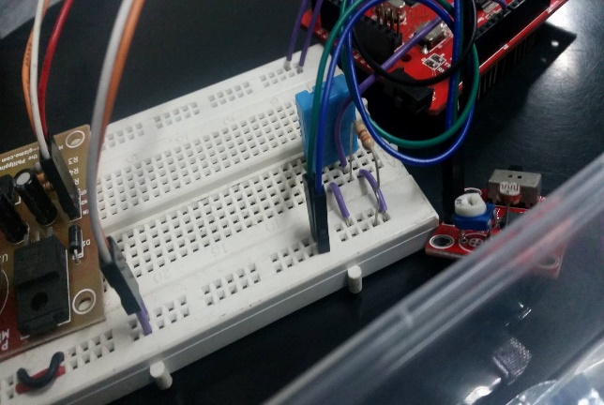

4) Arduino: Arduino can be used to develop interactive objects, taking inputs from a variety of switches or sensors, and controlling a variety of lights, motors, and other physical outputs. Arduino projects can be stand-alone, or they can communicate with software running on your computer (e.g. Flash, Processing, MaxMSP.) The boards can be assembled by hand or purchased preassembled; the open-source IDE can be downloaded for free. The Arduino programming language is an implementation of Wiring, a similar physical computing platform, which is based on the Processing multimedia programming environment.



5) Gizduino: Arduino Compatible Kit: The Gizduino is a microcontroller board based on the ATmega328 and ATmega168, as shown in Figure 2-11. It has 14 digital input/output pins, 6 analog inputs, a 16 MHz crystal oscillator, a USB connection, a power jack, an ICSP header, and a reset button. It contains everything needed to support the microcontroller; simply connect it to a computer with a USB cable or power it with an AC-to-DC adapter or battery to get started. It is an open source computing platform based on a simple input/output (I/O) board and the use of standard programming language; in other words, it is a tool for implementing a program you have designed. Gizduino is programmed using the IDE (Integrated Development Environment).

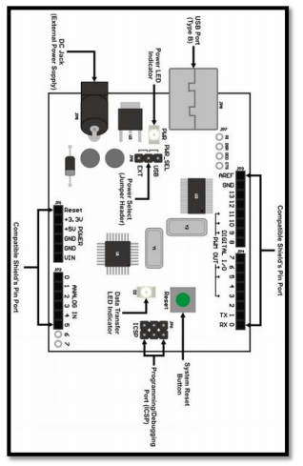

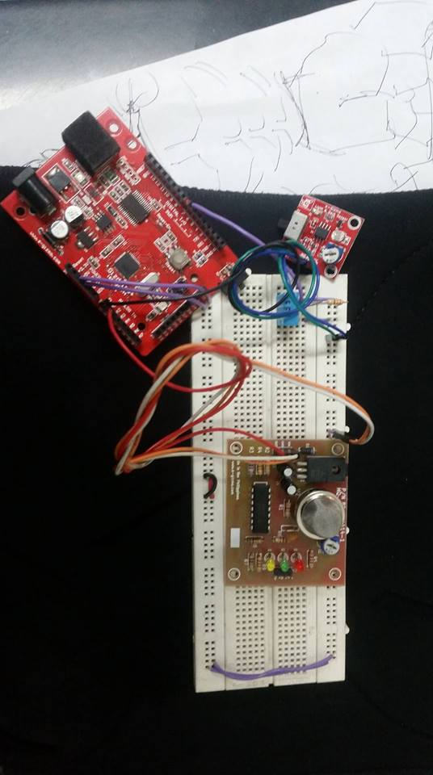

IV. Conclusions

Automotive climate sensor is performed using modem control theory in an air-conditioning system with a variable-capacity compressor. As a result, even without detecting changes in weather conditions, a robust climate control achieved under changes causing parameter variables or disturbances. In addition, by means of the variable compressor capacity, climate control was possible without compromising comfort or energy consumption. The air-conditioning system model obtained using a statistical identification method to determine model order and parameters

V. Recommendations

The group would like to recommend to individuals interested with the design to improve the range of the sensors. Not just on the room but on the whole house. Also, they could add a loud speaker in the gas sensor in order for the user to be more alert if there is presence of gas.

VI. Acknowledgment

The group has taken efforts in this project. However, it would not have been possible without the kind support and help of many individuals and organizations. We would like to extend our sincere thanks to all of them.

We would like to express our gratitude towards our parents, friends and organizations for their kind co-operation and encouragement which helps us in completion of this project.

We would like to express our special gratitude and thanks to industry persons for giving us such attention and time.

Our thanks and appreciations also go to my colleague in developing the project and people who have willingly helped me out with their abilities.

Last, but not least, the group would like to thank the ever loving God for showering us with overflowing wisdom, blessings, guidance and intelligence, thus making this project attainable.

References

1. (2002) The IEEE website. [Online]. Available: http://www.ieee.org/
2. M. Shell. (2002) IEEEtran homepage on CTAN. [Online]. Available: http://www.ctan.org/tex-archive/macros/latex/contrib/supported/IEEEtran/
3. [I] M. Kaneda and H. Kuraoka, "A CAD System on a Personal Computer for Designing an Actual Control System," Proc. IECON, vol. 1, pp. 237-242, 1984. [2] M. Kaneda and K. Matsui, "Numerically Stable Algorithm for Practically Minimal Realization and Its Application," Proc. IECON, vol. 2. pp. 593-597, Nov. 1985