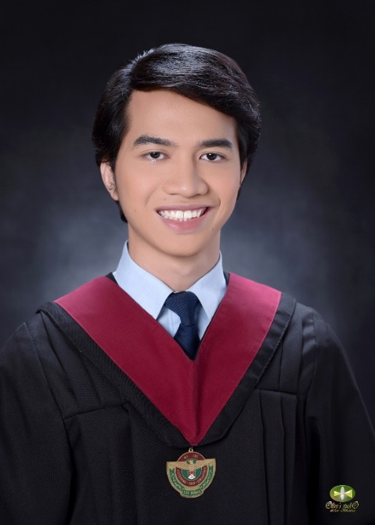

JOSE MIGUEL Y. CARITOS



651 Borja Subdivision, Parian, Calamba City, Laguna

0916 – 299 – 4473

jycaritos@up.edu.ph

**EDUCATIONAL BACKGROUND**

**PERSONAL SUMMARY**

**UNIVERSITY OF THE PHILIPPINES LOS BAÑOS**

2014 – 2019 Bachelor of Science in Civil Engineering

Undergraduate Thesis:

*“Site Selection and Design of Storage Facility for Chemical Hazardous Wastes Produced in UPLB Using Analytical Hierarchy Process (AHP)”*

* Designed a facility based on R.A. 6969 and other occupational health standards
* Utilized QGIS, Google Earth, and AHP in choosing the ideal location for the facility
* Established route and schedule for waste collection

A responsible and goal-driven graduate with a desire to develop knowledge in the civil engineering field. Has a penchant for detail-oriented works and can work independently as an individual or in a collaborative team setting.

**RELEVANT SKILLS**

* Good leadership and management abilities
* Excellent oral and written communication skills
* Has background in technical and critical writing
* Capable of using Microsoft Office, Visual Basic, ArcGIS, and modelling software: SketchUp and AutoCAD
* With background experience in analyzing and checking safety standards
* Certified Safety Officer 2

**AFFILIATIONS / EXPERIENCES**

**THE GRAPHIC LITERATURE GUILD (2016 – 2019)**

*Finance Committee Head* (2018 – 2019)

* Safeguarded the organization’s finances
* Organized income generation activities
* Released monthly financial reports

*Project Committee Head* (2017 – 2018)

*Event Head, ELBIKON 2018*

* Supervised all external activities that represent the organization
* Organized, monitored, and evaluated said activities

*Deputy Guild Master* (2017 – 2018)

* Presided over the Logistics Committee, a special *ad hoc* committee which overlaps other committees in major events

**PHILIPPINE INSTITUTE OF CIVIL ENGINEERS –**

**UPLB STUDENT CHAPTER (2016 – 2019)**

**TRAININGS / CERTIFICATES**

**CONSTRUCTION OCCUPATIONAL SAFETYAND HEALTH**

*Community Health Education Emergency Rescue Services Corp.*

July 2020

**FUNDAMENTALS OF GIS**

*Coursera*

May 2020