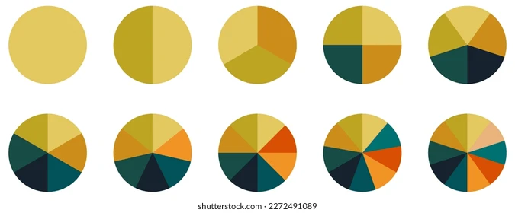
Lab 6: Aggregating Data with Pie Charts
In this lab, you will explore a real-world movie dataset from Kaggle (IMDB) and create pie chart visualizations using D3. Unlike previous labs, the challenge here is not drawing shapes, but deciding how to aggregate data so that a visualization makes sense.
You will work with categorical data (genres, ratings, decades) and reflect on how your design and aggregation choices affect interpretation.
Before You Start…
➡️ Here is some starter code to guide you
Things To Know
📖 D3 resources on Pie Chart

Learning Goals
By the end of this lab, you should be able to:
- Clean and aggregate categorical data
- Handle multi-valued fields (e.g., movies with multiple genres)
- Create a pie chart using D3

Part 0: Download the dataset
You will download this CSV file containing information about movies scraped from IMDb.
https://www.kaggle.com/datasets/carolzhangdc/imdb-5000-movie-dataset
Each row represents one movie.
Some relevant columns include:
- genres – one or more genres separated by |
- content_rating – PG, PG-13, R, etc.
- title_year – year the movie was released
- imdb_score – IMDb rating
- budget, gross – financial data
⚠️ Important: Not all fields are clean or complete. This is intentional.

Part 0: Setting up your project
Make sure your index.html has a container for the chart:

COPY & PASTE
<div id="piechart"></div>
<script type="module" src="./main.js"></script>

Part 1: Inspecting the Data
In your main.js file, you’ll want to use D3 to open the CSV and print the data to the console.

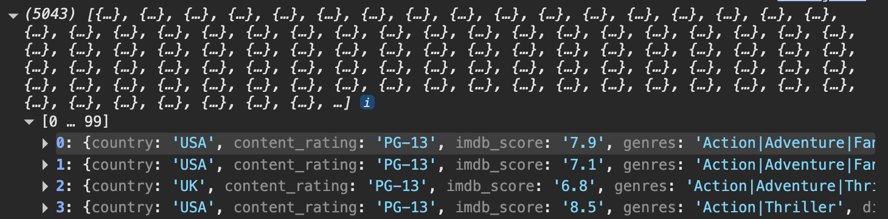
Before writing visualization code, answer the following:
- Which columns are numeric?
  - Num_critic_for_reviews, duration, director_facebook_likes, actor_3_facebook_likes, actor_1_facebook_likes, gross, num_voted_users, cast_total_facebook_likes, facenumber_in_poster, num_user_for_reviews, budget, actor_2_facebook_likes, imdb_score, aspect_ratio, movie_facebook_likes
- Which columns are categorical?
  - Color, language, country, content_rating, director_name, title_year
  - Genres, plot_keywords
- Which columns look “messy” or hard to visualize directly?
  - Genres, plot_keywords

Part 2: Aggregating Genres
Each movie can belong to multiple genres (e.g., Action|Adventure|Sci-Fi).
Your task is to create a data structure that counts how many times each genre appears
This means:
- A single movie may increment multiple genre counts
- You must split the genres string
- You must aggregate values yourself (this is the core skill of the lab)
Requirements
- Ignore movies with missing genre data
- Split genres using the | character
- Count each genre occurrence
- Store the result in a structure suitable for D3 (e.g., an array of { genre, count } objects)

Step 1: filter genres to remove invalid data

Data is often incomplete or contains null values. In this case, we want to remove any rows with null values or empty strings. We can do that using the filter command below:

COPY & PASTE
const filteredData = data.filter(d => {
// remove rows with missing genre or content rating
if (!d.genres || d.genres.trim() === "") return false;
if (!d.content_rating || d.content_rating.trim() === "") return false;
return true;
});

console.log("Rows after filtering:", filteredData.length);

Notice that filteredData is receiving the output of data.filter this is because data is not changed by the filter command.

Bonus Step: Find the missing values

Create a table using console.table() to show which columns contain missing or null values. You can do this with for loops or use the data.forEach command.

Step 2: typecast the data and only keep the variables you need

Create a simplified version of the dataset that only includes the columns you need:

COPY & PASTE
const mappedData = filteredData.map(d => ({
title: d.movie_title,
genre: d.genres,
rating: d.content_rating
}));

console.log("Mapped data sample:");

Step 4: Explore Raw Groupings

Before counting, it’s helpful to see the “buckets” of data.

COPY & PASTE
const genreGroups = d3.group(mappedData, TODO);

console.log("Movies grouped by genre (raw arrays):");
for (const [genre, movies] of genreGroups) {
console.log(genre, movies.slice(0,3)); // show first 3 movies
break; // just show one example
}

Can you answer the following questions?
- How many movies are in the first genre bucket?
- What is the first movie in that bucket?
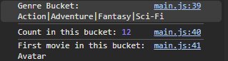

Step 5: Count Movies by Genre
Now that you have filtered and mapped your data, we want to see how many movies exist for each genre. We’ll use D3’s d3.rollup to do this.
EXAMPLE CODE
const genreCounts = d3.rollup(
mappedData, // the array of movie objects
group => TODO, // how do we count movies in this group?
d => TODO // what do you want to group?
);

Step 6: Convert the returned map into an array
D3’s pie chart generator works with arrays, not Maps. To convert:
COPY & PASTE
const genreArray = Array.from(
genreCounts,
([genre, count]) => ({ genre, count })
);

Log it to the console as a table: console.table(genreArray)

Part 3: Create a Pie Chart
Let’s bring it all together with the following code .

COPY & PASTE
const width = 400, height = 400, radius = Math.min(width, height) / 2;

const svg = d3.select("#piechart")
.append("svg")
.attr("width", width)
.attr("height", height)
.append("g")
.attr("transform", `translate(${width/2}, ${height/2})`);

const color = // create an ordinal colorscale

const pie = d3.pie().value(TODO); // should be a function!
const arcs = pie(genreArray);

// we will use a similar pattern as below in the linegraph lab
const arcGenerator = d3.arc()
.innerRadius(0)
.outerRadius(radius);

svg.selectAll("path")
.data(arcs) // we’re not passing raw data! We pass the geometry
.join("path")
.attr("d", arcGenerator) // we’re passing the arc generator
.attr("fill", d => TODO )
.attr("stroke", "white")
.attr("stroke-width", 1);

