1. Clone source code from github
2. Set project Android/iOS is startup project
3. Deploy to device
4. Testing
   1. Create a mobile application on <https://mobile.azure.com>   
      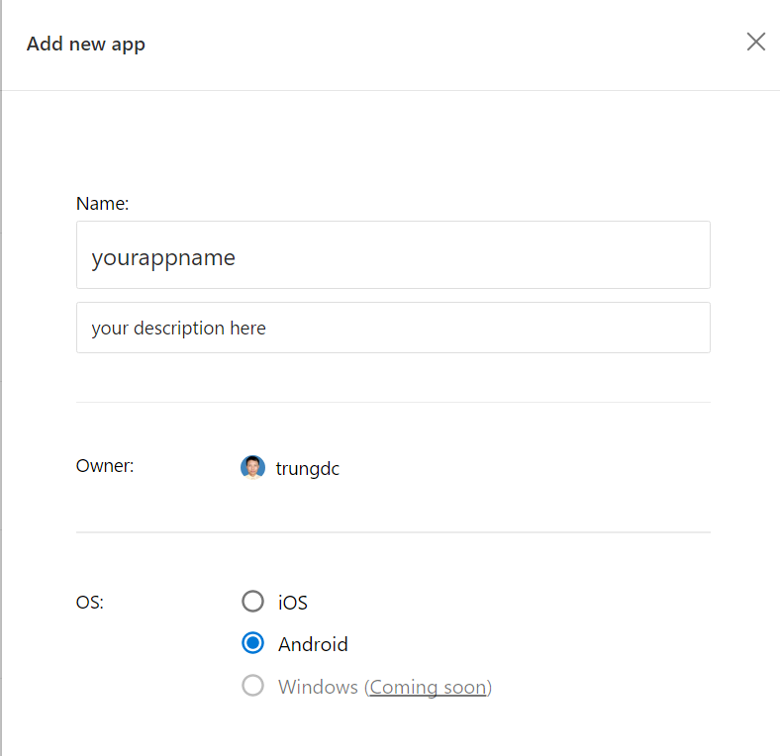  
        
      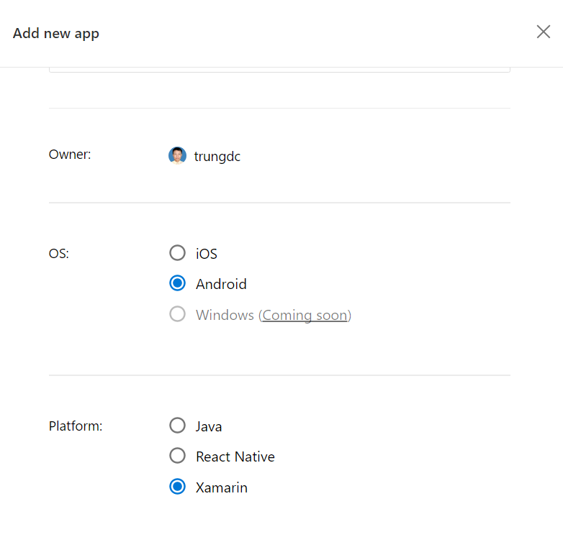
   2. Create test run  
      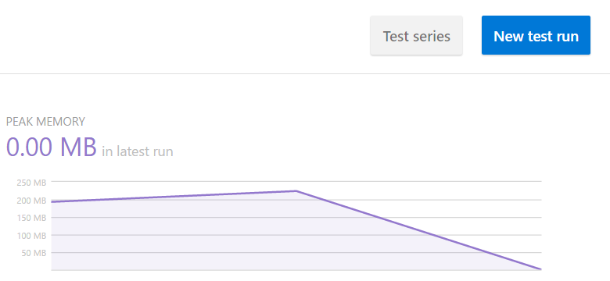  
        
      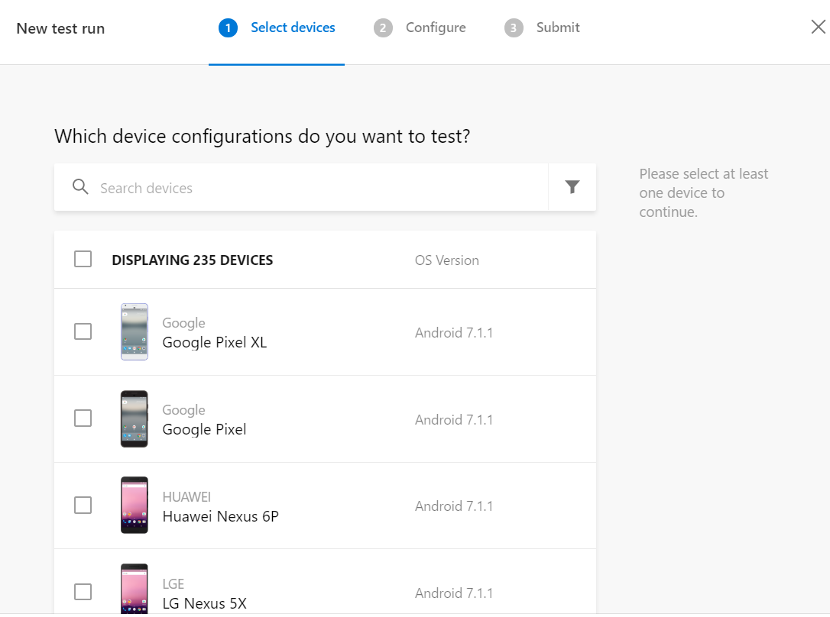  
      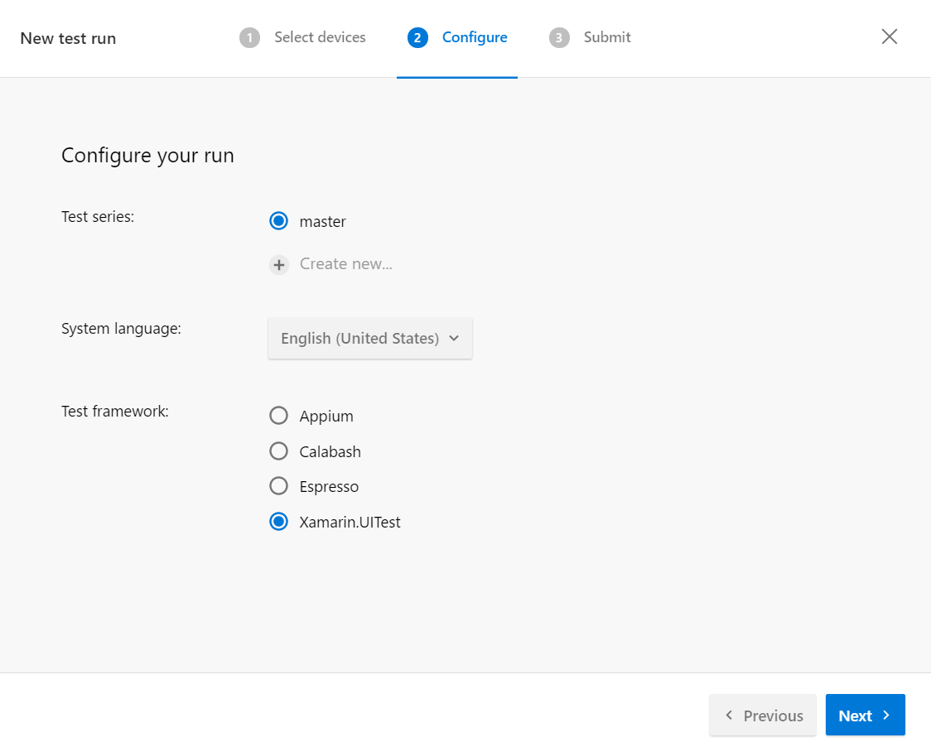  
      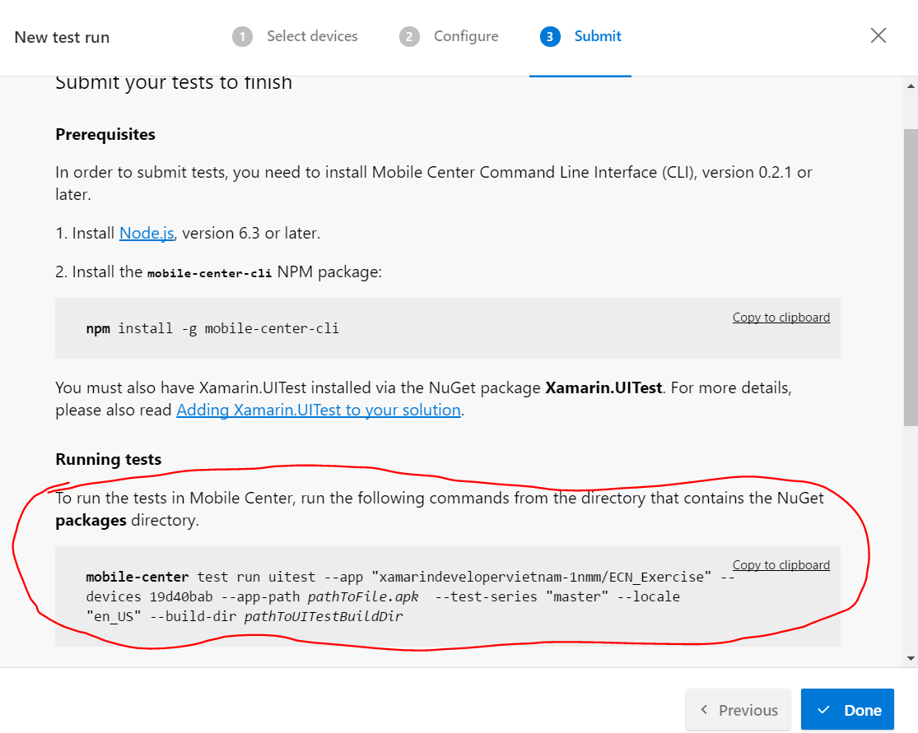
5. Result  
   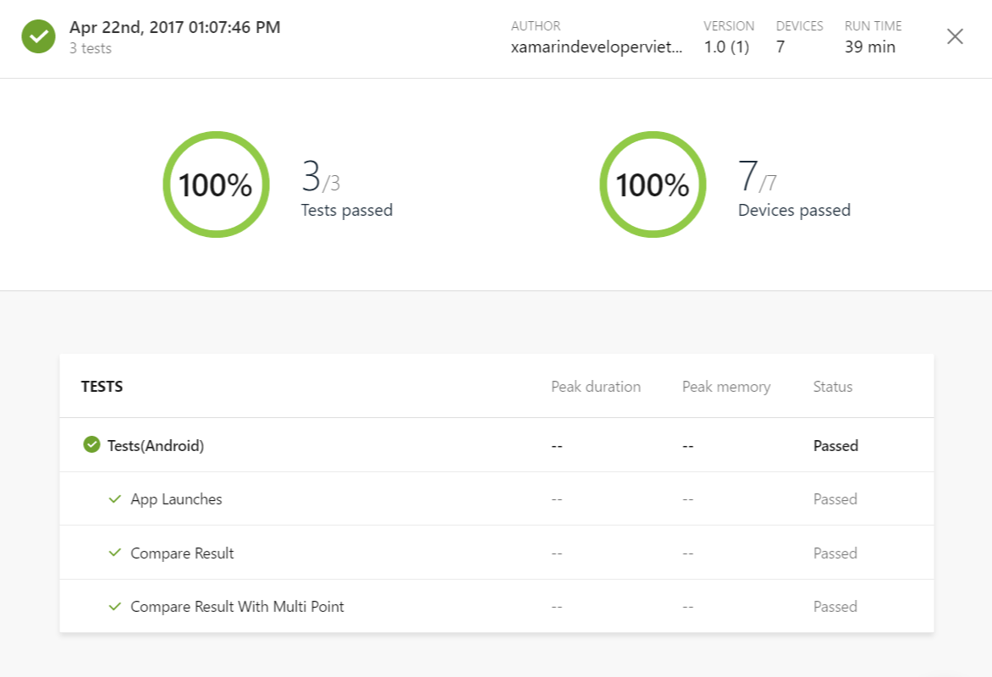  
   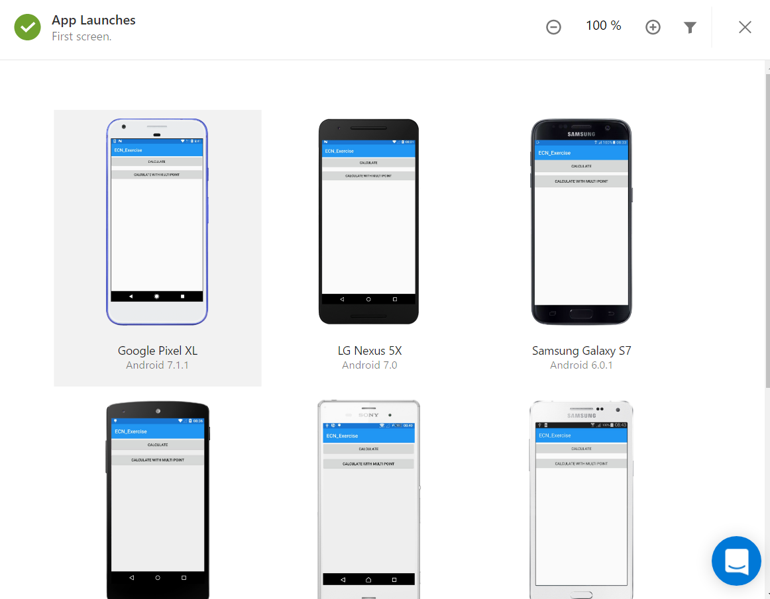  
   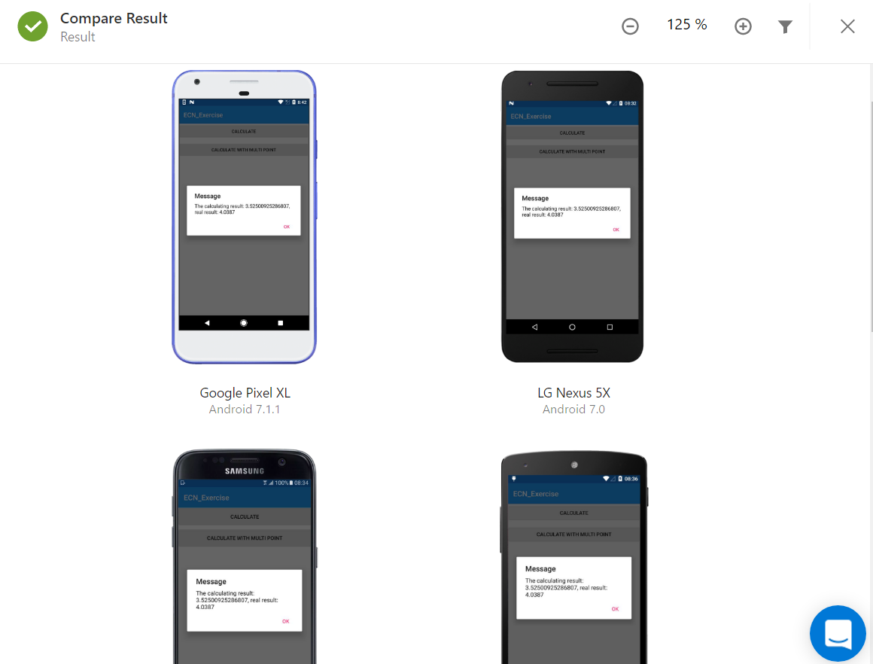
6. How accurate is the predictor? How could we make it more accurate?  
   With 12 sampling points we get the result with quite large deviations. For accurate results we need as many sampling points as possible, as the deviation becomes smaller.