SAMPLE…

1. What are the predominant multimodal sentiments expressed in Philippine internet memes related to elections?

|  |  |  |
| --- | --- | --- |
| Type of Multimodal Sentiment | Number of Memes | Sample Memes |
| **Neutral** | 25, 000 | Philippine political memes? : r/Philippines |
| **Positive** | 10,000 | Use of Memes In Activism - Coconet |
| **Negative** | 15, 000 | Facebook Groups | Ni di nga sila mag kamag anak eh |
| **Total number of Memes** | 50, 000 |  |

(Ang ilagay lang sa table is yung pinaka mataas na rate ng emotion e.g neutral, positive & negative)…

2. 2. How are these memes linguistically and visually organized in contributing to the overall expression of these sentiments?

(Should be answered through sa TEXT EXTRACTION and IMAGE CAPTIONING)…

Let’s say…. This sample table:

|  |  |  |  |
| --- | --- | --- | --- |
| Type of Multimodal Sentiment | Sample Meme | Text Extracted | Image Caption |
| **Neutral** | politics philippines Memes & GIFs - Imgflip | *When you realize how dirty the country you run really is…* | *This image shows a man, likely a political figure based on the podium and microphone setup, wearing a striped polo shirt. The text at the top reads: "WHEN YOU REALIZE HOW DIRTY THE COUNTRY YOU RUN REALLY IS..." A woman standing next to him is reaching toward his shoulder, where there is a visible stain or dirt spot (highlighted with a red circle).* |
| **Positive** | Meme Maker - I am a Filipino and my President is a Duterte Meme Generator! | I am Filipino and my president is Duterte. | *The image shows former Philippine President Rodrigo Duterte speaking at a formal event or hearing, as he is seated at a table with a microphone in front of him. He is gesturing with his hands, possibly emphasizing a point he is making. He is wearing a white jacket over a black shirt.* |
| **Negative** | Trump & Duterte - Imgflip | *“Mr. Duterte, have you violated anyone’s human rights?”*  *“No Way!!!!”*  *“Great! Didn’t think so. Say, how have you managed to acquire so many outstanding journalists there in the Philippines?”* | *This image is a meme featuring two well-known political figures in a split-screen format. On the left side, there is a man, likely former U.S. President Donald Trump, with a smug or amused expression, suggesting sarcasm. On the right, the man appears to be former Philippine President Rodrigo Duterte, sitting at a formal event, wearing a suit and tie, and looking serious.* |

3. How do sentiments in memes vary across different political affiliations?

|  |  |  |  |  |
| --- | --- | --- | --- | --- |
| **Political Affiliations** | **Type of Sentiment** | **Number of Memes** | **Percentage** | **Sample Meme** |
| PDP-Laban (Partido Demokratiko Pilipino-Lakas ng Bayan) | Neutral  Positive  Negative | 3,333  4,444  5,999 | 6.67%  8.89%  12.00% | iMPACT Leadership - 'WALA SIYANG MAGAWA' Sen. Robinhood Padilla, acting  president of the once-ruling Partido Demokratiko Pilipino (PDP) chaired by  former President Rodrigo Duterte, said Sen. Bato Dela Rosa followed their  party's |
| Liberal Party (LP) | Neutral  Positive  Negative | 6,666  7,757  10,102 | 13.33%  15.51%  20.20% |  |
| Nacionalista Party (NP) | Neutral  Positive  Negative | 1,234  2,222  1,000 | 2.47%  4.44%  2.00% |  |
| Lakas–Christian Muslim Democrats (Lakas–CMD) | Neutral  Positive  Negative | 500  500  800 | 1.00%  1.00%  1.60% |  |
| United Nationalist Alliance (UNA) | Neutral  Positive  Negative | 2,300  3,000  143 | 4.60%  6.00%  0.29% |  |
| Total Number of Memes |  | 50, 000 | 100% |  |

After nitong table 3 Kuys, para ma determine if there exists a variation of sentiments sa political affiliations, e run yung data sa Orange Software for further additional analysis gamit ang **ANOVA.**

*May sample below kuys pero ang data nito is tweets (sentiments sa types of situation ciris).*

*Excerpt of the dissertation paper:*

To further determine if there exists a variation of sentiments on the public voice of Filipinos across crisis situations, the data that were run from Orange Software were further subjected to additional analysis through ANOVA. It was revealed that the mean score is 261.882 and the f value is 16928.542 with the p-value of .000. Since this is lower than .05 level of significance, this means that there exists a variation in regard to the sentiments of Filipinos across different types of crisis situations.

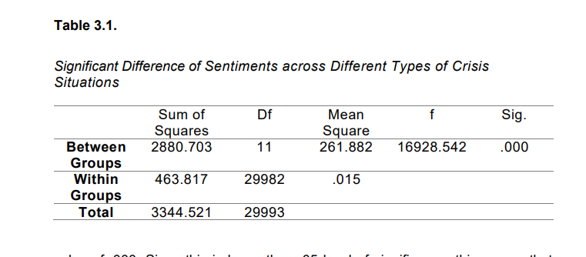

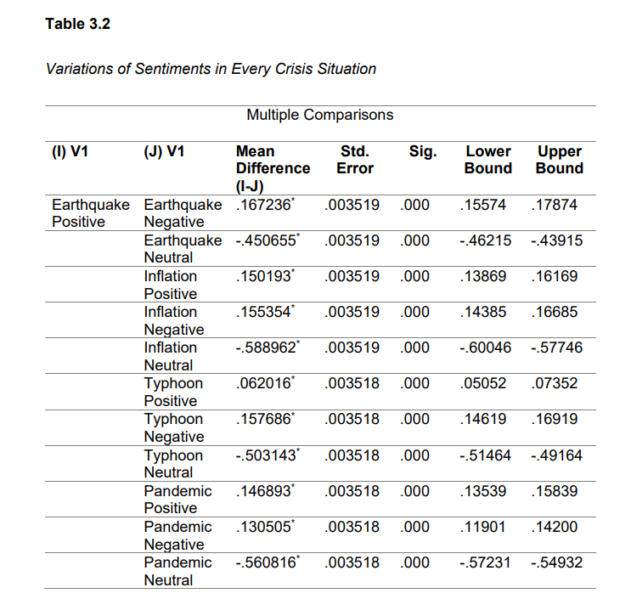 Further, to confirm the result contained in Table 3.1, the data was subjected to Multiple Comparison using **Tukey HSD**. In here, the sentiments of the Filipinos in each crisis situation were considered in order to see if there are variations. As seen in the data in Table 3.2, the mean difference is shown between each pair of variables, along with a significance code indicating whether the difference is statistically significant at the 0.05 level.

As the table contains, there are a number of statistically significant differences between the variables. For example, the mean score for Earthquake Positive Emotion is significantly higher than the mean score for Earthquake Negative Emotion, Inflation Neutral Emotion, Typhoon Neutral Emotion, and Pandemic Neutral Emotion. Additionally, the mean score for Earthquake Negative Emotion is significantly lower than the mean score for Earthquake Neutral Emotion, Inflation Positive Emotion, Inflation Negative Emotion, Inflation Neutral Emotion, Typhoon Positive Emotion, Typhoon Negative Emotion, Typhoon Neutral Emotion, Pandemic Positive Emotion, Pandemic Negative Emotion, and Pandemic Neutral Emotion. The data above reveal significant variations in public sentiment across different crisis situations, suggesting that the type of crisis significantly impacts how people perceive and react to it. Positive sentiment appears highest during earthquakes, suggesting a potential sense of community and resilience in the face of natural disasters. Inflation also elicits a relatively positive response, possibly indicating an understanding of its economic implications and potential for adaptation. However, pandemic generates the lowest positive sentiment, likely due to their widespread impact and associated fear and uncertainty. Negative sentiment peaks during typhoons, reflecting the immediate threat and potential devastation they pose. Earthquakes and pandemics also evoke a significant degree of negativity, while inflation generates the least negative response. This pattern suggests that the perceived level of danger and immediacy plays a crucial role in shaping negative sentiment. Neutral sentiment is most prevalent in the context of inflation, potentially indicating a more balanced perspective on this complex economic issue. Conversely, pandemics trigger the lowest level of neutral sentiment, highlighting a stark polarization of opinions and lack of consensus around their management. These findings highlight the complex relationship between crisis type and public emotions, offering valuable insights for crisis management and communication strategies.

4. What types of ideological appeals are depicted in these memes?

|  |  |  |  |  |
| --- | --- | --- | --- | --- |
| **Political Ideologies** | **Type of Sentiment** | **Number of Memes** | **Percentage** | **Sample Meme** |
| Liberalism | Neutral  Positive  Negative | 3,333  4,444  5,999 | 6.67%  8.89%  12.00% |  |
| Conservatism | Neutral  Positive  Negative |  |  |  |
| Socialism | Neutral  Positive  Negative |  |  |  |
| Anarchism | Neutral  Positive  Negative |  |  |  |
| Nationalism | Neutral  Positive  Negative |  |  |  |
| Fascism | Neutral  Positive  Negative |  |  |  |
| Feminism | Neutral  Positive  Negative |  |  |  |
| Green Ideology | Neutral  Positive  Negative |  |  |  |
| Islamism | Neutral  Positive  Negative |  |  |  |
|  |  |  |  |  |